**Transportation Infrastructure Precast Innovation Center**

**(TRANS-IPIC)**

**University Transportation Center (UTC)**

Data-Driven Smart Composite Reinforcement for Precast Concrete

PU-23-RP-05

Quarterly Progress Report

For the performance period ending *March 31, 2024*

**Submitted by:**

Chengcheng Tao (PI), [tao133@purdue.edu](mailto:tao133@purdue.edu)

Shanyue Guan (Co-PI), [guansy@purdue.edu](mailto:guansy@purdue.edu)

School of Construction Management Technology

Purdue University

**Collaborators / Partners:**

N/A

**Submitted to:**

TRANS-IPIC UTC

University of Illinois Urbana-Champaign

Urbana, IL

**TRANS-IPIC Quarterly Progress Report:**

**Project Description:**

1. **Research Plan - Statement of Problem**

Composite reinforcement has been increasingly applied in the precast concrete (PC) area [1], because of its high strength, lightweight, high fracture toughness, long-term corrosion, and crack resistance. The behavior of composite reinforcement plays an important role in the precast concrete infrastructure. It is important to monitor the material system and provide real-time situational awareness under different scenarios. Physical testing with trial-and-error approaches on composite reinforced PC components require substantial time, labor, and material resources to monitor the structural and materials conditions and detect failure or anomalies under service. There is a lack of an efficient and precise way to monitor and predict the risk of the composite reinforcement for PC components.

The proposed research aims to develop a smart composite reinforcement in precast concrete for real-time health condition monitoring using embedded sensors on the composite. The monitoring system can provide the health condition and risk information of the composite reinforcement and investigate the load transfer effectiveness between layers of the reinforcement and the precast concrete. The self-sensed composite reinforcement experimental data will be paired with computational models of composite-concrete system and data-driven machine learning algorithms to predict the risk of the composite reinforcement for a better reinforced precast concrete system. The research will integrate smart sensor technology, computational mechanics of materials, and data-driven machine learning algorithms to detect the structural and materials failure and anomaly mechanism, and predict the associated risk in a wide range of applications.

1. **Research Plan - Summary of Project Activities (Tasks)**

Task 1. Development and testing of embedded smart sensors for self-sensing composite reinforcement in precast concrete.

This task focuses on the smart sensor development and application for the composite reinforcement in PC. The testing data will be integrated with Tasks 2 and 3.

Task 2. Multi-scale multi-physics modeling with finite element analysis for the composite reinforcement mechanical and bonding performance.

The task focuses on the development of three-dimensional (3D) finite element analysis models to simulate the mechanical and bonding performance of composite reinforcement and precast concrete.

Task 3. Development of precast concrete risk index for the infrastructure integrity management enhanced by AI algorithms.

This task focuses on the machine learning-based risk analysis using data from Tasks and 2.

Task 4. Reporting.

Research outcomes will be summarized in the quarterly and final reports submitted to TRANS-IPIC and publications in journals. Presentations of the research findings will be disseminated to the TRB and ASCE conferences.

**Project Progress:**

1. **Progress for each research task**

**Task 1 progress [10% completed]**

In Task 1, the first step is the smart sensor information collection and literature review. We reviewed different types of sensors used in concrete reinforcement and contacted various smart sensor companies. We also conducted a comprehensive literature review on the distributed fiber optic sensors used in concrete and reinforcement and material testing of metallic and non-metallic reinforcement in concrete structure components. Experimental plans were developed for the mechanical testing and sensor installation. We follow ASTM C78 [2] and C293 [3] standards for the flexural tests and ACI 440.1R [4] for the composite-reinforced precast concrete beam design. We will conduct flexural strength testing on a composite reinforced concrete beam with the dimension of 6’’x6’’x20’’, shown in Figure 1.

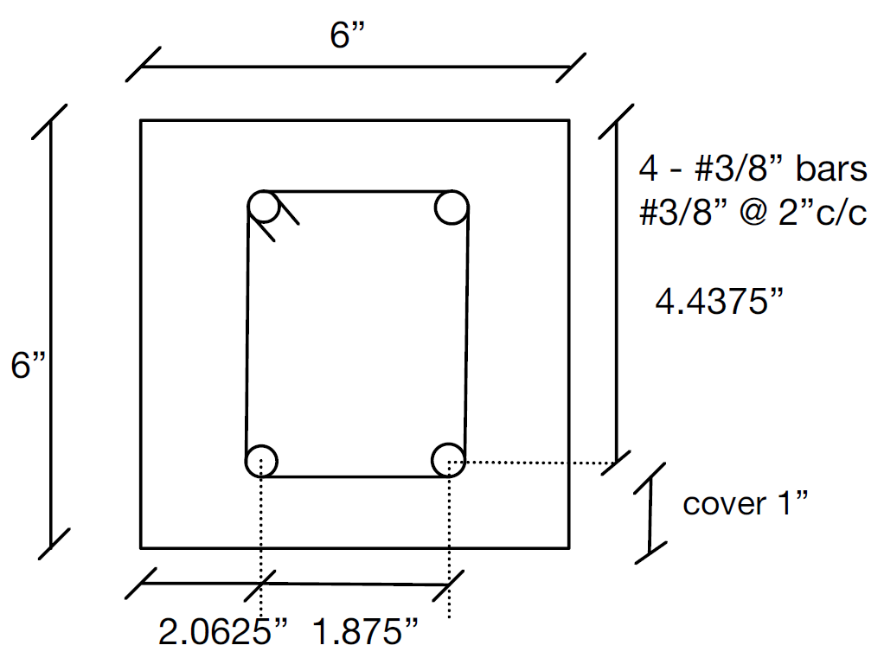

Figure 1. Dimension of the composite reinforced concrete beam for flexural test

**Task 2 progress [30% completed]**

Task 2 focuses on the finite element analysis (FEA) of the mechanical performance of the composite reinforcement and concrete. We create a three-dimensional (3D) finite element model of a composite reinforced concrete beam and conduct the flexural strength test in ABAQUS, shown in Figure 2. We setup up the dimension of the beam sample following the requirement in ASTM C293 [3], which consists of a 6’’x6’’x20’’ concrete beam and two #3 composite rebars. The rebar span is set as 18 in. The top loading block is positioned at the center, and two bottom rigid supports are placed 1 in away from the edges. The rebars have a bottom cover depth of 1 in and are evenly separated. Through monotonic downward movement of the top loading block, the concrete beam undergoes flexural bending, experiencing compression at the top and tension at the bottom. C40 concrete is used in the model with the modulus of elasticity of 32.1 GPa and the 28-day compressive strength of 49.88 MPa [5]. For the reinforcement, we choose the glass-fiber reinforced composite material with a high ultimate strength of 1003 MPa [6], [7]. We apply the concrete damage plasticity model and composite elasto-plasticity model for the nonlinear analysis. Figure 3 shows the cracks propagation process from the vertical flexural cracks at bottom center to the 45o shear crack towards the loading and supporting area. The modeling results aligns with the experimental data by Maranan et al. [8]. Figure 4 shows the strain distribution in the composite rebars. The maximum strain happens in the center of the bottom rebars. These FEA simulation results will be further validated with the experimental data in the next quarter.

|  |  |  |
| --- | --- | --- |
|  | | |
| (a) | (b) | (c) |

Figure 2. Schematic of 3D finite element model of a composite reinforced concrete beam for flexural strength test: (a) lateral view; (b) top view; (c) front view

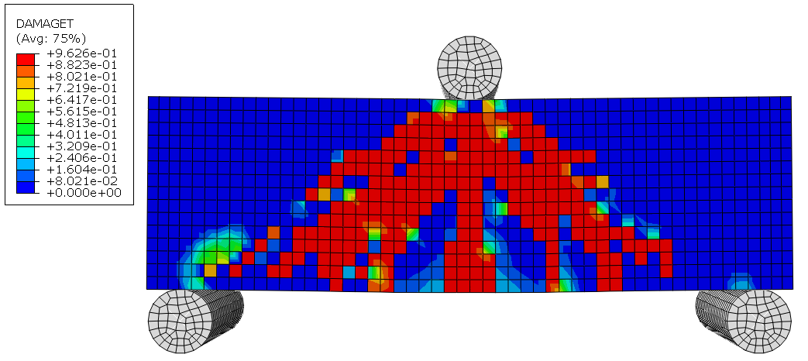

Figure 3. FEA results on the crack propagation of the concrete beam under flexural test

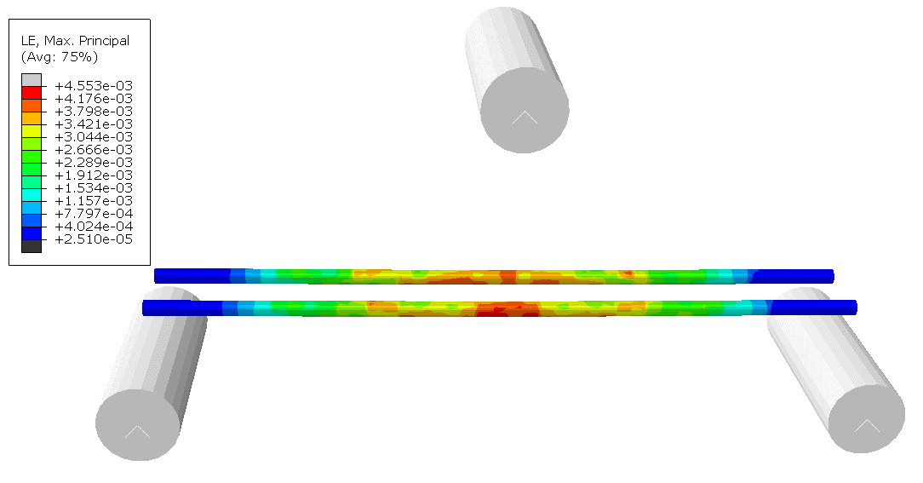

Figure 4. The strain distribution of composite rebars

**Task3 progress [0% completed]**

This task hasn’t started.

**Task4 progress [0% completed]**

This task hasn’t started.

1. **Percent of research project completed**

Total project completed through the end of this quarter = 20%

1. **Expected progress for next quarter**

The next quarter will focus on the experiment setup, sensor installation, and finite element analysis for mechanical and bonding performance of for composite reinforced concrete.

1. **Educational outreach and workforce development**

N/A

1. **Technology Transfer**

N/A

**Research Contribution:**

1. **Number of papers**

No completed papers.

1. **Number presentations (when, where)**

No presentations have been presented.

**References:**

[1] E. Hamed, ‘Load-carrying capacity of composite precast concrete sandwich panels with diagonal fiber-reinforced-polymer bar connectors’, *PCI J*, vol. 62, no. 4, pp. 34–44, 2017.

[2] A. Designation, ‘C78; Standard Test Method for Flexural Strength of Concrete (Using Simple Beam with Third-Point Loading)’, *Am. Soc. Test. Mater. Phila. PA USA*, 2016.

[3] A. S. for T. and Materials, ‘ASTM C293, Standard Test Method for Flexural Strength of Concrete (Using Simple Beam with Center-Point Loading)’, 2001.

[4] American Concrete Institute, *Guide for the design and construction of structural concrete reinforced with fiber-reinforced polymer (FRP) bars*, 1st printing. Farmington Hills, MI: American Concrete Institute, 2015.

[5] H. Ş. Arel and Ş. Yazıcı, ‘Concrete–reinforcement bond in different concrete classes’, *Constr. Build. Mater.*, vol. 36, pp. 78–83, 2012.

[6] B. Dal Lago et al., ‘Full-scale testing and numerical analysis of a precast fibre reinforced self-compacting concrete slab pre-stressed with basalt fibre reinforced polymer bars’, *Compos. Part B Eng.*, vol. 128, pp. 120–133, 2017.

[7] M. Mohamed et al., ‘Manufacturing of prestressed glass fiber reinforced polymer rebars and effect of fiber pretension on durability of rebars after conditioning in alkaline solution’, *J. Compos. Mater.*, vol. 56, no. 26, pp. 4011–4024, 2022.

[8] G. B. Maranan et al., ‘Evaluation of the flexural strength and serviceability of geopolymer concrete beams reinforced with glass-fibre-reinforced polymer (GFRP) bars’, *Eng. Struct.*, vol. 101, pp. 529–541, 2015.