**Transportation Infrastructure Precast Innovation Center**

**(TRANS-IPIC)**

**University Transportation Center (UTC)**

Holistic Quality Management of Precast Concrete Construction for Transportation Infrastructure

PU-23-RP-01

Quarterly Progress Report

For the performance period ending on March 31, 2024

**Submitted by:**

Hubo Cai, [hubocai@purdue.edu](mailto:hubocai@purdue.edu)

Lyles School of Civil Engineering

Purdue University

**Collaborators / Partners:**

No other collaborators/partners

**Submitted to:**

TRANS-IPIC UTC

University of Illinois Urbana-Champaign

Urbana, IL

**TRANS-IPIC Quarterly Progress Report:**

**Project Description:**

1. Research Plan - Statement of Problem

Precast concrete systems (PCS) have been widely used by US State Department of Transportation (DOTs) as a promising alternative to cast-in-place concrete systems. High-quality PCS provide several benefits including: shorter lane closures and reduced traffic congestion attributed to accelerated construction with shorter project duration, and increased road user and worker safety when such systems are utilized correctly [1]. However, quality deficiencies during any PCS lifecycle phases (i.e., design, manufacturing, transporting, lifting and installation, and operation and maintenance (O&M)) can easily offset the expected benefits, leading to premature failures and excessive repair costs.

Current practice in quality management (QM) of PCS (PCS QM) heavily rely on manual approaches and remain isolated within each lifecycle stage. For instance, quality control (QC) during the precast-at-plant stage is done using labor-intensive performance audits and sporadic inspections with the potential to miss important problems and thus violate specifications at precast facilities [2]. Resulting quality deficiencies can impact the transportation of precast elements, their installation and connections with other components at transportation projects and their life-cycle performance and maintenance. Using checklists for pre-shipping and onsite acceptance can help capture certain quality deficiencies such as dimensions and locations of dowel bars. However, such actions are often reactive and offset benefits such as reduced project duration and shortened lane closures in transportation projects.

To address the mentioned problems, this research project aims to develop, validate, and test a holistic quality management framework/model for precast construction of transportation infrastructure. The framework collects, measures, and evaluates data of the precast process across its life cycle, from design to production, transport, installation/construction, commissioning, O&M, and decommission/reuse. By integrating BIM, laser scanning, GPR, vision sensing, extended reality (XR) along with advanced computational tools, the framework creates a digital twin as the ‘seamless’ method of information management and sharing that can be used for quality control and management of the precast systems from the life-cycle perspective. This framework is a step towards ensuring that the following key attributes of successful PCS projects can be achieved: constructability, concrete durability, load transfer at joints, panel support, performance efficiency [3].

1. Research Plan - Summary of Project Activities (Tasks)

***Task 1:*** *Design a system-level framework for lifecycle data/information/knowledge acquisition and data exchange in PCS.*

This task focuses on framework design and workflow and process modeling. It consists of three steps: (a) compiling knowledge of field practice of PCS QM, (b) assessing the state-of-the-art BIM practice in PCS QM, and (c) designing a BIM-based digital twin system.

***Task 2:*** *Design an expandable BIM approach to meet the data and information needs of lifecycle PCS QM.*

This task includes: (1) design of templates for expandable BIM, using IFC as the open standard, (2) identification of data needs in precast production, transporting, installation, and operation and maintenance, and (3) implementation to accommodate data needs in precast production and generate data to meet the transporting and installation needs.

***Task 3:*** *Validation and case study – the precast-at-plant stage.*

This task targets quality control considering different operations in precast manufacturing at plants. The task evaluates the newly designed BIM framework by comparing with the current QM practice in terms of utilization of resources, time and labor savings, capture of deficiencies in quality, and the completeness of the BIM model.

***Task 4:*** *Presentation/panel discussion at 2024 Purdue Road School.*

A presentation/panel discussion will be held at the 2024 Purdue Road School to share project findings and to engage with/learn from experienced researchers and practitioners in the field of precast concrete in transportation projects.

**Project Progress:**

1. Progress for each research task

**Task 1 progress [70% completed]**

*Subtask 1 - Compiling knowledge of field practice of PCS QM [80% completed]*

The first subtask in Task 1 is the assessment of the current field practice related to quality management throughout the life cycle of PCS. Since different PCSs have many QC/QA tasks in common, Jointed Precast Concrete Pavement (JPrCP) System was studied as an example PCS for this task. For each PCS QC/QA task in different lifecycle phases (except for design stage), we determined its checklists, timing, responsible parties, methods and tools by examining existing manuals and specifications that guide the implementation of precast concrete pavement projects [4,5]. A breakdown structure of QC/QA field practice was followed to compile the knowledge, as shown in Figure 1. Driven by the idea of object-oriented modeling in BIM, specific check items were identified and organized in the format of “object-attribute”. These results were used for the design of expandable BIM templates in Task 2.

**Figure 1 Breakdown structure of QC/QA field practice**

*Subtask 2 - Assessing the state-of-the-art BIM practice in PCS QM [70% completed]*

The current status of BIM practice in PCS QM was investigated by reviewing the related research literature. Three research themes regarding PCS QM were identified from existing literature: 1) advanced sensing technologies for automated inspection of PC components in fabrication and installation stages, 2) advanced sensing technologies that can automate the checking and assessment of PC components in O&M stage, and 3) BIM and IFC based data representation, storage and delivery. The sensing technologies were carefully evaluated by comparing their technical specifications, including the methods, tools, performance, working conditions, and limitations. Besides, different IFC-based data modeling approaches were reviewed by analyzing how the physical PC components can be digitally modeled by IFC entities.

*Subtask 3 - Designing a BIM-based digital twin system [0% completed]*

The framework of BIM-based digital twin system will be designed based on the compiled knowledge and findings from the previous two subtasks. The framework will be designed with an executable demo in Task 2; and assessed, validated, and improved in Task 3.

**Task 2 progress [60% completed]**

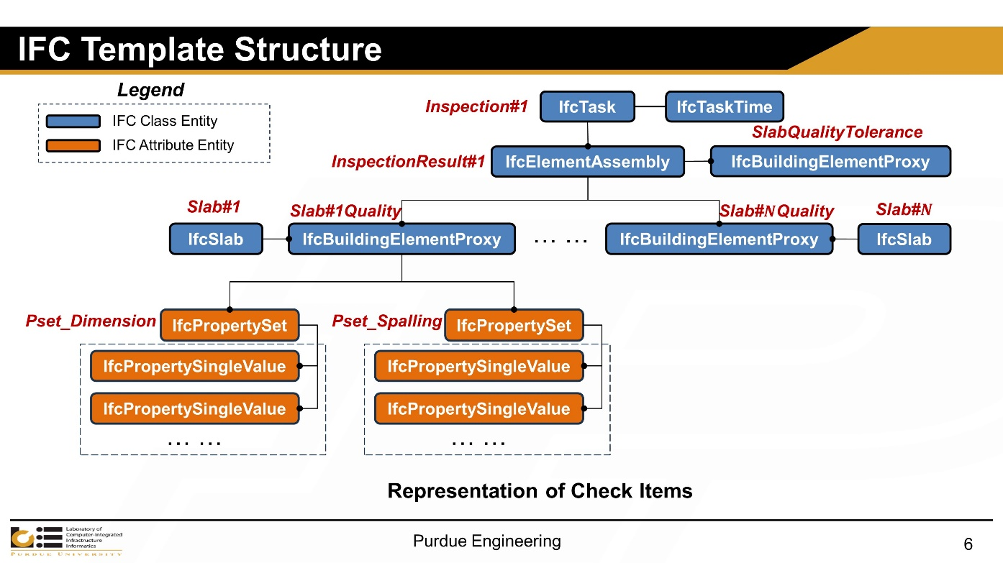

**Figure 2 Data structure of expandable BIM templates**

*Subtask 1 - Design of templates for expandable BIM, using IFC as the open standard [70% completed]*

First, the entity list of the up-to-date IFC data schema (IFC 4.3 ADD2) was examined to identify the IFC entities suitable to represent the quality inspection data of PCS components. The examination demonstrates that the extension of current IFC data schema is required to accommodate our needs of quality data representation. To achieve the extension goal with a minimum impact on IFC interoperability, we opted for adding customized object properties set instead of creating new IFC entities. We designed a common IFC data structure for expandable BIM templates. Figure 2 shows the data structure for the template of precast concrete pavement slab. The data structure is task-centered, which allows for the accumulation of quality information/knowledge with the collected data in each inspection task. The collected defect data is linked to the corresponding slab object as its property sets, such as dimension defect property set. The property set contains associated properties, such as length, width, squareness, and so on.

*Subtask 2 - Identification of data needs in precast production, transporting, installation, and operation and maintenance [70% completed]*

In this subtask, we assessed the data/information/knowledge needs and exchange in the BIM model and the levels of development (LOD) and accuracy. We qualitatively evaluated how the BIM data flow can assist in different data management tasks. An example is that storing the quality data using the designed template allows for automated compliance checking, considering the template is able to represent information of as-designed, as-built, and as-is models. In the next step, more cases will be analyzed and presented.

*Subtask 3 - Implementation to accommodate data needs in precast production and generate data to meet the transporting and installation needs [30% completed]*

An IFC toolkit named IfcOpenShell was utilized to create the designed template in Subtask 1. A LOD400 IFC model from Autodesk Revit was used as the base model to create the template. We generated synthetic data to simulate the quality data collected in precast production and test if the designed template can meet the data representation needs. The synthetic data is created based on the quality data samples and tolerance from existing inspection checklists and manuals [6]. Figure 3 demonstrates the representations of synthetic quality data enabled by the designed template. In the next step, we will create the templates for the other PCS components such as MSE walls, deck panels, and bridge beams.

**Figure 3 Representations of synthetic quality data**

**Task 3 progress [0% completed]**

This task hasn’t started.

**Task 4 progress [100% completed]**

**Figure 4 Panel discussion at Purdue Road School 2024**

We held a panel discussion at the Purdue Road School 2024 (Figure 4). We invited four keynote speakers: Tommy Nantung (Research Manager) and Andrew Pangallo (Construction Digital Lead Engineer) from INDOT, Jeff Brechbill (President and part owner) from First Group Engineering, and John Lendrum (President) from Norwalk Concrete Walk Concrete Industries to give presentations on 1) the growth of PCS, 2) common types of structure, 3) common challenges, 4) specific perspectives on QM, 5) Stakeholders and involved parties, and 6) Inspection, identification, and correction of defects. A Q&A session followed the presentations for the project team to ask key questions to the panelists and exchange ideas. The Purdue team also had a follow-up conversation with Tommy and John after the panel discussion.

1. Percent of research project completed

It is estimated that the total project is 55% completed in this quarter ending on March 31, 2024.

1. Expected progress for next quarter

We estimate that 80% work of the total project will be completed by the end of next (the 3rd) quarter. Task 1, Task 2, and Task 3 are expected to have 90%, 90%, and 80% completion, respectively. The specific results that will be delivered include:

* A BIM-based system-level framework for PCS digital twin
* Expandable BIM templates for MSE walls, deck panels, bridge beams, and concrete pavement

1. Educational outreach and workforce development

*NA*

1. Technology Transfer

*NA*

**Research Contribution:**

1. Number of papers

NA

1. Number presentations (when, where)

* Webinar presentation in TRANS-IPIC Monthly Research Webinar on February 19, 2024 through Zoom online meeting
* Poster presentation in JTRP posters session on February 22, 2024 in Indiana Government Center South, Indianapolis, IN 46204
* Poster presentation in Purdue Road School 2024 poster session on March 12, 2024 in Purdue Memorial Union, West Lafayette, IN 47906
* Panel discussion in Purdue Road School 2024 technical session on March 12, 2024 in Purdue Memorial Union, West Lafayette, IN 47906

**References:**

[1] L. P. Priddy, P. G. Bly, C. J. Jackson, and G. W. Flintsch, “Full-scale field testing of precast Portland cement concrete panel airfield pavement repairs,” *Int. J. Pavement Eng.*, vol. 15, no. 9, pp. 840–853, Oct. 2014, doi: 10.1080/10298436.2014.893320.

[2] D. Goulias and M. Scott, “Effective implementation of ground penetrating radar (GPR) for condition assessment & monitoring of critical infrastructure components of bridges and highways.,” University of Maryland (College Park, Md.). Dept. of Civil and Environmental Engineering, Tech Report MD-15-SHA-UM-3-11, Jan. 2015. Accessed: Jun. 19, 2023. [Online]. Available: https://rosap.ntl.bts.gov/view/dot/28443

[3] S. D. Tayabji, W. Brink, and United States. Federal Highway Administration, “Precast Concrete Pavement Implementation by U.S. Highway Agencies [techbrief],” FHWA-HIF-19-011, Jan. 2019. Accessed: Jun. 19, 2023. [Online]. Available: <https://rosap.ntl.bts.gov/view/dot/43534>

[4] P. Smith, and M.B. Snyder, “Manual for jointed precast concrete pavement (3rd Edition),” *National Precast Concrete Association*, 2017.

[5] S. Tayabji, “Jointed precast concrete pavement panel fabrication and installation checklists,” Federal Highway Administration (FHWA), 2019.

[6] Precast/Prestressed Concrete Institute (PCI) (2000), 135-Tolerance Manual for Precast and Prestressed Concrete Construction.