

Transportation Infrastructure Precast Innovation Center
(TRANS-IPIC)

University Transportation Center (UTC)

3D Printed Advanced Materials to Mitigate Prestressed
Concrete Girder End Cracks – Phase II
UB-23-RP-02

Quarterly Progress Report
For the performance period ending June 30, 2025

Submitted by:
Ravi Ranade, Associate Professor, ranade@buffalo.edu
Department of Civil, Structural and Environmental Engineering
University at Buffalo

Co-PIs: Chi Zhou (chizhou@buffalo.edu) and Pinar Okumus (pinaroku@buffalo.edu), University at Buffalo

Collaborators / Partners:
None

Submitted to:
TRANS-IPIC UTC
University of Illinois Urbana-Champaign
Urbana, IL

TRANS-IPIC Quarterly Progress Report:

Project Description:
- Research Plan - Statement of Problem
Precast-prestressed concrete bridge girders are susceptible to cracking at their ends [1,2]. Such end-cracking is a major concern for bridge owners as these cracks could facilitate rapid chloride penetration and lead to corrosion of the prestressing strands and deterioration of the girder’s load capacity. A new method to mitigate girder end cracks using 3D-printed ductile concrete covers was proposed and significantly developed in the first year of this project. The second year of the research aims to transform this novel method into a practical solution by solving inter-layer and inter-material bonding issues, quantifying gains in durability, and demonstrating the construction of lab-scale beam specimens.

The specific objectives of this project’s second-year research are as follows:
1. To investigate the inter-layer bond of 3D-printed SHCC filaments and the inter-material bond of 3D-printed SHCC covers with conventional concrete.
2. To understand the durability of concrete with 3D-printed covers in uncracked and cracked conditions at varying levels of tensile cracking.
3. To explore the behavior of concrete beams with partial length covers as permanent formwork by performing small-scale beam tests.

- Research Plan - Summary of Project Activities (Tasks)
The following research tasks will be performed to meet the objectives of this study:

1.1 Inter-material bond characterization: While there are several methods for characterizing the bond between two cementitious composites under tension and shear [3,4], this research will utilize a direct shear (push-out) test for determining the SHCC-concrete bond, as the interfacial stress state in this test closely resembles that in the target application. In addition, direct tension (pull-off) tests following ASTM C1583 [5] will be performed to determine the lower bound of the SHCC-concrete bond.

1.2 Numerical modeling: A detailed numerical model of a prestressed concrete girder (Tx70) was developed during Year 1 of this project, and the model was calibrated using experimental results [1]. The model was used to establish the target material properties of 3D-printable SHCC. In Year 2, the numerical model will be refined and used to determine the bounds of shear stress demand at the SHCC/concrete interface, assuming either perfect or weak bond conditions, which will be used to check the adequacy of the bond strength determined in Task 1.1.

1.3 Mechanical testing: Quasi-static tension tests will be conducted on cylindrical specimens with a central longitudinal rebar to determine the effectiveness of the SHCC-concrete bonded system in reducing the widths (openings) of surface cracks that may propagate from the concrete core. SHCC-concrete bond modifications will be made if needed to reduce surface crack widths and improve durability.

1.4 Bond modifications: If the SHCC-concrete bond is deemed inadequate in either tasks 1.2 or 1.3, it will be modified as needed through various approaches. For increasing the bond, approaches such as roughening (for example, by sanding) the inside surface of the SHCC shell or printing the SHCC shell with grooves will be employed. To loosen the bond, approaches such as applying grease at selected locations on the inside surface of the SHCC shell will be used.

2.1 Inter-layer bond evaluation: Splitting tensile test (similar to [6]) and direct tension (pull-off) test (similar to [7]) will be used to evaluate the bond strength of SHCC between printed layers. As the proposed application is new, it is challenging to know beforehand whether the evaluated interlayer bond strength is enough. As an alternative, the ratio of interlayer bond strength to cracking strength of SHCC under direct tension will be compared to those presented in the literature for optimally bonded cementitious composites.

2.2 Bond improvement: There are several methods suggested in the literature to improve the inter-layer bond of cementitious composites. The investigators will explore the use of grooving and roughening of layers, along with modifying the printing parameters, such as changing the time gap and/or vertical displacement of printer head between successive layers.

3.1 Durability evaluation: To assess the implications of surface crack patterns on the corrosion of embedded steel reinforcement, accelerated corrosion tests will be performed on the specimens described in Task 1.3 after mechanical loading. The experimental arrangement, previously used by the investigators [8], will be employed for durability evaluation.

3.2 Post-processing and analysis of results: The anodic current obtained from the accelerated corrosion tests will be integrated over time to calculate the rebar mass loss using Faraday’s Law of Electrolysis. Additionally, the actual rebar mass loss will be determined after extracting and cleaning the corroded rebar from the cylindrical specimen. The rebar mass loss of specimens protected with SHCC shells will be compared to that of specimens made only of concrete.

4.1 Design of lab-scale composite beam specimens: Beam specimens will be used to understand the impact of SHCC-concrete bond at a larger scale. They will also demonstrate the effects of the cover discontinuity between the end zone and the rest of the beam on the capacity. Reinforced concrete specimens will be designed to fail under flexure and shear, with specimen sizes constrained by the dimensions of the in-house concrete printer. For each specimen with an SHCC cover, a benchmark specimen will be constructed using only conventional concrete.

4.2 Mechanical testing of beams: Three-point and four-point bending tests will be performed to observe the shear and flexural behavior, respectively. The formation of cracks, surface strains, gap opening, or slip at the SHCC concrete interfaces, as well as the load-displacement relationship, will be documented under a monotonically increasing load. The behavior of benchmark specimens will be compared to those with SHCC covers to ensure that the SHCC cover does not detach and adversely impact the capacity.

5. Printer optimization: In Year 1, the printability and buildability of SHCC materials were extensively investigated through rheological analysis of concrete and tested by a stand-alone extruder. The team developed a custom 3D printer, complete with motion control, material extrusion, and dedicated software to process shell design data and interface with the printer. In Year 2, the team plans to integrate an AC motor-driven extruder with the 3D printer system to ensure full control and coordination. Additionally, nozzle geometry will be optimized to enhance printing quality by improving accuracy, surface finish, and structural integrity, ensuring better inter-layer bonding with fewer voids.

Project Progress:
- Progress for each research task

Task 1.1 - 85% completed
This task aims to evaluate the bond strength between a 3D-printable SHCC developed in year 1 of the project and a conventional concrete typically used for bridge girders. Two types of experiments are being performed to assess the inter-material bonding behavior:

      - Axial pull-off experiments: Cylindrical specimens with a bonded circular zone of diameter 3”, as shown in Figure 1, were tested under uniaxial tension to determine the lower bound of the SHCC-concrete bond. Results showed an average bond strength of 0.16 ksi with a coefficient of variation (COV) of 21%. All the specimens failed at the interface between concrete and SHCC.

- Shear experiments: Shear tests will be performed on S-shaped specimens with a contact area of 2″ x 4″ as shown in Figure 2. The specimens will be loaded in compression to generate a pure shear loading at the bonded interface. Specimen preparation for these experiments is currently in progress.
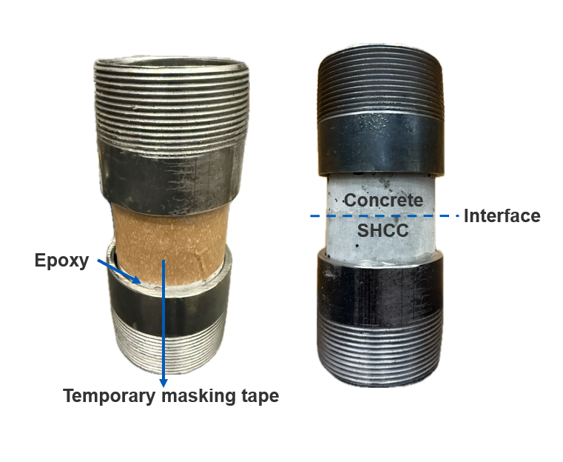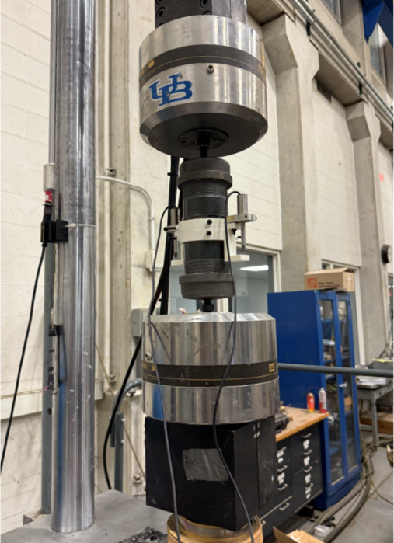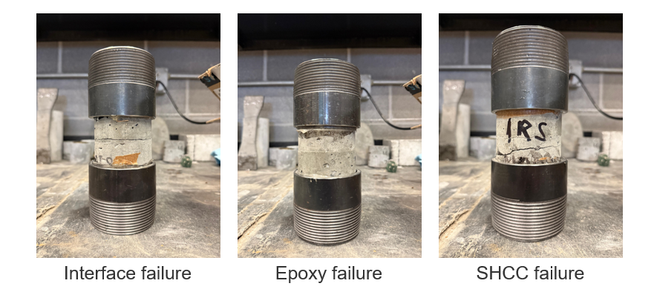
(c)
(b)
(a)

Figure 1. Axial pull-off test (a) Specimen (b) Loading arrangement (c) Interface failure

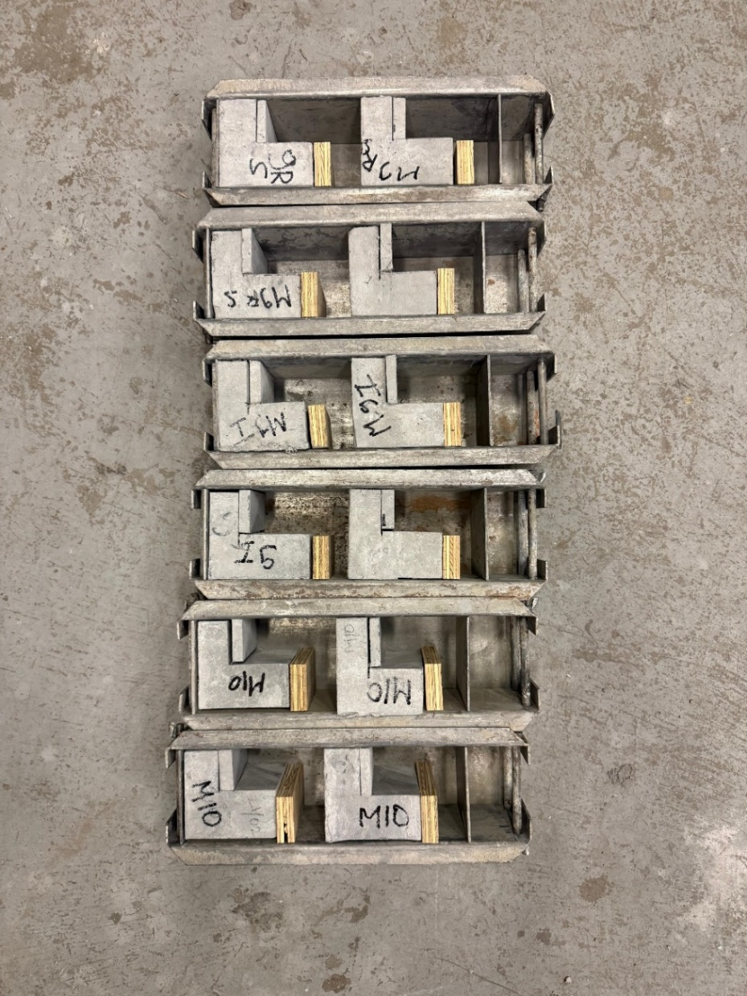
Figure 2. Shear test specimen preparation

Task 1.2 - 80% completed
This task aims to extend the numerical model developed in year 1 of the project to better simulate the bond between the concrete and SHCC covers. The bond is modeled using two approaches. The first approach considers a perfect bond (i.e., no interface slippage) between concrete and SHCC. This analysis is used to determine the bond demand and resulted in a bond strength demand of 0.07 ksi (0.5 MPa) in axial tension and 0.61 ksi (4.2 MPa) in shear. The analysis result is shown in Figure 3(a).The second approach assumes a cohesive frictional interface between concrete and SHCC, utilizing interface properties from existing literature [9] as a starting point. The interface properties will be updated with those for the concrete-SHCC system considered in this study upon completion of Task 1.1. In the direction perpendicular to the interface, the model assumes a linear, uncoupled traction-separation behavior, stress-based failure initiation, and energy-based damage evolution, as shown in Figure 3(b).
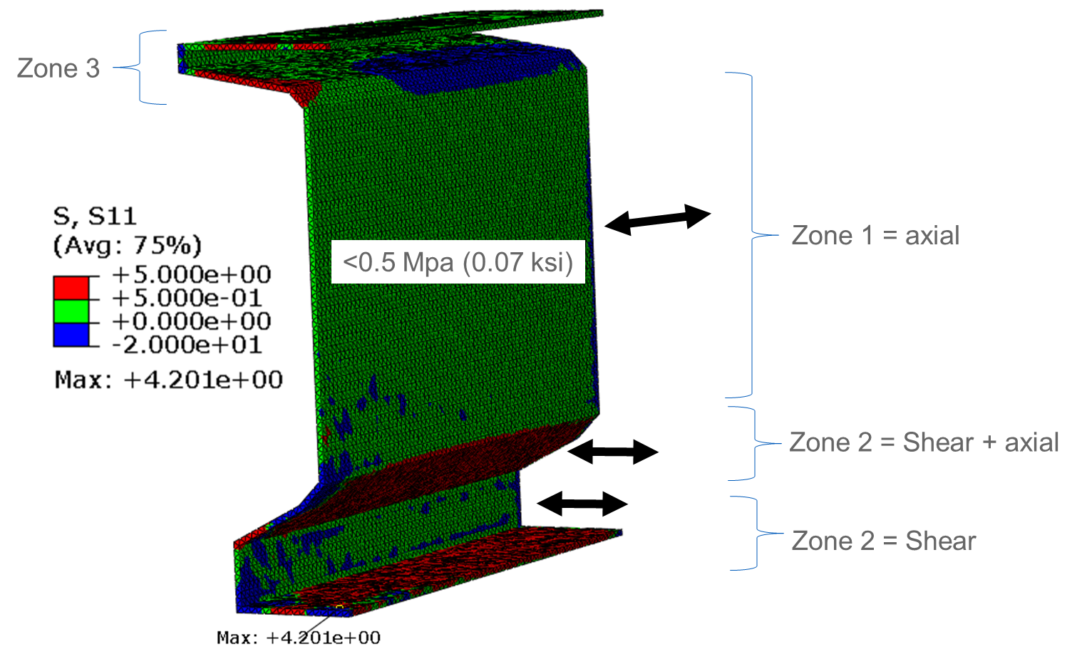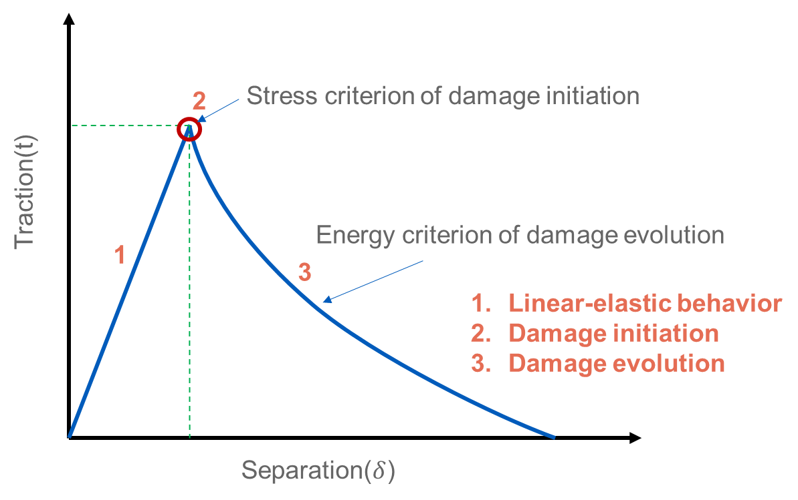

Figure 3. FE modeling (a) Stress distribution assuming perfect bond (b) Traction-separation model
Task 1.3 - 40% completed
This task evaluates the effect of SHCC covers on surface cracking in circular concrete specimens with central longitudinal rebar. The testing protocol for such specimens has been developed, and specimen preparation and loading setup are under development, as shown in Figure 4.

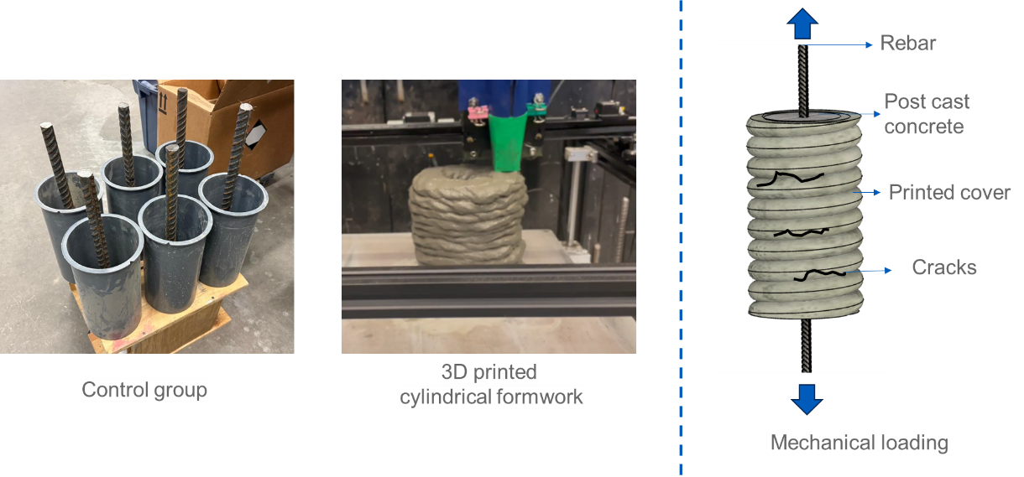
Figure 4. Preparation of cylindrical reinforced concrete cylinders with 3D printed SHCC covers

Task 1.4 - 50% completed
This task examines the bond strength’s adequacy based on the experimental findings in tasks 1.1 to 1.3. The bond tests and numerical models will provide more comprehensive insights into the following three methodologies for improving inter-material bond strength.
- Optimizing the duration between the printing of covers and the casting of concrete inside the cover
- Improving the interface friction coefficient
- Incorporating grooves in 3D-printed cover if needed
As mentioned under Task 1.1, the axial pull-off tests resulted in a concrete-SHCC bond strength of 0.16 ksi, which exceeded the 0.07 ksi bond strength target obtained from the finite element analysis in Task 1.2. These preliminary results indicate that the bond strength is adequate.

Task 2.1 - 80% completed
This task aims to evaluate the bond strength between the printed layers of the 3D-printable SHCC developed in year 1 of the project. For testing the interlayer bond strength, the following two experiments are currently underway.

- Uniaxial tensile test – Single-filament thick sheets of SHCC were printed and cut into dogbone shapes for the axial tension test, as shown in the last quarterly report. These specimens are being tested using a protocol similar to tensile testing of SHCC specimens [10].

- Split tensile test – Split-tensile test specimens were prepared by printing two-layered sheets and cutting the sheets into cubes with a two-filament thickness, as shown in the last quarterly report. The specimens will be loaded in a compression testing machine with steel cylinders at the interface to generate tensile stresses at the interface.

The interlayer bond strength of SHCC obtained from the uniaxial tensile tests was 0.37 ksi, which was about 60% of the tensile strength of SHCC.
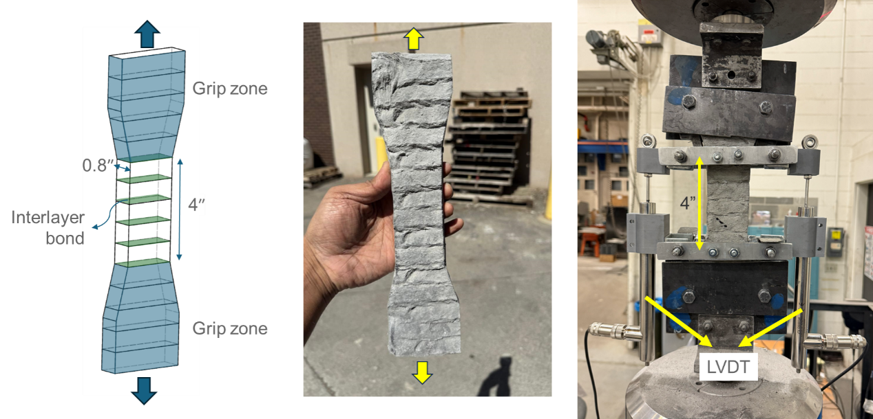
Figure 7. Axial tensile test for interlayer bond strength of 3D printed SHCC

Task 2.2 to Task 4.2 – 0% completed
Not started

Task 5 - 15% completed
Task 5 aims to enhance and optimize the small-scale 3D concrete printer developed in the project’s first year. The printer is being optimized to improve the printing of SHCC covers. Specifically, the following three improvements are being incorporated into the 3D concrete printing system.
- Extrusion control
- Nozzle with integrated extrusion system
- Horizontal extrusion through nozzles.

- Percent of research project completed
The percent completion rates of individual tasks are given above. Overall, we have completed approximately 40% of the project thus far.

- Expected progress for next quarter
Tasks 1.1 to 2.2 will be completed and tasks 3.1, 3.2, and 4.1 are expected to have significant (> 50%) progress. Overall, our goal is to achieve 65-75% project completion by the next quarter’s end.

- Educational outreach and workforce development
None

- Technology Transfer
None

Research Contribution:

- Papers that include TRANS-IPIC UTC in the acknowledgments section:
None in this quarter

- Presentations and Posters of TRANS-IPIC funded research:

- Poster presentation at the Annual meeting of the TRANSportation Research Board (TRB) in Washington, D.C. from January 7-11, 2024. Authors: Singh, P., Gadde, V.S., Zhou, C., Okumus, P., and Ranade, R. Title: 3D printed advanced materials to mitigate prestressed concrete girder end cracks.
- Presentation at TRANS-IPIC workshop, Chicago, April 22, 2024. Authors: Singh, P., Gadde, V.S., Zhou, C., Okumus, P., and Ranade, R. Title: 3D printed advanced materials to mitigate prestressed concrete girder end cracks.
- Presentation to the UB Institute of Bridge Engineering External Advisory Board, which consists of current and past DOT officials, practicing engineers, and UB alums, April 30, 2024, Buffalo, NY. Authors: Singh, P., Gadde, V.S., Zhou, C., Okumus, P., and Ranade, R. Title: 3D Printed Advanced Materials to Mitigate Prestressed Concrete Girder End Cracks.
- Presentation at TRANS-IPIC monthly research webinar, July 22, 2024, online. Authors: Singh, P., Zhou, C., Okumus, P., and Ranade, R. Title: 3D printed advanced materials to mitigate prestressed concrete girder end cracks.
- Presentation at conference BEFIB 2024 XI International symposium on fiber reinforced concrete. 15-18 September 2024, Dresden, Germany. Authors: Singh, P., Gadde, V.S., Zhou, C., Okumus, P., and Ranade, R., Title: Development of 3D printable strain hardening cementitious composites for bridge-related applications
- Poster presentation at Summer School of the Research Training Group GRK 2250 “Mineral-bonded composites for enhanced structural impact safety” 18-20 September 2024, Dresden, Germany. Authors: Singh, P., Landge, S.D., Zhou, C., Okumus, P., and Ranade, R., Title: 3D printed SHCC as permanent formwork for crack width control in prestressed precast concrete bridge girders.
- Extended abstract and Presentation at TRB AAMCT 2024 – Transportation Research Board Conference on Advancing Additive Manufacturing and Construction in Transportation, November 2024. Authors: Singh, P., Gadde, V.S., Zhou, C., Okumus, P., and Ranade, R. Title: Development of 3D printable strain hardening cementitious composites for bridge-related applications.
- Presentation at the Annual meeting of the Transportation Research Board (TRB) in Washington, D.C. from January 5-9, 2025. Authors: Singh, P., Zhou, C., Okumus, P., and Ranade, R. Title: Additive Manufacturing of Concrete for Corrosion Protection of Prestressed Concrete Bridges.
- Presentation at TRANS-IPIC research highlight webinar, February 19, 2024, online. Authors: Singh, P., Zhou, C., Okumus, P., and Ranade, R. Title: 3D printed advanced materials to mitigate prestressed concrete girder end cracks.
- Presentation at TRANS-IPIC workshop, Chicago, April 23, 2025. Authors: Singh, P., Zhou, C., Okumus, P., and Ranade, R. Title: 3D printed advanced materials to mitigate prestressed concrete girder end cracks.
- Prestation at PCINE (Precast Concrete Institute North East) Technical Bridge Committee Meeting, Online, April 24, 2025. Authors: Singh, P., Zhou, C., Okumus, P., and Ranade, R. Title: Additively manufactured fiber reinforced shells for concrete bridge durability.
- Presentation at ASU-Swinburne Workshop on Advances in Concrete 3D printing, June 11-13, 2025. Authors: Singh, P., Zhou, C., Okumus, P., and Ranade, R. Title: 3D-Printed Concrete Covers for Girder Ends: Advancing Bridge Durability, One Layer at a Time.

- Please list any other events or activities that highlights the work of TRANS-IPIC occurring at your university (please include any pictures or figures you may have). Similarly, please list any references to TRANS-IPIC in the news or interviews from your research.

- Poster presentation at “Celebration of Academic Excellence 2025, Student Showcase”
Location- Alumni Arena, University at Buffalo, Buffalo, New York.
Date- April 30, 2025
Details- The 2025 Student Showcase was held on Wednesday, April 30, at the University at Buffalo. The event featured student research and creative projects completed under the mentorship of UB faculty and was coordinated by the UB Experiential Learning Network. PhD student Pranay Singh showcased TRANS-IPIC-supported research at the event.

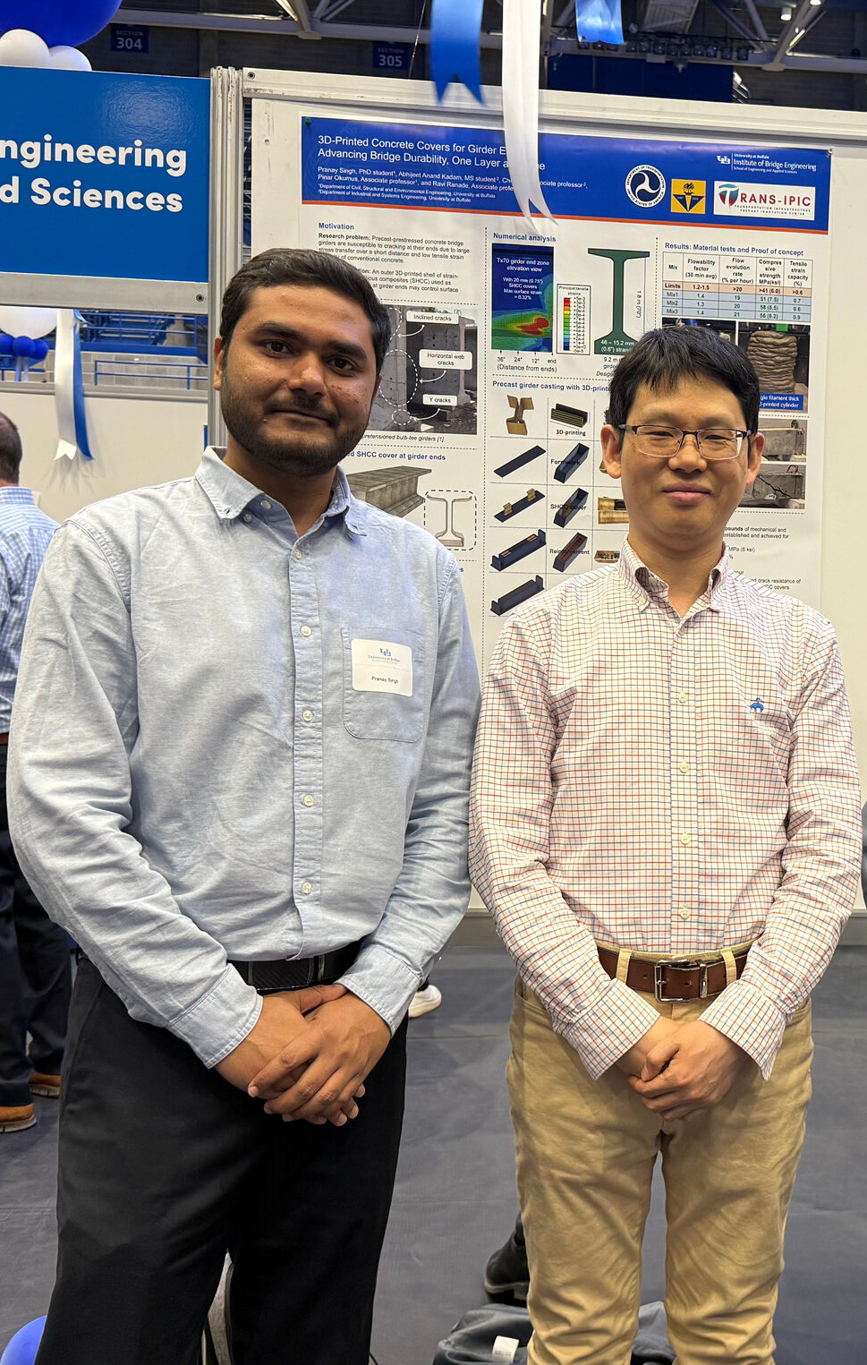

TRANS-IPIC associated PhD student participation in Celebration of Academic Excellence 2025, Student Showcase

- Presentation at PCINE (Precast Concrete Institute-North East) Technical Bridge Committee Meeting
Location- Online
Date- April 24, 2025
Details- TRANS-IPIC associated PhD student presented TRANS-IPIC supported ongoing research at Precast Concrete Institute North (PCINE) Technical Bridge Committee Meeting and received feedback from meeting participants.

- Presentation at ASU-Swinburne Workshop on Advances in Concrete 3D printing
Location- Swinburne University of Technology, John Street, Hawthorn, Victoria, Australia.
Date- June 11, 2025 to June 13, 2025
Details- This 3-day workshop in Melbourne, Australia, was intended to bring together academic researchers, research students, and industrial innovators to share the latest knowledge on various aspects of concrete 3D printing. TRANS-IPIC associated PhD student Pranay Singh received a travel grant to attend the workshop and presented TRANS-IPIC supported research at the workshop.

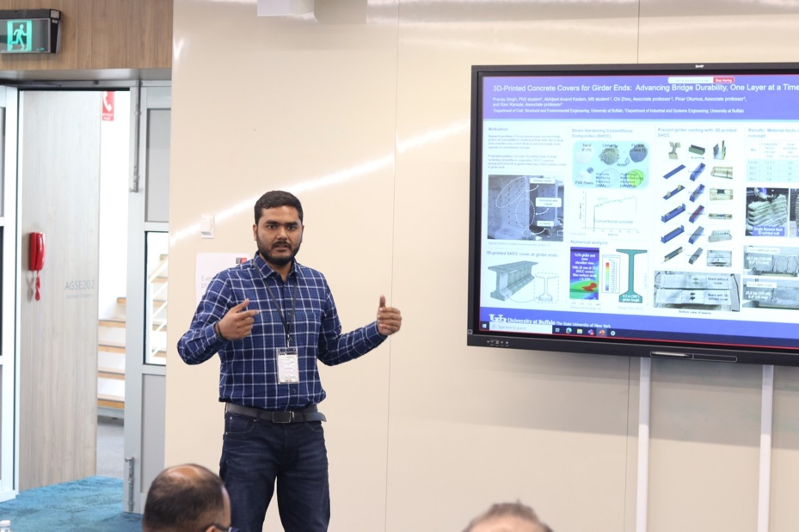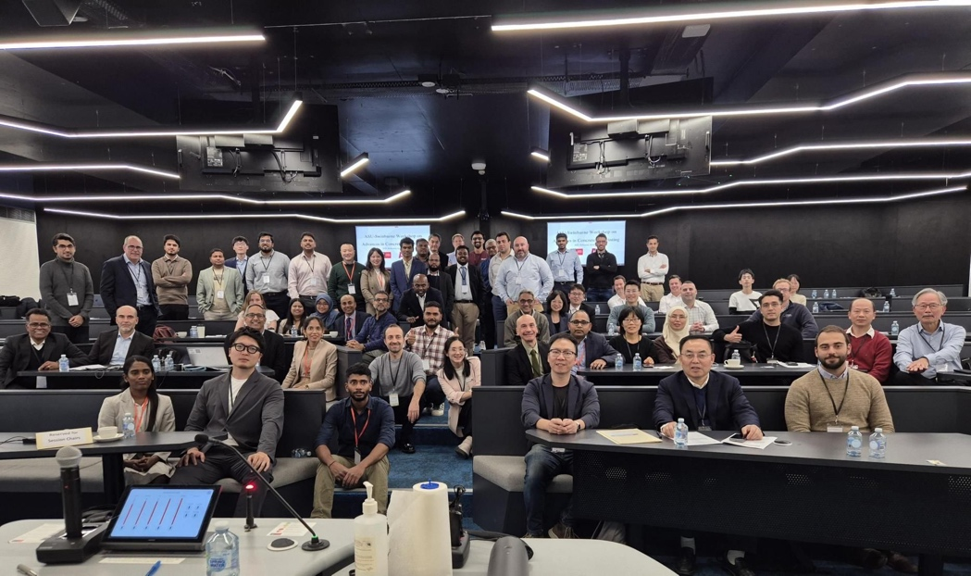

TRANS-IPIC associated PhD student participation in ASU-Swinburne Workshop on Advances in Concrete 3D Printing

Appendix 1: Research Activities, leadership, and awards (cumulative, since the start of the project)

- Number of presentations at academic and industry conferences and workshops of UTC findings
- No. = 12

- Number of peer-reviewed publications submitted based on outcomes of UTC funded projects
- No. = 1

- Number of peer-reviewed journal articles published by faculty.
- No. = 23

- Number of peer-reviewed conference papers published by faculty.
- No. = 1

- Number of TRANS-IPIC sponsored thesis or dissertations at the MS and PhD levels.
- No. MS thesis = 0
- No. PhD dissertations = 0
- No. citations of each of the above = 0

- Number of research tools (lab equipment, models, software, test processes, etc.) developed as part of TRANS-IPIC sponsored research
- Research Tool #1 = Customizable small-scale 3D concrete printing system with non-proprietary hardware and firmware components for specimen preparation at material scale.

- Research Tool #2 = Method for integrating 3D-printed covers with precast workflow as permanent formworks.

- Research Tool #3 = Rapid screening protocol for 3D-printable strain-hardening cementitious composites development and iterative modifications.

- Number of transportation-related professional and service organization committees that TRANS-IPIC faculty researchers participate in or lead.
- Professional societies
  - No. participated in = 4
  - No. lead = 0
- Advisory committees (No. participated in & No. led)
  - No. participated in = 3
  - No. lead = 0
- Conference Organizing Committees (No. participated in & No. led)
  - No. participated in = 2
  - No. lead = 0
- Editorial board of journals (No. participated in & No. led)
  - No. participated in = 2
  - No. lead = 0
- TRB committees (No. participated in & No. led)
  - No. participated in = 0
  - No. lead = 0

- Number of relevant awards received during the grant year
- No. awards received = 0

- Number of transportation related classes developed or modified as a result of TRANS-IPIC funding.
- No. Undergraduate = 0
- No. Graduate = 2

- Number of internships and full-time positions secured in the industry and government during the grant year.
- No. of internships = 0
- No. of full-time positions = 1

References:

- O’Callaghan, M.R. and O. Bayrak, Tensile stresses in the end regions of pretensioned I-beams at release. 2008, University of Texas: Austin, TX.
- Okumus, P. and M.G. Oliva, Evaluation of crack control methods for end zone cracking in prestressed concrete bridge girders. PCI Journal, 2013. 58(2): p. 91-105.
- Momayez, A., et al., Comparison of methods for evaluating bond strength between concrete substrate and repair materials. Cement and Concrete Research, 2005. 35(4): p. 748-757.
- Zanotti, C. and N. Randl, Are concrete-concrete bond tests comparable? Cement and Concrete Composites, 2019. 99: p. 80-88.
- ASTM C1583-20, Standard Test Method for Tensile Strength of Concrete Surfaces and the Bond Strength or Tensile Strength of Concrete Repair and Overlay Materials by Direct Tension, in ASTM International. 2020: West Conshohocken, PA.
- Teng, F., et al., Development of strain-hardening cementitious composites (SHCC) as bonding materials to enhance interlayer and flexural performance of 3D printed concrete. Cement and Concrete Composites, 2024. 152: p. 105657.
- Sanjayan, J.G., et al., Effect of surface moisture on inter-layer strength of 3D printed concrete. Construction and Building Materials, 2018. 172: p. 468-475.
- Fakhri, H., Y. Han, and R. Ranade. Influence of Damage on the Effectiveness of SHCC Covers for Reducing Corrosion Rates in Reinforced-Concrete Structural Elements. in 3rd International RILEM Conference on Strain-Hardening Cement-Based Composites (SHCC4). 2018. Dresden, Germany: Springer Netherlands.
- Luu, X.-B., and S.-K. Kim. Finite Element Modeling of Interface Behavior between Normal Concrete and Ultra-High Performance Fiber-Reinforced Concrete. Buildings, 2023. 13 (4): p. 950.
- Kumar, D., and R. Ranade. Development of strain-hardening cementitious composites utilizing slag and calcium carbonate powder. Construction and Building Materials, 2020. 273: p. 122028.

