

Transportation Infrastructure Precast Innovation Center (TRANS-IPIC)

# University Transportation Center (UTC)

*Unveiling synergistic effects of Nano-modification and CO2 curing on the durability and carbon footprint of precast elements*

*PU-23-RP-02*

### Quarterly Progress Report

For the performance period ending *6/30/2024*

## Submitted by:

*Mirian Velay-Lizancos (PI), Lyles School of Civil and Construction Engineering,* [*mvelayli@purdue.edu*](mailto:mvelayli@purdue.edu)

*Jan Olek (Co-PI), Lyles School of Civil and Construction Engineering,* [*olek@purdue.edu*](mailto:olek@purdue.edu) *Raikhan Tokpatayeva(Co-PI), Lyles School of Civil and Construction Engineering,* [*rtokpata@purdue.edu*](mailto:rtokpata@purdue.edu)

*Aniya Edwards, Lyles School of Civil and Construction Engineering,* [*edwar242@purdue.edu*](mailto:edwar242@purdue.edu) *Department: Civil Engineering*

*University: Purdue University*

## Collaborators / Partners:

*N/A*

## Submitted to:

TRANS-IPIC UTC

University of Illinois Urbana-Champaign Urbana, IL

# TRANS-IPIC Quarterly Progress Report:

## Project Description:

1. **Research Plan - Statement of Problem**

The optimization of the application of new technologies and novel materials in precast concrete elements plays a crucial role in advancing the precast industry toward a greener future. The enhancement of durability and the reduction of the carbon footprint of precast concrete elements are two of the main paths toward this advancement.

Both CO2 curing (a precast treatment) and the use of nano-additives enhance the strength and reduce the porosity of cementitious composites, enhancing the durability of the concrete elements. However, CO2 curing and nano-modification may interfere with each other if used simultaneously, especially considering that the addition of nanoparticles may affect the size of calcium hydroxide crystals, which react with the CO2 during the CO2 curing process. Thus, understanding the interactions between these two treatments is vital to producing superior-quality precast concrete elements in terms of durability and sustainability.

## Research Plan - Summary of Project Activities (Tasks)

To achieve the objectives of Phase I of this project, a systematic research approach will be followed, consisting of the following tasks:

***Task 1. Characterization of the materials.*** This task will involve the physical and chemical characterization of the nanoparticles, the aggregates, and the cement to be used in this study, according to the relevant standards for each type of the proposed material. Particle size, oxide, and mineralogical analyses will be performed.

***Task 2. Preparation of specimens and curing process.*** Concrete, mortar, and cement paste mixtures with 0%, 0.5%, 1%, and 2% of nanoparticles by mass of cement and two different water-to-cement ratios will be used in this study. Two different nanomaterials will be used: nano-silica and carbon black. Thus, a total of 14 different mixtures will be studied for each cementitious composite (paste, mortar, and concrete). Various types of specimens will be prepared and used to perform microstructural analysis, chemical analysis, and to determine the compressive strength development, transport properties, and durability performance. Two different curing regimes and two different curing regimens will be examined: (i) standard curing at 21 ± 1 °C and 50% ± 5% RH (for reference) for 12 hours, (ii) CO2 curing (20% concentration) for 12 hours (from age 24h to 36h) at a temperature of 23±1 °C and 50%±5% RH.

***Task 3. Analysis of hydration process, porosity and microstructure.***

Image analysis of microstructure of concrete, captured via optical microscope, will be used to directly quantify the characteristics of observable porosity. At the same time, water absorption and density tests will be used to evaluate volume of porosity and the connectivity of the pores (ASTM C6421, ASTM C1585)2. Besides, the microstructure of samples will be investigated through Scanning Electron Microscopy (SEM). The hydration kinetics and type of hydration products present in the pastes will be estimated by Isothermal Calorimeter test (IC), Thermogravimetric analysis (TGA) and X-ray diffraction (XRD) analysis.

***Tasks 4. Evaluation of transport properties.*** The bulk electrical resistivity and formation factor of the concrete samples will be estimated as per ASTM 1876-19. The Rapid Chloride permeability test (ASTM C1202 3) will be used to evaluate the resistance of the concretes to chloride ions ingress. The transport properties will be assessed through the analysis of the results of this section in combination with the results from water absorption test performed in task 3.

***Tasks 5. Compressive strength of mortars and concretes.*** Compressive strength tests will be performed for each mixture design at 3, 7, and 28 days according to ASTM C39 4.

***Task 6. Analysis of the results*.** A comparative analysis of the test results from tasks 1 to 5 for samples with and without nanoparticles and with and without CO2 curing will be carried out. Then, the interconnection of the results of the different tests will be analyzed to acquire a deeper understanding on the combined effect of nanoparticle addition and CO2 curing; This task will help with understanding the synergistic effects of CO2 curing and nanomodification on the concrete's properties, providing insights into the optimal combination of parameters associated with these modifications.

***Task 7. Draft of the report, Review and submission of Final report.*** This task will consist of the preparation, revision and submission of the final report of the project, summarizing the research findings, methodologies, conclusions and recommendations.

## Project Progress:

1. **Progress for each research task**

**Note:** It is noted that the delay in funding distribution has affected the progress of the first quarter. Whenever possible, the research team is striving to accelerate the execution of the relevant tasks in order to minimize the effect of this delay.

*Task 1. Characterization of the Materials [100% Completed]*

#### a. Mineralogical Analysis of Nanosilica with X-Ray Diffraction (XRD)

Procedure: The composition of nanosilica was analyzed using XRD. 30mL of aqueous nanosilica solution was placed in an oven at 40C°. A portion of the remaining nanosilica crystals were ground to a fine powder using a mortar and pestle and passed through a No. 200 sieve in preparation for the experiment per ASTM E3294 5.

Results: Mineralogical analysis of the nanosilica powder shows a single amorphous hump, with a peak coinciding with that of silicon dioxide. This alone is not enough information to determine the mineralogical and chemical content. The x-ray fluorescence data presented in Quarterly Progress Report 1 also proved the solution is comprised of silicon dioxide. According to the XRD pattern and x-ray fluorescence results, the nanosilica in the aqueous solution is found to be silicon dioxide of amorphous morphology.

Task 2. *Preparation of specimens and curing process* [60% Completed]

#### Mixing, Casting and Curing of Specimens

Procedure: Pastes and mortars were mixed and prepared per ASTM C305 6. Slump and spread of mortars were measured and collected per ASTM C1810 7.

After mixing and casting, the samples were cured under a tarp in the molds for 12 hours. Samples were then transported to an environmental chamber at 50%RH and left to cure for an additional 12 hours. Next, half of the samples were placed in a VWR Symphony CO2 curing chamber at 23°C with an RH ranging from 50%-90%±5% and CO2 concentration of 20% for 12 hrs. The other half of samples were placed in the environmental chamber with an RH of 50%±5% for 12 hrs. After this 12-hour period, all samples were placed in the moist room to cure until their corresponding tests. A diagram of this process is provided in Figure 1.

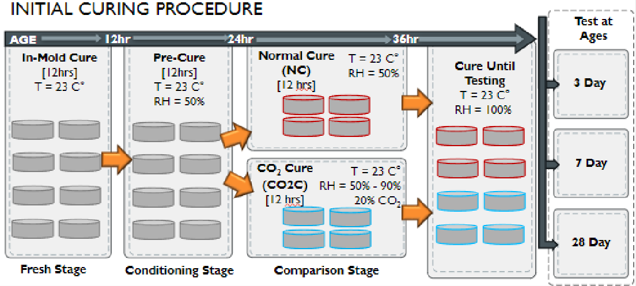

Figure 1. Initial Method of Curing Samples over the First 36 Hours of Hydration

It was then decided that samples should be CO2 cured at higher temperatures to more accurately reflect the curing temperatures commonly used in precast plants. It is suspected that wet curing after CO2 treatment negatively affects the properties of the samples, and that samples should instead be cured in open-air after the comparison stage. Upon this decision, CO2 cured samples were instead CO2 cured at 60°C, and all samples were cured in open-air at room temperature and approximately 40%RH after the comparison stage (see Figure 2)

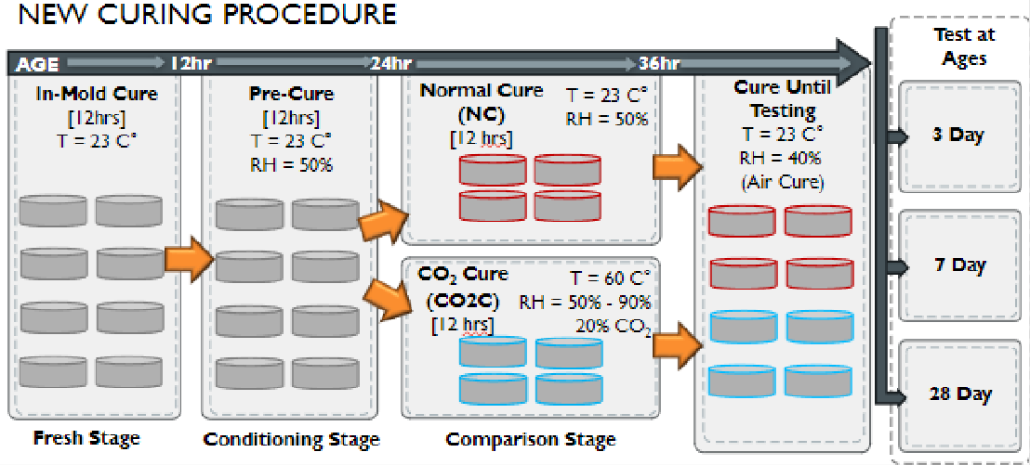Figure 2. New Method of Curing Samples over the First 36 Hours of Hydration Results:

Mortars with 0.48 w/c were cured using the “initial” curing procedure. Results from this procedure were omitted from future processes. Mortars at 0.42 w/c, pastes at 0.42 w/c, and pastes at 0.48 w/c were mixed and cured using the newly proposed procedure.

#### Maintenance of Relative Humidity in CO2 Chamber

A CO2 curing chamber that moderates the relative humidity to 70%RH will be used for all concrete specimens.

Task 3. *Analysis of hydration process, porosity and microstructure* [50% Completed]

#### Thermogravimetric Analysis (TGA) of Pastes

TGA was performed on pastes with a 0.48 w/c at 3-, 7-, and 28-day ages. The amount of Ca(OH)2 (CH) and calcium carbonate (CC) was quantified as per the *Kim and Olek*8 *method* for each mix. Paste samples were crushed and ground to a fine powder for all TGA experiments, however, powder samples were taken at random from each sample. Instead, powder samples will be taken from a maximum depth of 0.1 inches from the surface of the paste samples to effectively evaluate carbonation.

Tasks 4. *Evaluation of transport properties.* [0% Completed]

Tasks 5. *Compressive strength of mortars and concretes.* [50% Completed]

#### Compressive Strength of Mortars

Using ASTM C109, compressive tests were performed on mortars at 0.48 w/c, and mortars with a 0.42 w/c at 3- and 7-day ages. The average compressive strength of mortar

specimens was then calculated. The 0.48 w/c mortars will be mixed again with the new curing method proposed in Task 2.

Task 6. *Analysis of the results.* [55% Completed]. Initial analysis of the results of Task 1, Task 2, Task 3, and Task 5 was partially completed.

Task 7. *Draft of the report, Review and submission of Final report.* [20% Completed]

## Percent of research project completed.

Approximately 50% of the total project has been completed this quarter.

## Expected progress for next quarter

By the end of next quarter, October 1st of 2024, 85% of this project is expected to be completed.

Task 1. *Characterization of the Materials* [100% completed]: Completed in Q3

Task 2. *Preparation of specimens and curing process* [100% completed]: All mortar and concrete samples are expected to be mixed and cured at the end of the next quarter.

Task 3. *Analysis of hydration process, porosity, and microstructure* [60% completed]: Isothermal Calorimetry will be completed for all mortar and paste samples. Scanning electron microscopy will be completed for 25% of all samples. XRD will be completed for 20% of all paste samples. TGA will be completed for 75% of paste samples. Absorption and density will be completed for 40% of concrete samples.

Task 4. *Evaluation of transport properties* [60% completed]:

Task 5. *Compressive strength of mortars and concretes.* [70% completed]: Compression tests of mortar samples will be completed. Compression tests of 50% of concrete samples will be completed.

Task 6. *Analysis of the results.* [80% Completed]: Analysis of the results of the completed test will be performed.

Task 7. *Draft of the report, Review and submission of Final report.* [60% Completed]

## Educational outreach and workforce development

The educational outreach and workforce development plan were outlined in the previous quarterly progress report. Future educational outreach and workforce development plans include the following:

* + Civil Engineering for a Day (Project Feature)

In Fall 2024, an engineering research event will be held at select High Schools offered by the graduate student working on the project. Conversations between

high school administrators and the student have started, and dates have been scheduled. Select high schools are listed below:

* + - Civil Engineering for a Day: Merrillville High School Merrillville, Indiana

October 9th , 2024

* + - Civil Engineering for a Day: West Side Leadership Academy Gary, Indiana

Fall 2024

* + Civil Engineering Materials Tutorial Videos

In September and October, the graduate student will create a video series showing how experiments used during the project are conducted. The series will be used to educate undergraduate students and introduce them to engineering principles and for prospective students interested in joining this project and others. These videos have a dual purpose in terms of workforce development: (i) to train the Master student in terms of improving communication and teaching skills, and (ii) to create material that can be used for educational outreach activities that can connect easier with underrepresented groups, since the Master student will be a role model for the next generation of researchers.

## Technology Transfer

*No progress on technology transfer yet.*

## Research Contribution:

1. **Number of papers**

*No papers were published during this quarter.*

## Number presentations.

*Presentations given by the end of this quarter include the following:*

* + *TRANS-IPIC UTC Spring Workshop 2024 – April 22nd, 2024*

*The Grainger College of Engineering. (2024). 2024 Trans-IPIC UTC Workshop. 2024 TRANS-IPIC UTC Workshop. https://trans-ipic.illinois.edu/workshop*

* + *Monthly Research Webinar TRANS-IPIC UTC – June 17th, 2024*

*Trans-Ipic Monthly Research Webinar - June, 2024. Illinois Media Space. (n.d.). https://mediaspace.illinois.edu/media/t/1_xt7op9zl*

## References:

1. ASTM. C642-21 Standard Test Method for Density, Absorption, and Voids in Hardened Concrete. *ASTM Int*. Published online 2021:1-3. doi:10.1520/C0642-21.2
2. ASTM. C1585-20 Standard Test Method for Measurement of Rate of Absorption of Water by Hydraulic Cement Concretes. *ASTM Int*. Published online 2020:1-6. doi:10.1520/C1585- 20.2
3. ASTM. C1202-22e1 Standard Test Method for Electrical Indication of Concrete’s Ability to Resist Chloride Ion Penetration. *ASTM*. Published online 2022:1-8. doi:10.1520/C1202- 22E01.2
4. ASTM. C39/39M-21 Standard Test Method for Compressive Strength of Cylindrical Concrete Specimens. *ASTM Int*. Published online 2021:1-5. doi:10.1520/C0039
5. ASTM E3294 - 23. Standard Guide for Forensic Analysis of geological materials by powder X- ray diffraction. *ASTM Int*. Accessed December 30, 2023. [https://www.astm.org/e3294-](https://www.astm.org/e3294-22.html)

[22.html](https://www.astm.org/e3294-22.html).

1. *ASTM C305-20* Standard Practice for Mechanical Mixing of Hydraulic Cement Pastes and Mortars of Plastic Consistency. ASTM Int. Accessed July 1, 2024. [www.astm.org/c0305-](http://www.astm.org/c0305-20.html)

[20.html](http://www.astm.org/c0305-20.html).

1. ASTM C1810/C1810M-23. Standard guide for comparing performance of concrete-making materials using mortar mixtures. *ASTM Int.* Accessed March 31, 2024. https://[www.astm.org/Standards/C1810.htm](http://www.astm.org/Standards/C1810.htm)
2. T. Kim, J. Olek, “Effects of Sample Preparation and Interpretation of Thermogravimetric Curves on Calcium Hydroxide in Hydrated Pastes and Mortars”, *Transp. Res. Rec. J. Transp. Res. Board*, 10-18, 2290 (2012).