**Transportation Infrastructure Precast Innovation Center**

**(TRANS-IPIC)**

**University Transportation Center (UTC)**

Data-driven smart composite reinforcement for precast concrete - Phase II

PU-23-RP-05

Quarterly Progress Report

For the performance period ending *March 31, 2025*

**Submitted by:**

Chengcheng Tao (PI), [tao133@purdue.edu](mailto:tao133@purdue.edu)

Shanyue Guan (Co-PI), [guansy@purdue.edu](mailto:guansy@purdue.edu)

School of Construction Management Technology

Purdue University

**Collaborators / Partners:**

Heidelberg Materials, North Dakota State University

**Submitted to:**

TRANS-IPIC UTC

University of Illinois Urbana-Champaign

Urbana, IL

**TRANS-IPIC Quarterly Progress Report:**

**Project Description:**

1. Research Plan - Statement of Problem

It is critical to design high-performance, sustainable, and cost-effective reinforced precast concrete to extend the life of PC transportation infrastructure. Physical testing with trial-and-error approaches on reinforced PC components require substantial time, labor, and material resources to achieve the optimal design for superior material properties, ecological and economic sustainability. There is a lack of an efficient and precise way to design the reinforced precast by fully considering potential configurations and material options with optimal performance. To address these challenges, the proposed research innovatively integrates sensing technology, physical testing , multivariant numerical modeling, and multi-objective metaheuristic optimization with Pareto front analysis to achieve optimal performance of the reinforced precast concrete materials in terms of mechanical, environmental, and economic performance. The expected output will guide the design and manufacturing of reinforced PC components with improved durability, environmental impact, and economic value.

1. Research Plan - Summary of Project Activities (Tasks)

Task 1. Experimental investigation of mechanical properties of various reinforced precast concrete components.

Built upon the testbed from our ongoing funded TRANS-IPIC Year 1 project, we will investigate the mechanical performance of various reinforced precast concrete components with different reinforcement configurations, geometries, and materials types of rebar and concrete.

Task 2. Multivariate numerical modeling of reinforced precast concrete components and physics-informed database establishment,

In this task, we will perform computer-guided design via three-dimensional (3D) numerical analysis and parametric study to analyze the sensitivity of various influencing factors on the mechanical properties of the reinforced concrete components.

Task 3. Development of multi-objective metaheuristic optimization framework with Pareto front analysis to achieve optimal mechanical properties, sustainability, and economic values.

In this task, we will develop a multi-objective optimization framework to efficiently provide optimal solutions for high-performance, sustainable, and low-cost reinforced precast concrete components.

Task 4: Reporting:

Research outcomes will be summarized in the quarterly and final reports submitted to TRANS-IPIC and publications in high-impact journals and TRB or PCI conferences.

**Project Progress:**

1. Progress for each research task

**Task 1. Experimental investigation of mechanical properties of various reinforced precast concrete components [50% completed]**

In this task, we investigate the effect of factors including fiber, water content through the slump test, compressive test, and flexural test to on the reinforced concrete beams.

1.1. Slump test

Water content is a critical factor influencing the properties of concrete, as it directly affects the material's porosity and, consequently, its mechanical strength and durability. A lower water content typically leads to higher strength and reduced permeability, while a higher water content can increase porosity, diminishing strength and durability. The incorporation of fibers into concrete mixtures has been shown to enhance certain mechanical properties, such as tensile strength and ductility. However, increasing fiber content can adversely affect the workability of the concrete mix, often necessitating adjustments in the water content to maintain desired workability. This adjustment can lead to increased porosity and a subsequent reduction in compressive strength. Given these complexities, determining the optimal water content for concrete mixtures with varying fiber contents is crucial to achieving the desired balance between workability, strength, and durability. This task aims to investigate the relationship between fiber content, water content, and the resulting mechanical properties of concrete, to establish guidelines for optimizing mix designs to achieve the desired performance characteristics. We perform slump tests to determine the optimum water content for various fiber contents. The slump test is a key quality control tool that evaluates workability, consistency, and water-cement ratio. It helps ensure proper placement, compaction, and finishing without defects like segregation or cracking. According to ACI 211 [1] Section 6.3.1, the recommended slump range for concrete beams is 1 to 4 inches, which we follow closely in our design. In our experiment, PVA fibers are added during or after batching and mixed at high speed for at least five minutes to ensure uniform dispersion. By varying the fiber and water content and analyzing the slump and compressive strength results, we aim to determine the ideal water-to-cement ratio for achieving desired concrete performance.

For each mixing process, a slump test was performed on the concrete samples to evaluate their workability. As illustrated in Figure 1, when the fiber content was 0.2%, the slump measured 0.4 inches with a water content of 1.3L. Increasing the water content to 1.5L resulted in a significant rise in slump to 6 inches. Since this exceeded the 4-inch upper limit specified by the standard, further testing in this condition was discontinued. For a fiber content of 0.4%, the corresponding slump values for water contents of 1.3L, 1.5L, and 1.7L were 0.625 inches, 1.5 inches, and 6 inches, respectively. When the fiber content increased to 0.6%, the slump values for the same water content levels were 0 inches, 0.75 inches, and 4 inches, respectively. Through this systematic series of experiments, we have effectively determined the interactive effects of fiber and water content on concrete workability. These findings serve as a crucial reference for optimizing mixed designs to achieve the desired balance between strength and workability.

|  |  |  |  |
| --- | --- | --- | --- |
|  |  |  |  |
| (a) | (b) | (c) | (d) |
|  |  |  |  |
| (e) | (f) | (g) | (h) |

Figure 1. Slump test with various settings (a) 0.2% fiber with 1.3L water; (b) 0.2% fiber with 1.5L water; (c) 0.4% fiber with 1.3L water; (d)0.4% fiber with 1.5L water; (e) 0.4% fiber with 1.7L water; (f) 0.6% fiber with 1.3L water; (g) 0.6% fiber with 1.5L water; (h) 0.6% fiber with 1.7L water.

1.2 Compressive test

We designed a series of experiments using the control variable method to investigate the influence of fiber and water content on concrete strength. The water content gradient was established based on slump test results, with three levels: 1.3 L, 1.5 L, and 1.7 L. Similarly, fiber content was varied across three gradients: 0.2%, 0.4%, and 0.6% [2], [3]. A one-to-one correspondence was adopted, resulting in nine experimental groups, each consisting of three parallel specimens. The compressive strength tests were conducted in accordance with ASTM C39/C39M-24 [4], specifically following section 8.5.1. Within the prescribed loading speed range, a mid-value of 0.25 MPa/s was selected to ensure consistency and reliability in the testing process. This systematic approach ensures a comprehensive evaluation of the interactive effects of fiber reinforcement and water content on the mechanical performance of concrete. All samples are shown in Figure 2 (a) and (b). Figure 2 (c) shows a typical compressive test for a concrete cylinder.

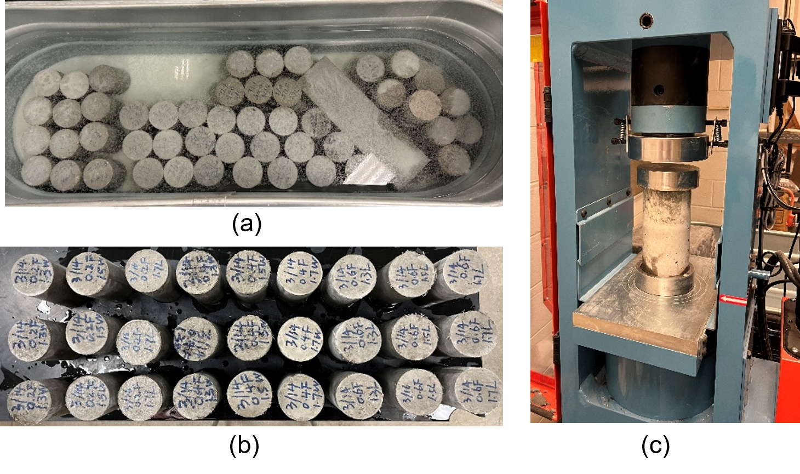

Figure 2. (a) Curing cylinder samples (b) Cylinder samples after curing (c) Compressive test

Detailed analysis found that varying water contents (1.3L, 1.5L, and 1.7L) significantly influence the mechanical behavior of fiber-reinforced concrete. Figure 3 (a) shows time-stress curves when fixing the fiber content to 0.2% with different water content. All of the curves initially exhibit linear growth since the loading speed is 0.24 MPa/s. The specimen with 1.3 L water reaches the highest strength among this group. With the water content of the samples increasing, the maximum stress exhibits a decreasing trend, but the ductility is enhanced. For the 0.4% fiber group, as shown in Figure 3 (b), the specimen with 1.3L of water experienced a sharp drop after peak stress, indicating a brittle failure mode. In contrast, the 1.5L sample showed a more gradual decline, and the 1.7L specimen exhibited a prolonged post-peak plateau, suggesting enhanced ductility and energy absorption capacity. However, despite its improved toughness, the 1.7L mix had a lower peak strength, highlighting that excessive water compromises compressive strength. Compared to the 0.4% group, the 0.6% fiber specimens demonstrated improved residual strength after failure, particularly at higher water contents, as shown in Figure 3 (c). The 0.6%-1.7L curve displayed more post-peak oscillations, potentially indicating enhanced fiber bridging but also possible matrix instability. Overall, increasing both fiber and water content enhances ductility but reduces peak compressive strength. Table 1 compares the peak compressive strengths for three fiber contents (0.2%, 0.4%, and 0.6%) across different water levels. At 0.2% fiber content, the peak stresses of those samples were recorded across three water contents, among which the 1.3 L water showed the highest strength. As water content increased, peak stress consistently decreased. This illustrates that excessive water may negatively affect strength. However, at the fiber content of 0.4 %, strength peaked at 1.5 L water but declined at 1.3 L or 1.7 L, implying that optimal performance may be achieved around an appropriate water content instead of the fewer the better. Notably, the 0.6% fiber group maintained relatively stable peak values at around 30 MPa, suggesting that higher fiber volumes may partially mitigate the strength loss due to added water. The best water content of 0.6 % fiber is 1.7L, which highlights the critical need to balance fiber volume with water content to maximize compressive strength in fiber-reinforced concrete. Nevertheless, the overall trend confirms that fiber decreases compressive strength, even though it finds the correspondingly optimal water content.

|  |  |  |
| --- | --- | --- |
|  |  |  |
| (a) 0.2% fiber with various water | (b) 0.4% fiber with various water | (c) 0.6% fiber with various water |

Figure 3. Compressive test results of concrete cylinders with different fiber and water contents

Table 1. Summary of compressive stress among different samples.

|  |  |  |  |
| --- | --- | --- | --- |
| Fiber Content (%) | Water Content (L) | Peak Stress (MPa) | Compressive Stress (MPa) |
| 0.20 | 1.3L | 42.36 | 41.11 |
| 42.24 |
| 38.72 |
| 1.5L | 30.30 | 30.51 |
| 30.41 |
| 30.81 |
| 1.7L | 27.36 | 27.94 |
| 28.13 |
| 28.33 |
| 0.40 | 1.3L | 30.55 | 30.18 |
| 30.13 |
| 29.87 |
| 1.5L | 33.84 | 34.09 |
| 34.69 |
| 33.73 |
| 1.7L | 23.84 | 24.95 |
| 25.77 |
| 25.23 |
| 0.60 | 1.3L | 30.44 | 29.48 |
| 28.18 |
| 29.83 |
| 1.5L | 27.77 | 29.02 |
| 29.45 |
| 29.83 |
| 1.7L | 32.93 | 32.08 |
| 32.01 |
| 31.30 |

1.3 Flexural test

We also conducted a flexural test to figure out how fiber influences the beam performance under a three-point bending condition. The experimental setting is overall similar to the beam in Phase I of this project, except for an additional 0.6 % PVA fiber of the total volume in the concrete beam. The material properties are summarized in Table 2. Figures 4 (a) and (b) show the crack patterns of the beams with and without fiber after the flexural test. The beam with 0.6 % fiber indicated a ductile failure since the main crack width is larger than the beam without fiber. The experimental results also proved that fiber enhanced the ductility of the beam as shown in Figure 4 (c). Compared with the red line that had no fiber in the beam, the blue line contained a slower decreasing section after the peak stress, illustrating that there was still a load resistant ability after failure. And the preliminary results also showed that this fiber-reinforced beam reached a peak stress of 8.32 MPa, which was lower than the strength of the beam without fiber at 10.20 MPa. This result aligns with the compressive test, which indicates that the fiber enhances the ductility while weakening the strength of the concrete.

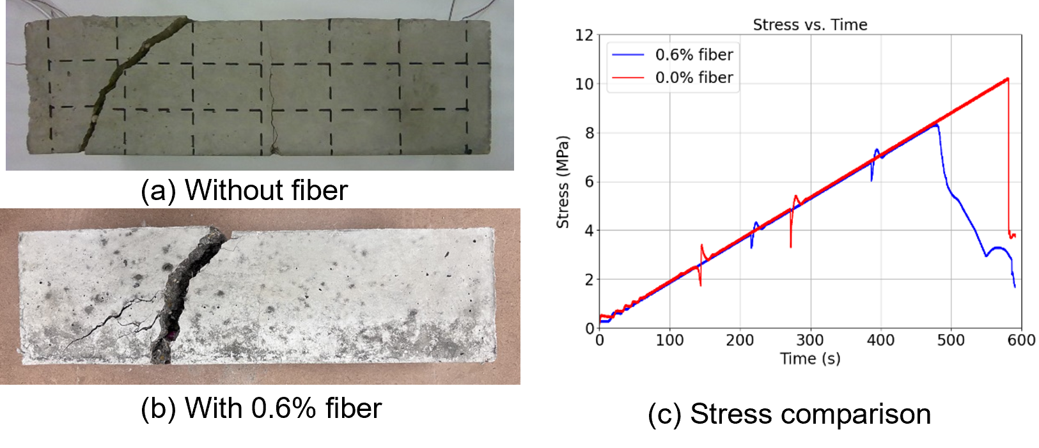

Figure 4. Comparison of the results after flexural test

Table 2. List of material properties for composite reinforced concrete system [5]–[10].

|  |  |  |
| --- | --- | --- |
| Composite rebar (Glass Fiber Reinforced Polymer) | Rebar Young’s modulus, *Er* (GPa) | 46.88 |
| Poisson's Ratio, *ν* | 0.3 |
| Composite rebar ultimate strength, *fu.r* (MPa) | 1,003 |
| Diameter, *d* (inches) | 3/8 |
| Concrete | Concrete compressive strength, *f’c* (MPa) | 35.8 |
| Concrete Young’s modulus, *Ec* (GPa) | 32.28 |
| PVA | Young’s modulus, *Ef* (GPa) | 36 |
| Poisson's Ratio, *ν* | 0.2 |
| Ultimate strength, *fu.f* (MPa) | 1,560 |
| Diameter, *df* (μm) | 38 |
| Length, *Lf* (mm) | 13 |

**Task 2. Multivariate numerical modeling of reinforced precast concrete components and physics-informed database establishment [10% completed]**

We conducted three-dimensional finite element modeling on the reinforced concrete beam under flexual tests and validate one benchmark simulation with the experiment in Task 1. The train distribution along the reinforcement is compared between DFOS and FEA at 3 distinct moments, as illustrated in Figure 5. Figure 5(a) shows the strain comparison results at 100 s. The FEA results remain within the range of DFOS results. Additionally, the FEA results are slightly lower than analytical solutions, with the maximum difference is 12.9 𝜇𝜀. Overall, the FEA results closely match with both the DFOS and analytical solutions, demonstrating the accuracy of the finite element model before concrete cracks. Figure 5(b)(c) present the strain comparisons between FEA and DFOS at 300 s and 500 s. Across all these moments, the numerical results align reasonably well with the experimental data. Notably, the maximum strain recorded by DFOS is not perfectly centered at the midspan but is slightly shifted. This observation is consistent with experimental findings, where the first crack does not form precisely under the loading nose. This demonstrates the high sensitivity and accuracy of DFOS in detecting the localizing the crack. It can be seen that the FEA results greatly match with the DFOS with the R2 of 0.9456.

|  |  |  |
| --- | --- | --- |
|  |  |  |
| (a) | (b) | (c) |

Figure 5. The comparison between DFOS, FEA, and analytical results of composite reinforcement at 3 distinct moments. (a) 100s; (c) 300s; (e) 500s.

**Task 3. Development of multi-objective metaheuristic optimization framework [0% completed]**

**Task 4: Reporting [20% completed]**

The first quarterly report has been completed and submitted.

1. Percent of research project completed

Total project completed through the end of this quarter: 25%

1. Expected progress for next quarter

In the next quarter, we will keep working on Tasks 1 and 2. We will conduct more experimental and numerical investigation on the effect of various factors for reinforced concrete components.

1. Educational outreach and workforce development

The PIs mentored Ph.D. students through weekly individual meetings, and bi-weekly group meetings, Purdue University, West Lafayette, IN, January 1 – March 31, 2025.

1. Technology Transfer

None.

**Research Contribution:**

1. Papers that include TRANS-IPIC UTC in the acknowledgments section:

Duan, J., Yan, H., Tao, C.*, Wang, X., Guan, S., & Zhang, Y. (2025), Integration of Finite Element Analysis and Machine Learning for Assessing Spatial-Temporal Conditions of Reinforced Concrete. *Buildings*, 15(3), 435*.*

1. Presentations and Posters of TRANS-IPIC funded research:

Tao, C., Data-Driven Smart Composite Reinforcement for Precast Concrete, TRANS-IPIC Monthly Research Webinar, March 28, 2025.

1. Please list any other events or activities that highlights the work of TRANS-IPIC occurring at your university (please include any pictures or figures you may have). Similarly, please list any references to TRANS-IPIC in the news or interviews from your research.

None

**Appendix 1**: Research Activities, leadership, and awards (cumulative, since the start of the project)

1. Number of presentations at academic and industry conferences and workshops of UTC findings

* No. = 1

1. Number of peer-reviewed publications submitted based on outcomes of UTC funded projects

* No. = 1

1. Number of peer-reviewed journal articles published by faculty.

* No. = 1

1. Number of peer-reviewed conference papers published by faculty.

* No. = 0

1. Number of TRANS-IPIC sponsored thesis or dissertations at the MS and PhD levels.

* No. MS thesis = 0
* No. PhD dissertations = 2
* No. citations of each of the above = 0

1. Number of research tools (lab equipment, models, software, test processes, etc.) developed as part of TRANS-IPIC sponsored research

* Research Tool #1 (Name, description, and link to tool) = 0
* Research Tool #2 (Name, description, and link to tool) = 0
* Research Tool #3 (Name, description, and link to tool) = 0

1. Number of transportation-related professional and service organization committees that TRANS-IPIC faculty researchers participate in or lead.

* Professional societies
  + No. participated in = 1
  + No. lead = 0
* Advisory committees (No. participated in & No. led)
  + No. participated in = 1
  + No. lead = 0
* Conference Organizing Committees (No. participated in & No. led)
  + No. participated in = 0
  + No. lead = 0
* Editorial board of journals (No. participated in & No. led)
  + No. participated in = 1
  + No. lead = 0
* TRB committees (No. participated in & No. led)
  + No. participated in = 0
  + No. lead = 0

1. Number of relevant awards received during the grant year

* No. awards received = 0

1. Number of transportation related classes developed or modified as a result of TRANS-IPIC funding.

* No. Undergraduate = 0
* No. Graduate = 1

1. Number of internships and full-time positions secured in the industry and government during the grant year.

* No. of internships = 0
* No. of full-time positions = 0

**References:**

[1] *ACI PRC-211.7-20: Guide for Proportioning Concrete Mixtures with Ground Calcium Carbonate and Other Mineral Fillers*. [Online]. Available: https://www.concrete.org/store/productdetail.aspx?ItemID=211720&Format=PROTECTED_PDF&Language=English&Units=US_Units. [Accessed: 25 Mar. 2025].

[2] Z. Xu et al., ‘Effect of PVA fiber content on creep property of fiber reinforced high-strength concrete columns’, in *AIP Conference Proceedings*, 2018, vol. 1955, no. 1[Online]. Availablehttps://pubs.aip.org/aip/acp/article-abstract/1955/1/020026/1003297[Accessed: 25March2025].

[3] Z. Luo et al., ‘Carbonation Model and Prediction of Polyvinyl Alcohol Fiber Concrete with Fiber Length and Content Effects’, *Int. J. Concr. Struct. Mater.*, vol. 16, no. 1, p. 9, Dec. 2022 [Online]. Available: 10.1186/s40069-022-00503-1.

[4] *ASTM C39 / C39M Standard Test Method for Compressive Strength of Cylindrical Concrete Specimens -- eLearning Course*. [Online]. Available: https://store.astm.org/astm-tpt-174.html. [Accessed: 25 Mar. 2025].

[5] *PVA Fibers*. [Online]. Available: https://concretecountertopsupply.com/pva-fibers/. [Accessed: 19 Mar. 2025].

[6] *PINKBAR®+ FiberglasTM Rebar | Owens Corning Composites*. [Online]. Available: https://www.owenscorning.com/en/composites/product/pinkbar-plus-fiberglass-rebar. [Accessed: 19 Mar. 2025].

[7] NYCON, ‘RECS15,PVA fiber datasheet’. .

[8] M. L. Manfaluthy and J. J. Ekaputri, ‘The Application of PVA Fiber to Improve the Mechanical Properties of Geopolymer Concrete’, *MATEC Web Conf.*, vol. 138, p. 01020, 2017 [Online]. Available: 10.1051/matecconf/201713801020.

[9] R. Diao et al., ‘Mechanical performance study of PVA fiber-reinforced seawater and sea sand cement-based composite materials’, *Sci. Rep.*, vol. 14, no. 1, p. 18161, Aug. 2024 [Online]. Available: 10.1038/s41598-024-65000-9.

[10] K. Brózda et al., ‘ANALYSIS OF PROPERTIES OF THE FRP REBAR TO CONCRETE STRUCTURES’, vol. 2, no. 1, 2017.