Exhibit D

Research project name: Adaptive camber precast concrete girder for deflection mitigation of highway bridges

Recipient/Grant (Contract) Number: University of Illinois at Urbana-Champaign / Grant Number 69A3552348333

Center Name: Transportation Infrastructure Precast Innovation Center (TRANS-IPIC)

Research Priority: Improving the Durability and Extending the Life of Transportation Infrastructure

Principal Investigator(s): Ann Sychterz and Jacob Henschen

Project Partners: N/A

Research Project Funding: $97,500.00 ($65,000.00 Federal and $32,500.00 Non-Federal)

Project Start and End Date: 9/01/2023 to 8/31/2024

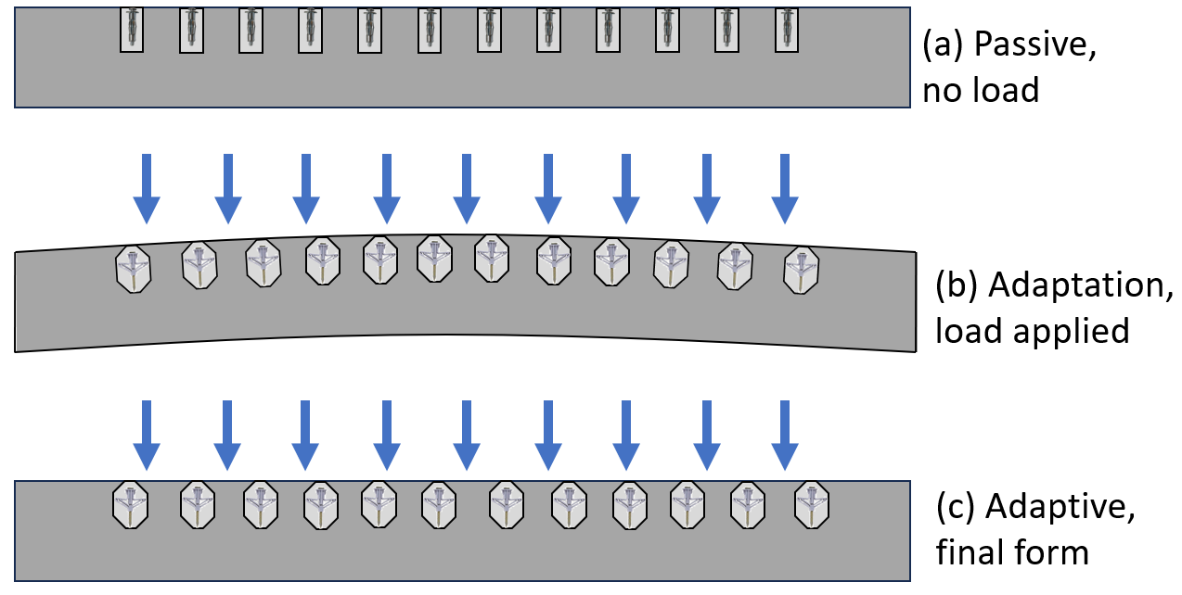
Project Description: The vision of this work is that through innovative use of expanding mechanical anchors, precast concrete bridge girders can adaptively camber to have zero deflection when subjected to external loads. Motivation for this work is twofold: topology optimization and long-term deflection control for transforming precast concrete research. This work will lead to cross-cutting research between concrete materials, structural design, architecture, and mechanical engineering. Work will begin on specimens intended for pedestrian bridges and will expand to highway and rail bridges in future projects.
Figure 1: System concept for adaptive precast concrete girder. Embedded anchors are inactive when there is no load (a) and actively cause camber when load is applied (b) and final form (c).

US DOT Priorities:
This project addresses the reduction of concrete materials through innovative active cambering technology. Through this work, the project will extend the life of transportation infrastructure. This project also addresses the RD&T strategic goals of sustainability & climate, safety, and transformation. Adaptive camber in precast concrete girders has not yet been studied in the United States, thus this project seeks to pioneer this field to use less material in precast concrete while promoting longer service life of infrastructure.

Outputs:
Anticipated research results will inform the expected forces in the 4-ft precast concrete girder specimen and the achievable camber. Modeling of this innovative concept of adaptive precast concrete will provide a new technology that can be implemented to calculate the adaptive camber capacity for highway bridge girders. Deliverables include an open-access data set of the form-finding force and resulting form sensitivity analysis as well as a conference paper on the results of the finite element model and the form-finding model on adaptive precast girders to be presented at the Precast/Prestressed Concrete Institute (PCI) Convention 2024 in Denver, Colorado. Deliverable will also be a journal paper that compares the modeling results with the experimental measurements of the 4-ft span adaptive precast girder to be submitted to the Journal of Structural Engineering.

Outcomes/Impacts:
Transformation: Science of adaptive structures has not yet been applied to concrete structures in the United States and has strong potential to transform the precast community. This proposed work will provide technology and fundamental science to change the shape of a precast concrete girder on-demand with applied loads for highway bridge girders. The embedment, spacing, and capacity for camber of this proposed system will be first targeting pedestrian bridge precast bridge girders. Pedestrian bridges are test bed projects due to lower applied loads and shorter span structures compared with highway bridges. Following the feasibility study with pedestrian bridges, adaptive precast bridge girders would be applied to highway bridges and other transportation infrastructure.

Climate & Sustainability: Adaptive precast concrete girders will reduce the required depth of the section for deflection criteria. This avenue of topology optimization maintains simple geometric forms unlike traditional topology optimization research. Reduction of required material for girders through adaptive camber will exponentially impact highway bridge construction by reducing the load capacity of piers and abutments. As Earth’s climate is changing at an unprecedented rate, adaptive structures enable infrastructure built today to address future external stressors.

Safety: An adaptive expanding anchor system can provide both local and global camber to negate deflection from external loads. This will reduce tensile loads in the girder, thus increasing the resilience of the structural member to tensile cracking.

Durability: During the experimental design, durability of the adaptive camber precast girder specimens will be a driving design factor. Repeatability of the camber action over the lifetime of the structural component will lead to meaningful contributions to translative research.

Final Research Report: URL link to the project's final report will be provided upon the completion of the project.

