**Transportation Infrastructure Precast Innovation Center**

**(TRANS-IPIC)**

**University Transportation Center (UTC)**

*Design, Manufacturing, and Characterization of Fiber Reinforced Shape*

*Memory Polymer Rebars*

*[LS-23-RP-01]*

Quarterly Progress Report

For the performance period ending *[06/30/2024]*

**Submitted by:**

*Pl: Guoqiang Li, Department of Mechanical & Industrial Engineering,*

*Louisiana State University, Baton Rouge, LA 70803, E-mail:* [*lquogi1@Isu.edu*](mailto:lquogi1@Isu.edu)

**Collaborators / Partners:**

*[None]*

**Submitted to:**

TRANS-IPIC UTC

University of Illinois Urbana-Champaign

Urbana, IL

**TRANS-IPIC Quarterly Progress Report:**

**Project Description:**

1. Research Plan - Statement of Problem

*The objective of this one-year project is to design, manufacture, and tension program fiber reinforced shape memory polymer (FRSMP) rebars and test their shape memory effect. A total of five tasks were proposed. Task 1. Selection of SMP matrix. Task 2. Selection of glass fibers. Task 3. Manufacturing of FRSMP rebars. Task 4. Programming of FRSMP rebars. Task 5. Recovery stress testing.*

1. Research Plan - Summary of Project Activities (Tasks)

*In our last report, Task 1: Selection of SMP matrix has been completed and Task 2: Selection of glass fibers has been partially completed. In the current reporting period, we focused on completing Task 2: Selection of glass fibers and started Task 3: Manufacturing of FRSMP rebars. In completing Task 2, we further investigated the effect of fiber braiding pattern on the uniaxial tension behavior. To this end, we braided both three and six wires into cables and used three and six straight wires as controls. Each wire consists of six fiber tows. Therefore, each of the braided cable and straight wire cable consist of either eighteen or thirty-six fiber tows. The purpose is to investigate which pattern can allow more axial tensile strain, which is critical for the SMP matrix to be deformed during tension programming of FRSMP rebars. In addition to the experimental testing of the cables, we also started finite element analysis, which is going on. At the same time, we started investigating the manufacturing approach to fabricate FRSMP rebars. Combining with testing the two types of fiber cables, which need the end sections to be clamped by the MTS machine, we found a way of fabricating the FRSMP rebars, which will be utilized in our next step of study.*

**Project Progress:**

1. **Progress for each research task**

***Task 2. Selection of glass fibers***

The primary experimental tasks of the project involve the construction and subsequent testing of lab-scale fiber reinforced shape memory polymer (FRSMP) rebars. These rebars feature a unique composition: a shape memory polymer matrix combined with a cylindrical, braided glass fiber core. The core consists of individual glass fiber strands bundled into groups that are woven together to form a distinctive reinforcing structure. The rebars will undergo tensile and bending tests to determine their strength. Because there are many ways to braid fiber tows into cable as reinforcement in the FRSMP rebars, we started using finite element to assist in identifying the optimal braided cable.

***Modeling Effort***

In FRSMP rebars, it is the SMP matrix that has the shape memory effect. In order for the FRSMP rebars to have shape memory effect, more mechanical energy needs to be input to the rebars during tension programming. It is well known that glass fibers have limited deformability, limiting the amount of deformation that the FRSMP rebars can have. Therefore, the idea is that if the glass fibers tows are braided into different patterns, the braided fiber cables may have higher ductility than that of the plain fiber cable, i.e., the cable is made of straight fiber tows.

Our first study is to model two fiber cables, one is helical cable, and the other is plain cable. We used 37 steel wires as our preliminary investigation. The two types of cables are shown in **Figure 1**.

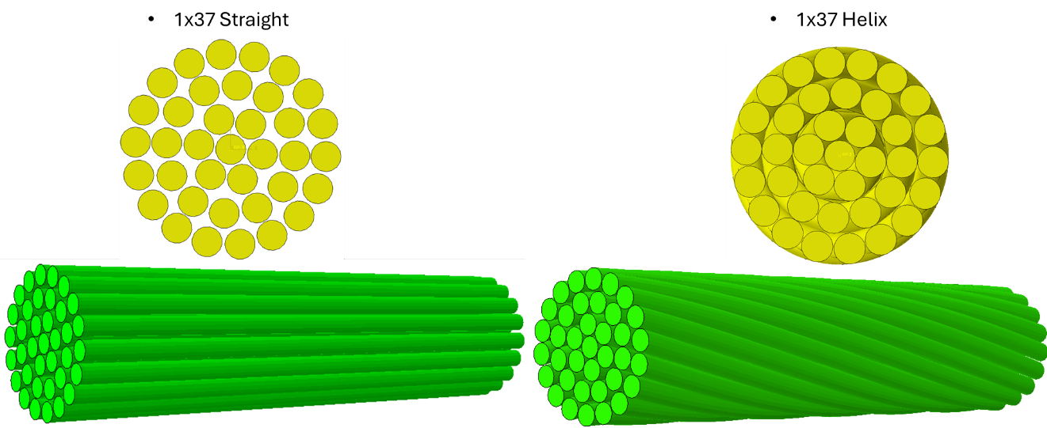

**Figure 1**. Geometry of the two cables.

**Figures 2-7** show the comparisons of normal stress, shear stress, principal stress, normal strain, shear strain, and principal strain distributions between the two types of cables, respectively. It is clear that with the same boundary conditions, loading conditions, materials, and number of wires, the braided cable has 66 times lower normal stress, 98 times of higher shear stress, 7 times lower principal stress, 44 times lower normal strain, 93 times higher shear strain, and 68 times higher principal strain than those of the plain cable, respectively. The lower principal stress and higher principal strain suggest that the braided helical cable can be deformed more than the plain cable with lower principal stress, which is desired for FRSMP rebars so that the rebars can be deformed more during uniaxial tension programming.

To further investigate the effect of braiding patterns on the strength and deformation of the braided cables, we started modeling other braiding patterns. As shown in **Figure 8**, we braided three fiber tows into a braided pattern. Modeling a well-laid braided rope involves considering various geometrical factors to accurately represent its structure. The key factors include d**iameter of individual strands, number of strands, helix angle, pitch, rope diameter, and braid pattern.** To model a well-laid braid rope, it is crucial to consider the diameter of individual strands and the total number of strands used in the braid. Another vital factor is the helix angle and the pitch, or the distance along the rope's length over which a complete helical turn of a strand occurs, which is also an essential geometrical factor that refers to the angle at which the strands are braided around the rope. As an example, we modeled a cable braided by three fiber tows and a cable by plain fiber tows as control, as shown in **Figure 8**. The longitudinal stress, principal stress, and longitudinal displacement are shown in **Figures 9-11**, respectively. From **Figure 9**, it is seen that the braided cable has lower longitudinal stress than that of the control plain cable. We are optimizing the parameters essential for modeling the well-laid 3 braid rope, focusing on key geometrical factors. These parameters include the diameter of individual strands and the number of strands, which together determine the rope's overall diameter. Additionally, the pitch, or the distance over which a complete helical turn of a strand occurs, has been fine-tuned to achieve the desired compactness and tightness.

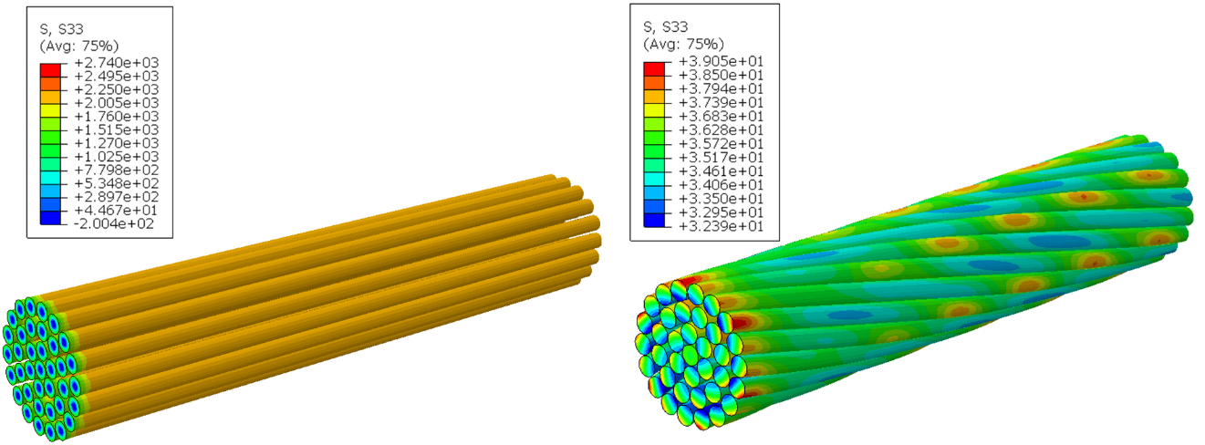

**Figure 2**. Normal stress distribution in the two types of cables.

**Figure 3**. Shear stress distribution (left: plain; right: braided).

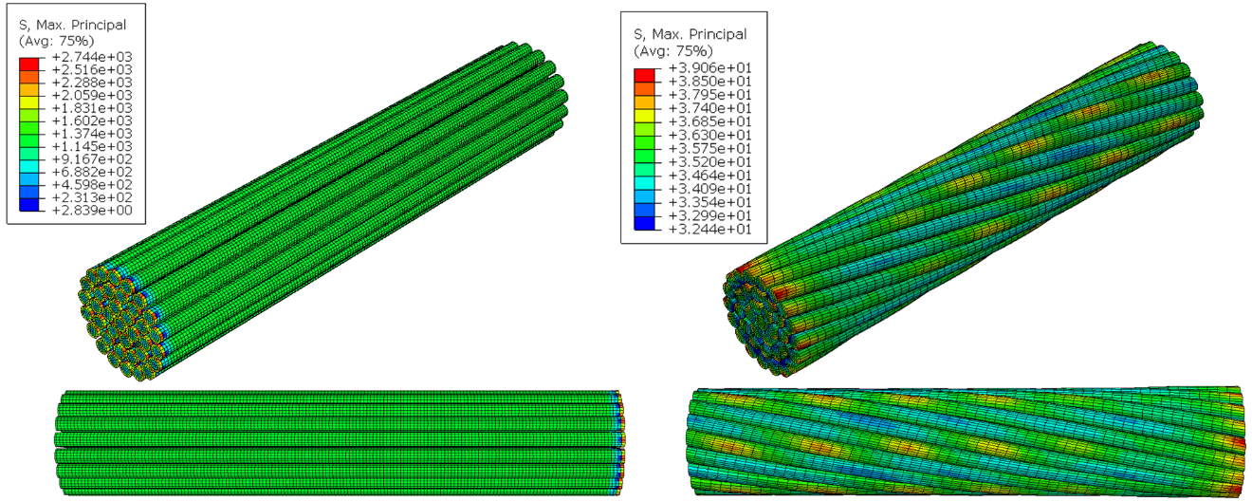

**Figure 4**. Principal stress distribution.

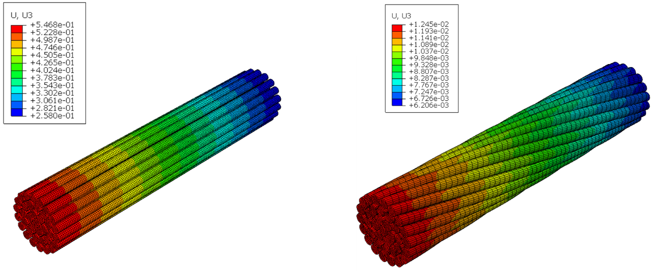

**Figure 5**. Normal strain distribution.

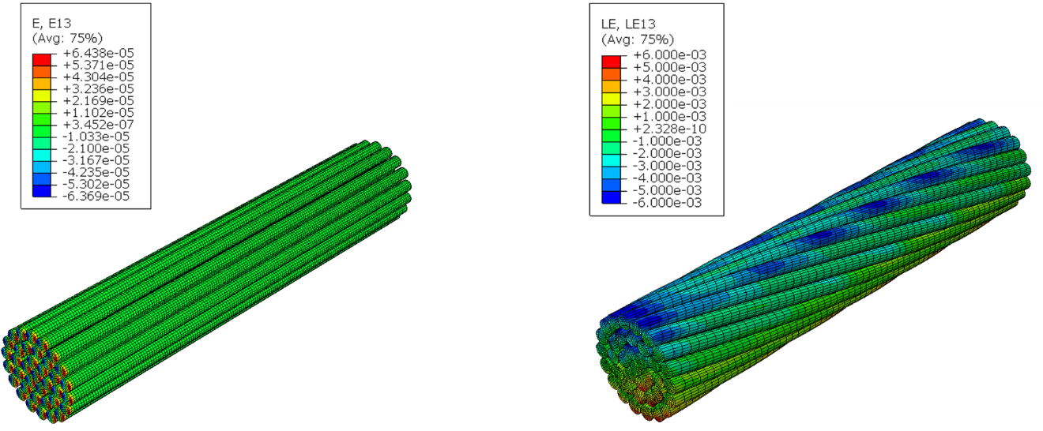

**Figure 6**. Shear strain distribution.

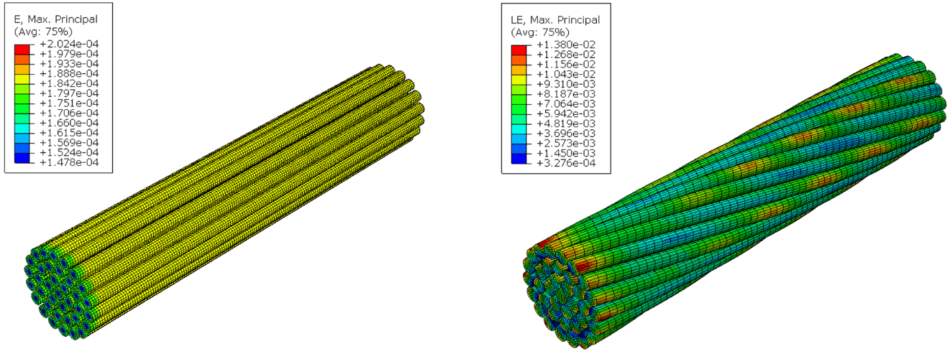

**Figure 7**. Principal strain distribution.

1. Simple modeling b) Well-laid 3-strands braided cable

**Figure 8**. CAD models of braided fiber cables.

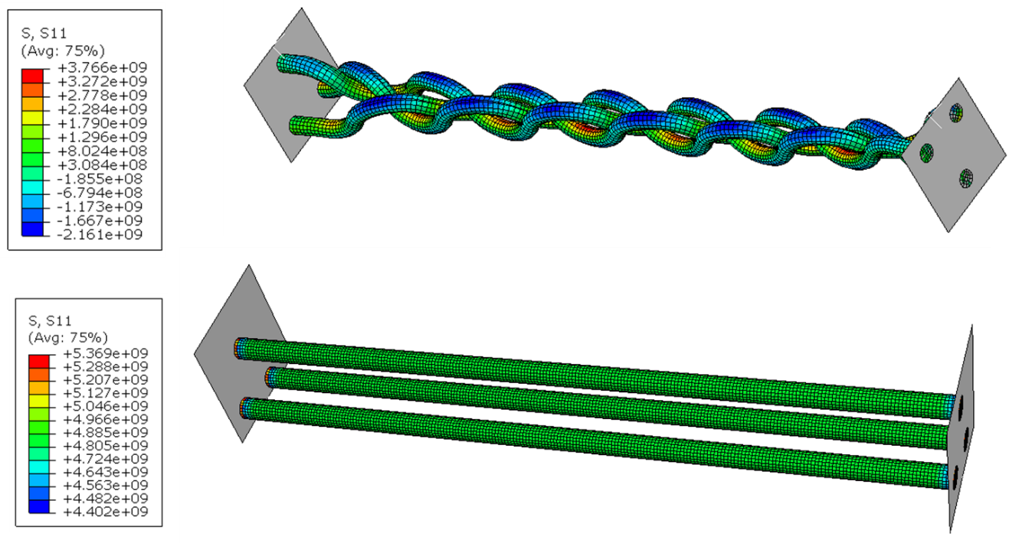

**Figure 9.** Longitudinal stress distribution.

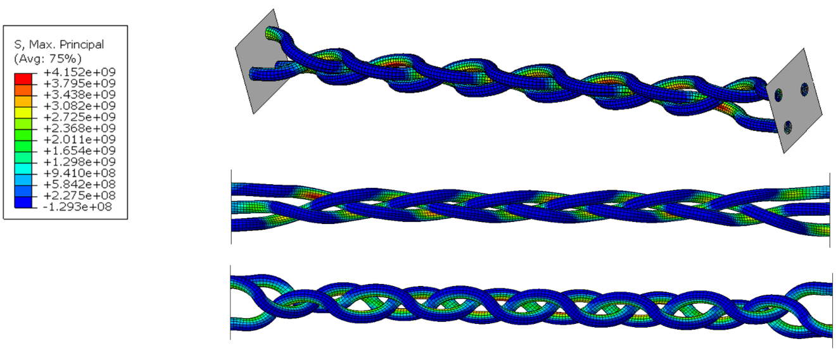

**Figure 10**. Principal stress in braided cable.

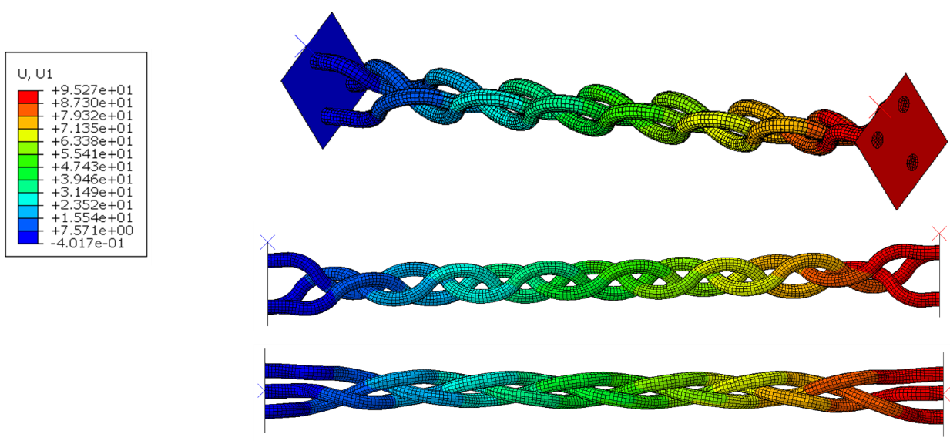

**Figure 11**. Longitudinal displacement distribution in braided cable

***Fabrication and testing of braided cable and plain control cable***

Concurrent with modeling work, we started braiding glass fiber tows into cables, and testing them. In this effort, we first braided three fiber wires into cables. Each wire consisted of six fiber tows. The same number of wires was used to prepare three-wire plain cables as control. We used the SMP to bond the end sections of the cables so that the cable can be clamped by the MTS machine. **Figure 12** shows the uniaxial tensile test results. It is seen that the two types of cables have similar peak load and strain at the peak load. However, it is seen that the braided cable shows a gradual post-peak descending branch, instead of brittle failure in the control cable, suggesting that the braided cable can sustain larger axial tensile strain, which is desired for programming the FRSMP rebars.

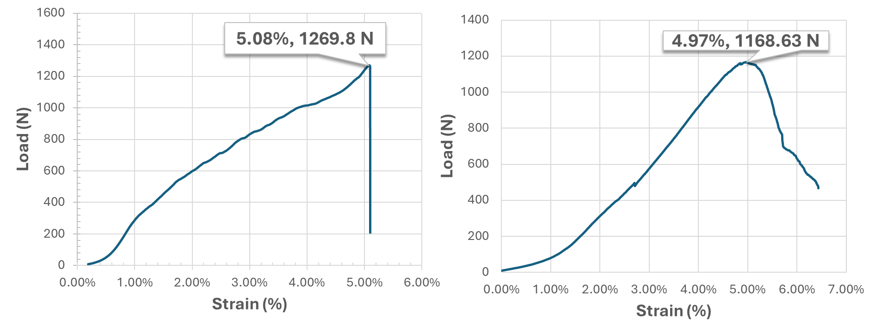

**Figure 12**. Uniaxial tensile test results (left) control cable and (right) braided cable.

We then braided six fiber wires into cables. Each wire consisted of six fiber tows. Therefore, the cable consisted of thirty-six fiber tows. The cables were braided manually. The glass fiber reinforcement was created by first bundling six strands or tows of glass fibers of equal length together for each of the six cords or wires. After anchoring one end of all six cords to a fixed support, the cords were separated into two groups of three, one to the left and the other to the right as seen in Step A in **Figure 13**. The braiding process then began by bringing the leftmost bundle (cord 1) behind all other cords to the right and then weaving it over cord 6, under cord 5, and over cord 4 until finally returning to the left group/side stopping in cord 3’s previous position as seen in Step B in **Figure 13**. Next, the rightmost bundle (cord 6) was brought behind all other cords to the left and then woven over cord 2, under cord 3, and over cord 1 after which it finally returned to the right group/side stopping in cord 4’s former position as depicted in Step C in **Figure 13**. This process was repeated with the same pattern for the outermost cord alternating between the left and right side until the same initial configuration was obtained with the cords in their original order from 1 to 6. Then, the loose braid was tightened into a compact structure, and the process was continued until the desired length of braided cable was achieved. At the same time, the plain cables made of six straight fiber wires were also prepared manually, as controls. The two end sections of each cable were impregnated with SMP, so that the cables can be clamped by the clamps of the MTS machine. We then conducted uniaxial tension tests of each cable until failure. The typical load versus strain curves are shown in **Figure 14**.

**Figure 13**. Schematic of preparing the braided cable (from left to right, they are Step A, Step B, and Step C).

**Figure 14**. Typical load versus strain test results of braided cable and plain cable.

From **Figure 14**, it is seen that under the sample axial load, the strain of the braided cable is larger than that of the plain cable. This feature is desired because it allows more deformation of the SMP matrix when the FRSMP rebars are tension programmed. As a result, it is expected that the FRSMP rebars with the braided cable reinforcement will have higher energy storage, and higher recovery strain when triggered to have shape recovery, and thus may have the potential to close wider-opened cracks in FRSMP rebar reinforced concrete beams.

**Figure 15** shows the two types of cables under uniaxial tests. The failure modes of the two types of glass fiber cables are shown in **Figure 16**. It is seen that the failure is due to fracture of the fiber tows, at the middle of the gauge length of the cables. The SMP bonded cable ends are in integrity, suggesting that the SMP has very good bonding with the fiber cables. The fiber reinforced SMP section can survive the tensile, shear, and compressive forced applied to it by the clamps of the MTS machine. In other words, the method used to prepare FRSMP rebars, which is a focus of the Task 3, is reliable.

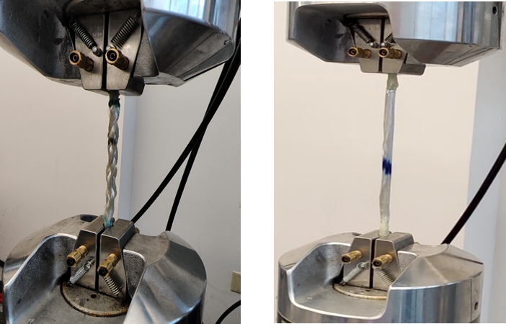

**Figure 15**. Cables under uniaxial tensile tests (left: braided cable; right: plain cable).

***Task 3. Manufacturing of FRSMP rebars***

During this reporting period, coupled with the clamp section of the fiber cables in Task 2, we investigated the approach of fabricating FRSMP rebars. We used the pultrusion and vacuum assisted resin infusion molding (VARIM) method to prepare FRSMP rebars. We used 9 mm inner diameter Teflon tubing as the mold, the resin bath which prevented the resin from entering the vacuum pump, and various other supplies including hose clamps, connectors, barbs, and plugs, in preparing the clamp sections for the fiber cables. The setup is shown in **Figure 17**. In this setup, the shape memory polymer resin was siphoned out of the rectangular aluminum resin both into the Teflon tubing which contained the braided fiber cable or plain fiber cable and acted as the mold, giving the rebar its external shape and dimensions. The vacuum pump ensured the fiber was completely infused with resin throughout its length and that voids were minimized. After the fiber core was fully saturated, the tubing containing the composite rebar was disconnected, plugged at both ends, and placed in an oven for curing. Based on the test results in **Figure 16**, it is seen that the FRSMP rebars prepared using this approach works. In the next reporting period, we will use this approach to prepare full-length FRSMP rebars.

**Figure 16**. Failure modes of the braided (right) and plain (left) cables after uniaxial tensile tests.

**Figure 17.** Preliminary Rebar Fabrication Setup.

1. Percent of research project completed

*Task 1 progress [100% completed]*

*Task 2 progress [90% completed]*

*Task 3 progress [30% completed]*

*Task 4 progress [0% completed]*

*Task 5 progress [0% completed]*

1. Expected progress for next quarter

In the next reporting period, we will (1) complete Task 2 by modeling and testing more braided glass fiber cables and determine the optimal one for preparing FRSMP rebars; (2) almost complete Task 3 by preparing FRSMP rebars; and (3) start Task 4 by programming FRSMP rebars.

1. Educational outreach and workforce development

*During this reporting period, Dr. Guoqiang Li presented “Fiber Reinforced Shape Memory Polymer Rebars” in two seminars:*

*Seminar 1:*

*TRANS-IPIC Workshop*

*Chicago*

*April 22, 2024.*

*Seminar 2:*

*TRANS-IPIC Monthly Seminar*

*Online through Zoom*

*May 13, 2024*

1. Technology Transfer

*None*

**Research Contribution:**

1. Papers that include TRANS-IPIC UTC in the acknowledgments section:

*None*

1. Presentations and Posters of TRANS-IPIC funded research:

*None*

1. Please list any other events or activities that highlights the work of TRANS-IPIC occurring at your university (please include any pictures or figures you may have). Similarly, please list any references to TRANS-IPIC in the news or interviews from your research.

*None*