

Transportation Infrastructure Precast Innovation Center (TRANS-IPIC)

# University Transportation Center (UTC)

***Shape Memory Alloy Transverse Reinforcement for Precast Bridge Girders End Regions***

*Project No.: UI-23-RP-01*

### Quarterly Progress Report

For the performance period ending *March 31st, 2024*

## Submitted by:

PI: Bassem Andrawes, [andrawes@illinois.edu](mailto:andrawes@illinois.edu) Department of Civil and Environmental Engineering University of Illinois at Urbana-Champaign

## Collaborators / Partners:

- County Materials Corporation

## Submitted to:

TRANS-IPIC UTC

University of Illinois Urbana-Champaign Urbana, IL

# TRANS-IPIC Quarterly Progress Report:

## Project Description:

1. **Research Plan - Statement of Problem**

Despite the success of using concrete prestressing technology in the longitudinal direction, it has not been implemented in the transverse direction due to many practical challenges. The reason is that no practical method exists for prestressing internal shear reinforcement such as hoops, stirrups, or spirals because these reinforcements are fully embedded in the concrete; hence, gripping the reinforcement ends for prestressing is not feasible. This research will investigate a new technology for applying prestressing in the transverse direction using a class of smart metallic materials known as shape memory alloys (SMAs). Excessively deformed bars and wires made of SMAs can remember their original shape when subjected to a temperature of approximately 200⁰C. This project will use this novel material to solve the longstanding problem of splitting and bursting cracking at the end regions of precast concrete (PC) bridge girders. Applying prestressing in the transverse direction (i.e., vertically) within that local region will help mitigate concrete cracking during prestressing and reduce steel congestion in this region.

## Research Plan - Summary of Project Activities (Tasks)

The research plan for this project includes two primary tasks:

**Task (1):** Design of Specimens using Finite Element Method:

This task will focus on evaluating the behavior of the specimens through a detailed finite element (FE) analysis. The end region behavior of the specimens at web by a single prestressing strand will be investigated using the amount of transverse steel specified by AASHTO. The effect of SMA reinforcement compared to the conventional (non-prestressed) reinforcement will also be investigated, focusing on the end region. The case that produces the highest damage mitigation will be employed for the experimental stage of the project.

**Task (2):** Fabrication, Instrumentation, and Testing of Specimens:

Three specimens (one used as a control specimen with conventional steel and two specimens with SMA) will be fabricated and tested. Before casting, prestressing strands will be tensioned, and SMA transverse reinforcement will be placed at the specimen's ends. Next, the strands will be detensioned, and the progression of bursting stresses/cracks will be monitored. The thermo-mechanical properties of SMA by electric activation method will be tested in a self-made test setup.

## Project Progress:

1. **Progress for each research task**

**Task 1 progress (80% completed):** The work in this task during this quarter focused on using the finite element (FE) method to analyze several designs for the test specimens that will be used during the experimental phase of the project. The test specimens considered will be of a length equal to 36 in, which represents the end region of a precast prestressed girder.

For example, using the FE program ABAQUS, the end region damage of the half-scale of AASHTO Type I girder caused by prestress transfer by a single prestressing strand at web region was examined. The numerical model is seen in **Figure 1**. The end region specimen was attached to a fixed end block to imitate the end region motion while prestress release by only allowing vertical displacement and rotation. A comparable section area was utilized with a single wire for the prestressing strands rather than modeling seven wires. The element type used for modeling the prestressing steel was a linear 3-D truss with two

nodes (T3D2). A prestress of 202.5 ksi was applied by taking advantage of the strands’ thermal expansion. The embedded constraint type was used to bind prestressing strands and reinforcing bars to concrete.

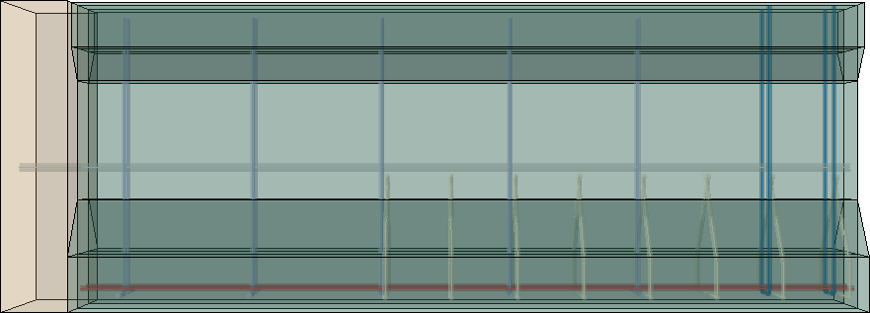

Confinement reinforcement

Longitudinal bars

End block

Prestressing strand

End stirrups

Stirrups

**Figure 1.** Finite element model considered in the analysis

Damage-evaluation was first performed with the conventional steel model by placing #2 steel stirrups at the end region at 1 in. and 4 in. from the end face (spacing = 3 in.). **Figure 2** shows the tensile damage along the prestressing strand. The hues are categorized based on the tensile damage magnitude. The sections that are blue indicate locations where the tensile damage was almost negligible, indicating the crack propagation is not expected. Green areas indicate the tensile damage reached 50%, implying minor cracks would be propagated. Red areas represent regions where the concrete is entirely cracked. According to the FE analysis, major cracks were estimated to develop within 2.5 in. with following minor cracks up to 14 in.

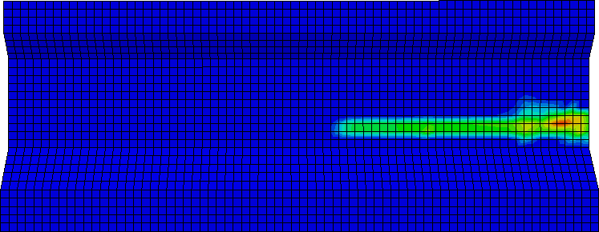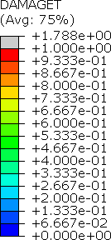

**Figure 2.** Tensile damage at the end region resulting from FE analysis

Using the results from conventional steel model, steel stirrups were replaced by transverse prestressing stirrups (SMA) with different spacing and activation length to evaluate the tensile damage. **Table 1** illustrates the type, layout, and activation range of models considered in the FE analysis with end region #2 (d = 0.25 in.) reinforcement upon 4 in. from the end face.

**Table 1.** Layout and activation range of end stirrups

|  |  |  |
| --- | --- | --- |
| Type | Distance of end stirrups from the end face | Activation range |
| Steel | No.1 @ 1 in. and No. 1 @ 4in. | - |
| SMA-F | No.1 @ 1 in. and No. 1 @ 4in. | Full |
| SMA-B | No.2 @ 1 in. (bundled) | Full |
| SMA-P | No.1 @ 1 in. and No. 1 @ 4in. | Partial (vertical component) |

**Figure 3** shows the reduced damage on girder at the web areas when SMA stirrups replaced steel stirrups in each case. With full activation at an equal spacing (SMA-F) compared to steel case, nearly all damages were reduced, leaving negligible cracks. SMA-B also reduced significant amounts of cracking, but still left minor cracks near the end face. The case could relieve steel congestion by bundling, which would be prospecting method. Partial activation on vertical component of SMA (SMA-P) had some effect on crack

reduction, but the lowest amount compared to other SMA models. Still, major cracks were eliminated, only prompting minor cracks.

|  |  |  |
| --- | --- | --- |
|  |  |  |
| (a) SMA-f | (b) SMA-b | (c) SMA-P |
| **Figure 3.** Tensile damage on SMA models after prestress release | | |

**Task 2 progress (30% completed):** This task during this quarter focused on building the forms, setting test setup, and prestressing and activating SMA stirrups in the lab. The goal is to understand the thermo- mechanical properties of NiTiNb SMA during prestressing and activation. Also, finishing the experimental setup (such as fastening steel frame for test setup, testing on prestressing strands to 202.5 ksi), including practicing and planning instrumentation (digital image correlation (DIC) and strain gauges) was conducted.

**Figure 4** shows the built form with reinforcing bars and prestressing strands assembled together. Styrofoam was attached at both sides of the form to develop the I shape of the girder while casting concrete. The steel frames needed for pretensioning the steel strands were fastened to the Newmark lab strong floor with twelve collar bolts in equal spacing of 3 ft as shown in **Figure 5**.

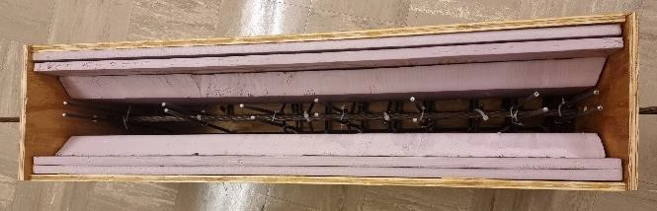

**Figure 4**. Built form steel assembly

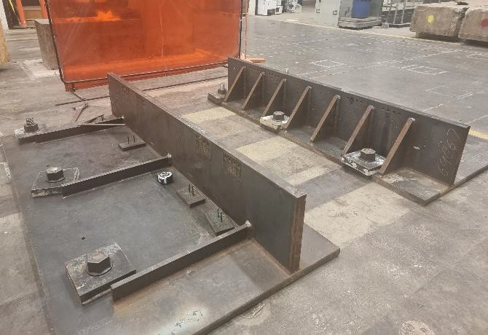

**Figure 5**. Test setup for prestress release experiment

Thermo-mechanical characteristics of NiTiNb SMA were evaluated by straining and activating as shown in stress strain curve in **Figure 6**. With prestraining SMA to 15% (a) at the Martensite phase, it resulted in recovery stress of 40 ksi (b) by electrically heating it up to 215°C and then cooling to ambient temperature with both ends fixed. Next, straining – activating – restraining ((c) to (e)) in the Austenite phase was conducted to investigate the reusability of SMA and corresponding recovery stress. By 8% additional strain, 35 ksi of recovery stress was rebuilt and the SMA could be restrained after reactivation.





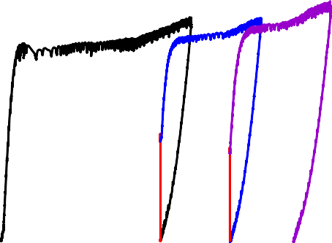

(c)

(a)

(b)

(d)

(e)



### Figure 6. Stress strain curve of NiTiNb SMA in each phase

1. Percent of research completed

*Total project completed through the end of this quarter =* **45%**

### Expected progress for next quarter

The next quarter will focus on performing prestressing of steel strands and casting concrete in the forms. The effect of SMA activation inside the concrete will also be evaluated. Instrumentation plan is expected to be finalized and at least two specimens are assumed to be constructed and placed on the steel frame for prestress release testing.

### Educational outreach and workforce development

The following are the educational and workforce developments carried out during this quarter:

1. A presentation was delivered at the 2024 Transportation Research Board (TRB) Annual Meeting.
2. A presentation was delivered at the February TRANS-IPIC webinar. The recording of the presentation is published on the TRANS-IPIC website.
3. An in-person presentation is planned to be delivered at the 1st TRANS-IPIC Annual Workshop in Rosemont/Chicago, IL.
4. A journal paper is currently in preparation and will be submitted to the Smart Materials and Structures Journal.

### Technology Transfer

Nothing to report yet.

## Research Contribution:

### Number of papers

* + Andrawes, B., Sung, M., and Park, S. (In preparation) “Behavior of Hot-Rolled Annealed NiTiNb Bars under Full and Partial Heating for Concrete Prestressing Applications” *Smart Materials and Structures*. (Federal Funds Acknowledgment: Yes)
  + Park S. and Andrawes B. "Damage Mitigation of Prestressed Girders End Regions Using Shape Memory Alloys" 2024 Transportation Research Board Annual Meeting. (Federal Funds Acknowledgment: Yes)
  + Perez-Claros E. and Andrawes B. "Active Confinement of Precast Concrete Columns using FeMnSi Shape Memory Alloy Hoops" 18th World Conference on Earthquake Engineering, July 2024, Milan, Italy. (Federal Funds Acknowledgment: Yes)

### Number of presentations (when, where)

* + Park S. and Andrawes B. "Damage Mitigation of Prestressed Girders End Regions Using Shape Memory Alloys" *2024 Transportation Research Board Annual Meeting*. Jan. 2024. (Federal Funds Acknowledgment: Yes)
  + Park S. and Andrawes B. “Shape Memory Alloy Transverse Reinforcement for Solving End Region Problems in Precast Bridge Girders” *Transportation Infrastructure Precast Innovation Center (TRANS- IPIC) Monthly Research Webinar*. Feb. 2024.

## References:

N/A