**Transportation Infrastructure Precast Innovation Center**

**(TRANS-IPIC)**

**University Transportation Center (UTC)**

*Photogrammetry and LiDAR-Based Precast Railroad Crossties Abrasion Damage Detections*

*PU-23-RP-04*

Quarterly Progress Report

For the performance period ending *09/30/2024*

**Submitted by:**

*PI: Shanyue Guan, Assistant Professor,* [*guansy@purdue.edu*](mailto:guansy@purdue.edu)

*School of Construction Management Technology*

*Purdue University*

**Collaborators / Partners:**

*CO-PI: Chao Sun, Associate Professor,* [*csun@lsu.edu*](mailto:csun@lsu.edu)

*Department of Civil and Environmental Engineering*

*Louisiana State University*

*Industry Partner: MxV Rail*

**Submitted to:**

TRANS-IPIC UTC

University of Illinois Urbana-Champaign

Urbana, IL

**TRANS-IPIC Quarterly Progress Report:**

**Project Description:**

1. Research Plan - Statement of Problem

The railroad industry has been struggling with precast concrete crossties abrasion damage for a long time. Our research team has communicated with multiple class I railroads and all have responded that some of their crossties are facing the abrasion issue. To extend the precast concrete crossties service life and ensure railroad safety, there is a strong demand to mitigate the crossties abrasion damage. As it is not practical for the railroad industry to inspect thousands of miles of track to find concrete crosstie abrasion loss manually, an automated, low-cost, mobile, and accurate monitoring approach is urgently needed for the crossties' maintenance and repair.

1. Research Plan - Summary of Project Activities (Tasks)

Task 1: Visit precast concrete crossties damage site

Work closely with railroad industry (e.g. MxV Rail) to understand abrasion damage of precast concrete damage and typical approach the industry use to measure the damage.

Task 2: Develop a photogrammetry and LiDAR system detecting damages

Develop a photogrammetry and LiDAR hardware system to detect the precast concrete crossties abrasion damage automatically.

Task 3: Validate the system performance in indoor and outdoor environments

Validate the system performance at Purdue University (West Lafayette, IN) Test Track Facilities.

Task 4: Reporting

Document all the completed work for paper publication and project report.

**Project Progress:**

1. Progress for each research task

Task 1 progress [100% completed]

Our team visited MxV Rail and discussed with their railroad crossties group to understand the damage pattern of precast concrete crossties and learn their technologies detecting concrete crossties conditions. Our team received three precast concrete crossties donated by MxV Rail. These precast concrete ties shown in Figure 1 will be used as test specimens for our project.

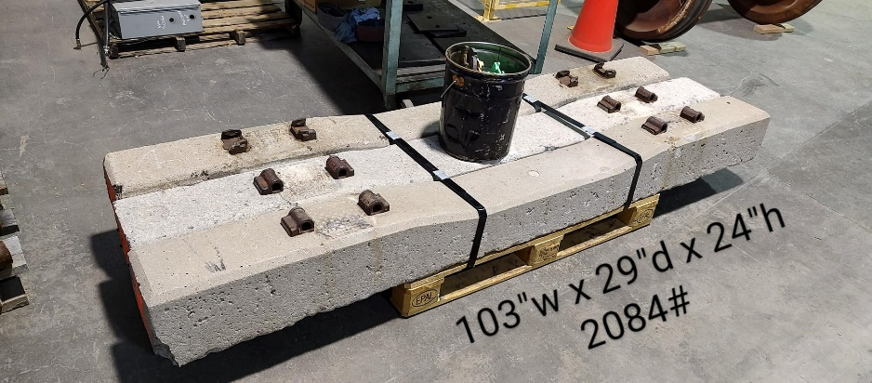

Figure 1. Precast concrete crossties donated by MxV Rail

Task 2 progress [90% completed]

Our team purchased a DJI Mavic 3 Thermal drone and used it to conduct 3D scanning of the concrete ties. DJI Mavic 3 Thermal is equipped with Wide-angle (Equivalent Focal Length: 24mm, 48MP) and zoom-in (Equivalent Focal Length: 162mm, 12MP, 56× Hybrid Zoom) cameras. The cameras have captured high-resolution images for reconstruction of a 3D model with detailed concrete crossties conditions. With the images captured by the drone cameras, we create a 3D model of the concrete crossties using Agisoft Metashape Pro software. After the 3D model is created, it will be imported to Cloudcompare software to conduct further analysis to identify the geometry and damage information of the concrete crossties.

Task 3 progress [80% completed]

Our team has conducted a series of laboratory experiments using a drone-based photogrammetry approach to conduct 3D scanning to sense the concrete crossties conditions. As shown in Fig. 2, three concrete ties are stationed on the ground with a 2-foot interval to simulate the practical concrete crossties distribution. The DJI Mavic 3 flied over the concrete crossties along pre-defined paths to take high-resolution video footage and images (Figure 2), which took15 to 20 minutes. Then the images and videos were imported to Agisoft Metashape to create a high-resolution 3D model (Figure 3). After the 3D model is created, it is analyzed using Cloudcompre software to understand the concrete crossties conditions (Figure 4). We measured the geometry of the concrete crossties and calculated the volume of the concrete crossties to determine their volume loss. We adopted a reference target with all known dimensions to quantify our measurement errors. The discrepancy between the reference target and our 3D model measurements is minimal (Table 1). Then we compared our model results with the actual dimensions of the concrete crossties (Table 2) and the errors are less than 3.33%, which is promising for real application in railroad industry . In addition to the volume loss measurements, our team also quantified the alignments of the crossties which is another critical factor of the railroad safety. The crossties demonstrate good alignments based on the distance between each individual crosstie (Figure 5). In addition to laboratory experiments, our team also conducted a site visit to Madison Railroad company in Indiana to validate our system performance (Figure 6).

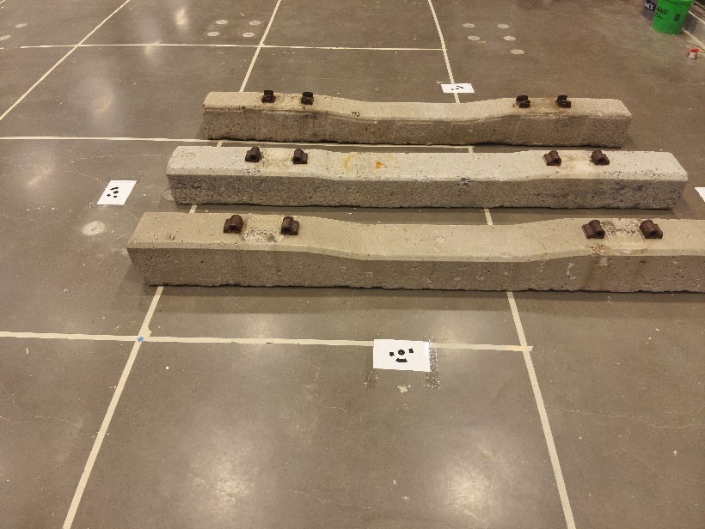

Figure 2. A drone captured concrete crossties image.

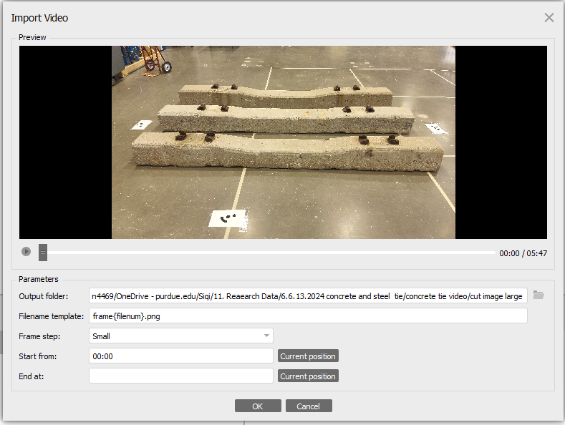

Figure 3. 3D model created by AgiSoft Metashape via the drone-based photogrammetry.

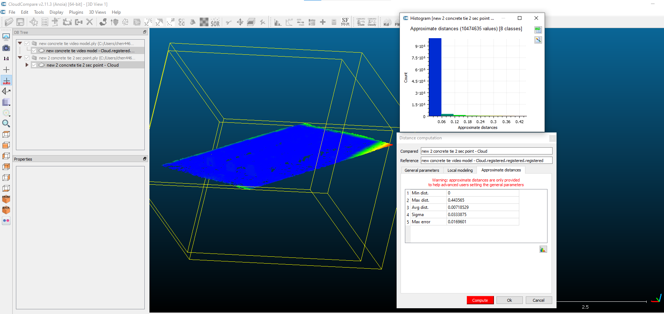

Figure 4. 3D model imported to Cloudcompare for further analysis.

Table 1. Rectangular shape volume calculations comparison.

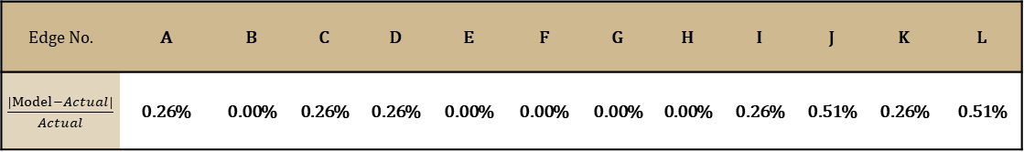

Table 2. Concrete crossties volume calculations comparison.

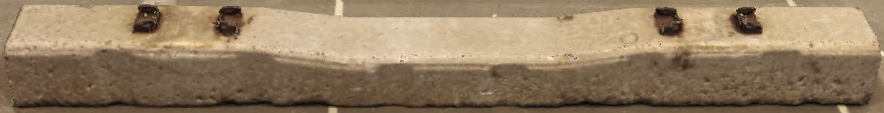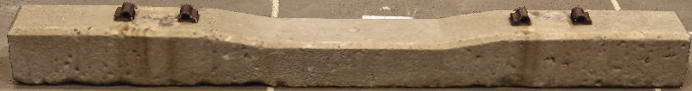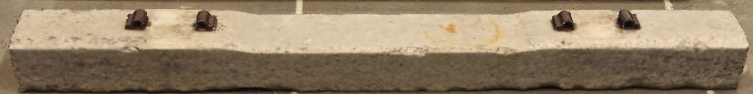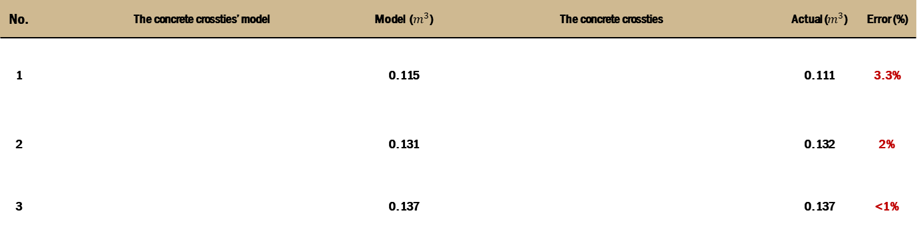

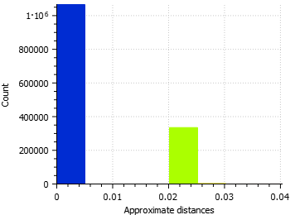

Figure 5. Crossties alignments.

Figure 6. Madison Railroad site visit.

Task 4 progress [0% completed]

1. Percent of research project completed

We have completed the majority of tasks 1, 2 and 3, and will start task 4. We have completed 80% of this project.

1. Expected progress for next quarter

For the fourth quarter of this project, our team will conduct experiments using the test track facility at Purdue University to calibrate our system performance. We plan to manually cut a piece of the concrete crossties with known volumes. Then use our drone detect the volumes of the concrete crossties prior and post the volume lost. Then we can use our 3D model to calculate the volume lost and compare this result with the known volume loss. We will draft the final report for this project and send it to TRANS-IPIC fore review at least one month ahead of the time. We will make changes of the final report based on the review committee comments if needed.

1. Educational outreach and workforce development

In our CM370 Heavy Civil Infrastructure course at Purdue University, we developed a lecture topic about precast concrete crossties, introduced the damages of concrete crossties, and how to maintain their performance.

1. Technology Transfer

None

**Research Contribution:**

1. Papers that include TRANS-IPIC UTC in the acknowledgments section:

Our team submitted one paper to 2025 TRB convention and is still under review.

1. Presentations and Posters of TRANS-IPIC funded research:

Our team presented at TRANS-IPIC September Workshop Webinar

1. Please list any other events or activities that highlights the work of TRANS-IPIC occurring at your university (please include any pictures or figures you may have). Similarly, please list any references to TRANS-IPIC in the news or interviews from your research.

None.

**References:**

[1] You, R., Wang, J., Ning, N., Wang, M., & Zhang, J. (2022). The Typical Damage Form and Mechanism of a Railway Prestressed Concrete Sleeper. Materials, 15(22), 8074.

[2] El-sayed, H. M., Fayed, M. N., Riad, H. S., & Zohny, H. N. (2022). A review of the structural performance of prestressed monoblock concrete sleepers in ballasted railway tracks. Engineering Failure Analysis, 140, 106522.

[3] Shurpali, A. A., Edwards, J. R., Kernes, R. G., Lange, D. A., & Barkan, C. P. (2014). Investigation of material improvements to mitigate the effects of the abrasion mechanism of concrete crosstie rail seat deterioration. Journal of Transportation Engineering, 140(2), 04013009.

[4] Shurpali, A. A., Van Dam, E., Edwards, J. R., Lange, D. A., & Barkan, C. P. (2012, April). Laboratory investigation of the abrasive wear mechanism of concrete crosstie rail seat deterioration (RSD). In ASME/IEEE Joint Rail Conference (Vol. 44656, pp. 99-108). American Society of Mechanical Engineers.

[5] Riding, K. A., Peterman, R. J., Guthrie, S., Brueseke, M., Mosavi, H., Daily, K., & Risovi-Hendrickson, W. (2018, April). Environmental and track factors that contribute to abrasion damage. In ASME/IEEE Joint Rail Conference (Vol. 50978, p. V001T01A009). American Society of Mechanical Engineers.