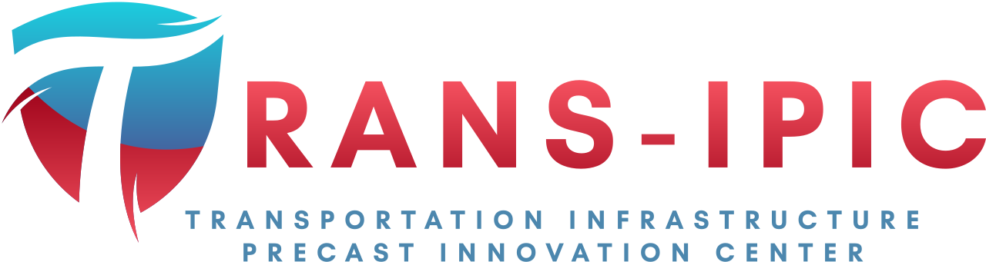

Transportation Infrastructure Precast Innovation Center
(TRANS-IPIC)

University Transportation Center (UTC)

Gaze-directed UAV-UGV Coordination Framework for Onsite Quality Inspection of Precast Bridge Construction
UT-23-RP-02

Quarterly Progress Report
For the performance period ending March 31, 2024.

Submitted by:
PI: Dr. Jiannan Cai, School of Civil & Environmental Engineering, and Construction Management (CECM), The University of Texas at San Antonio (UTSA); jiannan.cai@utsa.edu
Co-PI: Dr. Ao Du, CECM, UTSA, ao.du@utsa.edu
Co-PI: Dr. Ibukun Awolusi, CECM, UTSA, ibukun.awolusi@utsa.edu

Collaborators / Partners:
N/A

Submitted to:
TRANS-IPIC UTC
University of Illinois Urbana-Champaign
Urbana, IL

TRANS-IPIC Quarterly Progress Report:

Project Description:
- Research Plan - Statement of Problem
This project will develop a novel gaze-directed UAV-UGV coordination framework for on-site quality inspection of precast bridge construction. UAV will provide global coverage for inspectors to quickly identify the components and construction activities for inspection while UGV will navigate to specific locations for close inspection following human guidance. A new gaze-directed human-machine interface will be developed, where inspectors can express their guidance via natural gaze movements, to reduce worker mental load. The proposed framework is expected to transform the practice of onsite quality inspection for precast infrastructure construction by establishing intuitive multi-robot-human teaming for efficient inspection. Such a system can be extended to provide guidance during bridge installation, thus improving construction quality and durability with reduced rework. The proposed framework can also be extended for lifecycle inspection, including offsite component inspection and condition monitoring of existing infrastructure, and eventually improve the durability and extend the life of precast transportation infrastructure.

- Research Plan - Summary of Project Activities (Tasks)
Task 1. UAV-UGV coordinated localization and navigation.
This task aims to develop a hierarchical framework that will enable UGV to automatically locate and navigate to the inspection area as indicated by the UAV, leveraging sensing data from onboard GPS and camera of both robots.

Task 2. Gaze-directed and AI-powered human-robot interface.
This task aims to develop a gaze-directed and AI-powered human-robot interface (HRI) such that the robot could navigate to a specific location based on the guidance from human natural gaze movement.

Task 3. Prototype development and experimental demonstration.
This task aims to develop and test a prototype of the proposed framework. In our preliminary study, we have developed a mobile robot teleoperation interface that can be used for inspection on jobsites.

Project Progress:
- Progress for each research task

Task 1 progress [5% completed]
Task 2 progress [100% completed]
Task3 progress [0% completed]

Note: The research planned for Task 1 and Task 2 is relatively independent. Therefore, based on our current research schedule and resources, we started Task 2 first and have completed the technical development of Task 2, i.e., a gaze-directed and AI-powered interface for ground robot inspection. Then, we will focus on the Task 1 development as well as the integration between Task 1 and Task 2.

Our developed methods and results for this quarter are detailed below.
- We developed a gaze-directed robot inspection framework, which implements a configurable user interface designed to seamlessly integrate into existing robot-based inspection applications. Integrated with a mobile eye tracker, i.e., Pupil Core eye tracking glasses in our study, this interface enables an operator at a control station to remotely direct Unmanned Ground Vehicles (UGVs) at a construction site toward a specific object of interest by simply adjusting their line of sight on video streams from UGV. Given the coordinates of the remote operator’s gaze relative to the world view of the Pupil glasses, an image frame captured from the world video stream of the Pupil glasses can be segmented at the coordinate to isolate an object of interest. The user has the flexibility to start the segmentation over as required. When a suitable target has been isolated, it is then sent to the UGV to localize the target in its scene leveraging depth information obtained from an onboard sensor. The UGV would then autonomously navigate to the target and gather a collection of images of the structure. The collected dataset is then streamed back to the control station for further inspection and data processing. Figure 1 presents a visualization of the proposed framework.

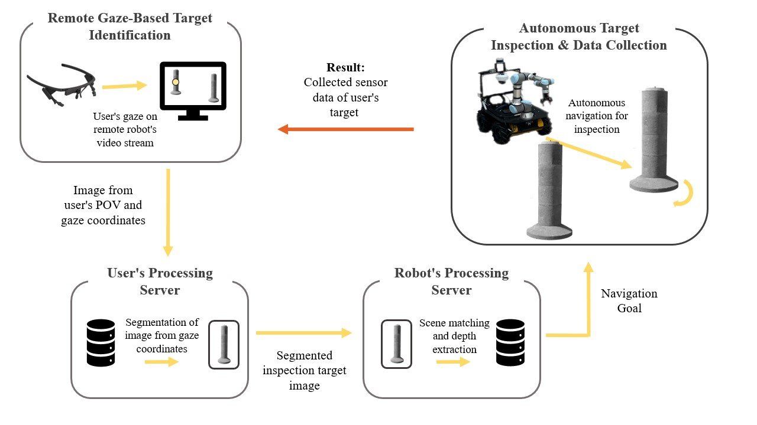
Fig. 1 Framework for gaze-directed robot inspection

- To validate our framework, we tested the pipeline from the remote operator inspection process up to the scene matching and depth results. Our experiment consisted of three sessions, with each session requiring the operator to land their gaze on one of the objects in the robot’s scene (Figure 2). The objects were selected to simulate common materials and objects in construction sites. The first session’s target object was the large wood block, the second session’s target was the small wood plank, and the third session’s target was the orange cone. The three sessions were conducted by a single remote operator.

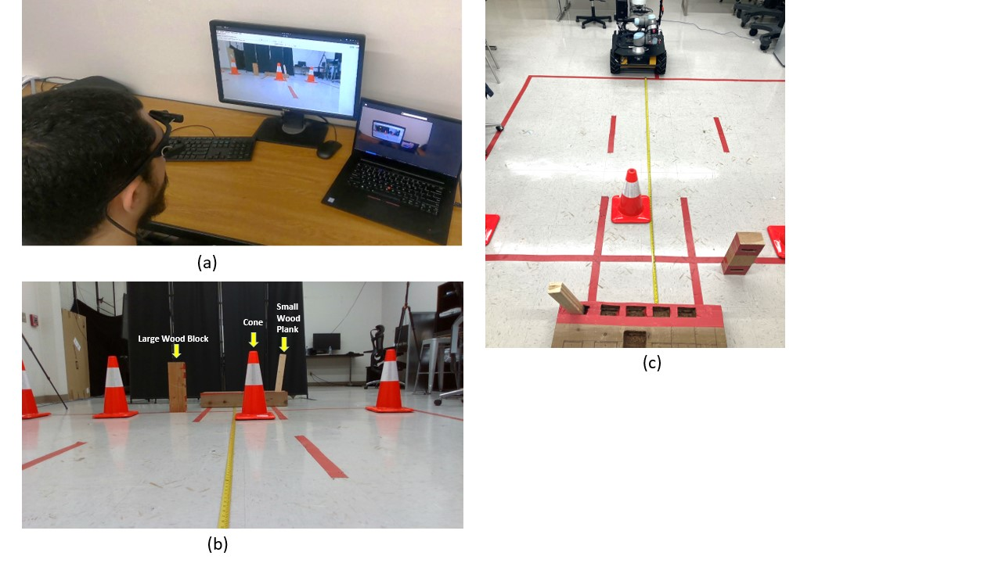
Fig. 2 Experiment Setup: (a) Operator performing an inspection task. (b) Robot’s viewable scene and labeled session targets. (c) Robot setup and scene configuration for experiment.

- The gathered metrics and results from the experiment can be seen in Table 1. Testing and real-world implementation of the autonomous navigation portion of the framework are planned for later works.

Table 1. Captured metrics from the experiment.
Object | Actual Distance (mm) | Program Output Distance (mm) | % Error of Distance Capture | Inspection Process Time (s) | Attempts to Acquire Target in Inspection Window | Scene Matching Process Time (s)
Large wood block | 2742 | 2684 | 2.12 % | 14.42 | 1 | 3.57
Small wood block | 3068 | 3900 | 27.11 % | 6.21 | 6 | 5.39
Cone | 2440 | 2475 | 1.43% | 7.36 | 2 | 2.68
Note: For the third object, feature matching resulted in two highly rated matched objects: one was of the intended cone, while the other was of the leftmost cone. The inspection node chose the leftmost cone, and the distance and corresponding error in Table 1 reflect the case for the leftmost cone in Figure 4(2).

- We have also provided a video as an initial demonstration of how the developed gaze-based inspection works: https://youtu.be/gjA9Ecur4_g

- Percent of research project completed
Estimate 30% of total project completed through the end of this quarter.

- Expected progress for next quarter
- Complete the technical development of Task 1, including
  - an autonomous navigation method for ground robot given GPS-specified destination
  - image matching method for UAV-UGV coordination
- Initial test of developed methods in simulation environment for Task 1.

- Educational outreach and workforce development
- Supported and trained one Ph.D. student, Xiaoyun Liang (female student) and, one master student, Juan Cruz Rivera (Hispanic student), on robotic research with applications in transportation infrastructure.

- Technology Transfer
N/A

Research Contribution:
- Number of papers
One conference paper under review
- Juan Cruz Rivera, Xiaoyun Liang, Ibukun Awolusi, Ao Du, and Jiannan Cai. (2024). A Gaze-Controlled Robotic Framework for Remote Site Inspection. ASCE International Conference on Computing in Civil Engineering 2024. (under review)

- Number presentations (when, where)
N/A

References:
N/A

