

Transportation Infrastructure Precast Innovation Center (TRANS-IPIC)

# University Transportation Center (UTC)

**Adaptive camber precast concrete girder for deflection mitigation of highway bridges**

Project # UI-23-RP-04

Quarterly Progress Report

For the performance period ending June 30, 2024

## Submitted by:

Ann C. Sychterz, Assistant Professor, Civil and Environmental Engineering, University of Illinois Urbana-Champaign, [asychter@illinois.edu](mailto:asychter@illinois.edu)

## Collaborators / Partners:

Jacob Henschen, Teaching Assistant Professor, Civil and Environmental Engineering, University of Illinois Urbana-Champaign, [jhensche@illinois.edu](mailto:jhensche@illinois.edu)

## Submitted to:

TRANS-IPIC UTC

University of Illinois Urbana-Champaign Urbana, IL

# TRANS-IPIC Quarterly Progress Report:

## Project Description:

1. Research Plan - Statement of Problem

The vision of this work is that through innovative use of mechanical anchors, precast concrete bridge girders can adaptively camber to have zero deflection when subjected to external loads. Motivation for this work is twofold: topology optimization and long-term deflection control for transforming precast concrete research. A bridge girder that contains the science of adding camber when loads are applied can reduce girder depth for stiffness requirements, optimizing material utilized as a sustainable solution in the light of climate change. Anchors inserted into slots along the top face of the girder expand longitudinally in the compression zone of the girder when vertical load is applied. The objectives of this proposed work are: 1) create a time-domain quasi static model for load-dependent adaptive camber concrete beam, and 2) compare and validate the model with experimental measurements of adaptive camber beam subjected to moving loads.

1. Research Plan - Summary of Project Activities (Tasks)

Task 1.1: Model stress distribution in precast concrete adaptive girder due to exerted force from adaptive anchor system. A finite element model will be created to characterize the stress distribution in the girder as a camber is forced into the compression face. Anchors will be embedded into slots on the top face of the precast girder.

Task 1.2: Create form-finding model of time-varying camber of adaptive precast girder. A form finding method, called dynamic relaxation, is a static analysis that does not require inversion of the stiffness matrix, thus well-suited for structures undergoing large deformations. This method is better suited to large deformations compared with finite element models for the structural member.

Task 2.1: Study adaptive camber effect of one anchor for parametric analysis. To examine the experimental behavior of the expanding anchor that will form the basis of the adaptive precast girder system, stress and strain from one expanding anchor will be studied. A specimen of approximately 1-ft span and 4-in depth will be formed with one slot on the compression face for an anchor of approximately 1-in length.

Task 2.2: Build 2-ft prototype of adaptive precast concrete girder and compare measurements with analytical model. A bench-scale precast girder will be approximately 4-ft span and a cross-section of 6-in depth and 4-in width. Minimum longitudinal tensile reinforcement will be provided. Strain gauges and high-fidelity camera measurements will be utilized for data collection during testing in the same manner as in Task 2.1.

## Project Progress:

1. Progress for each research task

Task 1.1: 100% complete: Figure 1 shows the adaptive concrete beam concept with expanding elements (anchors or lab jack) in the compression face of the beam. A preliminary 2D finite element model was built in Abaqus of the proposed reinforced concrete specimen of 16 in span by a square cross section of 4 in. The concrete had a concrete strength of 3 ksi and a density of 150 pcf. The model was simply supported on each end of the span and the actuation was located at the top face at midspan. The maximum force capable of the lab jack from Task 2.2 was utilized in this model to calculate the maximum possible camber in the finite element model.

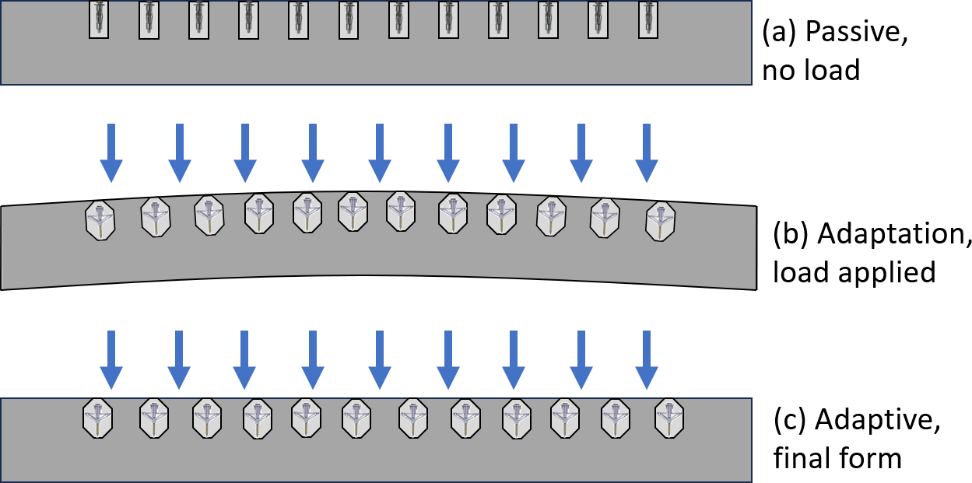

Figure 1: System concept for adaptive precast concrete girder. Embedded anchors are inactive when there is no load

(a) and actively cause camber when load is applied (b) and final form (c).

**RESULTS:** Figure 2 shows the finite element model of the concrete beam specimen and was modeled as a thick shell element using . Under self-weight, the deflection was 0.000028 in at the bottom of the plate. Applying the 22 lbs of force at the top face of the structure, the upwards camber was a maximum of 0.000080 in. Since actuation causes larger displacements, finite element models cannot be utilized throughout the process, therefore, a form-finding model will be effective to impose incremental elongation of the lab jack and deployable anchor.

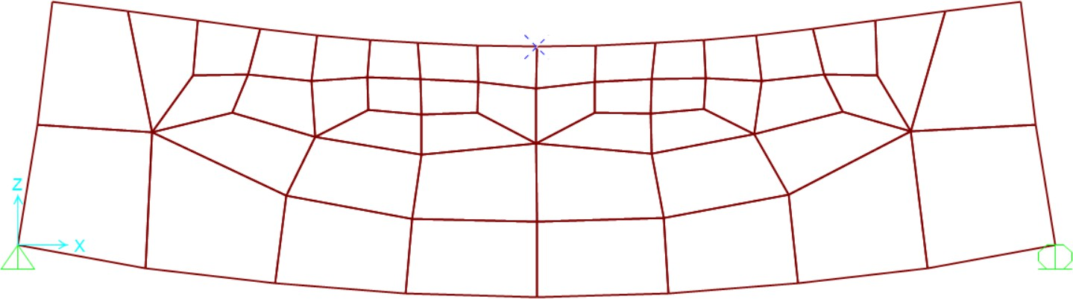

* 1. Self-weight deflection of the beam in finite element analysis.

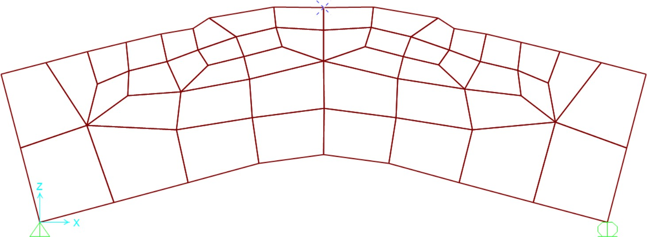

* 1. Actuation camber from lab jack in finite element analysis.

Figure XX: Results from finite element thick shell analysis of the adaptive concrete specimen.

Task 1.2: 80% complete: A form finding method, called dynamic relaxation, is a static analysis that does not require inversion of the stiffness matrix, thus well- suited for structures undergoing large deformations. This method is better suited to large deformations compared with finite element models for the structural member. The model leverages a strut-and-tie model of the concrete specimen with an additional element for actuation at the center where the expanding system is installed. The specimen boundary conditions are restrained for out-of-plane movement and simply supported at the ends of the beam as shown in Figure 3. The dynamic relaxation model utilized the same material properties as given for the finite element model. The #2 reinforcement placed at the bottom of the specimens is 60 ksi reinforcement steel. Activation of the anchors in the compression zone will be simulated in a stepwise manner, ignoring inertial effects of shock loading. The actuation element is infinitely stiff and is studied in increments of 0.5 in up to a maximum of 8 in, governed by the maximum expansion of the lab jack.

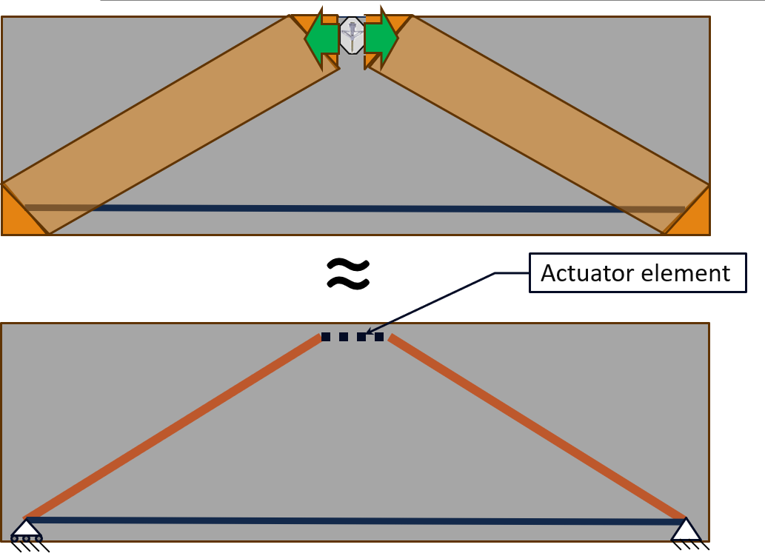

Figure 3: Comparison of a strut-and-tie concrete model with compression struts (orange) and tension ties (blue) due to applied load [top]. The dynamic relaxation formulation has axial elements in the same color scheme with an additional actuator element (black dashed) to simulate the expanding anchor or jack [bottom].

**RESULTS**: The maximum compressive utilization ratio of the concrete remains under 20% throughout the actuation process. This analysis provides the system- level camber behavior from the expanding anchors adding compression to the compression zone of the experimental girder. Load is applied to the girder via a sensitivity analysis and scaled from code prescribed loads. The outcome of this task is to determine the required force from the system of expanding anchors to yield a zero-deflection girder when subjected to the sweep of possible loads on the specimen.

This novel use of form-finding as a computational technique for the strut-and-tie model has not yet been studied prior to our research team. Since in the simplest form of the model shown in Figure XX, the compressive and tensile elements are axial members only without flexure, the model was then extended to have multiple elements along its length to simulate the deflection caused by self-weight and the actuation for camber.

Task 2.1: 75% complete

The stress distribution within the section was analyzed using fundamental principles of reinforced concrete design. Through the dimensions shown in Figure 4, the maximum compressive force that could be exerted from the lab jack is 22

lbs given the surface area and location above the neutral axis of the concrete specimen.

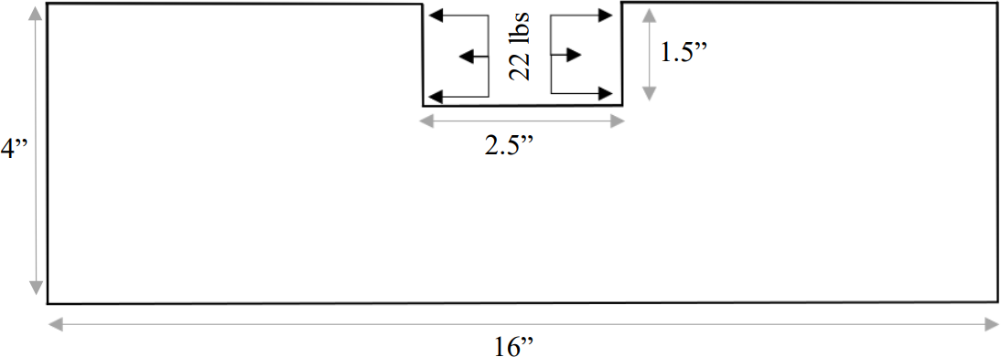

Figure 4: Elevation view of the concrete specimen with the maximum compressive force available from the lab jack to be applied in the compression zone for adaptive camber.

**RESULTS**: Through the analysis, the deflection due to self weight of the specimen ignoring creep, is 0.00003 in. Given the maximum compressive force from the lab jack, the possible camber available is 0.000075 in upwards. This would not only negate the deflection due to self-weight but would also provide possible camber for dead load and superimposed dead loads that would occur on precast highway bridges such as bridge decks, lighting, signage, and pedestrian guardrails

Task 2.2: 80% complete

Prior to installation of the anchors in the specimens, the expanding wall anchors had to be tested for their capability to provide lateral forces when they are activated. These wall anchors are specified for their pull-out strength perpendicular to the surface they are anchored, but not the lateral pressure. Therefore, a masters semester project in Fall 2023 was conducted to study the split-sleeve and winged anchor lateral force capacity.

Concrete specimens of a 16 in span, and a 3 in by 4 in section were cast in the concrete lab at the University of Illinois under the supervision of Prof. Henschen. The specimens were cast of normal weight concrete, targeting a 4 ksi strength (Table 1). Polypropolene fiber reinforcement (<0.05% by volume) was used to prevent brittle failure in laboratory testing but would not affect the compressive or tensile behavior. Two #2 steel reinforcement bars were placed at the bottom of the specimen for tensile resistance of the section.

Table 1: Concrete constituents

|  |  |  |
| --- | --- | --- |
|  | **Units** | **Quantity** |
| Cement | lb/ft3 | 21.4 |
| Coarse Aggregate | lb/ft3 | 69.8 |
| Fine Aggregate | lb/ft3 | 46.7 |
| Water | lb/ft3 | 12.7 |
| Superplasticizer | fl oz/cwt | 3.0 |
| Fibers | lb/ft3 | 2.0 |
| Slump | in | 5.5 |
| Air content | % | 1.5 |

**RESULTS**: Out of the tested anchors (hollow-wall and sleeve anchors), the hollow- wall anchors are the only anchor which produced measurable forces on the food scale. The sleeve anchors did not produce results using this test method and must be tested in another manner. The hollow-wall anchors produced 12 force readings. A scatter plot of Force vs Test Number is shown in Figure 5.

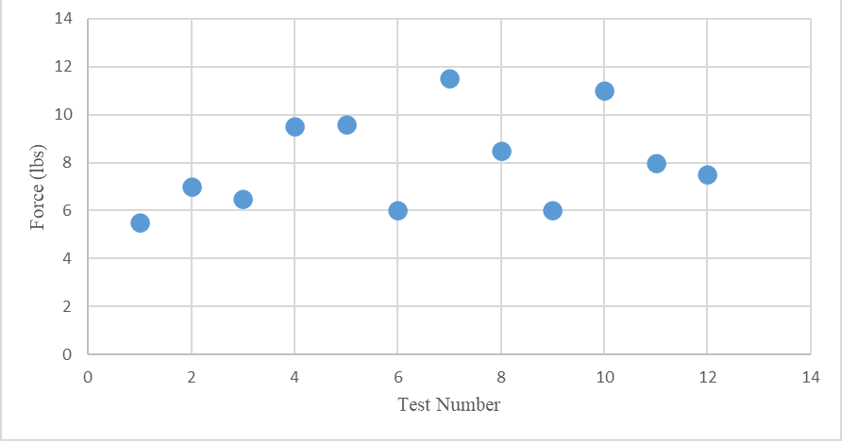

Figure 5: Lateral Force Capacity for the Hollow-Wall Anchors

Through twelve tests, force values ranged from 5.5-11.5 pounds producing a range of 6 pounds. The average of tests was 8.05 pounds with a standard deviation of 2 pounds. Testing the anchors using the wood produced results for the hollow wall anchor, but not for the sleeve anchor. The sleeve anchor was expanded fully and remained flush within the test frame but did not produce force on the scale. Sleeve anchors do not deploy in large deformations or high rates, which may have allowed the top plate to slip upward under the gradual application of force.

Concrete specimens were cast as shown in Figure 6 [left] and instrumented with strain gauges [right].

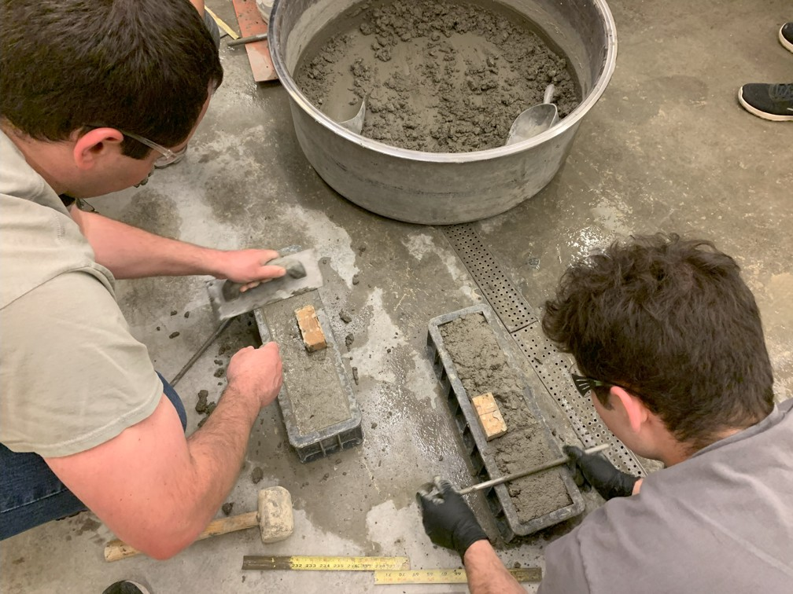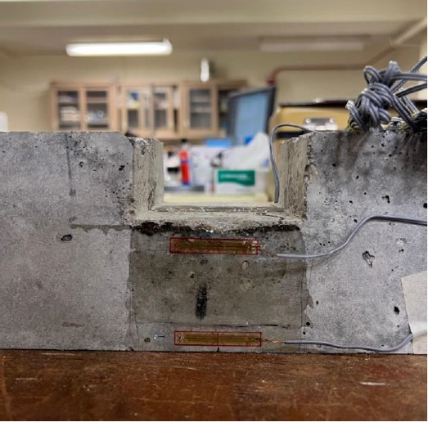

Figure 6: Casting of concrete specimens [left] and instrumentation [right].

Figure 7 shows the concrete specimens when the installation of the lab jack in the compression zone expanding longitudinally along the beam. Strain gauge data collected from these actuation tests are provided in Table 2.

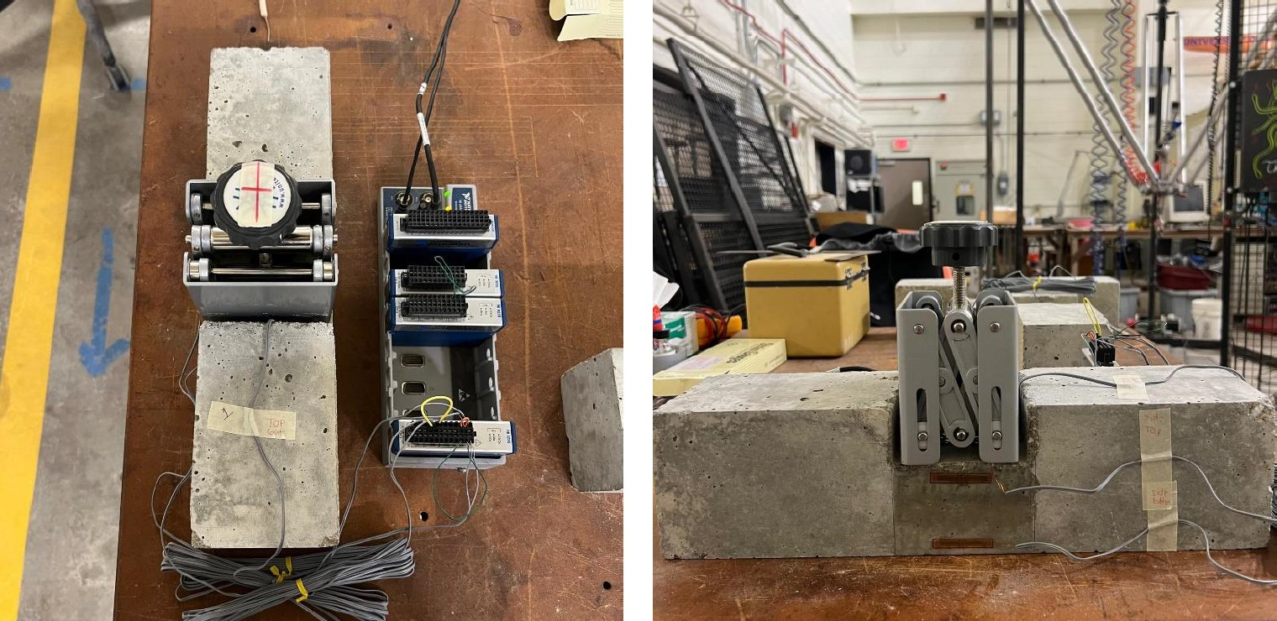

Figure 7: Experimental setup with the lab jack as the actuator.

Table 2: Strain gauge data from actuation of concrete specimens with lab jack.

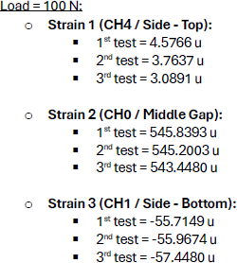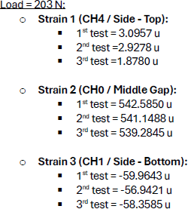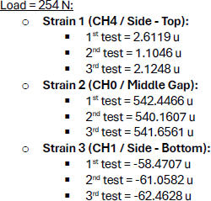

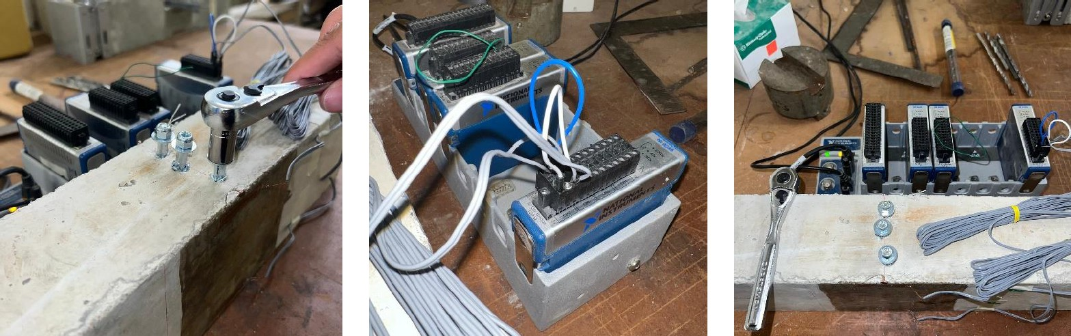The experimental setup of the actuation with deployable anchors in the concrete specimen is shown in Figure 8. Strain gauge results from the actuation of the deployable anchors is shown in Table 3.

Figure 8: Deployable anchors being installed into the concrete specimen [left]. Data acquisition system for the test setup collects strain of the concrete [center] and top view of the anchor installation with at least 1 in separation between the anchors at the midspan region of interest [right].

Table 3: Strain gauge data from actuation of concrete specimens with anchors

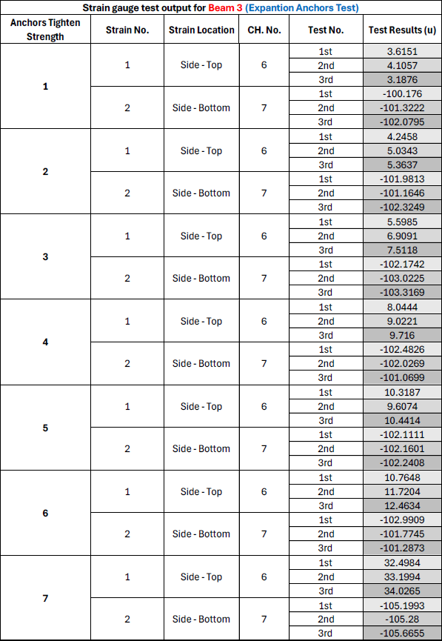

1. Percent of research project completed

*75%*

1. Expected progress for next quarter
2. Compare experimental results with computational results
3. Disseminate data in Transportation Research Board Annual Meeting conference paper.
4. Educational outreach and workforce development

Through this research initiative, three undergraduate student semester projects were supported in Spring 2024 (Figure 9) sand one masters student semester project in Summer 2024. The undergraduate students worked in a team to cast the concrete specimens for testing as well as calculating, using fundamentals of reinforced concrete design, to calculate the theoretical forces needed for camber in the concrete section to achieve 0.5 in of camber. The masters semester project is laboratory-based for installing strain gauges and measuring the deformation of the concrete specimen with actuation.

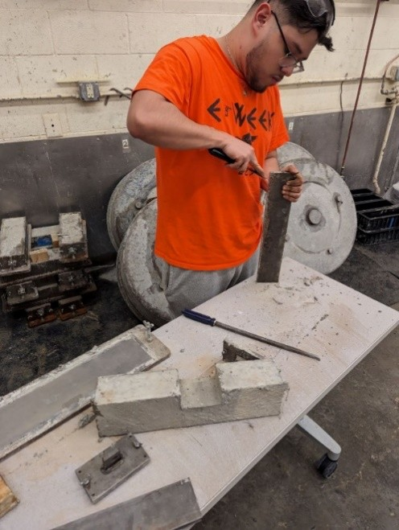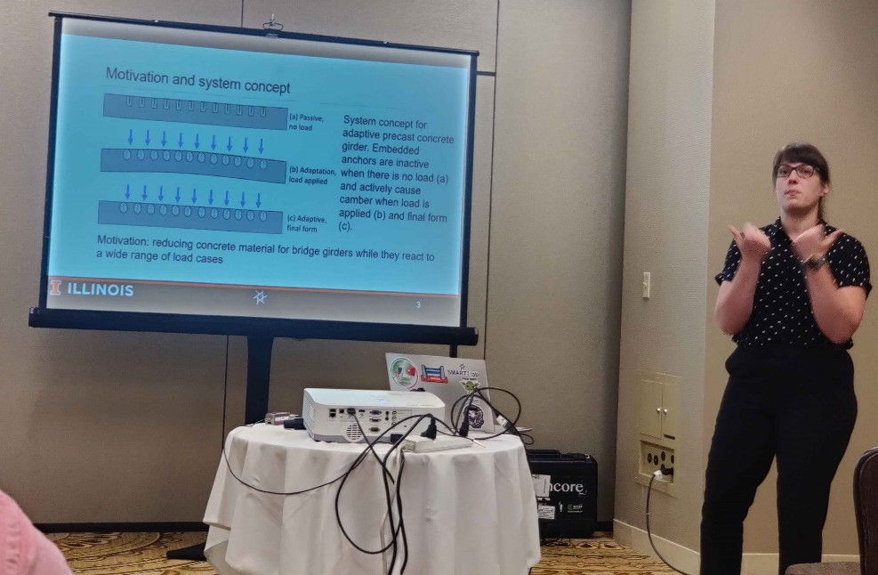

Figure 9: [left] Undergraduate semester project casting concrete specimens and [right] PI Sychterz presenting the preliminary findings at the ASCE Engineering Mechanics Institute Conference in Chicago, May 29, 2024.

1. Technology Transfer

No new patents or technology have been developed in this quarter. As this is a brand new concept in the United States, patents will be the subject of future funded projects with this project being the test bed.

## Research Contribution:

1. Number of papers

Alotaibi, A., Naranjo, M., Henschen, J., and Sychterz A.C. ADAPTIVE CAMBER OF A CONCRETE GIRDER FOR DEFLECTION MITIGATION, Transportation

Research Board Annual Meeting 2025, Washington DC (In preparation).

1. Number presentations (when, where)

Sychterz, A.C. Engineering Mechanics Institute 2024, May 29 2024, Chicago, IL, MS0102 Geometries and Design.

Sychterz, A.C. Adaptive Lightweight Infrastructure (part of seminar talk), June 15 2024, Stuttgart, Germany, University of Stuttgart.

1. Please list any other events or activities that highlights the work of TRANS-IPIC occurring at your university (please include any pictures or figures you may have). Similarly, please list any references to TRANS-IPIC in the news or interviews from your research.

The leader of TRANS-IPIC, Prof. Bassem Andrawes, is a professor at the University of Illinois Urbana-Champaign Department of Civil and Environmental Engineering within the structures group, in the same group at PI Sychterz. While this research team is confident that excellent research work is currently being conducted by his project team, this research team so no photos, interviews, or news links to share at this time.

## References:

Akgün, Y., Gantes, C. J., Sobek, W., Korkmaz, K., & Kalochairetis, K. (2011). A novel adaptive spatial scissor-hinge structural mechanism for convertible roofs.

*Engineering Structures*, *33*(4), 1365–1376. https://doi.org/10.1016/j.engstruct.2011.01.014

Pellegrino, S. (2001). *Deployable Structures*. Springer-Verlag.

Reksowardojo, A. P., Senatore, G., & Smith, I. F. C. (2020). Design of Structures That Adapt to Loads through Large Shape Changes. *Journal of Structural Engineering*,

*146*(5). https://doi.org/10.1061/(asce)st.1943-541x.0002604

Yin, L., & Ananthasuresh, G. K. (2003). Design of distributed compliant mechanisms.

*Mechanics Based Design of Structures and Machines*, *31*(2), 151–179. https://doi.org/10.1081/SME-120020289.

Precast, Prestressed Bridge Girders.” (August).

Brown, K. M. (1998). “Camber growth prediction in precast prestressed concrete bridge girders.” (December).

French, C. E., and O’Neill, C. R. (2012). “Validation of Prestressed Concrete I-Beam De

ection and Camber Estimates.” (June), 205.

Honarvar, E., Nervig, J., and Rouse, J. M. (2015). *Improving the accuracy of camber predictions for precast pretensioned concrete beams. DOT National Transportation Integrated Search - ROSA P*.

Precast/Prestressed Concrete Institute. (2018). *Guidelines for Camber and Profile Management in Adjacent Beams*.

Stallings, J. M., Barnes, R. W., and Eskildsen, S. (2003). “Camber and Prestress Losses in Alabama HPC Bridge Girders.” *PCI Journal*, 48(5), 90–104.

(2017). *PCI Design Handbook, 8th Edition*. *PCI Design Handbook, 8th Edition*.

Kelleter, C., Burghardt, T., Binz, H., Blandini, L., & Sobek, W. (2020). Adaptive Concrete Beams Equipped With Integrated Fluidic Actuators. *Frontiers in Built Environment*, *6*(July), 1–13. https://doi.org/10.3389/fbuil.2020.00091

Steffen, S., Nitzlader, M., Burghardt, T., Binz, H., Blandini, L., & Sobek, W. (2021). An actuator concept for adaptive concrete columns. *Actuators*, *10*(10). https://doi.org/10.3390/act10100273