**Transportation Infrastructure Precast Innovation Center**

**(TRANS-IPIC)**

**University Transportation Center (UTC)**

Developing a cost-effective, reliable and sustainable PC supply system under price volatility and uncertain materials supply – Phase II (2024-2025)

[Y1: LS-23-RP-04/Y2: LS-24-RP-01]

LSU Proposal ID: AWD-005947, GR-00016909

**Quarterly Progress Report: QPR Y2-2**

**Performance period:** *April 1- June 30, 2025*

**Submitted by:**

Bhaba R. Sarker (PI)

Professor, Department of Mechanical and Industrial Engineering

Louisiana State University, Baton Rouge, LA 70803

[**bsarker@lsu.edu**](mailto:bsarker@lsu.edu)

**Collaborators / Partners:**

*Advisor:* Dr. Tyson Rupnow, Associate Director, Louisiana Transportation Research Center (LTRC).

*Participating Co.:* Rinker, Gainey’s, Premier Concrete Products (PCP), & WASKEYfor collaboration and validation of research works.

*Graduate Assistant:* Anik Mazumder

**Submitted to:**

TRANS-IPIC UTC

University of Illinois Urbana-Champaign

Urbana, IL

**TRANS-IPIC Quarterly Progress Report (Y2-1)**

1. **PROJECT DESCRIPTION**

The role of precast concrete (PC) supply logistics under variable demand and probabilistic delivery times is explored here to enhance reliability, sustainability, and cost-effectiveness. In this section, we highlight the problem statement and the project’s tasks to be completed.

1. **Research Plan - Statement of Problem**

Reliability and sustainability of transportation infrastructure depend significantly on the optimal scheduling and routing of precast concrete (PC) resources, particularly in delivery operations (as experienced by companies like Gainey’s, WASKEY, and Premier Concrete Products in Louisiana). Efficient transportation ensures timely delivery of PC products, reducing project delays and preventing costly material degradation. Thus, this *USDOT Trans-IPIC* project focuses on developing cost-effective strategies to enhance reliability and sustainability in PC distribution systems under variable demand and probabilistic delivery times. The *primary goal* of this research is to provide a scalable solution that not only reduces the logistic costs associated with PC supply but also enhances the reliability and sustainability in facing variable demands and delivery times in constructions of transportation infrastructures and its logistical challenges.

1. **Research Plan - Summary of Project Activities (Tasks)**

As outlined in the proposed research plan for Year 1, the model addressing *uncertainty and price volatility* (UPV) in the PC supply network is in progress. In addition to that, probabilistic travel time and stochastic demand, which are quite common phenomena in transportation construction, are to be considered for achieving the current objective of Year 2 (2025) research undertaken and these include:

1. Task 1: *ANM (Activity Network Model):* It will highlight a proper representation of predecessors and successors related to PC production activities incorporating probabilistic travel time and stochastic demand with price fluctuation, to determine production and delivery times.
2. Task 2: *IOTC (In-plant and Off-plant Transportation Cost):* The IOTC model will optimize storage location/assignment to enhance utilization and maximize transportation costs for precast components from plants to construction sites.
3. Task 3: *DSC (Delivery System Cost):*The model will bring forth a shed on the general behavior of PC delivery schedules, minimize penalty costs, address material uncertainty and price volatility, ensuring reliable and sustainable PC supply systems.
4. **PROJECT PROGRESS**

In this section, the progress in completing the current research tasks is highlighted followed by future work, educational outreach, workforce development and technology transfer.

1. **Progress for each research task**

The total task of Year 2 is partitioned into three major segments: ANM, IOTC and DSC with an intended quarterly schedule for each of them, followed by a final report for the last quarter.

***3.1 Task 1 (QPR Y2-2): Activity Network Modeling***

Efficient logistics and delivery systems for PC components are critical for successful road and highway construction projects, significantly influencing overall project reliability, sustainability, and cost-efficiency. A proper process flow mapping approach is required to represent a systematic framework for analyzing logistical processes, spanning from procurement planning to the final delivery at construction sites.

Figure 1. Activity flow for PC shipments to construction sites

Figure 1 illustrates three critical stages such as optimal procuring, optimal yard layout, and delivery to construction sites that must be carefully optimized to ensure the durability and long-term performance of precast transportation infrastructure, including roads and highways. Efficient raw material purchasing, reliable supplier selection, and strategic inventory management directly influence the consistency, strength, and durability of precast concrete components by ensuring timely access to high-grade inputs and minimizing production disruptions. A well-planned yard layout ensures proper curing process, safe storage, and minimal handling damage, which directly affect structural integrity. Timely and secure transportation, accurate placement at construction sites, and continuous feedback loops are essential to avoid misalignment, physical damage, or scheduling disruptions. Any inefficiency or delay in raw material procurement, supplier coordination, or inventory management can result in the use of substandard or poorly timed materials, disrupting the curing process or mix quality. This, in turn, increases the risk of premature deterioration, cracking, or inadequate load transfer in the final precast concrete infrastructure. Therefore, optimizing these processes related to Figure 1 ensures consistent input quality and uninterrupted production, thereby reducing risks such as poor curing or material inconsistencies and ultimately improving the structural integrity, durability, and long-term performance of precast-based road and highway systems while minimizing construction delays.

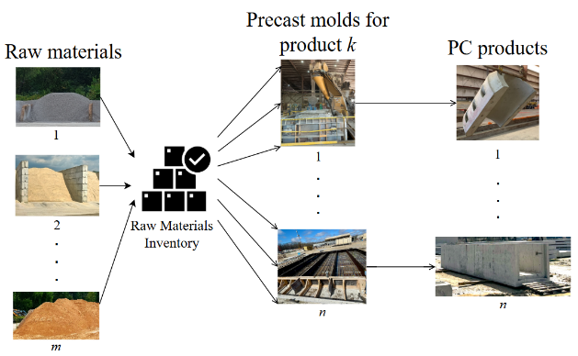

(a)

(b)

Figure 2. Optimal procuring in a typical PC manufacturing facility.

In reality, demands of different construction materials are not stable due to government policy changes and planning, materials markets and other lateral influencing factors such as technological changes, materials and changes in their proximities, and environmental conditions. So, to optimize procurement planning for a PC manufacturing facility (Figure 2a), we have developed a cost-minimization framework for multi-period inventory systems, accounting for linearly increasing or decreasing product demand and variable raw material costs. By analytically proving the convexity of the total cost function and applying iterative algorithms for varying demand phases (inception, stability, and declining), the study determines optimal cycle lengths and associated ordering quantities for multiple raw materials. A comprehensive industrial case illustrates how the proposed model outperforms traditional periodic review systems by reducing procurement costs in each ordering cycle throughout a certain planning phase and enhancing inventory reliability (Figure 2b).

This research has significant managerial implications for precast concrete manufacturers. By integrating variable demand and uncertain price fluctuations into a robust cost optimization model, managers are equipped with a powerful decision-support tool to precisely determine optimal ordering quantities.

***3.2 Task 2 (QPR Y2-2): IOTC (In-plant and Off-plant Transportation Cost)***

Improving yard layout and crane operations (as experienced in Premier Concrete and Waskey), is critically important for the durability of precast concrete products because it directly impacts how these heavy and sensitive components are handled, stored, and transported within the manufacturing facility. Precast elements are vulnerable to microcracking, edge damage, and surface defects if PC pieces are moved or stored improperly, especially during curing and post-curing phases when structural strength is still developing. An inefficient yard layout can lead to excessive/hazardous crane travel, congestion, and repeated handling, which increases the risk of physical damage, misplacement, and exposure to environmental stressors (e.g., uneven sunlight, moisture).

Through our hands-on engagement with Premier Concrete Products (PCP) and Waskey, we successfully applied data-driven methodologies to redesign and optimize their precast yard operations, directly enhancing efficiency and product durability. At PCP, we conducted detailed time-motion studies, inventory assessments, and truck flow analysis, which led to the implementation of a one-way truck routing system, designated storage zones, and a FIFO inventory framework (Figure 3a). These changes significantly reduced traffic congestion and improved product accessibility. At Waskey, we analyzed crane movement patterns using GPS data (Samsara) and production schedules and developed simulation-based yard layout alternatives through BlueBeam modeling (Figure 3b). Our final proposal introduced linear crane pathways, sector-based crane assignments, and strategic staging zones, which collectively decreased crane idle time and minimized material handling risks. These contributions not only addressed site-specific operational inefficiencies but also reinforced the structural integrity and long-term reliability of precast concrete components demonstrating the tangible impact of our engineering decisions on real-world infrastructure operations.

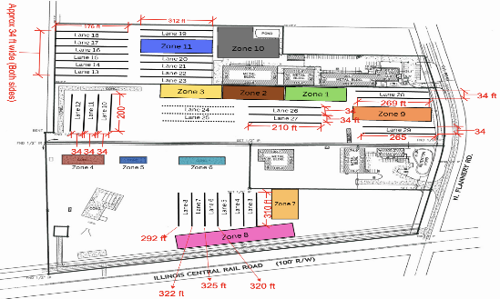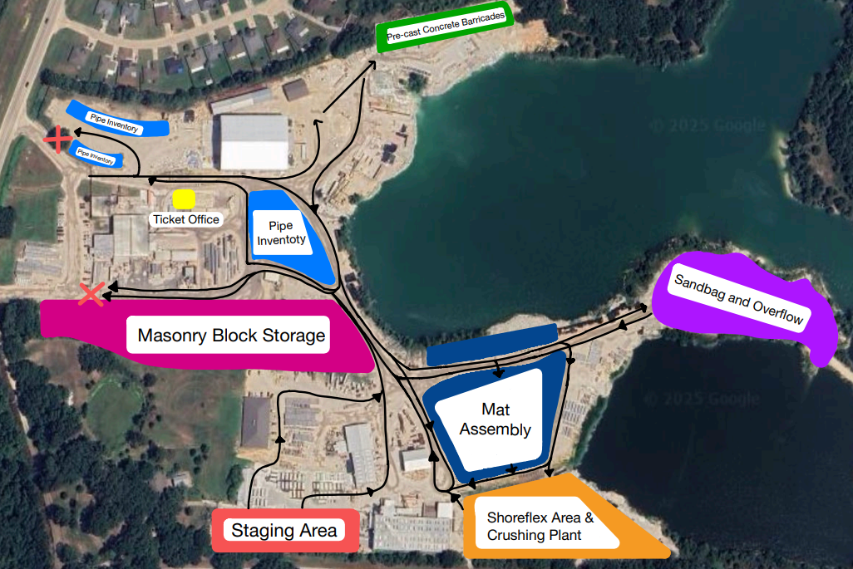

(a)

(b)

Figure 3. One way truck path at PCP

By addressing site-specific issues at PCP and Waskey, we achieved measurable improvements: truck path deviation time at PCP was reduced by 18%, while Waskey saw a 15% decrease in crane travel time, 10% less stoppage, and up to 30% better material handling efficiency. These changes enhanced workflow, reduced risks, and protected the structural integrity of precast components.

***3.3 Task 2 (QPR Y2-2): DSC (Delivery System Cost)***

Finished precast concrete products must be delivered to various construction sites with differing quantity, type, and timing requirements. This overall process (Figure 4) involves selecting the right inventory and optimizing delivery routes. The overall supply chain from raw material procurement to final delivery faces logistical challenges such as minimizing transportation costs, meeting deadlines, and maintaining product quality.

Figure 4. Shipment activities from precast plants to construction sites

The overall goal is to minimize delivery costs, ensure timely fulfillment, and improve resource utilization while accounting for uncertainty in demand and logistics. The research objective illustrated Figure 5 is to develop and optimize a Precast Concrete Delivery (PCD) model that supports strategic and operational decision-making under uncertainty.

**First‑Stage Decisions:**

* Number of vehicles for each mode
* Number of allocated resources

Scenario dependent parameters

Attributes for mode of transportation (18-wheelers, semi-trailers, cement trucks, etc.)

Scheduling and resource parameters

**Second‑Stage Decisions:**

* Amount of PC delivered.
* Unmet demand
* Start time for shipment.
* Completion time for shipment

PCD model

Figure 5. Model PCD

This model PCD was run by some collected data (Ref. [45]-[53]) to check its validity and Table 1 summarizes key logistics parameters for two transportation modes, including their payload capacities, per‐unit and fixed costs, and scenario‐based travel times. It also specifies project delay penalties, and the range of batch demands that the model must satisfy.

Table 1. Data table

|  |  |  |
| --- | --- | --- |
| **Parameter** | **Value** | **Unit** |
| Vehicle capacity (Semi trailer) | 22 | tons |
| Vehicle capacity (18-wheeler) | 25 | tons |
| Transport cost (Semi trailer) | 10 | $/ton |
| Transport cost (18-wheeler) | 15 | $/ton |
| Travel time (Semi trailer, Scenarios 1 / 2) | 4 / 5 | hours |
| Travel time (18-wheeler, Scenarios 1 / 2) | 6 / 7 | hours |
| Fixed cost per vehicle (Semi trailer / 18-wheeler) | 1,200 / 1,800 | USD |
| Delay penalty (Project 1 / 2) | 150 / 200 | $/hour |
| Batch demand range | 55 – 65 | tons |

The solver decided to contract four vehicles of semi-trailers and two of 18-wheelers, and to allocate all three available cranes, striking a balance between capacity and fixed-cost budgets. In Scenario 1, one semi-trailer carries 63 tons of Project 1’s second component and 54 tons of Project 2’s second component, while one 18-wheeler supplies smaller amounts (35 tons and 2 tons) of Project 2’s first and second components; in Scenario 2, semi-trailer is able to ship 59 tons of Project 1’s first component and 18-wheeler ships 63 tons of its second component, with no deliveries to Project 2. Because demand far exceeded capacity under these choices, large unmet volumes appear 65 tons short on Project 1’s first component and 25 tons short on Project 2 in Scenario 1, and total shortfalls of 130 tons on Project 2 in Scenario 2. All shipments start at their earliest allowable times (0 h for Site 1, 1 h for Site 2) and finish before deadlines, yielding positive “slack” but no tardiness. The resulting objective (~$1.11 million) is dominated by heavy penalties for unmet demand, indicating the need for more capacity or vehicles to avoid those costly shortfalls.

1. **Percent of research project completed.**

As the research project for this year has been divided into three parts, the percentage of the research project completed is approximately (95%×33.33%) + (60%×33.33%) + (70%×33.33%) ~ 75%. The computational parts of Stage 2 and 3 are in progress, and they will be included in the working paper to be submitted to a refereed journal.

1. **Expected progress for next quarter.**

Over the next quarter, we plan to integrate real project data into the model and run pilot tests to assess its performance under practical conditions. We will refine the solution approach to handle any new constraints that arise from these tests, aiming to enhance the model’s robustness and efficiency.

1. **Educational outreach and workforce development**

A total of 12 undergraduate (UG) students has been assigned to the following research projects in their respective industries as part of their capstone course requirement for *IE-4598: Senior Design Project II* (Spring 2025). Tracking and storing Besser Machines parts for precast concrete manufacturing (project PCP-1).

* Optimizing the yard layout to improve truck flow in transporting precast materials (project PCP-3).
* Improving yard layout for efficient handling and tracking of PC products (Waskey).
* Design of dunnage and rigging methods for oversized precast concrete: ensuring stability and minimizing damage (Gainey’s).

1. **Technology Transfer**

The research team is in contact with several companies [Precast Concrete Products (PCP), Waskey, Gainey’s and Rinker] through LTRC. Efforts have been made to collaborate and collect some real-life data for testing purposes and feedback on the project. Some of this data is expected to be incorporated in subsequent reports. The outcome is yet to be achieved for technology transfer.

1. **RESEARCH CONTRIBUTION**
2. **Papers that include TRANS-IPIC UTC in the acknowledgments section:**
   * + 1. Mazumder, A. and Sarker, B.R., “Determining optimal variable order quantities of raw materials for precast concrete production considering demand variability and uncertain material prices," Paper-1 (LS-23-RP-04), Submitted to *Journal of the Operations Research Society*. 1st submission: April 09, 2025 (*TJOR-252233581*)
       2. Mazumder, A. and Sarker, B. R. (2025b), “An Optimal Delivery System of Multiple Precast Components for Multiple Construction Sites of Transportation Infrastructure,” *Working Pape*r-2 (LS-24-RP-01), QPR Y2-1 (January 1 - March 31, 2025). Intended for *ASCE: Journal of Transportation Engineering.*
3. **Presentations and Posters of TRANS-IPIC funded research:**
   * + 1. Mazumder, A. and Sarker, B. R. (2024), “Factors of the Precast Concrete Supply Chain: An Interpretive Structural Modeling Approach,” Graduate Research Conference (GRC), presented at the Students’ Union, Louisiana State University, Baton Rouge, LA on April 30, 2024.
       2. Mazumder, A. and Sarker, B. R. (2025a), “Optimizing Raw Material Ordering Policies for Efficient Precast Concrete Production under Fluctuating Demand and Price,” Abstract ID 6670, IISE Annual Conference & Expo 2025, Renaissance Atlanta Waverly Hotel & Convention Center (Room: Tyndall), Atlanta, Georgia, May 31- June 3, 2025.
       3. Mazumder, A. and Sarker, B. R. (2025b), “Optimal Component Allocation on Pallet to Minimize Curing Costs in Precast Manufacturing,” Abstract ID 8864, 2025 INFORMS Annual Meeting, Renaissance Atlanta Waverly Hotel & Convention Center (Room: Andover), Atlanta, Georgia, May 31- June 3, 2025.
       4. Mazumder, A. and Sarker, B. R. (2025c), “Optimizing Pallet Utilization to Reduce Curing Costs in Precast Concrete Manufacturing,” Abstract ID 7037, 2025 INFORMS Annual Meeting, Georgia World Congress Center and Omni Atlanta Hotel at Centennial Park, Atlanta, Georgia, October 26- 29, 2025.

Interim Report presentations at LSU (PFT-1206) on March 21, 2025, by the undergraduate students who are working in the precast manufacturing industries:

* PCP-1: *Tracking and storing Besser Machines parts for precast concrete manufacturing* (3 students).
* PCP-3: *Optimizing the yard layout to improve truck flow in transporting precast materials* (3 students).
* Waskey: *Improving yard layout for efficient handling and tracking of precast concrete products* (3 students).
* Gainey’s: *Design of dunnage and rigging methods for oversized precast concrete: ensuring stability and minimizing damage* (3 students).

1. **Please list any other events or activities that highlights the work of TRANS-IPIC occurring at your university (please include any pictures or figures you may have). Similarly, please list any references to TRANS-IPIC in the news or interviews from your research.** 
   * + 1. Images from interim report presentation slides on March 21, 2025, by the undergraduate students who are working in the precast manufacturing industries.

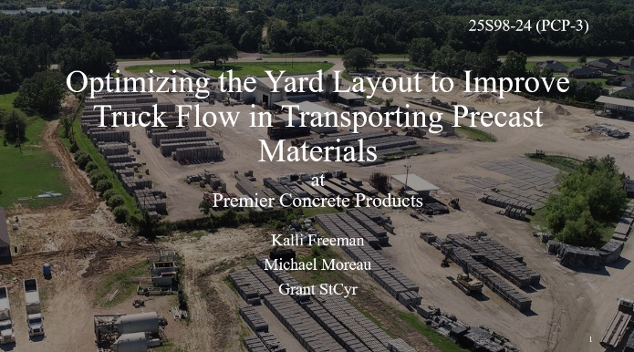

* + - 1. 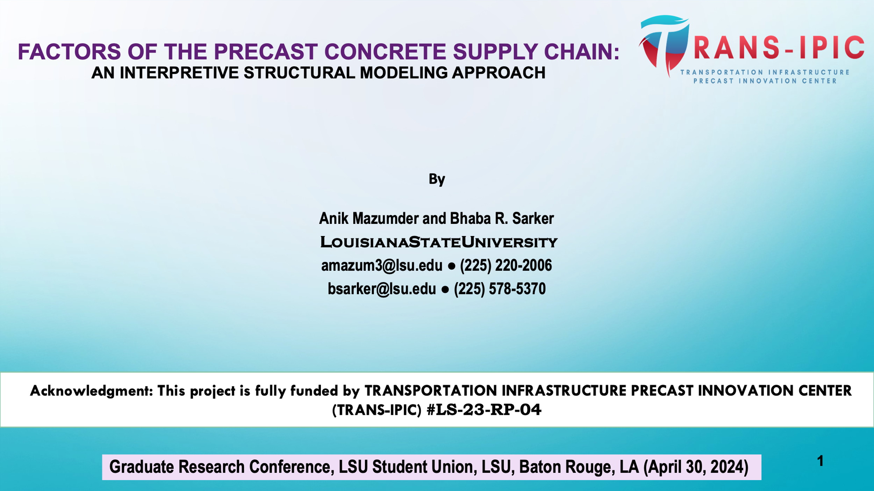Mazumder, A. and Sarker, B. R., “Factors of the Precast Concrete Supply Chain: An Interpretive Structural Modeling Approach,” Graduate Research Conference (GRC), presented at the Students’ Union, Louisiana State University, Baton Rouge, LA on April 30, 2024.
      2. Mazumder, A. and Sarker, B. R., “Optimizing Pallet Capacity Utilization to Minimize Curing Cost in Precast Concrete Manufacturing,” presented at the *DOT TRANS-IPIC* online research online seminar on July 22, 2024.



* + - 1. Plant tour and meeting to discuss potential challenges in precast concrete logistics for the TRANS-IPIC project proposal for Year 2, held at Rinker Materials in Alexandria, LA, on September 23, 2024.



* + - 1. Presentations cover slides at IISE Annual Conference & Expo 2025.



**Appendix 1**

Research Activities, leadership, and awards (cumulative, since the start of the project)

1. Number of presentations at academic and industry conferences and workshops of UTC findings

* No. = 3

1. Number of peer-reviewed publications submitted based on outcomes of UTC funded projects.

* No. = 1 (JORS)

1. Number of peer-reviewed journal articles published by faculty.

* No. = 0

1. Number of peer-reviewed conference papers published by faculty.

* No. = 0

1. Number of TRANS-IPIC sponsored thesis or dissertations at the MS and PhD levels.

* No. MS thesis = 1 (on-going)
* No. PhD dissertations = 1 (on-going)
* No. citations of each of the above = 0

1. Number of research tools (lab equipment, models, software, test processes, etc.) developed as part of TRANS-IPIC sponsored research.

* Research Tool #1 (Name, description, and link to tool) = 0
* Research Tool #2 (Name, description, and link to tool) = 0
* Research Tool #3 (Name, description, and link to tool) = 0

1. Number of transportation-related professional and service organization committees that TRANS-IPIC faculty researchers participate in or lead.

* Professional societies
  + No. participated in = 4 (DSI, IISE, INFORMS, POMS)
  + No. lead = 0
* Advisory committees (No. participated in and No. led)
  + No. participated in = 1 (IISE Fellow)
  + No. lead = 0
* Conference Organizing Committees (No. participated in and No. led)
  + No. participated in = 0
  + No. lead = 0
* Editorial board of journals (No. participated in and No. led)
  + No. participated in = 2
  + No. lead = 0
* TRB committees (No. participated in and No. led)
  + No. participated in = 0
  + No. lead = 0

1. Number of relevant awards received during the grant year.

* No. awards received = 0

1. Number of transportation related classes developed or modified as a result of TRANS-IPIC funding.

* No. Undergraduate = 0
* No. Graduate = 0

1. Number of internships and full-time positions secured in the industry and government during the grant year.

* No. of internships = 0
* No. of full-time positions = 0

**REFERENCES**

1. Allison, J. (1990). Combining Petrov's heuristic and the CDS heuristic in group scheduling problems. *Computers and Industrial Engineering,* **19**(1), 212–215.
2. Anvari, B., Angeloudis, P., and Ochieng, W. (2016). A multi-objective GA-based optimisation for holistic manufacturing, transportation, and assembly of precast construction. *Automation in Construction,* **71**, 226–241.
3. Benjaoran, V., Dawood, N., and Hobbs, B. (2005). Flowshop scheduling model for bespoke precast concrete production planning. *Construction Management and Economics,* **23**(2), 93–105.
4. Chan, W., and Hu, H. (2000). Precast production scheduling with genetic algorithms. *Proceedings of the 2000 Congress on Evolutionary Computation,* **2**, 1087–1094.
5. Chan, W., and Hu, H. (2001). GA-based resource-constrained flow-shop scheduling model for mixed precast production. *Automation in Construction,* **11**(4), 439–452.
6. Chan, W., and Hu, H. (2002). Production scheduling for precast plants using a flow shop sequencing model. *Journal of Computing in Civil Engineering,* **16**(3), 165–174.
7. Chen, J.-H., Hsu, S., Chen, C.-L., Tai, H.-W., and Wu, T.-H. (2020). Exploring the association rules of work activities for producing precast components. *Automation in Construction,* **111**, 103059.
8. Chen, J.-H., Yan, S., Tai, H.-W., and Chang, C. (2017). Optimizing profit and logistics for precast concrete production. *Canadian Journal of Civil Engineering,* **44**(5), 393–406.
9. Chen, J.-H., Yang, L.-R., and Tai, H.-W. (2016). Process reengineering and improvement for building precast production. *Automation in Construction,* **68**, 249–258.
10. Dan, Y., Liu, G., and Fu, Y. (2021). Optimized flowshop scheduling for precast production considering process connection and blocking. *Automation in Construction,* **125**, 103575.
11. Hu, H. (2007). A study of resource planning for precast production. *Architectural Science Review,* **50**(2), 106–114.
12. Jiang, W., and Wu, L. (2021). Flow shop optimization of hybrid make-to-order and make-to-stock in precast concrete component production. *Journal of Cleaner Production,* **297**, 126708.
13. Khalili, A., and Chua, D. (2014). Integrated prefabrication configuration and component grouping for resource optimization of precast production. *Journal of Construction Engineering and Management,* **140**(8), 04013052.
14. Kim, T., Kim, Y.-W., and Cho, H. (2020). Dynamic production scheduling model under due date uncertainty in precast concrete construction. *Journal of Cleaner Production,* **257**, 120527.
15. Ko, C., and Wang, S.-F. (2010). GA-based decision support systems for precast production planning. *Automation in Construction,* **19**(7), 907–916.
16. Ko, C., and Wang, S.-F. (2011). Precast production scheduling using multi-objective genetic algorithms. *Expert Systems with Applications,* **38**(7), 8293–8302.
17. Kong, L., Li, H., Luo, H., Ding, L., and Skitmore, M. (2017). Optimal single-machine batch scheduling for the manufacture, transportation, and JIT assembly of precast construction with changeover costs within due dates. *Automation in Construction,* **81**, 34–43.
18. Kong, L., Li, H., Luo, H., Ding, L., and Zhang, X. (2018). Sustainable performance of just-in-time (JIT) management in time-dependent batch delivery scheduling of precast construction. *Journal of Cleaner Production,* **193**, 684–701.
19. Leu, S.-S., and Hwang, S.-T. (2001). A GA-based model for maximizing precast plant production under resource constraints. *Engineering Optimization,* **33**(6), 619–642.
20. Leu, S.-S., and Hwang, S.-T. (2002). GA-based resource-constrained flow-shop scheduling model for mixed precast production. *Automation in Construction,* **11**(4), 439–452.
21. Li, S. H. A., Tserng, H., Yin, S. Y. L., and Hsu, C.-W. (2010). A production modeling with genetic algorithms for a stationary pre-cast supply chain. *Expert Systems with Applications,* **37**(12), 8406–8416.
22. Li, Z., Shen, G., and Xue, X. (2014). Critical review of the research on the management of prefabricated construction. *Habitat International,* **43**, 240–249.
23. Liao, T. W, Egbelu, P. J., Sarker, B. R. and Leu, S. S. “Metaheuristics for project and construction management—A state-of-the-art review,” *Automation in Construction*, **20** (5): August 2011, pp. 491-505.
24. Liu, Y., Dong, J., and Shen, L. (2020). A conceptual development framework for prefabricated construction supply chain management: An integrated overview. *Sustainability,* **12**(5), 1878.
25. Liu, Z., Liu, Z., Liu, M., and Wang, J. (2021). Optimization of Flow Shop Scheduling in Precast Concrete Component Production via Mixed‐Integer Linear Programming. *Advances in Civil Engineering*, **2021**(1), 6637248.
26. Ma, Z., Yang, Z., Liu, S., and Wu, S. (2018). Optimized rescheduling of multiple production lines for flowshop production of reinforced precast concrete components. *Automation in Construction,* **95**, 86–97.
27. Nori, V. S., and Sarker, B. R. (1996). Cyclic scheduling for a multi-product, single-facility production system operating under a just-in-time delivery policy. *Journal of the Operational Research Society*, **47**(7), 930-935.
28. Parija, G. R., and Sarker, B. R. (1999). Operations planned in a supply chain system with fixed-interval deliveries of finished goods to multiple customers. *IIE transactions*, **31**(11), 1075-1082.
29. Prata, B., Pitombeira-Neto, A. R., and Sales, C. J. de M. (2015). An integer linear programming model for the multiperiod production planning of precast concrete beams. *Journal of Construction Engineering and Management,* **141**(9), 04015029.
30. Ruan, M., and Xu, F. (2022). Improved eight-process model of precast component production scheduling considering resource constraints. *Journal of Civil Engineering and Management,* **28**(3), 1–15.
31. Sarker, B. R., Egbelu, P. J., Liao, T. W. and Yu, J., “Planning and design models for construction Industry: A critical survey,” *Automation in Construction*, **22**(SI-1), March 2012, pp. 123-134.
32. Sarker, B. R., and Parija, G. R. (1994). An optimal batch size for a production system operating under a fixed-quantity, periodic delivery policy. *Journal of the Operational Research Society*, **45**(8), 891-900.
33. Sarker, B. R., and Parija, G. R. (1996). Optimal batch size and raw material ordering policy for a production system with a fixed-interval, lumpy demand delivery system. *European Journal of Operational Research*, **89**(3), 593-608.
34. Wang, D., Liu, G., Li, K., Wang, T., Shrestha, A., Martek, I., and Tao, X. (2018). Layout optimization model for the production planning of precast concrete building components. *Sustainability,* **10**(6), 1807.
35. Wang, Z., and Hu, H. (2017). Improved precast production-scheduling model considering the whole supply chain. *Journal of Computing in Civil Engineering,* **31**(6).
36. Wang, Z., Hu, H., and Gong, J. (2018). Framework for modeling operational uncertainty to optimize offsite production scheduling of precast components. *Automation in Construction,* **86**, 69–80.
37. Wang, Z., Hu, H., and Gong, J. (2018). Modeling worker competence to advance precast production scheduling optimization. *Journal of Construction Engineering and Management,* **144**(12), 04018109.
38. Wang, Z., Hu, H., and Gong, J. (2018). Simulation based on multiple disturbances evaluation in the precast supply chain for improved disturbance prevention. *Journal of Cleaner Production,* **177**, 232–244.
39. Wang, Z., Hu, H., and Gong, J. (2019). Precast supply chain management in off-site construction: A critical literature review. *Journal of Cleaner Production,* **232**, 1104–1116.
40. Wang, Z., Hu, H., Gong, J., and Ma, X. (2018). Synchronizing production scheduling with resources allocation for precast components in a multi-agent system environment. *Journal of Manufacturing Systems,* **49**, 109–120.
41. Wang, Z., Liu, Y., Hu, H., and Dai, L. (2021). Hybrid rescheduling optimization model under disruptions in precast production considering real-world environment. *Journal of Construction Engineering and Management,* **147**(5), 04021012.
42. Yang, Z., Ma, Z., and Wu, S. (2016). Optimized flow shop scheduling of multiple production lines for precast production. *Automation in Construction,* **72**, 321–329.
43. Yin, Y., Cheng, S.-R., and Wu, C.-C. (2014). Parallel-machine scheduling to minimize flowtime, holding, and batch delivery costs. *Asia-Pacific Journal of Operational Research,* **31**(6), 1450044.
44. Zhang, H., and Yu, L. (2020). Dynamic transportation planning for prefabricated component supply chain. *Engineering, Construction and Architectural Management,* **27**(10), 2553–2576.
45. ATS Inc. (2025). How much weight can I put on a flatbed trailer? <https://www.atsinc.com/blog/how-much-weight-can-flatbed-trailers-carry-kingpin-laws-explained>
46. Freedom Heavy Haul. (2025). Flatbed trailer weight limits. <https://freedomheavyhaul.com/flatbed-trailer-weight-limits/>
47. Sonar. (2025). How is freight priced? A dive into freight rates by mode of transit. <https://gosonar.com/freight-market-blog/how-is-freight-priced-a-dive-into-freight-cost-per-unit-of-measurement>
48. Method CRM. (2025). Freight rates: Trucking rates per mile 2024. <https://www.method.me/pricing-guides/trucking-rates-per-mile/>
49. Bureau of Transportation Statistics. (2025). Average truck speeds on select metropolitan area interstates. <https://www.bts.gov/browse-statistical-products-and-data/freight-facts-and-figures/average-truck-speeds-select>
50. Omni Calculator. (2025). Drive time calculator – travel time calculator. <https://www.omnicalculator.com/everyday-life/drive-time>
51. Federal Highway Administration. (2025). Estimating handbook, <https://highways.dot.gov/media/47116>
52. Alobees. (2025). Penalties for late construction site delivery explained. <https://www.alobees.com/en/conseils/penalties-late-construction>
53. Stahlton Prestressed Concrete. (2025). Panels*.* [*https://stahlton.co.nz/products/panels/*](https://stahlton.co.nz/products/panels/)