Transportation Infrastructure Precast Innovation Center (TRANS-IPIC)

University Transportation Center (UTC)

Innovative Precast Concrete Truss Using Adaptive Shape Memory Prestressing System

Project No.: UI-23-RP-02

1st Quarterly Progress Report
For the performance period ending December 31st, 2023

Submitted by:
PI: Bassem Andrawes, andrawes@illinois.edu Department of Civil and Environmental Engineering University of Illinois at Urbana-Champaign

Collaborators / Partners:
- Utility Concrete Products (UCP), LLC
- Illinois Department of Transportation (IDOT)

Submitted to:
TRANS-IPIC UTC
University of Illinois Urbana-Champaign Urbana, IL

TRANS-IPIC Quarterly Progress Report:

Project Description:
- Research Plan - Statement of Problem

The ever-growing demand for making our transportation infrastructure more sustainable requires serious efforts to reduce carbon emissions associated with the concrete and steel used in transportation infrastructure. One way to achieve sustainability is by optimizing the materials used in transportation infrastructure. This research helps address this issue by studying the application of an innovative Adaptive Prestressing System (APS) in a geometrically optimized (truss) PC system. The new APS includes a shape memory alloy fuse that applies localized prestressing in any direction without mechanical tensioning or special hardware, ideal for prestressing short diagonal or vertical members of a PC truss. The research includes experimental testing and numerical simulation of geometrically complex PC truss structures with APS placed in tension members that are difficult to prestress using conventional methods. The performance of the new APS-reinforced PC truss is compared with traditional PC bridge girders to prove the feasibility of the new concept.

Research Plan - Summary of Project Activities (Tasks)
This project aims to investigate the new technology of using APS to construct lightweight, sustainable, and durable (crack-free) PC truss systems for bridges. During this phase of the project (12 months), this research will attempt to address the following questions: 1) What is the optimum design (diameter and length) for the APS in PC truss that would help eliminate the cracking of concrete under realistic design loads. 2) What is the most efficient and practical method for installing and activating the APS's SMA fuse internally in PC truss members. The research plan for this project includes two primary tasks:

Task 1: Design of Specimens using Finite Element Method:
The first step of the research is to evaluate the behavior of the specimens through detailed finite element (FE) analysis using the software ABAQUS. This step aims to define the size and location of the APS strands and the level of the target prestressing force. A realistic prestress force that satisfies all AASHTO limit states will be adopted. Both concrete and strands (steel and SMA) will be modeled in 3D. The final decision on the design of the specimens will be made based on the results of the 3D FE analyses. Close attention will be given to the degree of cracking and/or stress concentration associated with various detailing configurations. The specimen's behavior with conventional (non-prestressed) steel reinforcement will be used as a baseline.

Task 2: Fabrication, Instrumentation, and Testing of Specimens:
Three specimens (one used as a control specimen with conventional steel and two specimens with SMA) will be fabricated. Before casting, prestressing strands in the bottom chord will be tensioned, and the APS will be placed in the vertical tension members. The SMA fuse used to activate the system will be in the form of pre-deformed no. 2 bars. The APS will be enclosed in a thermally/electrically insulating polymeric sleeve. To provide anchorage for the APS, the two HSS ends of the APS will be bent to form 90-degree hooks. After casting the concrete, the SMA fuse will be stressed using an electrical current. Next, the HSS strands in the bottom chord will be detensioned and the specimens will be tested under two concentrated loads. Digital Image Correlation (DIC), and conventional instrumentation will be used to evaluate the behavior of the tested trusses.

Project Progress:
- Progress for each research task

Task 1 progress (50% completed): The work in this task during this quarter focused on using the finite element (FE) method to analyze full-scale bridges with a superstructure system comprising a truss system

reinforced with SMAs and comparing its performance with conventional bridge designs. The goal was to examine numerically the feasibility of applying prestressing with SMAs in designing a truss system that can withstand conventional design loads as per the AASHTO LRFD design specifications.

Concrete bridge girders were chosen as an example application in this study to demonstrate the viability of the concrete truss concept. With five prestressed concrete girders, the example bridge was intended to be a standard single-span mid-range bridge (Fig. 1a). Five American Association of State Highway and Transportation Officials (AASHTO) type 2 girders, placed equally apart, supported the 203 mm thick deck. Five concrete trusses support the deck of the same bridge, which was created utilizing the concrete truss method. According to the truss analogy, a common model for concrete behavior in flexure, the concrete truss was constructed as a Howe truss (see Fig. 1.b).
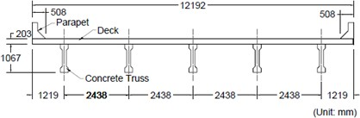
  - Bridge cross-section
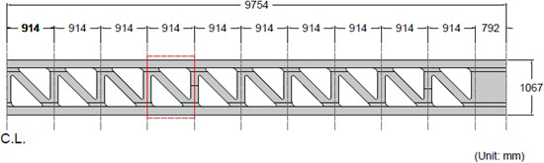
  - Truss layout

Figure 1. Design of the truss bridge considered in the study

The precast concrete truss was prestressed using SMAs in conjunction with a traditional pre-tensioning method. Because the bottom chord could prestress more than its SMA counterpart, it was reinforced with traditional pre-tensioning reinforcements. SMA bars, which can apply targeted prestressing force considerably more easily than the traditional prestressing system, were used to prestress the vertical parts. According to the Load-and-Resistant Factor Design (LRFD) strength limit states of the American Association of State Highway and Transportation Officials (AASHTO), the concrete truss was designed with realistic loading conditions in mind (AASHTO, 2020).

The live load capacity and demand curves for the reference and concrete truss models are displayed in Fig.
2. Only the additional load over the factored dead load as per the AASHTO strength I limit state was reported, as the dead load of the two models differs. The additional load represents the reserved capacity for the live load. According to the AASHTO strength I limit state's live load, dashed lines depict the demand curve for the moment (Fig. 2a) and shear (Fig. 2b) along the distance from the midspan. The reference and truss systems, in every case, surpass the AASHTO strength I limit states. Along the girder's length, the capacities of the concrete truss model range from 60.0% to 90% of those of the reference model.

(a) (b)

3000

2500

2000
Moment (kN*m)

1500

1000

500
2000

1600

AASHTO Strength I
AASHTO
Truss
AASHTO Strength I AASHTO
Truss

1200
Shear (kN)

800

400

0
-10 -8 -6 -4 -2 0 2 4 6 8 10
0
-10 -8 -6 -4 -2 0

2 4 6 8 10

Distance (m)
Distance (m)

Figure 2. Demand vs. capacity of the truss and reference bridge models for (a) moment and (b) shear

Task 2 progress (10% completed): This task during this quarter focused on evaluating the truss concept experimentally using small-scale specimens (see Fig. 3). The specimens were built using 2mm diameter NiTiNb SMA wires placed at th. The testing of the specimens is planned to take place during the next quarter. Strain gauges and digital image correlation (DIC) will be used to monitor the strain development through the specimens during activation and under flexural testing.

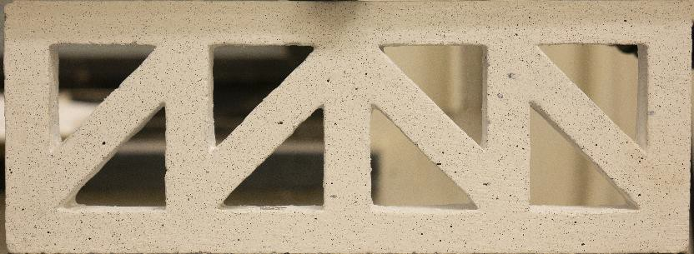

Figure 3. Small-scale truss specimen

Percent of overall completed research

Total project completed through the end of this quarter = 20%

Expected progress for next quarter

The next quarter will focus on finalizing the analysis needed to design the test specimens and test the small- scale truss specimens, and constructing the truss using additive manufacturing (3D printing) will also be investigated.

Educational outreach and workforce development

A poster is submitted and accepted for the 2024 ASCE Transportation Conference.

Technology Transfer

None yet.

Research Contribution:

Number of papers

- Minsoo Sung and Andrawes B. “Innovative Precast Concrete Truss System Using Shape Memory Alloys for Infrastructure Applications” Intelligent Materials Systems and Structures journal (Under review)). (Federal Funds Acknowledgment: Yes)

Number of presentations (when, where)

None.

References:

N/A

