**Transportation Infrastructure Precast Innovation Center**

**(TRANS-IPIC)**

**University Transportation Center (UTC)**

*Gaze-directed UAV-UGV Coordination Framework for Onsite Quality Inspection of Precast Bridge Construction*

*UT-23-RP-02*

Quarterly Progress Report

For the performance period ending *09/30/2024*

**Submitted by:**

*PI: Dr. Jiannan Cai,* [*jiannan.cai@utsa.edu*](mailto:jiannan.cai@utsa.edu)

*School of Civil & Environmental Engineering, and Construction Management (CECM)*

*The University of Texas at San Antonio (UTSA)*  
*Co-PI: Dr. Ao Du,* [*ao.du@utsa.edu*](mailto:ao.du@utsa.edu)*,CECM, UTSA*

*Co-PI: Dr. Ibukun Awolusi,* [*ibukun.awolusi@utsa.edu*](mailto:ibukun.awolusi@utsa.edu)*, CECM, UTSA*

**Collaborators / Partners:**

*N/A*

**Submitted to:**

TRANS-IPIC UTC

University of Illinois Urbana-Champaign

Urbana, IL

**TRANS-IPIC Quarterly Progress Report:**

**Project Description:**

1. Research Plan - Statement of Problem

This project will develop a novel gaze-directed UAV-UGV coordination framework for on-site quality inspection of precast bridge construction. UAV will provide global coverage for inspectors to quickly identify the components and construction activities for inspection while UGV will navigate to specific locations for close inspection following human guidance. A new gaze-directed human-machine interface will be developed, where inspectors can express their guidance via natural gaze movements, to reduce worker mental load. The proposed framework is expected to transform the practice of onsite quality inspection for precast infrastructure construction by establishing intuitive multi-robot-human teaming for efficient inspection. Such a system can be extended to provide guidance during bridge installation, thus improving construction quality and durability with reduced rework. The proposed framework can also be extended for lifecycle inspection, including offsite component inspection and condition monitoring of existing infrastructure, and eventually improve the durability and extend the life of precast transportation infrastructure.

1. Research Plan - Summary of Project Activities (Tasks)

Task 1. UAV-UGV coordinated localization and navigation.

This task aims to develop a hierarchical framework that will enable UGV to automatically locate and navigate to the inspection area as indicated by the UAV, leveraging sensing data from the onboard GPS and camera of both robots.

Task 2. Gaze-directed and AI-powered human-robot interface.

This task aims to develop a gaze-directed and AI-powered human-robot interface (HRI) such that the robot can navigate to a specific location based on the guidance of human natural gaze movement.

Task 3. Prototype development and experimental demonstration.

This task aims to develop and test a prototype of the proposed framework. In our preliminary study, we have developed a mobile robot teleoperation interface that can be used for inspection on jobsites.

**Project Progress:**

1. Progress for each research task

*Notes based on feedback from the previous report: 1) Due to the scope and time/budget limitation of the Year 1 project, we focused on technology development and prototype testing in controlled environments. We have proposed extending the project to Year 2, where we plan to collaborate with industry partners to test and implement the developed technology on transportation construction sites if funded. 2) Regarding sharing the demo videos listed in the report, we will organize and improve the quality of the videos after finishing all research activities at the end of the project, and upload them to YouTube for public access.*

Task 1. UAV-UGV coordinated localization and navigation [100% completed to date]

* A visual matching method was developed to supplement the GPS-based target localization we previously developed. The matching method uses aerial reference images captured from the drone and matches them to the ground robot’s perspectives to better localize the intended target.
  + Simulated demo: <https://youtu.be/vNXgrsHZGac>
* The matching method was assessed and validated on previously captured multi-perspective outdoor data. For the validation, we gauged the similarity between ground robot perspectives and aerial robot perspectives of an object.
  + Demonstration video: <https://www.youtube-nocookie.com/embed/jgKPjxe3YOM?playlist=jgKPjxe3YOM&autoplay=1&iv_load_policy=3&loop=1&start=>

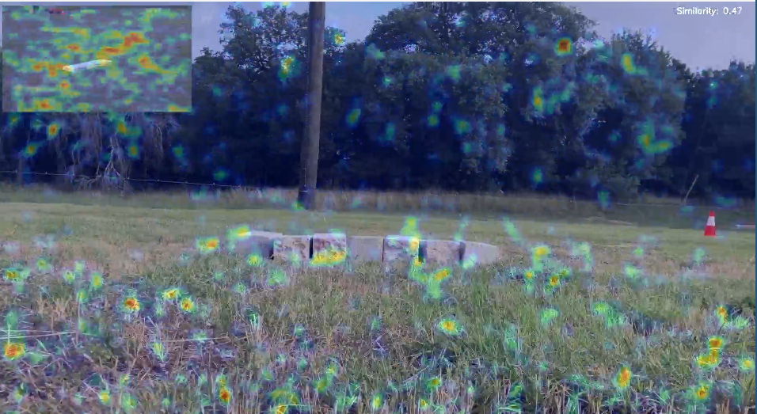

Figure 1. Example of visual matching method. Top left corner shows aerial perspective. A heatmap is rendered on both perspectives to show how key points densities are being mapped. The top right corner shows the similarity score value between the two images.

* The methods were then validated outdoors in an urban environment. Initial testing found navigation and path planning challenges related to the narrow navigation space available in our testing environment. These challenges will be addressed in the full system integration for Task 3.

Task 2. Gaze-directed and AI-powered human-robot interface. [100% completed to date]

* A gaze transformation method was tested and validated. This method would allow the translation of user gaze to pixel coordinates from any screen, allowing for improvement over the previously developed interface method. This development is being considered for implementation in Task 3.

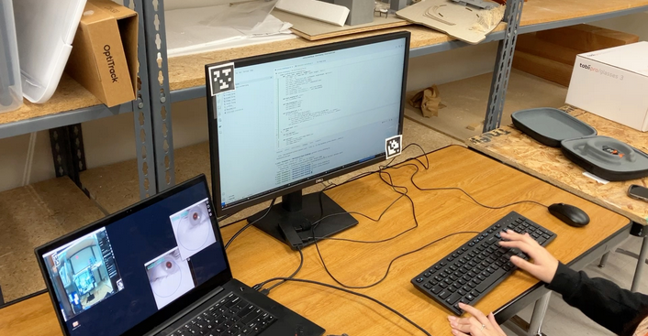

Figure 2. Demonstration of gaze to screen coordinate method. AprilTags are used to create a bounded surface to which gaze is translated to.

Task 3. Prototype development and experimental demonstration [50% completed]

* A wireless LAN network was tested and validated in an outdoor environment. This setup allows the remote operator to communicate with the ground robot and stream video within about a 300-meter range.

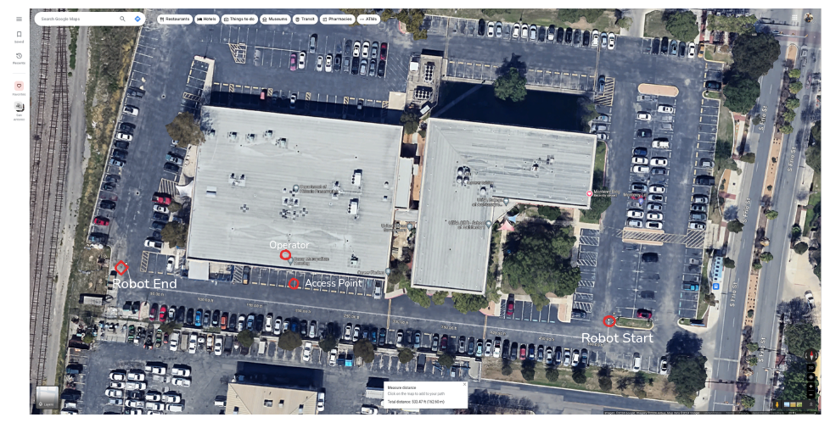

Figure 3. Satellite image of LAN range testing location. A ground robot and remote operator were connected wirelessly to test the range of our remote operation range.

* The remote interface application is being prepared for the complete outdoor testing. A method for the automatic generation of waypoints from drone controller data is being developed. This would allow a remote operator to leverage a gaze-based interface for the entire data generation pipeline.

1. Percent of research project completed

*83.3% of project was completed by the end of this quarter.*

1. Expected progress for next quarter

In the following quarter, we expect to have the full gaze-directed UAV-UGV inspection system integrated and tested in an outdoor environment. A final project report will be completed and submitted.

1. Educational outreach and workforce development

* K-12 students’ lab visit
  + Location: PI Cai’s lab on the UTSA downtown campus
  + Time: Summer 2024
  + Activity: PI Cai and three graduate students hosted around 10 K-12 students in the lab for a half-day lab visit, where interactive games and hands-on activities were designed to engage students in robots and AI concepts, see Fig. 4

Fig. 4 Lab visit of K-12 students

* Summer research internship for high school students
  + Location: PI Cai’s lab on the UTSA downtown campus
  + Time: Summer 2024
  + Activity: PI Cai mentored 2 high school students as summer interns (one was co-mentored with Co-PI Awolusi). The PI met with them weekly and had graduate students assist in the mentorship by designing mini projects on sensors and robotics tailored for high school students and providing timely advice and guidance.
* TRANS-IPIC August monthly webinar
  + Location: online
  + Time: 8/22/2024
  + Activity: Graduate student, Juan Cruz Rivera, presented the project in the TRANS-IPIC monthly webinar
* Supported and trained three Ph.D. students, Xiaoyun Liang, Mohsen Navazani, and Roy Lan, and one master’s student, Juan Cruz Rivera, on robotic research with applications in transportation infrastructure.

1. Technology Transfer

*N/A*

**Research Contribution:**

1. Papers that include TRANS-IPIC UTC in the acknowledgments section:

*N/A (two conference papers have been accepted, which were reported in the previous quarterly report)*

1. Presentations and Posters of TRANS-IPIC funded research:

* *Graduate student,* *Juan Cruz Rivera, presented at the 2024 ASCE International Conference on Computing in Civil Engineering a paper entitled, “A Gaze-Controlled Robotic Framework for Remote Site Inspection”.*
* *Graduate student, Xiaoyun Liang, presented at the 2024 ASCE International Conference on Computing in Civil Engineering a paper entitled, “Gaze-enhanced and LLM-enabled System for Intuitive Human-Robot Collaboration”.*
* *Graduate student,* *Juan Cruz Rivera, presented this project in the TRANS-IPIC monthly webinar.*

1. Please list any other events or activities that highlight the work of TRANS-IPIC occurring at your university (please include any pictures or figures you may have). Similarly, please list any references to TRANS-IPIC in the news or interviews from your research.

Our research with TRANS-IPIC was referenced in local news article: <https://www.expressnews.com/business/article/utsa-drone-testing-facility-san-antonio-19586030.php>

**References:**

*N/A*