**Transportation Infrastructure Precast Innovation Center**

**(TRANS-IPIC)**

**University Transportation Center (UTC)**

Developing a cost-effective, reliable and sustainable PC supply system under price volatility and uncertain materials supply - Phase II

[USDOT/Trans-IPIC: PU-23-RP-02]

LSU Proposal ID: AM-230085, GR-00016909

**Quarterly Progress Report: Y2-1**

**Performance period:** *January 1- March 31, 2025*

**Submitted by:**

Bhaba R. Sarker (PI)

Professor, Department of Mechanical and Industrial Engineering

Louisiana State University, Baton Rouge, LA 70803

[**bsarker@lsu.edu**](mailto:bsarker@lsu.edu)

**Collaborators / Partners:**

*Advisor:* Dr. Tyson Rupnow, Associate Director, Louisiana Transportation Research Center (LTRC).

*Participating Co.:* Rinker, Gainey’s, Premier Concrete Products, & WASKEYfor collaboration and validation of research works.

*Graduate Assistant:* Anik Mazumder

**Submitted to:**

TRANS-IPIC UTC

University of Illinois Urbana-Champaign

Urbana, IL

**TRANS-IPIC Quarterly Progress Report (Y2-1)**

1. **PROJECT DESCRIPTION**

The role of precast concrete (PC) supply logistics under variable demand and probabilistic delivery times is explored here to enhance reliability, sustainability and cost-effectiveness. In this section, we highlight the problem statement and the project’s tasks to be completed.

1. **Research Plan - Statement of Problem**

Reliability and sustainability of transportation infrastructure depend significantly on the optimal scheduling and routing of precast concrete (PC) resources, particularly in delivery operations (as experienced by companies like Gainey’s, WASKEY, and Premier Concrete Products in Louisiana). Efficient transportation ensures timely delivery of PC products, reducing project delays and preventing costly material degradation. Thus, this *USDOT Trans-IPIC* project focuses on developing cost-effective strategies to enhance reliability and sustainability in PC distribution systems under variable demand and probabilistic delivery times.

***Research Goal****:* The primary goal of this research is to provide a scalable solution that not only reduces the logistics costs associated with PC supply but also enhances reliability and sustainability in facing variable demands and delivery times in constructions of transportation infrastructures and its logistical challenges.

1. **Research Plan - Summary of Project Activities (Tasks)**

As outlined in the proposed research plan for Year 1, the model addressing *uncertainty and price volatility* (UPV) in the PC supply network is in progress. In addition to that, probabilistic travel time and stochastic demand, which are quite common phenomena in transportation construction, are to be considered for achieving the current objective of Year 2 (2025) research undertaken and these include:

1. **Task 1: *ANM (Activity Network Model):*** It will highlight a proper representation of predecessors and successors related to PC production activities incorporating probabilistic travel time and stochastic demand with price fluctuation, to determine production and delivery times.
2. **Task 2: *IOTC (In-plant and Off-plant Transportation Cost):***The IOTC model will optimize storage location/assignment to enhance utilization and maximize transportation costs for precast components from plants to construction sites.
3. **Task 3: *DSC (Delivery System Cost):*** The model will bring forth a shed on the general behavior of PC delivery schedules, minimize penalty costs, address material uncertainty and price volatility, ensuring reliable and sustainable PC supply systems.
4. **PROJECT PROGRESS**

In this section, the progress in completing the research tasks is highlighted followed by future work, educational outreach, workforce development and technology transfer.

1. **Progress for each research task**

The total task of Year 2 is partitioned into three major segments: ANM, IOTC and DSC with an intended quarterly schedule for each of them, followed by a final report in the last quarter. Thus, activity network modeling (ANM) is pursued in the first quarter (January 1 – March 31, 2025) for the PC production activities with manufacturing logistics operations and deliveries.

***3.1 Task 1 (QPR Y2-1): Activity Network Modeling***

Efficient logistics and delivery systems for PC components are critical for successful road and highway construction projects, significantly influencing overall project reliability, sustainability, and cost-efficiency. The activity network modeling approach provides a structured framework to analyze these logistical processes, from procurement planning to final delivery at construction sites. By clearly visualizing and evaluating transportation modes, capacity constraints, and scheduling flexibility, this approach helps the management or logistics engineer identify potential inefficiencies and bottlenecks within the delivery system. The following description elaborates on a specific activity network workflow, highlighting essential steps and decision points in the transportation process, ultimately aiding in the development of cost minimization models essential to the broader transportation infrastructure sector.

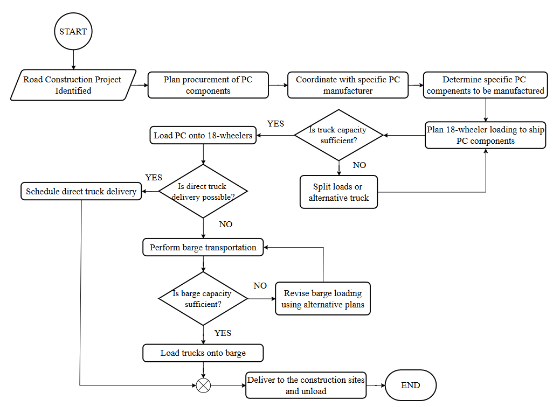

Figure 1. Activity flow for PC shipments to construction sites

The flow chart in Figure 1 illustrates the logistics process for delivering PC components to road and highway construction sites from an activity network modeling perspective. The process begins by identifying the road construction project, followed by procurement planning of PC components and coordination with manufacturers to determine specific products. Once components are ready, they are loaded onto 18-wheelers or other special transporters, with capacity constraints determining whether loads should be split, or alternative vehicles should be used. Next, the feasibility of direct truck delivery is evaluated; if possible, delivery is scheduled directly; otherwise, barge transportation or transshipment is arranged (in case of river-crossing), subject to its own capacity considerations and/or potential need for loading/reloading revisions for road or bridge constraints. Finally, products are delivered and unloaded at construction sites. Modeling this sequence of logistics activities through an activity network is essential for identifying cost-saving opportunities (as experienced in *GAINEY’S* country-wide deliveries*)*, particularly by optimizing resource allocation, transport routes, scheduling, and return of transporter(s) to its original location(s). This approach contributes significantly to cost minimization and supports the reliability and sustainability goals critical in transportation infrastructure projects.

Figure 2. Activity Network of PC flow

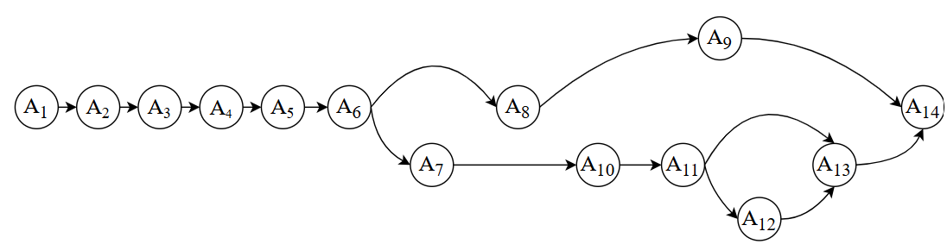

The flowchart in Figure 1 was broken down into individual tasks and decision points. Each step received a simple label (A1, A2, etc.) and was arranged in the required order, with decision nodes directing to different paths. Figure 2 illustrates an activity network that clearly delineates the sequential steps and their interconnections, thereby facilitating planning and scheduling for transportation projects. In this diagram, nodes represent the activities or decisions, while the directed arcs indicate the required sequence of tasks. [See Appendix 2.1 for descriptions for each node].

Figure 3. Intermodal and Multi-modal Transportation Network

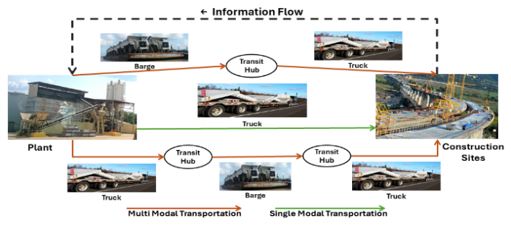

This network shows a step-by-step process for delivering PC components for multiple road construction projects. The process begins with identifying the road construction project and planning the procurement of concrete components, which includes coordinating with manufacturers and determining exactly which components to produce. Next, the concrete is loaded onto trucks, and the trucks’ capacity is checked. If the trucks have enough capacity, the next decision is whether direct truck delivery can be used. If direct delivery is possible, the delivery is scheduled; if not, the process shifts to barge transportation. In the barge route, the barge’s capacity is checked and, if necessary, the loading plan is revised until the trucks can be loaded onto the barge properly. Finally, once either the truck or barge delivery is arranged, the concrete is delivered and unloaded at the construction site, completing the process (Figure 3).

The objective of this quarter’s project was to develop a two-stage stochastic optimization model that efficiently plans and schedules precast concrete deliveries for various road construction projects. The model accounts for uncertainties in demand and travel times while minimizing costs and delays through optimal resource allocation and transportation mode selection (Figure 3). Therefore, the project’s objective was to minimize the sum of first-stage fixed costs and the expected second-stage resource costs [See Appendix 2.2 for notations]. The mathematical formulation developed for the precast concrete delivery (PCD) model is given in Problem PCD below, wherein the optimal values of the number of vehicles contracted, the shipment quantities, the unmet demands, and the shipment start times are determined as follows:

*Problem PCD:*

(1)

First stage constraints:  (1a)

and (1b)

Second stage constraints (for each scenario)

(1c)

(1d)

(1e)

(1f)

, (1g)

Constraint (1a) ensures that the fixed cost for assigning vehicles or vessels of any particular mode remains within the budget. Constraint (1b) requires that the number of vehicles assigned to each transportation mode must be a nonnegative integer number. Constraint (1c) ensures that for every project, component, and shipment batch in each scenario, the total amount delivered across all transportation methods should meet the required demand for that batch. Meanwhile, Constraint (1d) limits the total shipments made through each transportation mode by ensuring that the aggregate amount delivered does not exceed the available capacity. Constraint (1e) defines the completion time for each shipment as the sum of its start time and the travel time associated with the chosen mode, establishing a clear schedule for deliveries. Finally, constraint (1f) mandates that every shipment must be finished before the project’s required delivery time, thereby ensuring that no delivery is completed before the necessary deadline. The rest of them are non-negativity constraints for the second stage decision variables.

The solution methodology divides the planning and optimization process into four distinct stages (Figure 4). First, the project is identified, and initial resource decisions are set up, establishing a baseline for truck and barge allocations. Next, the model addresses various uncertain scenarios—such as fluctuating demand and travel times—by solving subproblems that refine cost estimates and update capacity usage. In the third stage, these insights are to be fed into the master problem where advanced techniques (like Benders cuts) and heuristic adjustments guide improvements in routing and scheduling. Finally, the approach checks for convergence to ensure a high-quality, near-optimal solution. This multi-stage, structured method is valuable particularly for transportation infrastructure projects because it systematically tackles complexities involving demand uncertainty, multiple delivery modes, and tight timelines—ultimately helping planners and engineers allocate resources efficiently, minimize delays, and control costs.

By breaking the problem into logical stages and iteratively refining decisions, project planners can better allocate resources (like trucks, barges, loading/unloading cranes), reduce congestion, control costs, and meet tight deadlines. In practice, it leads to smoother operations, fewer delays, and more reliable project timelines, all of which are crucial when constructing or maintaining roads, bridges, and other vital infrastructure.

Figure 4. Solutional methodology for optimized PC flow

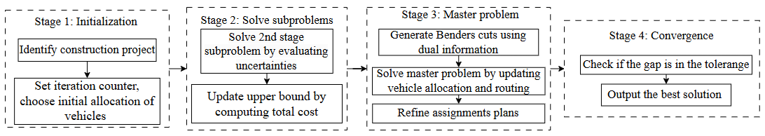

1. **Percent of research project completed**

As the research project for this year has been divided into three parts, the percentage of the research project completed is approximately (90%×33.33%) + (0%×33.33%) + (0%×33.33%) ~ 30%. The computational part of Stage 1 is in progress, and it will be included in the working paper to be submitted to a refereed journal.

1. **Expected progress for next quarter**

Over the next quarter, we plan to integrate real project data into the model and run pilot tests to assess its performance under practical conditions. We will refine the solution approach to handle any new constraints that arise from these tests, aiming to enhance the model’s robustness and efficiency. This progress should help transition of the model from a proof-of-concept to a viable tool for optimizing precast concrete deliveries in transportation infrastructure projects.

1. **Educational outreach and workforce development**

A total of 12 undergraduate (UG) students have been assigned to the following research projects in their respective industries as part of their capstone course requirement for IE-4598 Senior Design Project II (Spring 2025). This is their second semester continuation on the projects.

* Tracking and storing Besser Machines parts for precast concrete manufacturing (PCP-1).
* Optimizing the yard layout to improve truck flow in transporting precast materials (PCP-3).
* Improving yard layout for efficient handling and tracking of precast concrete products (Waskey).
* Design of dunnage and rigging methods for oversized precast concrete: ensuring stability and minimizing damage (Gainey’s).

1. **Technology Transfer**

The research team is in contact with several companies (Precast Concrete Products, Waskey, Gainey’s and Rinker) through LTRC. Efforts have been made to collaborate and collect some real-life data for testing purposes and feedback on the project. Some of this data is expected to be incorporated in subsequent reports. The outcome is yet to be achieved for technology transfer.

1. **RESEARCH CONTRIBUTION**
2. **Papers that include TRANS-IPIC UTC in the acknowledgments section:**
   * + 1. Mazumder, A. and Sarker, B.R., “Determining optimal variable order quantities of raw materials for precast concrete production considering demand variability and uncertain material prices," Paper-1 (LS-23-RP-04), Submitted to *European Journal of Operational Research*. 1st submission: March 27, 2025 (EJOR-S-25-01345), BS@lsu/3209T@PFTH, Corr: BRS
       2. Mazumder, A. and Sarker, B. R. (2025b), “An Optimal Delivery System of Multiple Precast Components for Multiple Construction Sites of Transportation Infrastructure,” *Working Pape*r 2 (LS-24-RP-01), QPR Y2-1 (January 1 - March 31, 2025). Intended for *ASCE: Journal of Transportation Engineering.*
3. **Presentations and Posters of TRANS-IPIC funded research:**

Interim Report presentations at LSU (PFT-1206) on March 21, 2025, by the undergraduate students who are working in the precast manufacturing industries:

* PCP-1: *Tracking and storing Besser Machines parts for precast concrete manufacturing* (3 students).
* PCP-3: *Optimizing the yard layout to improve truck flow in transporting precast materials* (3 students).
* Waskey: *Improving yard layout for efficient handling and tracking of precast concrete products* (3 students).
* Gainey’s: *Design of dunnage and rigging methods for oversized precast concrete: ensuring stability and minimizing damage* (3 students).

1. **Please list any other events or activities that highlights the work of TRANS-IPIC occurring at your university (please include any pictures or figures you may have). Similarly, please list any references to TRANS-IPIC in the news or interviews from your research.** 
   * + 1. Images from interim report presentation slides on March 21, 2025, by the undergraduate students who are working in the precast manufacturing industries.

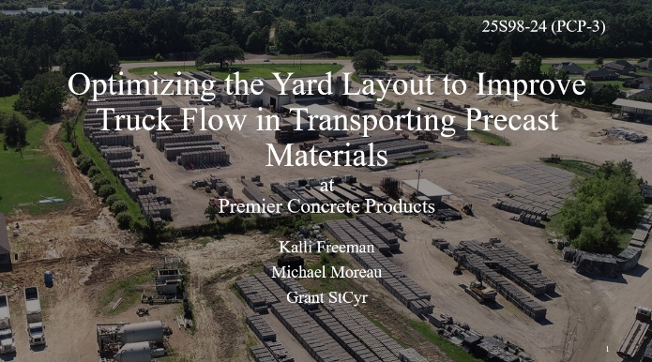

* + - 1. Mazumder, A. and Sarker, B. R., “Factors of the Precast Concrete Supply Chain: An Interpretive Structural Modeling Approach,” Graduate Research Conference (GRC), presented at the Students’ Union, Louisiana State University, Baton Rouge, LA on April 30, 2024.

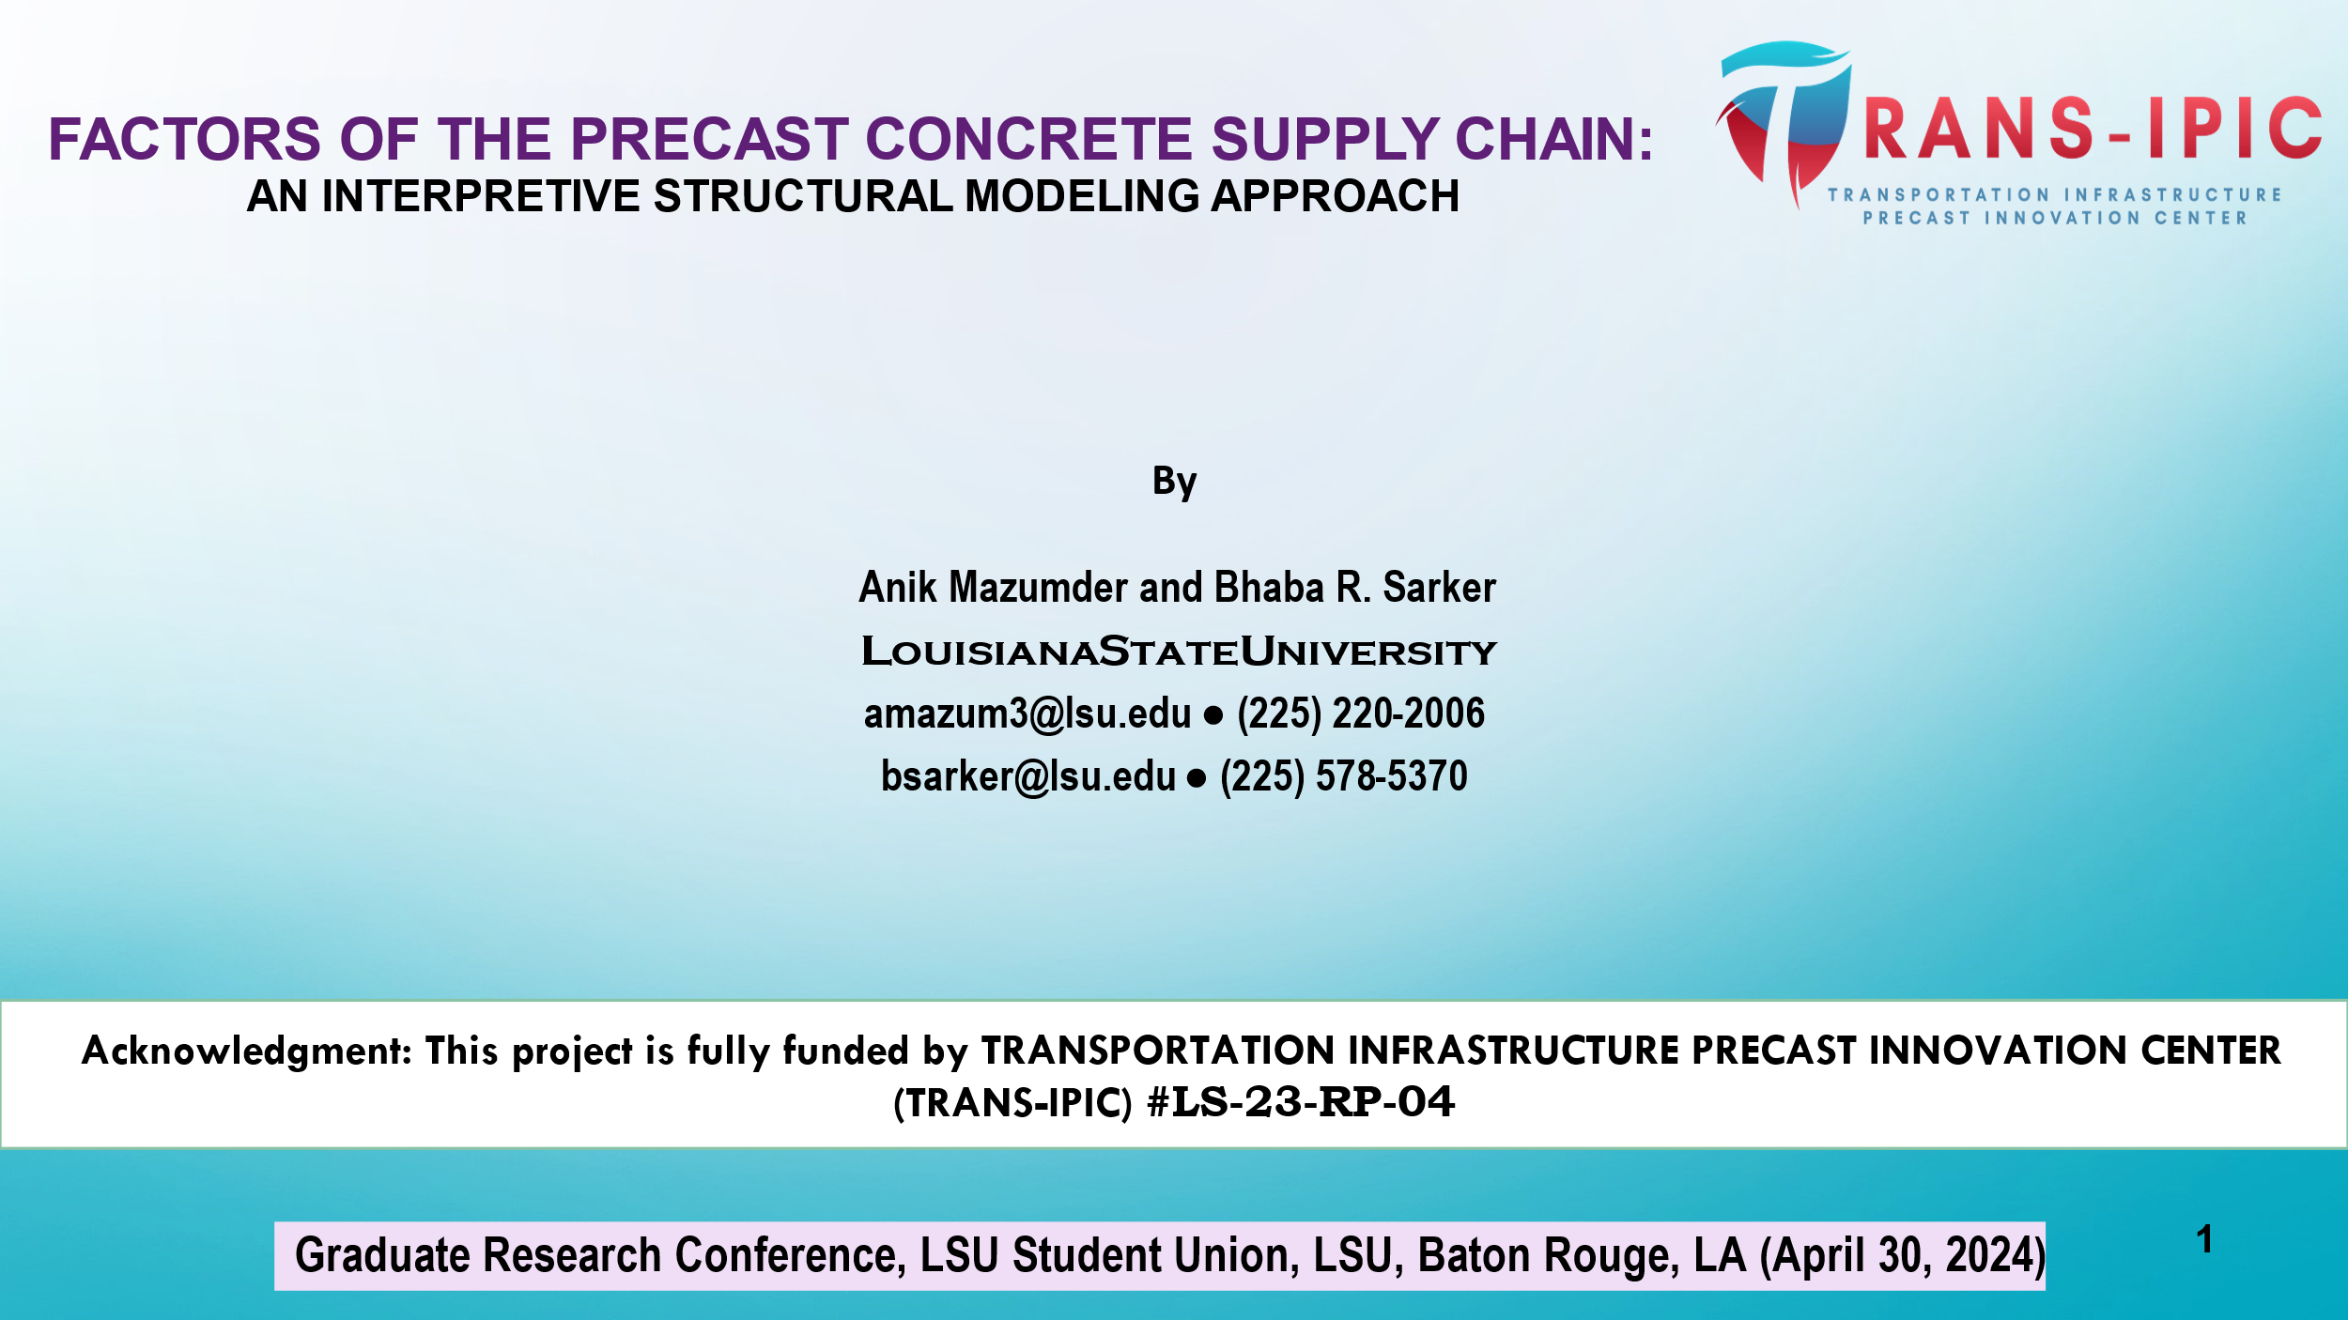

Figure 5. Cover Slide of the presentation file that was presented at GRC, LSU.

* + - 1. Mazumder, A. and Sarker, B. R., “Optimizing Pallet Capacity Utilization to Minimize Curing Cost in Precast Concrete Manufacturing,” presented at the *DOT TRANS-IPIC* online research online seminar on July 22, 2024.



Figure 6. Research online seminar presentation on July 22, 2024

* + - 1. Plant tour and meeting to discuss potential challenges in precast concrete logistics for the TRANS-IPIC project proposal for Year 2, held at Rinker Materials in Alexandria, LA, on September 23, 2024.



Figure 7. Certificate of attendance from Rinker Materials



**Appendix 1**

Research Activities, leadership, and awards (cumulative, since the start of the project)

1. Number of presentations at academic and industry conferences and workshops of UTC findings

* No. = 3

1. Number of peer-reviewed publications submitted based on outcomes of UTC funded projects

* No. = 1 (EJOR)

1. Number of peer-reviewed journal articles published by faculty.

* No. = 0

1. Number of peer-reviewed conference papers published by faculty.

* No. = 0

1. Number of TRANS-IPIC sponsored thesis or dissertations at the MS and PhD levels.

* No. MS thesis = 1 (on-going)
* No. PhD dissertations = 1 (on-going)
* No. citations of each of the above = 0

1. Number of research tools (lab equipment, models, software, test processes, etc.) developed as part of TRANS-IPIC sponsored research

* Research Tool #1 (Name, description, and link to tool) = 0
* Research Tool #2 (Name, description, and link to tool) = 0
* Research Tool #3 (Name, description, and link to tool) = 0

1. Number of transportation-related professional and service organization committees that TRANS-IPIC faculty researchers participate in or lead.

* Professional societies
  + No. participated in = 4 (DSI, IISE, INFORMS, POMS)
  + No. lead = 0
* Advisory committees (No. participated in and No. led)
  + No. participated in = 1 (IISE Fellow)
  + No. lead = 0
* Conference Organizing Committees (No. participated in and No. led)
  + No. participated in = 0
  + No. lead = 0
* Editorial board of journals (No. participated in and No. led)
  + No. participated in = 2
  + No. lead = 0
* TRB committees (No. participated in and No. led)
  + No. participated in = 0
  + No. lead = 0

1. Number of relevant awards received during the grant year

* No. awards received = 0

1. Number of transportation related classes developed or modified as a result of TRANS-IPIC funding.

* No. Undergraduate = 0
* No. Graduate = 0

1. Number of internships and full-time positions secured in the industry and government during the grant year.

* No. of internships = 0
* No. of full-time positions = 0

**Appendix 2.1 Nodes for PC Flow Activities**

|  |  |
| --- | --- |
| PC Flow Activities | |
|  | Road Construction Project Identified |
|  | Plan procurement of PC components |
|  | Coordinate with specific PC manufacturer |
|  | Determine specific PC components to be manufactured |
|  | Load PC onto 18-wheelers |
|  | Check truck capacity |
|  | Split loads/use alternative plan (if truck capacity is insufficient) |
|  | Is direct truck delivery possible? (feasibility check) |
|  | Schedule direct truck delivery (if feasible) |
|  | Perform barge transportation (if direct truck delivery is not feasible) |
|  | Check barge capacity |
|  | Revise barge loading using alternative plans (if barge capacity is insufficient) |
|  | Load trucks onto barge (if capacity is sufficient) |
|  | Deliver to the construction site and unload |

**Appendix 2.2 Notations for PCD Model**

|  |  |
| --- | --- |
| Indices | |
|  | Road construction projects () |
|  | Types of PC components () |
|  | Shipment of lots () |
|  | Modes of transportation () |
|  | Scenarios for joint realization of random variables (demand, travel time) with probability (s) |
|  | Time periods in planning horizon () |
|  | Shared resources (*e.g.,* loading/unloading equipment, cranes, etc.) () |

|  |  |
| --- | --- |
| Scenario dependent parameters | |
|  | Demand for lot of component for project (pounds/unit time) |
|  | Realized travel time when using mode in scenario (time unit) |

|  |  |
| --- | --- |
| Vehicle and mode attributes | |
|  | Capacity per vehicle/vessel for mode (pounds/vehicle) |
|  | Unit variable cost per shipment for mode (dollars) |
|  | Fixed cost for contracting one unit of mode (dollars) |
|  | Budget for fixed cost for one unit of mode (dollars) |
|  | Maximum no of trips a single vehicle of mode can make during planning horizon |
|  | Volume capacity per vehicle for mode () |
|  | Time periods in planning horizon () |

|  |  |
| --- | --- |
| Scheduling and resource parameters | |
|  | Earliest start time for project |
|  | Availability of resources |
|  | Required delivery time of PC products for project |
|  | Penalty cost per unit time of delay beyond the deadline for project |
|  | Penalty cost per unit shortfall for project |

|  |  |
| --- | --- |
| First‑Stage (Here‐and‑Now) Decisions | |
|  | Number of vehicles (or vessels) contracted for mode |
| Second‑Stage (Recourse) Decisions (Scenario Dependent) | |
|  | Tons of PC from batch shipped via mode in scenario |
|  | Unmet demand for batch in scenario |
|  | Start time for shipment of batch shipped via mode in scenario |
|  | Completion time for shipment of batch shipped via mode in scenario |

**REFERENCES**

1. Allison, J. (1990). Combining Petrov's heuristic and the CDS heuristic in group scheduling problems. *Computers and Industrial Engineering,* **19**(1), 212–215.
2. Anvari, B., Angeloudis, P., and Ochieng, W. (2016). A multi-objective GA-based optimisation for holistic manufacturing, transportation and assembly of precast construction. *Automation in Construction,* **71**, 226–241.
3. Benjaoran, V., Dawood, N., and Hobbs, B. (2005). Flowshop scheduling model for bespoke precast concrete production planning. *Construction Management and Economics,* **23**(2), 93–105.
4. Chan, W., and Hu, H. (2000). Precast production scheduling with genetic algorithms. *Proceedings of the 2000 Congress on Evolutionary Computation,* **2**, 1087–1094.
5. Chan, W., and Hu, H. (2001). GA-based resource-constrained flow-shop scheduling model for mixed precast production. *Automation in Construction,* **11**(4), 439–452.
6. Chan, W., and Hu, H. (2002). Production scheduling for precast plants using a flow shop sequencing model. *Journal of Computing in Civil Engineering,* **16**(3), 165–174.
7. Chen, J.-H., Hsu, S., Chen, C.-L., Tai, H.-W., and Wu, T.-H. (2020). Exploring the association rules of work activities for producing precast components. *Automation in Construction,* **111**, 103059.
8. Chen, J.-H., Yan, S., Tai, H.-W., and Chang, C. (2017). Optimizing profit and logistics for precast concrete production. *Canadian Journal of Civil Engineering,* **44**(5), 393–406.
9. Chen, J.-H., Yang, L.-R., and Tai, H.-W. (2016). Process reengineering and improvement for building precast production. *Automation in Construction,* **68**, 249–258.
10. Dan, Y., Liu, G., and Fu, Y. (2021). Optimized flowshop scheduling for precast production considering process connection and blocking. *Automation in Construction,* **125**, 103575.
11. Hu, H. (2007). A study of resource planning for precast production. *Architectural Science Review,* **50**(2), 106–114.
12. Jiang, W., and Wu, L. (2021). Flow shop optimization of hybrid make-to-order and make-to-stock in precast concrete component production. *Journal of Cleaner Production,* **297**, 126708.
13. Khalili, A., and Chua, D. (2014). Integrated prefabrication configuration and component grouping for resource optimization of precast production. *Journal of Construction Engineering and Management,* **140**(8), 04013052.
14. Kim, T., Kim, Y.-W., and Cho, H. (2020). Dynamic production scheduling model under due date uncertainty in precast concrete construction. *Journal of Cleaner Production,* **257**, 120527.
15. Ko, C., and Wang, S.-F. (2010). GA-based decision support systems for precast production planning. *Automation in Construction,* **19**(7), 907–916.
16. Ko, C., and Wang, S.-F. (2011). Precast production scheduling using multi-objective genetic algorithms. *Expert Systems with Applications,* **38**(7), 8293–8302.
17. Kong, L., Li, H., Luo, H., Ding, L., and Skitmore, M. (2017). Optimal single-machine batch scheduling for the manufacture, transportation and JIT assembly of precast construction with changeover costs within due dates. *Automation in Construction,* **81**, 34–43.
18. Kong, L., Li, H., Luo, H., Ding, L., and Zhang, X. (2018). Sustainable performance of just-in-time (JIT) management in time-dependent batch delivery scheduling of precast construction. *Journal of Cleaner Production,* **193**, 684–701.
19. Leu, S.-S., and Hwang, S.-T. (2001). A GA-based model for maximizing precast plant production under resource constraints. *Engineering Optimization,* **33**(6), 619–642.
20. Leu, S.-S., and Hwang, S.-T. (2002). GA-based resource-constrained flow-shop scheduling model for mixed precast production. *Automation in Construction,* **11**(4), 439–452.
21. Li, S. H. A., Tserng, H., Yin, S. Y. L., and Hsu, C.-W. (2010). A production modeling with genetic algorithms for a stationary pre-cast supply chain. *Expert Systems with Applications,* **37**(12), 8406–8416.
22. Li, Z., Shen, G., and Xue, X. (2014). Critical review of the research on the management of prefabricated construction. *Habitat International,* **43**, 240–249.
23. Liao, T. W, Egbelu, P. J., Sarker, B. R. and Leu, S. S. “Metaheuristics for project and construction management—A state-of-the-art review,” *Automation in Construction*, **20** (5): August 2011, pp. 491-505.
24. Liu, Y., Dong, J., and Shen, L. (2020). A conceptual development framework for prefabricated construction supply chain management: An integrated overview. *Sustainability,* **12**(5), 1878.
25. Liu, Z., Liu, Z., Liu, M., and Wang, J. (2021). Optimization of Flow Shop Scheduling in Precast Concrete Component Production via Mixed‐Integer Linear Programming. *Advances in Civil Engineering*, **2021**(1), 6637248.
26. Ma, Z., Yang, Z., Liu, S., and Wu, S. (2018). Optimized rescheduling of multiple production lines for flowshop production of reinforced precast concrete components. *Automation in Construction,* **95**, 86–97.
27. Nori, V. S., and Sarker, B. R. (1996). Cyclic scheduling for a multi-product, single-facility production system operating under a just-in-time delivery policy. *Journal of the Operational Research Society*, **47**(7), 930-935.
28. Parija, G. R., and Sarker, B. R. (1999). Operations planning in a supply chain system with fixed-interval deliveries of finished goods to multiple customers. *IIE transactions*, **31**(11), 1075-1082.
29. Prata, B., Pitombeira-Neto, A. R., and Sales, C. J. de M. (2015). An integer linear programming model for the multiperiod production planning of precast concrete beams. *Journal of Construction Engineering and Management,* **141**(9), 04015029.
30. Ruan, M., and Xu, F. (2022). Improved eight-process model of precast component production scheduling considering resource constraints. *Journal of Civil Engineering and Management,* **28**(3), 1–15.
31. Sarker, B. R., Egbelu, P. J., Liao, T. W. and Yu, J., “Planning and design models for construction Industry: A critical survey,” *Automation in Construction*, **22**(SI-1), March 2012, pp. 123-134.
32. Sarker, B. R., and Parija, G. R. (1994). An optimal batch size for a production system operating under a fixed-quantity, periodic delivery policy. *Journal of the Operational Research Society*, **45**(8), 891-900.
33. Sarker, B. R., and Parija, G. R. (1996). Optimal batch size and raw material ordering policy for a production system with a fixed-interval, lumpy demand delivery system. *European Journal of Operational Research*, **89**(3), 593-608.
34. Wang, D., Liu, G., Li, K., Wang, T., Shrestha, A., Martek, I., and Tao, X. (2018). Layout optimization model for the production planning of precast concrete building components. *Sustainability,* **10**(6), 1807.
35. Wang, Z., and Hu, H. (2017). Improved precast production-scheduling model considering the whole supply chain. *Journal of Computing in Civil Engineering,* **31**(6).
36. Wang, Z., Hu, H., and Gong, J. (2018). Framework for modeling operational uncertainty to optimize offsite production scheduling of precast components. *Automation in Construction,* **86**, 69–80.
37. Wang, Z., Hu, H., and Gong, J. (2018). Modeling worker competence to advance precast production scheduling optimization. *Journal of Construction Engineering and Management,* **144**(12), 04018109.
38. Wang, Z., Hu, H., and Gong, J. (2018). Simulation based on multiple disturbances evaluation in the precast supply chain for improved disturbance prevention. *Journal of Cleaner Production,* **177**, 232–244.
39. Wang, Z., Hu, H., and Gong, J. (2019). Precast supply chain management in off-site construction: A critical literature review. *Journal of Cleaner Production,* **232**, 1104–1116.
40. Wang, Z., Hu, H., Gong, J., and Ma, X. (2018). Synchronizing production scheduling with resources allocation for precast components in a multi-agent system environment. *Journal of Manufacturing Systems,* **49**, 109–120.
41. Wang, Z., Liu, Y., Hu, H., and Dai, L. (2021). Hybrid rescheduling optimization model under disruptions in precast production considering real-world environment. *Journal of Construction Engineering and Management,* **147**(5), 04021012.
42. Yang, Z., Ma, Z., and Wu, S. (2016). Optimized flow shop scheduling of multiple production lines for precast production. *Automation in Construction,* **72**, 321–329.
43. Yin, Y., Cheng, S.-R., and Wu, C.-C. (2014). Parallel-machine scheduling to minimize flowtime, holding, and batch delivery costs. *Asia-Pacific Journal of Operational Research,* **31**(6), 1450044.
44. Zhang, H., and Yu, L. (2020). Dynamic transportation planning for prefabricated component supply chain. *Engineering, Construction and Architectural Management,* **27**(10), 2553–2576.