**Transportation Infrastructure Precast Innovation Center**

**(TRANS-IPIC)**

**University Transportation Center (UTC)**

*3D Printed Smart Permanent Concrete Formwork for Precast Structural Component*

*LS-24-RP-02*

Quarterly Progress Report

For the performance period ending December 31, 2025

**Submitted by:**

Yen-Fang Su, [ysu@lsu.edu](mailto:ysu@lsu.edu)

Department of Civil & Environmental Engineering

Louisiana State University and A&M College

**Collaborators / Partners:**

No other collaborators/partners

**Submitted to:**

TRANS-IPIC UTC

University of Illinois Urbana-Champaign

Urbana, IL

**TRANS-IPIC Quarterly Progress Report:**

**Project Description:**

1. Research Plan - Statement of Problem:

A crucial choking point of transportation infrastructure is the degradation over a long period of time. The detection of change in the structural integrity of roads, bridges, tunnels, etc. requires a practical and economical approach. A commonly used method for structural health monitoring (SHM) is the utilization of external sensors that require constant power supply, protection against weathering, and higher budget. However, these restrictions potentially can be obviated through the usage of advanced materials and fabrication methods. This research utilizes novel self-sensing cementitious composites (SSCCs) to achieve stress-sensing property in precast concrete components. Furthermore, conventional molds for precast concrete elements are replaced with additively manufactured permanent molds facilitating the cost-effective fabrication geometrically irregular shapes. Finally, the layer-by-layer deposition system, which is the defining feature of AM, aids with topological optimization and precise control over the properties of individual layers.

1. Research Plan - Summary of Project Activities (Tasks)

Task 1: Material Properties assessment

Task 2: Specimen fabrication and determining the preliminary SSCCs placement

Task 3: Load testing and strain monitoring

Task 4: Construction of preliminary Multiphysics model

**Project Progress:**

1. Progress for each research task

**Task 1: Material Properties assessment**

* + 1. Literature survey & Mix design

The current state of knowledge related to self-sensing concrete is investigated. The driving mechanisms of self-sensing in cementitious materials is explored. The use of electrically functional fillers in concrete is the major force in boosting stress-strain sensing. The answers to the following questions are during the literature review process:

1. What are the different types of conductive fillers that are fit to be used in concrete to attain self-sensing?
2. What are the optimal dosages of each filler for achieving self-sensing in concrete?
3. What are the prevalent theories associated with the piezoresistivity in cementitious materials?
4. What are the validated testing methods for gauging self-sensing in concrete?
5. What are the potential challenges inhibiting the wide usage of self-sensing concrete?

From the various types of conductive fillers 2 different types were selected: Carbon fiber (CF) and graphene oxide (GO). There are numerous derivatives of CF with exceptional mechanical and electrical properties that have the potential to be used as the electrically conductive agent in concrete. Short CF is a category of this carbon-based filler that is 2D and possess high aspect ratio. Short CF has 2 subcategories: chopped CF and milled CF. Although both of these share similar diameters, their average length diverge from each other. Table 1. Summarizes the physical properties of the short CFs that is used for the purpose of self-sensing in concrete. Milled CF is a byproduct of the processing of continuous CF. It is a sustainable and affordable source conductive filler that is chosen for this study. We found out that despite the impressive properties that milled CF possess, investigation on the self-sensing characteristics of this fiber has been severely limited. Furthermore, it has a significant advantage over chopped CF. Since it is a byproduct of the CF industry, its fecundity and cost-effectiveness can be leveraged for mass-use in the transportation infrastructure.

Graphene oxide is one of the most unique materials that has gained attention from researchers due to its extremely high aspect ratio, mechanical properties, and electrical conductivity. It was found that that the oxidation of the graphene by oxygen-containing functional groups renders it hydrophilic. The proper dispersion of each component of the cementitious mix affects the mechanical as well as self-sensing properties. Therefore, the potency of different types of conductive fillers in self-sensing property in SSCCs is deemed necessary.

Table 1. The list of short CF usage in the self-sensing concrete.

|  |  |  |  |  |  |  |
| --- | --- | --- | --- | --- | --- | --- |
| **Type** | **Length (mm)** | **Diameter (µm)** | **Tensile Strength (MPa)** | **Modulus of Elasticity (GPa)** | **Resistivity (10-3.Ω.cm)** | **Reference** |
| Copped CF | 3 | 7 | 4137 | 242 | 1.55 | [1] |
| 5 | 7 | 3800 | 220 | N/A | [2] |
| 6 | 11 | 2600 | N/A | 2.30 | [3] |
| 6 | 7 | 4000 | 240 | N/A | [4] |
| 6 | 7 | 3500 | 230 | 1.50 | [5] |
| 6 | 7 | 4000 | 240 | 1.50 | [6] |
| 6 | 7 | 3000 | 230 | 1.50 | [7] |
| 6 | 7.5 | 4000 | 240 | 1.50 | [8] |
| 6.25 | 7 | 3800 | 228 | 1.55 | [9] |
| 9 | 10 | 4000 | 220 | 1.50 | [10] |
| 18 | 7 | 4900 | 230 | 1.60 | [11] |
| Milled CF | 0.15 | 7.2 | 3800 | 242 | 1.52 | [12] |

The dosage of conductive filler incorporated also is a critical parameter in the self-sensing concrete. When the electrically conductive fiber or particles are used in the optimal dosage, a significant decrease in the resistivity of the cementitious composite is observed. There is considerable research on the effect of the different dosages of carbon-based fillers. The ideal content of conductive fillers in self-sensing concrete is also influenced by their resistivity and aspect ratio. Based on the reports on the effect of different conductive fillers with comparable properties, the ideal dosage of milled CF in cementitious composite seemed to be 0.1%-1%. Therefore, samples based on the mix design in Table 2. was prepared.

Table 2. Weight-based mix design ratios

|  |  |  |  |  |  |
| --- | --- | --- | --- | --- | --- |
| **Mix** | **OPC** | **Sand** | **W/C** | **Filler Type** | **Filler Dosage\*** |
| R (Reference) | 1 | 1.5 | 0.45 | - | - |
| mCF1 | Milled CF | 0.001 |
| mCF5 | Milled CF | 0.005 |
| mCF10 | Milled CF | 0.01 |
| GO | graphene oxide | 0.001 |
| *\* By weight of cement* | | | | | |

1. Mechanical testing (Compressive and interfacial bond strength)

The 1, 3, 7, and 28-day compressive strength were tested for mortar samples with the mix design discussed above. Interfacial bond strength is aimed to be tested on the 28-day after casting. Compressive strength tests results are illustrated in Figure 1.

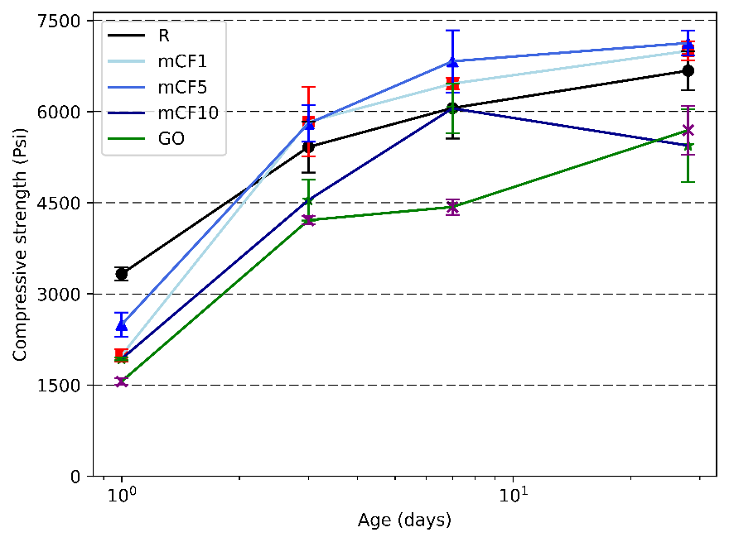

Figure 1. Compressive strength development of SSCCs.

1. Sensing performance quantification

The SSCCs samples intended for piezoresistive testing is casted. On the 28th day, piezoresistivity-based self-sensing test will be performed on the cubic specimens. The test will be conducted under both AC and DC currents. The self-sensing performance of different dosages and conductive filler types will be evaluated through several indices. Piezoresistive property of the SSCCs are quantified through the resistivity, fractional change in resistivity (FCR), gauge factor (GF), and stress sensitivity (SS). Furthermore, the stability of the of the recorded electrical signals will evaluated by calculating an index “repeatability”.

**Task 2: Specimen fabrication and determining the preliminary SSCCs placement**

Preliminary design of the 3D printed samples has been developed. The sensing mixes from Task 1 will be used to fabricate cylindrical specimens. As shown in the figure below, four types of samples will be prepared: M-0 and M-1 are mold-cast using the reference and sensing mixes, respectively. P-0 and P-1 will have 3D printed shells serving as precast concrete formwork, also using the reference and sensing mixes. Electrodes will be embedded in each sample to capture the electrical signals of the self-sensing cementitious composites, with preliminary placement determined by accessibility and print geometry.

Figure 2 Preliminary design of the 3D printed samples

1. Percent of research project completed

*Task 1: Material properties assessment (85% complete)*

*Task 2: Specimen fabrication and determining the preliminary SSCCs placement (10% complete)*

*Task 3: Load Testing and strain monitoring (0% complete)*

*Taks 4: Construct preliminary Multiphysics model (0% complete)*

1. Expected progress for next quarter

For the next quarter, optimization of the printing parameters is expected to be completed. Furthermore, permanent formwork infill structure and design will be performed in depth. Finally, ideal configuration for the placement of electrodes and the SSCCs mix in the precast additively manufactured members will be investigated.

1. Educational outreach and workforce development

*None*

1. Technology Transfer

*None*

**Research Contribution:**

*None*

**Appendix 1**: Research Activities, leadership, and awards (cumulative, since the start of the project)

1. Number of presentations at academic and industry conferences and workshops of UTC findings

* No. = 0

1. Number of peer-reviewed publications submitted based on outcomes of UTC funded projects

* No. = 0

1. Number of peer-reviewed journal articles published by faculty.

* No. = 0

1. Number of peer-reviewed conference papers published by faculty.

* No. = 0

1. Number of TRANS-IPIC sponsored thesis or dissertations at the MS and PhD levels.

* No. MS thesis = 0
* No. PhD dissertations = 0
* No. citations of each of the above = 0

1. Number of research tools (lab equipment, models, software, test processes, etc.) developed as part of TRANS-IPIC sponsored research

None

1. Number of transportation-related professional and service organization committees that TRANS-IPIC faculty researchers participate in or lead.

* Professional societies
  + No. participated in =1
  + No. lead =0
* Advisory committees (No. participated in & No. led)
  + No. participated in =0
  + No. lead =0
* Conference Organizing Committees (No. participated in & No. led)
  + No. participated in = 3
  + No. lead =0
* Editorial board of journals (No. participated in & No. led)
  + No. participated in =0
  + No. lead =0
* TRB committees (No. participated in & No. led)
  + No. participated in = 0
  + No. lead = 0

1. Number of relevant awards received during the grant year

* No. awards received = 0

1. Number of transportation related classes developed or modified as a result of TRANS-IPIC funding.

* No. Undergraduate = 3
* No. Graduate = 2

1. Number of internships and full-time positions secured in the industry and government during the grant year.

* No. of internships = 0
* No. of full-time positions = 0

**References:**

[1] L. Wang and F. Aslani, “Structural performance of reinforced concrete beams with 3D printed cement-based sensor embedded and self-sensing cementitious composites,” *Eng. Struct.*, vol. 275, no. 115266, p. 115266, Jan. 2023.

[2] W. Tian *et al.*, “Electrical performance of conductive cementitious composites under different curing regimes: Enhanced conduction by carbon fibers towards self-sensing function,” *Constr. Build. Mater.*, vol. 421, no. 135771, p. 135771, Mar. 2024.

[3] F. Azhari and N. Banthia, “Cement-based sensors with carbon fibers and carbon nanotubes for piezoresistive sensing,” *Cem. Concr. Compos.*, vol. 34, no. 7, pp. 866–873, Aug. 2012.

[4] A. Belli, A. Mobili, T. Bellezze, F. Tittarelli, and P. Cachim, “Evaluating the self-sensing ability of cement mortars manufactured with graphene nanoplatelets, virgin or recycled carbon fibers through piezoresistivity tests,” *Sustainability*, vol. 10, no. 11, p. 4013, Nov. 2018.

[5] T. Luo, Y. Ma, H. Xie, F. Li, Z. Li, and J. Fu, “Piezoresistivity of carbon fiber-reinforced alkali-activated materials: Effect of fly ash microspheres and quartz sands,” *Constr. Build. Mater.*, vol. 425, no. 136125, p. 136125, Apr. 2024.

[6] A. D’Alessandro, H. B. Birgin, and F. Ubertini, “Carbon microfiber-doped smart concrete sensors for strain monitoring in reinforced concrete structures: An experimental study at various scales,” *Sensors (Basel)*, vol. 22, no. 16, p. 6083, Aug. 2022.

[7] Y. Ma *et al.*, “Self-sensing properties of alkali-activated materials prepared with different precursors,” *Constr. Build. Mater.*, vol. 409, no. 134201, p. 134201, Dec. 2023.

[8] J. Zhang *et al.*, “Piezoresistivity and piezopermittivity of cement-based sensors under quasi-static stress and changing moisture,” *Constr. Build. Mater.*, vol. 425, no. 136052, p. 136052, Apr. 2024.

[9] X. Fan, D. Fang, M. Sun, and Z. Li, “Piezoresistivity of carbon fiber graphite cement-based composites with CCCW,” *J. Wuhan Univ. Technol. (Mater. Sci. Ed.)*, vol. 26, no. 2, pp. 339–343, Apr. 2011.

[10] J. Han, J. Pan, and J. Cai, “Self-sensing properties and piezoresistive effect of high ductility cementitious composite,” *Constr. Build. Mater.*, vol. 323, no. 126390, p. 126390, Mar. 2022.

[11] H. Ran, M. Elchalakani, F. Boussaid, S. Yehia, M. A. Sadakkathulla, and B. Yang, “Development and evaluation of conductive ultra-lightweight cementitious composites for smart and sustainable infrastructure applications,” *Constr. Build. Mater.*, vol. 375, no. 131017, p. 131017, Apr. 2023.

[12] F. J. Baeza, O. Galao, I. J. Vegas, M. Cano, and P. Garcés, “Influence of recycled slag aggregates on the conductivity and strain sensing capacity of carbon fiber reinforced cement mortars,” *Constr. Build. Mater.*, vol. 184, pp. 311–319, Sep. 2018.