

Transportation Infrastructure Precast Innovation Center
(TRANS-IPIC)

University Transportation Center (UTC)

Thermally Conductive Pre-cast Concrete Pavement for Urban Heat Island mitigation

[UT-23-RP-01]

Quarterly Progress Report
For the performance period ending [Mar 31st, 2024]

Submitted by:
Islam Radwan, Graduate Student, Islam.Radwan@my.utsa.edu
Samer Dessouky, Professor, Samer.dessouky@utsa.edu
School of Civil & Environmental Engineering and Construction Management
University of Texas at San Antonio

Collaborators / Partners:
[List any universities, companies, government agencies, etc., this research project has partnered with (if any)]

Submitted to:
TRANS-IPIC UTC
University of Illinois Urbana-Champaign
Urbana, IL
TRANS-IPIC Quarterly Progress Report:

Project Description:

- Research Plan - Statement of Problem

The Urban Heat Island (UHI) effect refers to higher temperatures in urban areas compared to the surrounding countryside due to human development. Increased thermal energy storage in paving materials contributes to the UHI effect, leading to elevated surface temperatures. Precast concrete pavement with improved mix designs is recognized globally as an emerging technology for mitigating climate change and addressing UHI. These precast elements can be incorporated into innovative pavement systems to enhance mitigation practices, employ efficient construction methods, and promote sustainable pavement restoration. The study investigates the use of precast concrete pavement to create cooler rigid pavement using various cooling mechanisms. These mechanisms involve modifying the thermal properties of pavement materials and reducing heat energy absorption or emission by pavements, while prioritizing environmental sustainability.

- Research Plan - Summary of Project Activities (Tasks)

Task 1: Literature Review
Review existing literature on UHI mitigation, thermally conductive pavements, and precast concrete technologies to identify gaps.

Task 2: Experimental Design & Material Selection
Define parameters for thermal conductivity evaluation and select optimal mix designs for testing. Acquire samples of phase changing materials (PCM) and efforts is undergoing to fabricate concrete samples.

Task 3: Laboratory Testing
Measure thermal conductivity, analyze results, and consider additional factors for various precast concrete pavement samples.

Task 4: Pavement System Design
Develop design guidelines and compile a comprehensive report.

Task 5: Field Implementation & Monitoring
Identify sites, plan installation, collect UHI data, and prepare for implementation.

Task 6: Reporting
Compile findings into comprehensive and summary reports and present them at conferences while publishing in journals.

Project Progress:

- Progress for each research task

- Task 1: Literature Review [70% Completed]
- Task 2: Experimental Design & Material Selection [75% Completed]
- Task 3: Laboratory Testing [30% Completed]
- Task 4: Pavement System Design [20 % Completed]
- Task 5: Field Implementation & Monitoring [0 % Completed]
- Task 6: Reporting [0 % Completed]

- Percent of research projects completed by the end of this quarter.

- Task 1: 70% completed
- Task 2: 75% completed
- Task 3: 30% completed
- Task 4: 20% completed
- Task 5: 0% completed
- Task 6: 0% completed

The average completion percentage would be:
(70% + 75% + 30% + 20% + 0% + 0%) / 6 tasks = % 195/ 6 tasks ≈ 32.5%

Pictures:

- Samples Preparation & Mixing:

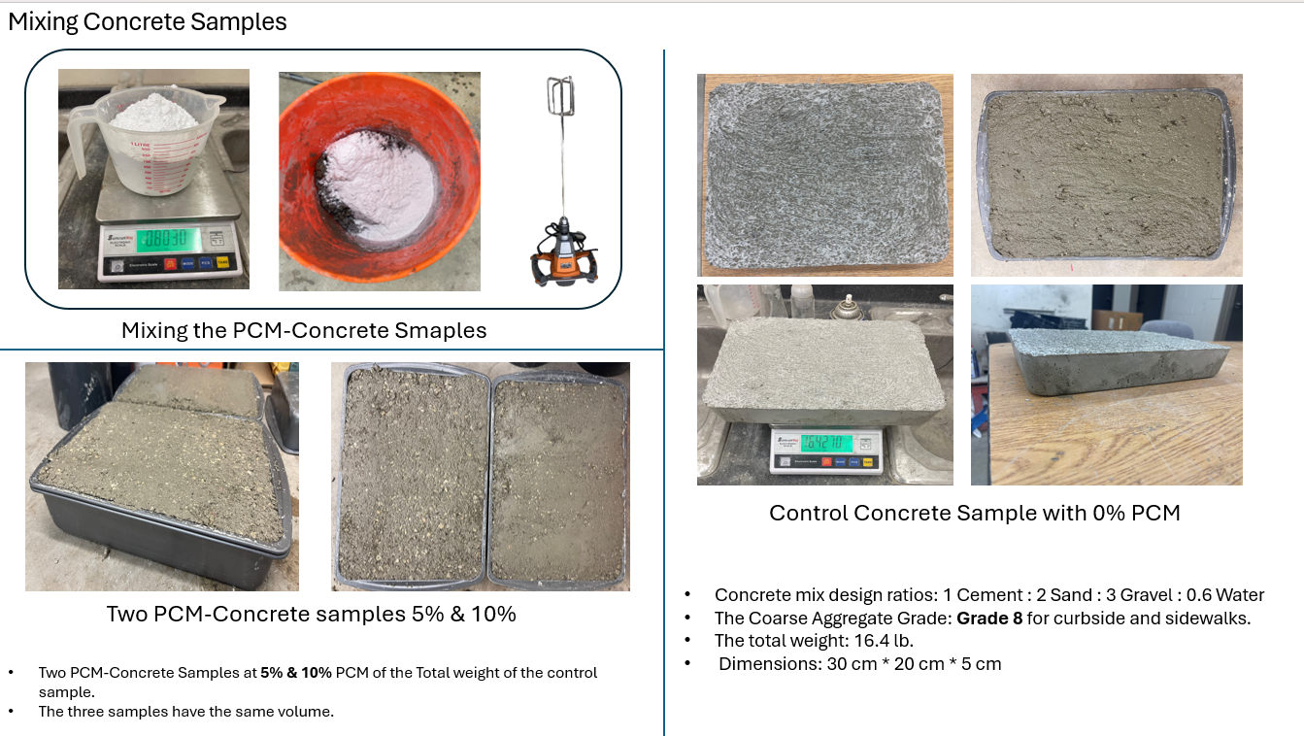
- CONCRETE – PCM Samples:

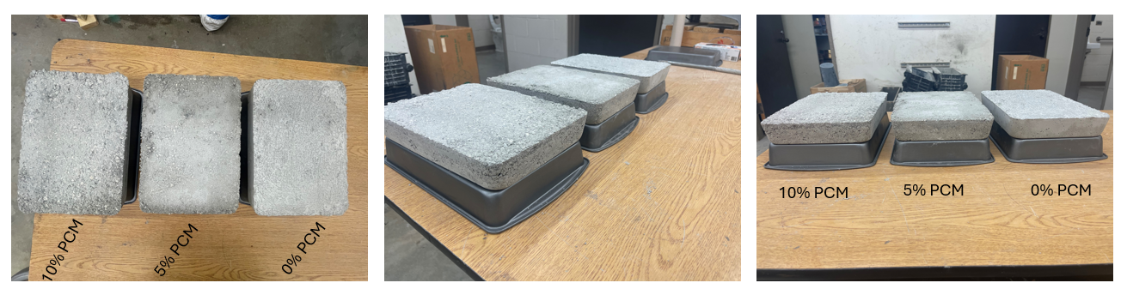

- 250-watt Bulbs:

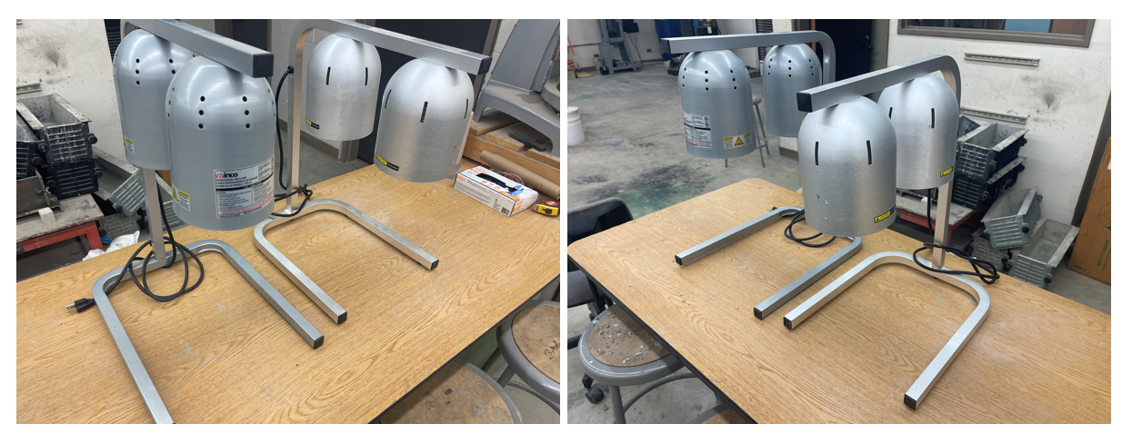

- Reflective Thermal – Insulated Box Preparation:

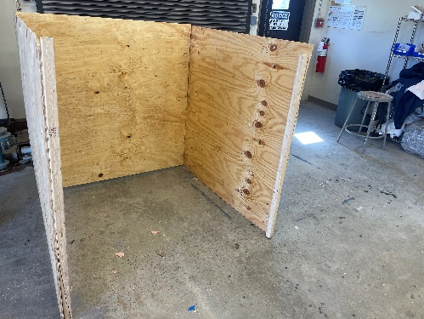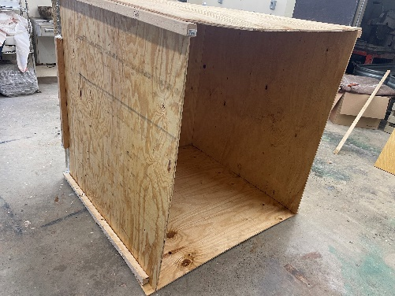

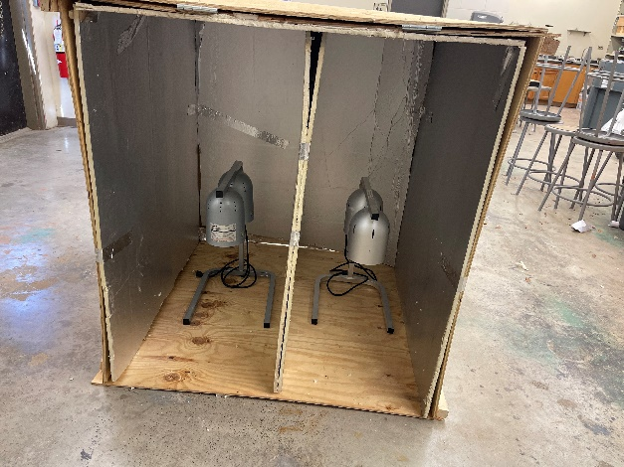
- Measuring the Specific heat Capacity, the Diffusivity, and the densities:

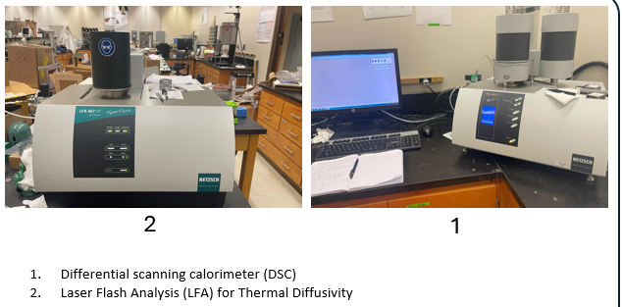

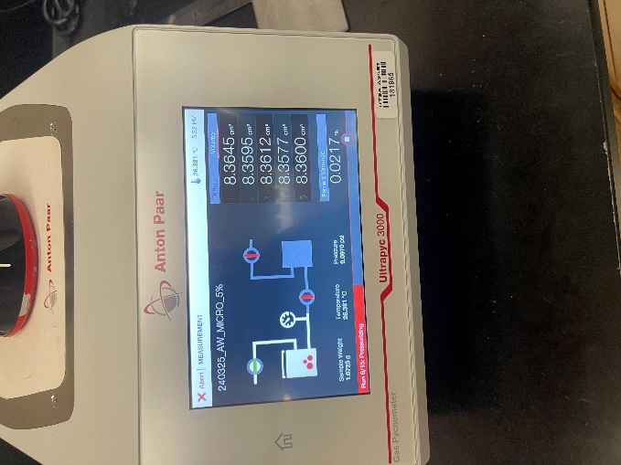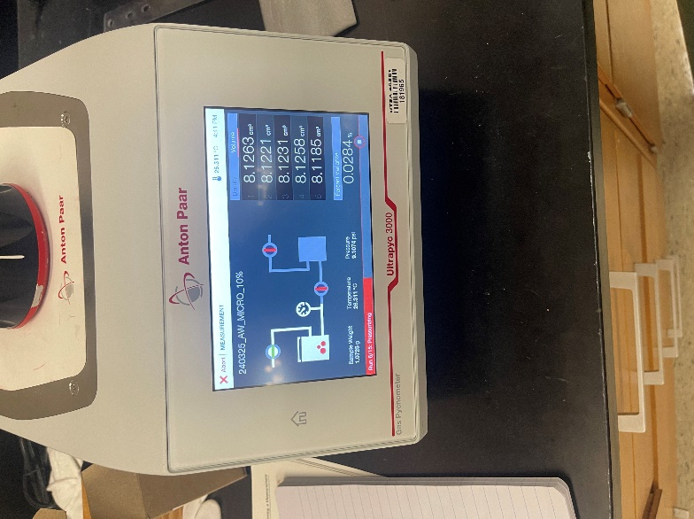

3. Pycnometer

- Expected progress for next quarter.

- Task 1: 100% completed
- Task 2: 90% completed
- Task 3: 75% completed
- Task 4: 40% completed
- Task 5: 30% completed
- Task 6: 90% completed

The average completion percentage would be:
(100% + 90% + 75% + 40% + 30% + 90%) / 6 tasks = 425% / 6 tasks ≈ 70.8%

- Educational outreach and workforce development

- A brief summary of the project has been shared with the undergraduate students in the CE 3243 class “properties and behavior of construction materials). More outreach activities will be presented as we continue to make progress in the project.

- On Feb 2024, a summary of the project was presented to the Highway Engineering Class CE 3223.

- Technology Transfer

Currently, there is no activities to present.

Research Contribution:

- Number of papers

Currently, there have been no journal and conference papers/publications resulting from this project. We anticipate that such publications may emerge as the research progresses and we begin to gather significant findings.

- Number presentations (when, where)

- TRANS-IPIC Monthly Research Webinar – March 4th, 2024

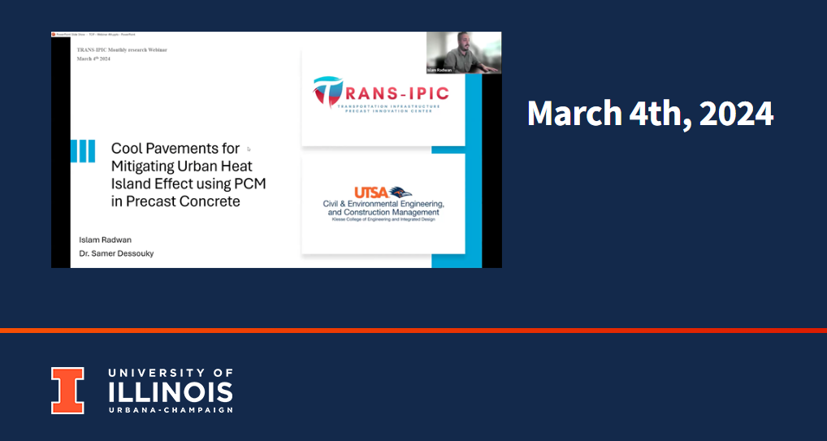

References:

- Haselbach, L., Boyer, M., Kevern, J. T., & Schaefer, V. R. (2011). Cyclic heat island impacts on traditional versus pervious concrete pavement systems. Transportation Research Record, 2240, 107–115. https://doi.org/10.3141/2240-14
- Li, H. (2012). Evaluation of Cool Pavement Strategies for Heat Island Mitigation. www.its.ucdavis.edu
- Roesler, J., & Sen, S. (2016). IMPACT OF PAVEMENTS ON THE URBAN HEAT ISLAND FINAL PROJECT REPORT. http://www.chpp.egr.msu.edu/
- Sanjuán, M. Á., Morales, Á., & Zaragoza, A. (2022). Precast Concrete Pavements of High Albedo to Achieve the Net “Zero-Emissions” Commitments. Applied Sciences (Switzerland), 12(4). https://doi.org/10.3390/app12041955

