Exhibit D

Research Project Requirement Template

Research project name: Gaze-directed UAV-UGV Coordination Framework for Onsite Quality Inspection of Precast Bridge Construction

Recipient/Grant (Contract) Number: University of Illinois Urbana-Champaign / The University of Texas at San Antonio / Grant Number 69A3552348333

Center Name: Transportation Infrastructure Precast Innovation Center (TRANS-IPIC)

Research Priority: Improving the Durability and Extending the Life of Transportation Infrastructure

Principal Investigator(s): Jiannan Cai, Ao Du, Ibukun Awolusi

Project Partners: N/A

Research Project Funding: $97,500 ($65,000 Federal and $32,500 Non-Federal)

Project Start and End Date: 01/01/2024 – 12/31/2024

Project Description:
Precast bridge components such as girders, decks, and columns facilitate accelerated bridge construction while offering improved construction quality due to the high quality control standards at the offsite precast plants. In the offsite precast plants, components need to go through rigorous dimensional and surface quality inspection, after which they are transported to the jobsite for final assembly. Contrastively, onsite quality inspection, which still largely relies on manual visual inspection on limited samples, is yet to match up with the standards of the offsite practices. Onsite quality inspection for precast bridge construction is crucial due to potential defects after the offsite construction phase. For example, damage and defects may occur during the component transportation process. The quality of onsite construction activities such as connection joint sealing, post-poured wet joints, and component localization and alignment, also significantly affect the overall structural integrity and durability. Recently, many sensing systems, such as laser scanning and vision-based systems have been developed for quality inspection of precast components. Most efforts have been dedicated to creating new data processing and analysis algorithms to improve accuracy, with very limited focus on improving the efficiency and accuracy of the data collection process using automated technology. There is a critical need to develop a robot-assisted platform to improve the efficiency and coverage of data collection and inspection for QA/QC of onsite precast bridge construction. The objective of this project is to develop a novel gaze-directed unmanned aerial vehicle (UAV)-unmanned ground vehicle (UGV) coordination framework for onsite quality inspection of precast bridge construction, see Figure 1. Specifically, UAV will provide global coverage for inspectors to quickly identify the components and construction activities for inspection while UGV will navigate to specific locations for close inspection following human guidance. A new gaze-directed human-machine interface will be developed, where inspectors can express their guidance via natural gaze movements, to reduce worker mental load. By establishing a new multi-robot-human coordination framework with natural and intuitive interactions, this project will develop an efficient and automated infrastructure inspection approach, thus improving the quality and durability and eventually extending the life of precast transportation infrastructure.

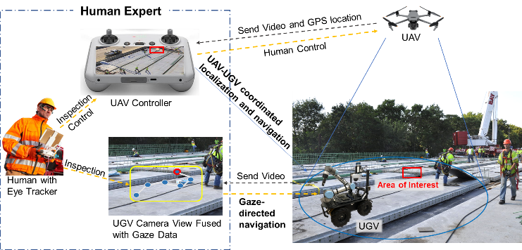
Figure 1. Proposed gaze-directed UAV-UGV coordinated framework for quality inspection

US DOT Priorities:
The proposed framework is expected to transform the practice of onsite quality inspection for precast infrastructure construction by establishing intuitive multi-robot-human teaming for efficient inspection. Such a system can be extended to provide guidance during bridge installation, thus improving construction quality and durability with reduced rework. The proposed framework can also be extended for lifecycle inspection, including offsite component inspection and condition monitoring of existing infrastructure, and eventually improve the durability and extend the life of precast transportation infrastructure.

Outputs:
The anticipated outputs include 1) a framework for UAV-UGV coordinated localization and navigation, which enables UAV to provide global coverage and the UGV to navigate to the targeted area autonomously without close proximity of UAV and UGV; 2) a gaze-directed human-robot interface where human operator could provide guidance on robot inspection via natural behavior without increasing their mental load; and 3) a prototype of the integrated gaze-directed UAV-UGV coordinated system for onsite quality inspection.

Outcomes/Impacts:
The anticipated research outcomes could be implemented with potentially practical impacts in different ways: 1) UAV or UGV could be independently used with developed gaze-directed human-robot interface, based on the availability of resources and the inspection focus. Compared with traditional control interface via physical controllers, our approach can improve efficiency and reduce mental load for human inspectors. 2) The proposed UAV-UGV coordinated inspection framework could be used as an entire system to achieve both rapid coverage and close inspection from both aerial and ground views. 3) The proposed system could be naturally integrated with the commercial drone platforms that are commonly used in practice, as it leverages mobile eye-tracker to transmit human intention to UGV without the need to integrate drones with other systems. 4) Our system could be expanded with AI modules for data analysis, such as crack detection, dimension estimation and surface condition detection for quality check, etc., thus automating the inspection work.

Final Research Report: URL link to the project's final report will be provided upon the completion of the project.

