

Transportation Infrastructure Precast Innovation Center
(TRANS-IPIC)

University Transportation Center (UTC)

Precast concrete with self-powering defrosting capability
UB-24-EP-01

Quarterly Progress Report
For the performance period ending March 31, 2025

Submitted by:
Deborah D.L. Chung, ddlchung@buffalo.edu
Department of Mechanical and Aerospace Engineering
University at Buffalo, The State University of New York

Collaborators / Partners:
None

Submitted to:
TRANS-IPIC UTC
University of Illinois Urbana-Champaign
Urbana, IL
TRANS-IPIC Quarterly Progress Report (Section 1 – 7, 5 pages max.):

Project Description:
- Research Plan - Statement of Problem
Each year, 24% of weather-related vehicle crashes occur on snowy or icy pavement and 15% happen during snowfall or sleet. Over 1,300 people are killed and >116,800 people are injured in vehicle crashes on snowy or icy pavement annually. Snow and ice increase road maintenance costs. Winter road maintenance accounts for ~20% of State DOT maintenance budgets. State and local agencies spend more than $2.3 billion on snow and ice control operations annually. Each year, these road agencies also spend millions of dollars to repair infrastructure damage caused by snow and ice. (FHWA website).
This project is aimed at developing precast concrete with self-powering defrosting capability. Defrosting capability has long (Chung, 2004) been shown to be effective in cement-based materials by resistance (Joule) heating, provided that conductive admixtures are used to reduce the resistivity. Short carbon fiber is the most cost-effective conductive admixture to greatly lower the resistivity (Chen and Chung, 1993), so that resistance heating becomes effective. Short steel microfiber is even more effective than short carbon fiber (Wang, Wen and Chung, 2004), but it is much higher in price.
The main challenge relates to self-powering, which means the provision of electric power without any external energy source (such as solar panels and wind turbines), i.e., the powering capability is built-in to the concrete. The embedment of batteries or battery components in concrete for supplying energy is not desirable, due to the short service life of batteries compared to concrete structures and the difficulty of replacing the embedded batteries. Moreover, the embedment weakens the concrete structure and the battery disposal is of environmental concern. Pyroelectricity may be rendered to concrete for the sake of self-powering under temperature variation by the use of pyroelectric admixtures such as lead zirconotitanate (PZT), which is expensive, needs to be poled, and suffers from depoling tendency. Poling requires the application of a high electric field, which is challenging when the concrete is substantial in size. Although cement-based materials are electrets (Xi and Chung, 2020), the energy provision is too low. The embedment of solar cells is also challenging, due to the fragility of the cells and the difficulty of getting sunlight into the embedded cells.
The proposed self-powering approach is based on a novel concept that does not involve any of the concepts mentioned above. Rather, it works through the thermal contraction that occurs automatically upon cooling (frosting). The contraction decreases the dielectric layer thickness of a capacitor unit, thereby increasing the capacitance and causing DC current to flow in the cement matrix in the immediate vicinity of the capacitor unit. The conductivity rendered by the carbon fiber admixture is not adequate for shorting the capacitor unit, but it is adequate for allowing current to flow from one electrode to the other in each capacitor unit as the capacitor unit discharges while the heating (defrosting) occurs and the capacitance of the unit decreases. During each instance of cooling (frosting), the capacitor charges. During each instance of defrosting (heating), which automatically and immediately occurs after cooling, the capacitor discharges. The toughness enhancement provided by the latex admixture is for avoiding the debonding (if any) of the capacitor unit from the cement matrix as it contracts thermally upon cooling.

- Research Plan - Summary of Project Activities (Tasks)
Task 1 (Month 1). Preparation of the capacitor units by 3D printing, with selection of the polymer and the dimensions of each of the layers in a capacitor unit. Ordering the needed materials and supplies.
Task 2 (Month 2). Testing the capacitor units by capacitance measurement during imposed cooling (capacitor charge, from above 0°C to below 0°C) and during subsequent imposed heating (capacitor discharge, from below 0°C to above 0°C).
Task 3 (Month 3-4). Prepare precast concrete specimens of thickness around 1 inch, with inclusion of fine and coarse aggregates and the three admixtures (carbon fiber, capacitor units and latex, as listed above) and selection of the aggregate and admixture proportions.
Task 4 (Month 4). Measure the electrical resistivity of the specimens obtained in Task 3. If the resistivity is not lower than that of conventional concrete by a few orders of magnitude, the carbon fiber content will be increased (e.g., from 1% to 2% by mass of cement) and then Tasks 3 and 4 will be repeated.
Task 5 (Month 5-6). Test the precast concrete specimens obtained in Task 3 (or repeated Task 3) by measuring the temperature continuously upon imposed cooling (capacitor charge) and during subsequent automatic heating (capacitor discharge) for assessing the effectiveness of self-powering defrosting.
Task 6 (Month 6). Devise the research plan after the proposed 6-month project and evaluate the pavement-related technology implementation feasibility. Prepare the final report.

Project Progress:
- Progress for each research task

Task 1 100% completed to date
Task 2 100% completed to date
Task 3 0% completed to date
Task 4 0% completed to date
Task 5 0% completed to date
Task 6 0% completed to date

The materials chosen for building the capacitor units are (i) commercially available carbon black filled polylactic acid (PLA) for the two conductive sheets (with in-plane electrical resistivity 30 Ω.cm and out-of-plane resistivity 115 Ω.cm, as supplied by Proto-pasta), and (ii) commercially available PLA for the dielectric (nonconductive) sheet. The PLA in (i) and (ii) is a thermoplastic polymer formed by the condensation polymerization of lactic acid; its chemical formula is (C₃H₄O₂)_{n}; it is widely used for 3D printing. The carbon black in (i) serves as a conductive filler. The dielectric sheet was sandwiched by two conductive sheets and its thickness was minimized (0.25 mm, 5 printed layers, 0.05 mm per printed layer) in order to maximize the capacitance of the capacitor. The conductive sheets can be thicker in order to provide mechanical robustness; its thickness is 1.0 mm, as consisting of 20 printed layers (of thickness 0.05 mm per printed layer) with the direction of printed lines being 45° and the direction alternating between the two 45° directions for alternate printed layers. The 3D printer (Original Prusa i3 MK3S & MK3S+, Fig. 1) has nozzle diameter 0.4 mm, nozzle temperature 102°C (215°F, below the melting point of PLA), build-plate temperature 70°C, and printing speed 200mm/s.

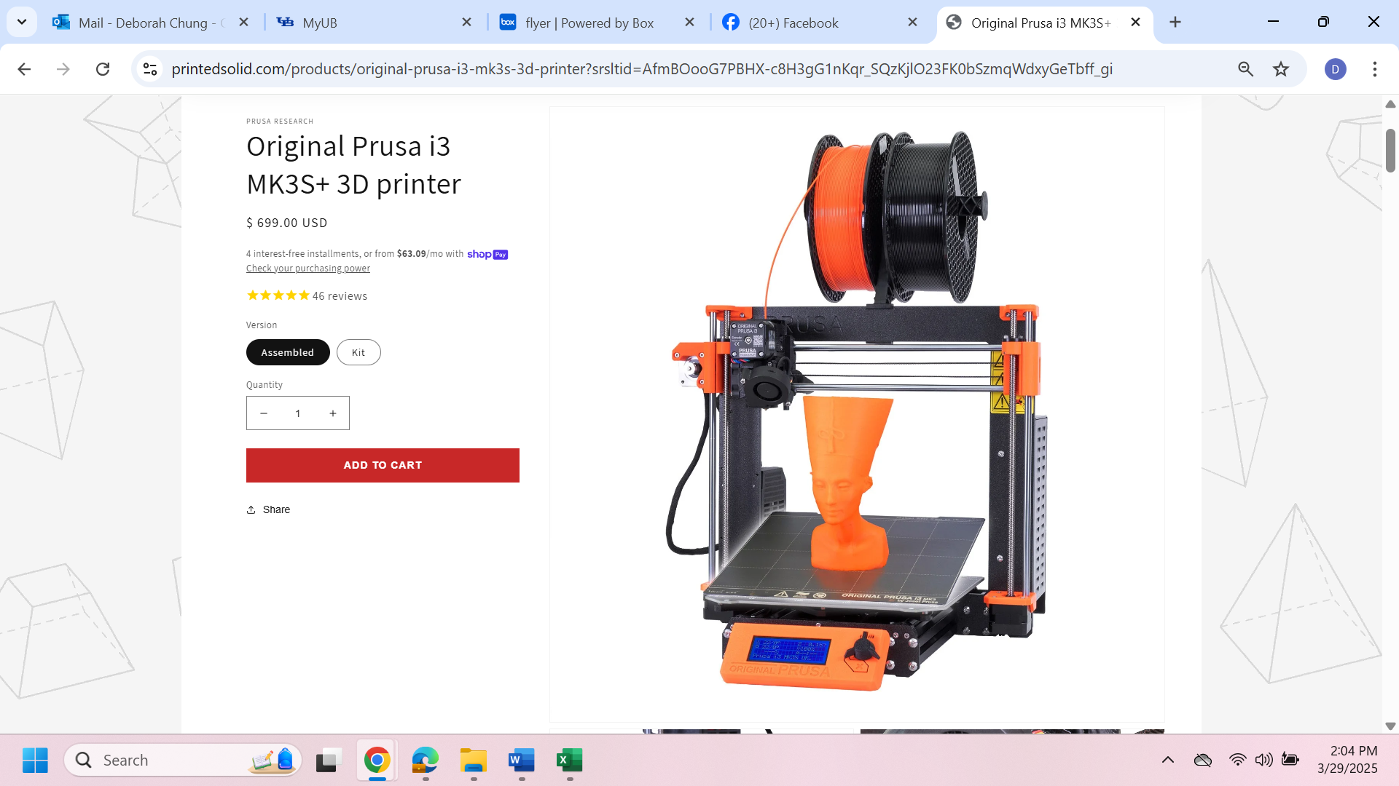
Fig.1 3D printer, operating using the FFF (Fused filament fabrication) method. Two commercially available filaments (1.75 mm diameter, melting point at 155°C or 310°F) are used - one is carbon black filled PLA (conductive) and the other is plain PLA (not conductive). (https://www.printedsolid.com/products/original-prusa-i3-mk3s-3d-printer?srsltid=AfmBOooG7PBHX-c8H3gG1nKqr_SQzKjlO23FK0bSzmqWdxyGeTbff_gi)

In order to enhance the capacitance, investigation was made with the dielectric sheet involving the printed lines either in-plane (45°, as mentioned above) or out-of-plane. It was discovered that the capacitance, which is in the out-of-plane direction, is much higher for the out-of-plane configuration than the in-plane configuration. This is reasonable, since the out-of-plane polarization continuity is much greater for the out-of-plane configuration than the in-plane configuration, as expected from the fact that the in-plane printed lines are not continuous along the out-of-plane direction, whereas the out-of-plane printed lines are continuous along the out-of-plane direction, which is the direction of the capacitance. The extrusion-based printing causes the polymer molecules to be preferentially aligned along the direction of the printed lines, but this alignment is expected to play a relatively minor role in affecting the out-of-plane polarization, since the polarization direction is not mainly along the molecular axis, but is mainly transverse to the molecular axis (Fig. 2).

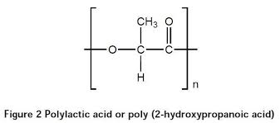
Fig. 2 The structure of a mer of polylactic acid.

The fabrication of the capacitor with the out-of-plane printed line direction for the dielectric sheet requires the printing of the conductive sheet separately from the printing of the two conductive sheets and then hot pressing the stack of three sheets to form a capacitor. In contrast, the fabrication of the capacitor with the in-plane printed line direction for the dielectric sheet is simpler, involving the three sheets printed in one operation, so that the three sheets are bonded during the printing operation, with the stacking operation not needed. For the case of the out-of-plane printed line direction, the two conductive sheets that sandwich the dielectric sheet do not need to be printed and can be simply metal foils (e.g., steel foils) in order to reduce the processing cost. Aluminum foils are less expensive than steel foils, but they tend to be dissolved in the silicates in cement when the capacitor is incorporated in cement. This means that only the dielectric sheet with the out-of-plane configuration needs to be printed. This printing may be scaled up for printing the dielectric sheet of many capacitors in one operation.

The in-plane dimensions of a capacitor is not critical. The larger are these dimensions, the greater is the area and hence the higher is the capacitance. However, for the purpose of incorporating the capacitors as an admixture in concrete, the in-plane dimensions should be limited. In this work, the capacitor area is a square of size 12.7 mm x 12.7 mm. For the purpose of capacitance measurement, each of the two conductive sheets protrude beyond the square area. In particular, the direction of the protrusion differs (180° apart) for the two conductive sheets, in order to avoid the possibility of the two clips touching one another (Fig. 3). Electrical clips are applied at the protruded parts for connection to the meter. However, for use of the capacitors as an admixture in concrete, no electrical contact is needed to any of the capacitors, so the protruded parts are not necessary.

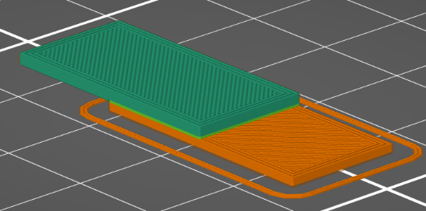

Fig. 3 Capacitor with conductive layers in green and orange, protruding out of the square overlap region (the capacitor area) in opposite direction.

The capacitance was measured using an LCR meter (set at 2 kHz, 1 V and electrical series configuration) during temperature variation, using a temperature controlled liquid bath, with the liquid being a commercially available mixture consisting of polyethylene glycol and water (equivalent to an anti-freeze, as needed due to the temperature range involving temperatures below 0°C and those above 0°C in view of the deicing application). It was observed that the capacitance increases substantially upon even slight cooling, due to the out-of-plane thermal contraction of the dielectric sheet in the capacitor and decreases substantially upon even slight heating, due to the out-of-plane thermal expansion of the dielectric sheet in the capacitor. Thus, a basic mechanism behind the deicing concept has been shown to work.

- Percent of research project completed
33% completed

- Expected progress for next quarter
The next quarter will involve Tasks 3-6.

- Educational outreach and workforce development
Three lectures on Jan. 6, 2025 in Hunan University (Department of Civil Engineering, Changsha, China), Structural self-sensing provided by measuring the resistance, capacitance or inductance of the structural material, without sensor incorporation; Carbon fiber multifunctionality enabled by conductivity, dielectricity and inductance; My 50-year journey in science.

One lecture on Jan. 8, 2025 in Sun Yat-sen University (School of Chemistry, Guangzhou), Carbon fiber multifunctionality enabled by conductivity, dielectricity and inductance. The photo in Fig. 4 was taken during this lecture.

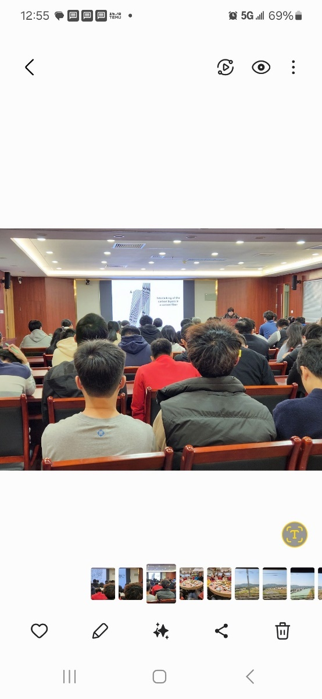

Fig. 4 Deborah Chung lecturing in Sunyatsen University, Guangzhou, China, on Jan. 8, 2025.

- Technology Transfer
None

Research Contribution:
- Papers that include TRANS-IPIC UTC in the acknowledgments section:
None

- Presentations and Posters of TRANS-IPIC funded research:
None

- Please list any other events or activities that highlights the work of TRANS-IPIC occurring at your university (please include any pictures or figures you may have). Similarly, please list any references to TRANS-IPIC in the news or interviews from your research.
None
Appendix 1: Research Activities, leadership, and awards (cumulative, since the start of the project)

- Number of presentations at academic and industry conferences and workshops of UTC findings
- No. = 0

- Number of peer-reviewed publications submitted based on outcomes of UTC funded projects
- No. = 0

- Number of peer-reviewed journal articles published by faculty.
- No. = 633

- Number of peer-reviewed conference papers published by faculty.
- No. = No record

- Number of TRANS-IPIC sponsored thesis or dissertations at the MS and PhD levels.
- No. MS thesis = 0
- No. PhD dissertations = 0
- No. citations of each of the above = 0

- Number of research tools (lab equipment, models, software, test processes, etc.) developed as part of TRANS-IPIC sponsored research
- Research Tool #1 (Name, description, and link to tool) = 0
- Research Tool #2 (Name, description, and link to tool) = 0
- Research Tool #3 (Name, description, and link to tool) = 0

- Number of transportation-related professional and service organization committees that TRANS-IPIC faculty researchers participate in or lead.
- Professional societies
  - No. participated in = 0
  - No. lead = 0
- Advisory committees (No. participated in & No. led)
  - No. participated in = 0
  - No. lead = 0
- Conference Organizing Committees (No. participated in & No. led)
  - No. participated in = 0
  - No. lead = 0
- Editorial board of journals (No. participated in & No. led)
  - No. participated in = 3
  - No. lead = 0
- TRB committees (No. participated in & No. led)
  - No. participated in = 0
  - No. lead = 0

- Number of relevant awards received during the grant year
- No. awards received = 0

- Number of transportation related classes developed or modified as a result of TRANS-IPIC funding.
- No. Undergraduate = 0
- No. Graduate = 0

- Number of internships and full-time positions secured in the industry and government during the grant year.
- No. of internships = 0
- No. of full-time positions = 0

References:
D.D.L. Chung. First review of capacitance-based self-sensing in structural materials. Sensor Actuators A 354, 114270 (2023).
D.D.L. Chung, Xiang Xi. A review of cement-based materials as electroceramics. Ceramics Int. 49, 24621-24642 (2023).
D.D.L. Chung, Murat Ozturk. Spatially resolved capacitance-based stress self-sensing in concrete. ISA Trans. 152, 299-307 (2024).
Patatri Chakraborty, Naga B. Gundrati, Chi Zhou and D.D.L. Chung, “Effect of stress on the capacitance and electric permittivity of three-dimensionally printed polymer, with relevance to capacitance-based stress monitoring”, Sensors and Actuators A, 263C, 380-385 (2017).
Patatri Chakraborty, Guanglei Zhao, Chi Zhou and D.D.L. Chung. Unprecedented sensing of interlayer defects in three-dimensionally printed polymer by capacitance measurement. Smart Mater. Struct. 27(11), 115012, 7 pp (2018).

