

Transportation Infrastructure Precast Innovation Center
(TRANS-IPIC)

University Transportation Center (UTC)

AI-based Lift Path Planning for Robotic Installation of Precast Bridge Components
[UT-24-EP-02]

Quarterly Progress Report
For the performance period ending 03/31/2025

Submitted by:
PI: Dr. Jiannan Cai, jiannan.cai@utsa.edu
School of Civil & Environmental Engineering, and Construction Management (CECM)
The University of Texas at San Antonio (UTSA)
Co-PI: Dr. Ao Du, ao.du@utsa.edu,CECM, UTSA

Collaborators / Partners:
N/A

Submitted to:
TRANS-IPIC UTC
University of Illinois Urbana-Champaign
Urbana, IL

TRANS-IPIC Quarterly Progress Report:

Project Description:
- Research Plan - Statement of Problem
Precast bridge components such as girders, decks, and columns are widely used to facilitate accelerated bridge construction. Compared to traditional cast-in-place construction, it improves efficiency, saves labor, and reduces traffic interruption. Accurate and rapid installation of precast components is crucial to ensure the quality and productivity of the entire project. Typically, large prefabricated structural components are transported by cranes to the installation location for initial positioning. Then, multiple workers are needed to collaboratively adjust the component pose so that it can precisely align with the target. The workers will need to cooperate with the crane to place the component to its final position. In current practice, the performance of crane operation is affected by multiple factors, such as the size and weight of the lifting components, experience of crane operator, complexity of jobsite, and status of outdoor environments. As a result, repetitive re-lifting and falling may be needed, which is time-consuming and reduces construction efficiency. Furthermore, it requires close coordination between skilled operators and ground workers, which is labor-intensive when the entire industry is facing a significant labor shortage crisis.
Robotic technologies have great potential to improve the accuracy and efficiency of precast component installation by automating crane operation. It was found that a partially automated tower crane, or even a simple observation device, could decrease the lifting time by 10% to 50%. Many studies have developed methods for automated crane path planning, which search for the shortest path in a controlled environment and plans a sequence of movement to transport objects between two points. Such approaches are only computationally optimal based on mathematical principles while ignoring the properties and kinematic constraints of the crane. Recently, AI-based approaches have been increasingly used for crane path planning owing to its advantages in adapting to diverse environments and better generalization capability. However, the majority of research focused on vertical projects in the building sector, and automated crane path planning for robotic installation of transportation infrastructure is yet to be studied. Considering the large scale of precast components and the complexity of site configurations in horizontal projects (e.g., bridge construction), it is critical to explore the feasibility of robotic approaches to generate optimal crane lifting path for better installation efficiency and accuracy.
The objective of this exploratory project is to develop and test an AI-based framework for 3D crane lift path planning in robotic installation of precast bridge components via physics-based dynamic simulation. The proposed method will consider the kinematic constraints of crane operation and is adaptive to diverse site configurations and structural designs. If successful, the project will prove the feasibility and benefits of using robotic technologies for installation of precast components in transportation infrastructure. The developed framework will establish the technical foundation and could be potentially extended and implemented in real construction projects with complex design and site conditions, thus improving construction productivity and reducing human efforts.

- Research Plan - Summary of Project Activities (Tasks)

Task 1: Physics-based Crane Simulation Environment Development
This task involves developing a detailed physics-based simulation environment using the MuJoCo simulation platform. Real-world specifications of crane operations and precast bridge components are modeled at a 1:1 scale. Key objectives include accurately replicating crane dynamics, visual realism, actuator behavior, and interactions with the environment to ensure the simulation accurately reflects real-world conditions.
Task 2: Reinforcement Learning (RL) Algorithm Development and Training
This task focuses on the development and training of advanced reinforcement learning algorithms tailored to robotic crane operation. The primary goal is to enable the crane model to autonomously and reliably execute complex tasks such as lifting, moving, and precisely placing precast bridge components. A critical aspect involves refining reward functions to encourage safe, accurate, and efficient operations while minimizing collision risks.

Task 3: Experimental Evaluation and Validation in Simulation
In this task, extensive simulation-based testing and evaluation are conducted to validate the performance of the developed RL algorithms. The evaluations assess the crane's accuracy, efficiency, and collision avoidance capabilities during simulated installations. Findings from these experiments inform iterative refinements to both the RL algorithms and the simulation environment, ensuring alignment with practical construction scenarios.

Project Progress:
- Progress for each research task
Task 1: Physics-based Crane Simulation Environment Development [90% Completed]
- Simulation Environment Setup:
  - Developed a custom simulation environment using MuJoCo (Multi-Joint dynamics with Contact), a physics engine widely used for simulating complex robotic systems and multi-body interactions with high accuracy. MuJoCo was chosen for its ability to model realistic physical dynamics, its compatibility with reinforcement learning algorithms, and its flexibility in designing custom environments, making it well-suited for replicating crane operations in precast bridge component installation (see Figure 1).
  - Modeled a crane (including cabin, boom, and hook actuators) and a precast concrete component at a 1:1 scale to ensure realism.
  - Enhanced the environment by resolving a wrap-around issue, adopting motor-based actuators for improved control, and adding a joint to separate the boom and hook for more accurate crane dynamics.
  - 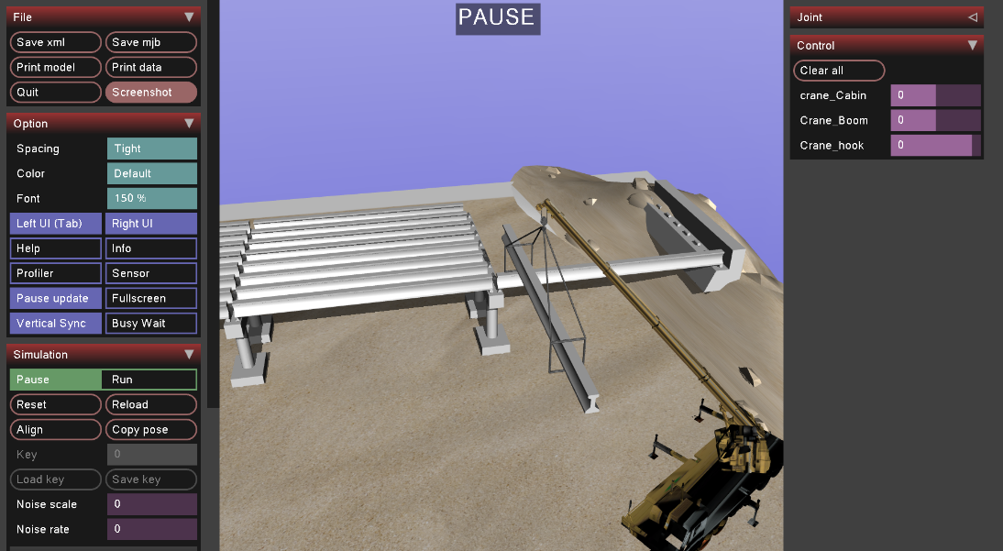
Figure 1: The Simulation Environment
  - Simulated demo: https://youtu.be/miQqFiNloU0
- Technical Improvements:
  - Redesigned the hook and concrete with ropes for realistic interactions).
  - Fixed rendering issues, updated simulation functions, and refined joint velocity calculations.

Task 2: Reinforcement Learning (RL) Algorithm Development and Training [70% Completed]
- Environment Preparation for RL:
  - Prepared the reinforcement learning (RL) environment using the Proximal Policy Optimization (PPO) algorithm within the custom MuJoCo simulation. The RL setting is defined as follows:
  - States: The observation space includes the crane’s concrete position (x, y, z coordinates from gripper_position), the target position, joint positions (qpos), joint velocities (qvel), and the concrete’s orientation as Euler angles derived from its quaternion. These states provide the agent with comprehensive information about the crane’s configuration and its relation to the installation target.
  - Actions (Control Variables): The action space consists of control inputs to the crane’s actuators (cabin, boom, and hook), defined within bounds to adjust their movements. These actions allow the agent to manipulate the crane’s position and orientation during lifting and placement tasks.
  - Reward Function: The reward encourages minimizing the distance between the concrete and the target (using a hyperbolic tangent function), maintaining a desired concrete angle (e.g., 90° vertical), and penalizing collisions with the floor or bridge, with phase-specific logic to refine behavior near the target.
  - Made considerable advancements in developing RL algorithms, with initial training demonstrating significant improvements in navigating complex trajectories and approaching target areas. Early results show the crane effectively lifting and moving the precast concrete, though final placement remains a challenge due to collision avoidance tuning.
- Reward Function and Training:
  - Began simulation training, enabling the model to learn to carry the concrete.
  - Improved the reward function to include target distance, concrete angle, and collision penalties.
  - The model navigates to the target area consistently but avoids placement due to high collision penalties.
- Current Status:
  - The RL model effectively lifts and moves the precast concrete but struggles with final placement. Debugging of the reward function and training process continues.
  - 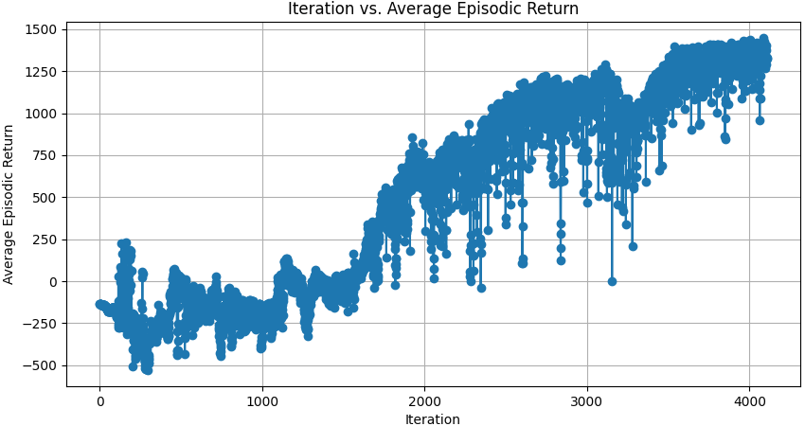
Figure 2: the Iteration vs Average Episodic retutn reward chart
  - The model after training: https://youtu.be/fsKUBFElpZY

Task 3: Experimental Evaluation and Validation in Simulation [0% Completed]
- Status:
  - This task has not started, as it relies on Task 2’s completion. Testing and validation will commence once the RL algorithms are adequately trained.
Progress Summary:
- Task 1: 90% completed (functional simulation environment established).
- Task 2: 70% completed (preliminary RL training underway, placement challenges ongoing).
- Task 3: 0% completed (not yet initiated).

- Percent of research project completed
As of March 31, 2025, approximately 53% of the project is complete, reflecting the near-completion of Task 1 (90%), substantial progress in Task 2 (70%), and the pending start of Task 3 (0%).

- Expected progress for next quarter
Task 1: Finalize the simulation environment by adding site-specific features for enhanced realism.
Task 2: Optimize the reward function to achieve precise placement of precast components.
Complete initial RL training and begin iterative refinements based on performance data.
Task 3: Start simulation-based testing to evaluate RL algorithm performance in accuracy, efficiency, and collision avoidance.

- Educational outreach and workforce development
One PhD funded via this project

- Technology Transfer
N/A

Research Contribution:
- Papers that include TRANS-IPIC UTC in the acknowledgments section:
N/A

- Presentations and Posters of TRANS-IPIC funded research:
N/A

- Please list any other events or activities that highlights the work of TRANS-IPIC occurring at your university (please include any pictures or figures you may have). Similarly, please list any references to TRANS-IPIC in the news or interviews from your research.
N/A

Appendix 1: Research Activities, leadership, and awards (cumulative, since the start of the project)

- Number of presentations at academic and industry conferences and workshops of UTC findings
- No. = 0

- Number of peer-reviewed publications submitted based on outcomes of UTC funded projects
- No. = 0

- Number of peer-reviewed journal articles published by faculty.
- No. =0

- Number of peer-reviewed conference papers published by faculty.
- No. =0

- Number of TRANS-IPIC sponsored thesis or dissertations at the MS and PhD levels.
- No. MS thesis = 0
- No. PhD dissertations =0
- No. citations of each of the above =0

- Number of research tools (lab equipment, models, software, test processes, etc.) developed as part of TRANS-IPIC sponsored research
- Research Tool #1 (Name, description, and link to tool) = 1 (Mujoco simulation environment)
- Research Tool #2 (Name, description, and link to tool) =0
- Research Tool #3 (Name, description, and link to tool) =0

- Number of transportation-related professional and service organization committees that TRANS-IPIC faculty researchers participate in or lead.
- Professional societies
  - No. participated in =1
  - No. lead =0
- Advisory committees (No. participated in & No. led)
  - No. participated in =0
  - No. lead =0
- Conference Organizing Committees (No. participated in & No. led)
  - No. participated in =1
  - No. lead =0
- Editorial board of journals (No. participated in & No. led)
  - No. participated in =0
  - No. lead =0
- TRB committees (No. participated in & No. led)
  - No. participated in =0
  - No. lead =0

- Number of relevant awards received during the grant year
- No. awards received = 0

- Number of transportation related classes developed or modified as a result of TRANS-IPIC funding.
- No. Undergraduate =0
- No. Graduate = 0

- Number of internships and full-time positions secured in the industry and government during the grant year.
- No. of internships =0
- No. of full-time positions = 0

References:
N/A

