**Transportation Infrastructure Precast Innovation Center**

**(TRANS-IPIC)**

**University Transportation Center (UTC)**

Data-Driven Smart Composite Reinforcement for Precast Concrete

PU-23-RP-05

Quarterly Progress Report

For the performance period ending *June 30, 2024*

**Submitted by:**

Chengcheng Tao (PI), [tao133@purdue.edu](mailto:tao133@purdue.edu)

Shanyue Guan (Co-PI), [guansy@purdue.edu](mailto:guansy@purdue.edu)

School of Construction Management Technology

Purdue University

**Collaborators / Partners:**

Heidelberg Materials

**Submitted to:**

TRANS-IPIC UTC

University of Illinois Urbana-Champaign

Urbana, IL

**TRANS-IPIC Quarterly Progress Report:**

**Project Description:**

1. **Research Plan - Statement of Problem**

Composite reinforcement has been increasingly applied in the precast concrete (PC) area [1], because of its high strength, lightweight, high fracture toughness, long-term corrosion, and crack resistance. The behavior of composite reinforcement plays an important role in the precast concrete infrastructure. It is important to monitor the material system and provide real-time situational awareness under different scenarios. Physical testing with trial-and-error approaches on composite reinforced PC components require substantial time, labor, and material resources to monitor the structural and materials conditions and detect failure or anomalies under service. There is a lack of an efficient and precise way to monitor and predict the risk of the composite reinforcement for PC components.

The proposed research aims to develop a smart composite reinforcement in precast concrete for real-time health condition monitoring using embedded sensors on the composite. The monitoring system can provide the health condition and risk information of the composite reinforcement and investigate the load transfer effectiveness between layers of the reinforcement and the precast concrete. The self-sensed composite reinforcement experimental data will be paired with computational models of composite-concrete system and data-driven machine learning algorithms to predict the risk of the composite reinforcement for a better reinforced precast concrete system. The research will integrate smart sensor technology, computational mechanics of materials, and data-driven machine learning algorithms to detect the structural and materials failure and anomaly mechanism, and predict the associated risk in a wide range of applications.

1. **Research Plan - Summary of Project Activities (Tasks)**

Task 1. Development and testing of embedded smart sensors for self-sensing composite reinforcement in precast concrete.

This task focuses on the smart sensor development and application for the composite reinforcement in PC. The testing data will be integrated with Tasks 2 and 3.

Task 2. Multi-scale multi-physics modeling with finite element analysis for the composite reinforcement mechanical and bonding performance.

The task focuses on the development of three-dimensional (3D) finite element analysis models to simulate the mechanical and bonding performance of composite reinforcement and precast concrete.

Task 3. Development of precast concrete risk index for the infrastructure integrity management enhanced by AI algorithms.

This task focuses on the machine learning-based risk analysis using data from Tasks 1 and 2.

Task 4. Reporting.

Research outcomes will be summarized in the quarterly and final reports submitted to TRANS-IPIC and publications in journals. Presentations of the research findings will be disseminated to the TRB and ASCE conferences.

**Project Progress:**

1. **Progress for each research task**

**Task 1 progress [30% completed]**

This task focuses on the development of smart composite reinforcement through the application of smart sensor technology. Sensor data will be collected from the three-point flexural test on a glass fiber-reinforced polymer (GFRP) composite reinforced concrete beam. ACI 440.11 [2] and ACI 440.1R [3] are used for the structure design of the composite reinforcement, and ASTM C293 [4] is used for the flexural test of concrete beam. The composite-reinforced concrete beam, with cross-sectional dimensions of 6x6 inches and a length of 20 inches, will be tested using the Forney™ 400 series compression machine. Figure 1 shows the schematic of the experimental setup. High-definition fiber optic strain sensor, together with two types strain gauges for rebar and concrete are embedded to develop self-sensing function for the system. Digital image correlation (DIC) camera is used to monitor the concrete crack propagation during flexural testing. The smart system allows for real-time monitoring of the reinforcement-concrete system, identify critical points during the loading, and provide dataset to validate finite element analysis results and train machine learning-based risk assessment in the following tasks.

Figure 1. Schematic of the experimental setup of the smart composite reinforcement-concrete system.

**Task 2 progress [60% completed]**

Task 2 focuses on the finite element analysis (FEA) of the mechanical performance of the composite reinforced concrete. As the complement of the sensor data, finite element analysis provides a more comprehensive physics-informed database by considering more scenarios such as geometry, materials, loading conditions, and rebar configurations. The database will be validated and integrated with experimental results to train the machine learning algorithms in Task 3. We conduct finite element analysis for the flexural strength test in Abaqus for the reinforcement-concrete system. The glass fiber-reinforced plastic composite rebars (PINKPAR) are simulated with the following material properties: Young’s modulus = 46.88 GPa, Poisson’s ratio = 0.3, and ultimate strength = 1,003 MPa. Uniform meshing is adopted for the concrete beam with a total of 90,900 elements, while relatively finer meshing is used for rebars their smaller sizes. The interfacial contact between concrete and reinforcements is set to be fully bonded, with the embedded element option selected in the simulation [5]. And we apply the concrete damage plasticity (CDP) and elasto-plasticity models for the nonlinear analysis. The plasticity parameters for the CDP model are defined as follows: dilation angle = 30o, eccentricity = 0.1, ratio of biaxial compressive strength to uniaxial compressive strength = 1.16, ratio of the second stress invariant on the tensile meridian = 0.66 [6]. Nonlinear analysis is conducted by controlling the displacement of the top loading head, with uniformly moves downwards. Figure 2 shows the crack propagation process from the vertical flexural cracks at the bottom center to the 45o shear crack that connects the top load head and two bottom supports. Larger damage in tension (DAMAGET) indicate higher damage level. The cracks in the concrete beam propagate from vertical flexural cracks at the bottom center to the 45o shear crack towards the loading and supporting area. At the final stage, shear cracks dominate and lead to the structural failure of the concrete beam. The simulation results generate a physics-informed database to train machine learning-based risk assessment algorithms in Task 3.

|  |  |
| --- | --- |
|  |  |
| (a) |
|  |
|  | (b) |
|  |  |
|  | (c) |
|  |  |
|  | (d) |

Figure 2. FEA results on the crack propagation of the composite reinforced concrete beams under flexural strength test (a) t = 0.15s; (b) t = 0.4s; (c) t = 0.6s; (d) t = 1s.

In addition to the flexural strength test, we study the bonding performance between composite rebar and concrete materials by conducting finite element analysis of the pull-out test. We first validate our finite element model of the pull-out simulation by comparing the analysis results with the reference data [6], based on the experimental setup defined in the standard pull-out test RC6 [7]. In the FEA of pull-out test we employ the same CDP and elastic-plasticity models used in the previous three-point flexural analysis. Figure 3 shows the geometry of the FEA model for pull-out test.

|  |  |
| --- | --- |
|  |  |
| (a) | (b) |

Figure 3. (a) 3D FEA model of the pull-out test for reinforcement and concrete; (b) 3D model of the rebar with ribs.

We validate our FEA model for the pull-out test by comparing the crack pattern using damage in tension (DAMAGET) with the reference. As shown in Figure 4(a), the FEA model exhibits splitting cracks, which is aligned with the experimental results by Metelli & Plizzari [8]. Figure 4(b) shows the comparison between the bonding stress 22MPa from our FEA and the bonding stress 21 MPa by Seok et al. [6]. We will conduct further pull-out simulations based on the specified composite rebar bonding strength test standard ASTM-D7913M [9] in the next report and evaluate its bonding performance.

|  |  |
| --- | --- |
|  |  |
| (a) | (b) |

Figure 4. Pull-out test results: (a) External cracking pattern; (b) Comparison of bonding stress results.

**Task 3 progress [30% completed]**

In this task, we train the machine learning (ML)-based risk assessment model using the finite element results of the three-point flexural test. We define the risk based on the crack propagation data during the flexural test. DAMAGET stands for "Tensile Damage Initiation" which is used to describe a level at which a material starts to be damaged in tension [10]. Specifically, when the tensile stress of the material reaches the threshold defined by DAMAGET, Abaqus starts to calculate the damage variables and simulate the damage behavior of the material. Higher DAMAGET values indicate greater tensile damage in the elements. In this way, DAMAGET could be a metric for risk prediction of composite beam. Thus, we train the DAMAGET data at different time steps generated from the FEA results in Task 2.

For three-point flexural test, the DAMAGET values at the surface of the beam across varying loading conditions are compiled into a dataset to train the risk model. We apply seven machine learning algorithms to train (80%) and test (20%) the FEA dataset. Table 1 summarizes prediction performance of the algorithms through the error analysis. is the coefficient of determination, showing the goodness of the fit. *MSE* is the mean square error, and *MAE* is the mean absolute error. *MSE* and *MAE* are used to measure the difference between the model's predicted value and the actual value.

Table 1. Prediction performance of DAMAGET with different machine learning algorithms.

|  |  |  |  |
| --- | --- | --- | --- |
| **Algorithms** |  | ***MSE*** | ***MAE*** |
| Support Vector Machine | -0.205 | 0.132 | 0.158 |
| Linear Regression | 0.109 | 0.097 | 0.219 |
| Ridge Regression | 0.109 | 0.097 | 0.219 |
| Decision Tree | 0.952 | 0.005 | 0.009 |
| Random Forest | 0.960 | 0.004 | 0.012 |
| XG Boost | 0.945 | 0.006 | 0.031 |
| Light GBM | 0.717 | 0.031 | 0.088 |

As shown in Table 1, linear algorithms (1-3), for example Ridge Regression, have a poor performance in DAMAGET predictions. However, tree algorithms (4-7) show a better effect, their goodness of fit is almost all above 0.9. Therefore, random forest regression is a suitable algorithm for risk prediction. Random forest regression is an ensemble learning method that combines multiple decision trees to predict a continuous target variable [11]. As shown in Figure 5. For each decision tree, a random subset of features is selected at each split point. This introduces additional randomness and helps in reducing the correlation between trees. The final prediction of the random forest regression model is obtained by averaging the predictions of all individual trees.

Figure 5. Typical structure of random forest regression algorithm.

Figure 6 shows comparison of the concrete crack patterns at *t* = 0.6 s (or displacement = 3 mm) between the DAMAGET distribution in FEA and risk distribution in ML. Risk index is obtained by normalizing the value of DAMAGET into 0 to 1. According to the comparison result, random forest regression provides a prediction with *R2* = 0.96, *MSE* = 0.004, and *MAE* = 0.012. To some extent, *R2* can be considered as the proportion of accuracy predicted by regression [12]. *R2* = 0.96 indicates the accuracy of the prediction.

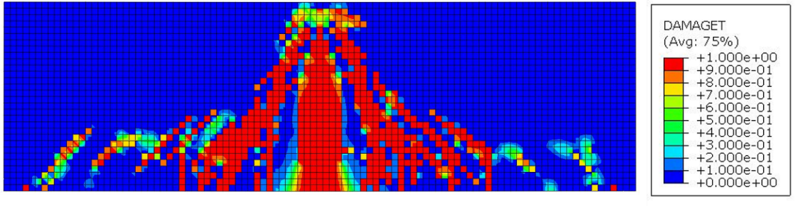

(a)

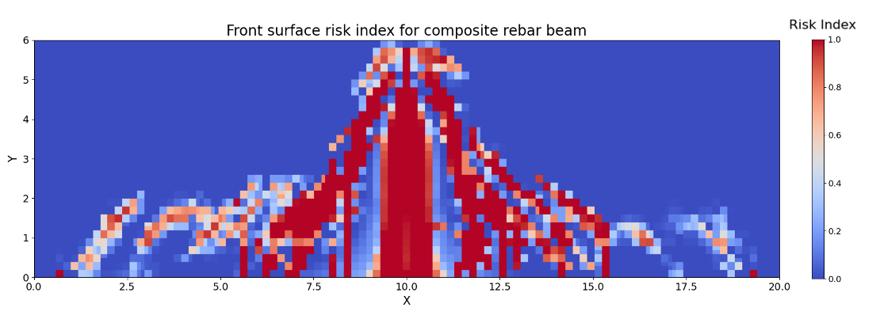

(b)

Figure 6. Comparison between FEA (a) and ML (b) results at t=0.6s.

For the composite reinforcement, the ‘risk’ usually means the risk of beam that may arise from tensile or shear force, instead of the risk of composite rebar. From the simulation results, the ultimate strength of the rebar is 1,003 MPa, which is significantly higher than the maximum von Mises stress (309.69 MPa) and maximum principal stress (321.91 MPa). Figure 7 shows the result of prediction of Von Mises stress and maximum principal stress of composite rebar at (or displacement = 3 mm). indicates that the prediction result is good.

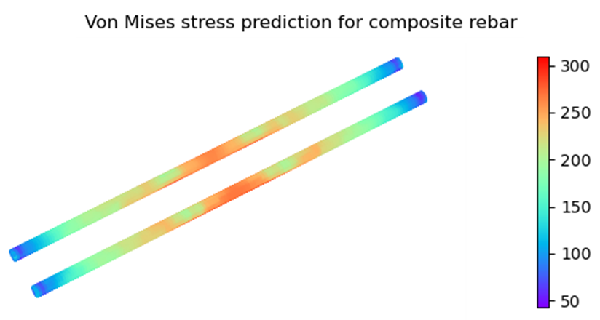

(a)

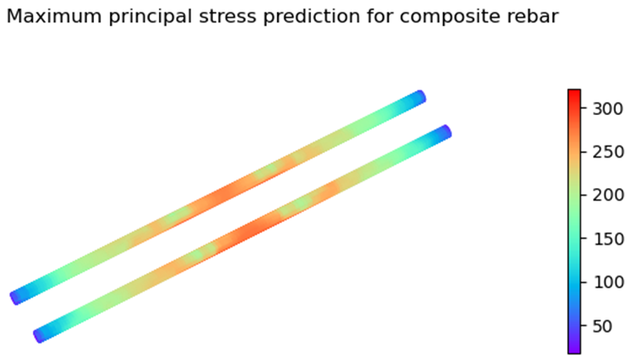

(b)

Figure 7. Stress prediction by Random Forest Regression. (a) Von Mises stress (b) Maximum principal stress.

Figure 8 shows the comparison of maximum principal strain of rebar between FEA simulation and ML prediction. By training and testing the random forest model, we accurately predict the maximum principal strain in the composite rebar, where and .

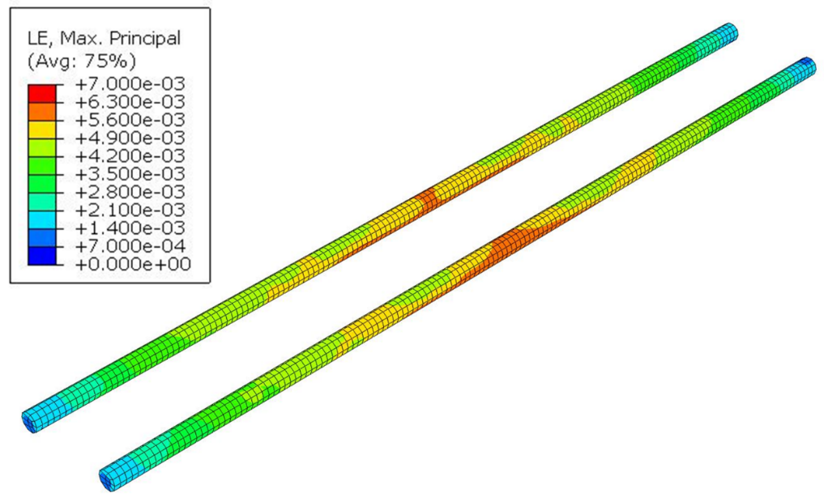

(a)

(b)

Figure 8. Comparison of maximum principal strain in composite rebar between FEA and ML prediction results.

**Task 4 progress [40% completed]**

Two quarterly reports have been completed. One paper submitted to the TRB Annual Meeting is in preparation.

1. **Percent of research project completed**

Total project completed through the end of this quarter = 55%

1. **Expected progress for next quarter**

The next quarter will focus on the experiment, sensor installation and calibration for mechanical performance of the composite reinforced concrete.

1. **Educational outreach and workforce development**

N/A

1. **Technology Transfer**

N/A

**Research Contribution:**

1. **Number of papers**

One paper submitted to the TRB Annual Meeting is in preparation.

1. **Number presentations (when, where)**

1. Tao, C., Guan, S, Duan, J., Lin, Y., & Yan, H. (2024). Data-Driven Smart Composite Reinforcement for Precast Concrete, U.S. Department of Transportation (USDOT) - University Transportation Center (UTC), Transportation Infrastructure Precast Innovation Center (TRANS-IPIC) Workshop, Chicago, IL, April 22, 2024.

**References:**

[1] E. Hamed, ‘Load-carrying capacity of composite precast concrete sandwich panels with diagonal fiber-reinforced-polymer bar connectors’, *PCI J*, vol. 62, no. 4, pp. 34–44, 2017.

[2] M. L. de Murphy et al., Eds., *Building code requirements for structural concrete reinforced with glass fiber-reinforced polymer (GFRP) bars-code and commentary: an ACI Standard*, First printing: September 2022. Farmington Hills, MI: American Concrete Institute, 2022.

[3] American Concrete Institute, *Guide for the design and construction of structural concrete reinforced with fiber-reinforced polymer (FRP) bars*, 1st printing. Farmington Hills, MI: American Concrete Institute, 2015.

[4] C09 Committee, ‘Test Method for Flexural Strength of Concrete (Using Simple Beam With Center-Point Loading)’. ASTM International[Online]. Availablehttp://www.astm.org/cgi-bin/resolver.cgi?C293C293M-16[Accessed: 27June2024].

[5] H. Sinaei et al., ‘Evaluation of reinforced concrete beam behaviour using finite element analysis by ABAQUS’, *Sci. Res. Essays*, vol. 7, no. 21, pp. 2002–2009, 2012.

[6] S. Seok et al., ‘Finite element simulation of bond-zone behavior of pullout test of reinforcement embedded in concrete using concrete damage-plasticity model 2 (CDPM2)’, *Eng. Struct.*, vol. 221, p. 110984, 2020.

[7] International Union of Testing and Research Laboratories for Materials and Structures, *RILEM technical recommendations for the testing and use of construction materials*. London Weinheim: Spon, 1994.

[8] G. Metelli and G. A. Plizzari, ‘Influence of the relative rib area on bond behaviour’, *Mag. Concr. Res.*, vol. 66, no. 6, pp. 277–294, Mar. 2014 [Online]. Available: 10.1680/macr.13.00198.

[9] ‘ASTM D7913M Standard Test Method for Bond Strength of Fiber-Reinforced Polymer Matrix Composite Bars to Concrete by Pullout Testing’. .

[10] I. Drygala et al., ‘Numerical evaluation of seismic-induced damages in masonry elements of historical arch viaduct’, in *IOP Conference Series: Materials Science and Engineering*, 2018, vol. 364, no. 1, p. 012006[Online]. Availablehttps://iopscience.iop.org/article/10.1088/1757-899X/364/1/012006/meta[Accessed: 29June2024].

[11] A. Singh et al., ‘A review of supervised machine learning algorithms’, in *2016 3rd international conference on computing for sustainable global development (INDIACom)*, 2016, pp. 1310–1315[Online]. Availablehttps://ieeexplore.ieee.org/abstract/document/7724478/[Accessed: 27June2024].

[12] D. Chicco et al., ‘The coefficient of determination R-squared is more informative than SMAPE, MAE, MAPE, MSE and RMSE in regression analysis evaluation’, *Peerj Comput. Sci.*, vol. 7, p. e623, 2021.