Transportation Infrastructure Precast Innovation Center (TRANS-IPIC)

University Transportation Center (UTC)

Shape Memory Alloy Transverse Reinforcement for Precast Bridge Girders End Regions

Project No.: UI-23-RP-01

Quarterly Progress Report
For the performance period ending December 31st, 2023

Submitted by:
PI: Bassem Andrawes, andrawes@illinois.edu Department of Civil and Environmental Engineering University of Illinois at Urbana-Champaign

Collaborators / Partners:
- Utility Concrete Products (UCP), LLC
- Illinois Department of Transportation (IDOT)

Submitted to:
TRANS-IPIC UTC
University of Illinois Urbana-Champaign Urbana, IL

TRANS-IPIC Quarterly Progress Report:

Project Description:
- Research Plan - Statement of Problem

Despite the success of using concrete prestressing technology in the longitudinal direction, it has not been implemented in the transverse direction due to many practical challenges. The reason is that no practical method exists for prestressing internal shear reinforcement such as hoops, stirrups, or spirals because these reinforcements are fully embedded in the concrete; hence, gripping the reinforcement ends for prestressing is not feasible. This research will investigate a new technology for applying prestressing in the transverse direction using a class of smart metallic materials known as shape memory alloys (SMAs). Excessively deformed bars and wires made of SMAs can remember their original shape when subjected to a temperature of approximately 200⁰C. This project will use this novel material to solve the longstanding problem of splitting and bursting cracking at the end regions of precast concrete (PC) bridge girders. Applying prestressing in the transverse direction (i.e., vertically) within that local region will help mitigate concrete cracking during prestressing and reduce steel congestion in this region.

Research Plan - Summary of Project Activities (Tasks)
The research plan for this project includes two primary tasks:

Task (1): Design of Specimens using Finite Element Method:
This task will focus on evaluating the behavior of the specimens through a detailed finite element (FE) analysis. A realistic longitudinal prestress force that satisfies all AASHTO limit states will be adopted. The specimen's behavior with conventional (non-prestressed) transverse reinforcement will also be investigated using the amount of transverse steel specified by AASHTO. The case that produces the highest bursting effect will be used for the experimental stage of the project.

Task (2): Fabrication, Instrumentation, and Testing of Specimens:
Three specimens (one used as a control specimen with conventional steel and two specimens with SMA) will be fabricated and tested. Before casting, prestressing strands will be tensioned, and SMA transverse reinforcement will be placed at the specimen's ends. Next, the strands will be detensioned, and the progression of bursting stresses/cracks will be monitored.

Project Progress:
- Progress for each research task

Task 1 progress (65% completed): The work in this task during this quarter focused on using the finite element (FE) method to analyze several designs for bridge girders with and without shape memory alloy reinforcement placed at the end region. The goal was to examine numerically the feasibility of the new concept of applying transverse prestressing to mitigate the end region damages due to the transfer of prestressing force.

For example, using the FE program ABAQUS, the end region damage of the BT-72 girder caused by prestress transfer was examined. The BT-72 numerical model is seen in Figure 1. The numerical model was intended to be half the length because of symmetry. A steel plate support with a pinned boundary condition was modeled at the bottom edge of the girder. A comparable section area was utilized with a single wire for the prestressing strands rather than modeling seven wires. The element type used for modeling the prestressing steel was a linear 3-D truss with two nodes (T3D2). A prestress of 202.5 ksi was applied by taking advantage of the strands' thermal expansion. The embedded constraint type was used to bind prestressing strands to concrete.

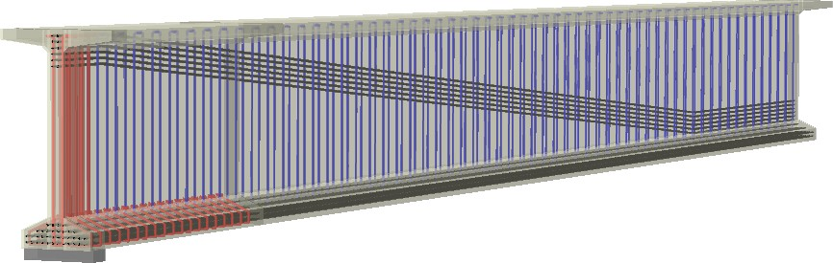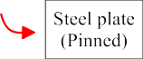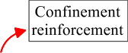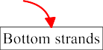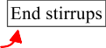
Figure 1. Finite element model of the BT-72 girder considered in the analysis

A graphic representation of the BT-72 girder's crack pattern may be found in Figure 2. The crack pattern is contoured using the maximum primary strain of the concrete at the critical area. The hues are categorized based on the major strain's magnitude (tensile strain). The sections that are blue indicate locations where the major strain was almost negligible, indicating that crack propagation is not expected. Where the primary strain is greater than the cracking strain, cracks are first seen in places indicated in green. Red areas represent regions where the concrete is entirely cracked.

When numerical models containing SMAs were analyzed, the impact of the SMA on the end region was assessed with little change to the design. At the points, the SMA stirrup's dimensions were altered. A U- shaped hoop at the bottom and a 90° hoop at the top comprised the original steel stirrup. To counteract the stress concentration brought on by SMA prestressing and prevent undesired cracks, a 90° hoop with a 6 in. heading outward was substituted for the lower U-shaped hoop in the SMA stirrup. Three examples were used to evaluate the impact of SMA in the end region, as Table 1 illustrates. The SMA models were designated in the following order: "S" for SMA, the number of stirrups (1 and 2), and the number of end region stirrups (3 and 5). The following is how the analysis went: 1) Replace one or two steel stirrups to assess the impact of SMA stirrups; 2) Reduce the number of end region stirrups to three and use one SMA stirrup to examine the damage.

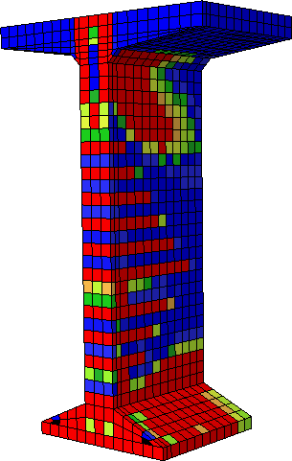
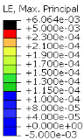

Figure 2. Damage at the end region resulting from FE analysis

Table 1: Number of steel and sMA components in the end region
Type | Stirrup
 | # of steel | # of SMA
BT-72 | 5 | 0

5S2 | 3 | 2
5S1 | 4 | 1
3S1 | 2 | 1

For every case, measurements were taken of the width and length of the crack at the bottom web-flange connection. In BT-72, 5S2, 5S1, and 3S1, the crack length was 6, 4, 2, and 2 inches, respectively. When it came to reducing crack length, single SMA stirrups outperformed multiple SMA stirrups. The prestressing force of the SMA has successfully contained the concrete, given that the stirrups were positioned 2 inches from the end face. At a distance of 4 inches from the end face, the fracture width at the bottom web-flange connection was measured (Figure 3). The SMA models' crack length—which showed no more cracking— was used to determine the length. The crack width for BT-72 was greater than 00.7 in, while for the SMA cases it was less than 0.004 ~ 0.005 in.
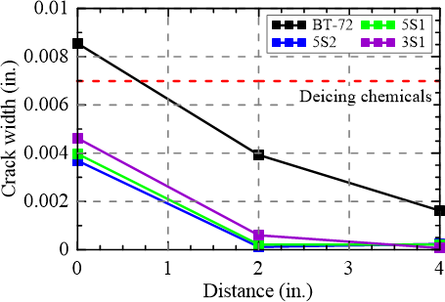

Figure 3. Crack width vs. the distance from the girder’s end

Task 2 progress (10% completed): This task during this quarter focused on evaluating the amount of material needed to build the specimens. Plans were developed for building the forms, prestressing the strands, and activating the SMA stirrups in the lab. The specimens will be built using No. 2 steel rebars, 0.5 in prestressing strands, and 0.25in diameter NiTiNb SMA bars used as end stirrups. A fixture frame will be anchored to the lab floor and used to tension the prestressing strand. Strain gauges and digital image correlation (DIC) will be used to monitor the strain development at the end region of the specimens.

Percent of research completed

Total project completed through the end of this quarter = 20%

Expected progress for next quarter

The next quarter will focus on finalizing the analysis needed to design the test specimens and start building the specimens. At least two specimens is expected to be constructed during the next quarter; the first specimen will be reinforced with conventional steel transverse reinforcement, while the second specimen will be reinforced with the SMA end stirrups.

Educational outreach and workforce development

A presentation at the Transportation Research Board (TRB) annual meeting and a webinar scheduled on February are planned as part of the educational outreach and workforce development activities carried out through this project.

Technology Transfer

Nothing to report yet.

Research Contribution:

Number of papers

  - Park S. and Andrawes B. "Damage Mitigation of Prestressed Girders End Regions Using Shape Memory Alloys" 2024 Transportation Research Board Annual Meeting (Accepted). (Federal Funds Acknowledgment: Yes)

  - Perez-Claros E. and Andrawes B. "Active Confinement of Precast Concrete Columns using FeMnSi
Shape Memory Alloy Hoops" 18th World Conference on Earthquake Engineering, July 2024, Milan, Italy

Number of presentations (when, where)

Nothing to report.

References:

N/A

