MC-SOLVE Practice Questions:

1. From the **Home tab**, identify which **slide/flowcell** contains the **largest number of cells**. How did you determine this?
2. Using the **Panel Information tab** > **Cell Type Reference**, for the **Brain MCA** reference profile, which cell type has the highest expression of **Ttr**?
3. In the flowcell **"normal_slide"**, how many **Fields of View (FOVs)** failed **quality control (QC)**? List the names or identifiers of the FOVs that did not pass QC.
4. Using the **FOV-level QC** tab, can you identify an additional FOV that you may want to exclude as well?
5. Using the **Visualize Slide** tab, where are these FOVs on the tissue?
6. **Visualize FOV 157** within the **"cancer_slide"** flowcell. How many **distinct cell types** were identified using the **IO reference profiles**?
7. Using **Visualize FOV**, can you find any **doublets** in any of the FOVs of the slides? Which slides? What are their cell type? (Hint: turn cell annotation color to “Area” to see large cells in Yellow)
8. Go to **Interactive Selection** in the **half brain slide**, how many cells are initially present, and how many are left after applying filters where **qcFlagsCell == "Pass"** and **insitutype_Brain_MCA_prob > 0.95**?  (Hint: open the **Filter** accordion)
9. You are specifically interested in **Neuron** cells (using the Brain MCA reference). Where on the slide are the Neuron cells located in the **top-left corner of UMAP**? What about **bottom-right corner of the UMAP**?
10. What part of the brain has the greatest expression of **MALAT1**? (Hint: use Half Brain). **Challenge**: What type of cells do these represent? (Hint: either download the metadata using the shopping cart)
11. Open discussions

* Based on this secondary analysis, what **tertiary questions** or hypotheses could you explore?
* In your own words, **what does spatial biology mean to you**, and how can it advance scientific discovery?

MC-SOLVE Practice Answers:

1. From the Home tab, identify which slide/flowcell contains the largest number of cells. How did you determine this?
2. half_brain_slide

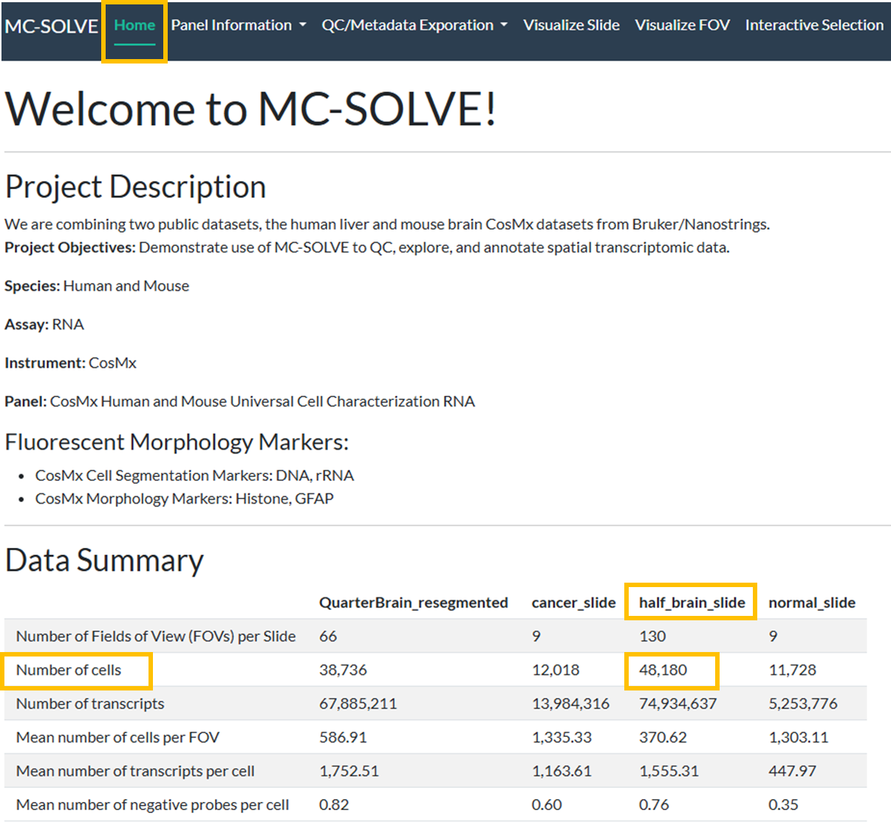

1. Using the **Panel Information tab** > **Cell Type Reference**, for the **Brain MCA** reference profile, which cell type has the highest expression of **Ttr**?
2. Schwann Cell



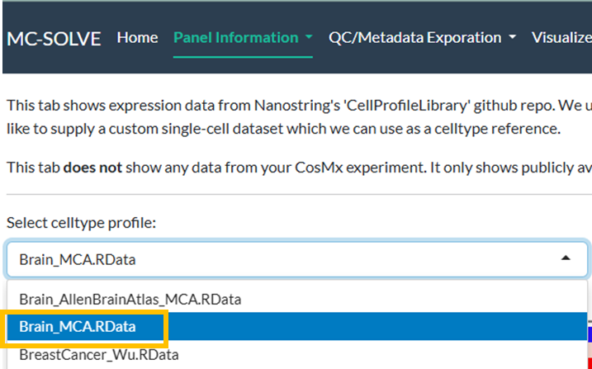

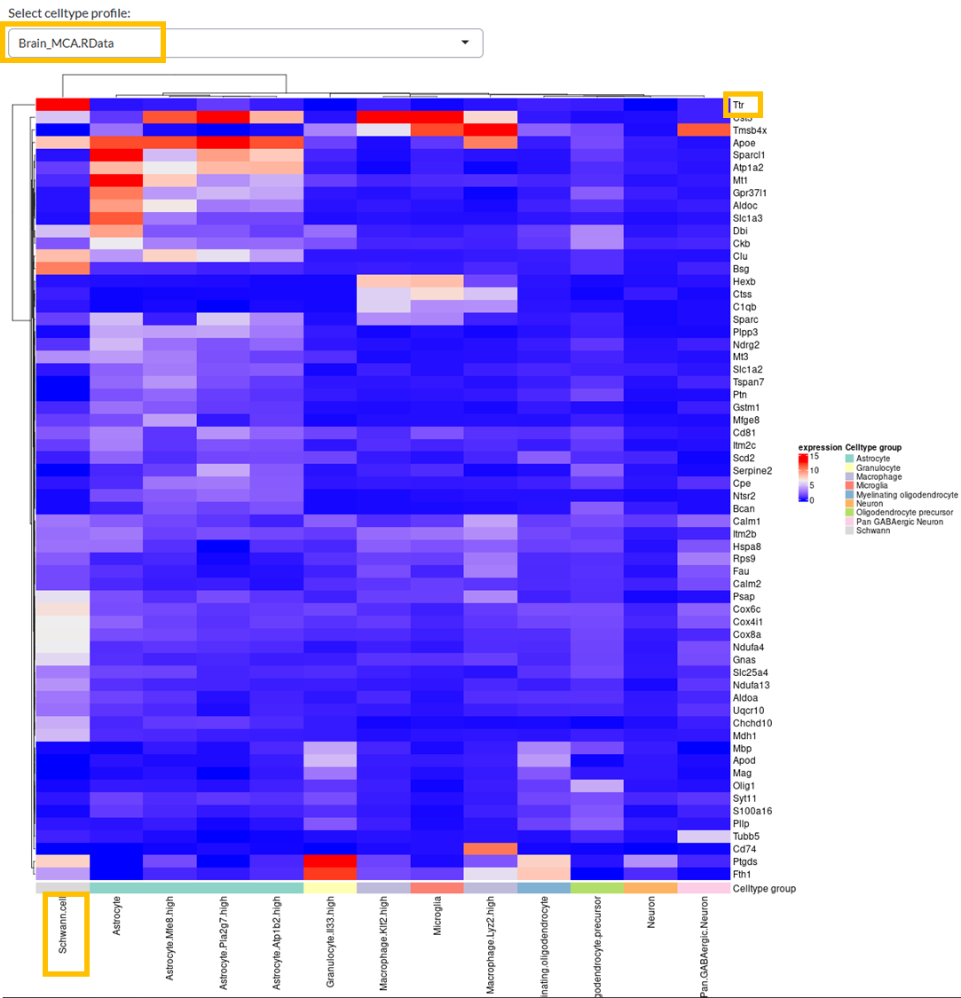

1. In the flowcell **"normal_slide"**, how many **Fields of View (FOVs)** failed **quality control (QC)**? List the names or identifiers of the FOVs that did not pass QC.

N=5, FOV148, FOV169, FOV21, FOV301, FOV42.

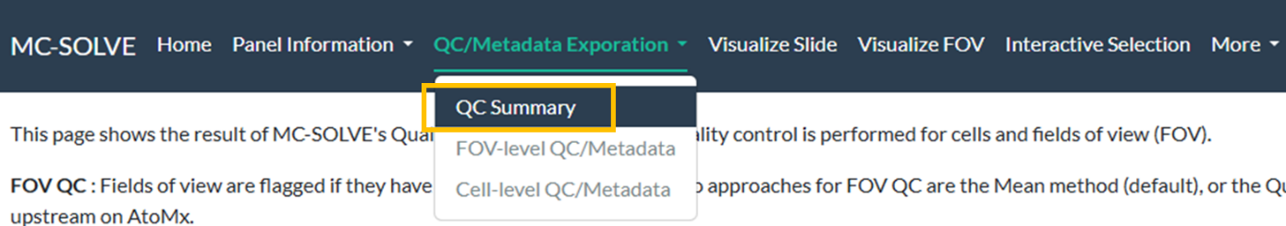

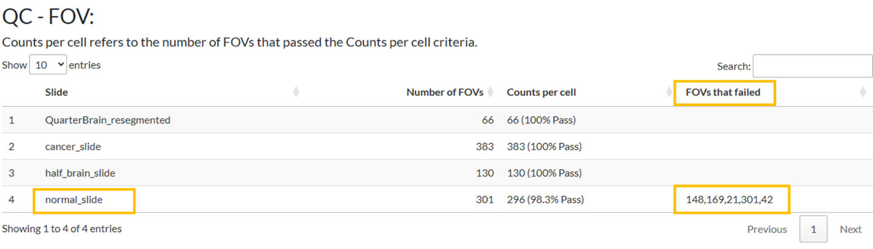

1. Using the **FOV-level QC** tab, can you identify an additional FOV that you may want to exclude as well?
2. You may also want to add 84 as it just barely passes the threshold and there is a big gap to the next FOV

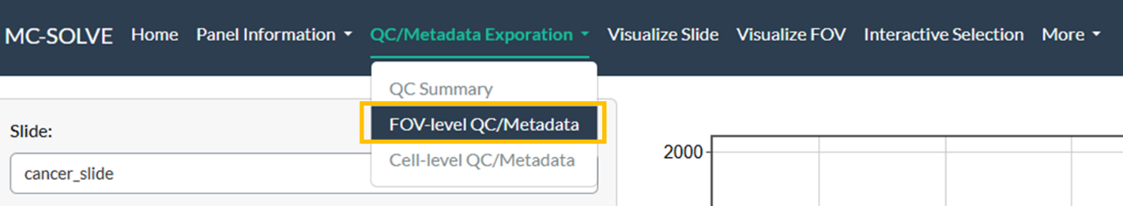

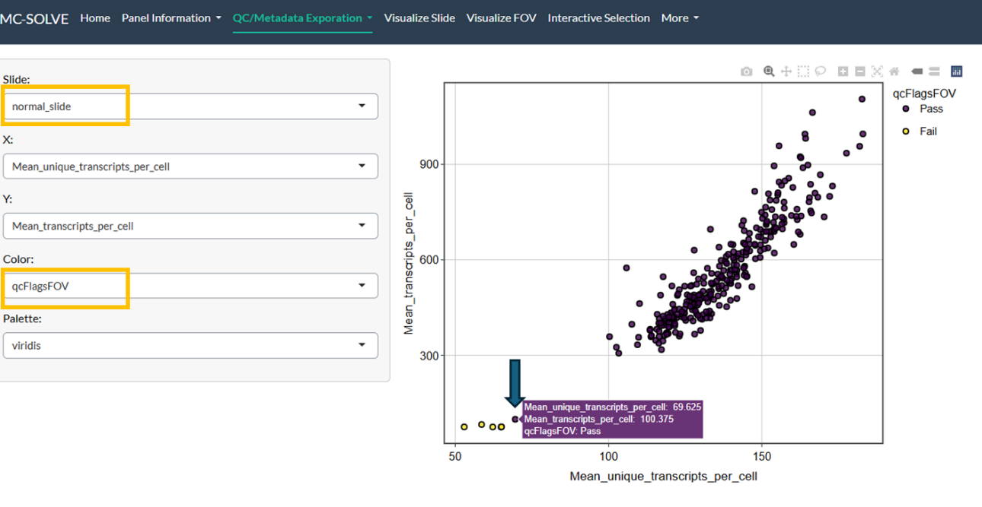

1. Using the **Visualize Slide** tab, where are these FOVs on the tissue?
2. All of these FOVs are on the edge of the tissue

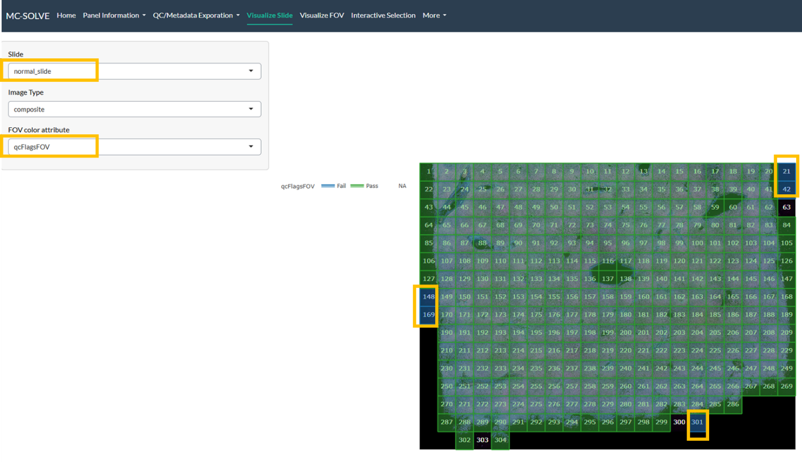

1. **Visualize FOV 157** within the **"cancer_slide"** flowcell. How many **distinct cell types** were identified using the **IO reference profiles**?
2. There are 14 cell types including 3 unsupervised clusters.

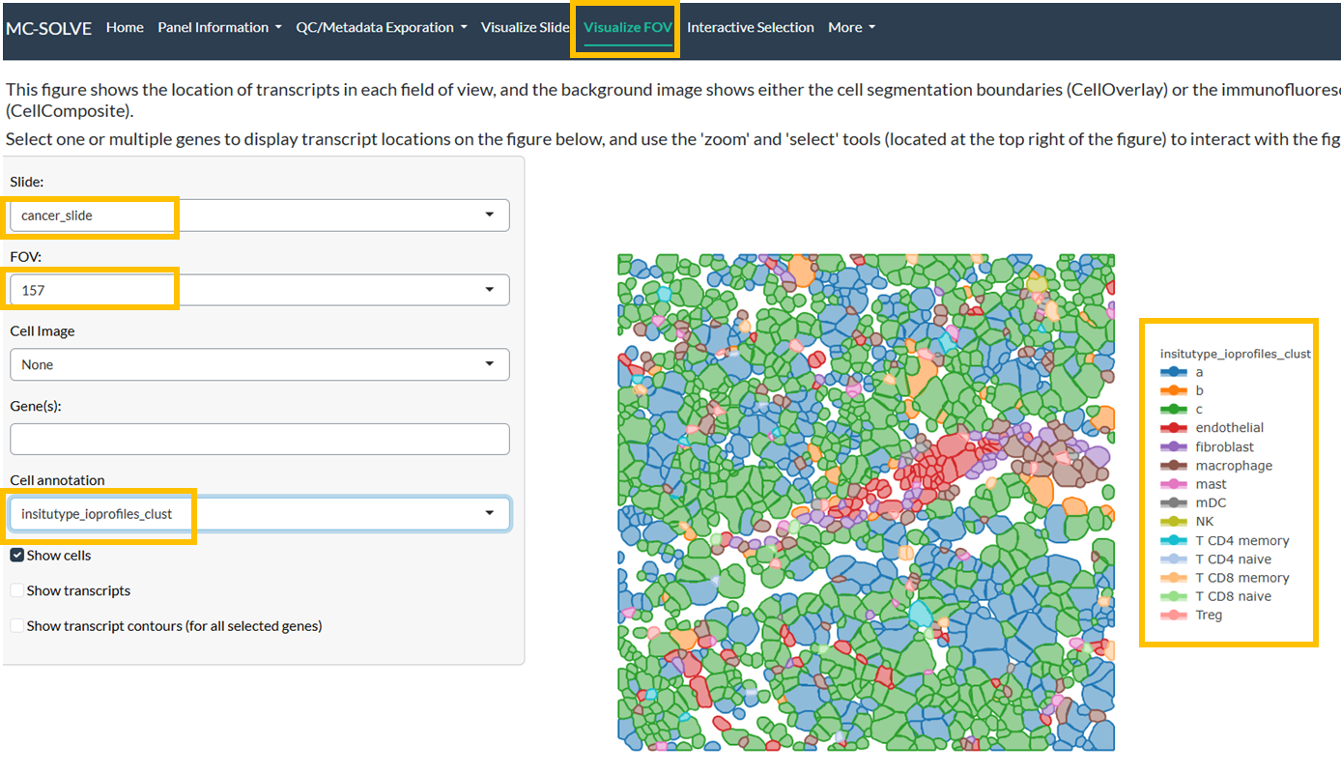

1. Using **Visualize FOV**, can you find any **doublets** in any of the FOVs of the slides? Which slides? What are their cell type? (Hint: turn cell annotation color to “Area” to see large cells in Yellow)
2. Doublets can somewhat easily be found in all of the cancer FOVs. They are generally found in unsupervised cells (these may represent tumor cells).

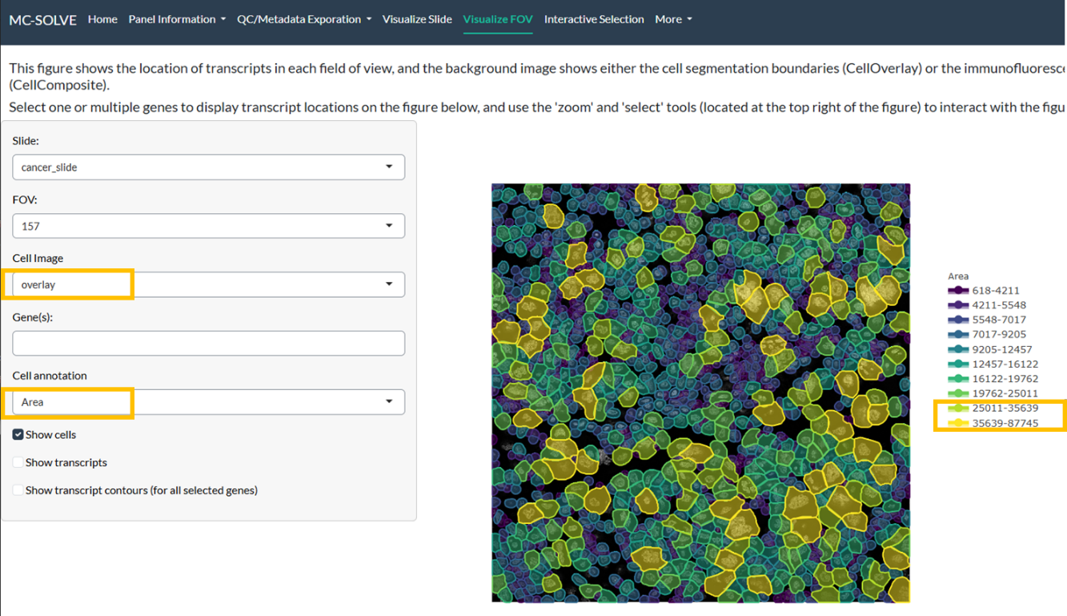

1. Go to **Interactive Selection** in the **half brain slide**, how many cells are initially present, and how many are left after applying filters where **qcFlagsCell == "Pass"** and **insitutype_Brain_MCA_prob > 0.95**?  (Hint: open the **Filter** accordion)
2. 48180 - > 46981

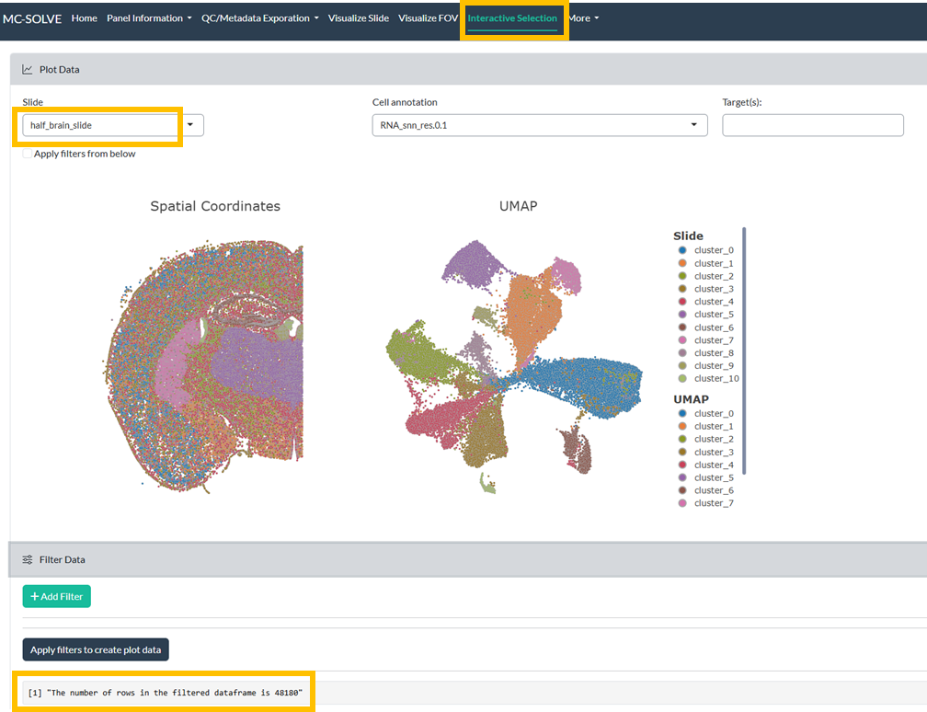

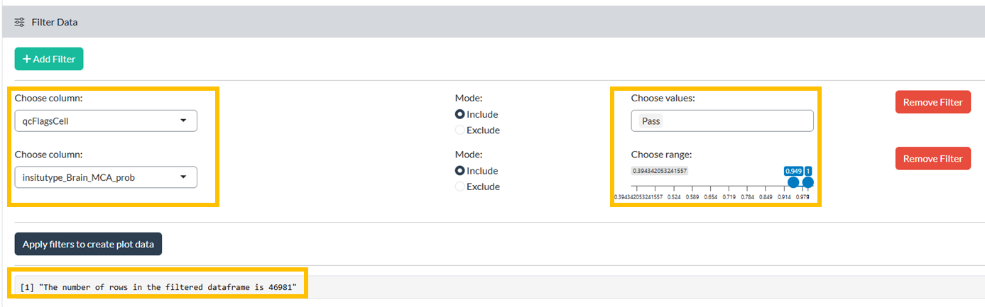

1. You are specifically interested in **Neuron** cells (using the Brain MCA reference). Where on the slide are the Neuron cells located in the **top-left corner of UMAP**? What about **bottom-right corner of the UMAP**?

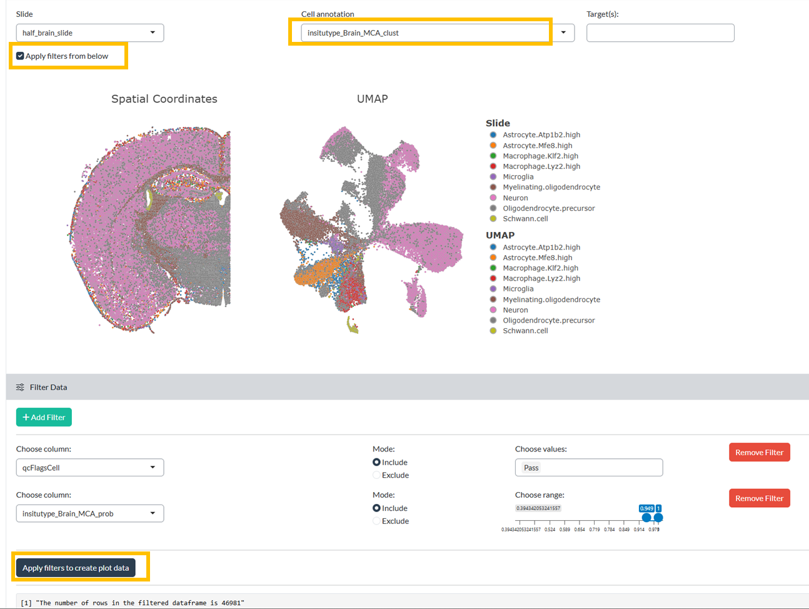

1. Middle/right of the Slide

1. This is the Dentate Gyrus

1. What part of the brain has the greatest expression of **MALAT1**? (Hint: use Half Brain). **Challenge**: What type of cells do these represent? (Hint: either download the metadata using the shopping cart)
2. The outer part of the cerebral cortex, neurons (specifically, L6.IT.CTX)

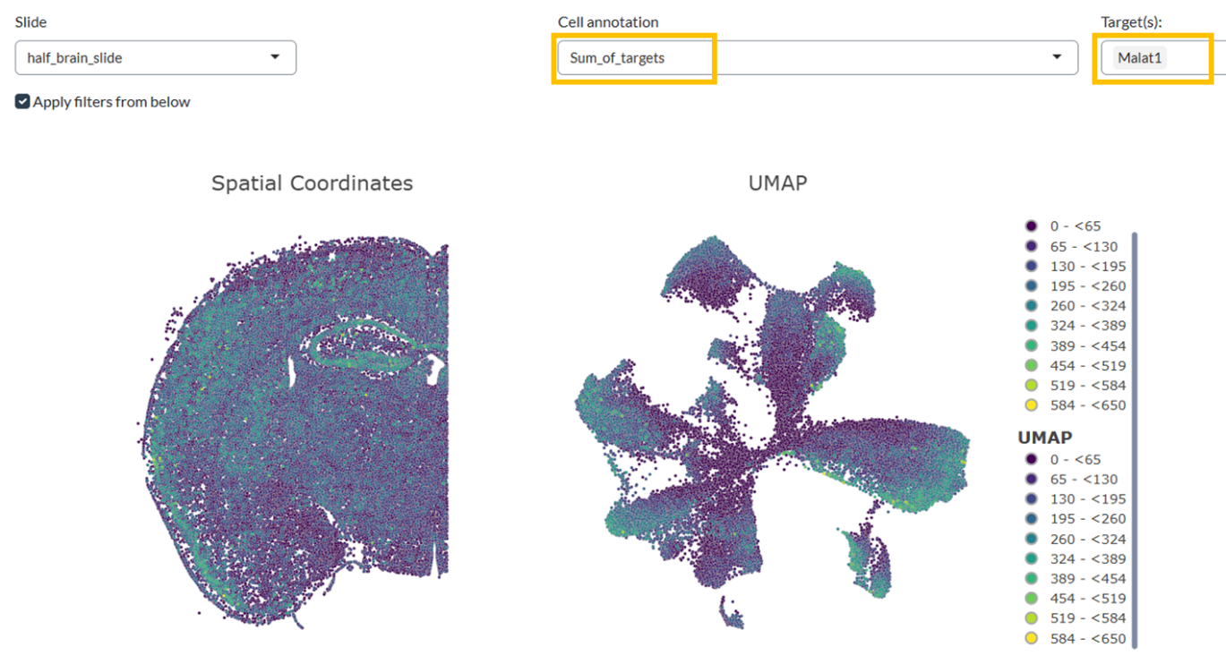

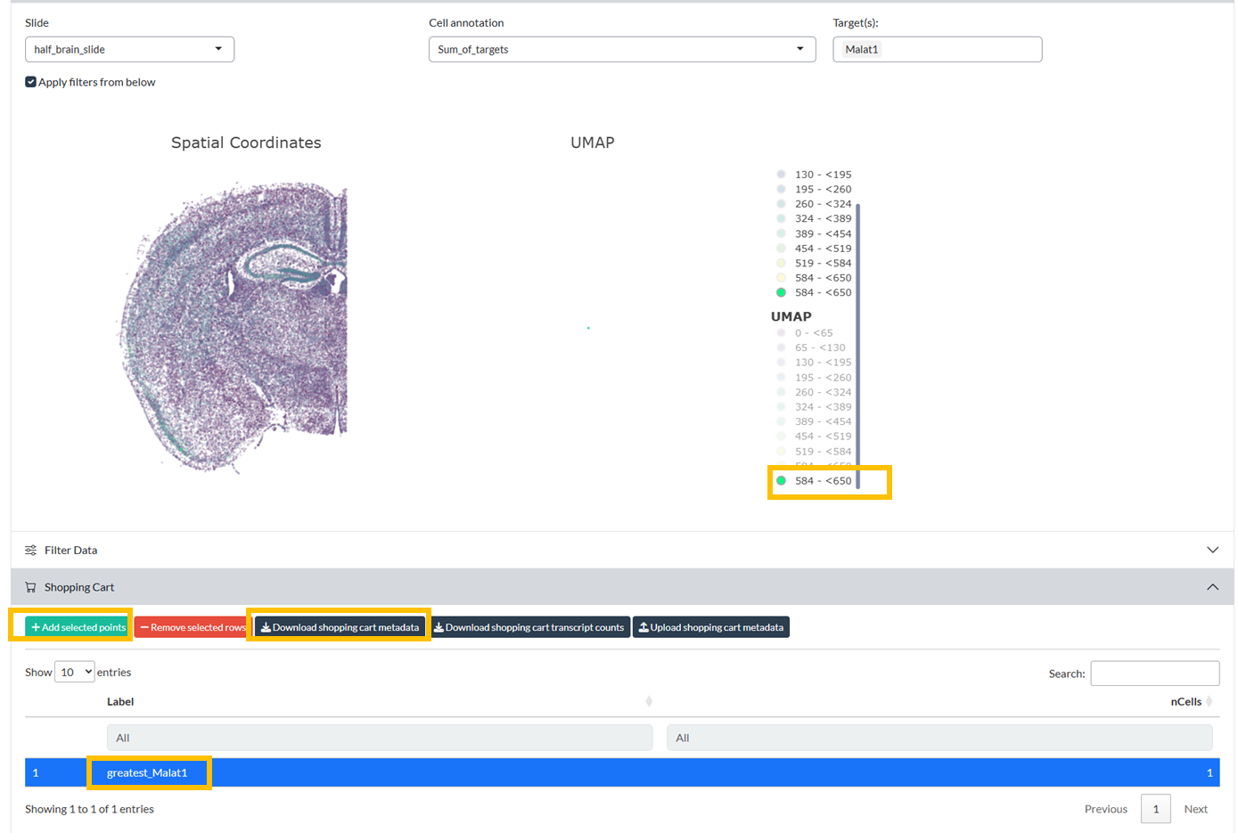



1. Open discussions

* Based on this secondary analysis, what **tertiary questions** or hypotheses could you explore?
* In your own words, **what does spatial biology mean to you**, and how can it advance scientific discovery?