

Transportation Infrastructure Precast Innovation Center (TRANS-IPIC)

# University Transportation Center (UTC)

***Innovative Precast Concrete Truss Using Adaptive Shape Memory Prestressing System***

*Project No.: UI-23-RP-02*

### 2nd Quarterly Progress Report

For the performance period ending *March 31st, 2024*

## Submitted by:

PI: Bassem Andrawes, [andrawes@illinois.edu](mailto:andrawes@illinois.edu) Department of Civil and Environmental Engineering University of Illinois at Urbana-Champaign

## Collaborators / Partners:

-None

## Submitted to:

TRANS-IPIC UTC

University of Illinois Urbana-Champaign Urbana, IL

# TRANS-IPIC Quarterly Progress Report:

## Project Description:

1. **Research Plan - Statement of Problem**

The ever-growing demand for making our transportation infrastructure more sustainable requires serious efforts to reduce carbon emissions associated with the concrete and steel used in transportation infrastructure. One way to achieve sustainability is by optimizing the materials used in transportation infrastructure. This research helps address this issue by studying the application of an innovative Adaptive Prestressing System (APS) in a geometrically optimized (truss) PC system. The new APS includes a shape memory alloy fuse that applies localized prestressing in any direction without mechanical tensioning or special hardware, ideal for prestressing short diagonal or vertical members of a PC truss. The research includes experimental testing and numerical simulation of geometrically complex PC truss structures with APS placed in tension members that are difficult to prestress using conventional methods. The performance of the new APS-reinforced PC truss is compared with traditional PC bridge girders to prove the feasibility of the new concept.

## Research Plan - Summary of Project Activities (Tasks)

This project aims to investigate the new technology of using APS to construct lightweight, sustainable, and durable (crack-free) PC truss systems for bridges. During this phase of the project (12 months), this research will attempt to address the following questions: 1) What is the optimum design (diameter and length) for the APS in PC truss that would help eliminate the cracking of concrete under realistic design loads. 2) What is the most efficient and practical method for installing and activating the APS's SMA fuse internally in PC truss members. The research plan for this project includes two primary tasks:

#### Task 1: Design of Specimens using Finite Element Method:

The first step of the research is to evaluate the behavior of the specimens through detailed finite element (FE) analysis using the software ABAQUS. This step aims to define the size and location of the APS strands and the level of the target prestressing force. A realistic prestress force that satisfies all AASHTO limit states will be adopted. Both concrete and strands (steel and SMA) will be modeled in 3D. The final decision on the design of the specimens will be made based on the results of the 3D FE analyses. Close attention will be given to the degree of cracking and/or stress concentration associated with various detailing configurations. The specimen's behavior with conventional (non-prestressed) steel reinforcement will be used as a baseline.

#### Task 2: Fabrication, Instrumentation, and Testing of Specimens:

Three specimens (one used as a control specimen with conventional steel and two specimens with SMA) will be fabricated. Before casting, prestressing strands in the bottom chord will be tensioned, and the APS will be placed in the vertical tension members. The SMA fuse used to activate the system will be in the form of pre-deformed no. 2 bars. The APS will be enclosed in a thermally/electrically insulating polymeric sleeve. To provide anchorage for the APS, the two HSS ends of the APS will be bent to form 90-degree hooks. After casting the concrete, the SMA fuse will be stressed using an electrical current. Next, the HSS strands in the bottom chord will be detensioned and the specimens will be tested under two concentrated loads. Digital Image Correlation (DIC), and conventional instrumentation will be used to evaluate the behavior of the tested trusses.

## Project Progress:

1. **Progress for each research task**

#### Task 1 progress (50% completed):

**Task 2 progress (25% completed):**

The work for this task during this quarter was focused on experimentally evaluating the bending of SMA wires to form anchorage points. Using the SMA to anchor itself would simplify the amount of hardware needed when compared to conventional forms of prestressing and post-tensioning. Two small-scale specimens were cast with two different anchorage configurations. Both used electricity to stress the pre- strained SMA. Digital image correlation (DIC) was used to measure the strains developed, which in turn was used to determine the prestressing performance.

The first specimen used 180° bent hooks at both ends (**Fig. 1**). A 216 mm long mortar beam was cast, and its cross-section was 12.7 mm wide and 17.8 mm tall. The SMA used was a 2 mm diameter NiTiNb wire with 6% pre-strain. The wire was placed in the center of the specimen, and plastic seats were used to maintain its location.

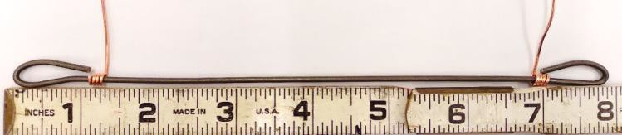

**Figure 1.** SMA with 180° hooks and lead wires

An external power supply was used to pass electricity through the lead wires and into the SMA. The DIC result for the final image taken when the beam cooled to room temperature is shown in **Fig. 2**. A compression region is visible in the center of the beam.

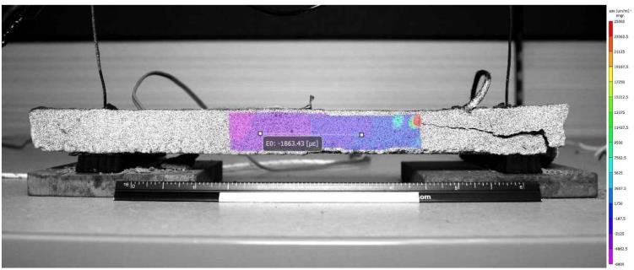

**Figure 2.** Result of DIC after cooling

Splitting cracks were observed at the two ends during the heating stage. One crack was visible from the front and the other, from the backside. Upon close examination of the damaged ends, it can be seen that the hooks had opened outwards, **Fig. 3**. The heat from the electricity radiated far enough to trigger the phase transformation of the SMA in the hooked regions. When the hooks attempted to straighten themselves, they split the mortar apart.

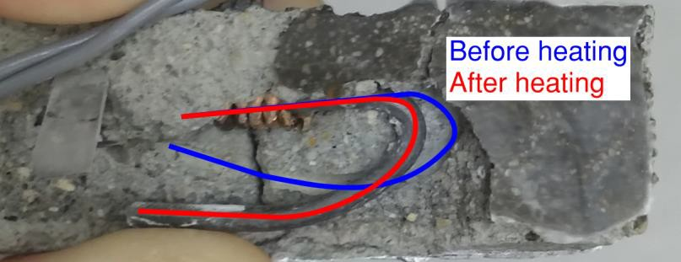

**Figure 3.** Overall movement of the hook

The second specimen was a 330 mm long mortar beam with a cross-section of 25.4 mm width and 38.1 mm height. The SMA used was the same 2 mm diameter NiTiNb wire with 6% pre-strain, but the hooks were only bent to 90°.

The DIC for the image taken after the beam cooled to room temperature is shown in **Fig. 4**. Compression regions can be seen in the middle section of the beam. This indicated that 90° angled hooks were enough to securely anchor the SMA to the mortar. The hooks also maintained their 90° angle throughout the activation phase. Furthermore, no cracks were observed on the specimen.

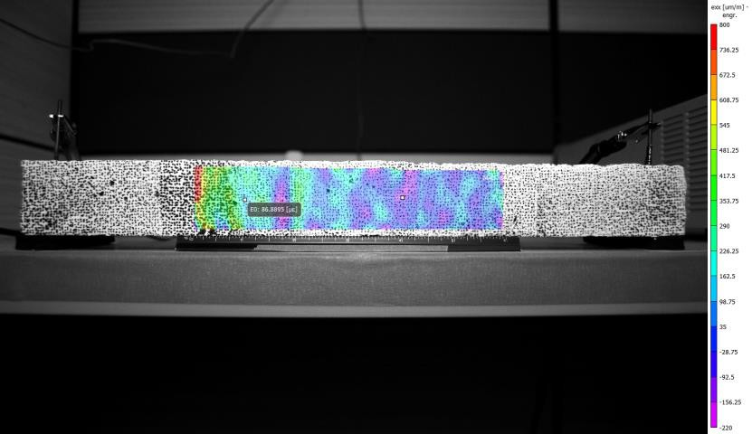

**Figure 4.** Result of DIC after cooling

### Percent of overall completed research

*Total project completed through the end of this quarter =* **35%**

### Expected progress for next quarter

The next quarter will focus on finalizing the analysis needed to design larger test specimens.

### Educational outreach and workforce development

* + A poster is submitted and accepted for the 2024 ASCE Transportation Conference that will be held in Atlanta, GA in June.
  + A poster will be presented at the 1st TRANS-IPIC Annual Workshop that will be held in Rosemont/Chicago, IL in April 22nd, 2024.

### Technology Transfer

None yet.

## Research Contribution:

### Number of papers

* + Minsoo Sung and Andrawes B. “Innovative Precast Concrete Truss System Using Shape Memory Alloys for Infrastructure Applications” *Intelligent Materials Systems and Structures journal* (Accepted). (Federal Funds Acknowledgment: Yes)

### Number of presentations (when, where)

None.

## References:

N/A