

Transportation Infrastructure Precast Innovation Center
(TRANS-IPIC)

University Transportation Center (UTC)

Thermally Conductive Pre-cast Concrete Pavement for Urban Heat Island mitigation

[UT-23-RP-01]

Quarterly Progress Report
For the performance period ending [July 1st, 2024]

Submitted by:
Islam Radwan, Graduate Student, Islam.Radwan@my.utsa.edu
Samer Dessouky, Professor, Samer.dessouky@utsa.edu
School of Civil & Environmental Engineering and Construction Management
University of Texas at San Antonio

Collaborators / Partners:
Microtek laboratories Company

Submitted to:
TRANS-IPIC UTC
University of Illinois Urbana-Champaign
Urbana, IL

TRANS-IPIC Quarterly Progress Report:

Project Description:

- Research Plan - Statement of Problem

The Urban Heat Island (UHI) effect refers to higher temperatures in urban areas compared to the surrounding countryside due to human development. Increased thermal energy storage in paving materials contributes to the UHI effect, leading to elevated surface temperatures. Precast concrete pavement with improved mix designs is recognized globally as an emerging technology for mitigating climate change and addressing UHI. These precast elements can be incorporated into innovative pavement systems to enhance mitigation practices, employ efficient construction methods, and promote sustainable pavement restoration. The study investigates the use of precast concrete pavement to create cooler rigid pavement using various cooling mechanisms. These mechanisms involve modifying the thermal properties of pavement materials and reducing heat energy absorption or emission by pavements, while prioritizing environmental sustainability.

- Research Plan - Summary of Project Activities (Tasks)

Task 1: Literature Review
Review existing literature on UHI mitigation, thermally conductive pavements, and precast concrete technologies to identify gaps.

Task 2: Experimental Design & Material Selection
Define parameters for thermal conductivity evaluation and select optimal mix designs for testing. Acquire samples of phase changing materials (PCM) and efforts is undergoing to fabricate concrete samples.

Task 3: Laboratory Testing
Measure thermal conductivity, analyze results, and consider additional factors for various precast concrete pavement samples.

Task 4: Pavement System Design
Develop design guidelines and compile a comprehensive report.

Task 5: Field Implementation & Monitoring
Identify sites, plan installation, collect UHI data, and prepare for implementation.

Task 6: Reporting
Compile findings into comprehensive and summary reports and present them at conferences while publishing in journals.

Project Progress:

- Progress for each research task

- Task 1: Literature Review [100% Completed]
- Task 2: Experimental Design & Material Selection [100% Completed]
- Task 3: Laboratory Testing [60% Completed]
- Task 4: Pavement System Design [50 % Completed]
- Task 5: Field Implementation & Monitoring [0 % Completed]
- Task 6: Reporting [0 % Completed]

- Percent of research projects completed by the end of this quarter.

- Task 1: 100% completed
- Task 2: 100% completed
- Task 3: 60% completed
- Task 4: 50% completed
- Task 5: 0% completed
- Task 6: 0% completed

The average completion percentage would be:
(100% + 100% + 60% + 50% + 0% + 0%) / 6 tasks = % 310/ 6 tasks ≈ 51.6%

Description:

- Task 1: Literature Review [100% Completed]

The literature review focuses on three main areas: Urban Heat Island (UHI) effects and mitigation strategies, cool pavement techniques, and the integration of phase change materials (PCMs) in pavement systems. The UHI section examines the contributing factors, environmental impacts, and current mitigation methods. In exploring cool pavements, both asphalt and rigid, particularly precast rigid pavements, are analyzed for their effectiveness in reducing surface temperatures. The review also delves into the properties, benefits, and challenges of incorporating PCMs into pavement designs, highlighting their potential to enhance thermal performance. The literature synthesis provides a comprehensive foundation for developing innovative, thermally efficient pavement solutions.

- Task 2: Experimental Design & Material Selection [100% Completed]

The experimental design focuses on selecting the appropriate phase change material (PCM) based on its melting point and heat of fusion, as provided by Microtek Laboratories. The chosen PCM, in powder form, ensures easy integration with the precast concrete mix. Adhering to local standards in San Antonio, Texas, the concrete design mix was formulated considering aggregate gradation and water-cement ratios. The mixing process and the dimensions of concrete samples with varying PCM dosages were established. Additionally, a heat simulation chamber was designed to observe the PCM's behavior in pavement samples. The necessary equipment, including a data acquisition system and light bulbs for heating, was acquired to facilitate the experiments.

- Samples Preparation & Mixing:

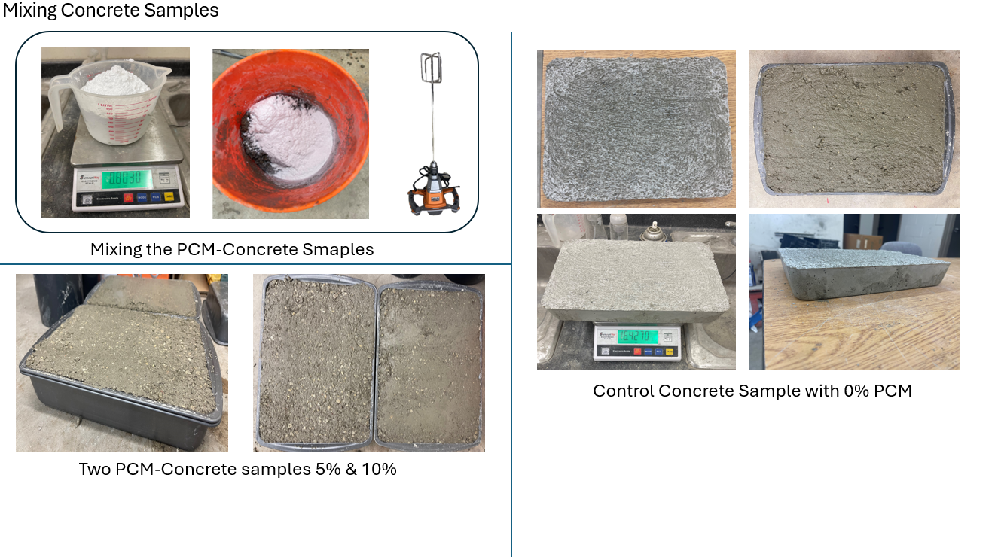

- CONCRETE – PCM Samples:

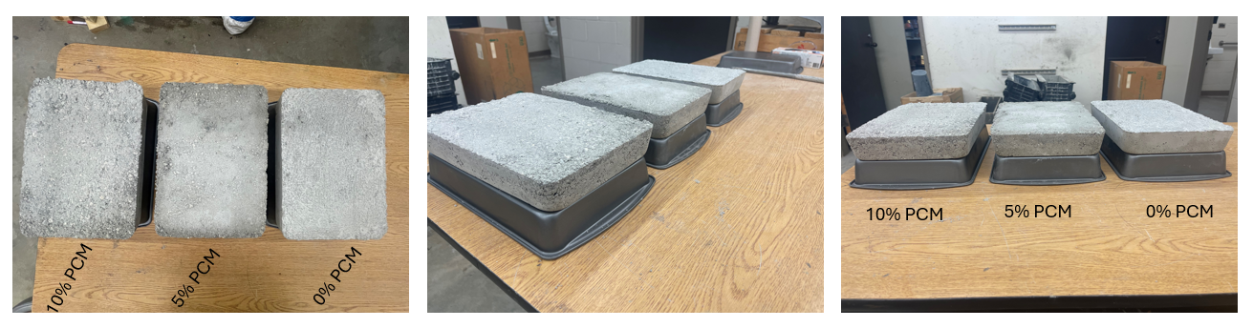

- Heat Source- Bulbs:

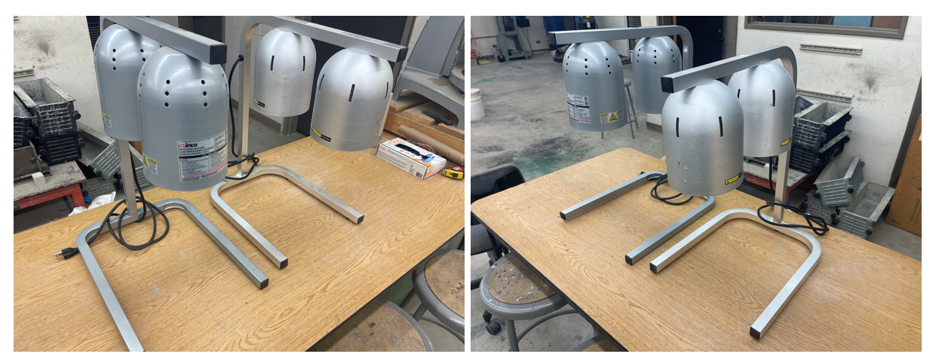

- Reflective Thermal – Insulated Box Preparation:

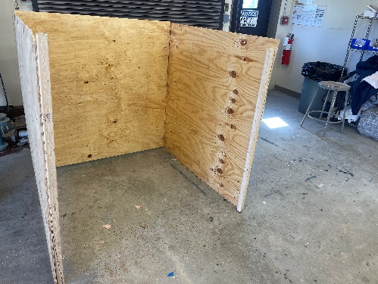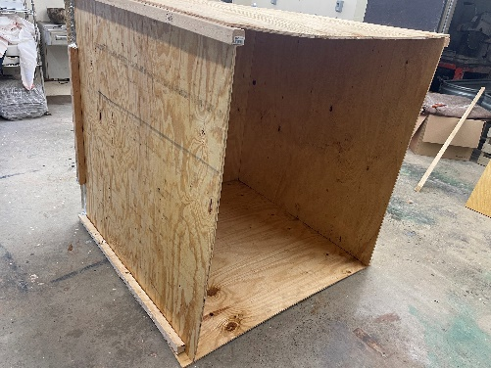

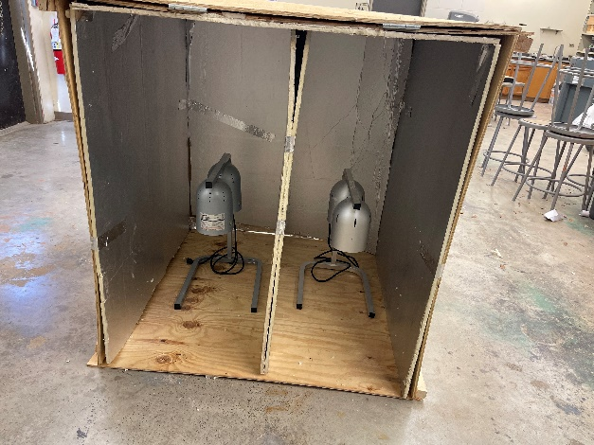

- Task 3: Laboratory Testing [60% Completed]
The laboratory testing phase involved subjecting the concrete samples to heating and cooling cycles to observe surface temperature reductions. Key thermal and material properties were measured using advanced devices. Differential Scanning Calorimetry (DSC) was employed to analyze the heat flow associated with PCM transitions, while Laser Flash Analysis measured thermal diffusivity and conductivity. Additionally, a pycnometer was used to determine the density and porosity of the samples. These tests provided critical data on the effectiveness of PCM integration in reducing surface temperatures and enhancing thermal performance of pavement materials.
Heat Experiments:
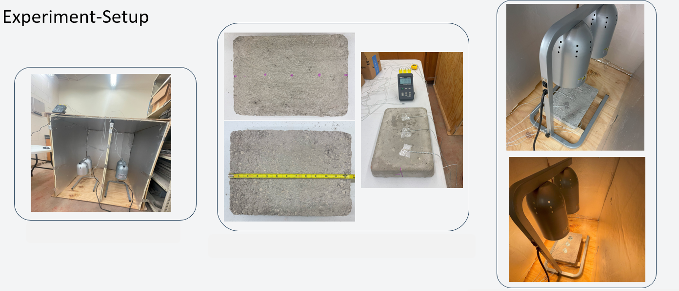

- Measuring the Specific heat Capacity, the Diffusivity, and the densities:

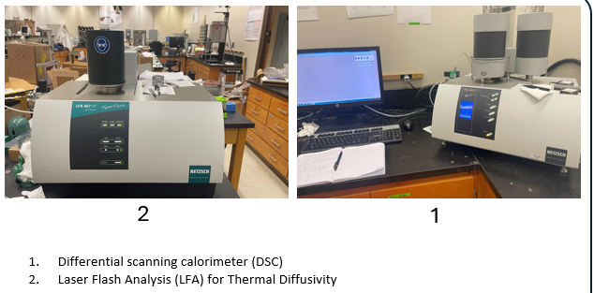

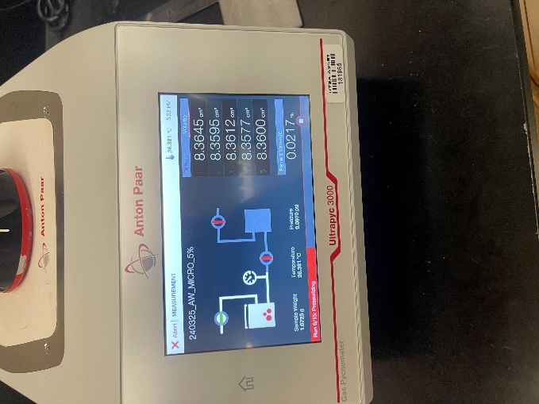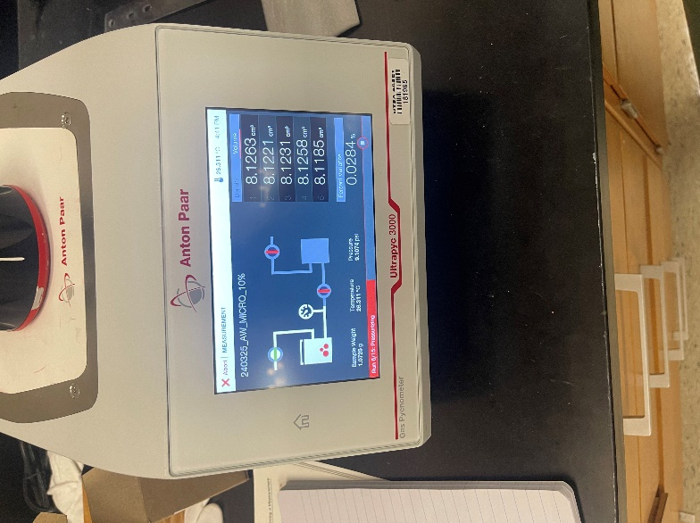

3. Pycnometer

- Task 4: Pavement System Design [30 % Completed]

The pavement system design phase involved initial trials with a specific type of PCM to assess its suitability for integration into concrete pavements. This included measuring the PCM's thermal properties, such as melting point and heat of fusion, to ensure it meets the requirements for effective thermal regulation. Subsequently, different dosages of the PCM were added to the concrete mix, and the resultant thermal properties of these mixes were meticulously measured. These properties included thermal conductivity, diffusivity, and specific heat capacity, evaluated using devices like Differential Scanning Calorimetry (DSC) and Laser Flash Analysis. The collected data informed the optimization of PCM dosage to achieve the desired balance of thermal performance and structural integrity in the pavement system.

- Expected progress for next quarter.

The upcoming quarter will focus on exploring various methods for integrating PCM into the precast concrete mix. This will involve experimenting with different techniques to enhance the uniformity and effectiveness of PCM distribution within the concrete. Additionally, a comprehensive mechanical study will be conducted to evaluate the performance and behavior of the concrete samples after PCM integration. The insights gained from these experiments will be crucial for optimizing the PCM-enhanced pavement design for real-world applications.

- Educational outreach and workforce development

- A brief summary of the project has been shared with the undergraduate students in the CE 3243 class “properties and behavior of construction materials). More outreach activities will be presented as we continue to make progress in the project.

- On Feb 2024, a summary of the project was presented to the Highway Engineering Class CE 3223.

- Technology Transfer

-None

Research Contribution:

- Number of papers

Currently, there have been no journal and conference papers/publications resulting from this project. We anticipate that such publications may emerge as the research progresses and we begin to gather significant findings.

- Number presentations (when, where)

- Radwan, I. and Dessouky, S. “Cool Pavements for Mitigating Urban Heat Island Effect using PCM in Precast Concrete” Transportation Infrastructure Precast Innovation Center (TRANS- IPIC) Monthly Research Webinar. March 4th. 2024.

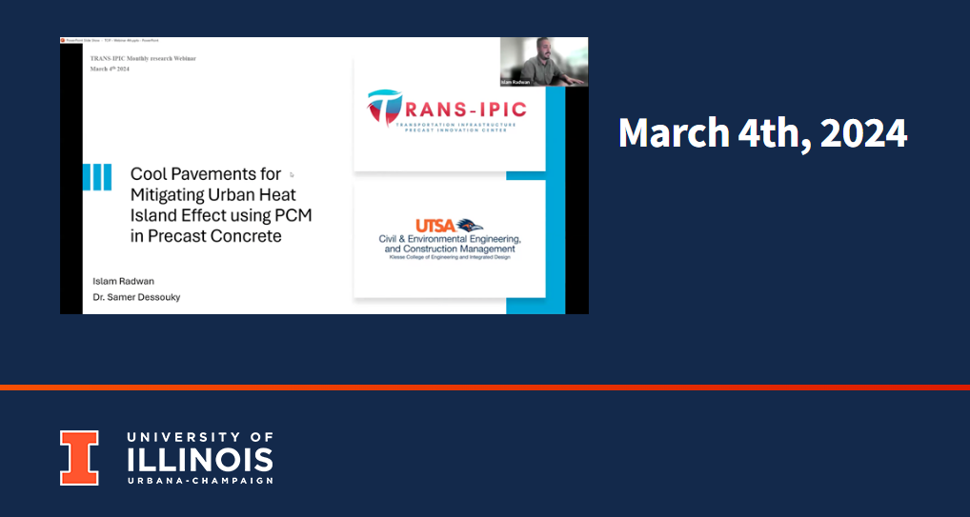

- Radwan, I. and Dessouky, S. “Cool Pavements for Mitigating Urban Heat Island Effect using PCM in Precast Concrete” Transportation Infrastructure Precast Innovation Center (TRANS- IPIC) Workshop, Presentation. April 22nd. 2024.

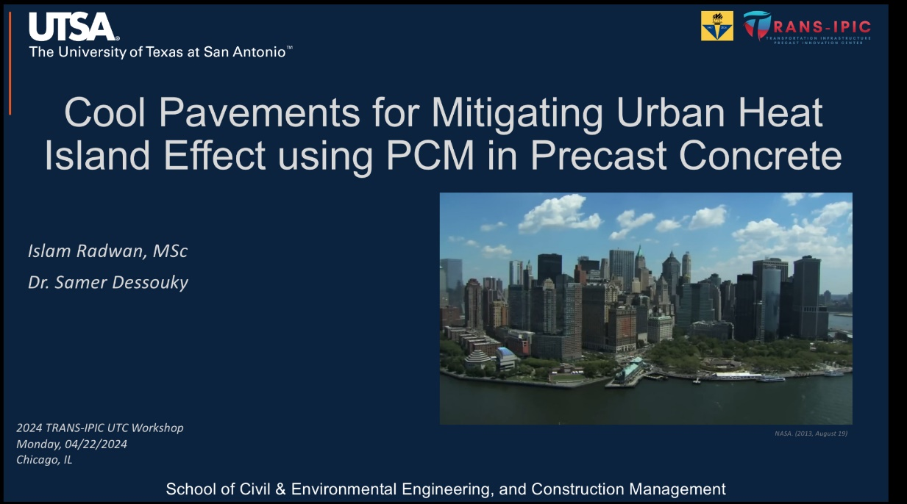

References:

- Haselbach, L., Boyer, M., Kevern, J. T., & Schaefer, V. R. (2011). Cyclic heat island impacts on traditional versus pervious concrete pavement systems. Transportation Research Record, 2240, 107–115. https://doi.org/10.3141/2240-14
- Li, H. (2012). Evaluation of Cool Pavement Strategies for Heat Island Mitigation. www.its.ucdavis.edu
- Roesler, J., & Sen, S. (2016). IMPACT OF PAVEMENTS ON THE URBAN HEAT ISLAND FINAL PROJECT REPORT. http://www.chpp.egr.msu.edu/
- Sanjuán, M. Á., Morales, Á., & Zaragoza, A. (2022). Precast Concrete Pavements of High Albedo to Achieve the Net “Zero-Emissions” Commitments. Applied Sciences (Switzerland), 12(4). https://doi.org/10.3390/app12041955

