**Transportation Infrastructure Precast Innovation Center**

**(TRANS-IPIC)**

**University Transportation Center (UTC)**

Data-driven smart composite reinforcement for precast concrete - Phase II

PU-23-RP-05

Quarterly Progress Report

For the performance period ending *June 30, 2025*

**Submitted by:**

Chengcheng Tao (PI), [tao133@purdue.edu](mailto:tao133@purdue.edu)

Shanyue Guan (Co-PI), [guansy@purdue.edu](mailto:guansy@purdue.edu)

School of Construction Management Technology

Purdue University

**Collaborators / Partners:**

Heidelberg Materials, North Dakota State University

**Submitted to:**

TRANS-IPIC UTC

University of Illinois Urbana-Champaign

Urbana, IL

**TRANS-IPIC Quarterly Progress Report:**

**Project Description:**

1. Research Plan - Statement of Problem

It is critical to design high-performance, sustainable, and cost-effective reinforced precast concrete to extend the life of PC transportation infrastructure. Physical testing with trial-and-error approaches on reinforced PC components requires substantial time, labor, and material resources to achieve the optimal design for superior material properties, ecological and economic sustainability. There is a lack of an efficient and precise way to design reinforced precast by fully considering potential configurations and material options with optimal performance. To address these challenges, the proposed research innovatively integrates sensing technology, physical testing, multivariate numerical modeling, and multi-objective metaheuristic optimization with Pareto front analysis to achieve optimal performance of the reinforced precast concrete materials in terms of mechanical, environmental, and economic performance. The expected output will guide the design and manufacturing of reinforced PC components with improved durability, environmental impact, and economic value.

1. Research Plan - Summary of Project Activities (Tasks)

Task 1. Experimental investigation of mechanical properties of various reinforced precast concrete components. Built upon the testbed from our ongoing funded TRANS-IPIC Year 1 project, we will investigate the mechanical performance of various reinforced precast concrete components with different reinforcement configurations, geometries, and materials types of rebar and concrete.

Task 2. Multivariate numerical modeling of reinforced precast concrete components and physics-informed database establishment. In this task, we will perform computer-guided design via three-dimensional (3D) numerical analysis and parametric study to analyze the sensitivity of various influencing factors on the mechanical properties of the reinforced concrete components.

Task 3. Development of multi-objective metaheuristic optimization framework with Pareto front analysis to achieve optimal mechanical properties, sustainability, and economic values. In this task, we will develop a multi-objective optimization framework to efficiently provide optimal solutions for high-performance, sustainable, and low-cost reinforced precast concrete components.

Task 4: Reporting. Research outcomes will be summarized in the quarterly and final reports submitted to TRANS-IPIC and publications in high-impact journals and TRB or PCI conferences.

**Project Progress:**

1. Progress for each research task

**Task 1. Experimental investigation of mechanical properties of various reinforced precast concrete components [70% completed]**

In highway and bridge infrastructure, precast concrete elements are frequently exposed to dynamic loading and corrosive environment, resulting in durability issues. To address the challenges, we experimentally investigate the effect of factors including PVA fiber, water content through compressive test and flexural test to on the reinforced concrete beams in this task.

1.1. Compressive test

Figure 1. Compressive strength with different PVA fiber content and water content

Figure 1 shows the compressive strength response of commercial concrete (blend of cement, sand, aggregate and other approved ingredients totaling 15 kg) with varying water contents (1.3 L, 1.5 L, and 1.7 L) and PVA fiber volume fractions (0.2%, 0.4%, and 0.6%), offering insights for transportation infrastructure elements. At 0.2% PVA fiber content, compressive strength reached peak (~6000 psi) at 1.3 L and decreased with increasing water content, consistent with the detrimental effects of excess water on porosity and matrix integrity. At 0.4% PVA fiber, peak strength (~4900 psi) shows that the favorable water consumption is 1.5 L. When PVA fiber content increased to 0.6%, the peak strength also showed a trend of first rising and then falling, with peak strength (~5000 psi) slightly higher than 0.4% PVA fiber content. This behavior is explained by the interplay between PVA fiber distribution and matrix integrity. At low PVA fiber contents, the load-bearing capacity is dominated by the concrete matrix. As the PVA fiber content increases to 0.4%, the introduction of more PVA fibers led to higher internal voids, compromising strength. However, at 0.6% PVA fiber content, the increased PVA fiber volume began to contribute to stress redistribution or internal reinforcement, partially offsetting the negative effects of void formation. Figure 2 (a)-(c) illustrates the progressive influence of PVA fiber dosage on fracture behavior. Figure 2 (a) shows the specimen with 0.2% PVA fiber content exhibits pronounced vertical cracks that extend continuously from top to bottom. The cracks are wide and linear, indicative of brittle failure with minimal energy dissipation. No visible PVA fiber bridging is observed, indicating the PVA fiber content is insufficient to enhance ductility or delay crack propagation. Figure 2 (b) shows the cylinder with 0.4% PVA fiber content. The fracture surface presents a denser and more irregular crack network, with multiple intersecting cracks distributed less uniformly. This pattern reflects a transition toward ductile behavior, indicating improved crack control and energy absorption due to the increased PVA fiber dosage. In Figure 2 (c), the specimen with 0.6% PVA fiber displays a highly fragmented surface with numerous fine cracks and evidence of crack branching. The absence of dominant vertical splits and the diffuse cracking pattern suggests effective PVA fiber bridging, stress redistribution, and enhanced resistance to localized failure. This behavior highlights increased toughness and strain capacity associated with higher PVA fiber volumes. The fine cracks propagation behavior and increased toughness lead to improved durability. These findings align with results in literatures. Li et al. reported that PVA fiber-reinforced composites significantly improve post cracking energy absorption, enhancing fatigue life of bridge decks and roadways under cyclic loads [1]. Similarly, Naraindas et al. demonstrated that PVA fiber reinforced concrete exhibits increased fracture toughness and fatigue resistance under vehicle live loads, making it well-suited for overlays and precast bridge deck panels [2]. Deitz et al. [3], affirming that FRP provides controlled failure modes, while steel reinforcement offers superior ductility and energy absorption critical for dynamic load applications such as seismic zones and truck-intensive bridges. The outcomes support the development of tailored mix designs for precast structural elements, promoting improved durability, crack control, and life cycle efficiency in transportation infrastructure.

Figure 2. Failure of cylinder with various PVA fiber content: (a) 0.2%; (b) 0.4%; (c) 0.6%

1.2 Flexural test

To assess how beam length and reinforcement type affect structural performance, 20-inch and 36-inch reinforced concrete beams were fabricated using both traditional steel rebars with stirrups and glass fiber reinforced polymer (GFRP) bars. Beams were cast in steel molds for consistency, as shown in Figure 3. The steel-reinforced beam design follows ACI 318-19 [4] that can be used for components in bridges and barriers. GFRP-reinforced beams were constructed based on ACI 440 [5], offering corrosion resistance and high tensile strength suitable for aggressive environments. All rebars were installed according to ASTM C192 [6] to ensure accurate placement, bonding, and concrete compaction, reflecting realistic service conditions in bridge decks and pavement panels. Figure 4(a) shows that the 36-inch GFRP beam reached nearly 20.9 kips, while the 20-inch beam failed around 7.2 kips. Both beams displayed linear behavior followed by brittle failure. The longer GFRP beam was observed to carry load after failure, indicating glass fiber bridging and crack arresting mechanisms. Beams with steel cage demonstrated more ductile behavior as shown in Figure 4(b). Concrete of 36-inch steel-reinforced beam failed around 400 seconds but continued to develop strength, demonstrating a multi-yield stage response due to progressive cracking and energy dissipation. The 20-inch beam peaked at 18 kips and failed suddenly. Steel cage in the longer beam delayed collapse and enhanced post-peak capacity. This response reflects progressive cracking and energy dissipation, important for highway structures subjected to repeated or impact loading. Figure 4(c) compares 36-inch beams with different reinforcement types. The steel-reinforced beam reached a higher peak load (nearly 40.5 kips), exhibited ductile behavior with post-peak load retention after concrete failure. In contrast, the GFRP-reinforced beam failed more brittlely but maintained tensile capacity beyond concrete failure at around 9 kips.

Figure 3. (a) 20-in beam with steel cage; (b) 20-in beam with GFRP; (c) 36-in beam with steel cage; (d) 36-in beam with GFRP

(a) (b) (c)

Figure 4. (a) Comparison of different length beams with GFRP; (b) Comparison of different length beams with steel cage (c) Comparison of beams of the same length bars of different materials

Beam length and reinforcement type significantly affect structural performance. Longer 36-inch beams show higher load capacity and deformation due to better stress distribution. GFRP-reinforced beams exhibit brittle failure but maintain load after concrete failure, especially in longer spans, while shorter beams lack sufficient length to activate GFRP’s tensile benefits. Steel stirrup beams display ductile behavior, with 36-inch beams showing multiple load peaks from progressive cracking and effective confinement. In summary, while increased length improves overall performance, reinforcement type governs post-crack behavior. Steel reinforcement provides superior ductility and resilience, making it more suitable for dynamic loading scenarios such as highways and bridges. Material selection should consider both mechanical demands and long-term structural integrity.

**Task 2. Multivariate numerical modeling of reinforced precast concrete components and physics-informed database establishment [70% completed]**

In this task, we generate the physics-informed mechanical performance database through finite element analysis (FEA). 384 numerical simulations were conducted to investigate the effects of various parameters on the structural behavior of reinforced concrete. Prior to the database generation, the FEA model was validated by replicating the geometry and loading conditions of experimental specimens. Simulated strain profiles were compared with data from embedded fiber-optic sensors, confirming the model’s accuracy. Once validated, Python scripts were used to automatically define geometry, assign material properties, generate meshes, apply displacement-controlled loading, and extract key results. The simulations varied critical parameters, including rebar type (AFRP, BFRP, CFRP, GFRP, and steel), cross-sectional area, manufacturer or material specification, concrete compressive strength (3000, 5000, and 7000 psi), presence of stirrups, and PVA fiber volume fraction (0%, 0.33%, 0.66%, and 1%). Each simulation models a reinforced concrete beam measuring 6 × 6 × 20 inches, representing one-fourth of the full-scale geometry to reduce computational demands. Longitudinal rebars are positioned 2 inches from the bottom surface and 1 inch from the lateral edges. In stirrup-reinforced configurations, four longitudinal rebars are included. Cases without stirrups contain only two rebars, aligning with practical reinforcement layouts. All stirrups are defined using Grade 60 steel with a 3/8-inch diameter. Figure 5 shows the details of the FEA model including geometry, materials, and beam configuration. Simulations were performed using the concrete damage plasticity (CDP) model under the Static General step in Abaqus.

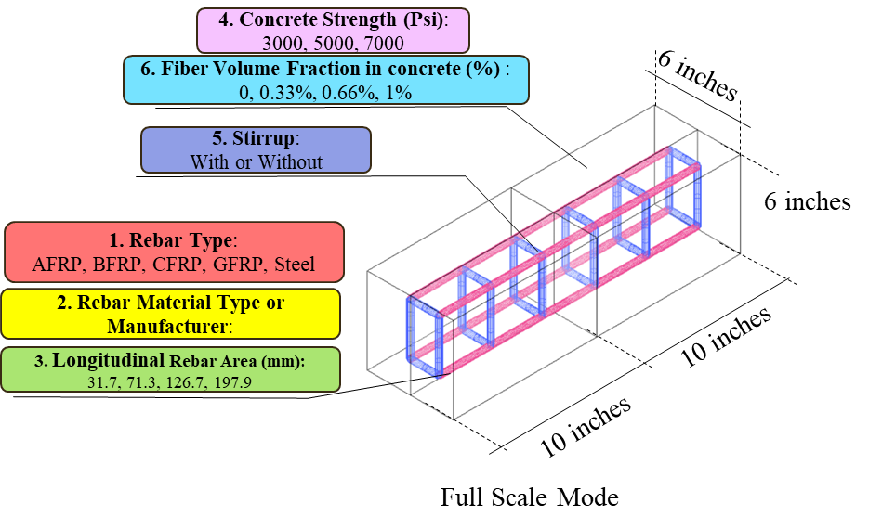

Figure 5. Geometric and parametric definition of the reinforced concrete beam used in FEA simulations

To evaluate the environmental impact of smart beams, life cycle assessment (LCA) was conducted for 40 cases with different materials using SimaPro 9.5, focusing on material input rather than full life cycle stages. The analysis included variations in concrete grade (3000, 5000, and 7000 psi), PVA fiber content (0%, 0.33%, 0.66%, and 1%), stirrups presence, rebar type (steel or GFRP), and rebar diameter (1/4 to 5/8 inch). Two beam sizes, 6 × 6 × 20 inches in and 6 × 6 × 36 inches, were selected as functional units, consistent with the configurations used in the FEA models. For the life cycle inventory, material composition data were compiled in SimaPro 9.5, and the Ecoinvent 3 Inventory database was used. Global warming potential (GWP) was calculated using the IPCC 2013 method. As shown in Figure 6, GWP increases with concrete grade, rising from 4.9 to 6.8 kg CO₂ eq for 3000 psi to 7000 psi concrete in 20-inch beams. The addition of stirrups increases GWP but enhances structural performance. Steel rebar contributes significantly more to GWP than GFRP. For instance, specimen No. 29 (steel) has a 15.4 kg CO₂ eq impact, compared to 12.9 kg CO₂ eq for specimen No. 40 (GFRP), highlighting GFRP’s environmental advantage. These results support the selection of GFRP reinforcement for sustainable smart beam design.

Figure 6. GWP results of each smart beam

The integrated database provides detailed outputs, including crack patterns, peak load, and maximum displacement, offering a design space for the multi-objective optimization in Task 3.

**Task 3. Development of multi-objective metaheuristic optimization framework [50% completed]**

A genetic algorithm (GA) is used to optimize the design variables of reinforced concrete (RC) beams from the integrated database generated in previous tasks. The dataset consisted of 240 FEA simulations of RC beams under bending. Four key design variables were considered including rebar grade, rebar area, concrete strength, and PVA fiber content. Multiple objectives were considered as (1) maximum load, indicating ultimate strength; (2) displacement at peak load, reflecting flexibility; and (3) damage ratio, measuring structural degradation. All features and targets were scaled to a [0,1] range using normalization to enable consistent optimization. To reduce computational cost, a K-Nearest Neighbors (KNN) regressor was used as a surrogate model, capturing the mapping between design parameters and the three performance metrics. The GA was then employed for optimization within the normalized design space, running for 100 generations with a 25% mutation rate per individual to effectively explore the solution space. The fitness function was defined based on the three objectives, yielding an efficient design approach for RC beams:

Fitness = Max Load – ｜Max Displacement｜- Damage Ratio

The fitness function favors high load capacity while penalizing excessive displacement and damage. The theoretical maximum fitness is 1.0, achieved when *Max Load* = 1.0, *Max Displacement* = 0.0, and *Damage Ratio* = 0.0. However, such ideal conditions are rarely observed due to inherent trade-offs among objectives. As shown in 7(a), fitness values increased rapidly within the first 20 generations and stabilized around 0.73, indicating that the GA efficiently identified a high-performing region in the design space. This convergence reflects an effective compromise between strength, flexibility, and structural integrity.

The best fitness score corresponded to a rebar grade of 49.79 ksi, rebar area of 18,305 mm², concrete strength of 6,357.51 psi, and PVA fiber content of 0.8%, yielding an ideal balance of strength, stiffness, and durability. The Pareto surface was constructed by applying trained KNN models to a random grid of 1,000 normalized input points and extracting non‑dominated candidates where no objective improves without degrading another. Figure 7 (b) illustrates this Pareto front as a coherent 3D manifold, color‑coded by damage ratio, highlighting performance trade‑off zones. The x‑, y‑, and z‑axes represent the three objectives: maximum load, maximum displacement, and damage ratio, respectively. And the 3D Pareto front surface reflects the optimal solutions that maximize the maximum load, minimize the maximum displacement, and minimize the damage ratio. The original data points (black) are scattered, while the Pareto front lies closer to the surface with low damage and displacement, identifying optimal design regions. This approach efficiently explores and visualizes design spaces, providing interpretable insights for multi‑objective optimization of RC beams.

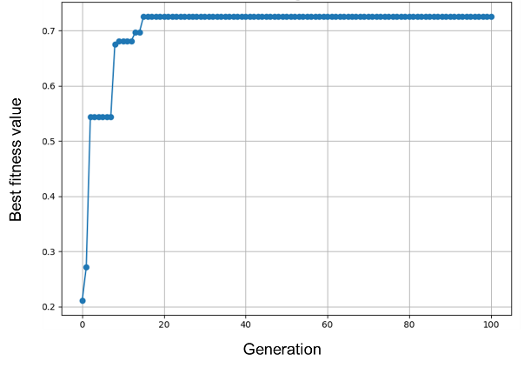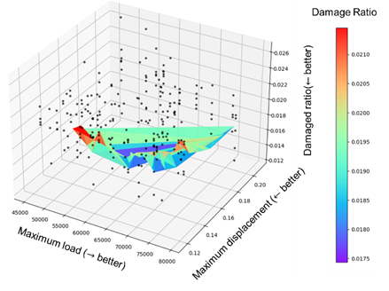

(a) (b)

Figure 7. (a) Fitness convergence curve; (b) 3D Pareto front of optimal solutions

**Transportation-related Application**

The developed data-driven smart composite reinforcement system for precast concrete can be used in monitoring concrete bridges reinforced with composite materials. Due to their scale and exposure to humid environment, bridges often face inspection difficulties and accelerated deterioration [7]. Smart composite reinforcement offers self-sensing capabilities, enabling real-time virtual monitoring. In this study, in order to demonstrate the transportation-related application, a digital twin model was created for a simply supported, composite-reinforced concrete girder bridge subjected to seismic loading. The bridge comprises five main components: guard, deck, girder, pier cap, and pier [8]. The single-span structure is 30 meters long and 10.5 meters wide, supported by five T-girders resting on a pier cap and two circular piers, as shown in Figure 8(a). All components except the guardrail utilize composite reinforcement. The concrete is modeled using solid elements and a damage plasticity model, while composite reinforcements are simplified with truss elements and modeled as linear elastic [9]. This setup allows accurate dynamic simulation and structural monitoring in challenging environments. Smart composite reinforcement provides continuous strain monitoring results along its entire length, enabling the detection of localized strain peaks associated with crack formation. By identifying these distinct strain signals, the location and severity of cracks can be accurately determined. Furthermore, finite element analysis is employed to correlate the strain results and provide a visualization representation of structural behavior through the digital twin model. The developed digital twin model simulates a bridge’s response under seismic loading, as shown in Figure 8(b)(c). The red regions indicate the crack. Vertical and minor horizontal cracks appear at the bottom of the bridge deck near the pier cap, while circumferential cracks are observed at the top and bottom of the piers. Pier cap damage is minimal. The model also reveals internal conditions of composite reinforcement, with high-stress zones aligning with damaged concrete areas. This virtual model enables real-time structural health monitoring and situational awareness for maintenance and recovery. The approach is adaptable for other infrastructures such as pavements, tunnels, and buildings.

(a) (b) (c)

Figure 8. Visualization of digital twin model of composite RC bridge under seismic impact: (a) finite element model of simply supported bridge; (b) concrete damage pattern; (c) reinforcement stress distribution

**Task 4: Reporting [50% completed]**

Two quarterly reports have been completed and submitted.

1. Percent of research project completed: 50%
2. Expected progress for next quarter

In the next quarter, we will expand the database with smart sensor data and image data and keep working on the multi-objective optimization.

1. Educational outreach and workforce development

The PIs mentored Ph.D. students through weekly individual meetings, and bi-weekly group meetings.

1. Technology Transfer

None.

**Research Contribution:**

1. Papers that include TRANS-IPIC UTC in the acknowledgments section:

One paper submitted, one paper in preparation.

1. Presentations and Posters of TRANS-IPIC funded research:

Duan, J., Lin, Y., & Yan, H.­, Wang, S., Xiong, X., Guan, S. & Tao, C., Data-Driven Smart Composite Reinforcement for Precast Concrete, U.S. Department of Transportation (USDOT) - University Transportation Center (UTC), Transportation Infrastructure Precast Innovation Center (TRANS-IPIC) Workshop, April 22-23, 2025.

1. Please list any other events or activities that highlights the work of TRANS-IPIC occurring at your university (please include any pictures or figures you may have). Similarly, please list any references to TRANS-IPIC in the news or interviews from your research.

None.

**Appendix 1**: Research Activities, leadership, and awards (cumulative, since the start of the project)

1. Number of presentations at academic and industry conferences and workshops of UTC findings

* No. = 1

1. Number of peer-reviewed publications submitted based on outcomes of UTC funded projects

* No. = 1

1. Number of peer-reviewed journal articles published by faculty.

* No. = 1

1. Number of peer-reviewed conference papers published by faculty.

* No. = 0

1. Number of TRANS-IPIC sponsored thesis or dissertations at the MS and PhD levels.

* No. MS thesis = 0
* No. PhD dissertations = 2
* No. citations of each of the above = 0

1. Number of research tools (lab equipment, models, software, test processes, etc.) developed as part of TRANS-IPIC sponsored research

* Research Tool #1 (Name, description, and link to tool) = 0
* Research Tool #2 (Name, description, and link to tool) = 0
* Research Tool #3 (Name, description, and link to tool) = 0

1. Number of transportation-related professional and service organization committees that TRANS-IPIC faculty researchers participate in or lead.

* Professional societies
  + No. participated in = 1
  + No. lead = 0
* Advisory committees (No. participated in & No. led)
  + No. participated in = 1
  + No. lead = 0
* Conference Organizing Committees (No. participated in & No. led)
  + No. participated in = 0
  + No. lead = 0
* Editorial board of journals (No. participated in & No. led)
  + No. participated in = 1
  + No. lead = 0
* TRB committees (No. participated in & No. led)
  + No. participated in = 0
  + No. lead = 0

1. Number of relevant awards received during the grant year

* No. awards received = 0

1. Number of transportation related classes developed or modified as a result of TRANS-IPIC funding.

* No. Undergraduate = 0
* No. Graduate = 1

1. Number of internships and full-time positions secured in the industry and government during the grant year.

* No. of internships = 0
* No. of full-time positions = 0

**References:**

1. Yuelin L. et al., ‘PVA fiber reinforced cement composites with calcined cutter soil mixing residue as a partial cement replacement’, Construction and Building Materials, 2022, Vol.326,126924.
2. Naraindas B. et al., ‘Effect of polyvinyl alcohol fiber on the mechanical properties and embodied carbon of engineered cementitious composites’, Results in Engineering, 2023, Vol.20, 101458.
3. Deitz et al., ‘Physical Properties of Glass Fiber Reinforced Polymer Rebars in Compression’, Journal of Composites for Construction, 2003,7(4)
4. American Concrete Institute. (2019). Building code requirements for structural concrete (ACI 318-19) and commentary. American Concrete Institute.
5. American Concrete Institute. (2015). Guide for the design and construction of structural concrete reinforced with FRP bars (ACI 440.1R-15). American Concrete Institute.
6. ASTM International. (2023). Standard practice for making and curing concrete test specimens in the laboratory (ASTM C192 / C192M – 23). ASTM International.
7. B. Graybeal et al., ‘Reliability of visual inspection for highway bridges, volume II: Appendices’, United States. Federal Highway Administration, 2001.
8. L. L. Ma et al., ‘Damage mode and dynamic response of RC girder bridge under explosions’, Engineering Structures, vol. 243, p. 112676, 2021.
9. S.-H. Lee et al., ‘ABAQUS modeling for post-tensioned reinforced concrete beams’, Journal of Building Engineering, vol. 30, p. 101273, 2020.