**Transportation Infrastructure Precast Innovation Center**

**(TRANS-IPIC)**

**University Transportation Center (UTC)**

Data-Driven Smart Composite Reinforcement for Precast Concrete

PU-23-RP-05

Quarterly Progress Report

For the performance period ending *September30, 2024*

**Submitted by:**

Chengcheng Tao (PI), [tao133@purdue.edu](mailto:tao133@purdue.edu)

Shanyue Guan (Co-PI), [guansy@purdue.edu](mailto:guansy@purdue.edu)

School of Construction Management Technology

Purdue University

**Collaborators / Partners:**

Heidelberg Materials, North Dakota State University

**Submitted to:**

TRANS-IPIC UTC

University of Illinois Urbana-Champaign

Urbana, IL

**TRANS-IPIC Quarterly Progress Report:**

**Project Description:**

1. Research Plan - Statement of Problem

Composite reinforcement has been increasingly applied in the precast concrete (PC) area [1], because of its high strength, lightweight, high fracture toughness, long-term corrosion, and crack resistance. The behavior of composite reinforcement plays an important role in the precast concrete infrastructure. It is important to monitor the material system and provide real-time situational awareness under different scenarios. Physical testing with trial-and-error approaches on composite reinforced PC components require substantial time, labor, and material resources to monitor the structural and materials conditions and detect failure or anomalies under service. There is a lack of an efficient and precise way to monitor and predict the risk of the composite reinforcement for PC components.

The proposed research aims to develop a smart composite reinforcement in precast concrete for real-time health condition monitoring using embedded sensors on the composite. The monitoring system can provide the health condition and risk information of the composite reinforcement and investigate the load transfer effectiveness between layers of the reinforcement and the precast concrete. The self-sensed composite reinforcement experimental data will be paired with computational models of composite-concrete system and data-driven machine learning algorithms to predict the risk of the composite reinforcement for a better reinforced precast concrete system. The research will integrate smart sensor technology, computational mechanics of materials, and data-driven machine learning algorithms to detect the structural and materials failure and anomaly mechanism, and predict the associated risk in a wide range of applications.

1. Research Plan - Summary of Project Activities (Tasks)

Task 1. Development and testing of embedded smart sensors for self-sensing composite reinforcement in precast concrete.

This task focuses on the smart composite reinforcement development and experimental testing of the smart composite reinforcement in PC. The sensor data and image data from the experiment will be used to validate numerical models in Task 2 and generate database of composite reinforced-concrete system for AI-based condition assessment model in Task 3.

Task 2. Multi-scale multi-physics modeling with finite element analysis for the composite reinforcement mechanical and bonding performance.

The task focuses on the development of three-dimensional (3D) finite element analysis models to simulate the mechanical and bonding performance of composite reinforcement and precast concrete. Multiple influencing factors will be considered including type of composite reinforcement, type of concrete materials, and geometry of the structure. The numerical analysis results will be compared and validated by the experimental data in Task 1. As the complement of the sensor data in Task 1, the numerical data will be integrated with sensor data and image data in Task 1 to establish a comprehensive physics-informed database for training AI algorithms in Task 3.

Task 3. Development of precast concrete risk index for the infrastructure integrity management enhanced by AI algorithms.

This task focuses on the machine learning-based condition assessment and risk analysis using sensor data, image data, and numerical model data from Tasks 1 and 2 to assess and predict the condition and risk level of composite reinforced concrete system.

Task 4. Reporting.

Research outcomes will be summarized in the quarterly and final reports submitted to TRANS-IPIC and publications in journals. Presentations of the research findings will be disseminated to the TRB and ASCE conferences.

**Project Progress:**

1. Progress for each research task

**Task 1: Development of Smart Sensor-Based Testbed for Composite Reinforcement in Concrete [100% completed]**

1.1 Experiment Setup

Figure 1 shows the schematic of the testbed for smart composite reinforcement in concrete beam. The composite reinforced concrete beam is subjected to testing using the Forney FHS-400-VFD automatic compression test machine. The span length is set to be 18 in, in accordance with the specified requirements of the ASTMC293 standard. The top anvil is positioned at the center, and two bottom rigid supports are placed 1 in from each edge. To develop smart composite reinforcement, we embed LUNA high-definition fiber optic strain sensors and Vishay micro-measurement strain gauges in this task. The fiber optic sensors have the advantages of being small in size (125 μm in diameter without additional coating), high flexibility (allowing them to wrap around reinforcement), long sensing range (up to 2 km per optic fiber), water-resistance, and affordable cost. Fiber optic sensors provide real-time strain monitoring along the entire length of the fiber. In this study, we embed the fiber optic sensor along the bottom of the composite rebars, with two strain gauges positioned at the ends and the midspan of the rebar, next to the fiber optic sensors. We apply Vishay micro-measurement strain gauges on the rebar at various points next to the fiber optic sensor for comparison and validation between two types of smart sensors. In addition to the embedded fiber optic sensors and strain gauges for the composite rebar, as well as linear strain gauges for the concrete. We also equip four image data collection devices, including cell phones, digital image correlation (DIC) cameras, GoPro, and drones. Two phones (iPhone 15 and iPhone 15 ProMax) are placed at the sides to capture deformations of the RC beam. A GoPro camera is attached at the side edge of the beam to observe the propagation of the bending crack. The Intel RealSense digital image correlation cameras face the front and back surfaces of the beam after failure. The DJI drone flies in the diagonally upward direction, filming the experiment and observing the top of beam.

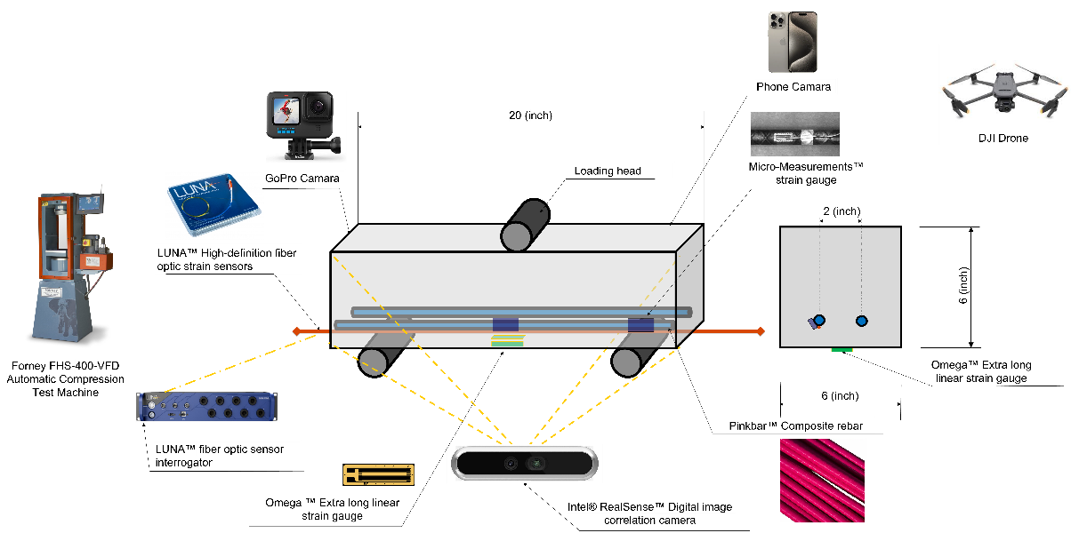

Figure 1. The schematic of the experimental setup of the smart composite reinforced concrete system.

Since the fiber optic sensor is very fragile and vulnerable, we create a groove on the composite rebar to embed the fiber optic sensor, using the method suggested by Bado et al. [2]. Figure 2(a) shows the groove on the rebar for fiber optic sensor embedment. Given the slim and delicate property of fiber optic sensors, we protect them with the coating of 3M DP460 two-component epoxy, which also serves as a glue to ensure strong bonding between the sensor and rebar, as depicted in Figure 2(b). A thin silica tube is used to provide extra protection near the rebar ends, mitigating the risk of fiber fracture. The same two-component epoxy is employed to attach two strain gauges at the midspan and end of the rebar next to the fiber optic sensor. Due to the high curvature of the rebar surface, as shown in Figure 2(b), a vacuum vise and rubber pad are used to secure the strain gauge firmly to the rebar. Once the epoxy has fully cured, the strain gauge functionality is tested using a micro-measurement data analyzer to verify that all gauges are operating correctly, as shown in Figure 2(c).

|  |  |  |
| --- | --- | --- |
|  |  |  |
| (a) | (b) | (c) |

Figure 2. Smart sensor embedment into composite reinforcement: (a) creating a groove on the composite rebar for fiber optic sensor installation and protection; (b) applying two-component epoxy on fiber optic sensor; (c) testing the workability of rebar strain gauge.

In addition, we also investigate the effect of groove on the performance of the composite reinforced concrete beam by comparing two composite rebars with and without groove. For the rebar without groove, we install the fiber optic sensor directly on the rebar, shown in Figure 3. Both composite rebars have the same protections, including two-component epoxy, and silica and PVC tubes. In section 1.2, we discuss the effect of groove on the performance of the beam from the smart sensor results of the two rebars.

|  |  |
| --- | --- |
|  |  |
|  |  |

Figure 3. Smart composite reinforcement: (a) with groove; (b) without groove.

For the development of a smart sensor-based testbed for composite reinforcement in concrete, we conduct a three-point flexural test for a smart composite reinforced concrete beam, following the ASTM C293 and ACI 440.1R standards to evaluate the performance of sensors. The RC beam is configured with cross-sectional dimensions of 6 x 6 inches and a length of 20 inches. Two #3 rebars are positioned with a bottom cover depth of 1 inch, evenly spaced on the rebar chairs, as shown in Figure 4(a). A silica tube is utilized to protect the fiber optic sensor within the concrete, and a PVC tube for the protection in the external parts. We select commercially available ready-mix concrete with a compressive strength of 5000 psi and pour it into a stainless-steel mold for curing, as shown in Figure 4(b). Figure 4(c) exhibits the demolded concrete beam after seven days of curing. In addition to the fiber optic sensor and strain gauge on rebar, this study incorporates the Omega extra-long linear strain gauge for concrete. We select two measurement locations: one at the bottom center of the beam to capture tensile strain data during the experiment, and another at the corresponding position of the rebars on the front surface, which will provide strain measurements close to the rebars. Figure 4(d) shows that these two locations have been finely polished, cleaned, and properly installed with strain gauges.

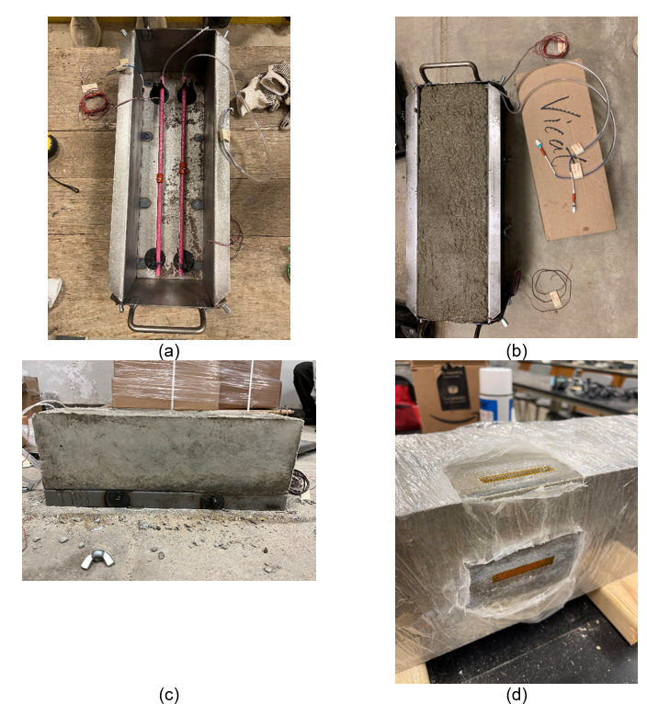

Figure 4. Smart composite reinforced concrete beam sample preparation: (a) configuration of smart composite rebar; (b) concrete beam in the mold; (c) demolded concrete beam sample; (d) Omega extra-long linear strain gauge installation for concrete beam.

During the flexural test, we use the fiber optic sensor interrogator and National Instrument data acquisition system (*NI-9235*) with LabView software to collect and monitor strain data along the rebars from fiber optic sensors and strain gauges in real-time, as shown in Figure 5(a). The distributed fiber optic sensors use the principle of light scatterings to measure strain distributions along with the composite reinforcement. The backscattering is an intrinsic property of optical media and is caused by the natural impurities and imperfections in the optical fiber core when a short laser pulse is beamed from one end and propagates along with the fiber. The interrogator can capture the changes in light properties and convert them to strain data. Due to the design of the Forney compression test machine, the middle section of the beam is obstructed. Consequently, Figure 5(b) displays the grid lines drawn on the beam surface to assist with cameras positioning and alignment, facilitating image preprocessing. After completing the grid lines, Figure 5(c) shows the composite reinforced concrete beam being moved to the Forney compression test machine. We also manually check the positions of the beam and the top anvil to ensure compliance with the standard, placing an additional leather compression shim between the top anvil and the beam top surface to eliminate any gap. In addition to the smart sensors, we utilize four types of cameras for this experiment: smart phones, digital image correlation cameras, drone and GoPro. Figure 5(d) exhibits a GoPro installed on the edge of beam for recording the entire experiment. Another two cables are connected to the strain gauge interrogator (*NI-9235*) for collecting and transmitting the data from strain gauges. Figure 5(e) shows the placement of a DIC camera at the front, together with two cellphone cameras on the sides. The cables are reorganized carefully to avoid shear rupture of the delicate fiber optic sensors. Figure 5(f) shows the final crack pattern on the beam, with a thin bending crack detected at the midspan and a wide shear crack near the bottom support.

|  |  |  |
| --- | --- | --- |
|  |  |  |
| (a) | (b) | (c) |
|  |  |  |
| (d) | (e) | (f) |

Figure 5. Three-point flexural testbed for composite reinforced concrete beam: (a) fiber optic sensor interrogator; (b) grid lines for image preprocessing; (c) transport test sample to test machine; (d) GoPro camara for video recording; (e) sensor and image data collection; (f) final crack propagation pattern.

1.2 Results from Smart Sensors

We create two sample beams for the test, Beam 1 is equipped with four strain gauges positioned at the midspan and ends of the rebars, together with two embedded fiber optic sensors along the rebars. Beam 2 also features two fiber optic sensors embedded along the rebars, and two rebar strain gauges at the midspans. For the data collected from the fiber optic sensors, only a portion of the fiber optic sensor data reflect the strain of the composite rebars. Thus, it is essential to determine the appropriate range of data first. As shown in Figure 6, the strain data from the first 0.8 m remains stable, indicating that only the data points after 0.8 m are useful, as highlighted in the red frame. Consequently, we consider the strain data from 0.8 m to 1.25 m as effective strain data for composite rebars, used for further analysis.

|  |  |  |  |
| --- | --- | --- | --- |
|  |  |  |  |
| (a) | (b) | (c) | (d) |

Figure 6. Raw data from fiber optic sensors: (a) Composite rebar 1 in Beam 1; (b) Composite rebar 2 in Beam 1; (c) Composite rebar 1 in Beam 2; (d) Composite rebar 2 in Beam 2.

First, we compare the strain gauge results of composite rebars at the midspan. Since the sensors usually work at relatively high frequencies to capture more data points within a given time, facilitating real-time monitoring, this high frequency can increase noise sensitivity and degrade data quality. To address this, we apply a Butterworth low-pass filter to smooth the signal data and attenuate high-frequency noise, ensuring a gradual transition but keep the important turning points. The sampling rate of the strain gauge is 100 Hz, hence the cutoff frequency is set to be 0.05 Hz. As the two composite rebars are symmetrically placed at the bottom of the composite reinforced concrete beam, the sensors on both rebars should yield similar results. Figure 7(a) displays a plot of the filtered strain gauge results of composite rebars at the midspan. The results from the two rebars are greatly matched, reflecting the bending cracks at 300 s and the shear crack at 620 s. Figure 7(b) – (d) presents the plots that split the entire experiment into three phases: from the beginning to the first crack, from the first crack to the second crack, and from the second crack to the end. The results confirm that the strain gauges function effectively, capturing the occurrence of cracks simultaneously. Figure 8 exhibits the strain gauge results at the two rebar ends. Some discrepancies are found between the first and second cracks, which is caused by the scale and the location of the sensors. Since the strain at the end is significantly lower than that of the midspan, slight differences are amplified by the scale. However, the strain difference is smaller than 10-4 mm/mm, and the trends are well aligned, indicating that the strain gauges accurately measure strain at both the midspan and ends of the composite rebars. Different from the strain gauge, the fiber optic sensor operates at a lower sampling rate of 15.625 Hz. To avoid over-filtering, the cutoff frequency is adjusted to 0.2 Hz. Additionally, due to the delicacy of fiber optic sensors, some bad points—where no data is provided—are inevitable. Therefore, we apply interpolation to estimate an average value to represent the strain at bad points. As shown in Figure 9, the strain data from fiber optic sensors perfectly matched across all phases, and also capture the happening of bending and flexural cracks. The results demonstrate excellent monitoring performance. Again, minor discrepancies are observed at the rebar ends in Figure 10, particularly when the shear crack occurs, but the overall trend remains consistent.

|  |  |  |  |
| --- | --- | --- | --- |
|  |  |  |  |
| (a) | (b) | (c) | (d) |

Figure 7. Strain gauge results of composite rebars at the midspan. (a) Entire experiment time; (b) From the beginning to the time of first crack; (c) From the time of the first crack to the second crack; (d) From the time of the second crack to the end.

|  |  |  |  |
| --- | --- | --- | --- |
|  |  |  |  |
| (a) | (b) | (c) | (d) |

Figure 8. Strain gauge results of composite rebars at the end: (a) entire experiment time; (b) from the beginning to the time of first crack; (c) from the time of the first crack to the second crack; (d) from the time of the second crack to the end.

|  |  |  |  |
| --- | --- | --- | --- |
|  |  |  |  |
| (a) | (b) | (c) | (d) |

Figure 9. Fiber optic sensor results of composite rebars at the midspan: (a) entire experiment time; (b) From the beginning to the time of first crack; (c) from the time of the first crack to the second crack; (d) from the time of the second crack to the end.

|  |  |  |  |
| --- | --- | --- | --- |
|  |  |  |  |
| (a) | (b) | (c) | (d) |

Figure 10. Fiber optic sensor results of composite rebars at the end: (a) entire experiment time; (b) from the beginning to the time of first crack; (c) from the time of the first crack to the second crack; (d) from the time of the second crack to the end.

Similarly, from the symmetric design configuration, the fiber optic sensor should provide the same data as strain gauges at the same locations. Therefore, we compare the strain data at the midspan and ends obtained from the strain gauges and fiber optic sensors. Figures 11 and 13 present the comparison of the two rebars at the midspan. The strains are well-matched between the two types of sensors, with the results of composite rebar 1 showing even closer agreement. The differences in the final phase are attributed to the higher sampling rate of the strain gauge. The comparison between the fiber optic sensor and strain gauge results for composite rebar 1 at the ends, shown in Figure 12 and 14, reveals some disparities. Fiber optic sensors measure higher strains compared to the strain gauges. A possible explanation is that fiber optic sensors are more sensitive and can capture finer strain variations, as they are directly embedded in the rebar.

|  |  |  |  |
| --- | --- | --- | --- |
|  |  |  |  |
| (a) | (b) | (c) | (d) |

Figure 11. The comparison between fiber optic sensor and strain gauge results of composite rebar 1 at the midspan: (a) entire experiment time; (b) from the beginning to the time of first crack; (c) from the time of the first crack to the second crack; (d) from the time of the second crack to the end.

|  |  |  |  |
| --- | --- | --- | --- |
|  |  |  |  |
| (a) | (b) | (c) | (d) |

Figure 12. The comparison between fiber optic sensor and strain gauge results of composite rebar 1 at the end: (a) entire experiment time; (b) from the beginning to the time of first crack; (c) from the time of the first crack to the second crack; (d) from the time of the second crack to the end.

|  |  |  |  |
| --- | --- | --- | --- |
|  |  |  |  |
| (a) | (b) | (c) | (d) |

Figure 13. The comparison between fiber optic sensor and strain gauge results of composite rebar 2 at the midspan: (a) entire experiment time; (b) from the beginning to the time of first crack; (c) from the time of the first crack to the second crack; (d) from the time of the second crack to the end.

|  |  |  |  |
| --- | --- | --- | --- |
|  |  |  |  |
| (a) | (b) | (c) | (d) |

Figure 14. The comparison between fiber optic sensor and strain gauge results of composite rebar 2 at the end: (a) entire experiment time; (b) from the beginning to the time of first crack; (c) from the time of the first crack to the second crack; (d) from the time of the second crack to the end.

As mentioned in 1.1, we also investigate the effect of the groove on the performance of composite rebar. We have one composite embedded directly into the beam without a groove, and another one has a groove for the fiber optic sensor. Figure 3 shows the smart composite reinforcements with and without grooves, respectively. As shown in Figure 15, the strain data from both rebars matches, indicating little effect on the rebar performance from the groove. A bending crack appears at 360 s, which induces a significant spike in the results. Again, although a strain difference is observed at the rebar ends after cracking, the difference is smaller than 2×10-4 mm/mm, indicating that the groove has a negligible impact on the rebar performance.

|  |  |  |
| --- | --- | --- |
|  |  |  |
| (a) | (b) | (c) |

Figure 15. Fiber optic sensor results of composite rebars at the midspan: (a) entire experiment time; (b) from the beginning to the time of bending crack; (c) from the time of the bending crack to the end.

Additionally, we conduct a tensile test on the composite reinforcement solely to have a better understanding of its material properties and facilitate the numerical study of the effect of fiber-reinforced polymers in composite rebar. The #3 rebar sample has a length of 8 in, is equipped with a strain gauge at the midspan to measure the tensile strain, as shown in Figure 16(a). Figure 16(b) shows the rebar clamped at two ends, subjected to a constant tensile rate of 0.15 mm per minute. The experiment is conducted using an INSTRON universal testing machine, which has a maximum load capacity of 50 kN, as shown in Figure 16(c). The results from the INSTRON machine and strain gauge are plotted in Figure 17. From the tensile test results, the composite reinforcement exhibits linear material property, consistent with the rebar product specifications.

|  |  |  |
| --- | --- | --- |
|  |  |  |
| (a) | (b) | (c) |

Figure 16. Tensile test for composite reinforcement: (a) test sample with strain gauge; (b) experiment setup overview; (c) tensile test on INSTRON universal testing machine.



Figure 17. Tensile test results from INSTRON machine and strain gauge.

Overall, in Task 1, we successfully develop smart composite reinforcement in concrete beams and demonstrate the real-time monitoring of composite reinforcement. The results from two types of smart sensors align well with each other. And the strain data is validated by images and videos, recorded by different types of cameras, showing the accuracy and reliability of our smart sensor-based testbed. The experiment results will be integrated with the numerical results from Task 2, and used as input to train machine learning algorithms in Task 3.

**Task 2: Numerical Modeling of Composite Reinforced Concrete [100% completed]**

In this task, we conduct three-dimensional (3D) finite element analysis (FEA) to simulate mechanical and bonding performance of composite reinforced concrete. The numerical modeling results in this task are used as complementary of the experimental and sensor data in Task 1 to establish a physics-informed database for machine learning algorithms in Task 2. We simulate the flexural test and pull-out test of the reinforcement-concrete system by considering various factors such as types of composite rebars, strength of concrete materials, and rebar configurations. We apply Abaqus for the numerical modeling of both flexural strength test and pull-out test.

2.1 Flexural Test

For the flexural test modeling, the glass fiber-reinforced polymer (FRP) composite rebars (PINKPAR) are modeled with the following material properties: Young’s modulus of 46.88 GPa, Poisson’s ratio of 0.3, and ultimate strength of 1,003 MPa. A uniform meshing is adopted for the concrete beam with a total of 90,900 elements, while relatively finer meshing is employed for the rebars given their smaller sizes. The interfacial contact between concrete and reinforcements is set to be fully bonded, with the embedded element option selected in the simulation [3]. We apply the concrete damage plasticity (CDP) and elasto-plasticity models for the nonlinear analysis, as they have been proven effective in modeling concrete damage and fracture [4]–[9]. The plasticity parameters for the CDP model are defined as follows: dilation angle = 30o, eccentricity = 0.1, the ratio of biaxial compressive strength to uniaxial compressive strength = 1.16, the ratio of the second stress invariant on the tensile meridian = 0.66 [10]. Nonlinear analysis is conducted by controlling the displacement of the top loading anvil, which uniformly moves downwards by 5 mm. Figure 18 shows the simulation model setup layout from font and isometric views.

|  |  |
| --- | --- |
|  |  |
| (a) | (b) |

Figure 18. Numerical model of flexural test: (a) front view; (b) isometric view.

The numerical modeling results will be used to establish a comprehensive physics-informed database together with experimental results by considering different scenarios and factors in composite reinforced concrete system. The database will be utilized to train machine learning-based condition assessment algorithms in Task 3*.* In this task, we consider three concrete grades: normal concrete with a compressive strength of 5,000 psi (same as the concrete we use in the experiment of Task 1), high-performance concrete (HPC) with a compressive strength of 10,000 psi, and ultra-high-performance concrete (UHPC) with a compressive strength of 22,000 psi. In addition to concrete grades, we also broaden the selection of FRPs in rebar composite materials. FRPs consist of fibers embedded in a polymeric resin matrix. We simulate four types of most widely used FRPs in the composite rebars: aramid FRP (AFRP), basalt FRP (BFRP), carbon FRP (CFRP), and glass FRP (GFRP) [11] in our study. All simulated composite rebars have a uniform diameter of 3/8 inches and a length of 18 inches. Furthermore, we investigate the effect of rebar ribs on the performance of composite reinforced concrete systems. The bond strength of ribbed GFRP rebar is primarily influenced by the mechanical interaction between the ribs and the surrounding concrete. As a result, the bond-slip behavior of GFRP ribbed rebars can vary depending on the geometries of the ribs [12]. The geometries of the composite rebars are established according to the reference [11]. Figure 19 provides detailed schematics of the specific geometries for AFRP, BFRP, CFRP, and GFRP rebars.

|  |  |
| --- | --- |
|  |  |
| (a) | (b) |
|  |  |
| (c) | (d) |

Figure 19. Simulation details for different types of FRP: (a) AFRP, (b) BFRP, (c) CFRP, and (d) GFRP.

Table 1 presents 16 cases evaluating the effects of concrete strength and rebar surface texture (ribbed vs. non-ribbed) among four different types of FRP rebars: AFRP, BFRP, CFRP, and GFRP. The concrete strength ranges from 5,000 psi to 22,000 psi. This combination model is designed to predict how varying these parameters influences the structural performance of composite reinforced concrete systems. The results provide insights for engineers, assisting in the selection of the optimal combination of concrete grades and FRP types based on specific project requirements.

Table 1. List of different FEA cases for composite reinforced concrete system

|  |  |  |  |  |
| --- | --- | --- | --- | --- |
| **Case** | **Concrete Compressive Strength (psi)** | **Rebar Type** | **Rebar Young’s Modulus (GPa)** | **Rebar Ultimate strength (MPa)** |
| 1 | 5,000 | AFRP with no ribs | 770 | 1450 |
| 2 | 5,000 | AFRP with ribs |
| 3 | 10,000 |
| 4 | 22,000 |
| 5 | 5,000 | BFRP with no ribs | 78 | 2000 |
| 6 | 5,000 | BFRP with ribs |
| 7 | 10,000 |
| 8 | 22,000 |
| 9 | 5,000 | CFRP with no ribs | 140 | 3000 |
| 10 | 5,000 | CFRP with ribs |
| 11 | 10,000 |
| 12 | 22,000 |
| 13 | 5,000 | GFRP with no ribs | 46.8 | 1003 |
| 14 | 5,000 | GFRP with ribs |
| 15 | 10,000 |
| 16 | 22,000 |

*2.1.1 Effect of different types of composite rebars*

This section primarily discusses the effect of different types of composite rebars. Figure 20 illustrates the vertical force-displacement curves for AFRP, BFRP, CFRP, and GFRP rebars embedded in concrete with a compressive strength of 5,000 psi. At the initial stage, up to a displacement of approximately 0.68 mm, all four rebars exhibit similar behavior. As displacement increases, the performance of each rebar diverges. CFRP reaches the highest peak force of approximately 8×10⁴ N, while GFRP has the lowest peak at around 4.5×10⁴ N. After reaching peak force, the vertical force decreases for all types of rebars as displacement continues to increase. The results also demonstrate variations in displacement at the ultimate load, with GFRP exhibiting the largest displacement capacity and CFRP having the lowest. In our study, CFRP demonstrated the highest flexural ultimate load among all rebar types within the same concrete grade. The numerical results align with the results by Sun et al. [13], indicating that concrete beams reinforced by lapped and continuous CFRP bars exhibited flexural bearing capacity increase of 127.5% and 160.4%, respectively, when compared to beams reinforced with hot-rolled ribbed steel rebars.

Figure 20. Vertical force versus displacement for different FRP rebars in 5,000 MPa concrete.

Figure 21 illustrates the crack propagation at the final failure stage for AFRP, BFRP, CFRP, and GFRP-reinforced beams. The transition of cracks from vertical flexural cracks at the bottom center to 45° shear cracks connecting the top anvil head to the two bottom supports. The level of damage in tension (DAMAGET) is used to assess structural damage, with higher values indicating greater damage intensity. The failure point is determined by the maximum load each beam can sustain during the simulation. At the final failure stage, all beams experience shear cracks, which dominate the failure mechanism. Among the four types of FRP rebars, CFRP exhibits the least cracking due to its smaller displacement of 1.40 mm, leading to more localized damage. AFRP and BFRP, in contrast, show more significant cracking, with BFRP having a larger displacement of 2.21 mm, resulting in more widespread damage throughout the beam. GFRP, which has the highest displacement of 2.61 mm, experiences the most severe and extensive cracking, as indicated by the larger red zones in the damage contour. Concrete reinforced with steel rebars, which have a higher Young's modulus, exhibits less crack propagation compared to concrete reinforced with BFRP rebars, which have a lower Young's modulus. Additionally, the vertical deflection at ultimate load is significantly lower for steel-reinforced concrete compared to composite-reinforced concrete, as BFRP has a lower Young's modulus but a higher ultimate stress capacity [14].

|  |
| --- |
|  |
| (a) |
|  |
| (b) |
|  |
| (c) |
|  |
| (d) |

Figure 21. Crack patterns for different FRP rebars at failure moment: (a) AFRP, (b) BFRP, (c) CFRP, (d) GFRP.

Figure 22 presents the analysis of maximum stress and strain levels for the four types of FRP rebars: AFRP, BFRP, CFRP, and GFRP. BFRP exhibits the highest logarithmic strain (LE) and the von Mises stress levels among the four types of rebars, indicating it undergoes the most deformation under loads. AFRP and CFRP show significantly lower stress and strain, while GFRP experiences the second lowest strain. This indicates that GFRP, while exhibiting lower stiffness, is more flexible. In contrast, CFRP has higher stiffness, resulting in minimal deformation.

|  |  |
| --- | --- |
|  |  |
| (a) | (b) |
|  |  |
| (c) | (d) |
|  |  |
| (e) | (f) |
|  |  |
| (g) | (h) |

Figure 22. Stress and strain distribution for different FRP rebars: (a) AFRP - LE, (b) von Mises stress of AFRP, (c) BFRP - LE, (d) von Mises stress of BFRP, (e) CFRP - L, (f) von Mises stress of CFRP, (g) GFRP - LE, (h) von Mises stress of GFRP.

*2.1.2 Effect of different types of concrete materials*

This section focuses on the influence of concrete strength on crack propagation and flexural loading in reinforced concrete systems. The four figures shown in Figure 23 illustrate the vertical force-displacement relationship for AFRP, BFRP, CFRP, and GFRP rebars embedded in concrete with varying compressive strengths of 5,000 MPa,10,000 MPa, and 22,000 MPa. Across all rebar types, increasing the concrete strength generally results in higher vertical force capacity and greater structural performance. For instance, BFRP embedded in 22,000 MPa concrete exhibits the highest peak force, while its performance in normal concrete (5,000 MPa) is significantly lower. In the case of CFRP, the concrete strength has a more significant effect, especially at higher displacements, where 22,000 MPa of concrete shows much greater load-bearing capacity. GFRP also follows a similar trend, with the UHPC concrete (22,000 MPa) supporting the highest forces and the normal concrete (5,000 MPa) leading to early failure. We also compare our FEA results with FRP flexural experiment in references to validate the accuracy of our model. For example, in our FEA, a GFRP-reinforced beam in 10,000 MPa concrete exhibited an approximate flexural ultimate load of 66 kN [12]. In contrast, a similar-sized concrete beam reinforced with GFRP in the literature showed a flexural ultimate load of 45 kN [12]. Overall, Our FEA results highlight the essential role of concrete strength in demonstrating the structural behavior and performance of different types of FRP rebars. A similar study shows that GFRP exhibits better bending resistance in higher-strength concrete, with a higher failure load and requiring greater loading force for the deflection at which the first crack appears [15].

|  |  |
| --- | --- |
|  |  |
| (a) | (b) |
|  |  |
| (c) | (d) |

Figure 23. Vertical force versus displacement for different FRP rebars in varying concrete compressive strengths: (a) AFRP, (b) BFRP, (c) CFRP, (d) GFRP.

Figure 24 shows the cracking pattern at the failure point for BFRP rebar embedded in concrete with varying compressive strengths—5,000 MPa, 10,000 MPa, and 22,000 MPa—under flexural loading. The data highlight how different concrete strengths influence crack propagation. Noticeably, BFRP embedded in UHPC (22,000 MPa) exhibits the most extensive cracking, with a peak displacement of approximately 3.0 mm. Due to the higher loading displacement at the failure point, the cracks propagate more widely across the structure, leading to more significant structural damage. In contrast, when BFRP is embedded in normal concrete (5,000 MPa), the displacement is lower, around 2.5 mm, and the cracks are more confined, resulting in less widespread damage. The HPC concrete strength (10,000 MPa) shows an intermediate behavior, with cracking patterns and displacement (approximately 2.8 mm) between those of the 5,000 MPa and 22,000 MPa cases. These results suggest that higher concrete strength while increasing the load-bearing capacity, may result in more extensive crack propagation. Other researchers have conducted similar studies on the crack patterns of concrete beams with varying compressive strengths. For example, in a study analyzing concrete specimens with 85 MPa,78 MPa, and 44 MPa, it was observed that higher-strength concrete tends to exhibit more complex and wider crack propagation, while lower-strength concrete shows a more ductile response with fewer cracks [16].

|  |
| --- |
|  |
| (a) |
|  |
| (b) |
|  |
| (c) |

Figure 24. Crack patterns for BFRP at the failure moment in different compressive strength concrete: (a) 5,000 psi, (b) 10,000 psi, (c) 22,000 psi.

The analysis of BFRP rebars embedded in different strengths of concrete is shown in Figure 25. The rebar embedded in 5,000 MPa concrete exhibits lower strain and von Mises stress values compared to the rebar in 22,000 MPa concrete. For the 5,000 MPa case, the LE is approximately 0.033, and stress peaks at around 2377 MPa. In contrast, in the 22,000 MPa concrete, the strain increases to 0.042, and the stress reaches up to 2991 MPa. This indicates that the rebar in the 22,000 MPa concrete experiences higher strain and stress at the failure point, suggesting it is subjected to greater deformation and loading conditions.

|  |  |
| --- | --- |
|  |  |
| (a) | (b) |
|  |  |
| (c) | (d) |
|  |  |
| (e) | (f) |

Figure 25. Stress and strain distribution for BFRP rebars in different strength concretes: (a) 5,000 psi - LE, (b) von Mises stress of 5,000 psi concrete, (c) 10,000 psi - LE, (d) von Mises stress of 10,000 psi concrete, (e) 22,000 psi - LE, (f) von Mises stress of 22,000 psi concrete.

*2.1.3 Effect of ribs on rebars*

This section focuses on the investigation of the effect of ribs on various types of composite rebars. Figure 26 illustrates the load-displacement relationship for various types of FRP rebars—AFRP, BFRP, CFRP, and GFRP—embedded in 5,000 MPa concrete, comparing rebars with and without ribs. Rebars with ribs generally exhibit higher peak vertical forces and better displacement capacity. For example, CFRP with ribs reaches around 8×10⁴ N, compared to its non-ribbed counterpart, which exhibits a lower peak force. This suggests that ribbed rebars enhance bonding with concrete, delay crack propagation, and improve the overall load-bearing capacity under flexural loading. In contrast, non-ribbed rebars tend to exhibit lower peak forces and less controlled cracking behavior. Overall, the presence of ribs contributes to better structural performance. Other researchers found similar results, showing that the surface treatment of CFRP bars is crucial for effectively transferring flexural stress within the tension zone of CFRP-reinforced concrete beams. Adequate bond strength between the CFRP bars and the concrete plays a key role in reaching the ultimate moment capacity in the flexural test. The study also shows that non-ribbed bars require a higher reinforcement ratio to achieve similar ultimate flexural strength than deformed CFRP bars [17].

Figure 26. Vertical force versus displacement for different FRP rebars with and without ribs embedded in 5,000 MPa concrete.

Figure 27 shows the difference between GFRP rebar with ribs and without ribs embedded in 5,000 psi concrete at the same failure point. In the case without ribs, the cracks are more localized, with damage concentrated in a smaller region, indicating less widespread failure. In contrast, with ribs, the cracks propagate more widely, covering a larger area with greater damage. This suggests that while ribs enhance the load transfer between the rebar and concrete, they also lead to more extensive crack distribution due to the increased bond strength and strain localization. Therefore, ribs can cause a broader spread of cracks under higher loads, even though they improve the overall structural performance.

|  |
| --- |
|  |
| (a) |
|  |
| (b) |

Figure 27. Crack patterns for GFRP at the failure moment: (a) without ribs, (b) with ribs.

Figure 28 shows that the ribbed GFRP rebar exhibits a more evenly distributed strain and stress compared to the non-ribbed rebar. The ribbed rebar exhibits slightly more localized strain and stress on the ribs themselves, indicating strong bonding stress at the ribs. The ribs enhance load transfer, resulting in greater load-bearing capacity in the flexural test.

|  |  |
| --- | --- |
|  |  |
| (a) | (b) |
|  |  |
| (c) | (d) |

Figure 28. Stress and strain distribution for GFRP rebars: (a) without ribs - LE, (b) von Mises stress of rebars without ribs, (c) with ribs - LE, (d) von Mises stress of rebars with ribs.

2.2 Pullout Test

*2.2.1 Model Setup*

In this section, we focus on the numerical modeling of the bonding performance of composite reinforced concrete through the simulation of a pull-out test. For the pull-out test of the reinforcement-concrete system, simulations are conducted using SIMULIA-ABAQUS [18]. The pull-out simulation is conducted based on the specified composite rebar bonding strength test standard ASTM-D7913M [19]. The study aims to propose an FEA modeling approach to simulate the bond-zone behavior of pull-out tests of reinforcement in concrete. Nonlinear analysis is conducted by controlling the displacement of the top loading head on the rebar, which constantly moves upwards. For the pull-out test modeling, the concrete CDP for the nonlinear analysis is applied in this study. The load-slip relationship curves are obtained from the load and displacement history in pull-out tests. The corresponding bonding stress *τ* between embedded rebar and concrete is assumed to be uniformly distributed along the embedment length, and it can be calculated by dividing the tensile force by the overall contact area between rebar and concrete as illustrated in the following Eq 1 [20]–[22]:

|  |  |  |
| --- | --- | --- |
|  |  | (1) |

where P is the load, db is the diameter of the rebar, and lb is the bonded embedment length of the rebar.

We apply the same GFRP rebars as previous section with the material properties: Young's modulus of 46.88 GPa, Poisson's ratio of 0.3, and ultimate strength of 1,003 MPa. Both rebars and concrete material information are listed in Table 2. The plasticity parameters for the CDP model are specified as follows: a dilation angle of 30 degrees, eccentricity of 0.1, a ratio of biaxial compressive strength to uniaxial compressive strength of 1.16, and a ratio of the second stress invariant on the tensile meridian of 0.66 [10].

Table 2. Material properties of pull-out test specimens for FEA.

|  |  |  |  |  |
| --- | --- | --- | --- | --- |
| GFRP composite rebars | Young’s modulus *E*  (MPa) | Yield stress *fy*  (MPa) | Ultimate stress  *fu*  (MPa) | Poisson ratio *ν* |
| 46880 | 600 | 1003 | 0.3 |
| Concrete | Young’s modulus (MPa) | Ultimate compressive stress | Ultimate tensile stress  (MPa) | Poisson ratio |
| 34554 | 40.1 | 4.6 | 0.2 |

Accurately representing rib geometry is essential, as optimal rib geometries can enhance bond performance [23]. The rib geometry is based on the actual measurements of the physical PINKBAR rebars. The schematic drawings for the rib and the pull-out simulation geometry are shown in the following Figure 29.

|  |  |  |
| --- | --- | --- |
|  | | |
| (a) | (b) | (c) |

Figure 29. (a) Schematic view of rib geometry of GFRP ribbed rebar; (b) top view of pull-out simulation setup; (c) side view of pull-out simulation setup.

In this study, the GFRP ribbed rebars are embedded in the center of a 200 mm x 200 mm x 200 mm concrete specimen. The bonding length of the rebar is set as specified in the ASTM D7913/D7913M standard [19], which states that the bonded length should be five times the effective diameter db of the FRP bar. Outside this bonded section, the rebar is sheathed with a material such as PVC to prevent bonding, ensuring that only the specified bonded length interacts with the concrete. The detailed geometry of the pull-out simulation is listed in Table 3. Since the model is fully symmetric along the x-z and y-z planes, a quarter section of the entire model is constructed to optimize computational efficiency. Consequently, the corresponding boundary conditions are set as symmetric.

Table 3. Geometry details of pull-out test specimens used for FEA.

|  |  |  |  |  |
| --- | --- | --- | --- | --- |
| Rebars | Rib width (mm) *RL* | Rib spacing (mm) *RS* | Rib diameter/Effective diameter *db* (mm) | Rebar radius (mm) *d* |
| 5.5 | 11 | 9.52 | 9.92 |
| Concrete | Concrete width (mm) *W* | Concrete length (mm) *L* | Concrete depth (mm) *D* | Bonding length (mm) *Lb* |
| 200 | 200 | 200 | 47.6 |

Figure 30 illustrates the setup of the pull-out simulation model, including rebar rib details. In this model, the embedded reinforcing bar is pulled vertically, while the vertical movement of the top surface concrete is fixed during the loading process.

|  |  |
| --- | --- |
| A ruler and pink stick |  |
| (a) | (b) |
|  | |
| (c) | |

Figure 30. (a) Rib configuration of a GFRP bar. (b) Rib details in FEA simulation. (c) FEA model setup for pull-out simulation.

Since the simulation is a bond-zone model, the interaction between the concrete and rebar is assigned using the contact model. Two types of contact models can be chosen: node-to-surface and surface-to-surface. The node-to-surface contact model is recommended when a surface is in contact with a point, such as a sharp object like a pin or bullet impacting a plate or membrane. In contrast, the surface-to-surface contact model is appropriate for modeling the contact between the surfaces of two bodies moving relative to each other [24]. The pullout behavior of reinforcement against surrounding concrete corresponds to the two bodies moving case. Thus, the general contact (surface-to-surface contact) in ABAQUS, facilitates contact interactions in a straightforward manner and efficiently enforces the described contact conditions, which is considered most appropriate and used in this study [25], [26]. Aure et al. conducted a crack propagation analysis by assigning cohesive elements. Among the three classes of cohesive elements available in ABAQUS, those based on the traction–separation formulation are the most suitable for crack propagation studies [5]. The cohesive element based on traction-separation behavior is chosen in this study for the contact area, as it is optimal for simulating bond-zone behavior. To further enhance computational efficiency for numerical analysis, the simulation employs a total of 29,736 elements: 11,272 linear tetrahedral elements of type C3D4 and 18,240 linear hexahedral elements of type C3D8R for the one-quarter model. A dynamic displacement is applied to analyze the overall cracking damage, as indicated by DAMAGET.

We calibrate our finite element model of the pull-out simulation by comparing the analysis results with the reference data [24], based on the experimental setup defined in the standard pull-out test RC6 [27]. Figure 31 shows the geometry of the FEA model for the pull-out test.

|  |  |
| --- | --- |
|  |  |
| (a) | (b) |

Figure 31. (a) 3D FEA model of the pull-out test for reinforcement and concrete; (b) 3D model of the rebar with ribs.

We calibrate our FEA model for the pull-out test by comparing the crack pattern using DAMAGET and bonding stress-displacement curve with the reference. As shown in Figure 32(a), the FEA model exhibits splitting cracks, which is aligned with the experimental results reported by Metelli & Plizzari [28]. Figure 32(b) shows a comparison of bonding stress-displacement curve from our FEA and results from Seok et al. [24].

|  |  |
| --- | --- |
|  |  |
| (a) | (b) |

Figure 32. Pull-out simulation results: (a) external cracking pattern; (b) comparison of bonding stress results.

*2.2.2 Pull-Out Simulation Results*

The simulation results indicate that the model failed due to concrete splitting initiated from the bonding zone, as shown in Figure 33. The concrete crack, indicated by DAMAGET, displays a vertical splitting crack pattern similar to that observed in the calibration process. Splitting cracks are commonly observed in pull tests, with these cracks predominantly propagating in the longitudinal direction along the rebar [22], [29]. The damage initiates at the interface where the rebar is embedded in the concrete, as shown in Figure 33(b). Damage is concentrated at the interface between the concrete and the ribbed rebar, with the damage gradually reducing as the area moves away from the embedded rebar region into the surrounding concrete. The ribs of the rebar play a crucial role in enhancing bonding but also concentrate stress, leading to localized damage. As illustrated in shown in Figure 33(a), the cracks propagate from this embedded region and spread outward at the bottom of the concrete. These cracks extend diagonally toward the corners of the concrete specimen on the external surface. Upon reaching the x-y external side face, the crack propagates longitudinally along the length of rebar in an upward direction. Additionally, there are no obvious cracks on the other y-z external side face or the top surface of the concrete.

|  |  |
| --- | --- |
|  |  |
| (a) | (b) |

Figure 33. Pull-out simulation results: (a) External cracking pattern; (b) Internal cracking pattern.

The bonding strength curve in Figure 34 demonstrates a nonlinear relationship, with the peak bond strength up to 17.5 MPa at a rebar slip of 2.75 mm, followed by a decline. Other researchers have observed a similar trend for the bond-slip curve. At very small slips, the behavior is predominantly attributed to the adhesion of the cement paste. Chemical adhesion and static friction resist the axial stress from the rebar, preventing shear slippage The peak strength occurs because of the relative slip between the rebar and the surrounding concrete, with the bond strength comprising frictional resistance and mechanical interaction. As the applied load continues to increase, the curve undergoes a sharp change in slope, indicating a breakdown of bond strength and nonrecoverable slip [20], [23].

Figure 34. Bond–slip simulation curve of GFRP ribbed rebars.

This study successfully proposes an FEA modeling approach to simulate bond-zone behavior of reinforcement in concrete in pull-out tests. Utilizing the concrete damage plasticity model in ABAQUS, the simulation captures critical cracking patterns and bonding-slip curves. Utilizing model symmetry enhances computational efficiency, using a total of 29,736 solid elements, which include 11,272 linear tetrahedral elements of type C3D4 and 18,240 linear hexahedral elements of type C3D8R. A dynamic displacement analysis is conducted to assess damage progression and bond stress. The validation, including the cracking pattern and bonding stress distribution, aligns well with reference data, confirming the accuracy of our model. The GFRP composite pull-out simulation predicted concrete splitting failure and achieved a peak bonding stress of 17.5 MPa.

**Task 3: AI-Driven Condition Assessment for Composite Reinforced Concrete [70% completed]**

In this task, our main research objective is to develop an condition assessment framework for composite reinforced concrete. Sufficient data from FEA simulations and experiments from Tasks 1 and 2 are employed to train machine learning and neural network models. In the last report, various ML algorithms were used to predict the risk index of the composite reinforced concrete beams when conducting flexural tests. In this quarter, convolutional neural networks (CNN) and graph neural networks (GNN) are applied to the image data, providing a more comprehensive method to predict crack propagation. We also use some algorithms to process the image captured during the experiment. In addition to the flexural test, the risk assessment for a pull-out test is also investigated.

3.1 Image Processing for Cracks

In this quarter, we design and conduct a three-point flexural test, which not only provides a reference for our finite element model in Task 2 but also brings us closer to investigate the smart rebar. However, as shown in Figure 35, the limitations of the compression test machine prevent us from directly capturing the crack propagation on the surface of the beam over time. To address this, image-processing techniques are applied to the recorded image data.

|  |
| --- |
|  |
| (a) |
|  |
| (b) |
| Figure 35 (a) Forney compression test machine; (b) Recording angle of the experiment |

The front view of the beam surface is essential in order to obtain accurate crack information. Here we use perspective transformation theory to process the image. To verify the effectiveness of this method, we conduct a test on a damaged concrete beam sample. As shown in Figure 36, a mesh was drawn on the beam surface with a minimum unit size of 2 inches by 1 inch. Four checking points (red points) at the corner are used for coordinate transformation. The 3D coordinates in the real picture are processed by using a transformation matrix and then mapped onto a 2D plane [30]. When the trapezoidal mesh is converted into a rectangle, we get a front view of the surface.

|  |
| --- |
|  |
| Figure 36. Perspective transformation |

Through this method, a more realistic crack image can be obtained. Since our goal is to define the risk index based on cracks, parameters such as crack length and width could be intuitive parameters. For example, ACI 318-08 [31] specifies that the reinforcement distribution is based on empirical equations with the maximum acceptable crack width of 0.016 inches. However, determining the exact size of cracks from images is challenging. Thus, image-processing methods are applied for crack calculation.

A common method is to convert the image into a binary format. In this way, the crack boundary can be clearly identified. First, we process the image into grayscale and then transfer all the pixels into black or white by setting a threshold, as shown in Figure 37. We choose two specific moments to illustrate this process: , when the bending crack appears, and , when the shear crack appears. It should be mentioned that the time interval between these two cracks is about 310 seconds, which is consistent with the time interval between the two strain surges detected by the fiber optic sensor. Here we have a place to improve, that is, the light source on the right side of the beam is insufficient compared to the left side. This causes the grayscale of this area to be close to the crack. In order to fully display the outline of the crack, this area will also be transformed into black. Fortunately, this does not affect displaying the boundary of the cracks.

|  |
| --- |
|  |
| (a) |
|  |
| (b) |
| Figure 37. Image processing workflow for pictures at (a) (b) |

After obtaining the binary images, two methods can be employed to calculate the size of cracks, as shown in Figure 38. The first one uses algorithms to identify the regions of color changes, and then draws the boundaries of the cracks into edge images. We can use the average length of the two boundaries to approximate the length of the cracks. The second algorithm is to skeletonize the figure, that is, keep eroding the outside surface until 1 pixel. Thus, the length of the crack can be measured from the main skeleton.

|  |
| --- |
|  |
| (a) |
|  |
| (b) |
| Figure 38. (a) Edge images (b) Skeleton images |

3.2 Risk Assessment for Pull-out Test

In the second section, we train the machine learning-based risk assessment model using the finite element results from the pull-out test. The risk is defined based on the crack propagation data collected during the pull-out test. Specifically, we use DAMAGET to define the risk index because it represents the level at which material starts to be damaged in tension. When the tensile stress of the material reaches the threshold defined by DAMAGET, Abaqus starts to calculate the damage variables and simulate the damage behavior of the material. Higher DAMAGET values indicate greater tensile damage in the elements. Thus, we train the DAMAGET data at different time steps generated from the FEA results in Task 2.

For the pull-out test, the DAMAGET values at different surfaces are compiled into a dataset to train the risk model. We apply five machine learning algorithms to train (80%) and test (20%) the FEA dataset of the bottom surface. Table 4 summarizes the prediction performance of the algorithms through the error analysis. is the coefficient of determination, showing the goodness of the fit. The mean square error (MSE) and mean absolute error (MAE) are used to measure the difference between predicted values and actual values of the model. As shown in Table 1, random forest regression is the most suitable algorithm for risk prediction, since it has the highest and lowest MSE and MAE.

Table 4. Algorithm comparison for the bottom surface DAMAGET prediction

|  |  |  |  |
| --- | --- | --- | --- |
| Algorithms |  | MSE | MAE |
| **Random Forest** | **0.931** | **0.0006** | **0.002** |
| XG Boost | 0.858 | 0.0006 | 0.003 |
| Light GBM | 0.807 | 0.0025 | 0.006 |
| Gaussian Process | 0.836 | 0.0009 | 0.003 |
| Support Vector Machine | 0.507 | 0.0790 | 0.024 |

After the random forest model is fully trained, it can be used to predict the risk index at different time steps. To illustrate crack propagation from the inner surface to the outer surface, we analyze a quarter of the pull-out model. Figure 39 shows comparisons between the DAMAGET distribution from FEA and risk distribution from ML at the final time step. The risk index is obtained by normalizing the value of DAMAGET into 0 to 1. To some extent, *R2* can be considered as the proportion of accuracy predicted by regression. The lowest *R2* still reaches 0.89, indicating the prediction is accurate.

|  |  |  |
| --- | --- | --- |
|  |  | Bottom surface |
|  |  | Y-inner surface |
|  |  | X surface |
|  |  | X-inner surface |
| 1. FEA simulation | 1. ML prediction |  |
| Figure 39. Comparison between FEA simulation and ML prediction in 2D views. | | |

In order to show the crack pattern more intuitively, the 3D pull-out models between FEA and ML are also compared. It can be seen from Figure 40 that these two results match well.

|  |  |
| --- | --- |
|  |  |
|  |  |
| 1. ML prediction | 1. FEA simulation |
| Figure 40. Comparison between FEA simulation and ML prediction in 3D views | |

3.3 Condition Prediction from Images

In previous tasks, we obtain the numerical and experiment results of smart composite reinforcement-concrete system. Hence, a rapid strain prediction method was proposed in the research which is based on convolutional neural network (CNN). Figure 41 shows the basic steps of the proposed method. At this stage, we utilized the DAMAGET images as the input, and the output is the maximum strain of the rebar, which are collected from our FEA model. The DAMAGET images have same patten as the cracks in the experiment. In the future, we will try to use more experiment data to refine the model, and the actual crack images can be used to gain the rebar strain.

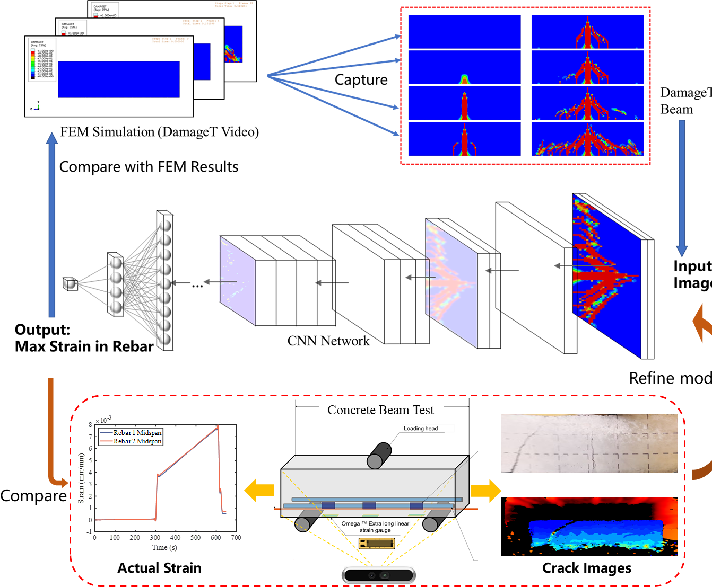

Figure 41. Schematic of strain regression by CNN

We adopted LeNet5 as the basic model. LeNet5 is a well-known CNN, and it is small and suitable for CPU training. In the research, we changed its super parameters and added an additional pooling layer to achieve a better effect of strain regression. The detailed structure of the model used in the research is listed in Table 5. All the active functions used in the network is ReLu.

Table 5. Structure of CNN used in the research

|  |  |  |  |  |  |
| --- | --- | --- | --- | --- | --- |
| **Layer** | **Input Channel** | **Output Channel** | **Kernel** | **Stride** | **Padding** |
| Conv2d | 3 | 6 | 5×5 | 1 | 2 |
| AvgPool2d | / | / | 5×5 | 2 | / |
| Conv2d | 6 | 16 | 5×5 | 2 | 0 |
| AvgPool2d | / | / | 5×5 | 2 | / |
| Conv2d | 16 | 32 | 5×5 | 2 | 0 |
| Conv2d | 32 | 64 | 5×5 | 2 | 0 |
| Conv2d | 64 | 128 | 5×5 | 1 | 0 |
| FC | 128 | 64 | / | / | / |
| FC | 64 | 32 | / | / | / |
| FC | 32 | 1 | / | / | / |

We collected data from the FEM simulation of reinforced beam. The video of DAMAGET was sliced by frames and cut to delete any redundant information. In the end, we got 64 RGB images of DAMAGET and their corresponding maximum strain in rebar. The epoch was set as 300 in model training, and the Adam optimizer was used. It should be noted that the strain values were normalized in the training. However, we inverse normalized the final result to show the actual strain in Figure 42(a). The regression of the trained model is 0.80.

 

(a) (b)

Figure 42. (a) regression results of RGB DAMAGET images; (b) regression results of binarization DAMAGET images.

The DAMAGET images obtained from FEM simulation is RGB format which means they are colorful. However, most of time, the actual crack images collected from the experiments are in gray and treated as binary images as shown as Figure 43. Hence, we also tested the performance of the model by training with binary DAMAGET images. The results shows that the model trained by binary images achieves almost same accuracy as RGB images training as demonstrated as Figure 43(b). Comparing with the FEM simulation, the CNN method only needs 0.61 second by using Intel® Core™ i7-10700 processor, which demonstrate a great potential for practical applications.

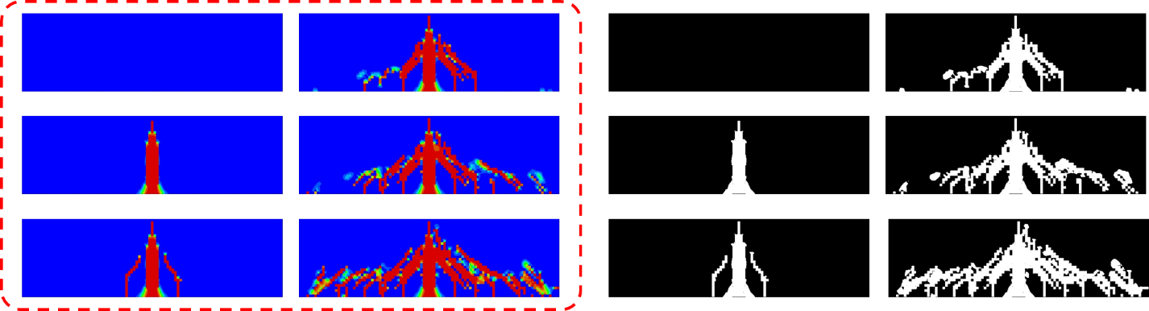

Figure 43. RGB and Binary images of DAMAGET

1. Percent of research project completed

Total project completed through the end of this quarter: 80%

1. Expected progress for next quarter

*In the next quarter, we will keep working on Task 3. We will focus on machine learning/deep learning condition assessment by training numerical data, image data, and sensor data from Tasks 1 and 2. We will also work on the publications, quarterly and final reports.*

1. Educational outreach and workforce development

The PIs organized their research teams for the composite reinforced concrete beam testing day on September 13, 2024, shown in Figure 44.

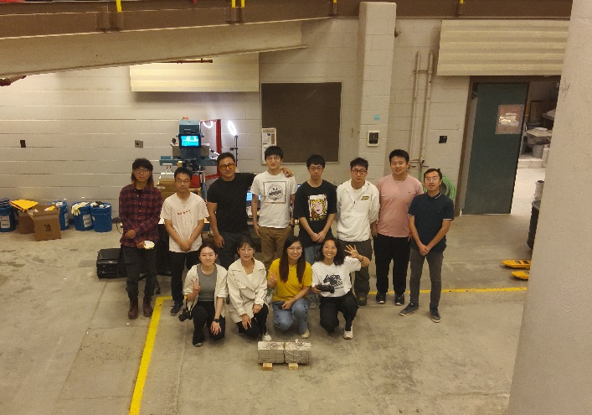

Figure 44. Concrete beam test day, Sep 13, 2024.

In addition, as shown in Figure 45, the PI and her graduate and undergraduate students have recently filmed a series of K-12 educational videos about sustainable construction materials and resilient infrastructure posted on YouTube as part of Purdue’s Superheroes of Science Series.



Figure 45. K-12 education videos filmed by PI’s group

1. Technology Transfer

*None*

**Research Contribution:**

1. Papers that include TRANS-IPIC UTC in the acknowledgments section:

Our team submitted one paper “Computational Investigation and Spatial-Temporal Risk Assessment of Reinforced Concrete Failure with Metallic and Composite Reinforcements Transportation Research Board” to 2025 TRB convention and is still under review.

1. Presentations and Posters of TRANS-IPIC funded research:

* Tao, C., & Junyi Duan, “Data-driven smart composite reinforcement for precast concrete”, TRANS-IPIC Monthly Research Webinar, September 23, 2024.
* Tao, C., Guan, S, Duan, J., Lin, Y., & Yan, H. (2024). Data-Driven Smart Composite Reinforcement for Precast Concrete, U.S. Department of Transportation (USDOT) - University Transportation Center (UTC), Transportation Infrastructure Precast Innovation Center (TRANS-IPIC) Workshop, Chicago, IL, April 22, 2024.

1. Please list any other events or activities that highlights the work of TRANS-IPIC occurring at your university (please include any pictures or figures you may have). Similarly, please list any references to TRANS-IPIC in the news or interviews from your research.

None.

**References:**

[1] E. Hamed, ‘Load-carrying capacity of composite precast concrete sandwich panels with diagonal fiber-reinforced-polymer bar connectors’, *PCI J*, vol. 62, no. 4, pp. 34–44, 2017.

[2] M. F. Bado et al., ‘Distributed optical fiber sensing bonding techniques performance for embedment inside reinforced concrete structures’, *Sensors*, vol. 20, no. 20, p. 5788, 2020.

[3] H. Sinaei et al., ‘Evaluation of reinforced concrete beam behaviour using finite element analysis by ABAQUS’, *Sci. Res. Essays*, vol. 7, no. 21, pp. 2002–2009, 2012.

[4] J. C. Simo and J. W. Ju, ‘Strain- and stress-based continuum damage models—I. Formulation’, *Int. J. Solids Struct.*, vol. 23, no. 7, pp. 821–840, Jan. 1987 [Online]. Available: 10.1016/0020-7683(87)90083-7.

[5] *Simulation of Crack Propagation in Concrete Beams with Cohesive Elements in ABAQUS*. [Online]. Available: https://journals.sagepub.com/doi/epdf/10.3141/2154-02. [Accessed: 27 Jul. 2024].

[6] G. M. Chen et al., ‘Finite-Element Modeling of Intermediate Crack Debonding in FRP-Plated RC Beams’, *J. Compos. Constr.*, vol. 15, no. 3, pp. 339–353, Jun. 2011 [Online]. Available: 10.1061/(ASCE)CC.1943-5614.0000157.

[7] Y. Huang et al., ‘3D meso-scale fracture modelling and validation of concrete based on in-situ X-ray Computed Tomography images using damage plasticity model’, *Int. J. Solids Struct.*, vol. 67–68, pp. 340–352, Aug. 2015 [Online]. Available: 10.1016/j.ijsolstr.2015.05.002.

[8] W.-F. Chen et al., *Plasticity for Structural Engineers*. J. Ross Publishing, 2007.

[9] A. S. Genikomsou and M. A. Polak, ‘Finite element analysis of punching shear of concrete slabs using damaged plasticity model in ABAQUS’, *Eng. Struct.*, vol. 98, pp. 38–48, Sep. 2015 [Online]. Available: 10.1016/j.engstruct.2015.04.016.

[10] S. Seok et al., ‘Finite element simulation of bond-zone behavior of pullout test of reinforcement embedded in concrete using concrete damage-plasticity model 2 (CDPM2)’, *Eng. Struct.*, vol. 221, p. 110984, 2020.

[11] K. Brózda et al., ‘ANALYSIS OF PROPERTIES OF THE FRP REBAR TO CONCRETE STRUCTURES’, vol. 2, no. 1, 2017.

[12] Q. Hao et al., ‘Bond strength improvement of GFRP rebars with different rib geometries’, *J. Zhejiang Univ.-Sci. A*, vol. 8, no. 9, pp. 1356–1365, Aug. 2007 [Online]. Available: 10.1631/jzus.2007.A1356.

[13] Y. Sun et al., ‘Theoretical and experimental investigations into flexural behavior of existing reinforced concrete beams strengthened by CFRP bars’, *J. Build. Eng.*, vol. 77, p. 107528, Oct. 2023 [Online]. Available: 10.1016/j.jobe.2023.107528.

[14] H. Zhu et al., ‘Flexural Performance of Concrete Beams Reinforced with Continuous FRP Bars and Discrete Steel Fibers under Cyclic Loads’, *Polymers*, vol. 14, no. 7, p. 1399, Mar. 2022 [Online]. Available: 10.3390/polym14071399.

[15] A. F. Ashour, ‘Flexural and shear capacities of concrete beams reinforced with GFRP bars’, *Constr. Build. Mater.*, vol. 20, no. 10, pp. 1005–1015, Dec. 2006 [Online]. Available: 10.1016/j.conbuildmat.2005.06.023.

[16] M. Hamrat et al., ‘Flexural cracking behavior of normal strength, high strength and high strength fiber concrete beams, using Digital Image Correlation technique’, *Constr. Build. Mater.*, vol. 106, pp. 678–692, Mar. 2016 [Online]. Available: 10.1016/j.conbuildmat.2015.12.166.

[17] M. B. C. Bakar et al., ‘Flexural Strength of Concrete Beam Reinforced with CFRP Bars: A Review’, *Materials*, vol. 15, no. 3, p. 1144, Jan. 2022 [Online]. Available: 10.3390/ma15031144.

[18] ‘Dassault Systèmes. (Year). Abaqus/CAE User’s Manual. Retrieved from [Abaqus/CAE User’s Manual (6.12)]’. .

[19] ‘ASTM D7913M Standard Test Method for Bond Strength of Fiber-Reinforced Polymer Matrix Composite Bars to Concrete by Pullout Testing’. .

[20] Z. Zhou and P. Qiao, ‘Bond behavior of epoxy-coated rebar in ultra-high performance concrete’, *Constr. Build. Mater.*, vol. 182, pp. 406–417, Sep. 2018 [Online]. Available: 10.1016/j.conbuildmat.2018.06.113.

[21] S. Khaksefidi et al., ‘Bond behaviour of high-strength steel rebars in normal (NSC) and ultra-high performance concrete (UHPC)’, *J. Build. Eng.*, vol. 33, p. 101592, Jan. 2021 [Online]. Available: 10.1016/j.jobe.2020.101592.

[22] A. Hu et al., ‘Bond Characteristics between High-Strength Bars and Ultrahigh-Performance Concrete’, *J. Mater. Civ. Eng.*, vol. 32, no. 1, p. 04019323, Jan. 2020 [Online]. Available: 10.1061/(ASCE)MT.1943-5533.0002919.

[23] Q. Hao et al., ‘Bond strength of glass fiber reinforced polymer ribbed rebars in normal strength concrete’, *Constr. Build. Mater.*, vol. 23, no. 2, pp. 865–871, Feb. 2009 [Online]. Available: 10.1016/j.conbuildmat.2008.04.011.

[24] S. Seok et al., ‘Finite element simulation of bond-zone behavior of pullout test of reinforcement embedded in concrete using concrete damage-plasticity model 2 (CDPM2)’, *Eng. Struct.*, vol. 221, p. 110984, Oct. 2020 [Online]. Available: 10.1016/j.engstruct.2020.110984.

[25] P. Wriggers, *Computational contact mechanics*, 2nd ed. Berlin ; New York: Springer, 2006.

[26] S. Seok et al., ‘High-resolution finite element modeling for bond in high-strength concrete beam’, *Eng. Struct.*, vol. 173, pp. 918–932, Oct. 2018 [Online]. Available: 10.1016/j.engstruct.2018.06.068.

[27] International Union of Testing and Research Laboratories for Materials and Structures, *RILEM technical recommendations for the testing and use of construction materials*. London Weinheim: Spon, 1994.

[28] G. Metelli and G. A. Plizzari, ‘Influence of the relative rib area on bond behaviour’, *Mag. Concr. Res.*, vol. 66, no. 6, pp. 277–294, Mar. 2014 [Online]. Available: 10.1680/macr.13.00198.

[29] A. A. Soliman et al., ‘Effects of the tensile properties of UHPC on the bond behavior’, *Constr. Build. Mater.*, vol. 392, p. 131990, Aug. 2023 [Online]. Available: 10.1016/j.conbuildmat.2023.131990.

[30] R. M. Haralick, ‘Using perspective transformations in scene analysis’, *Comput. Graph. Image Process.*, vol. 13, no. 3, pp. 191–221, Jul. 1980 [Online]. Available: 10.1016/0146-664X(80)90046-5.

[31] 318 ACI Committee, *Building code requirements for structural concrete (ACI 318-08) and commentary*. American Concrete Institute, 2008[Online]. Availablehttps://books.google.com/books?hl=zh-CN&lr=&id=c6yQszMV2-EC&oi=fnd&pg=PT10&dq=Building+Code+Requirements+for+Structural+Concrete+(ACI+318-08)+and+Commentary&ots=nZNrMX4yPF&sig=5FmtjAhkD_oWZdKzVcapZ34cqME[Accessed: 27September2024].