

Transportation Infrastructure Precast Innovation Center
(TRANS-IPIC)

University Transportation Center (UTC)

Thermally Conductive Pre-cast Concrete Pavement for Urban Heat Island mitigation
- phase II: Implementation

[UT-23-RP-01]

Quarterly Progress Report
For the performance period ending [July 1st, 2025]

Submitted by:
Islam Radwan, Graduate Student, Islam.Radwan@my.utsa.edu
Samer Dessouky (PI), Professor, Samer.dessouky@utsa.edu
Hatim Sharif (CO-PI), Professor, hatim.sharif@utsa.edu
School of Civil & Environmental Engineering and Construction Management
University of Texas at San Antonio

Collaborators / Partners:
Microtek laboratories Company
City of San Antonio
Tindall Corporation

Submitted to:
TRANS-IPIC UTC
University of Illinois Urbana-Champaign
Urbana, IL

TRANS-IPIC Quarterly Progress Report (Section 1 – 7, 5 pages max.):
Project Description:
- Research Plan - Statement of Problem
Urban areas are increasingly challenged by the Urban Heat Island (UHI) effect, where conventional concrete pavements absorb and retain excessive heat, resulting in higher surface temperatures, increased energy usage, and diminished pedestrian comfort. With paved surfaces covering a substantial portion of urban environments, they significantly contribute to UHI formation. Traditional cooling methods, such as reflective coatings and permeable pavements, face challenges related to durability, cost, and long-term efficiency, and are sometimes restricted by local municipal guidelines. This research tackles this issue by developing an innovative thermally adaptive concrete sidewalk pavement that incorporates phase change materials (PCMs) to regulate surface temperatures passively. By integrating organic microencapsulated PCMs within the concrete mix, the pavement can dynamically store and release heat, effectively lowering peak temperatures and improving thermal efficiency without relying on external energy sources. This novel approach establishes a sustainable cooling pavement system that offers a cost-effective, durable, and scalable solution for urban infrastructure. Through enhanced thermal performance, material sustainability, and improved cost-efficiency over time, this research redefines the functional role of concrete in mitigating urban heat challenges and enhancing urban resilience.
- Research Plan - Summary of Project Activities (Tasks)
Task 1: Mechanical Property Testing
Objective: To ensure PCM integration does not compromise the mechanical integrity of concrete.
Task 2: Finite Element Model (FEM) Simulation
Objective: Simulate the thermal behavior of PCM-enhanced pavements under various conditions presenting different geographical zones for broader applications.
Task 3: Optimization of PCM-Concrete Mix Design
Objective: To refine the mix design for maximum thermal performance and mechanical strength.
Task 4: Pilot Real-World Application
Objective: Evaluate the performance of PCM-enhanced concrete in a real-world environment.
Task 5: Development of Industry Guidelines
Objective: Provide practical guidelines for the adoption of PCM-enhanced concrete in the industry.
Task 6: Dissemination of Results
Objective: To share research findings with the academic and professional community.
Project Progress:
- Progress for each research task
- Task 1: Mechanical Property Testing [100% Completed]
- Task 2: Finite Element Model (FEM) Simulation [50% Completed]
- Task 3: Optimization of PCM-Concrete Mix Design [75% Completed]
- Task 4: Pilot Real-World Application [50% Completed]
- Task 5: Development of Industry Guidelines [0% Completed]
- Task 6: Dissemination of Results [0% Completed]
- Percent of research project completed
The average completion percentage would be:
(100% + 50% + 75% + 50% + 0% + 0%) / 6 tasks = % 275/ 6 tasks ≈ 45.83%

Description:
- Task 1: Mechanical Property Testing [100% Completed]
Comprehensive mechanical testing, including compressive strength tests, slump tests, and workability assessment, was conducted to evaluate the impact of PCM integration using the addition method and the sand-replacement method. The tests were performed at 7, 14, and 28 days of curing, following ASTM curing procedures to ensure consistency and reliability of the results. The mechanical performance evaluation aimed to determine how varying PCM content influences the structural integrity of the concrete, while the workability assessment focused on how PCM integration affects the concrete’s mixing, handling, and placement characteristics. Identifying the optimal PCM dosage is essential to balance improved thermal efficiency with acceptable mechanical strength and workable concrete properties for practical implementation.
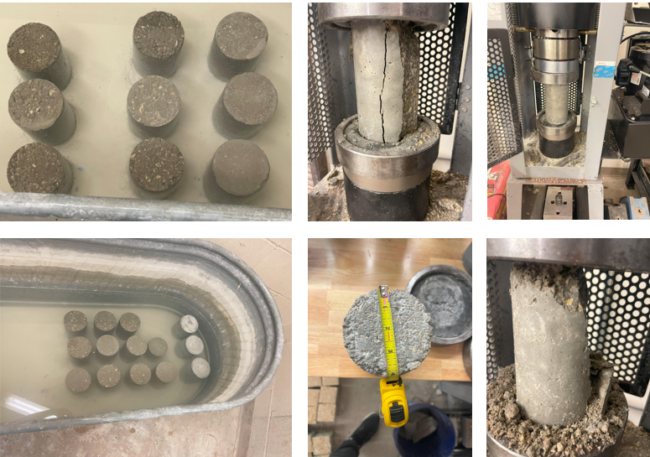
Mechanical Analysis.
- Task 2: Finite Element Model (FEM) Simulation [50% Completed]
A 3D Finite Element Model (FEM) was developed to simulate the thermal behavior of PCM-integrated concrete for the addition method and the sand-replacement method during 4-hours heating and cooling cycle and assess its effectiveness in reducing surface temperatures. The numerical modeling aimed to evaluate how PCM integration influences temperature regulation, moderates thermal fluctuations, and maintains cooling benefits over extended periods. This simulation provided valuable insights into optimizing PCM dosage and integration methods to achieve effective thermal management, reduce maintenance needs, and enhance energy efficiency. The FEM results will be compared with experimental findings to validate the model’s accuracy and reliability.
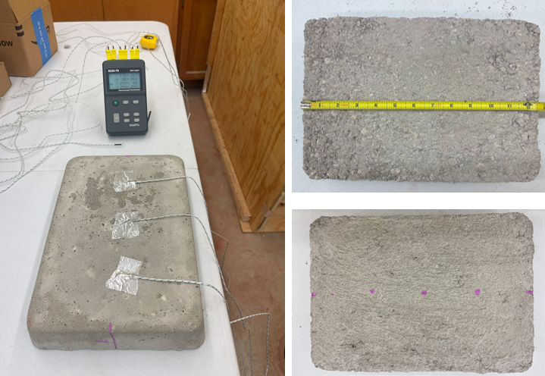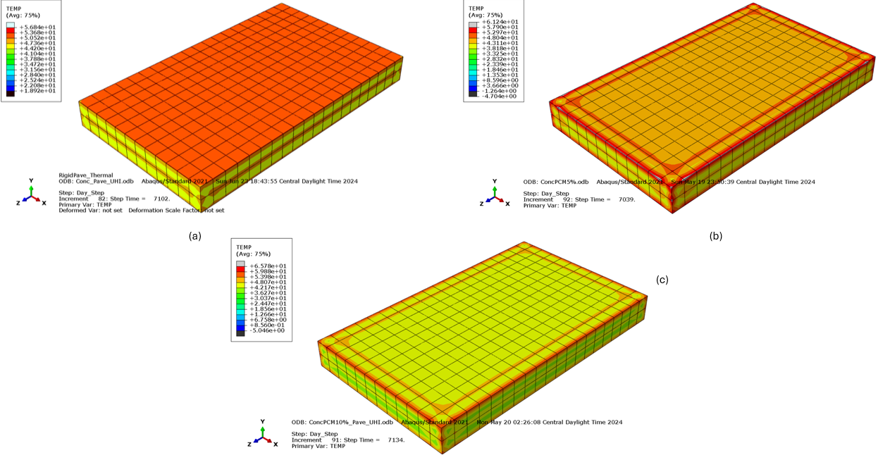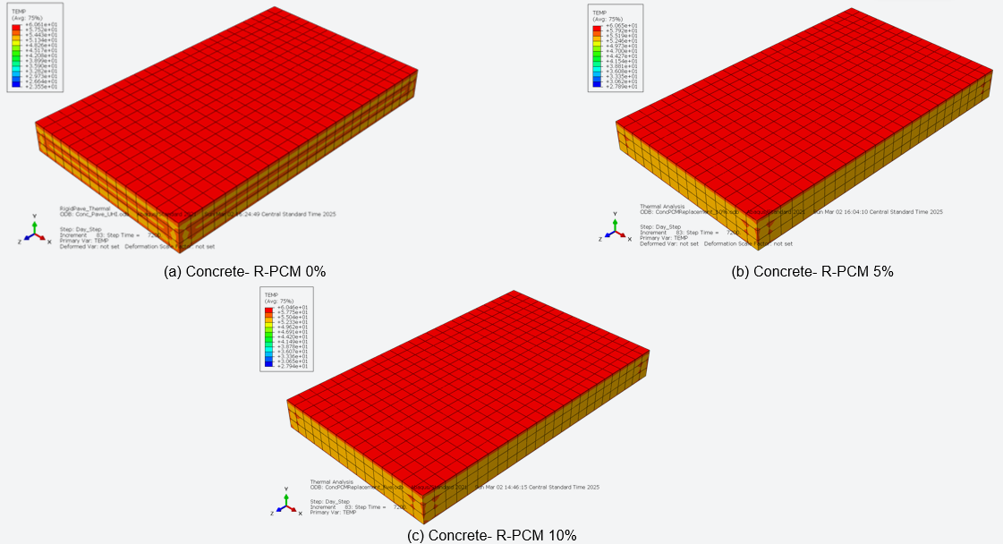
Examples of Different current Finite Element Models
- Task 3: Optimization of PCM-Concrete Mix Design [75% Completed]
Following the comprehensive mechanical study and concurrent thermal analysis for the addition method and the sand-replacement method, a significant step toward optimization has been initiated. The process focuses on refining the mix design to achieve maximum thermal performance while maintaining acceptable mechanical strength. This iterative approach involves assessing different PCM concentrations, conducting further thermal tests as necessary, and fine-tuning the mix proportions to strike a balance between structural integrity and thermal efficiency for practical implementation.
- Task 4: Pilot Real-World Application [75% Completed]
A full-scale sidewalk pilot has been successfully constructed on the UTSA campus, consisting of six distinct 4-ft by 4-ft segments to evaluate various cooling strategies. These include: (1) a control concrete segment, (2) a 5% PCM-integrated concrete using the sand replacement method, (3) a 2.5% PCM concrete segment with surface sandblasting, (4) a sandblasted concrete segment without PCM, (5) a 2.5% PCM concrete with a diamond-ground surface, and (6) a diamond-ground concrete segment without PCM. Thermal monitoring is actively being conducted, and surface temperature reduction is being recorded for each segment to assess the effectiveness of the different cooling mechanisms.
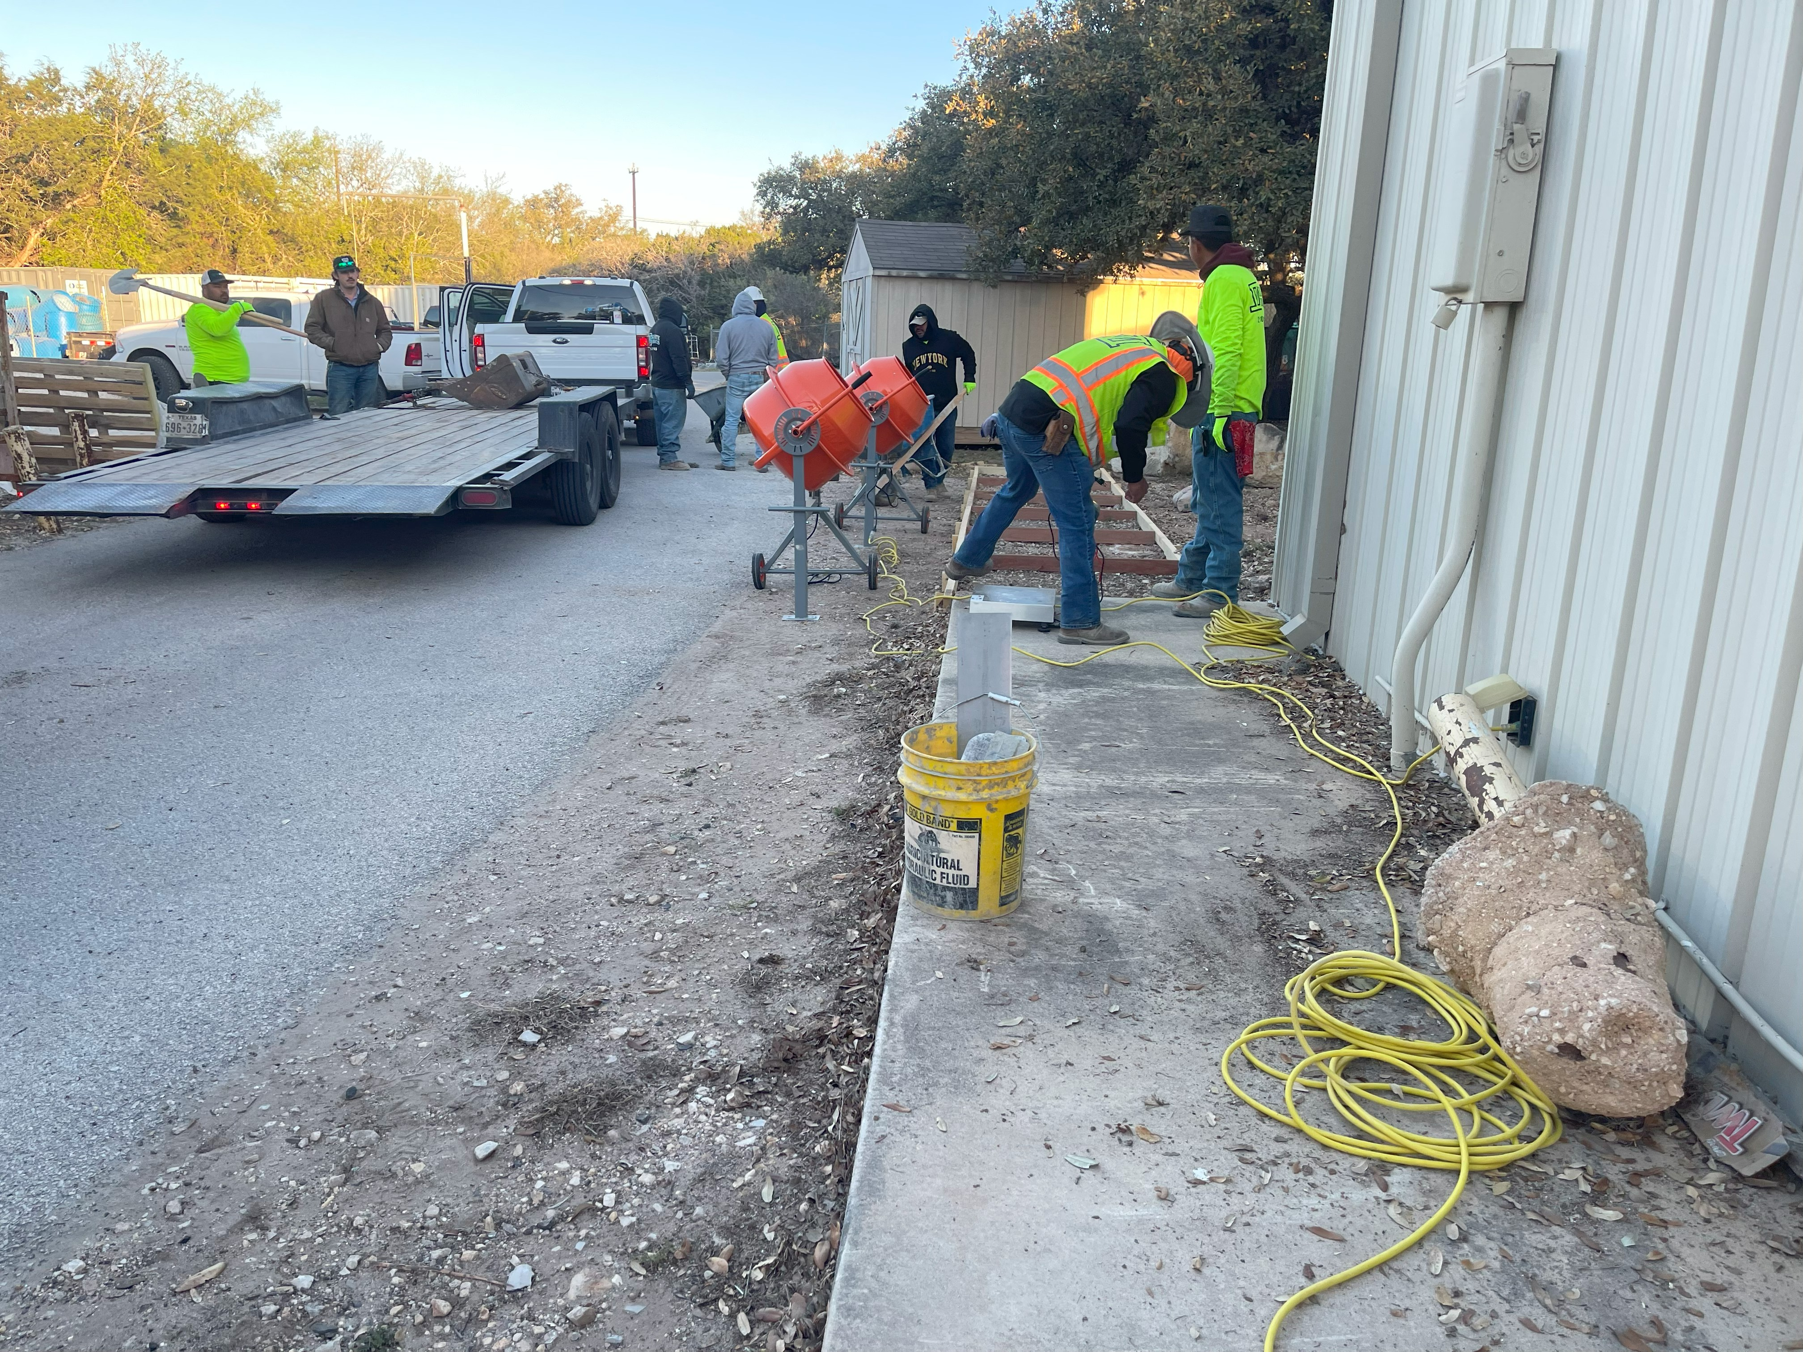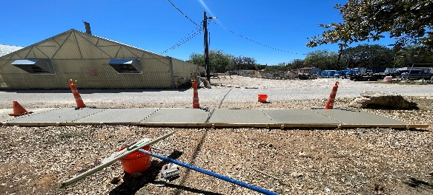
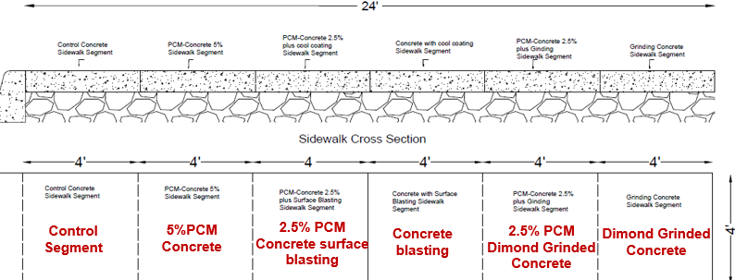
Proposed Real Pilot Test for Different Cool Sidewalk Mechanisms for each segment
- Expected progress for next quarter
In the upcoming quarter, long-term thermal monitoring of the constructed sidewalk at the UTSA campus will be conducted to observe temperature variations and evaluate heat reduction performance across each of the six surface segments. Additionally, extended thermal transient analysis will be performed using finite element modeling to simulate longer-duration heating and cooling cycles. This analysis will cover both the addition and sand replacement methods of PCM integration to assess their long-term thermal effectiveness under real-world conditions.
- Educational outreach and workforce development
- A tour to UTSA prospective high school students, emphasizing urban heat challenges, May 2025.
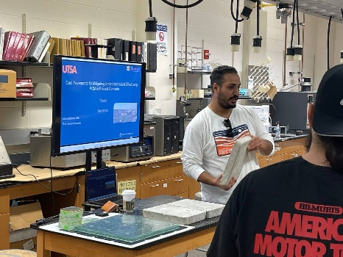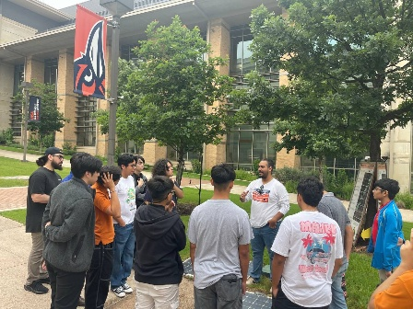
Educational Outreach Events at UTSA

- Technology Transfer
- Microtek Laboratories, Inc.: Shared our experimental results, highlighting the temperature reduction achieved in precast concrete integrated with PCM. These results provide insight into the thermal performance improvements enabled by PCM.
- Tindall Corporation: Collaborated in several meetings to share our design mixed details for scaling up the project. Leveraged Tindall's expertise in precast concrete to refine and adapt the design for large-scale implementation.
Research Contribution:
- Papers that include TRANS-IPIC UTC in the acknowledgments section:
- Submitted manuscript to Int. J. of Pavement Engineering, Dec 2024 (under review).
- Prepared manuscript for submission to J. of Construction and Building Materials.
- Presentations and Posters of TRANS-IPIC funded research:
- Presented in the (TRANS-IPIC) University Transportation Center (UTC) Workshop.
- Radwan, I. M., and Dessouky, S. (April 22, 2025). Innovative Precast Pavement Cooling Technologies, presentation and poster presentation at the Transportation Infrastructure Precast Innovation Center (TRANS-IPIC) University Transportation Center (UTC) Workshop.
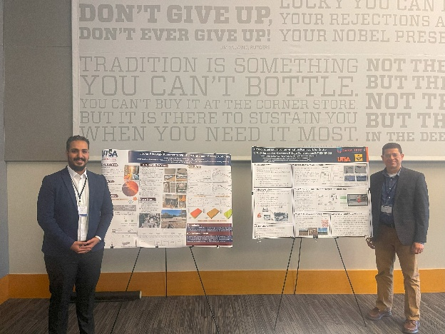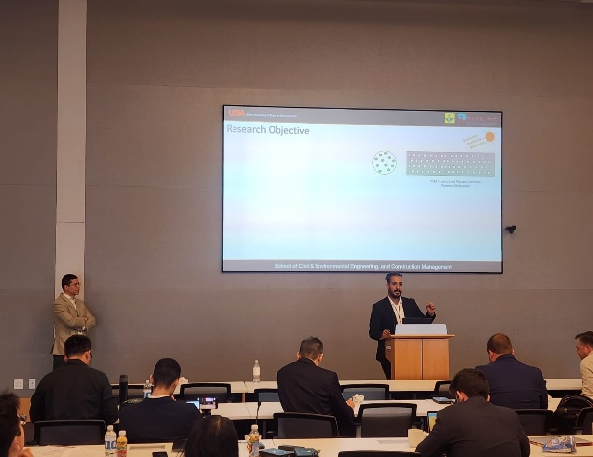
- Please list any other events or activities that highlights the work of TRANS-IPIC occurring at your university (please include any pictures or figures you may have). Similarly, please list any references to TRANS-IPIC in the news or interviews from your research.
- Radwan, I. M., & Dessouky, S. (2025). Cool concrete sidewalk pavements: Mitigating urban heat island effect with integrating phase change materials [Presented at the UTSA Graduate School Appreciation Week Research Showcase & Competition, April 2025]. UTSA Runner Research Press. https://hdl.handle.net/20.500.12588/7102
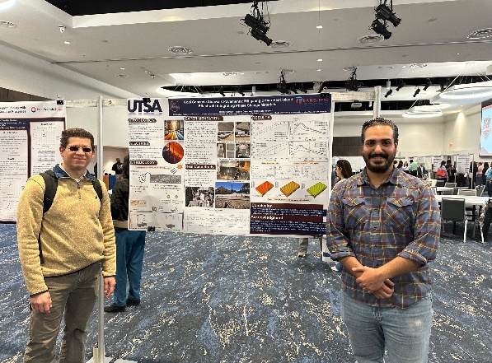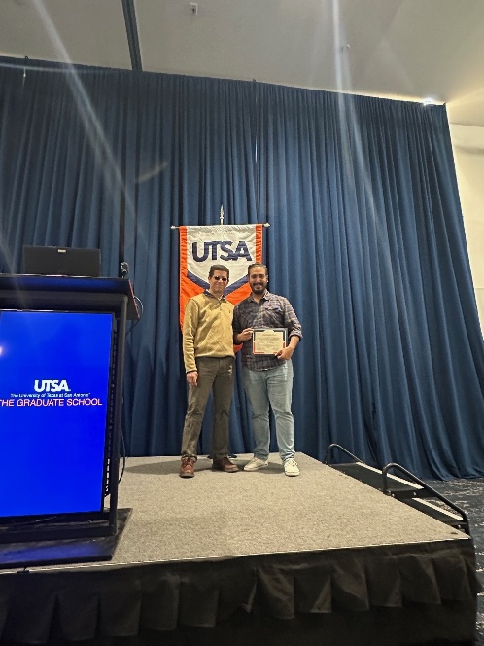

Appendix 1: Research Activities, leadership, and awards (cumulative, since the start of the project)
- Number of presentations at academic and industry conferences and workshops of UTC findings
- No. = 2
- Number of peer-reviewed publications submitted based on outcomes of UTC funded projects
- No. = 1
- Number of peer-reviewed journal articles published by faculty.
- No. = 7
- Number of peer-reviewed conference papers published by faculty.
- No. = 1
- Number of TRANS-IPIC sponsored thesis or dissertations at the MS and PhD levels.
- No. MS thesis =
- No. PhD dissertations = 1
- No. citations of each of the above = 6
- Number of research tools (lab equipment, models, software, test processes, etc.) developed as part of TRANS-IPIC sponsored research
- Research Tool #1 (Name, description, and link to tool) =
The pavement-based indoor experiments assess how PCM affects surface temperature under controlled conditions for four- and eight-hour cycles heating and cooling.
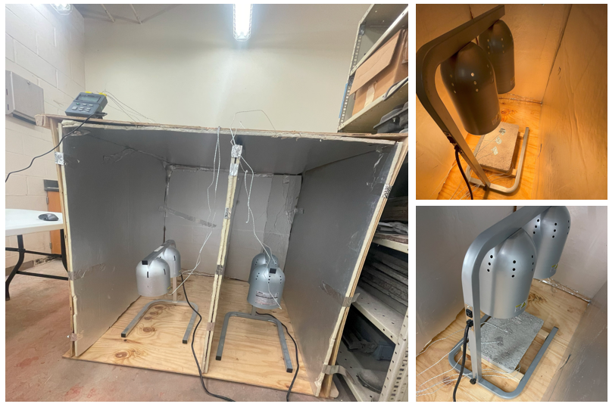
Reflective Thermal – Insulated Box for Indoor Heating Experiment set-up; Heating phase; Cooling phase.
- Research Tool #2 (Name, description, and link to tool) =
Perform compressive strength tests to ensure PCM integration does not compromise structural integrity.
Compressive stress testing
- Research Tool #3 (Name, description, and link to tool) =

Finite Element Models Using ABAQUS Software to analyze heat capacity fo flow for precast concrete
- Number of transportation-related professional and service organization committees that TRANS-IPIC faculty researchers participate in or lead.
- Professional societies
  - No. participated in = 1 (Bituminous Committee, ASCE)
  - No. lead =
- Advisory committees (No. participated in & No. led)
  - No. participated in =
  - No. lead = 1 (planning commission at City of San Antonio)
- Conference Organizing Committees (No. participated in & No. led)
  - No. participated in =
  - No. lead =
- Editorial board of journals (No. participated in & No. led)
  - No. participated in =
  - No. lead = 2 (ASCE J. of Materials, and Springer J. of Infr. Solution.)
- TRB committees (No. participated in & No. led)
  - No. participated in = 2
  - No. lead = 1
- Number of relevant awards received during the grant year
- No. awards received = 1 (City of San Antonio)
- Number of transportation related classes developed or modified as a result of TRANS-IPIC funding.
- No. Undergraduate = 40
- No. Graduate =
- Number of internships and full-time positions secured in the industry and government during the grant year.
- No. of internships = 1 (Texas Department of Transportation)
- No. of full-time positions = None
References:
[1] T. R. Oke, “The energetic basis of the urban heat island,” Quart J Royal Meteoro Soc, vol. 108, no. 455, pp. 1–24, Jan. 1982, doi: 10.1002/qj.49710845502.
[2] Oke, T. R. (1988). The urban energy balance. Progress in Physical Geography, 12(4), 471-508. https://doi.org/10.1177/030913338801200401
[3] A. J. Arnfield, “Two decades of urban climate research: a review of turbulence, exchanges of energy and water, and the urban heat island,” Int. J. Climatol., vol. 23, no. 1, pp. 1–26, Jan. 2003, doi: 10.1002/joc.859.
[4] K. S. Al-Jabri, A. W. Hago, A. S. Al-Nuaimi, and A. H. Al-Saidy, “Concrete blocks for thermal insulation in hot climate,” Cement and Concrete Research, vol. 35, no. 8, pp. 1472–1479, Aug. 2005, doi: 10.1016/j.cemconres.2004.08.018.
[5] C. S. B. Grimmond and T. R. Oke, “Heat Storage in Urban Areas: Local-Scale Observations and Evaluation of a Simple Model,” J. Appl. Meteor., vol. 38, no. 7, pp. 922–940, Jul. 1999, doi: 10.1175/1520-0450(1999)038<0922: HSIUAL>2.0.CO;2.
[6] K. Fortuniak, “Numerical estimation of the effective albedo of an urban canyon,” Theor Appl Climatol, vol. 91, no. 1–4, pp. 245–258, Feb. 2008, doi: 10.1007/s00704-007-0312-6.
[7] Y. Qin and J. E. Hiller, “Understanding pavement-surface energy balance and its implications on cool pavement development,” Energy and Buildings, vol. 85, pp. 389–399, Dec. 2014, doi: 10.1016/j.enbuild.2014.09.076.
[8] K. Anandakumar, “A study on the partition of net radiation into heat #uxes on a dry asphalt surface,” Atmospheric Environment, 1999.
[9] H. Akbari and L. S. Rose, “Characterizing the fabric of the urban environment: A case studyof Metropolitan Chicago, Illinois and Executive Summary,” LBNL--49275, Oct. 2001. doi: 10.2172/900694.
[10] H. Akbari, L. S. Rose, and H. Taha, “Characterizing the Fabric of the Urban Environment: A Case Study of Sacramento, California,” LBNL-44688, 764362, Dec. 1999. doi: 10.2172/764362.
[11] H. Li, “Evaluation of Cool Pavement Strategies for Heat Island Mitigation”.
[12] H. Akbari, M. Pomerantz, and H. Taha, “Cool surfaces and shade trees to reduce energy use and improve air quality in urban areas,” Solar Energy, vol. 70, no. 3, pp. 295–310, 2001, doi: 10.1016/S0038-092X (00)00089-X.
[13] L. Gartland, Heat islands: understanding and mitigating heat in urban areas. London; Sterling, VA: Earthscan, 2008.
[14] H. Akbari, “Energy Saving Potentials and Air Quality Benefits of Urban Heat Island Mitigation”.
[15] Y. Yamashita, K. Sakamoto, H. Akiyoshi, M. Takahashi, T. Nagashima, and L. B. Zhou, “Ozone and temperature response of a chemistry climate model to the solar cycle and sea surface temperature,” J. Geophys. Res., vol. 115, no. D3, p. 2009JD013436, Feb. 2010, doi: 10.1029/2009JD013436.
[16] B. J. Bloomer, J. W. Stehr, C. A. Piety, R. J. Salawitch, and R. R. Dickerson, “Observed relationships of ozone air pollution with temperature and emissions,” Geophysical Research Letters, vol. 36, no. 9, p. 2009GL037308, May 2009, doi: 10.1029/2009GL037308.
[17] M. Pomerantz, H. Akbari, L. B. Laboratory, and J. T. Harvey, “Cooler Reflective Pavements Give Benefits Beyond Energy Savings: Durability and Illumination”.
[18] Young, M., et al., “‘Field application of PCM in concrete pavement,’ Energy and Buildings, 2016, 122: 228-234.”.
[19] Wei, H., et al., “‘Phase change materials for thermal regulation of concrete,’ Journal of Cleaner Production, 2017, 162: 1182-1191.”.
[20] Lin, K.P., et al., “‘Experimental study on microencapsulated PCM for thermal management,’ Energy Conversion and Management, 2005, 46(6): 847-861.”.
[21] Y. Farnam, H. S. Esmaeeli, P. D. Zavattieri, J. Haddock, and J. Weiss, “Incorporating phase change materials in concrete pavement to melt snow and ice,” Cement and Concrete Composites, vol. 84, pp. 134–145, Nov. 2017, doi: 10.1016/j.cemconcomp.2017.09.002.
[22] D. P. Bentz and R. Turpin, “Potential applications of phase change materials in concrete technology,” Cement and Concrete Composites, vol. 29, no. 7, pp. 527–532, Aug. 2007, doi: 10.1016/j.cemconcomp.2007.04.007.
[23] Y. Farnam, A. Wiese, D. Bentz, J. Davis, and J. Weiss, “Damage development in cementitious materials exposed to magnesium chloride deicing salt,” Construction and Building Materials, vol. 93, pp. 384–392, Sep. 2015, doi: 10.1016/j.conbuildmat.2015.06.004.
[24] M. Hunger, A. G. Entrop, I. Mandilaras, H. J. H. Brouwers, and M. Founti, “The behavior of self-compacting concrete containing micro-encapsulated Phase Change Materials,” Cement and Concrete Composites, vol. 31, no. 10, pp. 731–743, Nov. 2009, doi: 10.1016/j.cemconcomp.2009.08.002.
[25] Ramakrishnan, S., et al., “Influence of phase change material (PCM) on the properties of concrete. Cement and Concrete Research, 96, 26-35” 2017.
[26] Jayalath, A., et al., “Thermal properties of concrete with microencapsulated phase change materials. Journal of Materials in Civil Engineering, 28(7), 04016034,” 2016.

