**Transportation Infrastructure Precast Innovation Center**

**(TRANS-IPIC)**

**University Transportation Center (UTC)**

*3D Printed Advanced Materials to Mitigate Prestressed Concrete Girder End Cracks*

*UB-23-RP-02*

Quarterly Progress Report

For the performance period ending September 30, 2024

**Submitted by:**

Ravi Ranade, Associate Professor, [ranade@buffalo.edu](mailto:ranade@buffalo.edu)

Department of Civil, Structural and Environmental Engineering

University at Buffalo

Co-PIs: Chi Zhou (chizhou@buffalo.edu) and Pinar Okumus (pinaroku@buffalo.edu), University at Buffalo

**Collaborators / Partners:**

*None*

**Submitted to:**

TRANS-IPIC UTC

University of Illinois Urbana-Champaign

Urbana, IL

**TRANS-IPIC Quarterly Progress Report:**

**Project Description:**

1. Research Plan - Statement of Problem

*Precast-prestressed concrete bridge girders are susceptible to cracking at their ends [1]. Release of large prestress forces within a short distance causes high tensile strains in concrete at the girder ends. This combined with the brittleness and low tensile strain capacity of conventional concrete lead to end cracking. This is a major concern for bridge owners as these cracks, especially those near the bottom of the beam that do not close under live load, could facilitate rapid chloride penetration and lead to corrosion of the prestressing strands and deterioration of the girder’s load capacity.*

*The specific objectives of this one-year project are as follows:*

1. *To investigate the feasibility of using strain-hardening cementitious composites (SHCC) shells for mitigating end cracking in precast-prestressed concrete beams*
2. *To develop a 3D-printable SHCC and appropriate printing parameters for the above application*
3. *To understand the level of composite action between SHCC shells and conventional concrete.*
4. Research Plan - Summary of Project Activities (Tasks)

*The following research tasks will be performed to meet the objectives of this study:*

*Task 1: Numerical simulation of pretensioned beams with SHCC shells at the end zone: Building upon the investigators’ experience with simulations of precast-pretensioned concrete girder ends [1-4], numerical models of girders with SHCC shells will be developed. The properties of a base SHCC will be used as input in these models. The models will be used to gain insights into the tensile strain distributions at the end zone and to understand how various parameters, such as shell thickness, strand placement, beam cross-section, and material tensile ductility impact end cracking. The results will inform the SHCC material development and shell design.*

*Task 2.1: Determination of target material properties for a printable SHCC: Targets for material properties needed for enabling 3D printing, such as viscosity, yield stress, storage moduli and loss moduli, extrudability, buildability, and shape retention ability, will be determined hand-in-hand with Task 1 using an extrusion printer to achieve optimal printing of SHCC shells. Computational fluid dynamics modeling and rheological characterization will be conducted to study the printability of SHCC. Based on past research, mechanical property targets for printable SHCC will be tensile strain capacity of at least 1% and compressive strength of at least 55 MPa.*

*Task 2.2: Trial mix designs: A two-prong approach will be used to develop trial mix designs. First, using the base SHCC as the starting point, material ingredients will be altered based on investigators’ experience and understanding of the effects of ingredients on each of the material properties described in task 2.1. Second, mix designs will be generated using first principles, such as particle packing, porosity-strength relationships, and effects of aggregate/paste ratio on various material properties. Approximately 4-6 convergent mix designs from these two methods will be developed for further analysis.*

*Task 2.3: Fresh and hardened properties testing and shortlisting of mix designs: Trial batches of the mixtures developed in the previous task will be prepared. A variety of fresh and hardened property tests will be conducted to determine which mix designs meet the targets set in task 2.1. Sample SHCC shells will be printed with the best-performing 1-2 mixtures to evaluate/verify their printability.*

*Task 2.4: Mixture refinement: Some iterative changes to the ingredient proportions may be needed to fine-tune the mix. This task might involve repeating a few steps performed in previous tasks.*

*Task 3.1: Preparation of composite beam specimens with 3D-printed SHCC shells: SHCC shells will be 3D-printed and composite beam specimens will be prepared to understand constructability of a composite beam. These non-prestressed beams will be composed of a small-scale rectangular beam. They will be reinforced using mild reinforcement.*

*Task 3.2: Testing of beams under mechanical loading: Reinforced beam specimens prepared in task 3.1, as well as control specimens, will be evaluated under 4-point bending. Control specimens will be composed of monolithically cast beams that are identical to the ones in task 3.1 but made without the SHCC shells, and beams that have mold-cast (not 3-D printed) SHCC shells. The goal of these tests is to understand the level of composite action that can be developed between the SHCC and conventional concrete layers, and to compare 3-D printed SHCC shells to mold-cast SHCC shells.*

**Project Progress:**

1. Progress for each research task

***Task 1 - 100% completed***

*Task 1 was aimed at numerically simulating a prestressed concrete bridge girder to understand the demand on the printed cover's material properties.*

*A non-linear finite element model was developed in software ABAQUS to perform numerical simulation of a prestressed-concrete girder. Appropriate material models for conventional concrete, SHCC, strands, and rebars were selected. Conventional concrete was modeled using the concrete damage plasticity model available in ABAQUS, SHCC was modeled using a trilinear model, and rebar and strands were modeled using bilinear models. Two-node linear 3D truss elements were adopted for strands and rebars. The concrete girder and SHCC cover were modeled using 4-node linear tetrahedron elements. Rebar and prestressing strands were embedded in the girder. The prestressing force was simulated through temperature strain applied to the strands. The interface between SHCC cover and concrete girder was modeled with tie constraints.*

*The structural design of the beam, including cross-section, prestressing force, and reinforcement detailing, was adopted from experiments performed by O'Callaghan and Bayrak [5]. A standard Tx70 girder was adopted for the numerical simulation. The element type and size in the numerical simulation were calibrated to match the transverse reinforcement strains observed by O'Callaghan and Bayrak [5] at the end zone of the concrete girder. Based on this calibration, a 2” element size was selected for numerical modeling. Subsequently, a 0.75” SHCC cover at the end zones was used in the numerical model, keeping all other parameters constant. A representative finite element model and observed surface strain profile of the simulated girder end with SHCC cover are shown in Figure 1.*

****

*Figure 1. (a) Representative fine element model (b) Surface strain profile at girder end with SHCC cover*

*Thus, this task resulted in a non-linear finite element model of a prestressed-concrete girder, which was used later in Task 2.1 to determine the target material properties for SHCC covers. The developed numerical model provided crucial insights about the proposed method of using SHCC covers to mitigate end zone cracking. For instance, the maximum tensile strain on the surface of the girder was computed as 0.32%, which was used to determine the minimum tensile strain capacity of SHCC needed for this application.*

***Task 2.1 - 100% completed***

*Task 2.1 entailed determination of the target material properties needed for enabling 3d printing of SHCC cover for the prestressed girder application.*

*The performance requirements for SHCC were categorized into two groups-(i) Fresh state requirements, and (ii) Hardened state requirements. The fresh state requirements were established for the following five steps of material production and printing:*

1. *Mixing: Mixing capacity, in terms of the maximum shear rate that the concrete mixer can apply, was considered for determining the target matrix viscosity needed for homogeneous fiber dispersion.*
2. *Pumping (Pump): Rheological properties of SHCC mixture were tuned and appropriate pumping equipment (motor) was selected for enabling continuous pumping while preventing fiber clumping and segregation.*
3. *Pumping (Pipe): Rheological properties of SHCC mixture were also adjusted and appropriate diameter and type of pipe were selected for preventing blockage and segregation in the pipe.*
4. *Extrusion (Nozzle): Blockage at the nozzle and filament tear was minimized by controlling the material’s rheological properties and using a customized nozzle (printed separately by the investigators).*
5. *Layering: Shape retention of layers was achieved by considering the setting characteristics and flow reduction rates of SHCC mixtures.*

*It was observed that the above steps require contrasting rheological characteristics. For example, a highly viscous mix is good for fiber dispersion, segregation prevention, and filament tearing prevention but it might cause issues in mixing and pumping due to the available equipment’s capacity limitations. High viscosity also increases the risk of blockage during pumping and extrusion. A flow table test (ASTM C1437) based on relative rheological characterization was implemented in this task due to its simplicity and strong correlation with material yield stress and viscosity. The flow table test was used to determine two parameters: (i) Flowability factor and (ii) Flow reduction rate. Suitable ranges of these two parameters were identified for tailoring SHCC mixtures. Further details of the testing procedure are presented below under Task 2.3.*

*The target mechanical properties for SHCC in the hardened state for the given application included compressive strength and tensile strain capacity. As the compressive strength of conventional concrete used in bridge girders typically exceeds 6 ksi, the same value was used as the lower bound for the SHCC’s compressive strength. Based on the numerical model results of task 1, the minimum tensile strain capacity for the SHCC was 0.32%. However, a higher strain capacity of 0.6% was targeted to account for material variability.*

*Thus, the following requirements were identified in this task:*

*Fresh state requirements (flow table test):*

1. *Flowability factor (slump diameter after 25 drops/original diameter) = 1.2 to 1.5; for the 0.76” or bigger nozzle size*
2. *Flow reduction rate (average percentage decrease rate in flowability factor in first 30 min) > 20% per hour*

*Hardened state requirements:*

1. *Compressive strength > 6 ksi*
2. *Tensile strain capacity > 0.4%*

***Task 2.2 - 100% completed***

*To achieve the above material properties, this task involved developing a suitable mixture composition for the 3d printable SHCC. An SHCC mixture, which has high tensile strain capacity but is non-printable and developed previously in PI’s lab, was adopted as the baseline. Iterative modifications in the mix were performed as follows to make it 3D printable:*

1. *Reduction in water/cementitious material (w/cm) weight ratio: The flow of the baseline SHCC mix was too high for 3D printing. Therefore, as the first step, the w/cm ratio was reduced from 0.38 (in the baseline mixture) to 0.31 to reduce the flow and enhance the compressive strength.*
2. *Use of 0.3” (8mm) PVA fibers: The fiber length of polyvinyl alcohol (PVA) fibers was reduced from 0.5” (12mm) (in the baseline mixture) to 0.3” (8mm) to enhance the pumping and extrusion of the mix.*
3. *Calibration of Viscosity Modifying Admixture (VMA) and High Range Water Reducing Admixture (HRWRA): To achieve the target fresh state characteristics identified in task 2.1, the VMA and HRWRA amounts were calibrated. Sixteen combinations of VMA and HRWRA amounts were prepared and screened using the flowability factors and flow reduction rates. Out of these 16 combinations, four mixtures were found suitable for further optimization.*
4. *Enhancement of thixotropic behavior: The mixtures selected in the previous step were further optimized to increase their flow reduction rate. Ingredients like micro silica, ground silica, and type III cement were incorporated into the mix, and the fresh state behavior was investigated. Based on the trials performed, three mixtures were selected for further evaluation. The details of these mixtures can be found in the conference paper referenced below.*

*The outcome of the task 2.2 is the SHCC mixture composition suitable for 3D printing applications.*

***Task 2.3 – 100% completed***

*Investigations of the fresh and hardened properties of the mixtures developed in the previous task were performed in task 2.3. This task was performed iteratively with tasks 2.1 and 2.2.*

*Fresh state testing protocol was developed using a caulking gun and flow table test to screen out non-printable and non-strain hardening SHCC mixtures. This screening was performed using the following qualitative and quantitative criteria:*

1. *Fiber dispersion was checked by hand to determine if there was fiber clumping. The mixtures with observable fiber clumps were rejected.*
2. *A grout caulking gun with a nozzle size of approximately 0.76” was employed to access the extrudability. Mixes that failed to extrude from this caulking gun were rejected.*
3. *Buildability/shape retention: Multiple layers of material were built using a caulking gun. If a mix failed to take the weight of at least one layer over it, it was rejected.*
4. *For relative quantification of the rheological behavior of the developed mix, a flow table test was conducted immediately after the mix was prepared and 30 minutes after the preparation of the mix to determine flow reduction with time.*
5. *After each flow table test, the mixtures were observed for segregation/water bleeding, and the mixtures with observable segregation/water bleeding were rejected.*

*Hardened properties of the screened mixtures were performed. The hardened property tests included compressive strength (ASTM C109), direct tension test, and four-point bend tests (ASTM C78). After initial screening and optimization, three mixtures were selected (as described in task 2.2) for further evaluation. Table 1 summarizes the hardened properties of the three 3D printable SHCC mixtures (mixes M9-MS, M9-IS, and M10).*

*Table 1. Hardened properties of 3D printable SHCC mixtures*

|  |  |  |  |  |  |  |
| --- | --- | --- | --- | --- | --- | --- |
| *Mix* | *Compressive strength* | | *Tensile strength (from direct tension test)* | | *Modulus of rupture*  *(4-point bend test)* | |
| *Mean (ksi)* | *COV (%)* | *Mean (ksi)* | *COV (%)* | *Mean (ksi)* | *COV (%)* |
| *M9-IS* | *7.5* | *5.6* | *0.8* | *19.0* | *1.5* | *12.5* |
| *M9-MS* | *8.5* | *2.4* | *0.7* | *17.5* | *1.5* | *8.0* |
| *M10* | *8.2* | *5.6* | *0.9* | *15.1* | *1.3* | *8.4* |

*Representative tensile stress-strain behaviors for mixtures M9-MS, M9-IS, and M10 are shown in Figure 2.*

*Figure 2. Stress-strain response of 3D printable SHCC mixtures under direct tension test.*

***Task 2.4 - 100% completed***

*In this task on mixture refinement, the three printable SHCC mixtures (M9-MS, M9-IS, and M10) were further modified to investigate the effect of fly-ash/cement weight ratio on printability and strain hardening behavior. Six new mixture compositions (2 variations for each mixture) were developed and their hardened properties, including compressive (in accordance with ASTM C109) and direct tensile behaviors, were evaluated. Table 2 provides a summary of the hardened properties for the modified SHCC mixtures.*

*Table 2. Hardened properties of modified 3D printable SHCC mixtures*

|  |  |  |  |  |  |  |  |
| --- | --- | --- | --- | --- | --- | --- | --- |
| *SHCC Mix* | *Fly ash to cement weight ratio* | *Compressive strength* | | *Tensile strength*  *(from direct tension test)* | | *Tensile strain capacity* | |
|  | *Mean (ksi)* | *COV (%)* | *Mean (ksi)* | *COV*  *(%)* | *Mean*  *(%)* | *COV*  *(%)* |
| *M9-IS* | *1.2 (Base)* | *7.5* | *5.6* | *0.8* | *19.0* | *0.7* | *22.6* |
| *1.5* | *6.4* | *12.8* | *0.7* | *4.8* | *1.4* | *17.4* |
| *1.8* | *6.3* | *12.5* | *0.7* | *2.0* | *2.1* | *17.2* |
| *M9-MS* | *1.2 (Base)* | *8.5* | *2.4* | *0.7* | *17.5* | *0.6* | *27.0* |
| *1.5* | *8.7* | *6.8* | *0.9* | *1.3* | *1.3* | *23.1* |
| *1.8* | *8.1* | *6.9* | *1.0* | *8.3* | *1.9* | *47.4* |
| *M10* | *1.2 (Base)* | *8.2* | *5.6* | *0.9* | *15.1* | *0.9* | *58.3* |
| *1.5* | *7.2* | *5.1* | *0.9* | *5.6* | *1.7* | *10.2* |
| *1.8* | *6.3* | *1.5* | *0.8* | *1.2* | *1.9* | *14.1* |

*With the increase in fly ash content in the SHCC mixtures, a marginal decline in 28-day compressive strength was observed. On the contrary, the tensile strain capacity showed an increasing trend with increased fly ash content. However, the variation in results (COV) was too high to make definitive conclusions. Although an elaborate quantification of the flow behavior was not performed, it was observed that the mix flowability was too high for the fly ash/cement weight ratio of 1.8, indicating the need for rheological re-optimization for 3D printing application at such a high proportion of fly ash in the mixture. Considering the need for rheological re-optimization, the modified mixtures are currently not considered for use in the composite beam tests planned in Tasks 3.1 and 3.2.*

***Task 3.1 - 60% completed***

*This task is aimed at evaluating the performance of SHCC covers as permanent formwork in mitigating the surface cracks developed in conventional concrete beams. The task involved multiple subtasks, as discussed below:*

1. *Conventional concrete mix design (complete): For our planned experimentation, a conventional concrete mix design was adopted from O’Callaghan and Bayrak [5]. Adjustments were made to account for the available raw materials, and the resulting mix design is given in Table 3. With a w/c ratio of 0.35, a compressive strength of 6.3 ksi was achieved at 24 hours since casting. The aggregate and cement properties are given in Table 4, and the moisture contents of aggregates are given in Table 5.*

*Table 3. Conventional concrete mix (adopted from [5])*

|  |  |
| --- | --- |
| *Material* | *lb/cyd* |
| *Coarse aggregate (SSD)* | *1799* |
| *Fine Aggregate (SSD)* | *1429* |
| *Cement (Type III)* | *611* |
| *Water* | *214* |
| *High Range Water Reducing Admixture, HRWRA* | *10 oz/Cwt* |

*Table 4. Material properties for conventional concrete mix*

|  |  |
| --- | --- |
| ***Fine aggregate:*** | |
| *Fineness modulus* | *2.71* |
| *Bulk specific gravity in saturated surface dry (SSD) state* | *2.60* |
| ***Coarse aggregate:*** | |
| *Nominal maximum aggregate size* | *0.5”* |
| *Bulk specific gravity in SSD state* | *2.58* |
| ***Cement:*** | *Type III* |

*Table 5. Moisture content of aggregate used in conventional concrete*

|  |  |  |
| --- | --- | --- |
|  | *Moisture content (%)* | |
|  | *Natural* | *SSD* |
| *Coarse aggregate* | *0.65* | *0.59* |
| *Fine aggregate* | *4.21* | *2.04* |

1. *Cross-section design (ongoing): Considering the scope of the project, a trial section for a rectangular beam was designed. The objectives for the design were to achieve a beam section with reasonable rebar sizes and a small (considering access to testing equipment and to limit material waste) but sufficient cross-sectional area to accommodate a 3D printed SHCC shell as well as a conventional concrete layer in the cover zone. Additionally, the beam was required to fail in flexure as the SHCC cover is implemented in the flexural cracking zone between the loading points in a four-point testing set-up. With these underlying objectives, multiple cross-sections were explored, and the selected section for initial testing is shown in figure 3. The section has a U-shaped 3D printed SHCC shell of thickness equal to 0.8” in the cover zone. To reduce any hinderance to aggregate flow around the stirrup, a clear spacing of 0.7” is provided between the 3D-printed cover and stirrups. Two No.4 rebars are used as main reinforcement. Additionally. No.3 rebars with 6” center to center spacing are employed as stirrups to maintain shear load capacity approximately twice the flexural load capacity of the beam.*

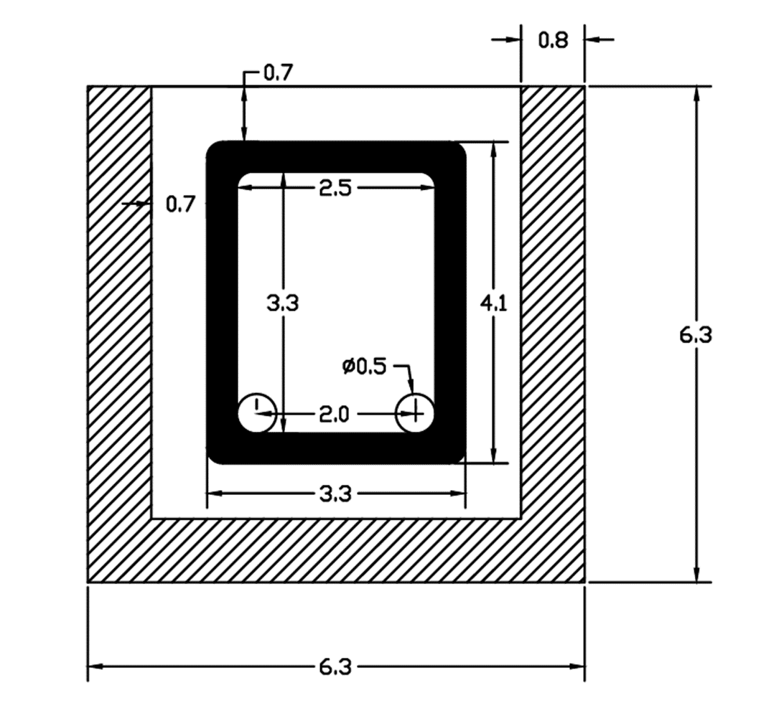

*Figure 3. Cross-section of planned beam for testing (all dimensions in inches rounded to first decimal place).*

1. *3D-printing of SHCC cover (ongoing): An SHCC cover was printed using the M9-MS 3d-printable SHCC mixture developed in task 2.2. The existing continuous extrusion system available in our laboratory creates material buildup at the ends while printing a U-shape. This problem is not observed with commercial printers and will be resolved for our printer with planned modifications to the printer. But for now, a rectangular SHCC cover was 3D-printed and then the sides were cut-off to create a U-shaped cover. Figure 4 shows the 3d printed cover and the U-shaped cover after cutting off the sides.*

*Figure 4 (left) 3D-printed SHCC rectangular cover, (right) 3D-printed SHCC U-shaped cover*

1. *Concrete casting (ongoing): For the considered cross-section, two beam specimens are currently being prepared. The first will represent a control beam without any SHCC cover in flexural zone, but with same cross-section and reinforcement as shown in figure 3. Another will be the beam with 3D-printed SHCC cover. Figure 5 shows 3D-printed SHCC cover as permanent formwork inside the outer formwork of the beam.*

Beam with 3d-printed SHCC cover

Control beam formwork

*Figure 5. Prepared formwork for control beam and beam with 3D-printed SHCC cover*

***Task 3.2 20% completed***

*The task is aimed at testing the beam specimens prepared in Task 3.1. Currently, in parallel with the specimen preparation, test setup for the beams and accompanying instrumentation is being planned and prepared. The beams will be tested using a four-point bending test setup, as shown in Figure 6.*

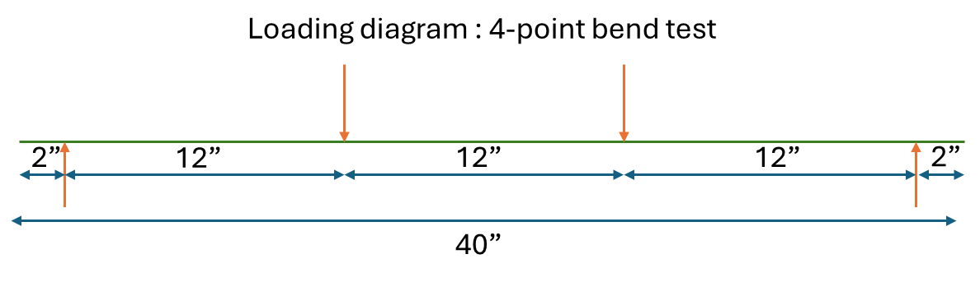

*Figure 6. Loading diagram for beam testing*

1. Percent of research project completed.

*90%*

1. Expected progress for next quarter.

*In the next quarter, Tasks 3.1-3.2 will be completed.*

1. Educational outreach and workforce development

*An undergraduate research intern worked on the project in June and July, 2024. Working alongside the graduate student, he gained vital skills of mixing, processing, casting, testing, and printing fiber-reinforced concrete materials. The undergraduate intern applied artificial neural networks to deduce fundamental rheological properties of SHCC based on the results of rheometer experiments.*

*A key outcome of this research will be the method for developing a printable SHCC. The material development process and the applications of the material to bridges be included in a lecture of the PI’s graduate course on Advanced Concrete Materials taught every Spring semester at the University at Buffalo and taken by students and professionals including ones from New York State Department of Transportation.*

1. Technology Transfer

*None*

**Research Contribution:**

1. Papers that include TRANS-IPIC UTC in the acknowledgments section:

*One peer-reviewed conference paper was published and presented at BEFIB 2024 – XI International symposium on fiber reinforced concrete. 15-18 September 2024, Dresden, Germany, pp. 451-458.*

*DOI: 10.1007/978-3-031-70145-0_55.*

*Authors: Singh, P., Gadde, V.S., Zhou, C., Okumus, P., and Ranade, R.*

*Title: Development of 3d printable strain hardening cementitious composites for bridge-related applications”.*

1. Presentations and Posters of TRANS-IPIC funded research:

*One poster presentation was given at the Annual meeting of the Transportation Research Board (TRB) in Washington, D.C. from January 7-11, 2024. The authors and title are given below:*

*Authors: Singh, P., Gadde, V.S., Zhou, C., Okumus, P., and Ranade, R.*

*Title: 3D printed advanced materials to mitigate prestressed concrete girder end cracks*

*One extended abstract was submitted for review at TRB AAMCT 2024 – Transportation Research Board Conference on Advancing Additive Manufacturing and Construction in Transportation, November, 2024. (Under review)*

*Authors: Singh, P., Gadde, V.S., Zhou, C., Okumus, P., and Ranade, R.*

*Title: Development of 3d printable strain hardening cementitious composites for bridge-related applications*

*One presentation was given to the UB Institute of Bridge Engineering External Advisory Board, which consists of current and past DOT officials, practicing engineers, and UB alums, April 30, 2024, Buffalo, NY.*

*Authors: Singh, P., Gadde, V.S., Zhou, C., Okumus, P., and Ranade, R.*

*Title: 3d Printed Advanced Materials to Mitigate Prestressed Concrete Girder End Cracks*

1. Other events or activities

*None*

**References:**

[1] P. Okumus, M.G. Oliva, Evaluation of crack control methods for end zone cracking in prestressed concrete bridge girders, PCI Journal 58(2) (2013) 91-105.

[2] P. Okumus, R.P. Kristam, M.D. Arancibia, Sources of Crack Growth in Pretensioned Concrete-Bridge Girder Anchorage Zones after Detensioning, J. Bridge Eng. 21(10) (2016) 04016072.

[3] P. Okumus, M.G. Oliva, S. Becker, Nonlinear finite element modeling of cracking at ends of pretensioned bridge girders, Engineering Structures 40 (2012) 267-275.

[4] P. Okumus, M.G. Oliva, Strand Debonding for Pretensioned Bridge Girders to Control End Cracks, ACI Structural Journal 111(1).

[5] M. R. O’Callaghan, and O. Bayrak, *Tensile stresses in the end regions of pretensioned I beams at release*. Master’s thesis, Univ. of Texas at Austin, Austin, TX, 265, 2007.