

Transportation Infrastructure Precast Innovation Center
(TRANS-IPIC)

University Transportation Center (UTC)

Desing, Manufacturing, and Characterization of Fiber Reinforced Shape Memory Polymer Rebars
[LS-23-RP-01]

Quarterly Progress Report
For the performance period ending [March 31, 2024]

Submitted by:
[PI (Guoqiang Li, lguoqi1@lsu.edu)]
[Department of Mechanical & Industrial Engineering]
[Louisiana State University]

Collaborators / Partners:
[None]

Submitted to:
TRANS-IPIC UTC
University of Illinois Urbana-Champaign
Urbana, IL

TRANS-IPIC Quarterly Progress Report:

Project Description:
- Research Plan - Statement of Problem
The objective of this one-year project is to design, manufacture, and tension program fiber reinforced shape memory polymer (FRSMP) rebars and test their shape memory effect. A total of five tasks were proposed. Task 1. Selection of SMP matrix. Task 2. Selection of glass fibers. Task 3. Manufacturing of FRSMP rebars. Task 4. Programming of FRSMP rebars. Task 5. Recovery stress testing.

- Research Plan - Summary of Project Activities (Tasks)
Task 1. Selection of SMP matrix. Although the PI has selected the SMP system as reported in January 1, 2024, the previous results show that the ultimate tensile strain is comparatively low (about 6.7%). In order to input more programming energy to the fiber reinforced SMP rebars during tension programming so that the recovery stress will be higher, which is critical for closing cracks, we investigated the effect of curing on the ultimate tensile strain and tensile strength. A total of 17 batches of SMP tensile specimens were prepared. Three curing conditions were investigated. The first condition used curing at 100 ºC for 1 hour, the second condition used curing at 100 ºC for 1 hour followed by curing at 150 ºC for 30 minutes, and the third condition used curing at 100 ºC for 1 hour followed by curing at 150 ºC for 1 hour. The ultimate tensile strain and tensile strength corresponding to the three curing conditions are shown in Figure 1.
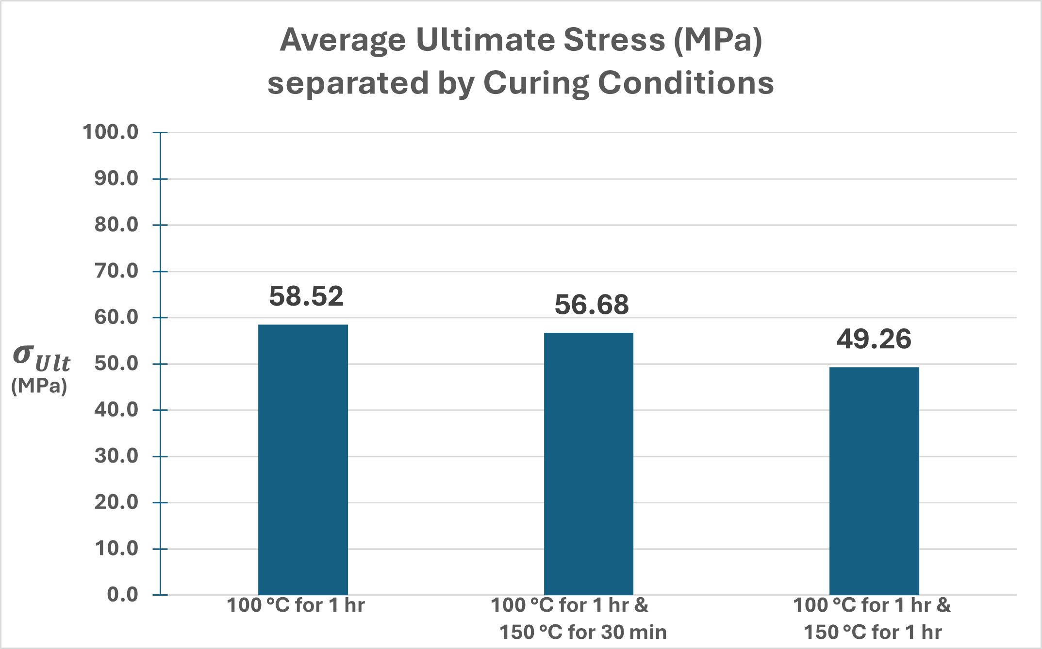
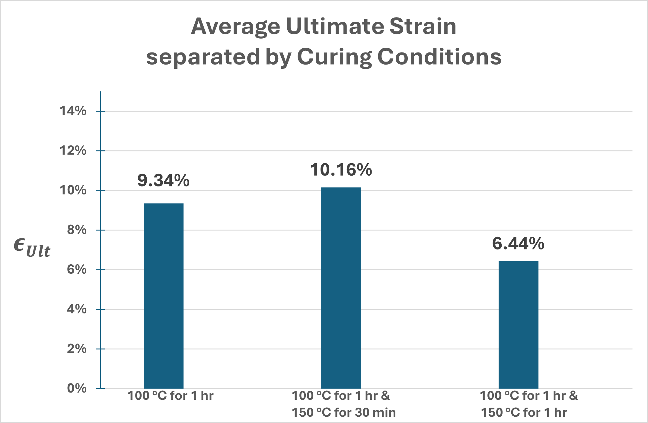
- Average Strain at Failure (b) Average Stress at Failure
Figure 1. Average Fracture Strain and Fracture Strength of SMP by Curing at Different Conditions

From Figure 1, it is seen that the curing conditions have a clear impact on the strength and ultimate strain. Because the purpose is to increase the failure strain without sacrificing the tensile strength, the condition of curing at 100 ºC for 1 hour followed by curing at 150 ºC for 30 minutes was selected for further study because it had the highest failure strain without too much reduction in tensile strength.

The glass transition temperature of the SMP was also investigated. The results are shown in Figure 2. From Figure 2, the glass transition temperature of the SMP was about 140 ºC.
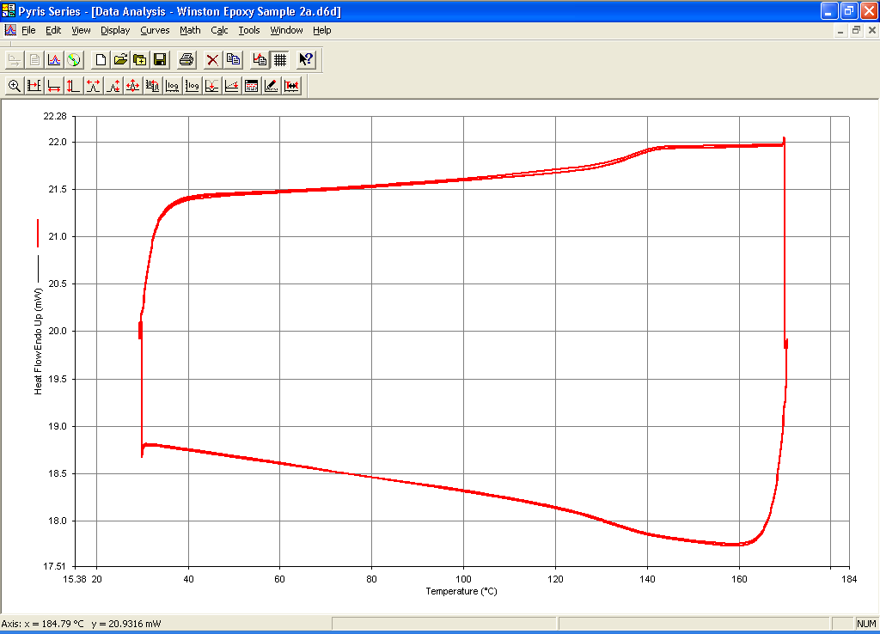

Figure 2. DSC test results.

Task 2. Selection of glass fibers. We also selected glass fibers. E-glass fiber rovings will be used as the reinforcement for preparing the fiber reinforced SMP rebars. We tested the compatibility of the E-glass fiber roving with our SMP matrix. We found that the SMP can easily wet through the glass fiber rovings.

Project Progress:
- Progress for each research task
Task 1 progress [80% completed]
Task 2 progress [100% completed]
Task 3 progress [0% completed]
Task 4 progress [0% completed]
Task 5 progress [0% completed]

- Percent of research project completed
As can be seen, although the subcontract has not been set up at LSU at the end of March 2024, the PI has managed to work on the project by leveraging other resources.

- Expected progress for next quarter
[Describe the expected progress to be made next quarter]
In the next quarter, the focus will be on Task 3. Manufacturing of FRSMP rebars.

- Educational outreach and workforce development
The Ph.D. student currently working on this project is a minority student.

- Technology Transfer
Nothing to report.

Research Contribution:
- Number of papers
None.

- Number presentations (when, where)
None.

