

Transportation Infrastructure Precast Innovation Center
(TRANS-IPIC)

University Transportation Center (UTC)

Design and Implementation of Digital Twin Models for Continuous Monitoring and Performance Prediction of Precast Concrete Bridges
UI-23-RP-03

Quarterly Progress Report
For the performance period ending 09/30/2024

Submitted by:
Volodymyr Kindratenko, kindrtnk@illinois.edu
National Center for Supercomputing Applications (NCSA)
University of Illinois at Urbana-Champaign

Bassem Andrawes, andrawes@illinois.edu
Department of Civil and Environmental Engineering
University of Illinois at Urbana-Champaign

Collaborators / Partners:
N/A

Submitted to:
TRANS-IPIC UTC
University of Illinois Urbana-Champaign
Urbana, IL

TRANS-IPIC Quarterly Progress Report:

Project Description:
- Research Plan - Statement of Problem

This research project aims to design and validate a digital twin model of a precast concrete bridge structure, subsequently integrating this model with sensor data derived from a real-world bridge. This integration will serve as the foundation for driving the simulation and analysis of the bridge model. The digital twin model will be constructed utilizing NVIDIA Omniverse, an innovative platform that facilitates the creation of collaborative and immersive 3D objects, equipped with real-time simulation capabilities.

- Research Plan - Summary of Project Activities (Tasks)

Task 1: Digital Model Development: We explore how to use technical drawings and the design and inspection data that may exist for the bridge itself or the precast parts used in its construction in order to rapidly implement a digital twin model. The outcome of this task is a methodology for rapidly prototyping a 3D model of a PC bridge based on the above-mentioned sources of initial information.

Task 2: Digital Model Implementation: We will study how NVIDIA Omniverse platform for digital twins operates and how to build new models within the platform’s capabilities, including linking it with external data sources. The outcome of this task is a PC bridge twin model implemented in NVIDIA Omniverse environment.

Task 3: Bridge Simulation using Real-Time Data: Our goal is to enable ingesting real-time data from a specific PC bridge to be incorporated with the digital twin model as well as any readily available environmental data, such as weather, traffic, any imagery. Such data will be used to model the bridge performance and predict its response to different usage conditions. The outcome of this task will be a data-driven digital twin model of a PC bridge updated each time new data about the bridge is available.

Project Progress:
- Progress for each research task

In this phase of the project, our main focus is on the integration of the research and development results from each task and a demonstration of the developed methodology and tools for a rapid prototyping of digital twin models.

Task 1 progress [100% completed]
Task 2 progress [100% completed]

We have developed two new virtual bridge models in Omniverse, situated near Champaign-Urbana. These bridges have clearly defined configurations, allowing for parameter inference from the National Bridge Inventory database. One bridge spans a creek at 2259 S Staley Rd, Champaign, while the other crosses I-74 highway at 879 N Cottonwood Rd, Urbana. We conducted site visits and visual inspections of these bridges and utilized the configuration data from the National Bridge Inventory to inform their implementation in Omniverse.

2259 S Staley Rd, Champaign
Street view Side view
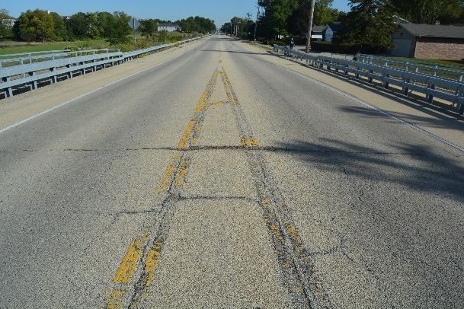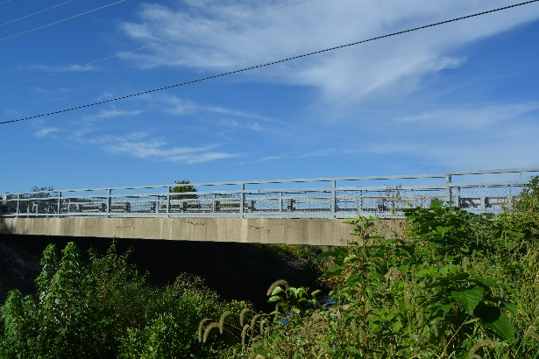

879 N Cottonwood Rd, Urbana
Side view
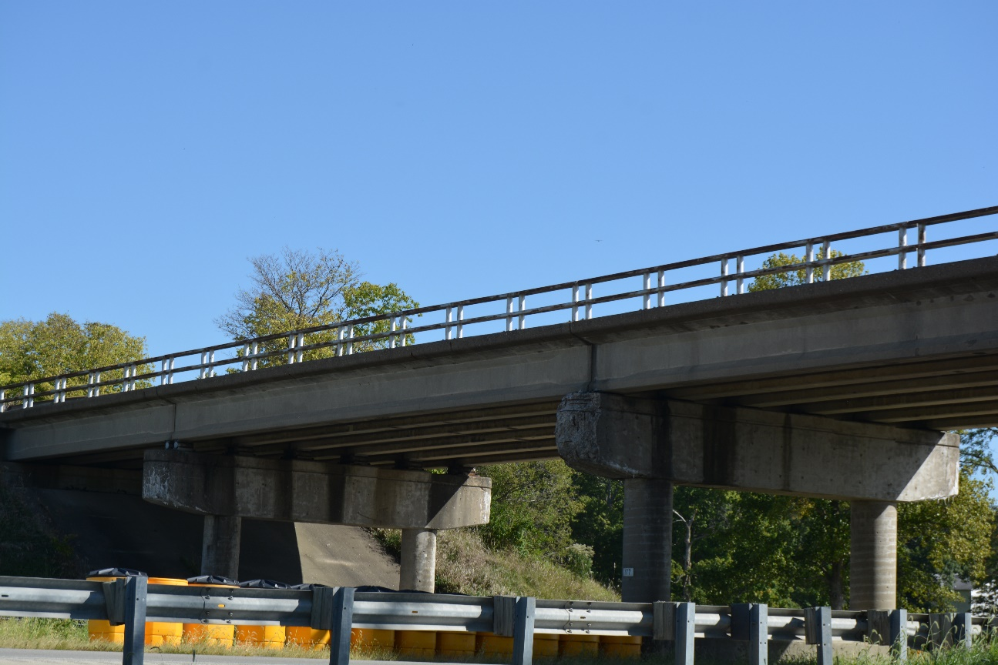

The screenshots below demonstrate the Omniverse implementation of two bridges. We create models for the beams, supports, and columns using the main span structure and building materials, then extract detailed geometry from inspection images and Google Map street view. These elements are eventually integrated into the Omniverse Platform.

2259 S Staley Rd, Champaign
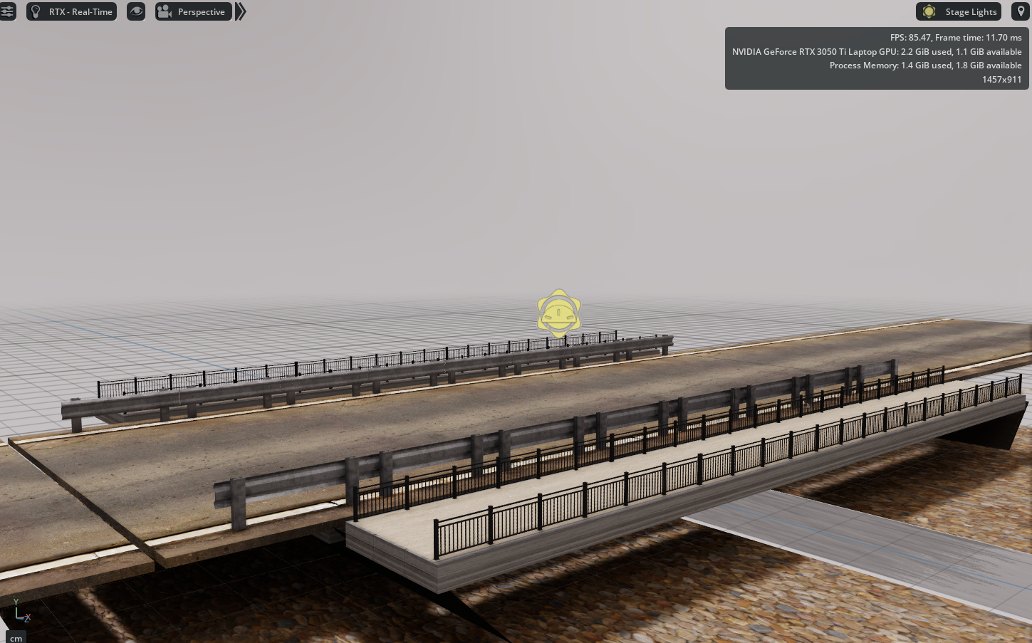

879 N Cottonwood Rd, Urbana
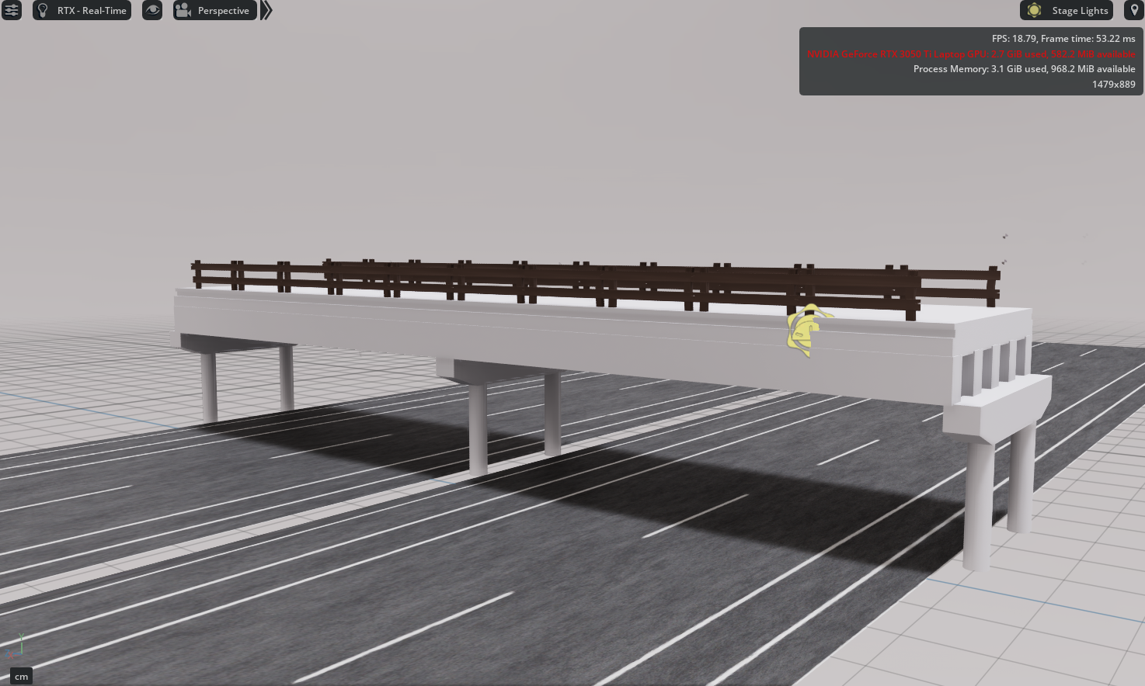

Task 3 progress [75% completed]:

We are in the process of integrating the Omniverse model with the data available for the recently implemented bridge models. The connectors and plugins that were previously developed to ingest data from external sources into an Omniverse model will link the two virtual bridges to these external data sources. One such data source is the images obtained from bridge inspections. Below is an example of an Omniverse extension that allows users to display images by clicking on the specific part of the bridge for which an image is available.

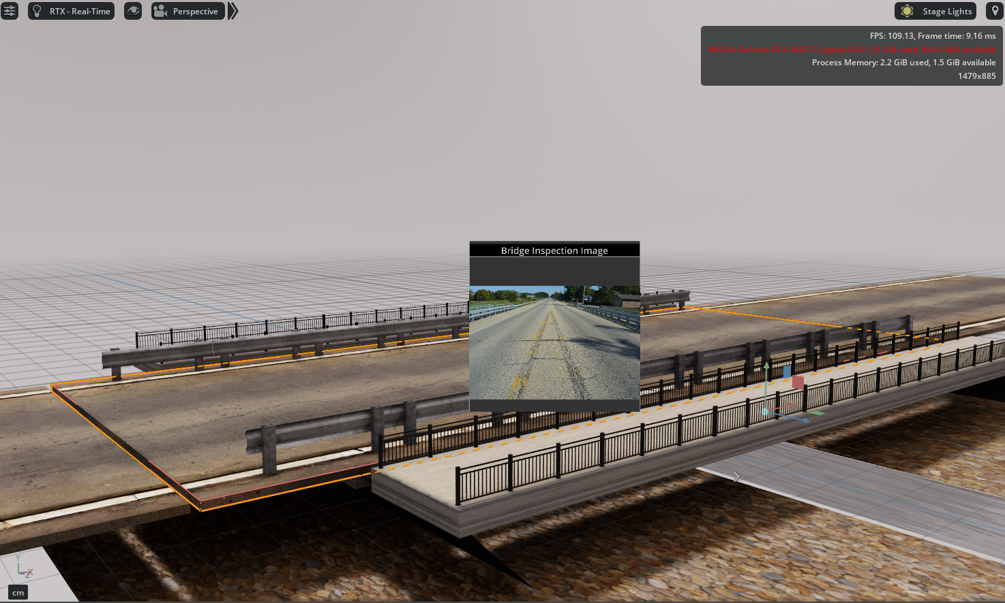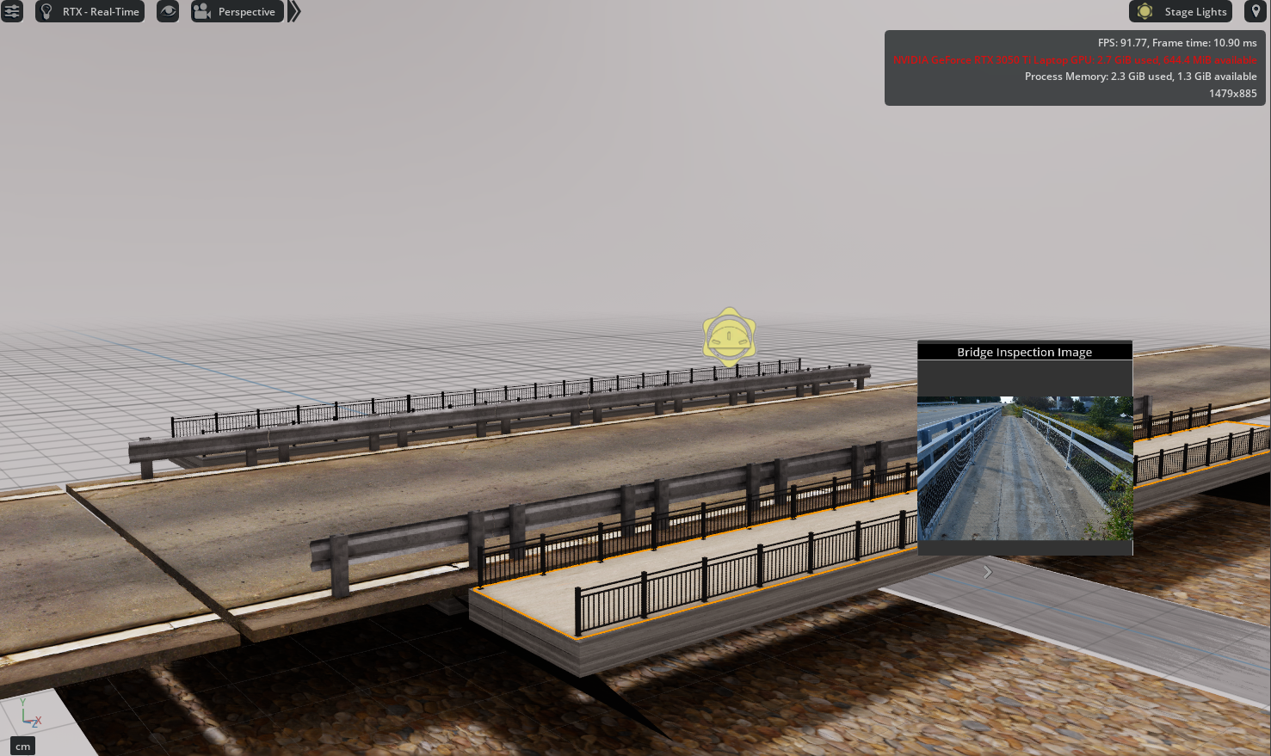

An additional feature was developed to exhibit the historical numerical data associated with that bridge. This information is sourced from the NBI database, encompassing metadata of the bridge, historical condition records, and traffic data. A screenshot illustrating this functionality is provided below.

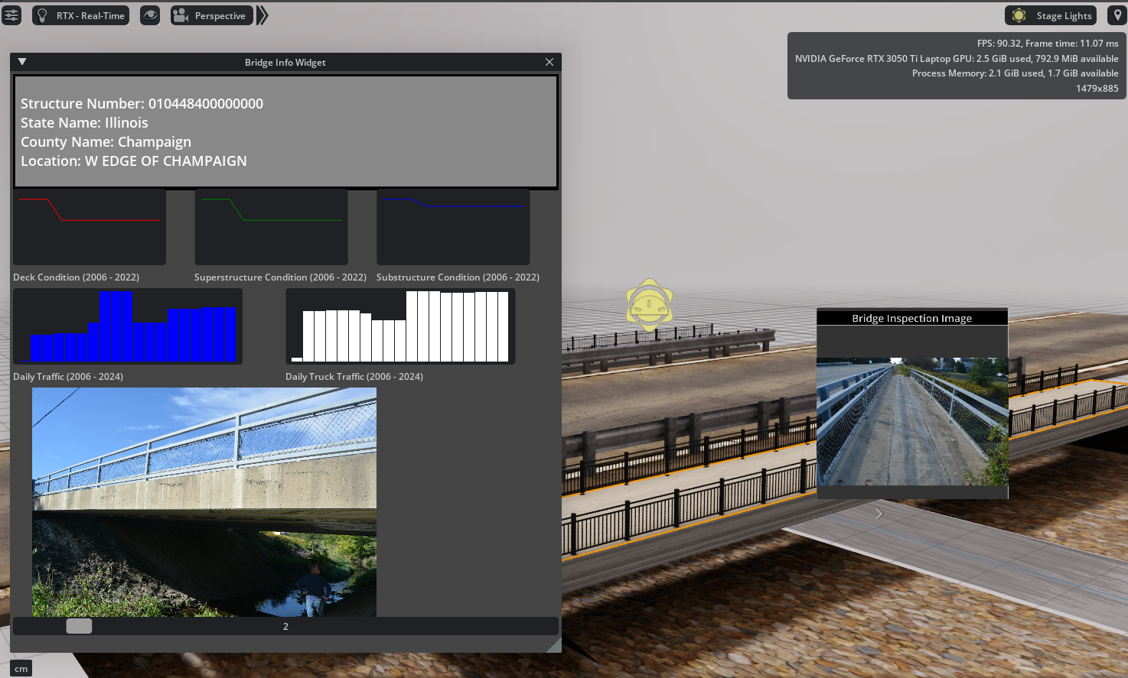

- Percent of research project completed

90%

- Expected progress for next quarter

Specific focus is on the integration of data from external sources and its accurate reflection in the Omniverse environment.

- Educational outreach and workforce development

Nothing to report.

- Technology Transfer

Nothing to report.

Research Contribution:
- Papers that include TRANS-IPIC UTC in the acknowledgments section:

Nothing to report.

- Presentations and Posters of TRANS-IPIC funded research:

Nothing to report.

- Please list any other events or activities that highlights the work of TRANS-IPIC occurring at your university (please include any pictures or figures you may have). Similarly, please list any references to TRANS-IPIC in the news or interviews from your research.

References:

