**Transportation Infrastructure Precast Innovation Center**

**(TRANS-IPIC)**

**University Transportation Center (UTC)**

*Design, Manufacturing, and Characterization of Fiber Reinforced Shape*

*Memory Polymer Rebars*

*[LS-23-RP-01]*

Quarterly Progress Report

For the performance period ending *[09/30/2024]*

**Submitted by:**

*Pl: Guoqiang Li, Department of Mechanical & Industrial Engineering,*

*Louisiana State University, Baton Rouge, LA 70803, E-mail:* [*lquogi1@Isu.edu*](mailto:lquogi1@Isu.edu)

**Collaborators / Partners:**

*[None]*

**Submitted to:**

TRANS-IPIC UTC

University of Illinois Urbana-Champaign

Urbana, IL

**TRANS-IPIC Quarterly Progress Report:**

**Project Description:**

1. Research Plan - Statement of Problem

*The objective of this one-year project is to design, manufacture, and tension program fiber reinforced shape memory polymer (FRSMP) rebars and test their shape memory effect. A total of five tasks were proposed. Task 1. Selection of SMP matrix. Task 2. Selection of glass fibers. Task 3. Manufacturing of FRSMP rebars. Task 4. Programming of FRSMP rebars. Task 5. Recovery stress testing.*

1. Research Plan - Summary of Project Activities (Tasks)

*[Describe briefly each research task associated with this project]*

*In our proposal, we proposed that we would further enhance the recovery stress of a shape memory polymer epoxy resin diglycidyl ether of bisohenol A (DGEBA) cured by isophorone diamine (IPD) [1], by dispersing nanoclay particles in the polymer matrix. Our target was to increase the recovery stress from 5 MPa as reported in [1], to 7 MPa or above. During the process of the project, we also figured out another way to enhance the properties of the SMP, i.e., through a step curing approach, which has been used in our previous reports of using the SMP to prepare rebars. However, we have not tested the idea of using nanoclay particles to improve the properties of the SMP.*

*In this current report, we focused on Task 1: developing a new nanoclay reinforced SMP composite for the purpose of enhancing its mechanical and shape memory properties. The SMP matrix was selected the same as the epoxy resin diglycidyl ether of bisohenol A (DGEBA) cured by isophorone diamine (IPD). We have reported the rebars prepared using E-glass fiber tows reinforced epoxy composite and tested their mechanical properties in our last report. We also conducted finite element modeling to evaluate the effect of braided fiber tows on the mechanical properties in the last report. Based on the result of this reporting period, it shows that the nanoclay reinforced epoxy composite exhibits poorer mechanical properties than those of the pure epoxy. Therefore, we will use the pure epoxy to prepare rebars in the next reporting period. However, we think one reason is that the solvent used to infiltrate the nanoclay particles may have not been fully removed from the mixture. We will further test it soon.*

**Project Progress:**

1. Progress for each research task

*[Describe the progress made this quarter for each research task and the % completed]*

***Task 1. Selection of SMP matrix.*** *[80% completed]*

***Nanoclay reinforced epoxy composite: raw materials and preparation***

*To improve the mechanical and shape memory properties of the epoxy used in our previous reports, we focused on reinforcing the epoxy using nanoclay in this reporting period. In this project, we purchased montmorillonite clay containing 15~35% octadecylamine from Sigma-Aldrich. The epoxy resin was diglycidyl ether of bisohenol A (EPON 826) and the curing agent was isophorone diamine (IPD), which were also purchased from Sigma-Aldrich.*

*The process of reinforcing the epoxy resin by nanoclay began with determining the amount of the nanoclay required to achieve 1%, 3%, and 5% mass fractions of the total resultant mixtures. The desired mass of the nanoclay for each variant was then weighed and placed into a round bottle, 3 neck angled flask. Next, 400 mL of high purity solvent N,N-Dimethylformamide (DMF) sourced from EMD Chemicals was introduced to the flask. The solution was then mixed with a mechanical mixer at 330 rpm while the outside of the flask was held submerged in an Emerson Bransonic 8800 CPXH digital ultrasonic bath to further agitate the clay solute; see* ***Fig. 1(a)****. The mixing was limited in duration to 100 minutes to keep the bath water at or below 25 °C and allow it to cool in between cycles. A minimum of four such cycles were conducted for each nanoclay and DMF solution. The flask was then removed from the mixer and the ultrasonic bath while the contents inside the flask were allowed to settle, if any, for 1 hour.*

**(a) Nanoclay/DMF Mixing Apparatus (b) EPON 826/Nanoclay**

**Figure 1. Nanoclay reinforced polymer prepareation.**

*After confirming that the nanoparticles remained completely suspended in the solution, the predetermined amount of the commercial epoxy EPON 826 was heated at 80 °C in a beaker until liquified. The nanoclay/DMF solution was combined with the epoxy resin in the beaker which was then mixed at 200 rpm at an elevated temperature of 130 °C for 24 hours to allow time for the DMF solvent to evaporate out of the solution; see* ***Fig. 1(b).*** *Once these preliminary steps were completed, the EPON 826/nanoclay mixture was prepared by the addition of the hardener Isophorone Diamine (IPD, 5-amino-1,3,3-trimethylcyclohexanemethylamine) into the EPON/nanoclay mixture at room temperature in a proper stoichiometric ratio of 23.2 g IPD per every 100 g of epoxy. The mixture was mixed fully at 75 rpm for 5 minutes and then transferred to a mold which was placed in a vacuum chamber for 30 minutes at room temperature to eliminate all air bubbles. The mixture was then cured in a stepwise manner from 30 °C to 150 °C in increments of 10 °C which were held constant for 5 minutes. The final step in the synthesis procedure involved curing at 150 °C for 1 hour. The first batches of 1%, 3%, and 5% nanoclay reinforced epoxy samples are seen to scale in* ***Fig. 2*** *on the top and the control samples at the bottom in* ***Fig. 2****.*

***Figure 2. Optical images of the prepared nanoclay reinforced epoxy composite samples and control samples (samples 1-5: 1% nanoclay; Samples 6-9: 3% nanoclay; Samples 10-13: 5% nanoclay; Samples 16-18: control.).***

***Mechanical properties test results****:*

*We conducted mechanical properties test at room temperature. The test results are shown in* ***Fig. 3****.*

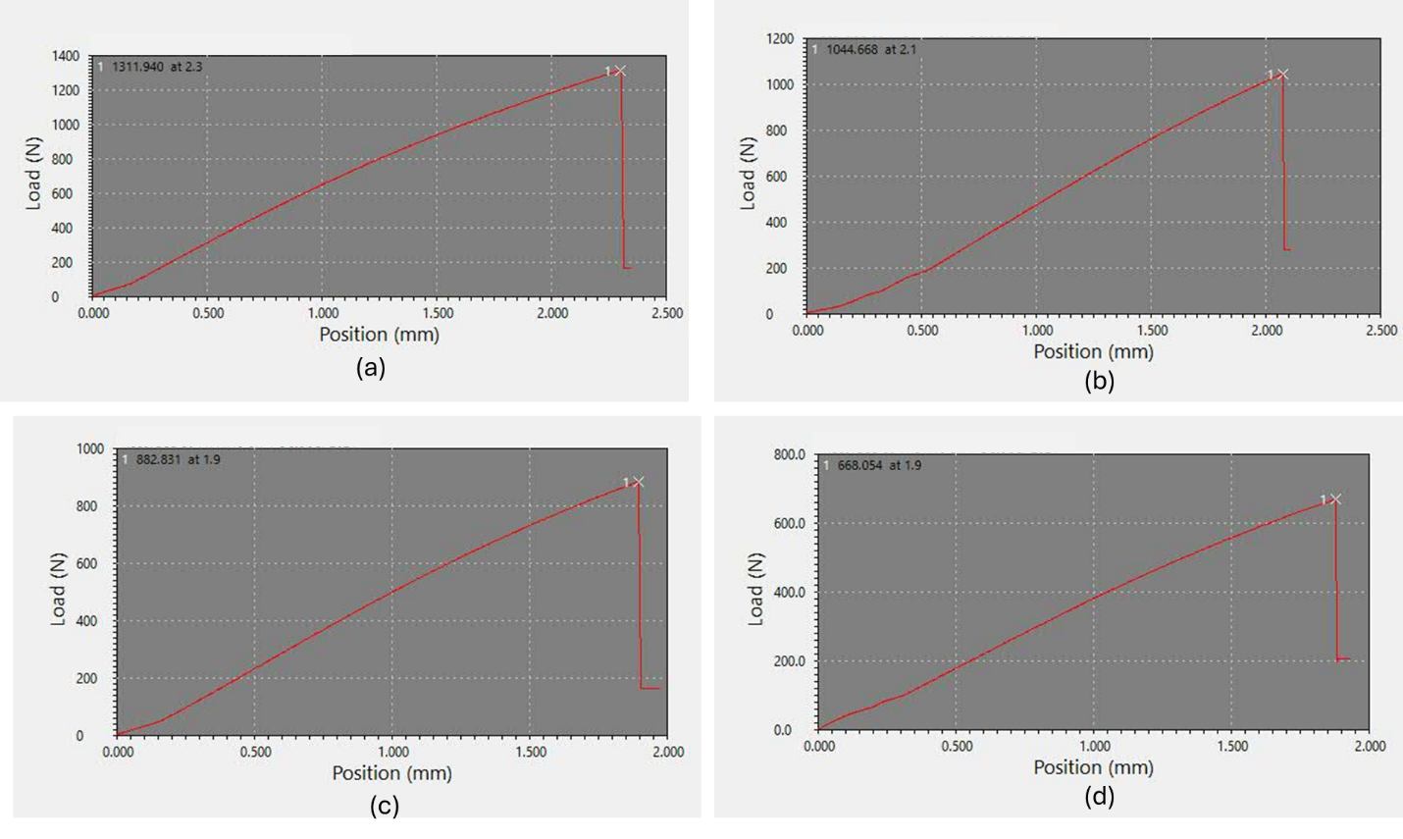

***Figure 3. Typical room temperature fracture tests results. (a) Control; (b) 1% nanoclay; (c) 3% nanoclay; and (d) 5% nanoclay.***

*When converting the peak load and peak displacement to stress and strain, the fracture stress and strain are 53.6 MPa and 3.04%, 43.4 MPa and 2.78%, 34.5 MPa and 2.51%, and 27.2 MPa and 2.50%, respectively, for the control polymer and the polymers containing 1%, 3%, and 5% nanoclay particles. It is clear that the polymers containing nanoclay particles are not performing as good as the control samples. Actually, with the increase in nanoclay concentration, both the fracture stress and fracture strain reduce. One possible reason for this is that the DMF solvent may have not been fully removed from the polymer matrix. We are currently working to find a better way to remove the DMF solvent from the mixture.*

***Shape memory effect test results***

*We conducted hot programming of the dogbone samples. The test was started by heating the MTS chamber to 170 oC, and the sample was also put into the chamber. Once the temperature was stabilized for 30 minutes, we opened the door of the chamber and quickly clamped the sample to the MTS machine grips. After about 5 minutes, we applied a tension force at a rate of about 0.5 mm/min. Once the strain comes to 5%, the tension was stopped, and the strain was maintained for 30 minutes. After that, we started cooling the specimen while keeping the strain constant. Once the temperature was dropped to below the glass transition zone (the glass transition temperature was 140 oC based on our DSC test results), the force was removed, accompanied by slight springback. The shape fixity ratio was about 85% for all the samples. During stress recovery test, we again heat the chamber to 170 oC, and stabilized for 30 minutes. We then quickly clamp the tension programmed sample to the grips of the MTS machine, and the MTS machine started to record the force as a function of time, while keeping the recovery strain zero. This led to the fully constrained stress recovery test. The test lasted 20 minutes to allow the change of the recovery stress with time. The typical stress recovery test results are shown in* ***Fig. 4****.*

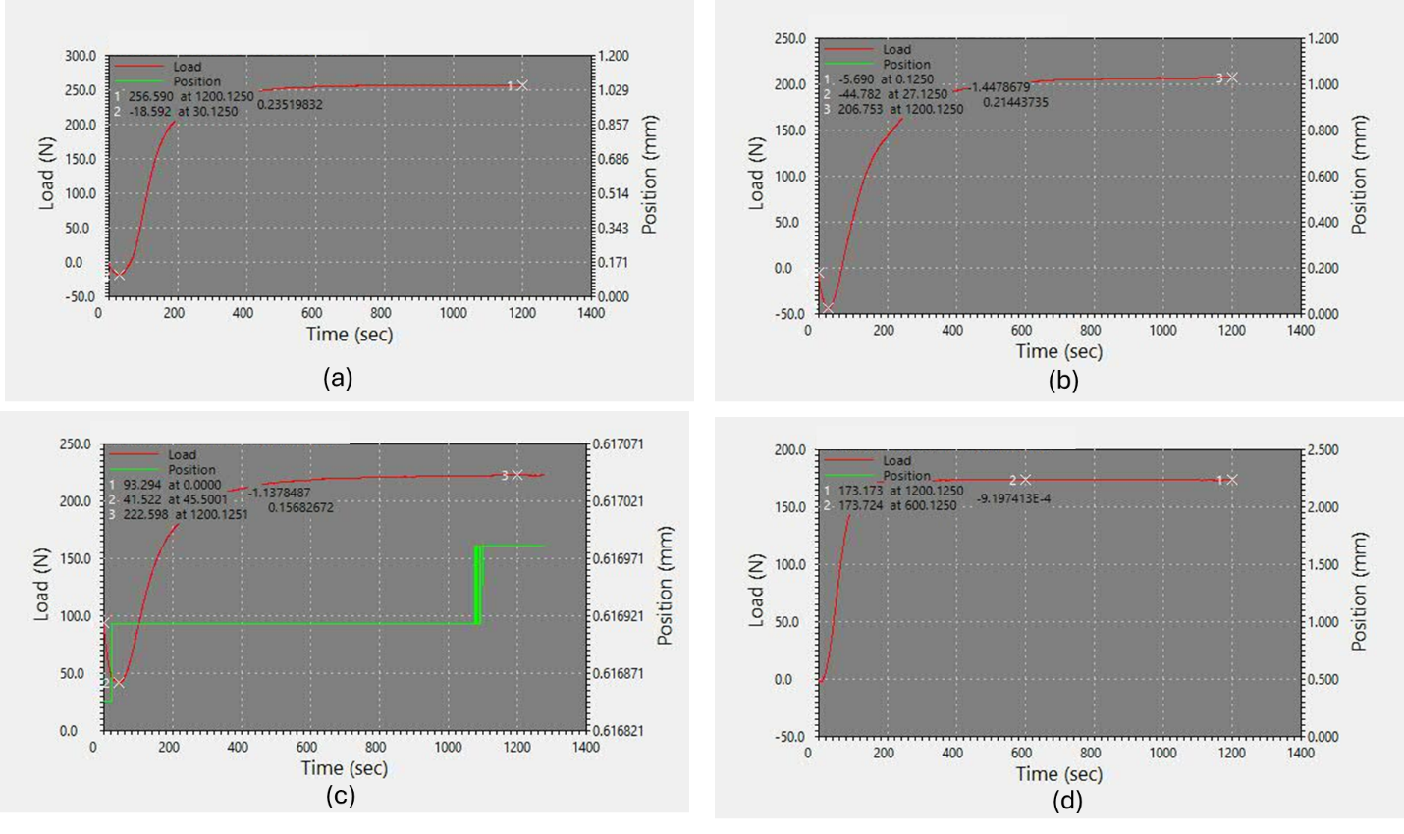

***Figure 4. Typical stress recovery test results. (a) Control; (b) 1% nanoclay; (c) 3% nanoclay; and (d) 5% nanoclay.***

*When converting the recovery force to recovery stress, it is found that the recovery stress was 10.44 MPa, 8.19 MPa, 8.19 MPa, and 6.89 MPa, respectively for the control polymer and the polymers with 1%, 3%, and 5% nanoclays. Like the room temperature fracture test results, the nanoclay reinforced polymers did not show improved recovery stress. Again, one reason is that the DMF solvent may have not been fully removed from the mixture during the process of preparing the composite.*

*However, it is noted that, during the stress recovery test, the recovery stress is quite stable, instead of stress relaxation at high temperature for most thermoset shape memory polymers. This is an advantage when using the rebar to close cracks because the polymer matrix can provide consistent recovery force. It is also noted that, the pure polymer shows a 10.44 MPa recovery stress, which is much higher than the reported recovery stress of 5 MPa [1]. As mentioned in our proposal, our target is to increase the recovery stress to 7 MPa. From the test results, the goal has been achieved by changing the curing approach, even without using the nanoclay.*

1. Percent of research project completed

*Task 1 progress [80% completed]*

*Task 2 progress [90% completed]*

*Task 3 progress [30% completed]*

*Task 4 progress [0% completed]*

*Task 5 progress [0% completed]*

1. Expected progress for next quarter

*With the new test results of Task 1, and the validated rebar manufacturing procedure in our previous reports, we will use continuous E-glass fiber tows to prepare shape memory rebars, by using the pure epoxy as the matrix, but using the step curing approach. In other words, our plan is to complete all the remining tasks by the end of December 2024.*

1. Educational outreach and workforce development

*In this reporting period, two Ph.D. students, Mr. Winston Capps (who has disability) and Mr. Alireza Ostadrahimi, and a postdoc, Dr. Chengbin Yu were directly involved in the project. One summer REU student, Miss. Mykhayla Carroll (Albany State University, Biology and Forensic Science Major, who was supported by an on-going NSF REU project “REU Site: Smart Polymer Composite Materials and Structures” at LSU for 10 weeks in summer 2024 (Dr. Guoqiang Li is the PI of this REU project)), who is a minority student, also helped in preparing the polymer composites. By involving minority and women undergraduate student and graduate student with disability, this project has made considerable impact on higher education.*

1. Technology Transfer

*None.*

**Research Contribution:**

1. Papers that include TRANS-IPIC UTC in the acknowledgments section:

*None.*

1. Presentations and Posters of TRANS-IPIC funded research:

*None.*

1. Please list any other events or activities that highlights the work of TRANS-IPIC occurring at your university (please include any pictures or figures you may have). Similarly, please list any references to TRANS-IPIC in the news or interviews from your research.

None.

**References:**

*[1] J. Fan and G. Li. High Enthalpy Storage Thermoset Network with Giant Stress and Energy Output in Rubbery State. Nature Communications, Vol. 9, No. 1, paper 642, (2018).*