

Transportation Infrastructure Precast Innovation Center (TRANS-IPIC)

# University Transportation Center (UTC)

Optimizing the Planning of Precast Concrete Bridge Construction Methods to Maximize Durability, Safety, and Sustainability

UI-23-RP-05

Quarterly Progress Report

For the performance period ending [6/30/2024]

### Submitted by:

PI (Khaled El-Rayes, Professor UIUC, [elrayes@illinois.edu)](mailto:elrayes@illinois.edu) Department of Civil and Environmental Engineering University of Illinois at Urbana-Champaign

### Collaborators / Partners:

None

### Submitted to:

TRANS-IPIC UTC

University of Illinois Urbana-Champaign Urbana, IL

# TRANS-IPIC Quarterly Progress Report:

### Project Description:

1. Research Plan - Statement of Problem

The poor conditions of aging bridges in the US prompted the federal government to enact a $1 trillion infrastructure bill in 2021 that includes $110 billion in additional funding for repairing and rebuilding US bridges and roadways (White House, 2022). State DOTs need to optimize the use of these investments to accomplish multiple objectives including maximizing durability, safety, sustainability, and mobility while minimizing life- cycle cost. This presents DOTs with a number of challenges including how to (1) select an optimal bridge construction method from a set of feasible alternatives including conventional cast-in-place, precast bridge elements or systems, precast lateral slide, and precast self-propelled modular transporter, for each planned project based on its specific conditions and requirements; (2) accurately predict the cost of these alternative bridge construction methods during the early project phase with limited design data; (3) optimize the planning of off-site PC manufacturing, transportation, and onsite installation; and (4) quantify and optimize the impact of important construction decisions on multiple objectives including durability, safety, sustainability, mobility, and life-cycle cost.

1. Research Plan - Summary of Project Activities (Tasks)

Task 1: Develop novel predictive Machine Learning (ML) models that can be used by DOT planners during the early design phase to quantify the impact of conventional and PC accelerated bridge construction methods on construction cost during the early design phase.

Task 2: Create a novel multi-objective optimization model to support DOTs in identifying optimal bridge construction planning decisions such as optimal size, number, transportation, and onsite installation of all bridge PC modules to maximize durability, safety, sustainability, and mobility while minimizing bridge life-cycle cost.

### Project Progress:

1. Progress for each research task

Task 1 progress [100% completed]. Last quarter, the research team successfully developed six machine learning (ML) models to support decision makers in estimating the cost of conventional and PC accelerated bridge construction projects during the early design phase. The ML models were developed in four main phases that focused on (1) collecting and analyzing a dataset of 413 bridge projects that were constructed in 29 US states; (2) preprocessing the dataset to classify, clean, and transform predictor and predicted variables as well as splitting the dataset into training and testing sets; (3) developing bridge cost estimating models using the six ML algorithms of Ordinary Least Squares, LASSO Regression, Ridge Regression, Random Forest Regressor, Gradient Boosting, and Extreme Gradient Boosting; and (4) evaluating and validating the performance of the developed ML models, as shown in Figure 1. The results of the performance evaluation and validation phase showed that non-linear models of Random Forest, Gradient Boosting, and Extreme Gradient Boosting outperformed linear models in both training and testing datasets. The performance evaluation results showed that the Gradient Boosting and the Extreme Gradient Boosting achieved the highest performance with an R² of 99.99% and 99.97%, respectively. Similarly, the validation

results showed that the Extreme Gradient Boosting model outperformed the other models in three metrics as it achieved the lowest 𝑀𝐴𝑃𝐸 of 13.90%, 𝑀𝐴𝐸 of $64.28/sf, and 𝑀ed. 𝐴𝐸 of $29.94/sf. On the other hand, the GB model outperformed the other models in the fourth metric with the lowest RMSE of $113.01/sf.

## Phase 1: Bridge Data Collection

* + Total Construction Cost
  + Project Type
  + Location Type
  + Design Type
  + Project Length
  + Bridge Length
  + Bridge Width
  + Maximum Span Length
  + Number of Spans
  + Number of Lanes
  + Beam Material
  + Average Daily Traffic
  + Mobility Impact Category

## Phase 2: Data Preprocessing

* Predictor and Predicted Variables Identification



* Data Classification
* Data Cleaning
* Data Transformation
* Data Splitting

## Phase 3: Model Development

* Selecting Machine Learning Algorithms
* Fitting Selected Algorithms to Training Datasets

## Phase 4: Evaluation and Validation

* Evaluating Performance of Developed Models
* Validating Results Using Testing Datasets

*Figure 1. Development Phases of Machine Learning Models.*

Task 2 progress [20% completed]. Last quarter, the research team started working on the second task that focuses on creating a novel multi-objective optimization model to identify optimal bridge construction planning decisions such as optimal size, number, transportation, and onsite installation of all bridge PC modules to maximize durability, safety, sustainability, and mobility while minimizing bridge life-cycle cost.

1. Percent of research project completed

60% of total project completed through the end of this quarter.

1. Expected progress for next quarter

In the next quarter, the research team will continue working on the second research task that focuses on developing multi-objective optimization Decision Support Tool (DST) for optimizing the construction decisions of PC bridges*.*

1. Educational outreach and workforce development

On April 22, 2024, the research team attended the first annual TRANS-IPIC workshop that was held at the Big Ten Office and Conference Center in Rosemont, IL to present their preliminary research findings and learn more about cutting-edge research for infrastructure PC construction, implementation, and maintenance process, as shown in Figure 2. Additionally, the research team actively participated in the TRANS-IPIC Monthly Webinars that were held online on May 13, 2024, and June 17, 2024.

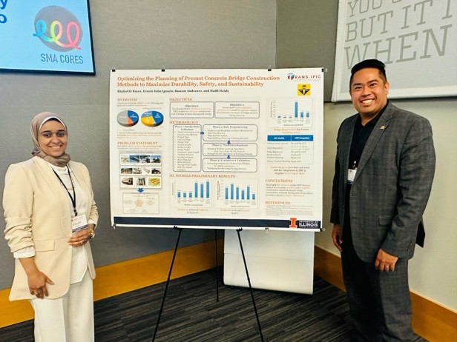 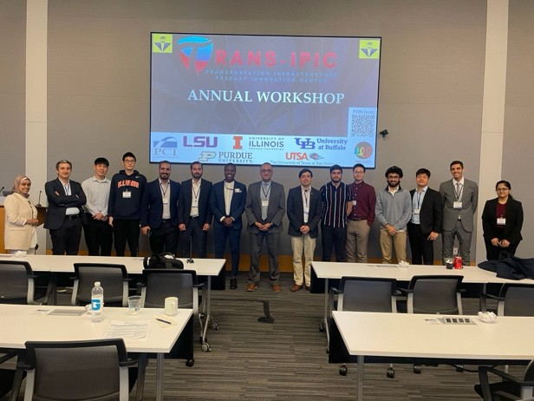

1. *The research team presen/ng their preliminary research ﬁndings at the ﬁrst TRANS-IPIC workshop*
2. *The research team with a group of other researchers in the workshop*

*Figure 2. The research team a=ending the ﬁrst annual TRANS-IPIC workshop in Rosemont, IL*

1. Technology Transfer

The research team developed six different ML predictive models to estimate the construction cost of alternative bridge construction methods including conventional and precast concrete accelerated bridge construction methods. The research team will develop a plan for sharing the ML and optimization models that will be developed in this research project.

### Research Contribution:

1. Papers that include TRANS-IPIC UTC in the acknowledgments section:

The research team submitted a paper titled “Comparison of Machine Learning Algorithms for Estimating Cost of Conventional and Accelerated Bridge Construction Methods During Early Design Phase” to the ASCE Journal of Construction Engineering and Management that is currently under review.

1. Presentations and Posters of TRANS-IPIC funded research:

The research team developed a poster presenting the preliminary results of their

TRANS-IPIC research that focuses on optimizing the planning of precast concrete bridge construction methods to maximize durability, safety, and sustainability (El-Rayes et al.

2024), as shown in Figure 3.

**Training Time (sec)**

*Figure 3. Poster presenJng the preliminary results of the TRANS-IPIC research (El-Rayes et al., 2024)*

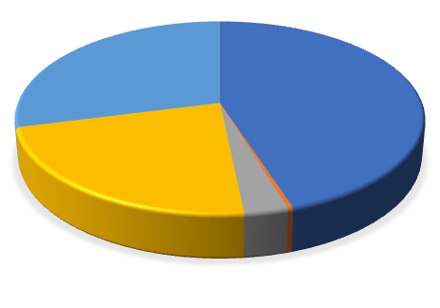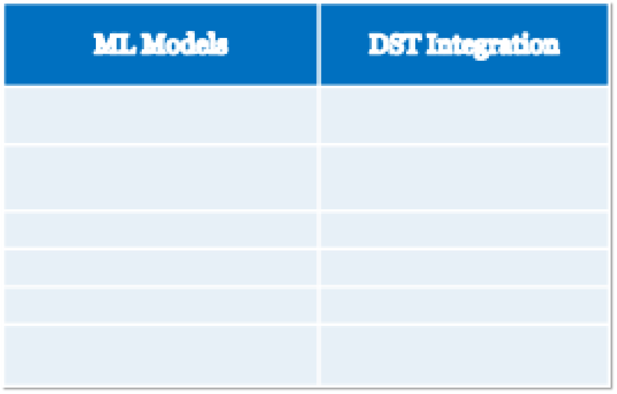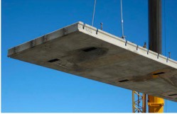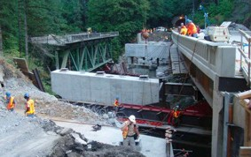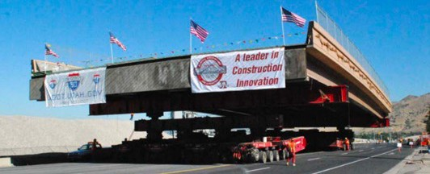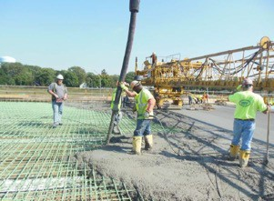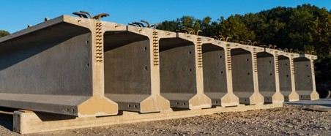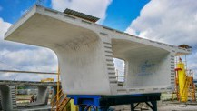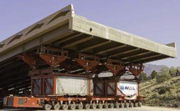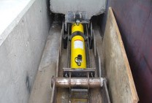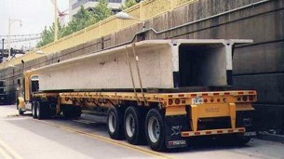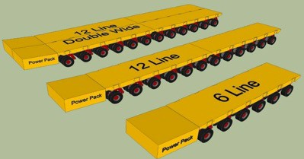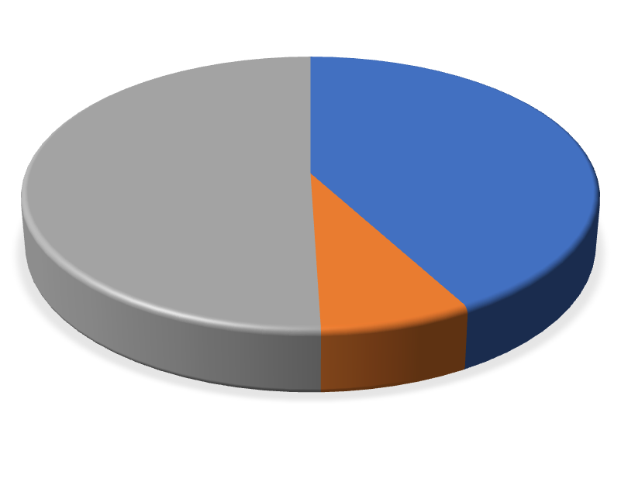

**OVERVIEW**

* Significant percentage of the **617,000** US bridges are aging and in need of **replacement**.

US Bridges Needing Work By Type

US Bridges Condition(ARTBA, 2023)1

of Repair (FHWA, 2023)2

**22%**

**Other Stucural Work**

**42%**

**< 50 Years old > 50 Years Old**

**35%**

**Bridge Replacement**

**17%**

**Widening &**

**Rehabilitation**

**3%**

**7.5%**

**Structurally Defficient**

**23% Deck Replacmen Rehabilitation**

* 2021 $1 Trillion Infrastructure Investment and Jobs Act includes **$110 Billion** for **bridge rehabilitation/ replacement** (White House, 2022)3**.**

**PROBLEM STATEMENT**

State DOTs need to **optimize** the use of these bridge investments to accomplish **multiple objectives**.

**Construction Decision Variables**

**Construction Method**

Cast in Place (CIP) Precast Bridge Elements Precast Lateral Slide Precast Self-Propelled

(PBES) (PLS) Modular Transporter (PSPMT)

**Size of PC Modules**

Girder Box Girder

Slab Large Module

**Transportation Method**

Trucks Hydraulic Jacks for Lateral Slide

PSPMT Size

**Optimization Objectives**

**Cost**

(minimize construction $)

**Sustainability** (minimize tons of greenhouse gas)

**Mobility** (minimize hours of total delay of all vehicles)

**Durability**

**Safety**

(maximize years of bridge (minimize work lifespan) zone crashes)

1 0.9463

0.9

0.8

0.7

0.6

0.5

0.8671

0.7946

0.4 0.3198 0.2733 0.2829

0.3

0.2

0.1

0

Ordinary Lasso Ridge Random Gradient Xt reme Least Regression Regression Forest (RF) Boosting Gradient Squares (Lasso) (Ridge) (GB) Boosting

(OLS) (XGBoost)

**Machine Learning Models**

0.15

0.145 0.1445

0.1408

0.14 0.1385

0.1394

0.1346

0.135

0.13

0.1289

0.125

0.12

Ordinary Lasso Ridge Random Gradient Xt reme Least Regression Regression Forest (RF) Boosting Gradient

Squares (Lasso) (Ridge) (GB) Boosting

(OLS) (XGBoost)

**Machine Learning Models**

**OBJECTIVES**

**Objective 1**

Develop predictive **Machine Learning** (ML) models to **estimate** construction cost of bridge projects during early design.

**Objective 2**

Create novel **multi-objective optimization** model to **optimize** impact of construction decisions on bridge projects during planning.

**METHODOLOGY**

**Phase 1: Bridge Data Collection**

* Total Construction Cost
* Construction Method
* Project Type
* Location Type
* Design Type
* Project Length
* Bridge Length
* Bridge Width
* Maximum Span Length
* Number of Spans
* Number of Lanes
* Beam Material
* Deck Material
* Average Daily Traffic
* Mobility Impact Category

**Phase 2: Data Preprocessing**

* Predictor and Predicted Variables Identification
* Data Classification
* Data Transformation
* Data Splitting (Training & Testing datasets)

**Phase 3: Model Development**

* Selecting Machine Learning Algorithms

(OLS, Lasso, Ridge, RF, GB, XGBoost)

* Fitting Selected Algorithms to Training Datasets

**Phase 4: Evaluation & Validation**

* Evaluating Performance of Developed Models

(R2, MAPE, training time, …)

* Validating Results Using Testing Datasets

**ML MODELS PRELIMINARY RESULTS**

**XGBoost** achieved **highest**

R-Squared

**XGBoost** achieved **lowest**

MAPE

10.000

9.000

8.000

7.000

6.000

5.000

4.000

3.000

8.995

3.076 2.704

2.000 0.938

1.000

0.000

0.546 0.529

Ordinary Lasso Ridge Random Gradient Xt reme Least Regression Regression Forest (RF) Boosting Gradient Squares (Lasso) (Ridge) (GB) Boosting

(OLS) (XGBoost)

**Machine Learning Models**

**Optimizing the Planning of Precast Concrete Bridge Construction Methods to Maximize Durability, Safety, and Sustainability**

**Khaled El-Rayes, Ernest-John Ignacio, Bassem Andrawes, and Hadil Helaly**

**t**

**Ridge Regression** has fastest

**training time**

Ordinary Least Squares No need for GUI Lasso Regression No need for GUI &

fewer required input

Ridge Regression No need for GUI

Random Forest Needs GUI

Gradient Boosting Needs GUI Xtreme Gradient Boosting Needs GUI

**Lasso Regression** does not need GUI for integration in DST & requires **least input data**

**CONCLUSIONS**

Developed **ML models** enable DOT decision makers to accurately **predict** and **compare** construction cost of alternative bridge construction methods during early design phase to achieve specific **project objectives**.

**REFERENCES**

1. American Road & Transportation Builders Association (ARTBA ). 2023. “2023-ARTBA-Bridge-Report.” Accessed April 2, 2024. https://artbabridgereport.org/.
2. Federal Highway Administration (FHWA). 2023. “Bridges & Structures.” Accessed April 2, 2024. https://[www.fhwa.dot.gov/bridge/.](http://www.fhwa.dot.gov/bridge/)
3. White House. 2022. “FACT SHEET: One Year into Implementation of Bipartisan Infrastructure Law, Biden-Harris Administration Celebrates Major Progress in Building a Better America.” Whitehouse.Gov. https://[www.whitehouse.gov/briefing-room/statements-releases/2022/11/15/fact-sheet-one-year-into-](http://www.whitehouse.gov/briefing-room/statements-releases/2022/11/15/fact-sheet-one-year-into-) implementation-of-bipartisan-infrastructure-law-biden-harris-administration-celebrates-major-progress- in-building-a-better-america/.

Conventional CIP

PSPMT, Large Module, SPMT 6 Line

**R Squared (%)**

**Mean Absolute Percentage Error (MAPE) (%)**

1. Please list any other events or activities that highlights the work of TRANS-IPIC occurring at your university (please include any pictures or figures you may have). Similarly, please list any references to TRANS-IPIC in the news or interviews from your research.

The following research paper was developed and submitted to the ASCE *Journal of Construction Engineering and Management* based on the completed research activities in this project. Helaly, H., K. El-Rayes, E.J. Ignacio, and H. J. Joan. (under review) “Comparison of Machine Learning Algorithms for Estimating Cost of Conventional and Accelerated Bridge Construction Methods During Early Design Phase.” *Journal of Construction Engineering and Management, ASCE.*

### References:

Alhusni, M. K., A. Triwiyono, and I. S. IrawaG. 2019. “Material QuanGty EsGmaGon Modeling of Bridge Sub-substructure Using Regression Analysis.” *MATEC Web of Conferences*. hSps://doi.org/10.1051/matecconf/20192.

American Road & TransportaGon Builders AssociaGon. 2023. “2023-ARTBA-Bridge-Report.” Accessed April 3, 2024. hSps://artbabridgereport.org/.

AprianG, E., S. Hamzah, and M. A. Abdurrahman. 2021. “The Analysis of Cost EsGmaGon using Cost Signiﬁcant Model on Bridge ConstrucGon in South Sulawesi.” *IOP Conf Ser Earth Environ Sci*. IOP Publishing Ltd.

ASCE. 2021. *Infrastructure Report Card*. *ASCE*. American Society of Civil Engineers (ASCE). Behmardi, B., T. Doolen, and H. Winston. 2015. “Comparison of PredicGve Cost Models for

Bridge Replacement Projects.” *Journal of Management in Engineering*, 31 (4): 04014058. hSps://doi.org/10.1061/(asce)me.1943-5479.0000269.

Bentéjac, C., A. Csörgő, and G. Marinez-Muñoz. 2021. “A comparaGve analysis of gradient boosGng algorithms.” *ArAf Intell Rev*, 54 (3): 1937–1967. Springer Science and Business Media B.V. hSps://doi.org/10.1007/s10462-020-09896-5.

Breiman, L. 2001. “Random Forests.” Mach Learn, 45: 5–32.

Chen, T., and C. Guestrin. 2016. “XGBoost: A Scalable Tree BoosGng System.” *Proceedings of the 22nd ACM SIGKDD InternaAonal Conference on Knowledge Discovery and Data Mining*, KDD ’16, 785–794. New York, NY, USA: AssociaGon for CompuGng Machinery.

Chengalur-Smith, I. N., D. P. Ballou, and H. L. Pazer. 1997. “Modeling the costs of bridge rehabilitaGon.” *Transp Res Part A Policy Pract*, 31 (4 PART A): 281–293. hSps://doi.org/10.1016/s0965-8564(96)00028-6.

Creese, R. C., and L. Li. 1995. “Cost EsGmaGon of Timber Bridges Using Neural Networks.” *Cost Engineering*, 37 (5).

Daly, A., T. Dekker, and S. Hess. 2016. “Dummy coding vs eﬀects coding for categorical variables: ClariﬁcaGons and extensions.” *Journal of Choice Modelling*, 21: 36–41. Elsevier Ltd. hSps://doi.org/10.1016/j.jocm.2016.09.005.

Doheny, M. 2023. *2023 Building ConstrucAon Costs*. Gordian/RSMeans Data.

El-Rayes, K., N. El-Gohary, M. Golparvar-Fard, E.J. Ignacio, and H. Helaly. 2023. *Economical Impact of Full Closure for Accelerated Bridge ConstrucAon and ConvenAonal Staged ConstrucAon*. Rantoul.

El-Rayes, K., E.J. Ignacio, B. Andrawes, and H. Helaly. 2024. “OpGmizing the Planning of Precast Concrete Bridge ConstrucGon Methods to Maximize Durability, Safety, and Sustainability.” *TRANS-IPIC Annual Workshop*.

Essegbey, A. E. 2021. “Conceptual cost esGmaGon models for bridge projects.”

FHWA (Federal Highway AdministraGon). 2023. “Bridges & Structures.” Accessed April 19, 2024. hSps://[www.twa.dot.gov/bridge/nbi/no10/condiGon23.cfm.](http://www.twa.dot.gov/bridge/nbi/no10/condiGon23.cfm)

FHWA (Federal Highway AdministraGon). 2005. *Framework for Prefabricated Bridge Elements and Systems (PBES) Decision-Making*.

FHWA (Federal Highway AdministraGon). 2007. *Self- Propelled Modular Transporters Manual*. FHWA (Federal Highway AdministraGon). 2013. *UTAH DEMONSTRATION PROJECT: RAPID*

*REMOVAL AND REPLACEMENT OF THE 4500 SOUTH BRIDGE OVER I-215 IN SALT LAKE CITY*.

FIU. 2024. “ABC Project and Research Databases.” *ABC Project and Research Databases*.

Accessed January 1, 2024. hSps://utcdb.ﬁu.edu/search/.

Fragkakis, N., S. Lambropoulos, and J.-P. Pantouvakis. 2010. “A cost esGmate method for bridge superstructures using regression analysis and bootstrap.” *Technology and Management in ConstrucAon10*, 2 (2): 182–190.

Fragkakis, N., S. Lambropoulos, and G. Tsiambaos. 2011. “Parametric Model for Conceptual Cost EsGmaGon of Concrete Bridge FoundaGons.” *Journal of Infrastructure Systems*, 17 (2): 66–

74. hSps://doi.org/10.1061/(ASCE)IS.1943-555X.0000044.

Hadi, M., W. Orabi, Y. Xiao, M. Ibrahim, and J. Jia. 2017. *EsAmaAng Total Cost of Bridge ConstrucAon Using ABC and ConvenAonal Methods of ConstrucAon*.

Hadi, M., W. Orabi, Y. Xiao, and J. Jia. 2016. *EsAmaAng Total Cost of Bridge ConstrucAon using Accelerated Bridge ConstrucAon (ABC) and ConvenAonal Methods of ConstrucAon*.

Hardy, M. A. 1993. *Regression with dummy variables*. SAGE PublicaGons, Inc.

IDOT (Illinois Department of TransportaGon). 2024a. “Bridge InformaGon System.” Accessed April 1, 2024. hSps://apps.dot.illinois.gov/bridgesinfosystem/main.aspx.

IDOT (Illinois Department of TransportaGon). 2024b. “NoGces of Leung.” *NoAces of Le[ng*.

Accessed June 2, 2024. hSps://webapps.dot.illinois.gov/WCTB/LbHome.

Juszczyk, M. 2020. “On the search of models for early cost esGmates of bridges: An SVM-based approach.” *Buildings*, 10 (1). hSps://doi.org/10.3390/buildings10010002.

Kim, K. J., K. Kim, and C. S. Kang. 2009. “Approximate cost esGmaGng model for PSC Beam bridge based on quanGty of standard work.” *KSCE Journal of Civil Engineering*, 13 (6): 377–388. hSps://doi.org/10.1007/s12205-009-0377-0.

Kovacevic, M., N. Ivaniševic, P. Petronijevic, and V. Despotovic. 2021. “ConstrucGon cost esGmaGon of reinforced and prestressed concrete bridges using machine learning.” *Gradjevinar*, 73 (1): 1–13. Union of CroaGan Civil Engineers and Technicians. hSps://doi.org/10.14256/JCE.2738.2019.

May, R. J., H. R. Maier, and G. C. Dandy. 2010. “Data spliung for arGﬁcial neural networks using SOM-based straGﬁed sampling.” *Neural Networks*, 23 (2): 283–294. hSps://doi.org/10.1016/j.neunet.2009.11.009.

McDonald, G. C. 2009. “Ridge regression.” *Wiley Interdiscip Rev Comput Stat*, 1 (1): 93–100. hSps://doi.org/10.1002/wics.14.

MDOT. 2013. *RC-1602 - Improving Bridges with Prefabricated Precast Concrete Systems*. Muthukrishnan R, and Rohini R. 2016. “LASSO: A Feature SelecGon Technique in PredicGve

Modeling For Machine Learning.”

Ozimok, E. J., and P. Claussen. 2020. “Is ABC a Good Fit? Development of the Illinois Department of TransportaGon’s Accelerated Bridge ConstrucGon EvaluaGon Method.”.

Park, D. Y., and S. H. Yun. 2023. “ConstrucGon Cost PredicGon Using Deep Learning with BIM ProperGes in the SchemaGc Design Phase.” *Applied Sciences (Switzerland)*, 13 (12). MDPI. hSps://doi.org/10.3390/app13127207.

Pawluszek-Filipiak, K., and A. Borkowski. 2020. “On the importance of train-test split raGo of datasets in automaGc landslide detecGon by supervised classiﬁcaGon.” *Remote Sens (Basel)*, 12 (18). MDPI AG. hSps://doi.org/10.3390/rs12183054.

Phillips, P. S. T. 2017. “PredicGng Costs For Bridge Replacement Projects.”

Ralls, M. Lou. 2014. “History of ABC ImplementaGon in U. S.” *NaAonal ABC Conference*, (December): 1–8.

Saito, M., K. C. Sinha, and V. L. Anderson. 1991. “StaGsGcal models for the esGmaGon of bridge replacement costs.” *TransportaAon Research Part A: General*, 25 (6): 339–350. hSps://doi.org/10.1016/0191-2607(91)90012-F.

Shanthi, D. L., and N. Chethan. 2023. “GeneGc Algorithm Based Hyper-Parameter Tuning to Improve the Performance of Machine Learning Models.” *SN Comput Sci*, 4 (2). Springer. hSps://doi.org/10.1007/s42979-022-01537-8.

The White House. 2023. “FACT SHEET: Biden-Harris AdministraGon Celebrates Historic Progress in Rebuilding America Ahead of Two-Year Anniversary of BiparGsan Infrastructure Law.” Accessed April 24, 2024. hSps://[www.whitehouse.gov/brieﬁng-room/statements-](http://www.whitehouse.gov/brieﬁng-room/statements-) releases/2023/11/09/fact-sheet-biden-harris-administraGon-celebrates-historic-progress-in- rebuilding-america-ahead-of-two-year-anniversary-of-biparGsan-infrastructure-law/.

UDOT. 2024. “Keeping Utah Moving.” Accessed April 29, 2024. hSps://udot.utah.gov/connect/. VTRANS Vermont Agency of TransportaGon. 2017. *The Accelerated Bridge Program*.

Winalytra, I., A. S. B. Nugroho, and A. Triwiyono. 2018. “Cost EsGmaGon Model for I-Girder Bridge Superstructure Using MulGple Linear Regression and ArGﬁcial Neural Network.” *Applied Mechanics and Materials*, 881: 142–149. hSps://doi.org/10.4028/www.scienGﬁc.net/amm.881.142.

Yang, Z., and H. Qiu. 2020a. “PredicGon Algorithm of Bridge ConstrucGon Cost Based on Regression Analysis.” *J Coast Res*, 103 (sp1): 979–982. hSps://doi.org/10.2112/SI103-204.1.

Yang, Z., and H. Qiu. 2020b. “PredicGon Algorithm of Bridge ConstrucGon Cost Based on Regression Analysis.” *J Coast Res*, 103 (sp1): 979–982. Coastal EducaGon Research FoundaGon Inc. hSps://doi.org/10.2112/SI103-204.1.

Zhang, Y., R. E. Minchin, and D. Agdas. 2017. “ForecasGng Completed Cost of Highway ConstrucGon Projects Using LASSO Regularized Regression.” *J Constr Eng Manag*, 143 (10): 4017071. hSps://doi.org/10.1061/(ASCE)CO.1943-7862.0001378.

Zhang, Z. 2016. “Variable selecGon with stepwise and best subset approaches.” *Ann Transl Med*, 4 (7). AME Publishing Company. hSps://doi.org/10.21037/atm.2016.03.35.

Zheng, Z., L. Zhou, H. Wu, and L. Zhou. 2023. “ConstrucGon cost predicGon system based on Random Forest opGmized by the Bird Swarm Algorithm.” *MathemaAcal Biosciences and Engineering*, 20 (8): 15044–15074. American InsGtute of MathemaGcal Sciences. hSps://doi.org/10.3934/mbe.2023674.