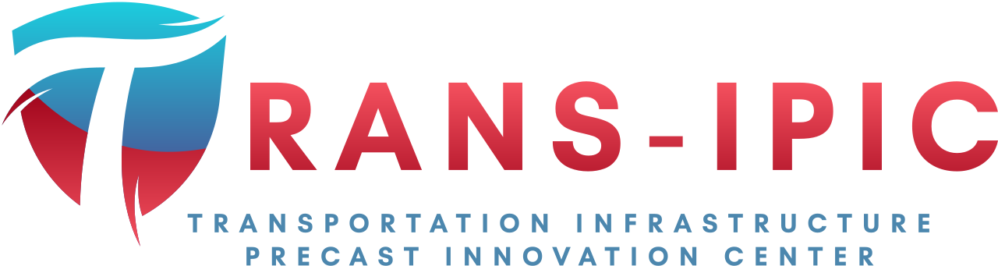

Transportation Infrastructure Precast Innovation Center
(TRANS-IPIC)

University Transportation Center (UTC)

Design and Implementation of Digital Twin Models for Continuous Monitoring and Performance Prediction of Precast Concrete Bridges
UI-23-RP-03

Quarterly Progress Report
For the performance period ending 12/31/2023

Submitted by:
Volodymyr Kindratenko, kindrtnk@illinois.edu
National Center for Supercomputing Applications (NCSA)
University of Illinois at Urbana-Champaign

Collaborators / Partners:
N/A

Submitted to:
TRANS-IPIC UTC
University of Illinois Urbana-Champaign
Urbana, IL

TRANS-IPIC Quarterly Progress Report:

Project Description:
- Research Plan - Statement of Problem

This research project aims to design and validate a digital twin model of a precast concrete bridge structure, subsequently integrating this model with sensor data derived from a real-world bridge. This integration will serve as the foundation for driving the simulation and analysis of the bridge model. The digital twin model will be constructed utilizing NVIDIA Omniverse, an innovative platform that facilitates the creation of collaborative and immersive 3D objects, equipped with real-time simulation capabilities.

- Research Plan - Summary of Project Activities (Tasks)

Task 1: Digital Model Development: We explore how to use technical drawings and the design and inspection data that may exist for the bridge itself or the precast parts used in its construction in order to rapidly implement a digital twin model. The outcome of this task is a methodology for rapidly prototyping a 3D model of a PC bridge based on the above-mentioned sources of initial information.

Task 2: Digital Model Implementation: We will study how NVIDIA Omniverse platform for digital twins operates and how to build new models within the platform’s capabilities, including linking it with external data sources. The outcome of this task is a PC bridge twin model implemented in NVIDIA Omniverse environment.

Task 3: Bridge Simulation using Real-Time Data: Our goal is to enable ingesting real-time data from a specific PC bridge to be incorporated with the digital twin model as well as any readily available environmental data, such as weather, traffic, any imagery. Such data will be used to model the bridge performance and predict its response to different usage conditions. The outcome of this task will be a data-driven digital twin model of a PC bridge updated each time new data about the bridge is available.

Project Progress:
- Progress for each research task

Task 1 progress [50% completed]:

We built 3D models of several basic components of PC bridges in Revit, including precast beams, supports and piers. These components are exported in USD (Universal Scene Description) format, which can be loaded into the NVIDIA Omniverse Platform. These basic components of bridges can be assembled either manually or programmatically in the Omniverse to build the model of the bridge.
A multi-box girder bridge (alt. PPC deck girder bridge) from Jersey County, IL was chosen as the example to explore the capabilities and ease of implementation in the NVIDIA Omniverse Platform. The bridge cross-section contained six 17x33 and three 17x48 PPC deck girder beams to form a 30’ roadway. The following images show the bridge cross-section and a snapshot of the two-span bridge model in the Omniverse platform.
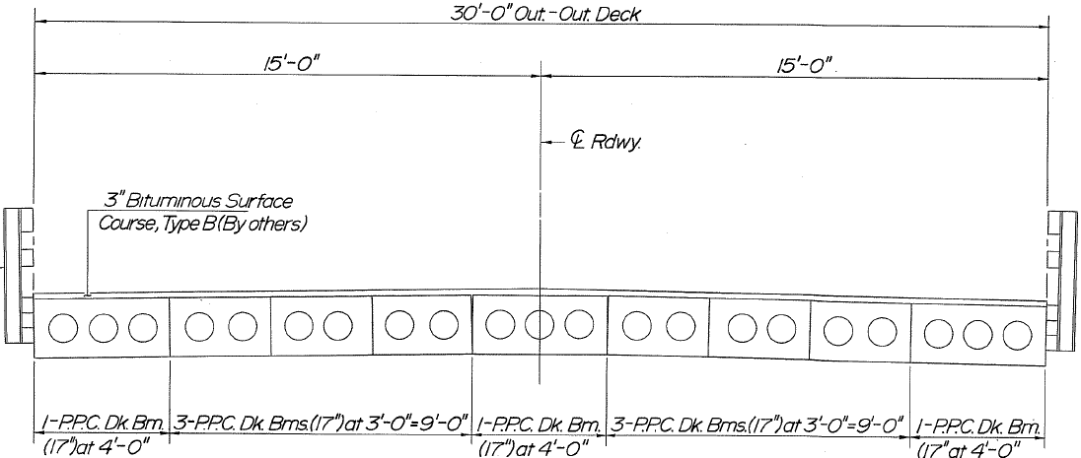

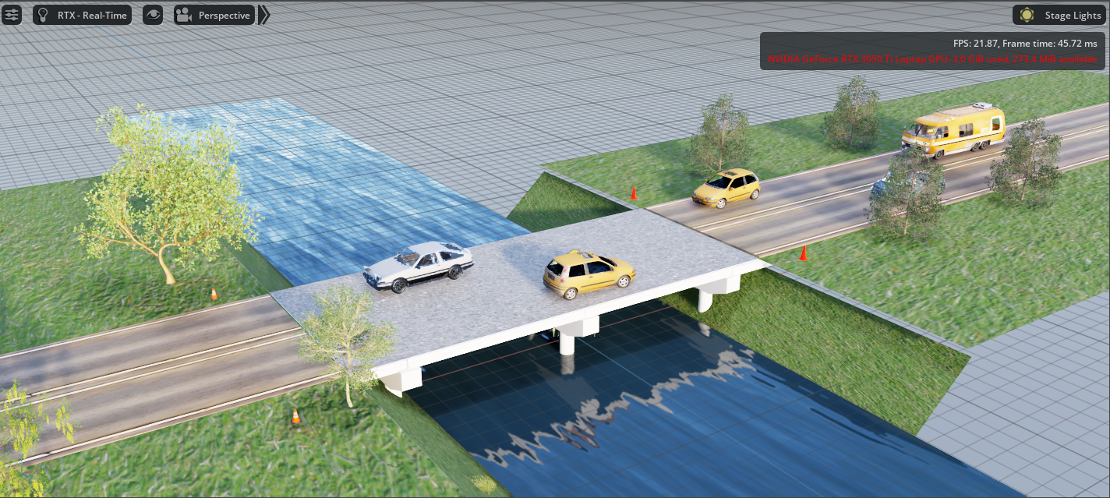

Task 2 progress [25% completed]:

Additionally, we experimented with constructing bridge twin models from 3D primitives directly in Omniverse in response for the actual bridge data extracted on the fly in real-time from the NBI database. We extract bridge metadata, such as bridge location, span material, number of spans, structure length, deck area into a MySQL database set locally. These data is then used to construct bridges automatically.

To support this functionality, we developed an Omniverse extension, with an interface as shown in the image below. The user can click the button in the widget, each specify a bridge and its configuration (number of spans, length for each span, beam number and category for each span, number of piers, etc.). The bridges are from the Champaign and Urbana area and their data is from the NBI database. This functionality is under development, currently the extension support configuration includes number of spans and their length only.
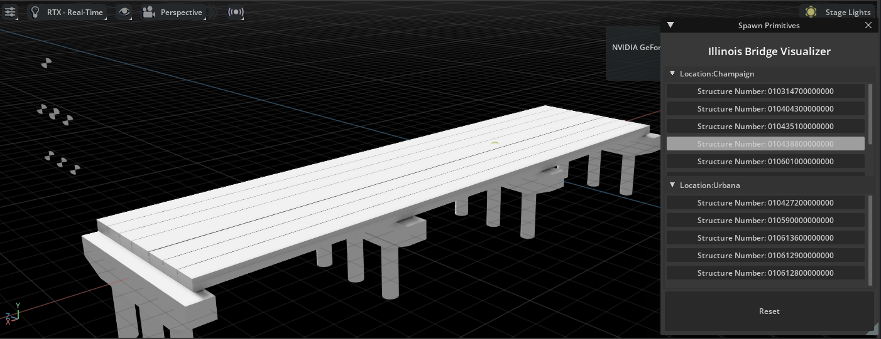

Task 3 progress [25% completed]:

Several sources of external data available in external databases were identified and explored for the purpose of integration of this data with the digital twin model. To enable the digital twin sensor data inspection, we build a widget extension to display sensor data that is stored in the SQL database. When a user clicks any component of that bridge, the widget will pop up to display the sensor data related to that component, if such data is available for the component. The display of sensor data includes line graph, histogram, and numerical data. Moreover, the recent inspection images of that component can also be displayed in the widget for an engineer to check the condition of the bridge in a more convenient way. The screenshot of widget is shown below.

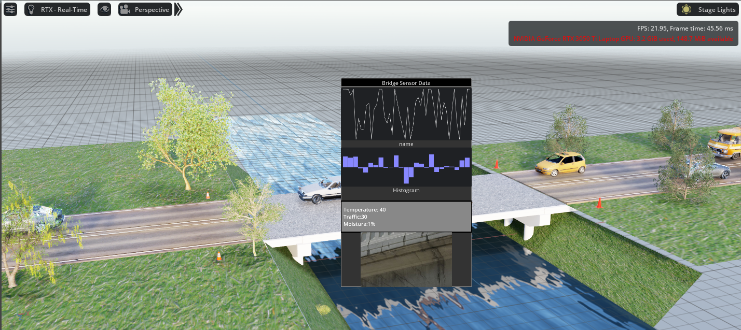

Additionally, we can also include experimental data of single beam under loads. On the bottom image, the widget shows the displacement of a beam under increasing load in the experiment. The line curve shows the displacement of the beam, and the slider on the bottom of widget indicates timestamps. It provides the functionality for engineers to review the experiment.
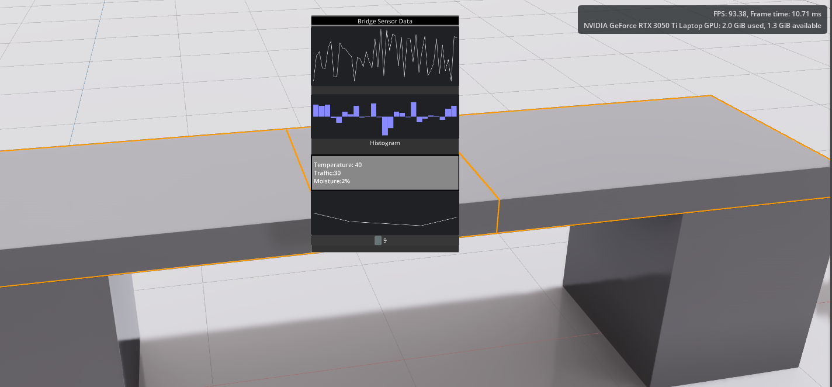

We also experimented with the physics extensions available on the Omniverse platform to conduct simulations of beams subjected to loads. This functionality enables us to visually represent the process of cracking and eventual failure under external pressures. This simulation is executed by incorporating fracture material data, wherein we define the breaking point. Force is applied to the beam at the initiation of the simulation within the Omniverse environment. A screenshot of this simulation is shown in the image below.

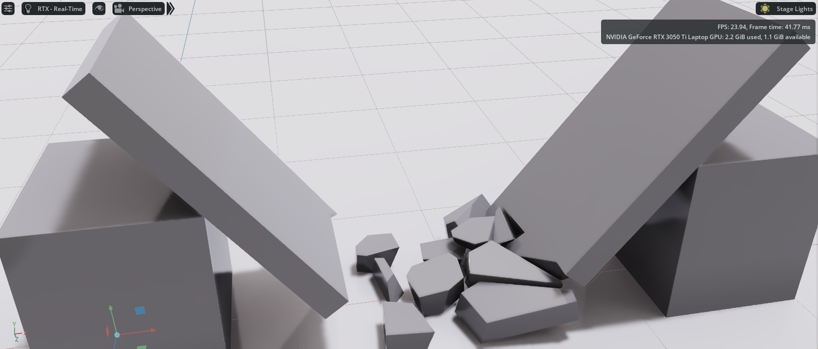

- Percent of research project completed

25%

- Expected progress for next quarter

For all three tasks, we have only explored the capabilities of the tools and identified integration and development issues. We will continue to add the necessary functionality needed to implement the original vision of this project. Specific focus will be on the integration of actual and simulated data and its accurate reflection in the Omniverse environment.

- Educational outreach and workforce development

None

- Technology Transfer

None

Research Contribution:
- Number of papers

None yet

- Number presentations (when, where)

Presentation given to Magnasoft on 11/20/2023

References:

National Bridge Inventory (NBI) database, US Department of Transportation, Federal
Highway Administration, https://www.fhwa.dot.gov/bridge/nbi.cfm

