**Transportation Infrastructure Precast Innovation Center**

**(TRANS-IPIC)**

**University Transportation Center (UTC)**

*3D Printed Smart Permanent Concrete Formwork for Precast Structural Component*

LS-24-RP-02

Quarterly Progress Report

For the performance period ending *[7/01/2025]*

**Submitted by:**

*Yen-Fang Su,* [*ysu@lsu.edu*](mailto:ysu@lsu.edu)

*Civil & Environmental Engineering*

*Louisiana State University and A&M College*

**Collaborators / Partners:**

**Submitted to:**

TRANS-IPIC UTC

University of Illinois Urbana-Champaign

Urbana, IL

**Project Description:**

1. Research Plan - Statement of Problem:

A crucial choking point of transportation infrastructure is the degradation over a long period of time. The detection of change in the structural integrity of roads, bridges, tunnels, etc. requires a practical and economical approach. A commonly used method for structural health monitoring (SHM) is the utilization of external sensors that require constant power supply, protection against weathering, and higher budget. However, these restrictions potentially can be obviated through the usage of advanced materials and fabrication methods. This research utilizes novel self-sensing cementitious composites (SSCCs) to achieve stress-sensing property in precast concrete components. Furthermore, conventional molds for precast concrete elements are replaced with additively manufactured permanent molds facilitating the cost-effective fabrication geometrically irregular shapes. Finally, the layer-by-layer deposition system, which is the defining feature of AM, aids with topological optimization and precise control over the properties of individual layers.

1. Research Plan - Summary of Project Activities (Tasks)

Task 1: Material Properties assessment

Task 2: Specimen fabrication and determining the preliminary SSCCs placement

Task 3: Load testing and strain monitoring

Task 4: Construction of preliminary Multiphysics model

**Project Progress:**

1. Progress for each research task

**Task 1: Material Properties assessment**

* 1. *Mix Design Configuration*: We have extended to use the pristine graphene for self-sensing concrete development. Pristine graphene (PG) is a carbon-based conductive material that possesses impressive mechanical properties. It is the building block of graphite, which has numerous utilities such as pencil tips. Its extraordinary physical properties, such as its high aspect ratio of low electrical resistivity are suspected to enhance the piezoresistive properties of cementitious composites. Although there is a noticeable difference in the material cost between milled carbon fiber (CF) and pristine graphene, the latter’s aspect ratio and electrical resistivity are orders of magnitude higher. SEM images taken from the conductive fillers used in this study are shown in Figure 1.

Figure . SEM images from (a) milled CF and (b) pristine graphene.

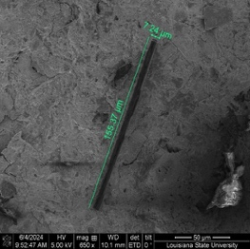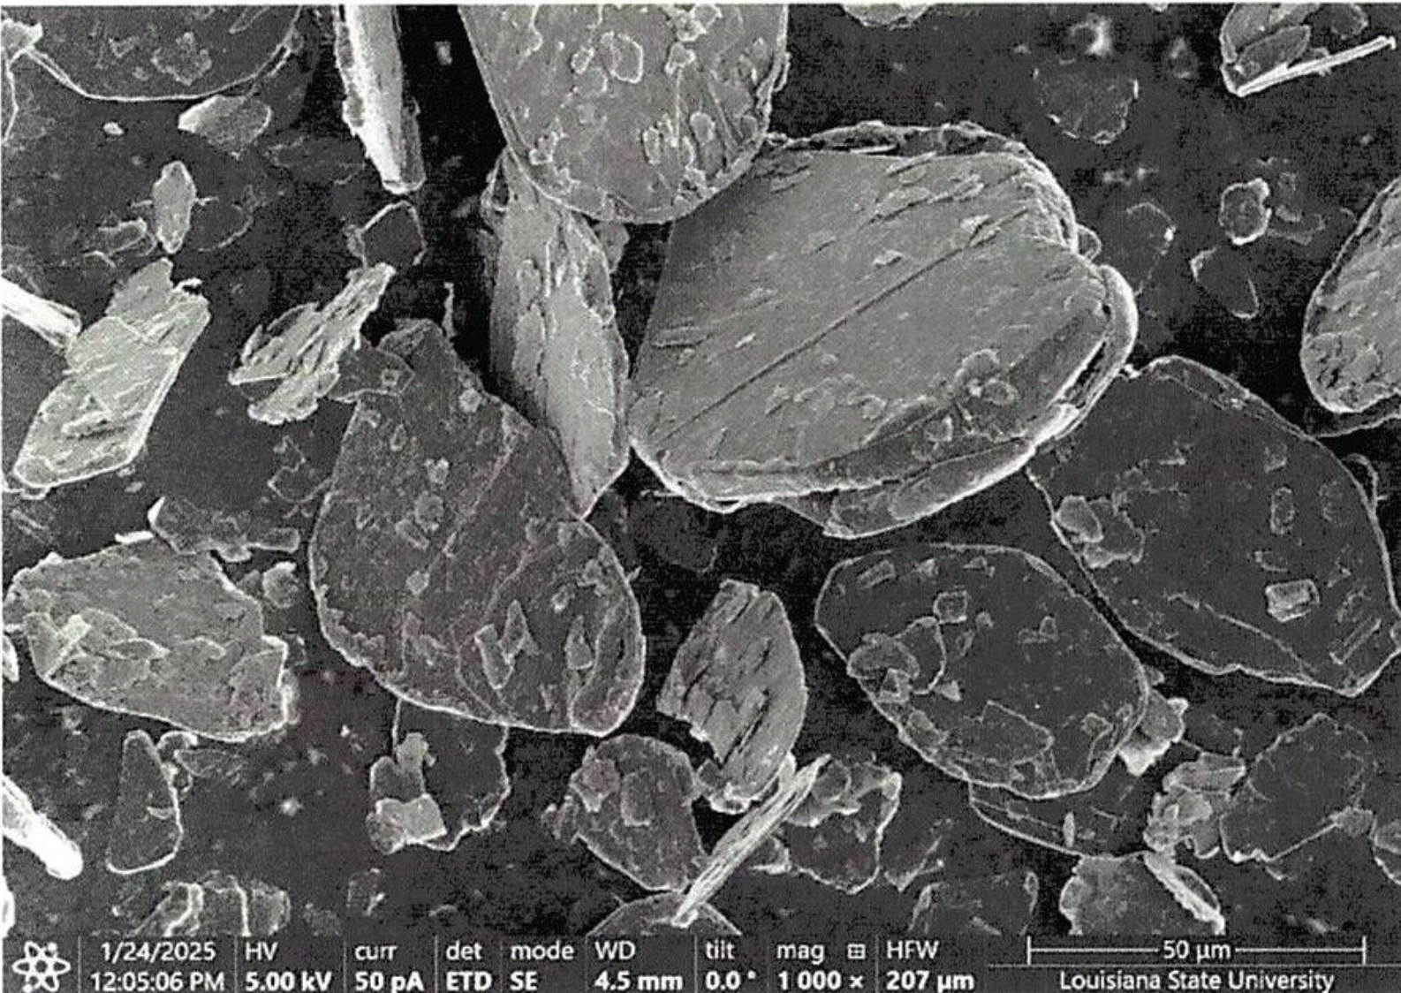

**(b)**

**(a)**

The mix design of 3D printable cementitious mixes is presented in Table 1. To achieve a printable mix, a preliminary study was done. The parameters for an acceptable print were the extrudability and buildability. Extrudability is the term used to describe the constant flow of the material that is extruded from the nozzle of a 3D printer. Buildability is commonly used for the ability of mortar filaments to be stacked on top of each other. Figure 2. demonstrates some examples of the trial mixes that didn’t meet printing parameter requirements and the successful mix. To ensure the same printing properties after the addition of conductive fillers, the rheological properties of the successful print were evaluated. The dosage of binder to sand was kept as 1:1 to obtain a high-cohesion mortar mix that doesn’t result in any discontinuities during the printing process. To prevent the drying shrinkage and increase the cohesion of the mortar even further, OPC was replaced with silica fume at 20 wt%. Finally, to obtain the optimum mix design to satisfy the 3D printing needs, such as extrudability, buildability, and open time, W/C of 0.4 and a certain dosage of polycarboxylate ether (PCE)-based superplasticizer were incorporated. The dosage of conductive filler incorporated is also a critical parameter in the self-sensing concrete. When the electrically conductive fiber or particles are used in the optimal dosage, a significant decrease in the resistivity of the cementitious composite is observed. There is considerable research on the effect of the different dosages of carbon-based fillers. The ideal content of conductive fillers in self-sensing concrete is also influenced by their resistivity and aspect ratio. Based on the reports on the effect of different conductive fillers with comparable properties, the ideal dosage of milled CF in cementitious composite seemed to be 0.1%-1%. The W/B Once the range for the dosage of milled CF was finalized, a preliminary study on the feasible dosage of PG was done. The upper threshold for the PG dosage was its effect on workability. The effect of milled CF and PG on the mix was evaluated using a flow table. It is revealed that both milled CF and PG had minimal effect of the fresh properties at the dosages used in this study.

|  |  |  |  |  |  |  |  |
| --- | --- | --- | --- | --- | --- | --- | --- |
| **Mix** | **OPC** | **Silica Fume** | **Sand** | **W/C** | **Filler Type** | **Superplasticizer** | **Filler Dosage\*** |
| R | 0.8 | 0.2 | 1 | 0.40 | - | PCE derivative | - |
| CF01 | Milled CF | 0.001 |
| CF05 | 0.005 |
| CF10 | 0.01 |
| PG005 | Pristine graphene | 0.005 |
| PG01 | 0.01 |
| PG02 | 0.2 |
| *\* By weight of cement*  **(a)**  **(b)**  **(c)** | | | | | | | |

Table 1. Weight-based mix design ratios

Figure . 3D printed shell that lacks a) buildability, b) extrudability, and c) sufficient buildability and extrudability

* 1. *Mechanical testing (Compressive and interfacial bond strength)*: 3, 7, and 28-day compressive strength is tested for triplicate mortar samples with the mix design discussed above. The compressive strength was tested in accordance with ASTM C109 [13]. Interfacial bond strength is aimed to be tested 28 days after casting. Compressive strength test results are illustrated in Figure 3 (a). The addition of milled CF at 0.5 wt% seems to have improved the compressive strength at all the ages that are measured. The effect of milled CF was minimal at 0.1 wt%, whereas its effect at 1% was significant. At 1%, it resulted in a decrease in the compressive strength. The highest compressive strength was when pristine graphene was used at 1%. However, once this dosage threshold was exceeded, the compressive strength had a downward trend. It is postulated that the higher dosages of the conductive fillers might have caused agglomeration in the mix. These agglomerations could have led to stress concentrations that negatively affect the mechanical properties. The increase of PG from 0.1 wt% to 0.2 wt%, caused the 28-day compressive strength to drop from 5372 psi to 3778 psi. Similarly, for milled CF, the increase from 0.5 wt% to 1% resulted in the 28-day compressive strength decreasing from 5099 psi to 3625 psi.

Figure 3. a) Compressive strength and b) interfacial bond strength of cementitious mixes.

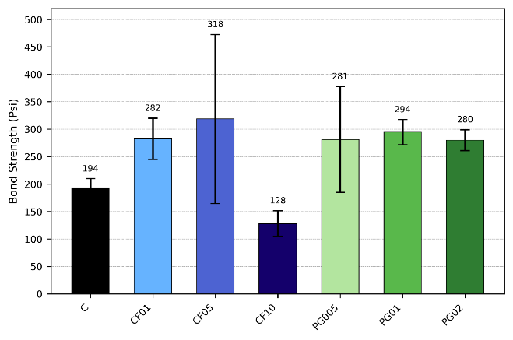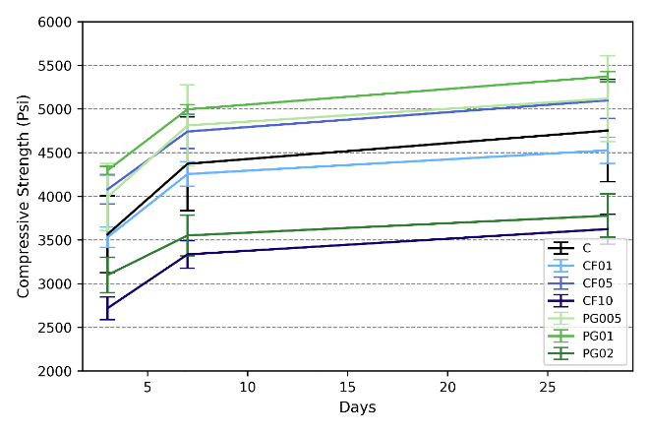

(a)

(b)

One of the choke points limiting the wider application of 3D printing technology in cementitious materials is its anisotropy in the mechanical properties. This is especially significant in the interlayer bond strength. To this end, the effect of filler materials on the bond strength was also evaluated. The interlayer bond strength was evaluated according to the ASTM C1583 standard [14]. Figure 3 (b) illustrates the bond strength measured after 28 days of curing. The bond strength ranged between 128 psi for the CF10 and 318 psi for the CF05. The addition of fillers, similar to compressive strength, increased the bond strength. Its effect was more prominent with milled CF than PG. The bond strength was increased by more than 50% with the addition of 0.5 wt% milled CF compared to the control mix. PG showed a similar effect at all the dosages.

* 1. Sensing performance quantification

Piezoresistivity-based self-sensing measurement is performed on the 2”x2” cubic mortar samples. The self-sensing performance of different dosages and conductive filler types is gauged. The piezoresistive property of the cementitious composites is quantified through the resistivity, fractional change in resistivity (FCR), and stress sensitivity (SS). Furthermore, the stability of the recorded electrical signals is evaluated by calculating an index “repeatability”. A constant current of 1 mA was applied to the 4-electrode cubic samples. The change in voltage was measured via a potentiometer. First, the resistance was calculated from the current and voltage using Ohm’s law, then the inherent resistivity of the material was derived by including the cross-sectional area (A) and the length between the electrodes (L). FCR is a unitless value obtained from the initial resistivity () and the impedance at a given load () as Equation (1). Stress sensitivity (SS) is obtained via the ratio FCR per applied stress (Equation 2). The stress applied in this study is a compressive cyclic loading that constitutes 20% of f’c, which amounts to 1000 psi. Repeatability, which is a measure of the stability of stress sensitivity through applied cycles, is calculated using Equation 3. Equation 4. shows the gauge factor (GF), which is another metric used for presenting the sensitivity of the self-sensing material. Contrary to SS, it is based on strain instead of stress.

|  |  |
| --- | --- |
| (1) | (2) |
| (3) | (4) |

Figure 4. demonstrates the applied loading regime and the electrical response provided by various SSCCs. The trend of the FCR curve matching the change in loading is a sign of a reliable self-sensing of the mechanical stress. The addition of the conductive fillers to the mortar mix seems to have improved the correlation between FCR and stress, as well as increased the peak FCR. The highest FCR of 10.9 %/ksi was measured in the CF05 mix. The further increase in the milled CF content did not improve the sensitivity. Furthermore, in the PG mixes, the trend of FCR didn’t closely follow the loading pattern until a critical dosage of 0.2 wt% was reached. A commonality in the CF01, CF10, and PG005 is that although the increase in the loading resulted in a change of resistivity, the change in resistivity was not linear at all points. However, both CF05 and PG02 show a consistent change in resistivity.

Figure . Fractional change in resistivity (FCR) measured from the application of direct current under cyclic loading.

Figure 5. presents the self-sensing index “Stress Sensitivity” and “Repeatability”. The highest stress sensitivity of 5.8 %/ksi was detected in the CF05 mixes. Although PG mixes corresponded to lower stress sensitivities, the repeatability in CF05 and PG02 was above 90%. It is important that the sensitivity, the consistency of the change in resistivity, and the indicators of a reliable stress-sensing. The gradual decline or increase in the resistivity that is observed might be due to a number of factors. First that comes to mind is polarization. However, this gradual change in the reference resistivity was not as prominent in some of the mixes. Therefore, we presume that it is related to the formation of a wide network that allows for the transfer of electrons in the mix.

Figure . Stress sensitivity and repeatability of SSCCs.

**Task 2: Specimen fabrication and determining the preliminary SSCCs placement & Task 3: Load Testing and strain monitoring**

Based on the self-sensing performance of the milled CF and PG containing mixes, CF05 was selected as the SSCC sensor for this step. For the fabrication of cylindrical shells, an SSCC mix and a control mix that didn’t include any conductive fillers were used. 4 configurations for the placement of the SSCC was taken into consideration (Figure 6). Color green and grey represent the SSCC mix and control mix, respectively. M-0 and M-1 were fabricated using 6”x12” conventional molds. P-0 and P-1 are 3D printed, the latter using SSCC mix. The shells were used as permanent molds and filled with the control mix 24 hours after printing. The compressive loading was applied after 28 days of curing.

Figure 6. demonstrates the electrical response of different configurations to the mechanical loading. The y-axis on the left shows the FCR, while the right shows the magnitude of the load. The effect of the SSCC mix emerges as the correlation of FCR with load in both M-1 and P-1. Whereas there is no clear association observed in M-0 and P-0. Furthermore, no gauge factor (GF) could be measured in these 2 configurations. For M-1 and P-1, on the other hand, GFs of 2.49 and 10.00 were calculated, respectively. Therefore, the fabrication of structural components through additive manufacturing can result in a more robust self-sensitivity. The mechanism that shifted piezoresistivity in this case might be the smaller area for the cross-section of the conductive path formed in the SSCC shell. It is also possible that the change in the interlayer pore structure caused by additive manufacturing might allow for an easier transfer of electrons, thus the higher GF in P-1.

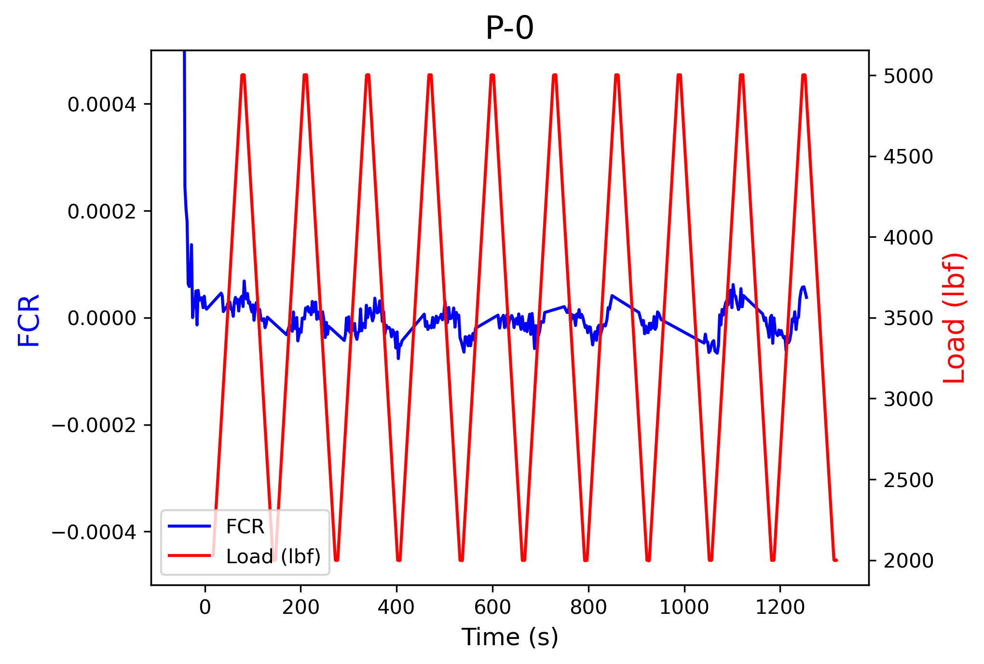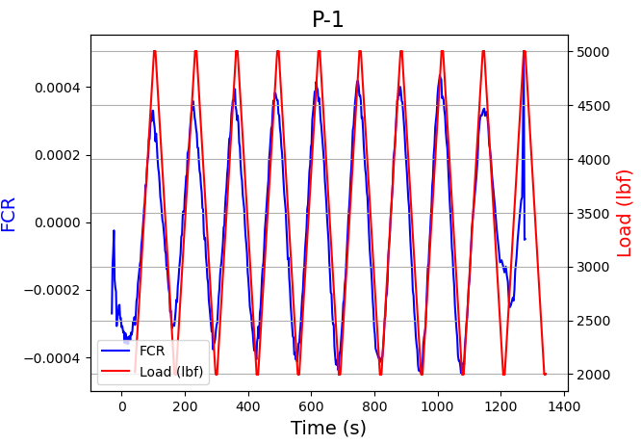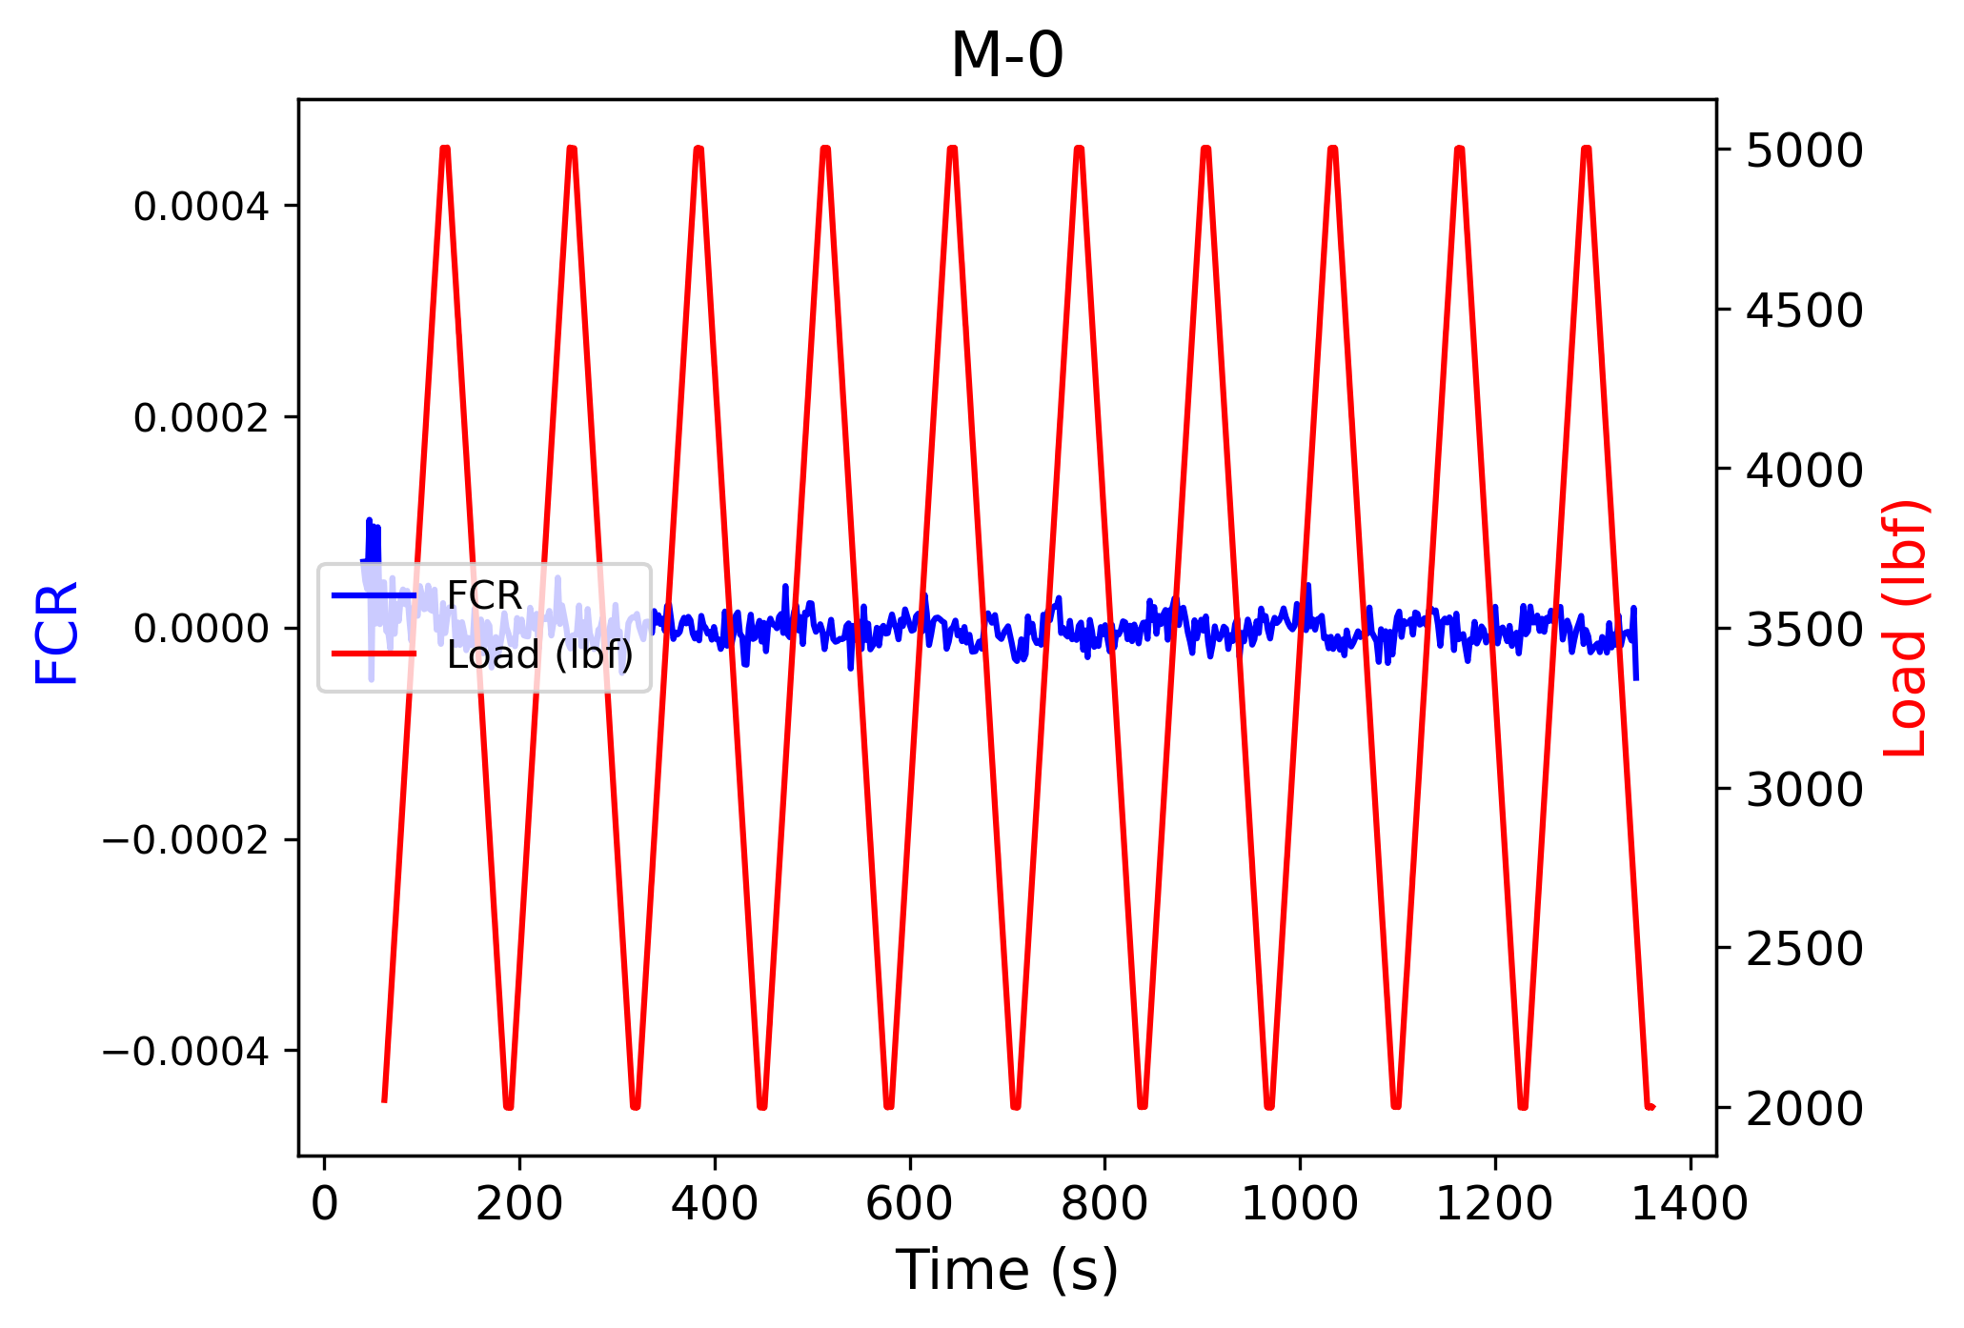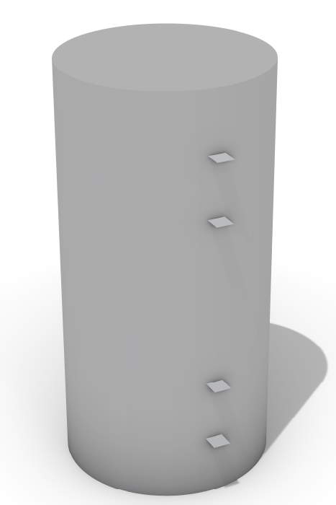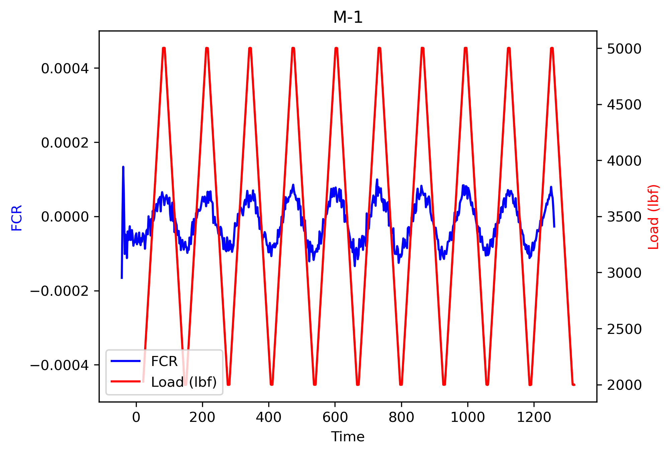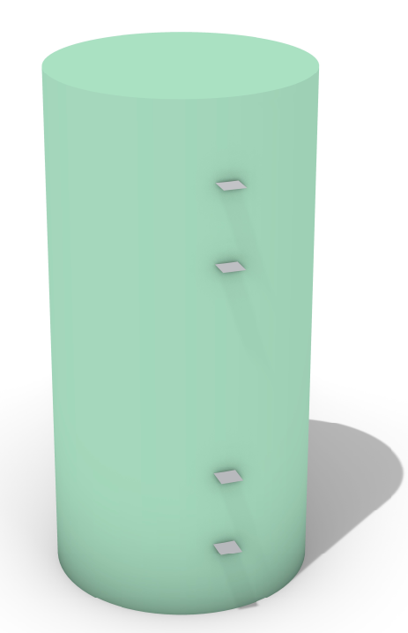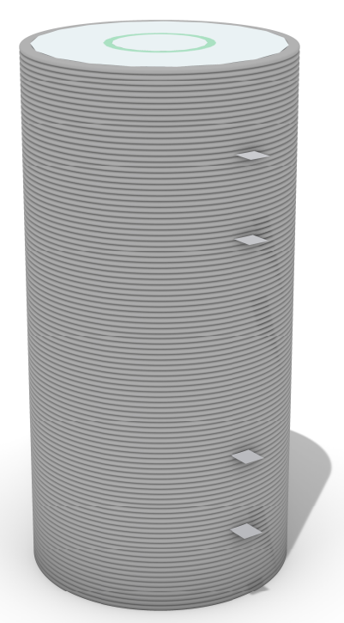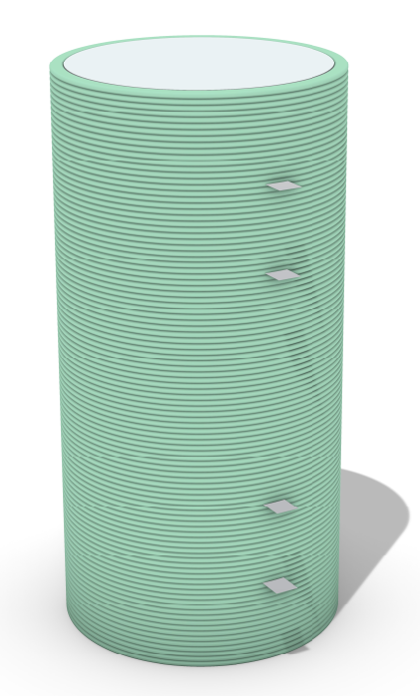

Figure . Piezoresistive response of conventional mold casted and 3D printed cylinders.

***Task 4:* Construct Preliminary Multiphysics Model**

A preliminary Multiphysics model has been developed using COMSOL Multiphysics simulation software. The Electric currents and the Solid Mechanics interfaces were employed to simulate the self-sensing behavior of concrete. The specimens were modeled as 2×2×2 in3 cubes. For the initial model, concrete was assigned an elastic modulus of 25 GPa and a Poisson’s ratio of 0.2. To simulate the self-sensing behavior, electric conductivity was defined using two models:

Exponential model: (5)

where *σ0* is the base conductivity which is equal to 0.01 S/m in this initial model. The *k* is the piezoresistive constant which is equal to 500 and *Ɛ* is the strain.

Vipulanandan p-q model: (6)

where base conductivity is the same as Eq. 1. The *p* is the sensitivity coefficient equal to 100 and *q*, which is 5000, controls the degree of nonlinearity.

A relative permittivity of 1 was used in both models. A 1 V potential was applied to the specimen. The bottom face was fixed, and a cyclic load was applied to the top face, defined by:

(7)

where the amplitude, *F0* was 10 kN and frequency, *f* was 1 Hz. The t represents the time.

Figure 7 shows the variation of strain, resistance and FRC over time, as obtained from both exponential and Vipulanandan p-q models.

Figure 7. Strains, Resistance and FRC obtained from Multiphysics simulation

As the next step, the model will be refined to incorporate experimental loading conditions and electrode configuration. The self-sensing simulation models will be further explored.

1. Percent of research project completed

*Task 1: Material properties assessment (100% complete)*

*Task 2: Specimen fabrication and determining the preliminary SSCCs placement (80% complete)*

*Task 3: Load Testing and strain monitoring (15% complete)*

*Task 4: Construct preliminary Multiphysics model (15% complete)*

1. Expected progress for next quarter

For the next quarter, 3D printing of more permanent formwork with different configurations will be completed. Piezoresistivity under monotonic and cyclic loading will be applied and strain monitoring will be performed using DIC. A refined Multiphysics model will be developed.

1. Educational outreach and workforce development

Mentoring one high school student on the high school summer research program this summer.

1. Technology Transfer

*None*

**Research Contribution:**

1. Papers that include TRANS-IPIC UTC in the acknowledgments section:

*None.*

1. Presentations and Posters of TRANS-IPIC funded research: *(G: graduate student)*
   1. **Y.-F. Su,** K. TajG, “Innovative Self-Sensing Cementitious Composites for Future Adaptive Transportation Infrastructure” *2025 Louisiana Transportation Conference, Baton Rouge, LA, USA, 2025* (Invited Talk)
   2. M. RamanchaG, M. PasbaniG, K. TajG, **Y.-F. Su,** A. Okeil,“Optimization of Self-Sensible Louisiana Sourced Ultra-High Performance Concrete: Balancing Mechanical Strength, Piezoresistivity, and Cost with Hybrid Fiber Reinforcement”**,** *2025 Louisiana Transportation Conference, Baton Rouge, LA, USA, 2025*
   3. K. TajG, **Y.-F. Su**, “Durability Investigation of Sustainable Smart Cementitious Composites” *2025 Louisiana Transportation Conference, Baton Rouge, LA, USA, 2025*
2. Please list any other events or activities that highlights the work of TRANS-IPIC occurring at your university (please include any pictures or figures you may have). Similarly, please list any references to TRANS-IPIC in the news or interviews from your research.

*None.*

**Appendix 1**: Research Activities, leadership, and awards (cumulative, since the start of the project)

1. Number of presentations at academic and industry conferences and workshops of UTC findings

* No. = 3

1. Number of peer-reviewed publications submitted based on outcomes of UTC funded projects

* No. = 1

1. Number of peer-reviewed journal articles published by faculty.

* No. = 0

1. Number of peer-reviewed conference papers published by faculty.

* No. = 0

1. Number of TRANS-IPIC sponsored thesis or dissertations at the MS and PhD levels.

* No. MS thesis = 0
* No. PhD dissertations = 0
* No. citations of each of the above = 0

1. Number of research tools (lab equipment, models, software, test processes, etc.) developed as part of TRANS-IPIC sponsored research

None

1. Number of transportation-related professional and service organization committees that TRANS-IPIC faculty researchers participate in or lead.

* Professional societies
  + No. participated in =2
  + No. lead =0
* Advisory committees (No. participated in & No. led)
  + No. participated in =0
  + No. lead =0
* Conference Organizing Committees (No. participated in & No. led)
  + No. participated in = 3
  + No. lead =0
* Editorial board of journals (No. participated in & No. led)
  + No. participated in =0
  + No. lead =0
* TRB committees (No. participated in & No. led)
  + No. participated in = 0
  + No. lead = 0

1. Number of relevant awards received during the grant year

* No. awards received = 0

1. Number of transportation related classes developed or modified as a result of TRANS-IPIC funding.

* No. Undergraduate = 2
* No. Graduate = 2

1. Number of internships and full-time positions secured in the industry and government during the grant year.

* No. of internships = 0
* No. of full-time positions = 0

**References:**

[1] L. Wang and F. Aslani, “Structural performance of reinforced concrete beams with 3D printed cement-based sensor embedded and self-sensing cementitious composites,” *Eng. Struct.*, vol. 275, no. 115266, p. 115266, Jan. 2023.

[2] W. Tian *et al.*, “Electrical performance of conductive cementitious composites under different curing regimes: Enhanced conduction by carbon fibers towards self-sensing function,” *Constr. Build. Mater.*, vol. 421, no. 135771, p. 135771, Mar. 2024.

[3] F. Azhari and N. Banthia, “Cement-based sensors with carbon fibers and carbon nanotubes for piezoresistive sensing,” *Cem. Concr. Compos.*, vol. 34, no. 7, pp. 866–873, Aug. 2012.

[4] A. Belli, A. Mobili, T. Bellezze, F. Tittarelli, and P. Cachim, “Evaluating the self-sensing ability of cement mortars manufactured with graphene nanoplatelets, virgin or recycled carbon fibers through piezoresistivity tests,” *Sustainability*, vol. 10, no. 11, p. 4013, Nov. 2018.

[5] T. Luo, Y. Ma, H. Xie, F. Li, Z. Li, and J. Fu, “Piezoresistivity of carbon fiber-reinforced alkali-activated materials: Effect of fly ash microspheres and quartz sands,” *Constr. Build. Mater.*, vol. 425, no. 136125, p. 136125, Apr. 2024.

[6] A. D’Alessandro, H. B. Birgin, and F. Ubertini, “Carbon microfiber-doped smart concrete sensors for strain monitoring in reinforced concrete structures: An experimental study at various scales,” *Sensors (Basel)*, vol. 22, no. 16, p. 6083, Aug. 2022.

[7] Y. Ma *et al.*, “Self-sensing properties of alkali-activated materials prepared with different precursors,” *Constr. Build. Mater.*, vol. 409, no. 134201, p. 134201, Dec. 2023.

[8] J. Zhang *et al.*, “Piezoresistivity and piezopermittivity of cement-based sensors under quasi-static stress and changing moisture,” *Constr. Build. Mater.*, vol. 425, no. 136052, p. 136052, Apr. 2024.

[9] X. Fan, D. Fang, M. Sun, and Z. Li, “Piezoresistivity of carbon fiber graphite cement-based composites with CCCW,” *J. Wuhan Univ. Technol. (Mater. Sci. Ed.)*, vol. 26, no. 2, pp. 339–343, Apr. 2011.

[10] J. Han, J. Pan, and J. Cai, “Self-sensing properties and piezoresistive effect of high ductility cementitious composite,” *Constr. Build. Mater.*, vol. 323, no. 126390, p. 126390, Mar. 2022.

[11] H. Ran, M. Elchalakani, F. Boussaid, S. Yehia, M. A. Sadakkathulla, and B. Yang, “Development and evaluation of conductive ultra-lightweight cementitious composites for smart and sustainable infrastructure applications,” *Constr. Build. Mater.*, vol. 375, no. 131017, p. 131017, Apr. 2023.

[12] F. J. Baeza, O. Galao, I. J. Vegas, M. Cano, and P. Garcés, “Influence of recycled slag aggregates on the conductivity and strain sensing capacity of carbon fiber reinforced cement mortars,” *Constr. Build. Mater.*, vol. 184, pp. 311–319, Sep. 2018.

[13] “ASTM C109/C109M-21. Standard Test Method for Compressive Strength of Hydraulic Cement Mortars (using 2-in. Or [50mm] cube specimens),” ASTM International, West Conshohocken, PA, 2021.

[14] “Standard Test Method for Tensile Strength of Concrete Surfaces and the Bond Strength or Tensile Strength of Concrete Repair and Overlay Materials by Direct Tension (Pull-off Method).” [Online]. Available: https://store.astm.org/c1583-04.html. [Accessed: 22-Jun-2025].