Mining Activity
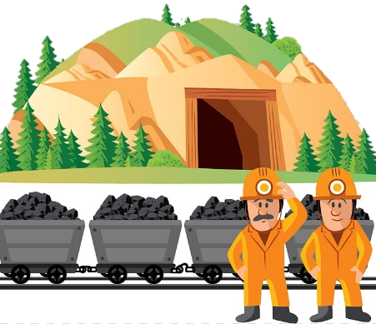
Welcome to the mines! Today we need your help to find the raw materials to make our plastic.
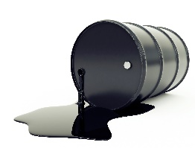
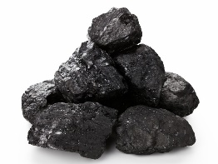
What do you need to do?
- Search for the raw materials inside your tray of rocks
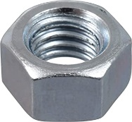
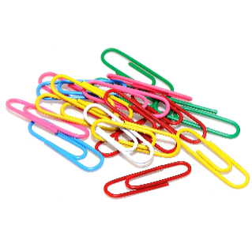
  - Coal (bolts)
COAL OIL
  - Oil (paperclips)
- Keep the bolts and paperclips you find in your own pile
How much “raw material” did we mine all together?
Use the scales to weigh each miner’s mixed pile of coal and oil. Write down the actual weight and then round to the nearest gram!
Miner #1: actual:___________ rounded:___________grams
Miner #2: actual:___________ rounded:___________grams
Miner #3: actual:___________ rounded:___________grams
Miner #4: actual:___________ rounded:___________grams
Total: ____________grams

Separation Activity
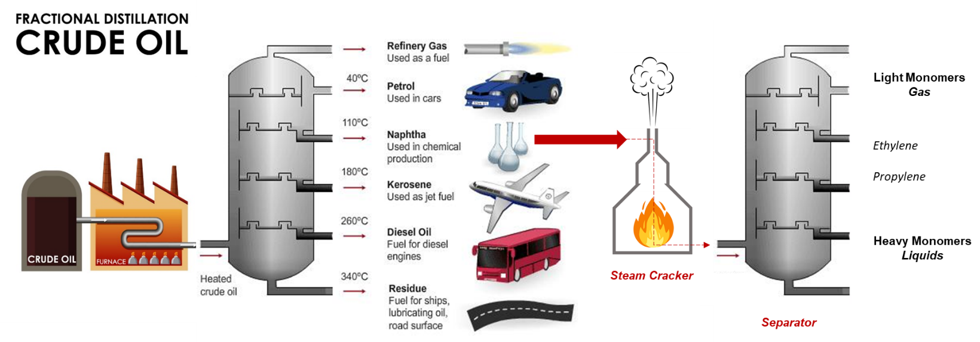
You have brought your crude oil and coal that you mined to the refinery. It is time to turn it into the building blocks (monomers) for our polymers!

What do you need to do?
- All the coal (bolts) can go together – so we can send it to the power plant
- All the crude oil (paper clips) needs to be separated into the different colors- these are our monomers
- Weigh each of the monomers
How much crude oil did we mine all together?
Use the scales to weigh each pile of the monomers
Monomer #1:color:________ number: _______ weight:____________grams
Monomer #2:color:________ number: _______ weight:____________grams
Monomer #3:color:________ number: _______ weight:____________grams
Monomer #4:color:________ number: _______ weight:____________grams
Monomer #5:color:________ number: _______ weight:____________grams
Monomer #6:color:________ number: _______ weight:____________grams
Monomer #7:color:________ number: _______ weight:____________grams
Monomer #8:color:________ number: _______ weight:____________grams
Total: ____________grams
BONUS: How much does one paperclip weigh?
Polymerization Activity
Now that we have all the refined building blocks (monomers), let’s make some polymers!

- First, let’s try linking these paperclips together as a bunch of chains.
- See if you can come up with different ways of linking paperclips other than a simple chain. Draw your original shapes here:

Molding and Extrusion Activity
You’ve brought your polymers to the molding and extrusion station.
Let’s make it into stuff we can use!

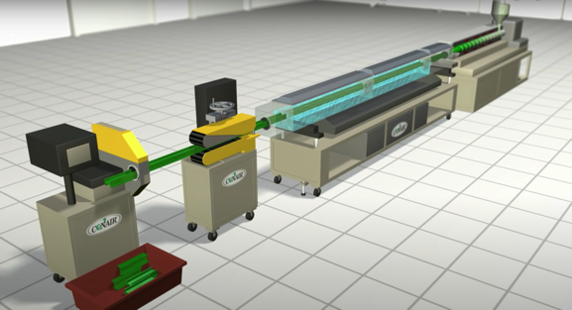
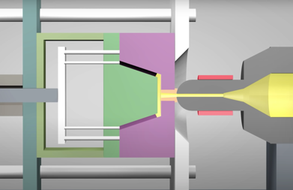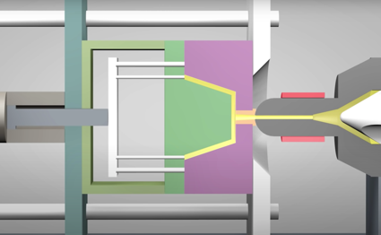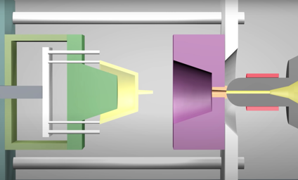
Mold is filled
Hopper
Pellets
Material is made into new item
Material in mold is cooled
Extrusion Unit
What do you need to do?
We must turn our polymer (Play-Doh) into shapes using our extrusion equipment!
Extrusion:
- Weigh out 50 grams of Play-Doh per person
- Split the 50g into 2 pieces, weigh each piece and mark it in the table below
- Push 1 piece out for each extruder (2)
- Weigh and inspect your final extruded item
Initial Piece | Piece 1 | Piece 2 | Extruded 1 | Extruded 2
Molding:
- Weigh out 50 grams of the material and split it into 5 pieces (as even as possible, but no need to be exact)!
- Fill one of your molds using the pieces available.
- Compare how many pieces for mold 1 and mold 2.
50÷5= ? | How many pieces for Mold 1? |  | How many pieces for Mold 2? |  | Difference in pieces for mold 1 and 2?
 | Guess | Actual | Guess | Actual
Did the amount you put in match your final product?

