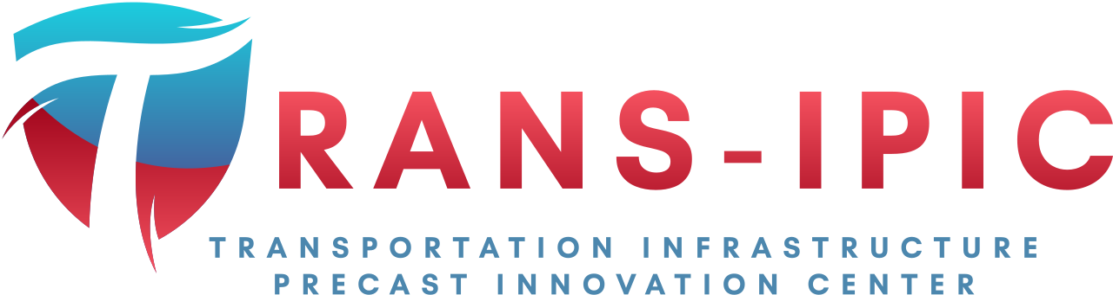

Transportation Infrastructure Precast Innovation Center
(TRANS-IPIC)

University Transportation Center (UTC)

Design and Implementation of Digital Twin Models for Continuous Monitoring and Performance Prediction of Precast Concrete Bridges
UI-23-RP-03

Quarterly Progress Report
For the performance period ending 06/30/2024

Submitted by:
Volodymyr Kindratenko, kindrtnk@illinois.edu
National Center for Supercomputing Applications (NCSA)
University of Illinois at Urbana-Champaign

Bassem Andrawes, andrawes@illinois.edu
Department of Civil and Environmental Engineering
University of Illinois at Urbana-Champaign

Collaborators / Partners:
N/A

Submitted to:
TRANS-IPIC UTC
University of Illinois Urbana-Champaign
Urbana, IL

TRANS-IPIC Quarterly Progress Report:

Project Description:
- Research Plan - Statement of Problem

This research project aims to design and validate a digital twin model of a precast concrete bridge structure, subsequently integrating this model with sensor data derived from a real-world bridge. This integration will serve as the foundation for driving the simulation and analysis of the bridge model. The digital twin model will be constructed utilizing NVIDIA Omniverse, an innovative platform that facilitates the creation of collaborative and immersive 3D objects, equipped with real-time simulation capabilities.

- Research Plan - Summary of Project Activities (Tasks)

Task 1: Digital Model Development: We explore how to use technical drawings and the design and inspection data that may exist for the bridge itself or the precast parts used in its construction in order to rapidly implement a digital twin model. The outcome of this task is a methodology for rapidly prototyping a 3D model of a PC bridge based on the above-mentioned sources of initial information.

Task 2: Digital Model Implementation: We will study how NVIDIA Omniverse platform for digital twins operates and how to build new models within the platform’s capabilities, including linking it with external data sources. The outcome of this task is a PC bridge twin model implemented in NVIDIA Omniverse environment.

Task 3: Bridge Simulation using Real-Time Data: Our goal is to enable ingesting real-time data from a specific PC bridge to be incorporated with the digital twin model as well as any readily available environmental data, such as weather, traffic, any imagery. Such data will be used to model the bridge performance and predict its response to different usage conditions. The outcome of this task will be a data-driven digital twin model of a PC bridge updated each time new data about the bridge is available.

Project Progress:
- Progress for each research task

Task 1 progress [100% completed]

We implemented a virtual laboratory environment in Omniverse that resembles the actual physical settings at the Newmark Structural Engineering Laboratory. We use this virtual laboratory Omniverse environment to reproduce the experiment on a new test beam (a 533mm x914 mm IDOT PPC deck girder beam with a span of 15.24m span length) under four-point bending test carried out by Prof. Andrawes’ team.

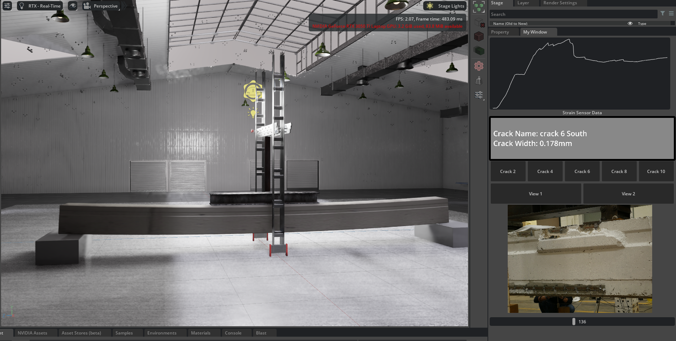
Figure 1. Virtual laboratory and playback of the experiment.

Task 2 progress [75% completed]:

We utilized Blender software to export the beam model and construct the virtual laboratory and actuator within the Omniverse platform. The experiment data is then linked to the digital twin model. Our developed extension facilitates the visualization of the beam under test and displays the strain and crack data in real-time during the experiment.

We implemented an Omniverse extension to replay the experiment in the Omniverse Platform. This extension includes a slider that represents the experiment’s timeline. Users can interact with this slider, moving it left or right, to retrospectively examine the experiment data, images, and bending of the beam within Omniverse. This feature provides engineers with a convenient method to conduct a post-analysis of the entire beam testing process.

Task 3 progress [50% completed]:

We have developed an extension in Omniverse that showcases bridge cracks in detail. Users can select a specific crack of interest, and the extension will display information about that crack and any nearby strain gauges in a dedicated panel. Additionally, by manipulating the slider bar, users can visualize the formation and progression of cracks throughout the experiment, offering a dynamic view of the structural behavior.

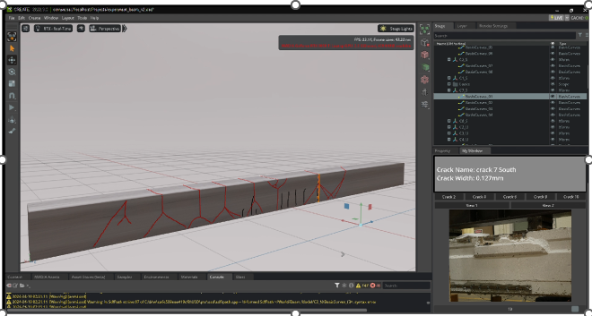
Figure 2. Crack visualization and analysis interface.

In addition to connecting Omniverse with the data from an actual lab experiment in the lab, we investigated how to connect the data produced through the Finite Element Analysis (FEA) modeling and simulation tools. In particular, we have implemented a beam in FEA tool Abaqus, and the geometry and simulation results are exported to ParaView software. This software provides an extension for Omniverse Platform to export and collaborate on simulation geometry. Through that, we could build more detailed digital model of the beam. We expect this to lead to a more accurate bending model visualization in Omniverse.

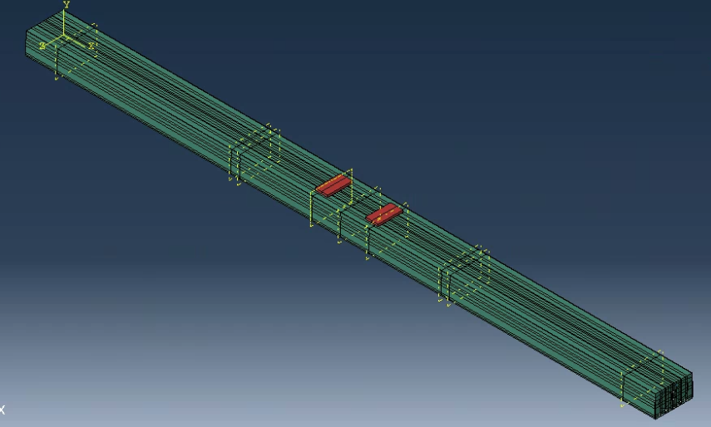
Figure 3. Rebar and Strand Layout for FEA.

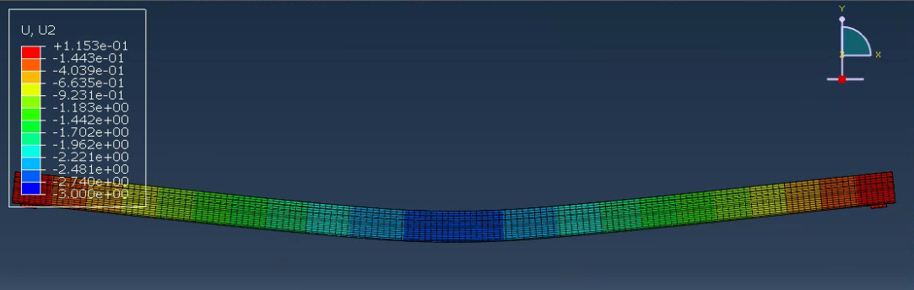
Figure 4. Displacement Results from FEA.

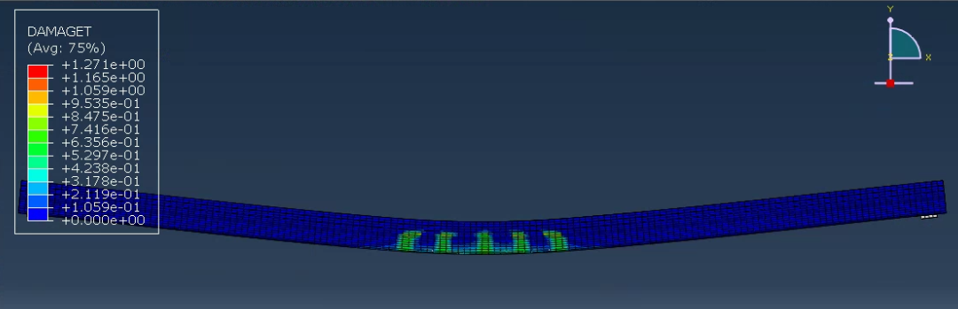
Figure 5. Damage Result from FEA.

- Percent of research project completed

75%

- Expected progress for next quarter

We will continue to add the necessary functionality needed to implement the original vision of this project. Specific focus is on the integration of observed and simulated data and its accurate reflection in the Omniverse environment.

- Educational outreach and workforce development

This work inspired a summer project as part of the NCSA REU program in which two students from underrepresented in science and engineering communities work on the development of a machine learning model for crack segmentation using publicly available datasets. The students undergone training in machine learning and are working towards developing a method for automatically extracting cracks from images of concrete structures.

- Technology Transfer

None

Research Contribution:
- Papers that include TRANS-IPIC UTC in the acknowledgments section:

An abstract was submitted to the ASCE Structures Congress.

- Presentations and Posters of TRANS-IPIC funded research:

The team presented at the 2024 TRANS-IPIC Annual Workshop and at the NCSA Annual Student Research Conference:

Wentao Yao, Dachina Gunasekaran, Tasho Madondo, Hyunwoo Kwon, Arslan Khan, Volodymyr Kindratenko, Bassem Andrawes, Design and Implementation of Digital Twin Models for Continuous Monitoring and Performance Prediction of Precast Concrete Bridges, 2024 TRANS-IPIC Annual Workshop, Chicago, IL, April 2024.

Wentao Yao, Dachina Gunasekaran, Tasho Madondo, Hyunwoo Kwon, Arslan Khan, Volodymyr Kindratenko, Bassem Andrawes, Design and Implementation of Digital Twin Models for Continuous Monitoring and Performance Prediction of Precast Concrete Bridges, 2024 NCSA Annual Student Research Conference, Urbana, IL, April 2024.

- Please list any other events or activities that highlights the work of TRANS-IPIC occurring at your university (please include any pictures or figures you may have). Similarly, please list any references to TRANS-IPIC in the news or interviews from your research.

None

References:

None

