

Transportation Infrastructure Precast Innovation Center
(TRANS-IPIC)

University Transportation Center (UTC)

3D Printed Advanced Materials to Mitigate Prestressed Concrete Girder End Cracks
UB-23-RP-02

Quarterly Progress Report
For the performance period ending June 30, 2024

Submitted by:
Ravi Ranade, Associate Professor, ranade@buffalo.edu
Department of Civil, Structural and Environmental Engineering
University at Buffalo

Co-PIs: Chi Zhou (chizhou@buffalo.edu) and Pinar Okumus (pinaroku@buffalo.edu), University at Buffalo

Collaborators / Partners:
None

Submitted to:
TRANS-IPIC UTC
University of Illinois Urbana-Champaign
Urbana, IL

TRANS-IPIC Quarterly Progress Report:

Project Description:
- Research Plan - Statement of Problem
Precast-prestressed concrete bridge girders are susceptible to cracking at their ends [1]. Release of large prestress forces within a short distance causes high tensile strains in concrete at the girder ends. This combined with the brittleness and low tensile strain capacity of conventional concrete lead to end cracking. This is a major concern for bridge owners as these cracks, especially those near the bottom of the beam that do not close under live load, could facilitate rapid chloride penetration and lead to corrosion of the prestressing strands and deterioration of the girder’s load capacity.

The specific objectives of this one-year project are as follows:
- To investigate the feasibility of using strain-hardening cementitious composites (SHCC) shells for mitigating end cracking in precast-prestressed concrete beams
- To develop a 3D-printable SHCC and appropriate printing parameters for the above application
- To understand the level of composite action between SHCC shells and conventional concrete.

- Research Plan - Summary of Project Activities (Tasks)
The following research tasks will be performed to meet the objectives of this study:

Task 1: Numerical simulation of pretensioned beams with SHCC shells at the end zone: Building upon the investigators’ experience with simulations of precast-pretensioned concrete girder ends [1-4], numerical models of girders with SHCC shells will be developed. The properties of a base SHCC will be used as input in these models. The models will be used to gain insights into the tensile strain distributions at the end zone and to understand how various parameters, such as shell thickness, strand placement, beam cross-section, and material tensile ductility impact end cracking. The results will inform the SHCC material development and shell design.

Task 2.1: Determination of target material properties for a printable SHCC: Targets for material properties needed for enabling 3D printing, such as viscosity, yield stress, storage moduli and loss moduli, extrudability, buildability, and shape retention ability, will be determined hand-in-hand with Task 1 using an extrusion printer to achieve optimal printing of SHCC shells. Computational fluid dynamics modeling and rheological characterization will be conducted to study the printability of SHCC. Based on past research, mechanical property targets for printable SHCC will be tensile strain capacity of at least 1% and compressive strength of at least 55 MPa.

Task 2.2: Trial mix designs: A two-prong approach will be used to develop trial mix designs. First, using the base SHCC as the starting point, material ingredients will be altered based on investigators’ experience and understanding of the effects of ingredients on each of the material properties described in task 2.1. Second, mix designs will be generated using first principles, such as particle packing, porosity-strength relationships, and effects of aggregate/paste ratio on various material properties. Approximately 4-6 convergent mix designs from these two methods will be developed for further analysis.

Task 2.3: Fresh and hardened properties testing and shortlisting of mix designs: Trial batches of the mixtures developed in the previous task will be prepared. A variety of fresh and hardened property tests will be conducted to determine which mix designs meet the targets set in task 2.1. Sample SHCC shells will be printed with the best-performing 1-2 mixtures to evaluate/verify their printability.

Task 2.4: Mixture refinement: Some iterative changes to the ingredient proportions may be needed to fine-tune the mix. This task might involve repeating a few steps performed in previous tasks.

Task 3.1: Preparation of composite beam specimens with 3D-printed SHCC shells: SHCC shells will be 3D-printed and composite beam specimens will be prepared to understand constructability of a composite beam. These non-prestressed beams will be composed of a small-scale rectangular beam and a similar sized I-shaped beam. They will be reinforced using mild reinforcement.

Task 3.2: Testing of beams under mechanical loading: Reinforced beam specimens prepared in task 3.1, as well as control specimens, will be evaluated under 3-point bending. Control specimens will be composed of monolithically cast beams that are identical to the ones in task 3.1 but made without the SHCC shells, and beams that have mold-cast (not 3-D printed) SHCC shells. The goal of these tests is to understand the level of composite action that can be developed between the SHCC and conventional concrete layers, and to compare 3-D printed SHCC shells to mold-cast SHCC shells.

Project Progress:

- Progress for each research task
Task 1 - 100% completed

Task 1 was aimed at numerically simulating a prestressed concrete bridge girder to understand the effect of the printed cover's material properties and structural parameters on the end-cracking.

A non-linear finite element model was developed in software ABAQUS to perform numerical simulation of a prestressed-concrete girder. Appropriate material models for conventional concrete, SHCC, strands, and rebars were selected. Conventional concrete was modeled using the concrete damage plasticity model available in ABAQUS, SHCC was modeled using a trilinear model, and rebar and strands were modeled using bilinear models. Two-node linear 3d truss elements were adopted for strands and rebars. The concrete girder and SHCC cover were modeled using 4-node linear tetrahedron elements. Rebar and prestressing strands were embedded in the girder. The prestressing force was simulated through temperature strain applied to the strands. The interface between SHCC cover and concrete girder was modeled with tie constraints.

The structural design of the beam, including cross-section, prestressing force, and reinforcement detailing, was adopted from experiments performed by O'Callaghan and Bayrak [5]. A standard Tx70 girder was adopted for the numerical simulation. The element type and size in the numerical simulation were calibrated to match the transverse reinforcement strains observed by O'Callaghan and Bayrak [5] at the end zone of the concrete girder. Based on this calibration, a 50 mm element size was selected for numerical modeling. Subsequently, a 0.75” SHCC cover at the end zones was applied in the numerical model, keeping all other parameters constant. A representative finite element model and observed surface strain profile of the simulated girder end with SHCC cover are shown in Figure 1.

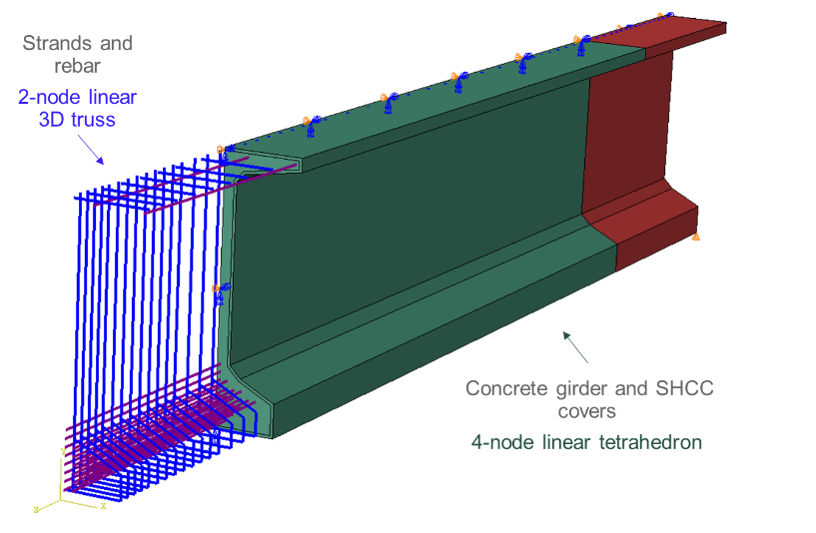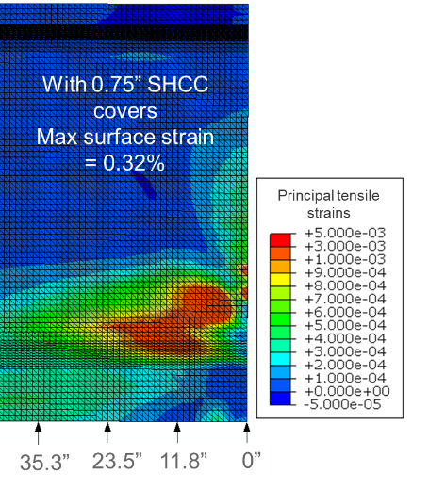
Figure 1. (a) Representative fine element model (b) Surface strain profile at girder end with SHCC cover

Thus, this task resulted in a non-linear finite element model of a prestressed-concrete girder, which was used later in Task 2.1 to determine the target material properties for SHCC covers. The developed numerical model provided crucial insights about the proposed method of using SHCC covers to mitigate end zone cracking. For instance, the maximum tensile strain on the surface of the girder was computed as 0.32%, which was used to determine the minimum tensile strain capacity of SHCC needed for this application.

Task 2.1 - 100% completed

Task 2.1 entailed determination of the target material properties needed for enabling 3D printing of SHCC cover for the prestressed girder application.

The performance requirements for SHCC were categorized into two groups-(i) Fresh state requirements, and (ii) Hardened state requirements. The fresh state requirements were established for the following five steps of material production and printing:
- Mixing: Mixing capacity, in terms of the maximum shear rate that the concrete mixer can apply, was considered for determining the target matrix viscosity needed for homogeneous fiber dispersion.
- Pumping (Pump): Rheological properties of SHCC mixture were tuned and appropriate pumping equipment (motor) was selected for enabling continuous pumping while preventing fiber clumping and segregation.
- Pumping (Pipe): Rheological properties of SHCC mixture were also adjusted and appropriate diameter and type of pipe were selected for preventing blockage and segregation in the pipe.
- Extrusion (Nozzle): Blockage at the nozzle and filament tear was minimized by controlling the material’s rheological properties and using a customized nozzle (printed separately by the investigators).
- Layering: Shape retention of layers was achieved by considering the setting characteristics and flow reduction rates of SHCC mixtures.
It was observed that the above steps require contrasting rheological characteristics. For example, a highly viscous mix is good for fiber dispersion, segregation prevention, and filament tearing prevention but it might cause issues in mixing and pumping due to the available equipment’s capacity limitations. High viscosity also increases the risk of blockage during pumping and extrusion. A flow table test (ASTM C1437) based on relative rheological characterization was implemented in this task due to its simplicity and strong correlation with materials yield stress and viscosity. The flow table test was used to determine two parameters: (i) Flowability factor and (ii) Flow reduction rate. Suitable ranges of these two parameters were identified for tailoring SHCC mixtures. Further details of the testing procedure are presented below under Task 2.3.

The target mechanical properties for SHCC in the hardened state for the given application included compressive strength and tensile strain capacity. As the compressive strength of conventional concrete used in bridge girders typically exceeds 6 ksi, the same value was used as the lower bound for the SHCC’s compressive strength. Based on the numerical model results of task 1, the minimum tensile strain capacity for the SHCC was 0.32%. However, a higher strain capacity of 0.6% was targeted to account for material variability.

Thus, the following requirements were identified in this task:

Fresh state requirements (flow table test):
- Flowability factor (slump diameter after 25 drops/original diameter) = 1.2 to 1.5; for the 0.76” or bigger nozzle size
- Flow reduction rate (average percentage decrease rate in flowability factor in first 30 min) > 20% per hour
Hardened state requirements:
- Compressive strength > 6ksi
- Tensile strain capacity > 0.4%
Task 2.2 - 100% completed

To achieve the above material properties, this task involved developing a suitable mixture composition for the 3d printable SHCC. An SHCC mixture, which has high tensile strain capacity but is non-printable, developed previously in PI’s lab was adopted as the baseline. Iterative modifications in the mix were performed as follows to make it 3d printable:

- Reduction in water/cementitious material (w/cm) weight ratio: The flow of the baseline SHCC mix was too high for 3d printing. Therefore, as the first step, the w/cm ratio was reduced from 0.38 (in the baseline mixture) to 0.31 to reduce the flow and enhance the compressive strength.
- Use of 8mm PVA fibers: The fiber length of polyvinyl alcohol (PVA) fibers was reduced from 12mm (in the baseline mixture) to 8mm to enhance the pumping and extrusion of the mix.
- Calibration of VMA and HRWRA: To achieve the target fresh state characteristics identified in task 2.1, the HRWRA and VMA amounts were calibrated. Sixteen combinations of VMA and HRWRA amounts were prepared and screened using the flowability factors and flow reduction rates. Out of these 16 combinations, for mixtures were found suitable for further optimization.
- Enhancement of thixotropic behavior: The mixtures selected in the previous step were further optimized to increase their flow reduction rate. Ingredients like micro silica, ground silica, and type III cement were incorporated into the mix, and the fresh state behavior was investigated. Based on the trials performed, three mixtures were selected for further evaluation. The details of these mixtures can be found in the conference paper referenced below.

The outcome of the task 2.2 is the SHCC mixture composition suitable for 3d printing applications.

Task 2.3 – 100% completed

Investigations of the fresh and hardened properties of the mixtures developed in the previous task were performed in task 2.3. This task was performed iteratively with tasks 2.1 and 2.2.

Fresh state testing protocol was developed using a caulking gun and flow table test to screen out non-printable and non-strain hardening SHCC mixtures. This screening was performed using the following qualitative and quantitative criteria:
- Fiber dispersion was checked by hand to determine if there was fiber clumping. The mixtures with observable fiber clumps were rejected.
- A grout caulking gun with a nozzle size of approximately 0.76” was employed to access the extrudability. Mixes that failed to extrude from this caulking gun were rejected.
- Buildability/shape retention: Multiple layers of material were built using a caulking gun. If a mix failed to take the weight of at least one layer over it, it was rejected.
- For relative quantification of the rheological behavior of the developed mix, a flow table test was conducted immediately after the mix was prepared and 30 minutes after the preparation of the mix to determine flow reduction with time.
- After each flow table test, the mixtures were observed for segregation/water bleeding, and the mixtures with observable segregation/water bleeding were rejected.
Hardened properties of the screened mixtures were performed. The hardened property tests included compressive strength (ASTM C109), direct tension test, and four-point bend tests (ASTM C78). After initial screening and optimization, three mixtures were selected (as described in task 2.2) for further evaluation. Table 1 summarizes the hardened properties of the three 3d printable SHCC mixtures (M9-MS, M9-IS, and M10).

Table 1. Hardened properties of 3d printable SHCC mixtures

Mix | Compressive strength |  | Tensile strength (Direct tension test) |  | Modulus of rupture  (4-point bend test)
 | Mean (ksi) | COV (%) | Mean (ksi) | COV (%) | Mean (ksi) | COV (%)
M9-IS | 7.5 | 5.6 | 0.8 | 19.0 | 1.5 | 12.5
M9-MS | 8.5 | 2.4 | 0.7 | 17.5 | 1.5 | 8.0
M10 | 8.2 | 5.6 | 0.9 | 15.1 | 1.3 | 8.4

Representative tensile stress-strain behaviors for mixtures M9-MS, M9-IS, and M10 are shown in Figure 2.

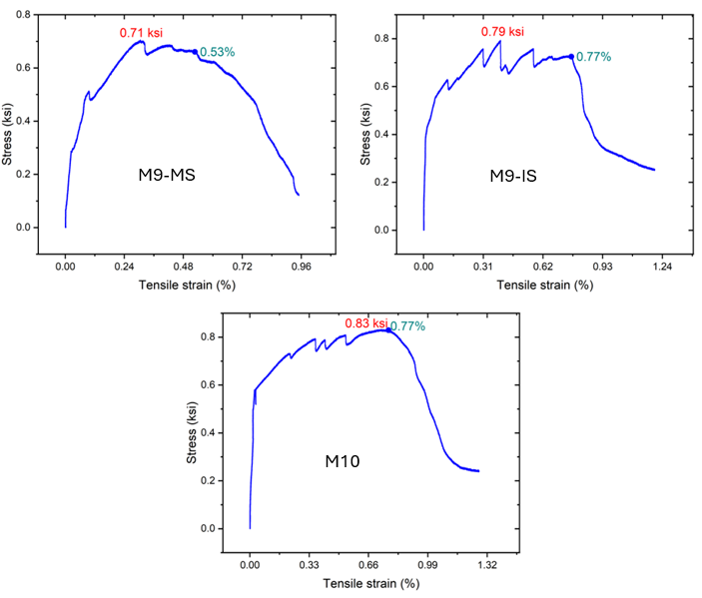
Figure 2. Stress-strain response of 3d printable SHCC mixtures under direct tension test.

Task 2.4 - 50% completed

This task of mixture refinement is ongoing. In this task, further modifications of the selected 3d printable mixtures are being performed to observe the effect of cement to-fly-ash ratio on 3d printability and strain hardening behavior. Six new mixture compositions (2 variations for each selected mix) have been developed by altering the cement to fly ash ratio, and specimens are being prepared for evaluating the hardened properties in the coming weeks.

Task 3.1 - 20% completed

This task is aimed at evaluating the performance of SHCC covers as permanent formwork in mitigating the surface cracks developed in conventional concrete beams. Currently, 3d printing trials for the SHCC covers and the development of composite beam specimens are in progress.

Task 3.2 Not started

- Percent of research project completed.
75%

- Expected progress for next quarter.
In the next quarter, Tasks 2.4 and 3.1-3.2 will be completed.

- Educational outreach and workforce development
A new undergraduate research intern started working on the project in June, 2022. Working alongside the graduate student, he will gain vital skills of mixing, processing, casting, testing, and printing fiber-reinforced concrete materials. The undergraduate intern will also apply artificial neural networks to deduce fundamental rheological properties of SHCC based on the results of rheometer experiments.

A key outcome of this research will be the method for developing a printable SHCC. The material development process and the applications of the material to bridges be included in a lecture of the PI’s graduate course on Advanced Concrete Materials taught every Spring semester at the University at Buffalo.

- Technology Transfer
None

Research Contribution:
- Papers that include TRANS-IPIC UTC in the acknowledgments section:
1 conference paper at BEFIB 2024 – XI International symposium on fiber reinforced concrete. September, 2024. (Accepted)
Authors: Singh, P., Gadde, V.S., Zhou, C., Okumus, P., and Ranade, R.
Title: Development of 3D printable strain hardening cementitious composites for bridge-related applications”.

- Presentations and Posters of TRANS-IPIC funded research:
1 poster presentation at the Annual meeting of the Transportation Research Board (TRB) in Washington, D.C. from January 7-11, 2024. The authors and title are given below:
Authors: Singh, P., Gadde, V.S., Zhou, C., Okumus, P., and Ranade, R.
Title: 3D printed advanced materials to mitigate prestressed concrete girder end cracks

1 extended abstract submitted for review at TRB AAMCT 2024 – Transportation Research Board Conference on Advancing Additive Manufacturing and Construction in Transportation, November, 2024. (Under review)
Authors: Singh, P., Gadde, V.S., Zhou, C., Okumus, P., and Ranade, R.
Title: Development of 3D printable strain hardening cementitious composites for bridge-related applications

1 presentation to the UB Institute of Bridge Engineering External Advisory Board, which consists of current and past DOT officials, practicing engineers, and UB alums, April 30, 2024, Buffalo, NY.
Authors: Singh, P., Gadde, V.S., Zhou, C., Okumus, P., and Ranade, R.
Title: 3D Printed Advanced Materials to Mitigate Prestressed Concrete Girder End Cracks

- Other events or activities
None

References:

[1] P. Okumus, M.G. Oliva, Evaluation of crack control methods for end zone cracking in prestressed concrete bridge girders, PCI Journal 58(2) (2013) 91-105.
[2] P. Okumus, R.P. Kristam, M.D. Arancibia, Sources of Crack Growth in Pretensioned Concrete-Bridge Girder Anchorage Zones after Detensioning, J. Bridge Eng. 21(10) (2016) 04016072.
[3] P. Okumus, M.G. Oliva, S. Becker, Nonlinear finite element modeling of cracking at ends of pretensioned bridge girders, Engineering Structures 40 (2012) 267-275.
[4] P. Okumus, M.G. Oliva, Strand Debonding for Pretensioned Bridge Girders to Control End Cracks, ACI Structural Journal 111(1).
[5] M. R. O’Callaghan, and O. Bayrak, Tensile stresses in the end regions of pretensioned I beams at release. Master’s thesis, Univ. of Texas at Austin, Austin, TX, 265, 2007.

