Standard Operating Procedure for Flammable Materials

|  |  |
| --- | --- |
| Department: | Choose a department.  Enter department here if not listed. |
| Principal Investigator: | PI name. |
| Group Safety Coordinator/Lab Manager: | Name of safety contact. |
| SOP written by:  *All author’s names should be recorded in “Changes” section.* | Chris Motter  Email: cmotter@illinois.edu |
| Date of this version of the SOP:  *Dates of revisions should be recorded in “Changes” section.* | Click here to enter the date of this version of the SOP. |
| Date SOP was approved by PI/lab supervisor: | Click here to enter date SOP was approved. |
| Lab Phone: | Enter the lab phone number |
| PI’s Phone: | Enter the PI office or mobile phone number |
| Location(s) covered by this SOP: | Enter the building and room number |
| Emergency contact information for this location: | Enter contact information of lab personnel to be notified in case of emergency. |

|  |  |  |  |
| --- | --- | --- | --- |
| Type of SOP: | Hazardous material  (SOP describes a specific hazardous chemical) | Hazardous class  (SOP describes a group of hazardous materials ) | Hazardous Process  (SOP describes a hazardous process or equipment) |

**NOTE**: This SOP is intended as an initial resource and as a general reference regarding the topic discussed. It is not a substitute for hands-on training and supervision by experienced laboratory personnel. The Principal Investigator must review and approve of all information in this document for the SOP to be valid and useable.

*This SOP is not complete until: 1) Clear and detailed instructions are written that will ensure safe handling of the material or safe performance of the procedure, and 2) SOP has been approved and dated by the PI or laboratory supervisor.*

Print a hardcopy and insert into your *Laboratory Safety Manual* and *Chemical Hygiene Plan*.

Table of Contents

Purpose 4

Key Points 4

Hazard Awareness 5

Definition of terms 5

Hazards and pertinent regulations 7

Means to control the hazards 7

Examples of hazardous materials or processes 7

Important considerations 8

Prior approval from PI required? 8

Consultation of other reference material, documents or knowledgeable persons required? 8

Pre-requisite training or skill? 8

Experiment Risk Assessment required? 8

Other important considerations: 8

Emergency response 9

Introduction to emergency response 9

Necessary emergency equipment 9

What to do if there is a spill or a fault in the process. 9

What to do if there is an exposure or injury 10

Storage 12

Considerations for safe storage of materials 12

Quantity limits and other considerations 13

Work Practices and Engineering Controls 14

Introduction to work practices and engineering controls 14

Designated area to work with the material or process 14

Necessary engineering or administrative controls. 15

If necessary, consult 15

Required Personal Protective Equipment (PPE). 15

If necessary, consult: 15

Detailed procedures or techniques 16

Step-by-step procedures 16

Waste disposal procedure. 23

Record of changes made to this SOP 25

Training record 26

# Purpose

These safe handling guidelines establish and describe standard procedures by which campus laboratories will perform chemical manipulations of flammable materials in research laboratories.

NOTE: These guidelines are intended to function as an initial resource and as a general reference for safe handling of flammable materials. They are not a replacement for personal hands-on training and supervision by experienced laboratory personnel, nor are they a replacement for ascertaining specific details concerning the safe handling of individual flammable reagents before use. Research laboratories needing to make lab-specific changes to these guidelines should edit this document however they deem necessary to suit their needs. The edited document should then be placed in the research group’s laboratory safety plan, with training being documented. Principle investigators must approve of all edits before they are accepted into this document.

# Key Points

* Keep flammable materials away from ALL ignition sources (sparks, heat, flames, etc.)! Electrical switches and unplugging electrical devices are an ignition source!
* Keep the dispersion of flammable vapors to a minimum at all times.
* Work with flammable materials as much as possible in a chemical fume hood or glove box.
* Know how to clean up a flammable material spill before working with it.
* Know the locations of the nearest emergency shower, eye wash and sink. The ability to quickly wash off spills is imperative in protecting your health and well-being.
* Know how to safely store flammable materials and what materials they are incompatible with, especially during the disposal of the flammable material.
* Know what personal protective equipment will protect you – your life may depend on it!
* National Fire Protection Association guidelines limit the amount of flammables you are allowed in your lab. Know your storage limits. See the Storage section of this document for guidance.

# Hazard Awareness

## Definition of terms

**The Fire Triangle**

All flammable materials need three things in order to burn: heat, oxygen, and fuel. If one of these elements is removed, a fire will be unsustainable.

How can a fire in the lab be prevented?

* Keeping flammable vapors to a minimum.
* Create inert atmospheres around flammable materials (utilize inerting techniques).
* Have a means to cover/smother a fire (lid, large inverted bowl, sand, blanket, fire extinguisher, etc.) to eliminate the oxygen source.
* Avoiding ignition sources (sparks, heat, open flames, etc.).
* Minimizing the amounts of flammable material needed for the experiment.
* Avoid having all three elements in the same proximity!

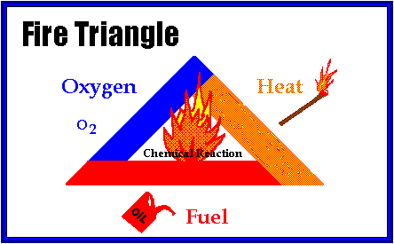

Researchers utilizing flammable materials must read and understand the manufacturer’s Safety Data Sheet (SDS) prior to commencing work with such materials. According to the Occupational Safety and Health Administration (OSHA) flammable material is defined as:

* *“Flammable liquid* means any liquid having a flashpoint at or below 199.4oF (93oC).”
* “*Flammable solid* means a solid which is a readily combustible solid, or which may cause or contribute to fire through friction”
* “*Flammable gas* means a gas having a flammable range with air at 20oC (68oF) and a standard pressure of 101.3 kPa (14.7 psi).”

Characteristics and requirements of flammable materials include:

* (Liquid) Have relatively low flash points* (below 93oC).
* (Liquid) May have high vapor pressures**.
* (Gas) Have widely varying upper-lower explosive and flammable limits.
* May readily ignite.
* May have the following hazard/GHS symbol;

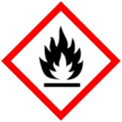

Requirements for safe flammable use include:

* Store in a flammable cabinet made of flame resistant material or in a purpose built flammable storage refrigerator-freezer. Label all flammable cabinets with the following hazard wording “Flammable – Keep Fire Away”.
* Store away from flames, heat sources and spark producing devices.
* Store only the quantities you need.

**From OSHA 29 CFR 1910.106 (Flammable and Combustible Liquids)**

**\*Flash point:** the minimum temperature at which a liquid gives off vapor within a test vessel in sufficient concentration to form an ignitable mixture with air near the surface of the liquid. The flash point is normally an indication of susceptibility to ignition. The flash point is determined by heating the liquid in test equipment and measuring the temperature at which a flash will be obtained when a small flame is introduced in the vapor zone above the surface of the liquid. A standard closed container is used to determine the closed-cup flash point and a standard open-surface dish for the open-cup flash point temperature, as specified by the American Society for Testing and Materials (ASTM). These methods are referenced in OSHA's 1910.106 standard.

**\*\*Vapor pressure:** the pressure, measured in pounds per square inch (absolute) exerted by a volatile liquid as determined by the *Standard Method of Test for Vapor Pressure of Petroleum Products (Reid Method)*, American Society for Testing and Materials ASTM D323-68. Vapor pressure is a measure of a liquid's propensity to evaporate. The higher the vapor pressure, the more volatile the liquid and, thus, the more readily the liquid gives off vapors. Ventilation as specified in this section is for the prevention of fire and explosion. It is considered adequate if it is sufficient to prevent accumulation of significant quantities of vapor-air mixtures in concentration over one-fourth of the lower flammable limit.

**\*FLAMMABLE (EXPLOSIVE) LIMITS**  
When vapors of a flammable or combustible liquid are mixed with air in the proper proportions in the presence of a source of ignition, rapid combustion or an explosion can occur. The proper proportion is called the **flammable range** and is also often referred to as the **explosive range**. The flammable range includes all concentrations of flammable vapor or gas in air, in which a flash will occur or a flame will travel if the mixture is ignited. There is a minimum concentration of vapor or gas in air below which propagation of flame does not occur on contact with a source of ignition. There is also a maximum proportion of vapor in air above which propagation of flame does not occur. These boundary-line mixtures of vapor with air are known as the **lower and upper flammable limits (LFL or UFL)** respectively, and they are usually expressed in terms of percentage by volume of vapor in air. In popular jargon, a vapor/air mixture below the lower flammable limit is too "lean" to burn or explode, and a mixture above the upper flammable limit is too "rich" to burn or explode. The LFL is also known as the **lower explosive limit (LEL)**. The UFL is also referred to as the **upper explosive limit (UEL)**. No attempt is made to differentiate between the terms *flammable* and *explosive* as applied to the lower and upper limits of flammability.

## Hazards and pertinent regulations

Refer to **OSHA 29 CFR 1910.106 (Flammable and Combustible Liquids).**

## Means to control the hazards

Refer to the Fire Triangle discussed above. All flammable materials in order to burn need three things: heat, oxygen, and fuel. If one of these elements is removed, a fire will be unsustainable.

## Examples of hazardous materials or processes

*PI’s and Lab managers: enter flammable materials used in your lab in this section.*

**NOTE:** Numbers in parentheses indicate lower – upper explosive or flammable limits. Examples of flammable materials include but are not limited to:

Potassium

Potassium hydride

Sodium

Sodium hydride

Raney Nickel

Magnesium

Lithium Aluminum Hydride)

Nitrocellulose

Acetone

Acetonitrile

Benzene

Diethyl Ether

Dioxane

Ethanol

Ethyl Acetate

Heptane

Hexanes

Isopropanol

Methanol

Pentane

Tetrahydrofuran

Toluene

Xylenes

Hydrogen gas (4 – 75%)

Carbon monoxide gas (12 – 75%)

Acetylene gas (2.5 – 81%)

Arsine gas (5.1 – 78%)

Ethane gas (3 – 12.4%)

Ethylene Oxide gas (3 – 100%)

Germane gas (unavailable)

Hydrogen Cyanide gas (5.6 – 40%)

Hydrogen Sulfide gas (4.3 – 46%)

Methane gas (5 – 15%)

Propane gas (2.1 – 10.1%)

Silane gas (1.5 – 98%)

# Important considerations

## Prior approval from PI required?

Answer Yes or No. If Yes, consent must be obtained from the PI before performing the experiment or procedure.

## Consultation of other reference material, documents or knowledgeable persons required?

Enter reference material, links to documents or name of resource person.

## Pre-requisite training or skill?

It is highly recommended that lab personnel working with flammable material undergo fire extinguisher training.

## Experiment Risk Assessment required?

If necessary, consult this link: [Risk Assessment for Chemical Experiments](http://www.drs.illinois.edu/site-documents/RiskAssessmentWorksheet.docx)

Enter any required risk assessment step or procedure.

## Other important considerations:

Any special First Aid concerns? Any special tips or tricks?

# Emergency response

## Introduction to emergency response

Fire is the most obvious hazard associated with flammable materials. While prevention is key, preparation for fire emergencies are necessary. Spills of flammable materials are another possible emergency scenario. Spill response requires taking the necessary steps to avoid conditions where combustion becomes favorable while cleaning up the material, followed by proper storage of the waste.

## Necessary emergency equipment

When preparing to work with flammable materials, emergency equipment must be present and in good working condition, and the researcher must be familiar with their operation. **Be aware of the location of emergency equipment at all times!**

* Fire Extinguisher.
* Fire alarm – identify where pull stations are.
* Emergency eye-wash – needs to be tested weekly. Make sure eye wash station access is unobstructed.
* Emergency shower – use the chemical fume hood that is closest to the shower if possible. Make sure emergency shower access is unobstructed.
* Chemical fume hood (to help expel flammable vapors out lab space) – chemical fume hoods must be working properly, free of clutter, and have all electrical devices elevated above the chemical fume hood floor. There should be no electrical outlets inside of the fume hood.
* Sprinklers – sprinklers need a minimum of 18” vertical clearance from the sprinkler head to the nearest object below the sprinkler head. Do not stack objects near sprinkler heads.

**Spill Kit for Flammable Materials**

A spill kit for flammable materials should be composed of the following;

* Chemical resistant gloves
* Absorbent pads (10-15)
* Sealable plastic bags
* Dust pan and broom
* 5-gallon plastic pail

Place all listed materials in the 5-gallon pail and label the pail “Spill Kit”. Place spill kit in an easily accessible location where all lab personnel have access.

## What to do if there is a spill or a fault in the process.

**IMPORTANT NOTES:**

**Before work begins –** You must know how to clean up any spill or leak of a material you are using before working with it!

**Comfort level** – If the person faced with cleaning up the spill or their supervisor feels that it is too large to safely clean up, he or she instead should proceed as described in Large/Complicated Spill section below.

**Ignition sources –** In the event of a flammable material spill NEVER turn on or off any electrical switches or unplug any electrical devices – these acts can create an ignition source.

**Small/Simple Spills**

To use the spill kit, first put on personal protective equipment (PPE) of proper chemical resistance: gloves, lab coat, and safety glasses. If flammable material is:

* **Solid –** use a broom and dust pan to carefully clean up the spill. Then place the material in a plastic bag or pail.
* **Liquid** – place absorbent pads on the spill and let stand for a few minutes. Carefully place soiled pads in a plastic bag or pail.

Seal the waste bags or pail and store in the chemical fume hood until the chemical waste personnel pick up the material. Carefully and thoroughly wash the spill area with soap and water. Dispose of all soiled spill material through the University of Illinois chemical waste management program (see **DISPOSAL** section).

**Large/Complicated Spills**

If an unmanageable spill of flammable material takes place;

* Inside the fume hood – close the sashes of the chemical fume hood.
* Outside the fume hood – open the sashes of the chemical fume hood (to evacuate flammable vapors) and cordon off the area where spill occurred.

Immediately evacuate the laboratory and close the lab doors. Call 911 to alert emergency responders. If fire occurs, use an appropriate fire extinguisher only if you feel you can do so without endangering yourself or others.

**LEAKS**

**Unmanageable leak inside/outside of chemical fume hood**

The fact that most flammable gases can be life threatening means most leaks should be considered exceptionally hazardous. If you believe the leak is too overwhelming to handle safely, evacuate the lab immediately, pull a fire alarm, and call 911.

**Manageable leak inside of chemical fume hood**

If a manageable leak of flammable gas happens inside of a chemical fume hood, close the valves of the plumbing leading to the equipment or experiment, close the sashes of the fume hood, and then wait for the flammable gas inside the fume hood to dissipate.

**Manageable leak outside of chemical fume hood**

If a manageable leak is outside of the chemical fume hood, close the main valve on the compressed gas cylinder and then immediately evacuate the laboratory. If possible, before evacuating the laboratory, open the chemical fume hood sashes to help exhaust flammable gas from the laboratory. Call 911 to alert emergency responders and wait for flammable gas in the laboratory to dissipate before re-entering.

## What to do if there is an exposure or injury

**FIRST AID**

Rinse the exposed areas with a large quantity of water. If it is during regular work hours, inform the PI or supervisor, and seek medical assistance. Call 911 for life threatening exposures.

*PI’s and Lab managers: enter first aid information for specific flammable materials used in your lab in this section. Document not valid until filled in.*

# Storage

## Considerations for safe storage of materials

Flammable materials must be stored:

* ALWAYS away from strong oxidizing materials and possible ignition sources (open flames, sources of heat, sparks, etc.).
* In a qualified testing agency approved (Underwriters Laboratory, Factory Mutual, etc.) flammable solvent cabinet and clearly labeled “Flammable – Keep Fire Away”.
* Only in freezers and refrigerators designed for flammable materials.
* With lids tightly closed – to prevent escaping vapors.
* Away from chemically incompatible material.
* According to manufacturers’ SDS.
* With quantities kept to a minimum.
* Gas cylinders should be secured in an upright position at mid-point of the cylinder or above with a bracketed or chain mount affixed to a solid structure.
* Gas cylinders not in use should be capped.
* Gas cylinders should be tagged as “In use,” “Empty,” or “Full,” as appropriate.

**NOTE: Flammable compressed gases must be stored 20 feet or more away from oxidizing gases or be separated by a 5-foot-high fire-proof barrier with a 30-minute fire rating.**

**Below is a common sign found on freezers and refrigerators designed for flammable materials:**

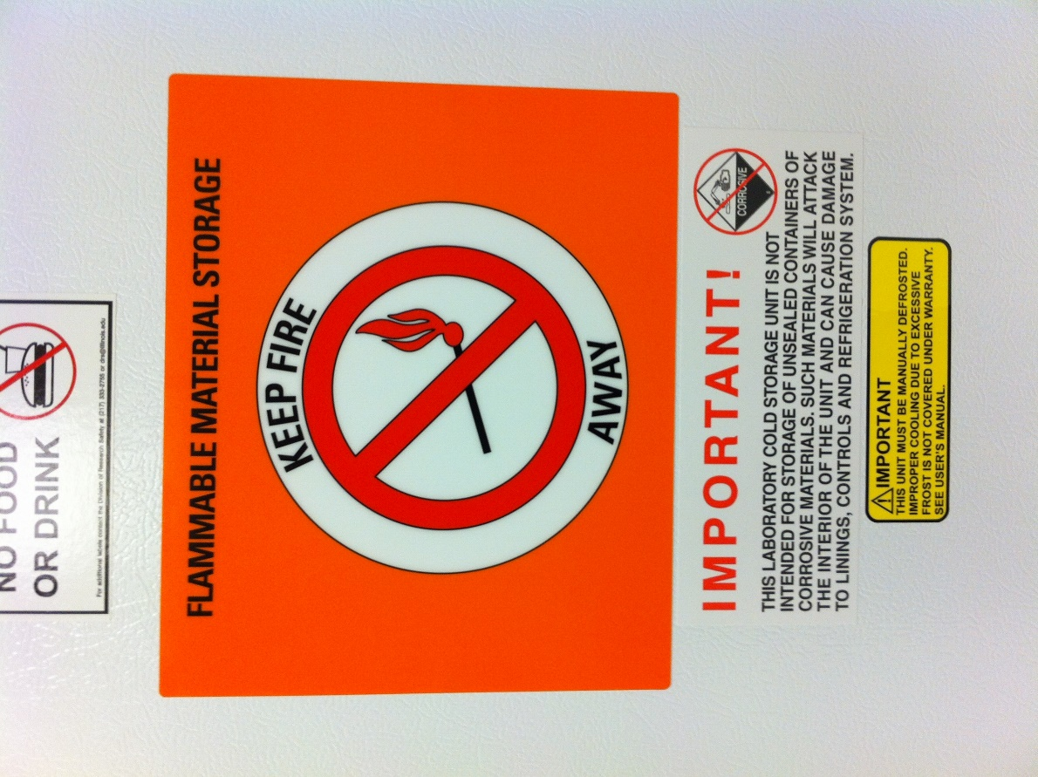

## Quantity limits and other considerations

**Flammable Material Quantities in Laboratories – Limitations**

Laboratories have limits in the amount of flammable materials that can be stored in them.

If your lab exceeds the following limits listed below, contact the [Division of Research Safety](mailto:drs-lss@illinois.edu) for a more in-depth flammable assessment of your lab space:

* 7.5 liters of flammable liquid per 100 ft2 of lab space (no flammable cabinet in lab space).
* 15 liters of flammable liquid per 100 ft2 of lab space (flammable cabinet present in lab space).
* 6.0 ft3 of compressed flammable gas for lab space (if <500 ft2).
* 0.012 ft3 of compressed flammable gas per ft2 of lab space (if >500 ft2).

**Tips for reducing flammable materials in lab spaces**

* **Avoid buying material in bulk** – buying material in bulk usually reduces the material cost but can increase the risk of a catastrophic fire by having excessive amounts of flammable material.
* **Only store what you need** – store only the amount of flammable material that is *realistically* needed for the immediate future (i.e., next three months).
* **Dispose of waste** – since flammable waste is still flammable after use, dispose of flammable waste as soon as possible to reduce the amount of flammable material in the lab.
* **Use smaller bottles** – most experiments are usually performed on a small scale and only require small amounts of flammable material. Purchasing flammable material in smaller quantities not only reduces the amount of flammable materials but can also ensure better reagent quality by ensuring a higher turnover rate.

**Stencil quantity limit on cabinets** – once the limit of flammable material has been determined, stencil the amount (e.g., number of gallons, liters, etc.) of flammable material onto the door of the storage cabinet. **HINT:** make it an easily determinable number by eye sight. Gallons work nicely since most solvents come in four-liter (one gallon) containers. This makes it easy to quickly determine if you are or getting close to your limit.

# Work Practices and Engineering Controls

## Introduction to work practices and engineering controls

**Recommended work practices**

* To prevent spills, don’t use vessels near their maximum volume of capacity.
* Manipulation of flammable materials should utilize locking mechanisms (e.g., luer locks, etc.) and clamps that secure the apparatus connections (e.g., keck clamps, etc.).
* Never transfer flammable materials into/onto hot equipment (glassware, vessels, needles, etc.).
* Never use a syringe at its maximum volume. Syringe plungers can quickly “pop-out” near their maximum volume. Examples: If you need 5 mL of reagent, use a 10 mL syringe. If you need 25 mL of a reagent, use a 40 mL syringe. If you need >50 mL of flammable liquid use a cannula, a double-tipped needle or use a multiple smaller with drawings *via* a syringe.
* Never pump flammable liquids from a drum without the drum being grounded/bonded.
* Elevate all electrical devices (e.g., hot plate-stirrer, variacs, etc.) from the bottom of the chemical fume hood with bricks, lab jacks, etc.
* Always be careful (especially on overnight reactions) when operating oil baths and heating mantles. Be certain to monitor their operation. Temperature probes and thermocouples do occasionally malfunction or become disconnected which can cause excessive heating and possibly a fire.
* Be sure all tubing is in good condition and free of holes, cracks, corrosion or any other defects that would compromise the integrity of the system utilizing the flammable gas.
* Be sure all plumbing is capable of withstanding generated pressures.
* Keep compressed gas cylinders capped at all times until ready for use or mount them in a secure fashion.

## Designated area to work with the material or process

* As much as possible, use flammable materials in a properly operating chemical fume hood (*prevents buildup of flammable vapors*), glove box (*inert environment*) or use appropriate engineering control with functional emergency (fire extinguishing) devices nearby.
* As much as possible, use flammable materials away from open flames, ignition sources or exposed electrical circuits.
* All electrical devices should be in good condition (no cracked or frayed cords) when working near flammable materials.
* De-clutter and remove from the work area any chemically incompatible (e.g., pyrophorics, oxidizers, etc.) material that is not necessary for the experiment.

## Necessary engineering or administrative controls.

If necessary, consult: [Chemical Fume Hoods](https://www.drs.illinois.edu/SafetyLibrary/ChemicalFumeHoods)

As much as possible, work with flammable materials in a properly operating chemical fume hood (*prevents buildup of flammable vapors*), glove box (*inert environment*) or use appropriate engineering control with functional emergency (fire extinguishing) devices nearby.

## Required Personal Protective Equipment (PPE).

If necessary, consult: [Personal Protective Equipment](https://www.drs.illinois.edu/SafetyLibrary/PersonalProtectiveEquipment)

Fully enclosed shoes (no holes in the top) must be worn with clothing that is not made of synthetic fibers that can melt to skin. Long hair should be tied back and full length pants or skirts must also be worn along with basic PPE to include but not limited to:

* **Eye protection –** Safety glasses meeting American National Standards Institute (ANSI) standard Z87.1 are required.
* **Gloves –** Proper protective gloves are required at all times.
* **Lab coat –** Flame resistant, knee-length lab coats that are buttoned up are required.

# Detailed procedures or techniques

## Step-by-step procedures

**SOLIDS**

**Unless the flammable solid is an oxygen-water reactive solid (See *Safe Handling Guidelines for Oxygen and Water Reactive Materials*), techniques for manipulating flammable solids are the same as for other standard solids (as taught in standard chemistry lab classes) with one exception: Avoid all ignition sources (e.g., flame, heat, exposed electrical, etc.). Avoiding ignition sources is of critical importance in reducing fires from flammable solids.**

**Flammable Liquids – Syringe Technique**

1. Clamp the bottle of reagent to a solid and immovable support to prevent unnecessary movement. If the bottle is coming from cold storage and is stable at ambient temperature, allow it to come to ambient temperature first.
2. Remove the screw cap from the reagent bottle and insert an inert gas line needle into the septum to place the reagent contents under low positive pressure of inert gas.
3. Purge the needle/syringe combination with inert gas a few times. Insert the needle (with syringe attached, locked and plunger fully forward) into the reagent bottle through the septum until the needle approaches the bottom of the reagent bottle.
4. Draw the reagent out slowly (to avoid air bubbles), with the syringe pointing downward, until a small excess of reagent is withdrawn.
5. Now flip the syringe so that the plunger is pointing upward and not toward the researcher and allow the gas in the syringe to rise to the tip. With the syringe still pointing upward, push on the plunger until the exact volume of liquid is desired and any gas bubbles expelled.
6. With the syringe still pointing upward, bring the tip of the needle out of the liquid reagent until it is in the headspace of the reagent bottle (headspace is the gas filled portion of the reagent bottle above the liquid), then slowly pull the plunger back to bring in inert gas as a head space inside the syringe.



1. With the syringe still pointing upward, pull the needle out of the septum of the reagent bottle but leaving the inert gas needle in place.
2. With the syringe still pointing upward, insert the needle into the septum of the reaction apparatus that has already been setup, purged with and under an inert gas. Slowly push the plunger of the syringe inward until it stops. Pull back on the plunger, withdrawing a few mL of inert gas and remove the needle from the septum of the apparatus.
3. Once done with the reagent bottle, withdraw the inert gas needle from the reagent bottle and recap the reagent bottle. Be sure to use parafilm, bakelite caps or other means to ensure liquid remains under inert atmosphere. Place reagent bottle back into its appropriate storage location
4. Rinse the syringe and needle with a solvent that is the same or compatible with the solvent the flammable liquid was dissolved within. Do this by inserting the needle into a flask of the solvent (twice the volume of the syringe) and slowly withdrawing and ejecting the solvent a few times. Then rinse with water and clean as normal.

**Below are some examples of septa that maybe required for working with flammable materials. Septa help with maintaining a sealed enclosure but still allow for the addition and withdrawal of material via needle-syringe.**

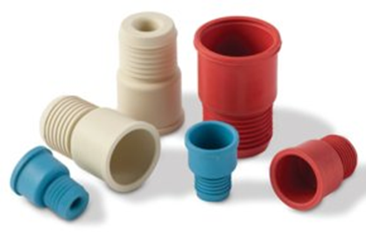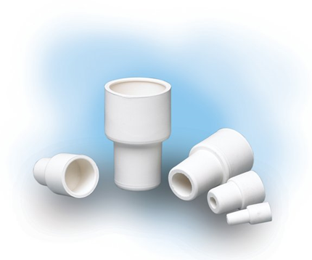

**Flammable Liquids – Pipette Technique**

The technique below can also be utilized with a mechanical or electronic pipettor by omitting the compressing/decompressing of the bulb with precise withdrawal and release of the liquid via pipettor controls.

1. Remove the cap from the reagent bottle and insert the pipette with the bulb that has been compressed.
2. Decompress the bulb and allow the flammable liquid to be drawn up into the pipette until an excess of the desired liquid has been reached.
3. Now manipulate the bulb (compressing and decompressing) until the desired level of flammable liquid has been obtained.

**OR**

If an analytical pipette is being utilized, remove the bulb and quickly stopper the bulb end of the pipette. Manipulate the bulb end opening with a finger/thumb, allowing excess liquid to drain out of the pipette until the desired liquid level is obtained.

1. Transfer the pipette of flammable liquid to the intended vessel and expel the flammable liquid from the pipette.
2. Close the reagent bottle and place it back into its proper storage location.
3. Cleanup equipment and the work surface in the appropriate manner.



**Flammable Liquids – Graduated Cylinder Technique**

1. Place a graduated cylinder on a level and stable surface.
2. Remove the cap from the reagent bottle and place a funnel in the mouth of the graduated cylinder.
3. With the lip of the reagent bottle in direct contact with the funnel, pour the flammable liquid into the graduated cylinder until the liquid level reaches the desired level. You may need to use a Pasteur pipette to get the exact level of flammable liquid.
4. Once the desired amount of flammable liquid is obtained in the graduated cylinder and with the lip of the graduated cylinder in direct contact with the funnel of your vessel, slowly pour the graduated cylinder contents into the desired vessel and close it.
5. Close the reagent bottle and place it back into its proper storage location.
6. Clean up the equipment and the work surface in the appropriate manner.



**Flammable Liquids – Bulk Solvent Technique Utilizing Pump (Grounding/Bonding to avoid static discharge from igniting flammable materials, see Figure 1.)**

1. Clamp one end of the approved grounding cable or wire onto a metal water pipe or other earthed conductor.
2. Clamp the other end of grounding cable to the drum that contains the flammable liquid to be dispensed.
3. Bond the receiving container to the dispensing container by creating a metal-to-metal contact between the containers using an approved bonding strap, cable or wire.
4. Insert the pump into the drum of flammable liquid.
5. Place under the pump spigot the vessel into which the flammable liquid is to be pumped.
6. Begin pumping, in a controlled manner, the flammable liquid into the vessel, stopping when the desired amount of flammable liquid is obtained.
7. Leave the pump in a flammable liquid drum (with grounding cable still attached) or remove the pump and recap the metal drum containing the flammable liquid.
8. Clean up the equipment and the work surface in the appropriate manner.
9. Place the flammable liquid drum and all equipment back into its proper storage location.

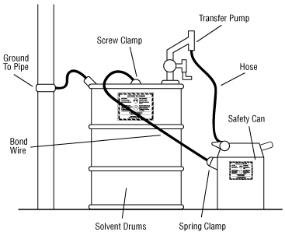

**Figure 1.** Grounded and bonded metal dispensing and receiving containers (source: [Canadian Centre for Occupational Health and Safety - Flammable and Combustible Liquids](http://www.ccohs.ca/oshanswers/prevention/flammable_static.html))

**GASES**

.

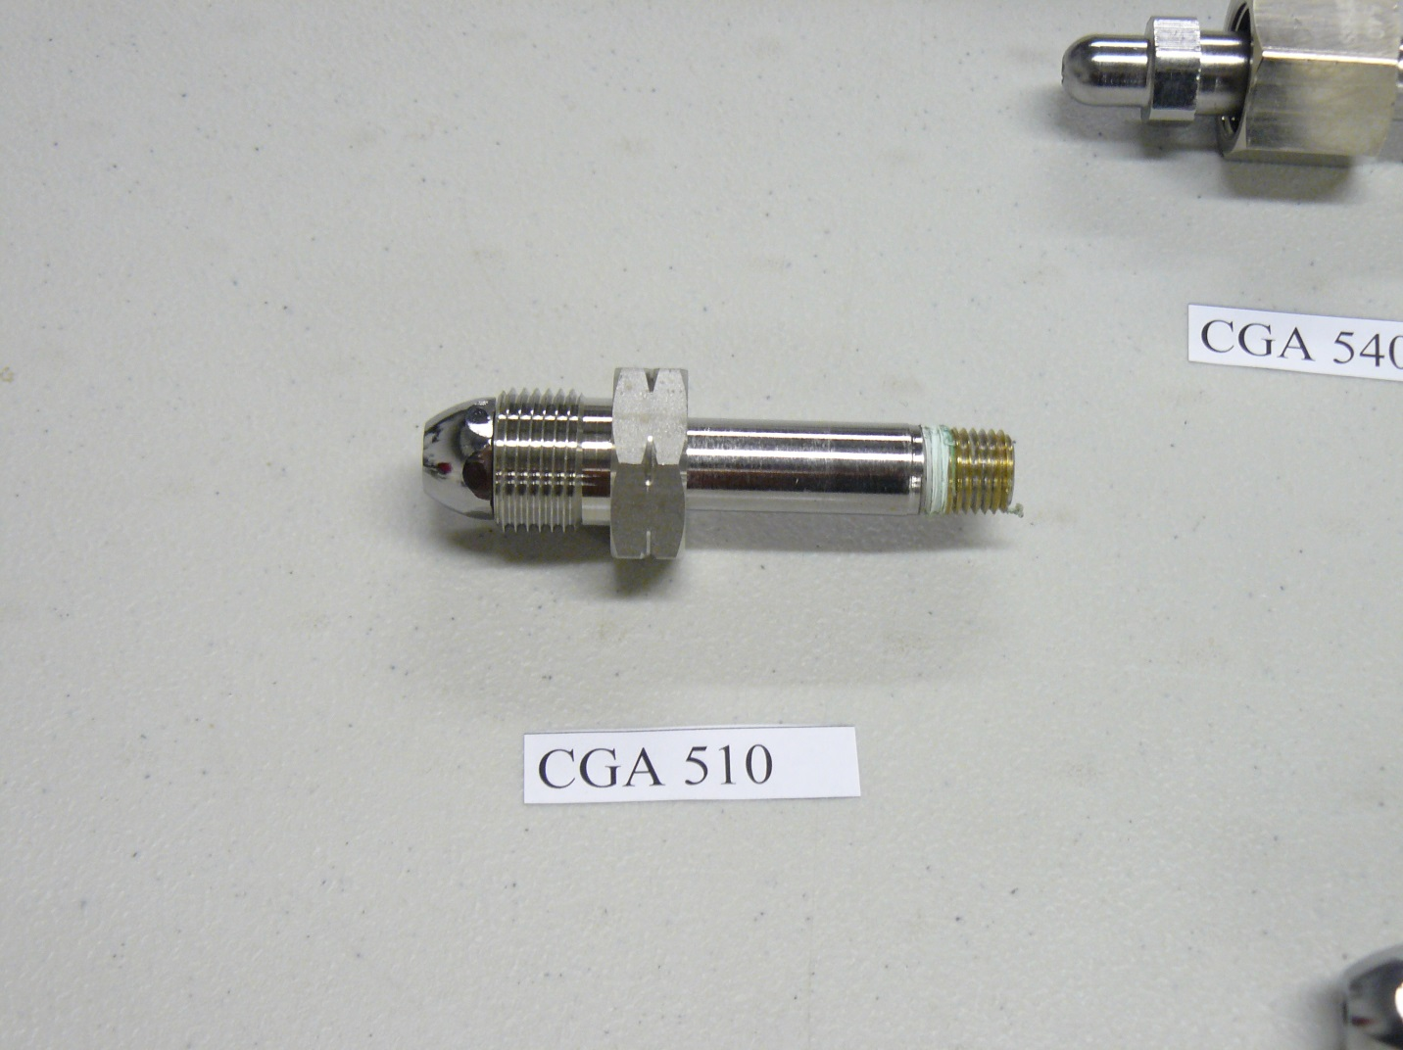

**Figure 2.** Regulator fitting for flammable or oxidizing gas – note notches on flats, which indicate left-hand thread (most flammable gas fittings are left-hand thread). CGA numbers refer to the classification of standardized gas fittings sanctioned by the Compressed Gas Association

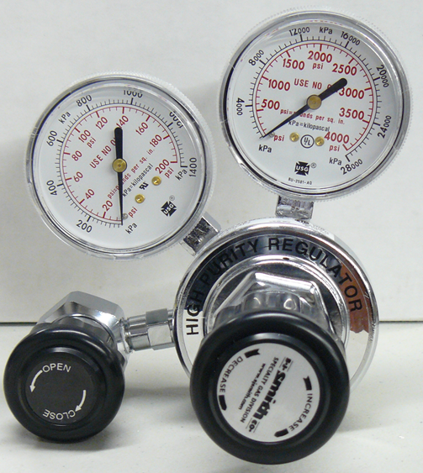

Measures internal cylinder pressure

Measures delivery pressure

**Figure 3.** Example of a 2-stage pressure regulator typically used for working with flammable gases.

**Flammable Gases – Setting up operation (see Figure 2)**

1. Secure the compressed gas cylinder to a solid structure.
2. Unscrew and remove the compressed gas cylinder cap.
3. Ensure CGA gas regulator fitting match is correct.
4. Install appropriate CGA gas regulator fitting using an adjustable wrench. **NOTE**: Do not use tools with teeth (such as pliers) to install regulator fitting – this will destroy the flat surfaces on the regulator fitting.
5. Install additional add-on pressure regulators/gauges as needed. Ensure all valves are closed (turned clockwise) before installing: additional equipment, backflow preventers, flow metering devices, etc. Use Teflon tape as needed on screws but **do not** use tape on regulator screws to be inserted into gas cylinder head. **NOTE:** NEVER use Teflon tape on the regulator fitting attaching into the cylinder head. The cylinder head connection point is a face seal, not a thread seal. Teflon tape may be used elsewhere but not in the cylinder head.
6. Open the compressed gas cylinder’s main valve by turning it counterclockwise. Ensure that the regulator is pointing away from you.
7. Check leak integrity of connections using soapy water or “snoop”. If no leaks are detected, proceed. If leaks are detected, close all valves and correct leak connections by rechecking and tightening connections.
8. If using pressure gauges, read the levels to ensure they are correct.
9. Continue opening valves (turning counterclockwise). Further downstream, check each connection for leaks until you reach the outlet pressure valve (the last valve before the tubing goes onto the apparatus).
10. Prepare the device that is to receive the desired gas. Attaching the tubing to the furthest downstream valve (outlet pressure valve or pressure regulator valve).
11. When the apparatus or device is ready, slowly open the outlet pressure valve (turning knob in a counterclockwise fashion) to allow gas to flow. Use the outlet pressure valve or the valve on the pressure regulator (watching the downstream pressure gauge) to adjust desired gas flow/pressure level.



**Figure 4.** Diagram of a setup used to deliver gases.

**Flammable Gases – Shutting down operation**

1. Once gas is no longer needed, close the outlet pressure valve (or pressure regulator valve) by turning it clockwise until it stops and gas flow stops.
2. Remove tubing from the furthest downstream valve.
3. Close the compressed gas cylinder main valve by turning it clockwise until it stops.
4. If the compressed gas cylinder is to be removed, with the main valve closed, open the downstream valves to release internal pressure in the plumbing.
5. Disconnect the pressure regulator from the compressed gas cylinder using an adjustable wrench.
6. Place the cylinder cap back on the cylinder.
7. Remove the compressed gas cylinder from the bracket or chain securing it and transport it back (via a cylinder cart) to storage. Be sure to properly secure the cylinder in the storage area.

## Waste disposal procedure.

If necessary, consult: [Waste Disposal Guide](https://www.drs.illinois.edu/site-documents/WasteDisposalGuide.pdf) and [Chemical Waste Quick Start Guide](https://www.drs.illinois.edu/Waste/ChemicalWasteQuickStartGuide)

Upon completion of working with flammable materials, dispose of the waste material in the following manner:

* Store the waste in an appropriate container.
* Each waste stream must have a unique number (UI#) assigned by DRS to identify a chemical waste generated on campus. Label the container clearly with a description of the contents and the corresponding UI#.
* Notify the DRS Chemical Waste Section by sending a completed CWM-TRK form to [this email](mailto:cws@illinois.edu).
* If the waste material remains flammable, store it under appropriate conditions and add the words “Flammable waste” to the label.

# Record of changes made to this SOP

Describe the changes made to this document since its creation.

|  |  |  |
| --- | --- | --- |
| **Date of change** | **Changed by** | **Description of change** |
| 11/17/2022 | Student Assistant | Updated footer and header |
|  |  |  |
|  |  |  |
|  |  |  |
|  |  |  |
|  |  |  |
|  |  |  |

Standard Operating Procedure for Flammable Materials

# Training record

|  |  |  |  |  |  |
| --- | --- | --- | --- | --- | --- |
| **Training Date** | **Name of Trainer** | **UIN of Trainer** | **Initials of Trainer** | **Name of Trainee** | **UIN of Trainee** |
|  |  |  |  |  |  |
|  |  |  |  |  |  |
|  |  |  |  |  |  |
|  |  |  |  |  |  |
|  |  |  |  |  |  |
|  |  |  |  |  |  |
|  |  |  |  |  |  |
|  |  |  |  |  |  |
|  |  |  |  |  |  |
|  |  |  |  |  |  |
|  |  |  |  |  |  |
|  |  |  |  |  |  |
|  |  |  |  |  |  |
|  |  |  |  |  |  |
|  |  |  |  |  |  |
|  |  |  |  |  |  |
|  |  |  |  |  |  |
|  |  |  |  |  |  |
|  |  |  |  |  |  |
|  |  |  |  |  |  |