**UNIVERSITY OF ILLINOIS AT URBANA-CHAMPAIGN**

**THE GRAINGER COLLEGE OF ENGINEERING**

306 Engineering Hall MC 266

1308 West Green Street

Urbana, Illinois 61801

Philippe H. Geubelle (217) 244-7648

Bliss Professor of Aerospace Engineering geubelle@illinois.edu

Executive Associate Dean http://ae.illinois.edu/directory/profile/geubelle

October 22, 2024

Karen Cromwell ([kcromwel@illinois.edu](mailto:kcromwel@illinois.edu), CSL – Chair)

Tessa Hile ([tmhile@illinois.edu](mailto:tmhile@illinois.edu), College Finance)

Jim Hurst ([jhurst@illinois.edu](mailto:jhurst@illinois.edu), Engineering IT – Ex Officio)

Emad Jassim ([jassim@illinois.edu](mailto:jassim@illinois.edu), Undergrad Programs)

Rebecca Seymore ([rseymore@illinois.edu](mailto:rseymore@illinois.edu), MechSE)

Kris Williams ([kbwillia@illinois.edu](mailto:kbwillia@illinois.edu), MRL)

Lori Willoughby ([rairden@illinois.edu](mailto:rairden@illinois.edu), College HR)

Dear Colleagues:

Thank you for agreeing to serve on the Grainger College of Engineering IT Governance Administrative Working Group for the academic year 2024-2025. This working group is critical to helping ensure that IT support of the administrative needs of all units in the College is of the highest quality and reliability.

Your recommendations and comments are advisory to the Executive Associate Dean, with primary responsibilities for:

* Application development oversight, including prioritizing application development/deployment.
* Assist with monitoring, providing feedback, and reporting on the progress of work to align Engineering IT services with campus-level IT services, with particular emphasis on services pertinent to the IT support for our administrative needs.
* Service quality assessment: Work with Engineering IT to implement and monitor service quality metrics
* Engineering IT funding model: Review and make recommendations about the Engineering IT budget for FY25 and the appropriate allocation of IT costs to services.

In particular, over this academic year, I would like to ask you to

* Provide input and recommendations for addressing impending costs of addressing Windows 11 incompatible hardware across the units.
* Evaluate funding and support necessary for future of instruction, including classroom technology, scaling of online programs, and the need for instructional resources for AI and machine learning.
* Review recommendations for Operational Excellence at Illinois including active and proposed partnerships between Engineering IT and Technology Services.

You will also be asked to provide a report at the end of the Academic Year, no later than June 1, 2025. Karen has graciously agreed to continue as chair of this working group. She will be in contact with you soon to arrange for your first meeting.

I am thankful to all of you for your willingness to contribute to this important work for our College. I look forward to joining you at your first meeting to discuss the charge and answer any questions.

Sincerely,

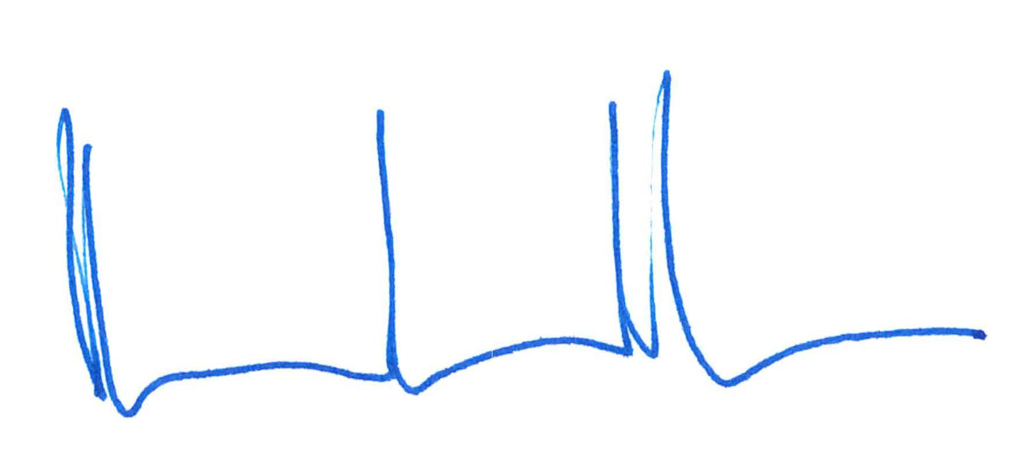

Philippe H. Geubelle