

Transportation Infrastructure Precast Innovation Center (TRANS-IPIC)

# University Transportation Center (UTC)

*Innovative Precast Concrete Truss Using Adaptive Shape Memory Prestressing System*

*Project No.: UI-23-RP-02*

### Quarterly Progress Report

For the performance period ending *June 30th, 2024*

## Submitted by:

PI: Bassem Andrawes, [andrawes@illinois.edu](mailto:andrawes@illinois.edu) Department of Civil and Environmental Engineering University of Illinois at Urbana-Champaign

## Collaborators / Partners:

- None

## Submitted to:

TRANS-IPIC UTC

University of Illinois Urbana-Champaign Urbana, IL

# TRANS-IPIC Quarterly Progress Report:

## Project Description:

### Research Plan - Statement of Problem

The ever-growing demand for making our transportation infrastructure more sustainable requires serious efforts to reduce carbon emissions associated with the concrete and steel used in transportation infrastructure. One way to achieve sustainability is by optimizing the materials used in transportation infrastructure. This research helps address this issue by studying the application of an innovative Adaptive Prestressing System (APS) in a geometrically optimized (truss) PC system. The new APS includes a shape memory alloy fuse that applies localized prestressing in any direction without mechanical tensioning or special hardware, ideal for prestressing short diagonal or vertical members of a PC truss. The research includes experimental testing and numerical simulation of geometrically complex PC truss structures with APS placed in tension members that are difficult to prestress using conventional methods. The performance of the new APS-reinforced PC truss is compared with traditional PC bridge girders to prove the feasibility of the new concept.

### Research Plan - Summary of Project Activities (Tasks)

This project aims to investigate the new technology of using APS to construct lightweight, sustainable, and durable (crack-free) PC truss systems for bridges. During this phase of the project (12 months), this research will attempt to address the following questions: 1) What is the optimum design (diameter and length) for the APS in PC truss that would help eliminate the cracking of concrete under realistic design loads. 2) What is the most efficient and practical method for installing and activating the APS's SMA fuse internally in PC truss members. The research plan for this project includes two primary tasks:

Task 1: Design of Specimens using Finite Element Method:

The first step of the research is to evaluate the behavior of the specimens through detailed finite element (FE) analysis using the software ABAQUS. This step aims to define the size and location of the APS strands and the level of the target prestressing force. A realistic prestress force that satisfies all AASHTO limit states will be adopted. Both concrete and strands (steel and SMA) will be modeled in 3D. The final decision on the design of the specimens will be made based on the results of the 3D FE analyses. Close attention will be given to the degree of cracking and/or stress concentration associated with various detailing configurations. The specimen's behavior with conventional (non-prestressed) steel reinforcement will be used as a baseline.

Task 2: Fabrication, Instrumentation, and Testing of Specimens:

Three specimens (one used as a control specimen with conventional steel and two specimens with SMA) will be fabricated. Before casting, prestressing strands in the bottom chord will be tensioned, and the APS will be placed in the vertical tension members. The SMA fuse used to activate the system will be in the form of pre-deformed no. 2 bars. The APS will be enclosed in a thermally/electrically insulating polymeric sleeve. To provide anchorage for the APS, the two HSS ends of the APS will be bent to form 90-degree hooks. After casting the concrete, the SMA fuse will be stressed using an electrical current. Next, the HSS strands in the bottom chord will be detensioned and the specimens will be tested under two concentrated loads. Digital Image Correlation (DIC), and conventional instrumentation will be used to evaluate the behavior of the tested trusses.

## Project Progress:

### Progress for each research task

#### Task 1 progress (65% completed):

Additional ABAQUS models were designed and analyzed to estimate a range of realistic loadings for a concrete truss girder system. The three best performing models are shown in **Fig. 1**. These trusses were based on the dimensions of the first truss girder presented in this project, but with some notable variations. The voids were moved further away from the ends to improve shear transfer. The number of bays were also adjusted so that the diagonals are at steeper angles, which reduces tension in the verticals.



***Figure 1.*** *ABAQUS models*

The stiffness of each model was determined and used to calculate their distribution factors per American Association of State Highway and Transportation Officials (AASHTO). Next, the forces in the tensile member were investigated for each model under different load cases. The load cases were applied under separate conditions to match a realistic construction process. Namely, the dead load and bottom chord prestressing force were applied to the girder while the deck was de-activated (**Fig. 2a**). This represents the time when the deck is poured but not yet cured. Then, live load was applied to model while the deck was activated (**Fig. 2b**). This represents the time when the deck is cured and able to carry load.

(a)



(b)



***Figure 2.*** *ABAQUS results for the first model*

The analysis results were combined using the principle of superposition along with load factors in accordance with the AASHTO Service I limit state. The largest demand in the most critical tensile member was found to be 32.1 kips.

#### Task 2 progress (40% completed):

The previously-activated 330 mm long mortar beam is loaded in a 3-point flexural test until a crack propagated through the center of the beam (**Fig. 3a**). The beam was then connected to a power supply to electrically heat the SMA wire inside. This triggered the shape-memory effect of the SMA and reduced the crack size (**Fig. 3b**). DIC was conducted on the beam for both the loading and the healing phase. The colors are opposite of each other, indicating that the SMA activation directly corresponds to closing of the crack.

(a)

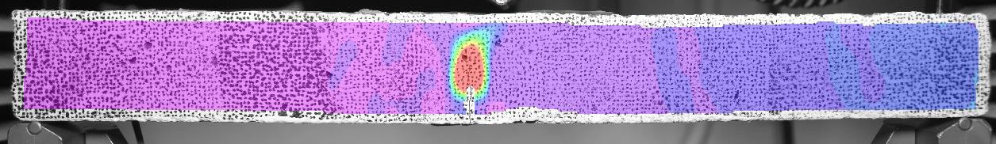

(b)

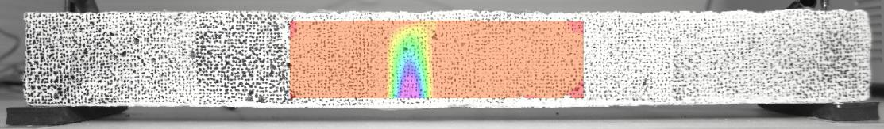

***Figure 3.*** *DIC results*

The crack width was initially 0.5 mm at the largest point after loading (**Fig. 4a**). The width reduced to 0.1 mm at the widest point after healing (**Fig. 4b**). This indicates an 80% reduction in the crack width.

(a) (b)

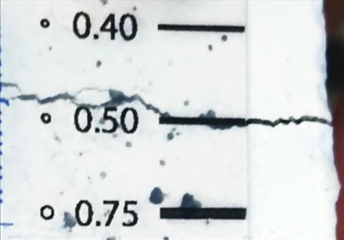 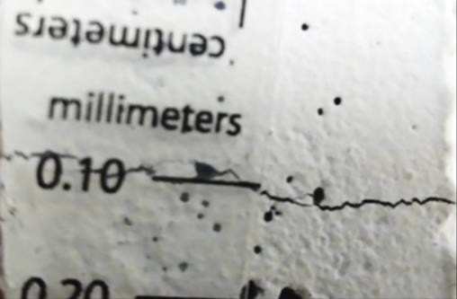

***Figure 4****. Crack close-up photos*

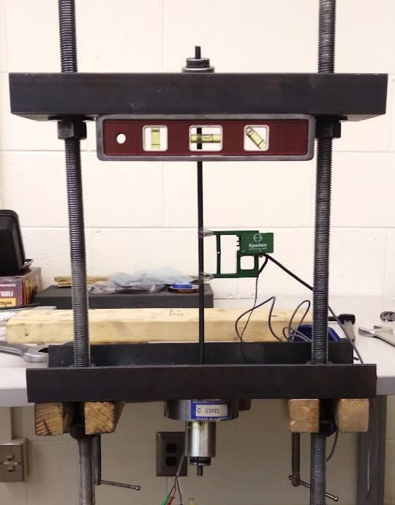

***Figure 5.*** *Pre-straining of SMA*

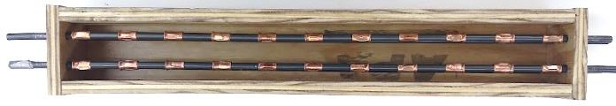

***Figure 6.*** *Formwork for tensile test specimen*

### Percent of research project completed

Total project completed through the end of this quarter = 50%

### Expected progress for next quarter

The next quarter will focus on activation and tensile testing of test specimens. Additional test specimens are planned to be cast and tested under pure tensile loading. The specimens’ dimensions will be based on the ABAQUS model but at a 1/3 scale. Multiple SMA bars will be used in lieu of a single SMA wire to reach the tensile demand calculated from the ABAQUS model. These bars are pre-strained manually in a steel frame prior to casting (Fig. 5). The effect of using crimped metal sleeves to anchor the SMA to the concrete will be studied (Fig. 6).

### Educational outreach and workforce development

We are participating in this summer’s TRIO Upward Bound program which encourages high school students to enroll in a post-secondary institution. Our portion of the program is called “Building Bridges with Memory” and explores the use of shape memory alloy in concrete bridges. The afternoon activities include a mixture of classroom lessons with hands-on demonstrations (**Fig. 7**). Topics have covered shape memory alloy, concrete casting, and computer-aided design (CAD) drawings. The students also see the research experiments of current PhD students (**Fig. 8**).

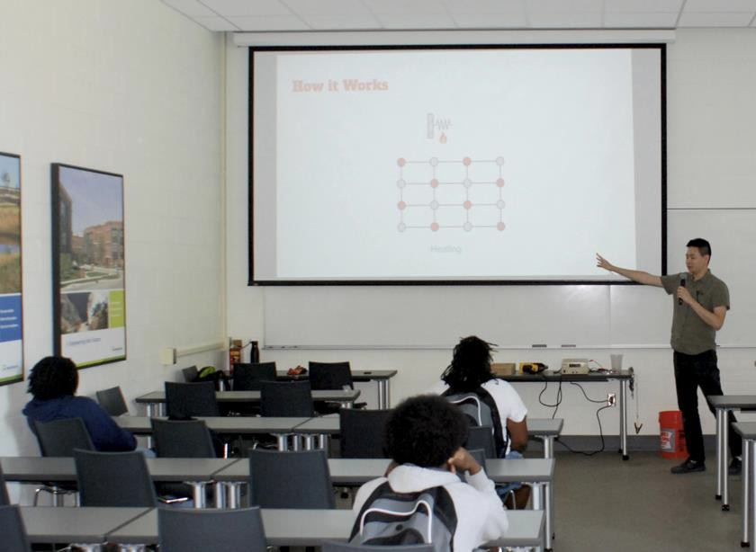

***Figure 7.*** *Lesson and demonstration of SMA*

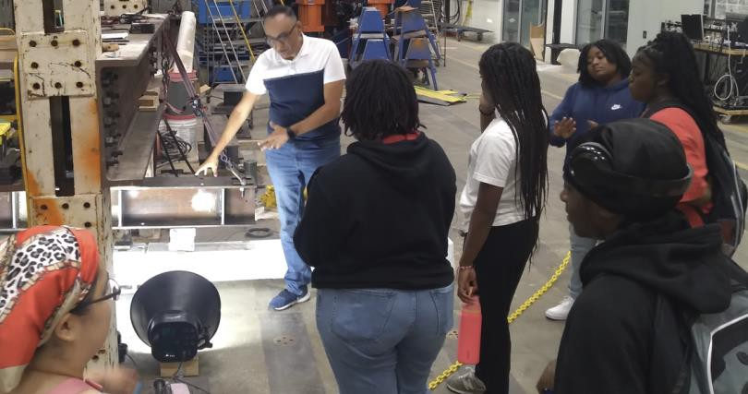

***Figure 8.*** *Loading test of a research specimen*

### Technology Transfer

None yet.

## Research Contribution:

### Papers that include TRANS-IPIC UTC in the acknowledgments section:

* + *Minsoo Sung and Andrawes B. “Innovative Precast Concrete Truss System Using Shape Memory Alloys for Infrastructure Applications” Intelligent Materials Systems and Structures journal (Accepted). (Federal Funds Acknowledgment: Yes)*

### Presentations and Posters of TRANS-IPIC funded research:

* + *A poster was presented at the 2024 ASCE Transportation Conference held in Atlanta, GA in June 16th-18th, 2024.*

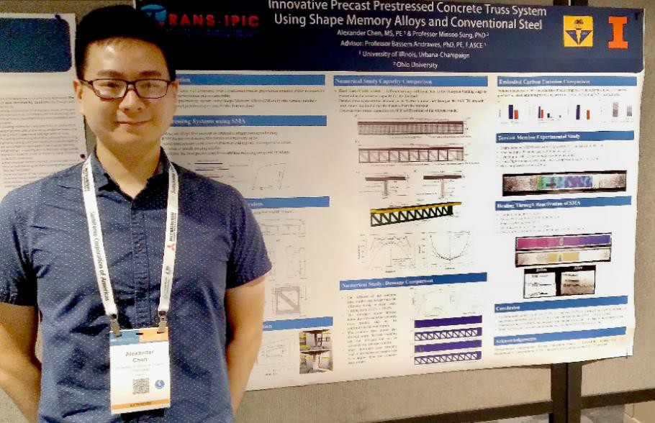

* + *A poster was presented at the 1st TRANS-IPIC Annual Workshop held in Rosemont/Chicago, IL in April 22nd, 2024.*

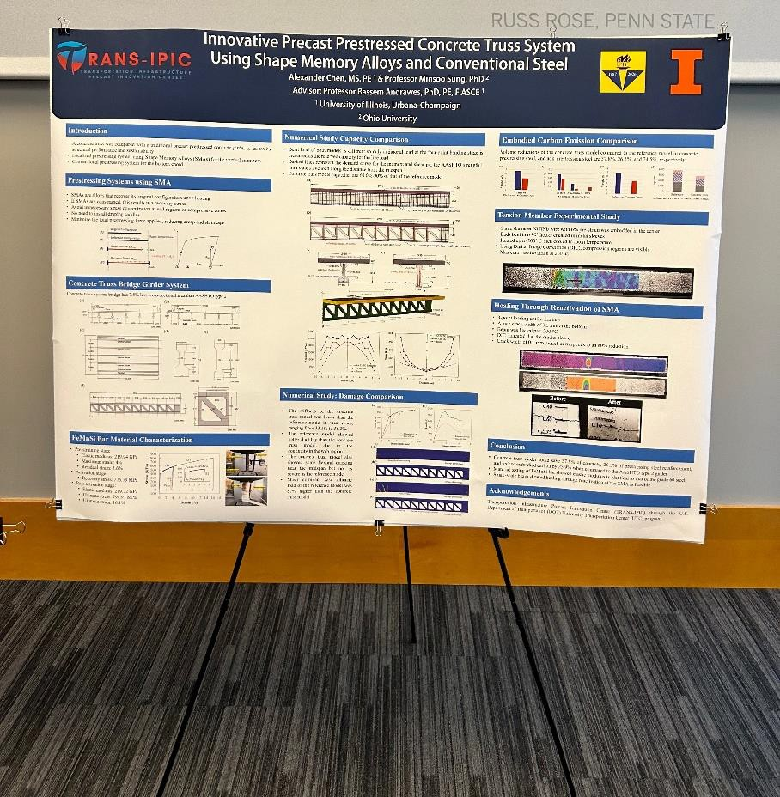

## References:

N/A