Day 2 Activities

Schedule:

15 min – Icebreaker and coloring page
15 min – Introduction slides and discussion of last weeks activity
5 min – Todays activity

Divide into groups

30 min- Activity #1
Repeating mining/separating/polymerizating activity from Day 1
3 minutes per round
Highlighting depletion of oil overtime

10 min- Group Discussion
We will run out of plastics due to limited resources.

10 min – Activity #2
Separating mushed together dinasaurs to highlight sorting plastic during recycling

10 min- Activity #3
Make dinosaurs out of the mixed play doh pieces to highlight

Till the end- Group Discussion
Reduce/Reuse/Recycle

Activity #1 30min
Give the kids 3 min to mine/separate/assemble as many chains as possible 3 min
- Record # of paper clips
- Record mass of paper clips
- Record # paper clips in the classroom
Introduce Exchange rate - paper clips chain for play-doh 3 min
- Calculate quantity of play-doh to receive
- Receive play-dough
Create dinosaurs (the dinosaurs should be accumulated in a trash-tray) 3min
- record the number of dinosaurs per person
- record the number of dinosaurs in the classroom
Repeat Activity twice. (The idea is to slowly run out of paper clips in the buckets.)
Group Discussion 10 min
As a group discuss the trend observed - more and more difficult to make objects and relate back (if possible) to the fact that we will run out of plastics due to limited resources.
Introduce the concept of recycling (create slides showing that all the plastics go in the same trash)
Activity #2: 10 min
Separation (the dinosaurs should be SOFTLY mushed into a big ball and the students should separate them based on color)
- record the number of dinosaurs made
Activity #3 10 min
Make dinosaurs out of the mixed colors (left over from the mushed play-doh).
- record the number of dinosaurs made
Group discussion till the end…
- Introduce the concept of reduce/reuse/recycle
- Wrap-up

Mining Activity Information Sheet

Protocol:
- Pre-mix rocks, paper clips, and bolts
- Each group will have a tray
- Every kid in the group will be asked to search for the paper clips and bolts
- You can have them use one hand to make it a little harder
- Have them keep the stuff they mine in their own piles so they can do the math portion (adding up all the piles)
- DO NOT SEPARATE BOLTS FROM PAPER CLIPS YET!
- Have them weigh each of their piles (both bolts and clips) and write down the actual weight.
- Then have them round to WHOLE NUMBERS! This will help with adding them all up together.

Thought Provoking Questions:
- What are we mining?
- What are some other things that we mine?
- What do we use oil for?
- What do we use coal for?
- How much raw material did we get?

Key Takeaways:
- Raw materials come mainly from crude oil (but also natural gas and coal)
- Coal is primarily used for producing electricity and energy
- Extraction of raw materials isn’t easy because these are a complex mixture of thousands of compounds that then need to be processed
Separation Activity Information Sheet
Protocol:
- Have all the kids start separating each of the different bolts and paperclips into different piles based on size and color
- Count and weigh each of the different colored paperclips
- Have them add up the total mass of paperclips
- Make sure to have them round to WHOLE NUMBERS.

Thought Provoking Questions:
- Are gases lighter or heavier than liquids?
- How do we separate liquids?
  - Boiling Point, viscosity, heavy vs light
- How hard would it be to separate the paper clips if we had 1000 different colors?

Key Takeaways:
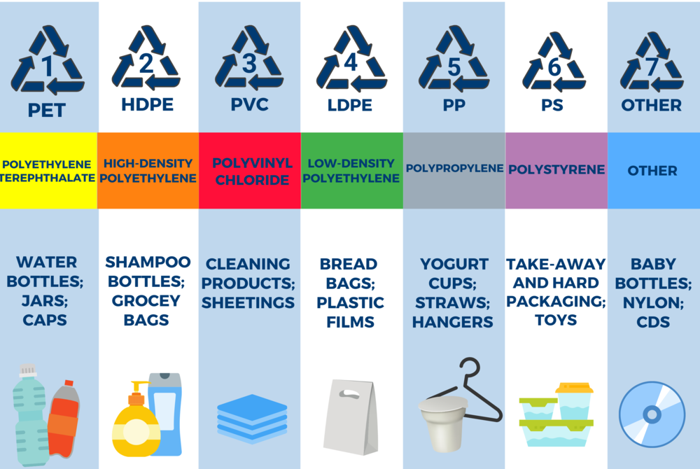
- Explain to them that the bolts (coal) will be going to make electricity (energy), and the paperclips are what we want to make the polymers
- Explain the different colors can make different polymers

Polymerization Activity Information Sheet

Protocol:
- Have all the kids try link the paper clips together.
- Stick to one color at a time at first. Then they can start linking 2 colors together to make different composition polymers.
- Ask them to come up with different ways of linking paper clips other than a simple chain. Draw the structure they find on the paper.
- Try to squeeze multiple chains together and then pull out one of these chains.

Thought Provoking Questions:
- What is the shape of chain of paperclips? (Like a snake)
- What happens when multiple chains are linked together
- What are the categories of the special structures they can summarize? (branched, looped, tree-like)

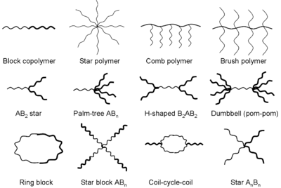
Key Takeaways:
- Polymers are long objects that look like a snake.
- The polymer melt can be jammed and hard to process.
There are many ways one can put the polymer chains together
Molding/Extruder Activity Information Sheet

Protocol:
- Each group will have 3 tubs of the same color play doh, 2 molds, 2 extruders
- Every kid in the group will be asked to split play doh into pieces following the worksheet
- Each kid will be asked to weigh their initial amount of play doh, weight after extrusion – some WILL get stuck in the extruder. Discuss how sometimes material gets stuck in instrument. In – Out= Acummulation (Stuck material)
- Each kid will be asked to guess how many pieces required for each mold and compared to how many used and finally take the difference in pieces between mold 1 and 2 (subtract pieces of mold 2 from pieces of mold 1 – whichever gives a positive integer since we’re not sure if they’ve covered negative numbers yet).

Thought Provoking Questions:
- What is extrusion?
  - Kid friendly definition: is a way of making objects by pushing a material (say play-doh) out of pre-made hole of a known size and shape.
- What is this used in real life for?
  - Can give them example of food – Pasta is extruded when it’s made, Cheetos are extruded, frosting is extruded when piped unto a cake, when you use toothpaste in the morning you are extruding it out of the tube. Straws are made via an extrusion process.
- What are molds used for?
  - Can go back to food examples – chocolate, lollipops, pie crust
  - Non food examples: water bottles, plastic toys, milk jugs, laundry detergent containers

Key Takeaways:
- The extrusion and molding process allows us to convert raw materials into something useful.
- The extrusion and molding process is used at both a large scale say water bottle manufacturing to as small as frosting a cake in your own home.
- Sometimes material can accumulate in our mold or extruder leading to differences in what we put in compared to what we get out.

