

Transportation Infrastructure Precast Innovation Center (TRANS-IPIC)

# University Transportation Center (UTC)

*Unveiling synergistic effects of Nano-modification and CO2 curing on the durability and carbon footprint of precast elements*

*PU-23-RP-02*

Quarterly Progress Report

For the performance period ending *09/30/2024*

## Submitted by:

*Mirian Velay-Lizancos (PI), Lyles School of Civil Engineering,* [*mvelayli@purdue.edu*](mailto:mvelayli@purdue.edu) *Jan Olek (Co-PI), Lyles School of Civil Engineering,* [*olek@purdue.edu*](mailto:olek@purdue.edu)

*Raikhan Tokpatayeva(Co-PI), Lyles School of Civil Engineering,* [*rtokpata@purdue.edu*](mailto:rtokpata@purdue.edu) *Aniya Edwards, Lyles School of Civil Engineering,* [*edwar242@purdue.edu*](mailto:edwar242@purdue.edu) *Department: Civil Engineering*

*University: Purdue University*

## Collaborators / Partners:

*N/A*

## Submitted to:

TRANS-IPIC UTC

University of Illinois Urbana-Champaign Urbana, IL

# TRANS-IPIC Quarterly Progress Report:

## Project Description:

1. **Research Plan - Statement of Problem**

The optimization of the application of new technologies and novel materials in precast concrete elements plays a crucial role in advancing the precast industry towards a greener future. The enhancement of durability and the reduction of carbon footprint of precast concrete elements are two of the main paths towards this advancement.

Both CO2 curing (a precast treatment) and the use of nano-additives enhance the strength and reduce the porosity of cementitious composites, enhancing the durability of the concrete elements. However, CO2 curing and nano-modification may interfere with each other if used simultaneously, especially considering that the addition of nanoparticles my affect the size of calcium hydroxide crystals, which react with the CO2 during the CO2 curing process. Thus, understanding the interactions between these two approaches is vital to leverage and maximize the advantages of the application of these approaches to produce superior quality precast concrete elements in terms of durability and sustainability.

## Research Plan - Summary of Project Activities (Tasks)

To achieve the objectives of Phase I of this project, a systematic research approach will be followed, consisting of the following tasks:

***Task 1. Characterization of the materials.*** This task will involve the physical and chemical characterization of the nanoparticles, the aggregates, and the cement to be used in this study, according to the relevant standards for each type of the proposed material. Particle size, oxide and mineralogical content analyses will be performed.

***Task 2. Preparation of specimens and curing process.*** Concrete, mortar and cement paste mixtures with 0%, 0.5%, 1%, and 2% of nanoparticles by mass of cement and two different water-to-cement ratios will be used in this study. Two different nanomaterials will be used: nano-silica and carbon black. Thus, a total of 14 different mixtures will be studied for each cementitious composite (paste, mortar and concrete). Specimens will be used to perform microstructural analysis, chemical analysis, and to determine the compressive strength development, transport properties and durability performance. Two different curing conditions and times will be examined: (i) standard curing at 21 ± 1 °C and 50% ± 5% RH (for reference), (ii) CO2 curing (20% concentration) for 12 hours (from age 24h to 36h) at a temperature of 23±1 °C and 50%±5% RH.

***Task 3. Analysis of hydration process, porosity and microstructure.*** Microscopic Image analysis of the polished section of concrete will be used as a direct quantification of pore volume, whereas water absorption and density tests will be applied for evaluation of other parameters of the pore structure (ASTM C642 1, ASTM C1585) 2. Besides, the microstructure of samples will be investigated through Scanning Electron Microscopy (SEM). The hydration kinetics and hydration products of the pastes will be estimated by Isothermal Calorimeter test (IC), Thermogravimetric (TGA) and X-ray diffraction (XRD) analyses.

***Tasks 4. Evaluation of transport properties.*** The bulk electrical resistivity and formation factor of the concrete samples will be estimated as per ASTM 1876-19. The Rapid Chloride

permeability test (ASTM C1202 3) will be used to evaluate the resistance of the concretes to chloride ions ingress. The transport properties will be assessed through the analysis of the results of this section in combination with the results from water absorption test performed in task 3.

***Tasks 5. Compressive strength of mortars and concretes.*** Compressive strength tests will be performed for each mixture design at 3, 7, and 28 days according to ASTM C39 4.

***Task 6. Analysis of the results*.** A comparative analysis of the test results from tasks 1 to 5 for samples with and without nanoparticles and with and without CO2 curing will be carried out. Then, the interconnection of the results of the different tests will be analyzed to acquire a deeper understanding on the combined effect of nanoparticle addition and CO2 curing; This task will help understanding the synergistic effects of CO2 curing and nanomodification on the concrete's properties, providing insights into the optimal combination.

***Task 7. Draft of the report, Review and submission of Final report.*** This task will consist of the preparation, revision and submission of the final report of the project, summarizing the research findings, methodologies, conclusions and recommendations.

## Project Progress:

1. **Progress for each research task**

**Note:** It is noteworthy that the delay in funding assignment has affected the progress of the first quarter. It is planned to accelerate the pace.

***Task 1. Characterization of the Materials [98% Completed]***

The physical characterization and composition of the nanoparticles and aggregates were analyzed.

In terms of testing of nanoparticles, the BolderBlack Recovered Carbon Black Powder provided by Bolder Industries and E5 CB8 Aqueous Nanosilica Solution provided by Nouryon were evaluated.

### Particle Size Analysis of nanomaterials with Transmission Electron Microscopy (TEM)

Procedure: A Tecnai T20 Transmission Electron Microscope was used to obtain the images. Particle suspensions were deposited on copper grids for analysis. ImageJ software in combination with the Labkit plugin was used to quantify the diameter of silica and recovered carbon black nanoparticles. Note that particle size analysis with laser diffraction was reported in the previous progress report.

Results: Figure 1 shows TEM images of the Levasil CB8 nanosilica sample. Nanosilica particles were found to range from 10-90nm in diameter. Using the figures below, the

average diameter of nanosilica particles was calculated to be approximately 20 nanometers.

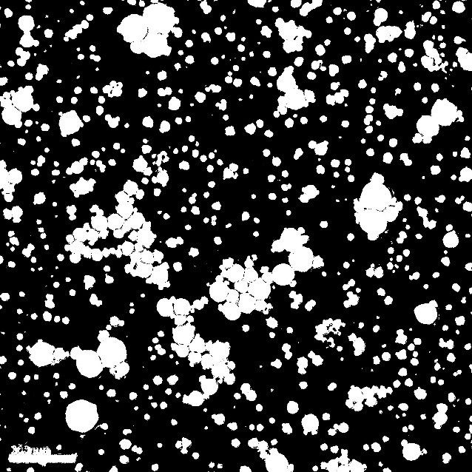

(b)

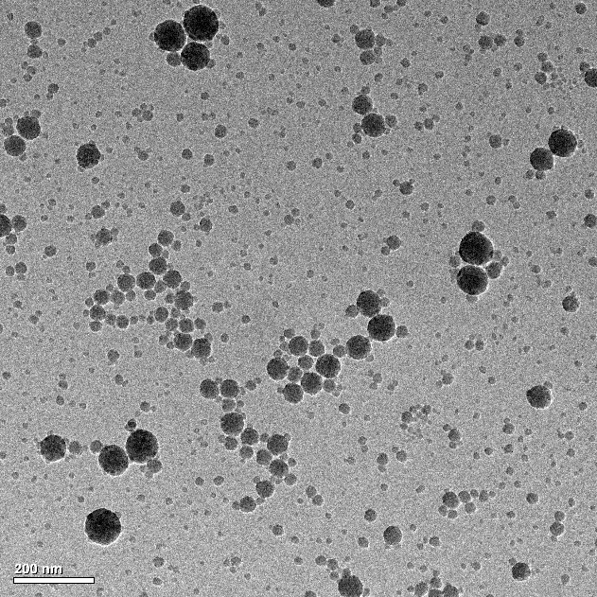

(a)

Figure 1. TEM image of Levasil CB8. (a) Received Image (b) ImageJ Contrast Image used for Analysis

Figure 2 shows TEM images of the BolderBlack Recovered Carbon Black sample. Particle diameters range from 5 to 100 nanometers.

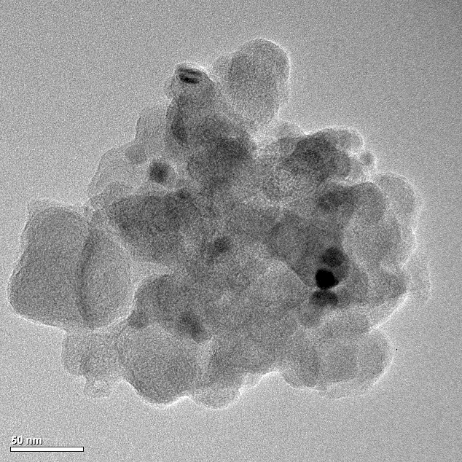

Figure 2. TEM image of BolderBlack Recovered Carbo Black Agglomerate.

### Particle Size Analysis of aggregates with Sieve Testing

Procedure: ASTM C13612 and AASHTO T2710 were used to perform sieve analysis on coarse aggregates. The first testing reported in the first quarter progress report was done

using only 4000 g of coarse aggregate. Due to the maximum size of the aggregate, a second test was conducted with a sample mass of 6000 g to comply with the minimum weight needed for a No. 8 Coarse Aggregate as per AASHTO T2710. Note that the determination of the gradation of fine aggregate was already completed and reported in the previous progress report.

Results: Figure 3 shows the gradation curve of coarse aggregates obtained in each test. It was observed that the maximum size of the aggregate is 1 inch and approximately 80% of the aggregate passing through a ¾ inch sieve. According to the *INDOT Aggregate Specifications 202311* this is a representative Coarse Aggregate Graded No. 8.

100%



4000 g Test

6000 g Test

INDOT No. 8 Boundary

Cumulative Percent Passing By Weight (%)

80%

60%

40%

20%

0%

Pan 2.36 4.75 9.5 12.5 19 25

Sieve Size (mm)

Figure 3. Gradation Curve of Coarse Aggregates

### Determination of solid part in the Nanosilica Solution

Procedure: To determine the solid concentration of nanosilica in aqueous dispersion, the colloidal nanosilica was weighted before and after drying it to constant mass (See Figure 4). The masses were used to determine the concentration and density of nanosilica in aqueous dispersion.

Results: Manufacturer safety data sheets detail the mass concentration of nanosilica to range from 50%-70% and density of the overall solution to be approximately 1.4 kg/m3. Experimental concentrations revealed that the concentration of solution tested was in range.

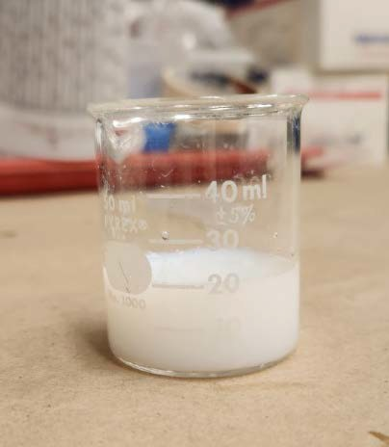 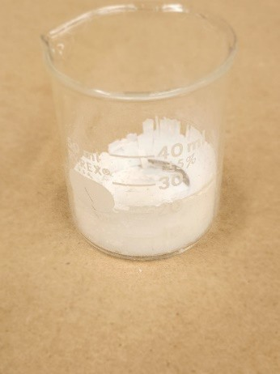

Figure 4. 20mL of CB8 Pre (left) and Post (right) Evaporation of Water

### Relative Density of Aggregates

Procedure: ASTM C127 was used to evaluate the relative density of the coarse aggregate. ASTM C12813 was used to evaluate the relative density and absorption of fine aggregates.

Results: Manufacturer reported values for coarse aggregates are a saturated surface dry relative density of 2.75 and an absorption of 1.39%.

The saturated surface dry relative density for coarse aggregate based on the lab data results were 2.61 (first test) and 2.72 (second test). In terms of water absorption, the results in the lab were 2.82% (first test) and 0.97% (second test).

Manufacturer reported values for fine aggregates are a saturated surface dry relative density of 2.65 and an absorption of 1.54%. Results from experiments result in an average saturated surface dry relative density of 2.697 and an average absorption of 1.21%.

Task 2. *Preparation of specimens and curing process* [30% Completed]

14 mixtures for concretes, mortars, and pastes were designed (Table 1). For each mixture, it is planned to cast 8 cement paste samples, 20 mortar samples, and 28 concrete samples.

The designation of each sample (See Figures 5, 6, and 7) are as follows:

* For pastes, 6 samples will be cast for Thermogravimetric Analysis (TGA) at 3, 7, and

28 days (2 per age and mixture). 2 samples will be cast for Scanning Electron Microscopy (SEM).

* For mortars, 18 samples will be cast for compressive testing at 3, 7, and 28 days (6 per age and mortar type). 2 samples will be cast for SEM.
* For concretes, 18 samples will be cast to test compressive strength at 3, 7, and 28 days (6 per age and concrete type; 3 cured at standard conditions and 3 with CO2 curing). 4 samples will be used to test resistivity at 3 and 28 days. 2 samples are to be made for pore volume analysis. 2 samples are to be made for absorption and density analysis. 2 samples are to be made for SEM.

The naming convention of these samples are in the structure summarized in Table 1.

Table 1. Mixture design designation

|  |  |  |  |  |  |
| --- | --- | --- | --- | --- | --- |
| **Material -** | **Nanomaterial** | **% Nano material by Cement Weight** | **(WC)** | **Curing Condition -** | **Sample No.** |
| P  (Paste) | R  (Reference) | 0.5 | 0.42 | N  (Standard Cure) |  |
| M  (Mortar) | NS  (Nanosilica) | 1 |  |  | # |
| C  (Concrete) | CB  (Carbon Black) | 2 | 0.48 | C  (CO2 Cure) |  |

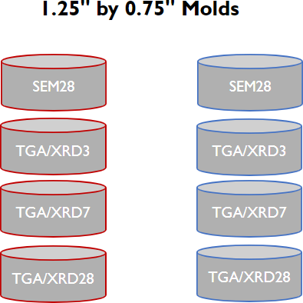

Figure 5. Diagram of Paste Samples to be Made Per Batch*

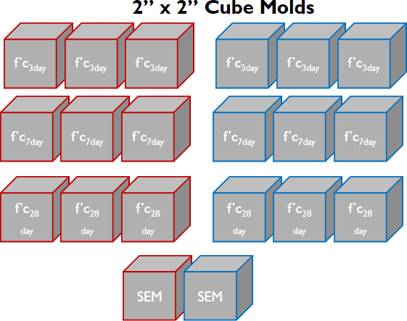

Figure 6. Diagram of Mortar Samples to be Made Per Batch*

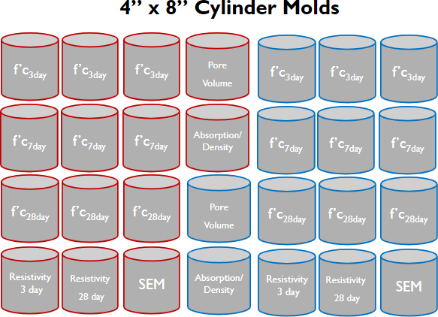

Figure 7. Diagram of Concrete Samples to be Made Per Batch*

*\*Samples outlined in blue represent samples to be CO*2 *cured. Samples outlined in red represent samples to be standard cured.*

### Mix Designs

Concrete reference mix designs at a water-to-cement ratio of 0.42 were formulated to be Class C concretes per *2022 INDOT Standard Specifications Section 70214*. Concrete reference mix designs at a water-to-cement ratio of 0.48 were formulated with an adjustment to contain the same volume of paste as those of a 0.42 water-to-cement ratio. Mortar reference mix designs were formulated per ASTM C181015. It is expected that superplasticizer or water reducing admixtures will be used for samples with 0.42 water-to- cement ratios.

### Material Preparation: Carbon Black Dispersion

Procedure: Two methods were used as a trial to determine the best way to disperse the carbon black in cement samples.

The first method consisted of dry mixing the carbon black in a bowl with cement powder (see Figure 8). After thoroughly mixing them, the mix procedure described in ASTM C30516 is followed, treating the carbon black as a part of the cement.

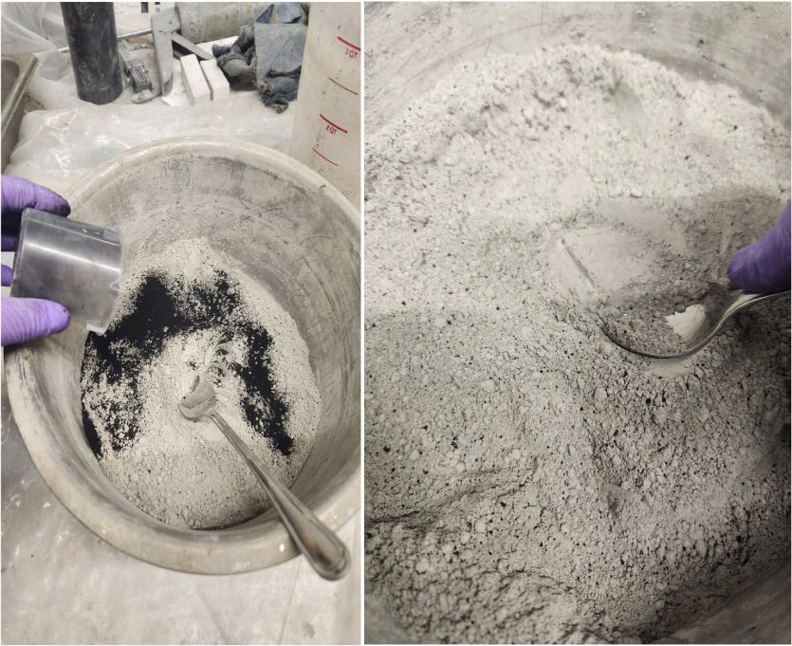

Figure 8. Method One: Dry Mixing BolderBlack with Type IL Cement

The second method consists of high shear mixing carbon black in a portion of the mixing water required for the batch (see Figure 9). The mixture is then added to the rest of the mixing water, and ASTM C305 is followed in case of cement paste and mortars.

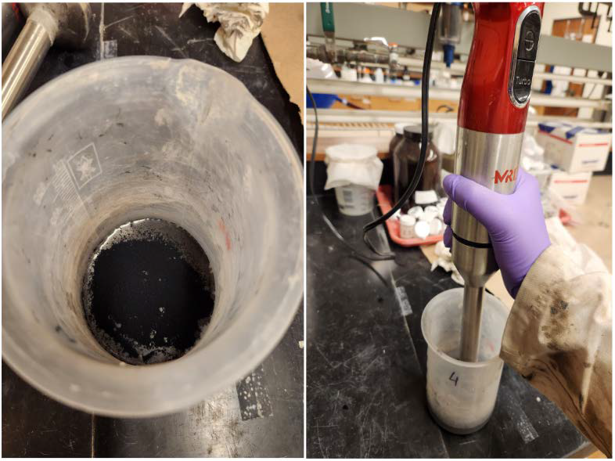

Figure 9. Method Two: High Shear Mixing of Cabon Black in Mix Water

Results: A trial following the second method was conducted using 10 grams of carbon black. The mixture was left idle after mixing for 10 minutes to ensure that the carbon black particles did not settle to the bottom (See Figure 10).

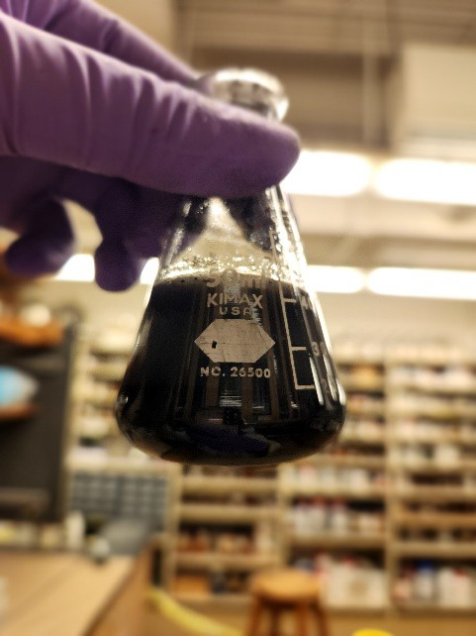

Figure 10. Stable BolderBlack Water after High Shear Mixing

After placing the pastes in molds, carbon black water formed a marbled surface on samples made with both methods. This is attributed to the appearance of a bleed water, which carried mixed carbon black to the paste's surface.

Paste samples were made using both methods. Images of their cross sections are shown below (see Figures 11 and 12).

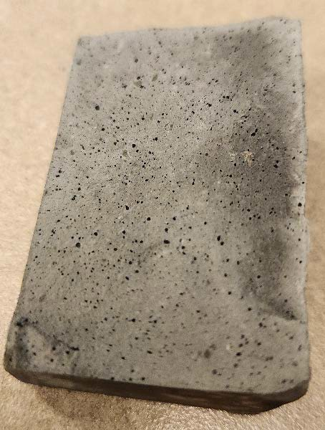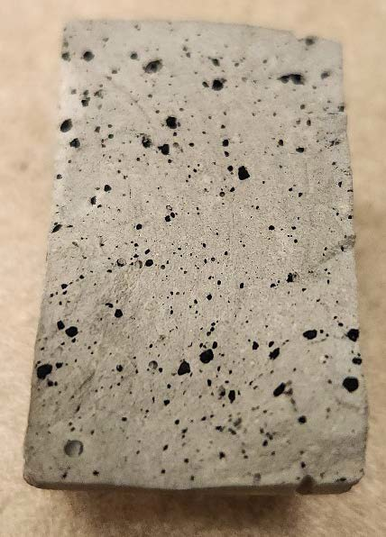

Figure 11 (left). Cross-Section of Paste Made with High Shear Mixing (Method Two) Figure 12 (right). Cross-Section of Paste Made with Dry Mixing (Method One)

Carbon black agglomerations are more common in the matrix of pastes made using the dry mixing than in pasted with high shear mixing preparation for carbon black dispersion (Figure 11). Using an optical microscope, it was observed that many of the small black dots observed in the high shear mix preparation are pores and not carbon black agglomerates. All samples to be used for testing will be made using the high shear rate mixture dispersion method. It should be noted that other methods using sonication and the addition of superplasticizers are likely to be explored in future stages of the research.

### Mixing, Casting and Curing of Specimens

Procedure: Pastes and Mortars were mixed and prepared per ASTM C305. Slump and spread of mortars were measured and collected per ASTM C1810.

After mixing and casting, the samples were cured under a tarp in the molds for 12 hours. Samples were then transported to an environmental chamber at 50%RH and left to cure for an additional 12 hours. Next, half of the samples were placed in a VWR Symphony CO2 curing chamber at 23°C with an RH of 95%±5% and CO2 concentration of 20% for 12 hrs. The other half of samples were placed in a wet chamber with an RH of 95%±5% for 12 hrs. After this 12-hour period, all samples were placed in the wet chamber to cure until their corresponding tests. A diagram of this process is provided in Figure 13.

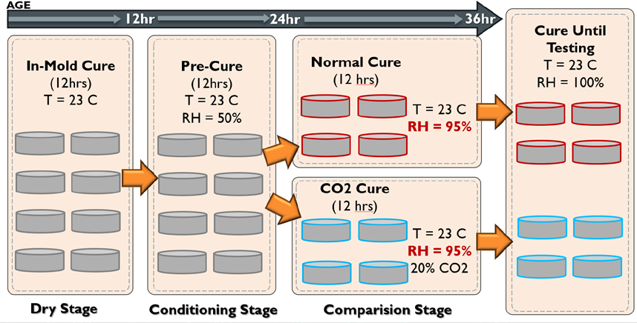

Figure 13. Current Method of Curing Samples over the First 36 Hours of Hydration

Results:

The weight changes due to CO2 exposure were not significant, potentially due to the high RH in the CO2 chamber, that may reduce the extent of carbonation due to the saturation of the pores with water. Thus, all batches will be mixed again using the initial proposed relative humidity of 50% during CO2 curing (see Figure 14.). In this quarter, 7 out of 14 paste mixtures and 4 out of 14 mortar batches were prepared and cured using this new approach. In the next quarter, the rest of the mixtures will be mixed and tested.

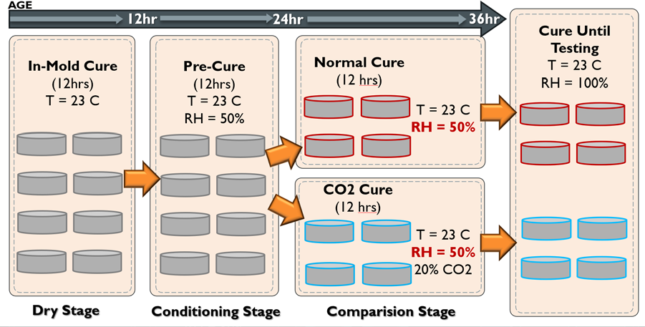

Figure 14. New Method of Curing Samples over the First 36 Hours of Hydration

### Maintenance of Relative Humidity in CO2 Chamber

Procedure: Following the guidelines established in *Solutions for Maintaining Constant Relative Humidity14*, 200g of sodium bromide (NaBr) was added to a bowl of 200mL of waterto achieve a target 50%±10% relative humidity. The solution was mixed with a glass stirring rod so that no clumps of NaBr were left in the solution. The bowl was placed in the CO2 chamber. Temperature and relative humidity were monitored using a LogTag Humidity and Temperature Recorder during the comparison stage.

Results: Humidity over the 24-hour period ranged from 77% to 41%. To maintain 50% relative humidity, the water from the NaBr bowl was removed from the solution by drying it in an oven at 40°C for 48 hours, and the remaining NaBr was placed into the curing chamber. This successfully lowered the relative humidity to a sustained 50%±10%. Wiping condensation from the interior surface of the chamber also helped lower the relative humidity. However, adding mortar samples to the chamber during the 12hour comparison stage increased humidity in the chamber by at least 50%. An additional 200 g of NaBr was added to the chamber during these stages to reduce humidity, but this only reduced humidity by a maximum of 5%.

The high relative humidity within the chamber might result in saturation of the samples, which can reduce the occurrence of carbonation. In future experiments, silica desiccants in conjunction with sodium bromide will be used to reduce humidity to the target 50% range during the comparison stage. This method will be used to cure CO2 samples for future experiments.

Task 3. *Analysis of hydration process, porosity and microstructure* [10% Completed]

### Isothermal Calorimetry (IC) of Pastes

A *TAM Air* calorimeter was used in conjunction with ASTM C170218 to perform IC of pastes at 0.48 water to cement ratio. The IC test was performed for 7 days at room temperature (23°C). From the heat flow curves, total heat of hydration and thermal setting times were determined for each mix.

### Thermogravimetric Analysis (TGA) of Pastes

TGA was performed on pastes of type P-R(0.48), P-NS(0.48), and P-CB(0.48) at an age of 3 days along with pastes of type P-R(0.48)SC at an age of 7 days. The amount of Ca(OH)2 and (CH) was quantified as per the *Kim and Olek method*19 for each mix.

Tasks 4. *Evaluation of transport properties.* [0% Completed]

Tasks 5. *Compressive strength of mortars and concretes.* [10% Completed]

### Compressive Strength of Mortars

Using ASTM C109, compressive tests were performed on mortars of type M-R(0.48), M- NS2(0.48), M-CB2(0.48), and M-CB0.5(0.48) at 3-day and 7-day ages. The average compressive strength of mortar specimens was then calculated.

Task 6. *Analysis of the results.* [25% Completed]. Initial analysis of the results of Task 1 and Task 2 was done.

Task 7. *Draft of the report, Review and submission of Final report.* [0% Completed]

## Percent of research project completed.

Approximately 25% of the total project has been completed this quarter. It is noteworthy to observe that the delay in funding transfer has affected the progress of the second quarter.

## Expected progress for next quarter

By the end of next quarter, July 1st of 2024, 60% of this project is expected to be completed.

Task 1. *Characterization of the Materials* [100% completed]: XRD will be performed on evaporated nanosilica dust.

Task 2. *Preparation of specimens and curing process* [70-80% completed]: All cement paste and mortar samples will be mixed and cured. At least 40% of concrete specimens will be prepared.

Task 3. *Analysis of hydration process, porosity and microstructure* [60% completed]: The hydration kinetics and hydration products of at least 80% of the cement pastes will be assessed by Isothermal Calorimeter test (IC), Thermogravimetric (TGA) and X-ray diffraction (XRD) analyses.

Task 4. *Evaluation of transport properties.* [50% completed].

Task 5. *Compressive strength of mortars and concretes.* [60% completed]: Compression tests of 75% of mortar samples will be completed. Compression tests of 25% of concrete samples will be completed.

Task 6. *Analysis of the results.* [60% Completed]: Initial analysis of the results of the completed test will be performed.

Task 7. *Draft of the report, Review and submission of Final report.* [20% Completed]

## Educational outreach and workforce development

The educational outreach and workforce development plan was outlined in the previous quarterly progress report. In Fall it is planned to have an engineering research event in a High School offered by the graduate student working on the project. Initial conversations between the administration of the High School and the students have started.

## Technology Transfer

*No progress on technology transfer yet.*

## Research Contribution:

1. **Number of papers**

*No papers were published during this quarter.*

## Number presentations.

*No presentations were done during this quarter. It is expected to have one during the next quarter.*

## References:

1. ASTM. C642-21 Standard Test Method for Density, Absorption, and Voids in Hardened Concrete. *ASTM Int*. Published online 2021:1-3. doi:10.1520/C0642-21.2
2. ASTM. C1585-20 Standard Test Method for Measurement of Rate of Absorption of Water by Hydraulic Cement Concretes. *ASTM Int*. Published online 2020:1-6. doi:10.1520/C1585- 20.2
3. ASTM. C1202-22e1 Standard Test Method for Electrical Indication of Concrete’s Ability to Resist Chloride Ion Penetration. *ASTM*. Published online 2022:1-8. doi:10.1520/C1202- 22E01.2
4. ASTM. C39/39M-21 Standard Test Method for Compressive Strength of Cylindrical Concrete Specimens. *ASTM Int*. Published online 2021:1-5. doi:10.1520/C0039
5. ASTM. D3849-22 Standard Test Method for Carbon Black—Morphological Characterization of Carbon Black Using Electron Microscopy. *ASTM Int*. Published online 2022:7-13. doi:12.3023/D3849-22
6. Ungár, T., Gubicza, J., Ribárik, G., Pantea, C., & Zerda, T. W. (2002). Microstructure of carbon blacks determined by X-ray diffraction profile analysis. Carbon, 40(6), 929–937. https://doi.org/10.1016/s0008-6223(01)00224-x
7. Small Volume Unit (SVU) with Kalliope Instruction Manual. Anton Paar Document Finder. Accessed December 29, 2023. [https://www.anton-paar.com/corp-en/services-](https://www.anton-paar.com/corp-en/services-support/document-finder/psa-series/) [support/document-finder/psa-series/](https://www.anton-paar.com/corp-en/services-support/document-finder/psa-series/).
8. ASTM C127 Standard test method for relative density (specific gravity) and absorption of coarse aggregate. *ASTM Int*. Accessed December 30, 2023.

<https://www.astm.org/standards/c127>.

1. ASTM E3294 - 23. Standard Guide for Forensic Analysis of geological materials by powder X- ray diffraction. *ASTM Int*. Accessed December 30, 2023. [https://www.astm.org/e3294-](https://www.astm.org/e3294-22.html)

[22.html](https://www.astm.org/e3294-22.html).

1. Sieve analysis of fine and coarse aggregates AASHTO T 27 - in.gov. Accessed December 30, 2023. <https://www.in.gov/indot/div/mt/aashto/testmethods/aashto_t27.pdf>.
2. INDOT. INDOT aggregate specifications 2023 - in.gov 2023. Accessed December 30, 2023.

[https://www.in.gov/indot/doing-business-with-](https://www.in.gov/indot/doing-business-with-indot/files/Aggregate_Specification_Chart.pdf) [indot/files/Aggregate_Specification_Chart.pdf](https://www.in.gov/indot/doing-business-with-indot/files/Aggregate_Specification_Chart.pdf).

1. ASTM C136 Standard test method for sieve analysis of fine and coarse aggregates. *ASTM Int.*

Accessed December 30, 2023. <https://www.astm.org/standards/c136>.

1. ASTM C128-22 Standard Test Method for Relative Density (Specific Gravity) and Absorption of Fine Aggregate. *ASTM Int*. Accessed February 29, 2024.
2. INDOT. 2022 INDOT standard specifications*. INDOT*. Accessed February 29, 2024[https://www.in.gov/dot/div/contracts/standards/book/sep21/2022%20Standard%20Sp](https://www.in.gov/dot/div/contracts/standards/book/sep21/2022%20Standard%20Specificatins%20(w_changes).pdf) [ecificatins%20(w_changes).pdf](https://www.in.gov/dot/div/contracts/standards/book/sep21/2022%20Standard%20Specificatins%20(w_changes).pdf)
3. ASTM C1810/C1810M-23. Standard guide for comparing performance of concrete-making materials using mortar mixtures. *ASTM Int.* Accessed March 31, 2024.

https://[www.astm.org/Standards/C1810.htm](http://www.astm.org/Standards/C1810.htm)

1. ASTM C305. Standard practice for mechanical mixing of hydraulic cement pastes and mortars of plastic consistency. *ASTM Int.* Accessed March 31, 2024.

<https://compass.astm.org/document/?contentCode=ASTM%7CC0305-20%7Cen-US>

1. Carr, D. S., & Harris, B. L. (1949). Solutions for maintaining constant relative humidity. Industrial &amp; Engineering Chemistry, 41(9), 2014–2015. https://doi.org/10.1021/ie50477a042
2. ASTM C1702. Standard test method for measurement of heat of hydration of hydraulic cementitious materials using isothermal conduction calorimetry. *ASTM Int.* Accessed March 31, 2024. https:[//www.astm.org/c1702-17.html](http://www.astm.org/c1702-17.html)
3. T. Kim, J. Olek, “Effects of Sample Preparation and Interpretation of Thermogravimetric Curves on Calcium Hydroxide in Hydrated Pastes and Mortars”, *Transp. Res. Rec. J. Transp. Res. Board*, 10-18, 2290 (2012).