**Transportation Infrastructure Precast Innovation Center**

**(TRANS-IPIC)**

**University Transportation Center (UTC)**

*Bio-Inspired Solutions for Roadside Barriers: Exploring 3D Printing as Alternative Precast Technology*

*PU-23-RP-03*

Quarterly Progress Report

For the performance period ending *[04/01/2024]*

**Submitted by:**

**Jan Olek***1(*[*olek@purdue.edu*](mailto:olek@purdue.edu)*)***,**

**Jeff Youngblood***2(*[*jpyoungb@purdue.edu*](mailto:jpyoungb@purdue.edu)*)***,**

**Pablo Zavattieri***1(*[*zavattie@purdue.edu*](mailto:zavattie@purdue.edu) *)*

*1Lyles School of Civil Engineering, Purdue University*

*2School of Materials Engineering, Purdue University*

**Collaborators / Partners:**

**Submitted to:**

TRANS-IPIC UTC

University of Illinois Urbana-Champaign

Urbana, IL

**TRANS-IPIC Quarterly Progress Report:**

**Project Description:**

1. Research Plan - Statement of Problem

The continuous improvement of transportation infrastructure is imperative for ensuring the safety of road users and the overall efficiency of the transportation network. One of the key aspects of this enhancement involves incorporating impact-resistant structures in the construction and retrofitting of various infrastructure components [1] such as roadside barriers. Traditionally, rigid concrete barriers are favored over flexible alternatives in situations of high impact loads due to their capacity to withstand such forces. However, the inherent stiffness of reinforced concrete materials can lead to insufficient energy absorption, potentially resulting in vehicle rollovers or increased vehicle damage. This project aims to utilize 3D printing technology and bio-inspired design principles to enhance the energy absorption capacity of concrete barriers, thereby improving their ability to protect drivers and passengers during roadside impacts. This innovative approach holds promise for advancing road safety and enhancing the efficiency of transportation infrastructure.

1. Research Plan - Summary of Project Activities (Tasks)

*Task 1 - literature review and research plan development*

This task involves conducting a literature review and developing a comprehensive research plan. The literature review aims to explore existing studies, research, and knowledge relevant to the chosen research topic, specifically focusing on potential designs for concrete barriers. This step helps to select potential designs using principles of architected materials and bioinspired concepts, including architectures such as Bouligand and sinusoidal architecture to enhance impact resistant capacity.

*Task 2 – large scale 3DP system development*

This task involves developing innovative 3D printing techniques using our Large-Area Lab-Scale (LALS) printer and Large-Scale Robotic Arm (LSRA), which are tailored for precise and reliable production of the barriers using cement-based materials and additive manufacturing processes, ensuring structural integrity and desired functional properties.

Task 3 - Material development and testing for large scale 3DP system

The goal of this task is to develop a sustainable and cost-efficient concrete mixture for task 4 and other future works. The objective is to develop a mixture that will incorporate a high weight percentage replacement of cement by limestone filler, combined with cellulose nano materials as additives, with the goal of enhancing rheology and hardened mechanical properties, improving sustainability and durability, and increasing cost-efficiency.

*Task 4 – Sample fabrications and experimental testing*

This task includes using the 3D printing system and 3DP mixture developed in tasks 2 and 3 to prepare samples with bio-inspired architectures. These samples will undergo a series of rigorous mechanical and durability tests aimed at assessing the performance of the fabricated samples in real-world scenarios. Quasi-static and drop-tower impact testing will be employed to evaluate mechanical strength and impact resistance capacity. Additionally, durability testing, such as the evaluation of the chloride diffusion coefficient, will be conducted to gauge the long-term performance. This multifaceted testing approach ensures a thorough evaluation of the bio-inspired architectures, providing valuable insights into their mechanical, impact resistance, and durability characteristics.

**Project Progress:**

1. Progress for each research task

*Task 1 progress [100% completed]*

Roadside barriers are usually categorized as flexible, semi-rigid, or rigid, depending on their deflection characteristics resulting from an impact (Table 1). Flexible systems are generally more forgiving since much of the impact energy is dissipated by the deflection of the barrier and thus lower impact forces are imposed upon the vehicle. Traditionally, concrete barriers (rigid) are preferred over flexible barriers when there is high impact load. However, the inherent stiffness of reinforced concrete materials can lead to insufficient energy absorption. This will potentially result in vehicle rollovers for Jersey type barriers or increased vehicle damage for vertical type barriers. The first part of this project includes the development of sustainable and cost-effective mixture for 3D printing applications. The second part of this project will investigate the mechanical behavior of flat and sinusoidal Bouligand (herringbone) architectures (3D printed using mortar mixtures) as such architectures are known for their outstanding compressive stress-bearing and impact resistance capacity.

Table-1. Types of barriers from roadside design manual [2]

*Task 2 – large scale 3DP system development [100% completed]*

In this task, a comprehensive large-scale 3D printing (3DP) system has been developed. The system comprises an ABB robotic arm (ABB 6700), a high-pressure mortar pump (M-Tech Duo mix P20), and a high-performance extruder designed by the research group. We’ve successfully printed a wall with 7’(L) x 4’(H) x 0.5’(W) using the 3D printing system (Figure-1). Details of the systems are included in the previous progress report.

Figure-1. A 7’(L) x 4’(H) x 0.5’(W) wall printed with the large scale 3DP system

*Task 3 - Material development and testing for large scale 3DP system 70% completed]*

This task includes development of a mixture for large scale 3DP applications using natural and cost-effective cellulose nanofiber (CNF) and high weight replacement of cement with limestone filler. The main objective is to develop a mixture with enhanced rheological and hardened mechanical properties, improved sustainability and durability, and cost effective.

The influence of CNF and limestone filler on the rheological properties was investigated in this study. As shown in Figure-2, 11LF represents 11% limestone filler that already exists in the Type IL cement used in this study. 40LF represents 40 wt% of cement that is replaced with limestone filler. CNF additions (0.15%, 0.3%) are calculated with respect to the dry weight of the total binder materials.

As depicted in Figure-2, the static yield stress for the mixture without CNF and with 11% limestone filler is 181 Pa, while with a 0.3% CNF addition, the static yield stress improved to 1634 Pa. The addition of 0.3 wt% CNF resulted in a remarkable (~800%) increase in the static yield stress. Moreover, nano clay is a widely studied additive for 3D printing applications, and therefore, it's meaningful to compare the results between CNF and nano clay. If the weight percent additions of the additives are normalized to 1%, the addition of nano clay yielded a static yield stress enhancement of ~400 Pa / 1 wt.% [3], whereas the incorporation of CNF increased the yield stress by ~4500 Pa / 1 wt.%. The enhancement achieved by CNF is notably ten times greater than that induced by nano clay. The addition of CNF did not have a significant influence on the storage modulus, whereas the incorporation of limestone filler increased it by approximately 300%. These notable enhancements hold promise for developing mixtures with superior rheological properties, thereby potentially enhancing both buildability and buckling resistance.

Figure-2. Static yield strength and storage modulus values of materials with different weight percentages (11%, 40%) of cement replaced with limestone filler and varying additions of CNF(0.15%, 0.3%)

A geometry featuring a substantial overhang was developed, with the assumption that achieving successful printing of this geometry will require mixture with high static yield strength and stiffness. Figure 3 illustrates 3D printing outcomes using different mixtures. Figure 3(a) depicts a mixture composed entirely of cement and sand, i.e., without CNF and limestone filler. Due to low stiffness and static yield stress of this mixture, the sample failed during printing. In Figure 3(b), a mixture with 40 wt % replacement of cement with limestone filler, without CNF, was utilized, resulting in failure after 12 layers. While buildability improved due to enhanced stiffness, the low static yield stress led to failure. Finally, in Figure 3(c), a mixture incorporating 40 wt % replacement of cement with limestone filler and 0.3% addition CNF (with respect to the dry weight of the binder) was employed, significantly enhancing buildability owing to significant improvements in stiffness and static yield stress. The development of such a mixture holds substantial promise for enhancing the cost-effectiveness and sustainability of 3D printing materials.

Some significant challenges we are facing with the current 3D printing mixture are the weak rheological properties, as well as the requirement of high cement usage and various costly additives. The poor rheological properties will limit buildability and design freedom, especially when fabricating samples with complex bio-inspired architectures. The high cement usage and various costly additives make the material more expensive than regular concrete, thereby limiting the application of this technology to large-scale structures. In this study, we developed a material with significantly enhanced rheological properties, which can help promote the design for architected cement-based materials. In the meantime, the mechanical properties are also enhanced by cellulose nano fibers. More importantly, we used cost-effective CNF fibers and limestone filler to reduce cement usage and the general cost of the mixture. These achievements can promote 3D printing technology and architected cement-based materials closer to real-world applications such as roadside barriers.

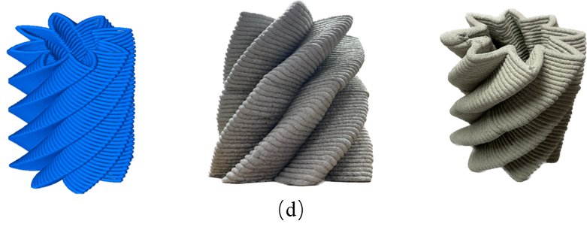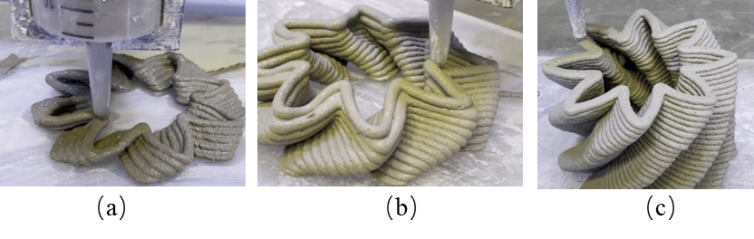

Figure-3. 3D printing with different mixtures: (a) plain mixture -no limestone filler and no CNF (b) 40 wt % replacement of cement with limestone filler and no CNF (c) 40 wt % replacement of cement with limestone filler and 0.3% addition of CNF(d) schematics and example of successfully printed sample

*Task 4 - Architected Sample fabrications and mechanical testing [20% completed]*

This task started with the development of toolpaths for sinusoidal Bouligand (herringbone) architectures. Two distinct tool paths were programmed and evaluated to attain the desired sinusoidal shape. Under Toolpath #1, the nozzle movement adhered to the sinusoidal pattern. Nevertheless, it was noted that the sample deviated from its intended shape as the printing progressed, as depicted in Figure-4(a). To address this deviation and ensure precision, Toolpath #2 was devised with adjusted printing parameters considering the geometry of the extruder and support base. Employing this optimized tool path resulted in the successful maintenance of the sinusoidal shape throughout the fabrication process (Figure-4(b)).

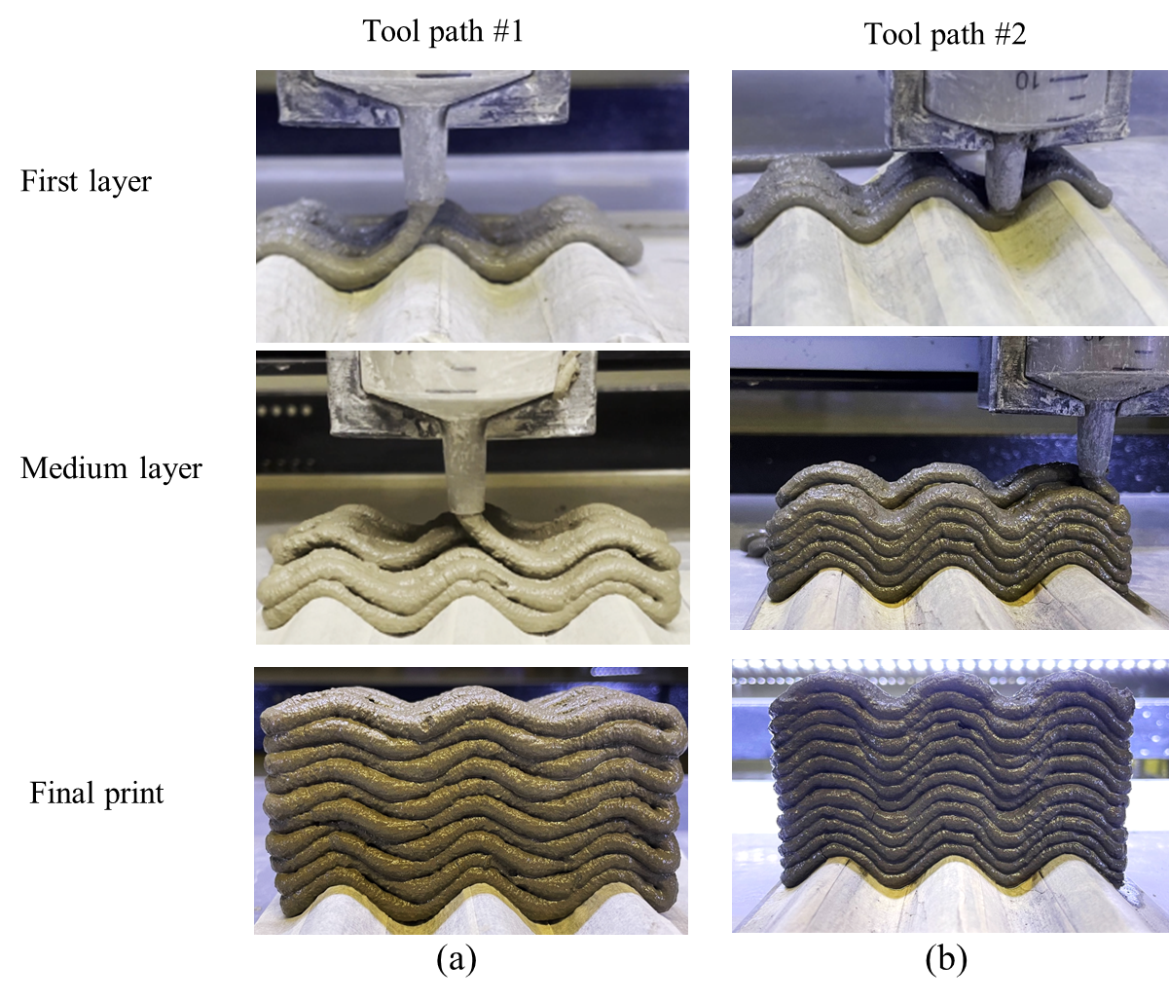

Figure-4. Tool path study for sinusoidal Bouligand (herringbone) architectures

1. Percent of research project completed.

Approximately 30% of the entire project has been completed. This milestone marks a significant achievement, particularly as we have successfully tackled some of the more high-risk tasks thus far. The remainder of the project involves tasks that we perceive as lower risk, as we will primarily focus on developing new samples with bioinspired designs for larger-scale testing under dynamic conditions. Fortunately, this aligns with our expertise, and we can adhere to standard procedures for dynamic testing. Looking ahead, the second year of the project will be pivotal, and our team is ready to execute the tasks outlined for year 2.

1. Expected progress for next quarter.

In the upcoming quarter, our focus will be on completing the material development phase tailored specifically for 3D printing applications. A significant challenge we face with the current 3D printing mixture is the utilization of a large volume of binder and costly additives. We will solve this by developing a mixture that not only enhances rheological and hardened properties but also optimizes cost-effectiveness and sustainability for large-scale 3D printing applications. Our aim is to achieve these improvements while concurrently reducing cement usage. Additionally, we will proceed with fabricating architected samples and conducting mechanical tests on these specimens.

1. Educational outreach and workforce development

Three undergraduate students, Taylor, Linda, Geiser Elizabeth Huatian, and Mathew, Sherine, actively contributed to the research activities. They assisted in conducting material testing and actively participated in large-scale 3D printing activities. Besides, the research team is offering a 3D printing class, CE 497 - 3D Printing for Infrastructure Applications at the Lyles School of Civil Engineering at Purdue University. The enrollment in the course is 23 students.

1. Technology Transfer

None to date

**Research Contributions:**

1. Number of papers

Two papers under preparation:

* Y. Wang, A. Douba, J. Olek, J. Youngblood, P. Zavattieri, Bio-inspired Sinusoidal Helicoidal Architecture in Additively Manufactured Cementitious Materials.
* Y. Wang, A. Douba, J. Olek, J. Youngblood, P. Zavattieri, Sustainable Cementitious Composite Containing Cellulose Nano Fiber and Limestone Filler for Concrete 3D-Printing.

1. Number presentations

* Y. Wang, A. Douba, J. Olek, J. Youngblood, P. Zavattieri (2024) “Sustainable cementitious composite containing cellulose nano fibers and limestone filler for concrete 3D-Printing”, American Concrete Institute (ACI) Spring 24 convention, New Orleans, LA.
* Y. Wang, P. Zavattieri, J. Olek, J. Youngblood, Bio-Inspired Solutions for Roadside Barriers: Exploring 3D Printing as Alternative Precast Technology, UTC Presentation (online), March 4, 2024
* P. Zavattieri, J. Youngblood, Nature-Inspired 3D Printing for Sustainable Infrastructure: From Design Concepts to Large-Scale Application, 3D Printing Natural Materials to Unlock Complex Nature-Inspired Infrastructure Collaborative Workshop: 7-8 Feb 2024, EWN, US Army Corp of Engineers (RDEC)

**References:**

[1] Roy, S., Unobe, I., & Sorensen, A. D. (2021). Vehicle-impact damage of reinforced concrete bridge piers: a state-of-the art review. Journal of Performance of Constructed Facilities, 35(5), 03121001.

[2] Transportation Officials. Task Force for Roadside Safety. (2011). Roadside design guide. AASHTO.

[3] Douba, A., Ma, S., & Kawashima, S. (2022). Rheology of fresh cement pastes modified with nanoclay-coated cements. Cement and Concrete Composites, 125, 104301.