**Transportation Infrastructure Precast Innovation Center**

**(TRANS-IPIC)**

**University Transportation Center (UTC)**

IFC-based BIM for Robotic Installation of Precast Bridge Components

*[PU-24-EP-01]*

Quarterly Progress Report

For the performance period ending *March 31, 2025*

**Submitted by:**

Jiansong Zhang, [zhan3062@purdue.edu](mailto:zhan3062@purdue.edu)

School of Construction Management Technology

Purdue University

Hubo Cai, [hubocai@purdue.edu](mailto:hubocai@purdue.edu)

Lyles School of Civil Engineering

Purdue University

**Collaborators / Partners:**

Atlas Excavating; Milestone Contractors; Force Construction; Kelley Construction; Walsh Group; Aldridge Electric; Superior Construction; FH Paschen; Indiana Constructors

**Submitted to:**

TRANS-IPIC UTC

University of Illinois Urbana-Champaign

Urbana, IL

**TRANS-IPIC Quarterly Progress Report (Section 1 – 7, 5 pages max.):**

**Project Description:**

1. Research Plan - Statement of Problem

Precast bridge projects have been widely adopted by US DOT agencies to accelerate construction, minimize traffic disruptions, and enhance structural quality and durability [1,2]. However, onsite assembly of precast components remains a time-consuming, repetitive, and hazardous task in precast projects [3]. Robotic installation of precast bridge components presents a promising solution to improve both efficiency and safety in precast bridge construction.

Building information modeling (BIM) plays an important role in gathering design and construction information for optimizing the robotic installation. AASHTO has adopted the Industry Foundation Classes (IFC) standard for BIM-based bridge modeling in 2019. Although the IFC bridge standard is well developed to facilitate the communication and coordination of building information modeling (BIM)-based bridge construction, there is a lack of interoperable BIM to support robotic installation and its constructability analysis. This limitation restricts the achievement of BIM benefits throughout the lifecycle of a bridge project, which involves a large number of precast products such as beams, girders, and deck panels.

This project aims at developing technologies that support IFC-based BIM interoperability and robotic installation of large and complex precast bridge components such as deck panels. Invariant signatures of AEC objects have been successfully demonstrated in many BIM interoperability scenarios [4]. Our project takes an invariant signatures and logic-based artificial intelligence (AI) approach to analyze precast bridge components’ designs in IFC-based BIM for supporting automation in onsite construction using robots. The invariant signatures are investigated in applications that support BIM interoperability among precast bridge design, robotic installation, and constructability analysis through the following four tasks.

1. Research Plan - Summary of Project Activities (Tasks)

*Task 1 – Model bridge in different BIM software.* This task selects representative large and complex pre-cast bridge deck components and models them using OpenBridge and Autodesk Revit, with the aim to generate non-proprietary bridge deck data for supporting later algorithm development.

*Task 2 – Export IFC from BIM models.* This task exports the components from different BIM software (OpenBridge and Revit) into IFC, directly and/or indirectly (thru third-party or open-source paths), with a focus on IFC4 and contingency use of IFC2X3 and IFC4X3.

*Task 3 – Develop planning algorithms and associated simulation*. This task develops invariant signature-based AI algorithms that take IFC-based precast bridge designs and automatically produce operation plans for robotic installation and corresponding construction simulations for constructability analysis and process optimization.

*Task 4 – Roundtable/workshop.* A roundtable or workshop with industry professionals will be held at Purdue Construction Advisory Council Meetings and Purdue Road School to gauge industry needs/interest and broadly disseminate the research findings.

**Project Progress:**

1. Progress for each research task

*Task 1 – Model bridge in different BIM software [50% completed to date]*

The model development was divided into two steps and utilizes two different software programs: OpenBridge Designer and Autodesk Revit. Step 1 involved creating models of the sample bridge with a precast deck based on our initial dimensions and primary information about the bridge (not according to any available existing construction bridge drawings). The models developed using OpenBridge Designer and Autodesk Revit are shown in Figure 1. Step 1 of this task is completed. Step 2 involved finding a set of bridge construction drawings and modeling the bridge based on the available dimensions as accurately as possible, especially regarding the deck information. Step 2 is ongoing.

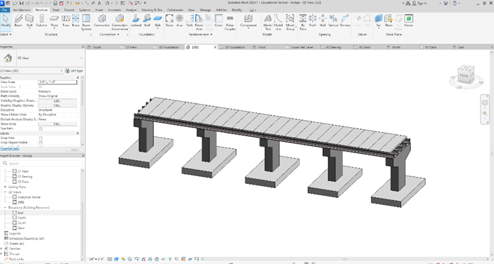

Figure 1. Bridge modelling with Openbridge Designer (left) and with Autodesk Revit (right)

*Task 2 – Export IFC from BIM models [50% completed to date]*

Task 2 involves converting the models from Task 1 (modeled using the two mentioned software) to IFC format. The sample bridge models from Task 1 were converted to IFC format, as shown in Figure 2. The next step is to further convert the models from Step 2 of Task 1.

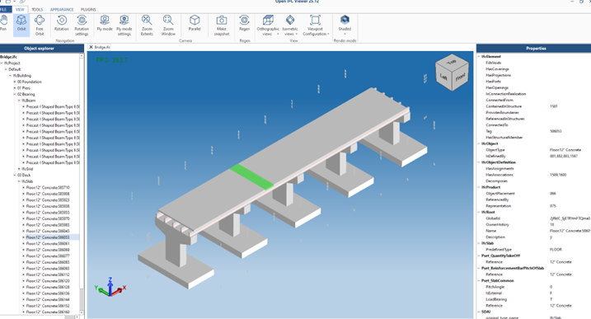

Figure 2. IFC file of the bridge modeled from Openbridge Designer (left) and modeled from Autodesk Revit (right).

*Task 3 – Develop planning algorithms and associated simulation [50% completed to date]*

Invariant signature-based algorithms were developed to generate installation plans in simulation, based on input IFC files. The algorithms aim to address includes three subtasks: element classification, information extraction, and plan generation. Focusing on installation of deck panels, we first developed a classification algorithm that can automatically identify/classify the decks among various bridge components using invariant geometric signatures (see Figures 3 & 4). Next, we developed information extraction algorithms that can extract necessary information (e.g., ID, location, bounding box) of the decks for installation planning. The developed algorithms can adapt to different software platforms (e.g., OpenBridge and Revit) and IFC versions (IFC4, IFC4X3, IFC2X3). In the next step, a logic-based AI algorithm will be developed to generate installation plans based on the extracted information.

Figure 3. Invariant geometric signatures adapted [5].

Figure 4. Partial results from the invariant signature-based classification algorithm.

An application for simulating the robotic bridge installation is under development. The application can take the plans generated from the invariant signature-based algorithms and executes the planned actions in simulated environments. Two simulation platforms (Unity3D and ROS) were integrated to utilize their strengths in high-quality visualizations and robot planning and control, respectively. Currently, the virtual construction environment has been created in Unity3D by importing the IFC bridge models exported from Task 2. In addition, a virtual mobile crane was developed and programmed to be able to lift, transport and install deck panels (Figure 5). On the other hand, we created a robotic crane in ROS and developed trajectory planning functions for the robot using MoveIt library. In the next step, we plan to integrate these two platforms and for implementing and testing the generated plans.

*

Figure 5. Simulating bridge installation process in Unity3D (left) and simulating robot planning and control in ROS (right).

*Task 4 – Roundtable/workshop [50% completed to date]*

We organized a roundtable discussion during school of construction management technology’s construction advisory council meeting to solicit industry inputs in challenges and pain points in bridge construction in general, and in precast bridge construction in particular. Main points of challenging construction operations received include: ground improvements, deep foundation, drilled shafts, cement stabilization, crane sizing, and jobsite layout. These will be taken into consideration in our next steps, by e.g., incorporating crane sizing into the planning algorithms. We also plan to give a presentation of this project at Purdue Road School 2026 or TRB 2026 to disseminate our research findings.

1. Percent of research project completed

It is estimated that the total project is 50% completed in this quarter ending on March 31, 2025, as per details in Section 3 above.

1. Expected progress for next quarter

We estimate that 100% work of the total project will be completed by the end of next quarter. The specific results that will be delivered include:

* Selected precast bridge decks modeled in different BIM software.
* Algorithms and implemented software examples that utilize the IFC-based bridge deck models and automatically generate a) construction plans for robotic installation and b) simulations for the corresponding bridge construction process to analyze its constructability and optimize its performance.

1. Educational outreach and workforce development

Research from this project has been included into:

(1) the PI’s graduate course CM 581-Technology in Construction Management, more specifically into Lecture 8 (BIM Interoperability and Invariant Signatures, Mar. 4th, 2025) and Lecture 11 (BIM for Infrastructure, Mar. 25th, 2025), Dudley Hall 4117B, Purdue University, West Lafayette, IN.

(2) “Empowering Seamless and Universal BIM Interoperability with Invariant Signatures of AEC Objects.” Panelist and Speaker at ISPRS - Webinars ICWG II/Ib, Mar. 27th, 2025.

1. Technology Transfer

*We plan to have one technology disclosure at the end of the project.*

**Research Contribution:**

1. Papers that include TRANS-IPIC UTC in the acknowledgments section:

*N/A*

1. Presentations and Posters of TRANS-IPIC funded research:

*N/A*

1. Please list any other events or activities that highlights the work of TRANS-IPIC occurring at your university (please include any pictures or figures you may have). Similarly, please list any references to TRANS-IPIC in the news or interviews from your research.

N/A

**Appendix 1**: Research Activities, leadership, and awards (cumulative, since the start of the project)

1. Number of presentations at academic and industry conferences and workshops of UTC findings

* No. = 2

1. Number of peer-reviewed publications submitted based on outcomes of UTC funded projects

* No. =

1. Number of peer-reviewed journal articles published by faculty.

* No. =

1. Number of peer-reviewed conference papers published by faculty.

* No. =

1. Number of TRANS-IPIC sponsored thesis or dissertations at the MS and PhD levels.

* No. MS thesis =
* No. PhD dissertations =
* No. citations of each of the above =

1. Number of research tools (lab equipment, models, software, test processes, etc.) developed as part of TRANS-IPIC sponsored research

* Research Tool #1 (Name, description, and link to tool) =
* Research Tool #2 (Name, description, and link to tool) =
* Research Tool #3 (Name, description, and link to tool) =

1. Number of transportation-related professional and service organization committees that TRANS-IPIC faculty researchers participate in or lead.

* Professional societies
  + No. participated in = 1
  + No. lead =
* Advisory committees (No. participated in & No. led)
  + No. participated in = 1
  + No. lead =
* Conference Organizing Committees (No. participated in & No. led)
  + No. participated in = 3
  + No. lead = 1
* Editorial board of journals (No. participated in & No. led)
  + No. participated in = 14
  + No. lead =
* TRB committees (No. participated in & No. led)
  + No. participated in = 1
  + No. lead =

1. Number of relevant awards received during the grant year

* No. awards received = 1

1. Number of transportation related classes developed or modified as a result of TRANS-IPIC funding.

* No. Undergraduate =
* No. Graduate = 19

1. Number of internships and full-time positions secured in the industry and government during the grant year.

* No. of internships =
* No. of full-time positions =

**References:**

[1] National Precast Concrete Association (NPCA), Precast Solutions Winter 2013 - Bridges and Transportation, 2013.

[2] B. Kirk Stelsel, Beauty and Durability Shine with Samuel De Champlain Bridge, 2019.

[3] C.P. Chea, Y. Bai, X. Pan, M. Arashpour, Y. Xie, An integrated review of automation and robotic technologies for structural prefabrication and construction, Transportation Safety and Environment 2 (2020) 81–96. https://doi.org/10.1093/tse/tdaa007.

[4] J. Zhang, F. Yang, Building a Bridge between Building Information Modeling and Digital Twins: Introducing Invariant Signatures of Architecture, Engineering, and Construction Objects, (2024).

[5] J. Wu, J. Zhang, Introducing geometric signatures of architecture, engineering, and construction objects and a new BIM dataset, in: ASCE International Conference on Computing in Civil Engineering 2019, American Society of Civil Engineers Reston, VA, 2019: pp. 264–271.