**Transportation Infrastructure Precast Innovation Center**

**(TRANS-IPIC)**

**University Transportation Center (UTC)**

*Photogrammetry and LiDAR-Based Precast Railroad Crossties Abrasion Damage Detections*

*PU-23-RP-04*

Quarterly Progress Report

For the performance period ending *03/31/2024*

**Submitted by:**

*PI: Shanyue Guan, Assistant Professor,* [*guansy@purdue.edu*](mailto:guansy@purdue.edu)

*School of Construction Management Technology*

*Purdue University*

**Collaborators / Partners:**

*CO-PI: Chao Sun, Associate Professor,* [*csun@lsu.edu*](mailto:csun@lsu.edu)

*Department of Civil and Environmental Engineering*

*Louisiana State University*

*Industry Partner: MxV Rail*

**Submitted to:**

TRANS-IPIC UTC

University of Illinois Urbana-Champaign

Urbana, IL

**TRANS-IPIC Quarterly Progress Report:**

**Project Description:**

1. Research Plan - Statement of Problem

The railroad industry has been struggling with precast concrete crossties abrasion damage for a long time. Our research team has communicated with multiple class I railroads and all have responded that some of their crossties are facing the abrasion issue. To extend the precast concrete crossties service life and ensure railroad safety, there is a strong demand to mitigate the crossties abrasion damage. As it is not practical for the railroad industry to inspect thousands of miles of track to find concrete crosstie abrasion loss manually, an automated, low-cost, mobile, and accurate monitoring approach is urgently needed for the crossties' maintenance and repair.

1. Research Plan - Summary of Project Activities (Tasks)

Task 1: Visit precast concrete crossties damage site

Work closely with railroad industry (e.g. MxV Rail) to understand abrasion damage of precast concrete damage and typical approach the industry use to measure the damage.

Task 2: Develop a photogrammetry and LiDAR system detecting damages

Develop a photogrammetry and LiDAR hardware system to detect the precast concrete crossties abrasion damage automatically.

Task 3: Validate the system performance in indoor and outdoor environments

Validate the system performance at Purdue University (West Lafayette, IN) Test Track Facilities.

Task 4: Reporting

Document all the completed work for paper publication and project report.

**Project Progress:**

1. Progress for each research task

Task 1 progress [80% completed]

Our team visited MxV Rail and discussed with their railroad crossties group to understand the damages pattern of precast concrete crossties, learn their technologies detecting concrete crossties conditions. Our team received three precast concrete crossties donated by MxV Rail. These precast concrete ties shown in Figure 1 will be used as test specimens for our project.

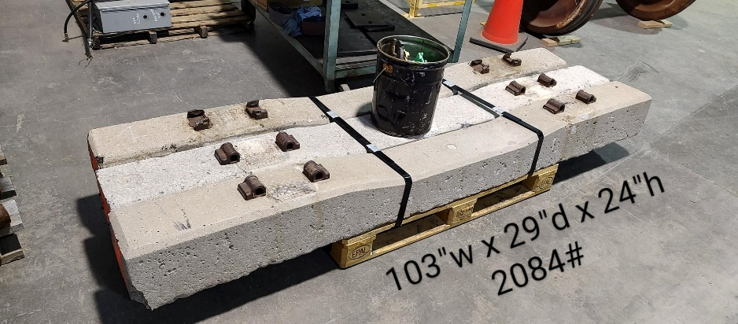

Figure 1. Precast concrete crossties donated by MxV Rail

Task 2 progress [20% completed]

Our team started purchasing devices and developing the prototype sensing equipment of detecting concrete crossties damages.

Task 3 progress [0% completed]

Task 4 progress [0% completed]

1. Percent of research project completed

As we completed most work of task 1 and started working on task 2, we are about 20% completion of this whole project.

1. Expected progress for next quarter

For the second quarter of this project, our team will develop the integrated sensing technology of detecting concrete crossties damages and start validating our prototype system performance using test track facility at Purdue University.

1. Educational outreach and workforce development

In our CM370 Heavy Civil Infrastructure course at Purdue University, we developed a lecture topic about precast concrete crossties, introduced the damages of concrete crossties and how to maintain their performance.

1. Technology Transfer

None

**Research Contribution:**

1. Number of papers

None

1. Number presentations

None

**References:**

[1] You, R., Wang, J., Ning, N., Wang, M., & Zhang, J. (2022). The Typical Damage Form and Mechanism of a Railway Prestressed Concrete Sleeper. Materials, 15(22), 8074.

[2] El-sayed, H. M., Fayed, M. N., Riad, H. S., & Zohny, H. N. (2022). A review of the structural performance of prestressed monoblock concrete sleepers in ballasted railway tracks. Engineering Failure Analysis, 140, 106522.

[3] Shurpali, A. A., Edwards, J. R., Kernes, R. G., Lange, D. A., & Barkan, C. P. (2014). Investigation of material improvements to mitigate the effects of the abrasion mechanism of concrete crosstie rail seat deterioration. Journal of Transportation Engineering, 140(2), 04013009.

[4] Shurpali, A. A., Van Dam, E., Edwards, J. R., Lange, D. A., & Barkan, C. P. (2012, April). Laboratory investigation of the abrasive wear mechanism of concrete crosstie rail seat deterioration (RSD). In ASME/IEEE Joint Rail Conference (Vol. 44656, pp. 99-108). American Society of Mechanical Engineers.

[5] Riding, K. A., Peterman, R. J., Guthrie, S., Brueseke, M., Mosavi, H., Daily, K., & Risovi-Hendrickson, W. (2018, April). Environmental and track factors that contribute to abrasion damage. In ASME/IEEE Joint Rail Conference (Vol. 50978, p. V001T01A009). American Society of Mechanical Engineers.