**Transportation Infrastructure Precast Innovation Center**

**(TRANS-IPIC)**

**University Transportation Center (UTC)**

*Bio-Inspired Solutions for Roadside Barriers: Exploring 3D Printing as Alternative Precast Technology*

*PU-23-RP-03*

Quarterly Progress Report

For the performance period ending *[06/30/2024]*

**Submitted by:**

**Jan Olek***1(*[*olek@purdue.edu*](mailto:olek@purdue.edu)*)***,**

**Jeff Youngblood***2(*[*jpyoungb@purdue.edu*](mailto:jpyoungb@purdue.edu)*)***,**

**Pablo Zavattieri***1(*[*zavattie@purdue.edu*](mailto:zavattie@purdue.edu) *)*

*1Lyles School of Civil Engineering, Purdue University*

*2School of Materials Engineering, Purdue University*

**Collaborators / Partners:**

*Terran Robotics*

*RCAM technology*

**Submitted to:**

TRANS-IPIC UTC

University of Illinois Urbana-Champaign

Urbana, IL

**TRANS-IPIC Quarterly Progress Report:**

**Project Description:**

1. **Research Plan - Statement of Problem**

The continuous improvement of transportation infrastructure is imperative for ensuring the safety of road users and the overall efficiency of the transportation network. One key aspect of this enhancement involves incorporating impact-resistant structures in the construction and retrofitting of various infrastructure components, such as roadside barriers.

Roadside barriers are typically categorized as flexible, semi-rigid, or rigid, depending on their deflection characteristics resulting from an impact (Table 1). Flexible systems are generally more forgiving since much of the impact energy is dissipated by the deflection of the barrier, thereby imposing lower impact forces on the vehicle [1]. Traditionally, rigid concrete barriers are favored over flexible alternatives in situations of high impact loads (test levels 4 and 5 in Table 1) due to their capacity to withstand such forces [2]. However, the inherent stiffness of reinforced concrete materials can lead to insufficient energy absorption, potentially resulting in vehicle rollovers or increased vehicle damage.

This project aims to utilize 3D printing technology and bio-inspired design principles to enhance the energy absorption capacity of concrete barriers, thereby improving their ability to protect drivers and passengers during roadside impacts. This approach will develop a barrier that is strong enough to withstand high impact loads while being flexible enough to dissipate impact energy. The proposed barrier design could be used in all test levels listed in Table 1. This innovative approach holds promise for advancing road safety and enhancing the efficiency of transportation infrastructure.

Table-1. Types of barriers from roadside design manual [3]

1. **Research Plan - Summary of Project Activities (Tasks)**

Task 1 - Literature Review and Research Plan Development

This task involves conducting a literature review and developing a comprehensive research plan. The literature review aims to explore existing studies, research, and knowledge relevant to the chosen research topic, specifically focusing on potential designs for concrete barriers. This step helps to select potential designs using principles of architected materials and bio-inspired concepts, including architectures such as Bouligand and sinusoidal structures to enhance impact resistance capacity.

Task 2 – Large Scale 3DP System Development

This task involves developing innovative 3D printing techniques using our Large-Area Lab-Scale (LALS) printer and Large-Scale Robotic Arm (LSRA). These systems are tailored for the precise and reliable production of barriers using cement-based materials and additive manufacturing processes, ensuring structural integrity and desired functional properties.

Task 3 - Material Development and Testing

The goal of this task is to develop a sustainable and cost-efficient concrete mixture for Task 4 and other future work. The objective is to develop a mixture that incorporates a high weight replacement of cement by limestone filler, combined with cellulose nanomaterials as additives. This aims to enhance rheology and hardened mechanical properties, improve sustainability and durability, and increase cost efficiency.

Task 4 – Sample Fabrication and Experimental Testing

This task includes using the 3D printing system and 3DP mixture developed in Tasks 2 and 3 to prepare samples with bio-inspired architectures. The mechanical strength and energy absorption capabilities of the samples will be evaluated.

**Project Progress:**

1. **Progress for each research task**

**Task 1 and Task 2 progress (100% completed):**

Please refer to the previous progress report for the details of these tasks.

**Task 3 progress (90% completed):**

This task includes the development of a mixture for 3DP applications using natural and cost-effective cellulose nanofiber (CNF) and a high weight replacement of cement with limestone filler (LF). The main objective is to develop a mixture that can be used for 3D-printed roadside barriers and general transportation infrastructure with enhanced rheological and hardened mechanical properties, improved sustainability and cost-effectiveness.

Readers are referred to refer to our previous progress report for the rheology properties and buildability tests results for the mixtures. In this quarter, we evaluated the compressive strength of different mixtures. Results of the 28-day compressive test under air-dry cure conditions are presented in Fig. 1. PLC-LF14 and PLC-LF29 represent 14% and 29% replacement of cement in PLC by the addition of LF. In general, there is an increase in compressive strength as the CNF addition increased, regardless of the level of limestone filler replacement. The PLC and PLC-LF14 mixtures show similar compressive strength, while the PLC-LF29 mixtures show decreased compressive strength due to the dilution effect. However, with 0.3% CNF addition, the dilution effect is mitigated. The PLC-LF14-CNF03 mixture shows similar compressive strength compared to the reference PLC mixture (without CNF and additional LF replacement). Moreover, the general compressive strength requirements for regular transportation infrastructure structural concrete are 35 MPa. In this study, the PLC-LF29-CNF03 mixture surpasses 35 MPa, while also exhibiting superior rheological properties and low cement usage. The low cement content, coupled with the natural and cost-effective additive (CNF), significantly improves the cost-effectiveness and sustainability of the 3DP mixture, bringing the 3DP technology closer to real-world transportation infrastructure applications.

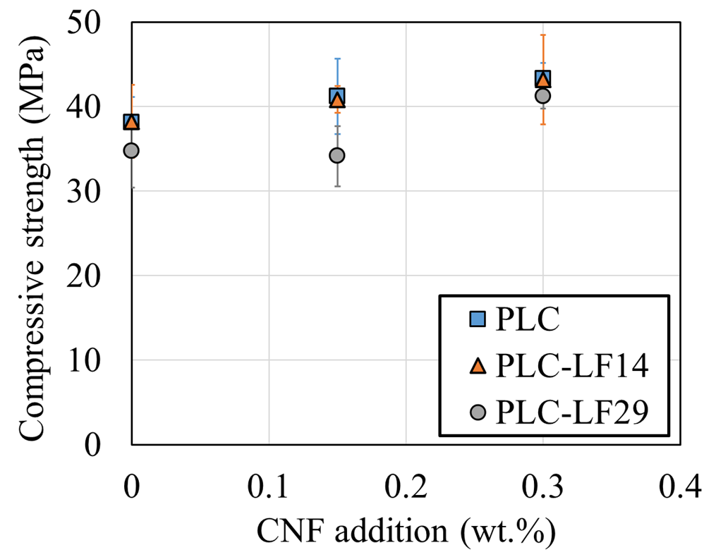

Fig.1 – 28 days compressive strength of mortar mixtures containing varying levels of LF replacement and CNF addition.

**Task 4 progress (80% completed):**

The main objective of this task is to evaluate the mechanical performance of 3D-printed concrete with bio-inspired designs for transportation infrastructure applications such as roadside barriers. The inspiration for these architected designs is drawn from the dactyl club of the mantis shrimp, a remarkable creature capable of delivering powerful strikes to its shelled prey. These dactyl clubs exhibit peak striking speeds of approximately 20 meters per second and can generate forces of around 700 Newtons [4]. What makes the dactyl club especially impressive is its capacity to withstand the immense forces encountered during these predation interactions [5]. The Bouligand and sinusoidal helicoidal architectures within the dactyl club play a pivotal role in providing energy dissipation, load-bearing capabilities, and damage tolerance [6][7]. These characteristics are attributed to their helicoidal arrangement and the presence of interfaces[8]. The interfaces are used to induce crack twisting and spread of damage to improve the impact resistance and energy dissipation capacity of the dactyl club [6].

In order to design 3DP concrete with these architectures and use these designs for transportation infrastructure such as roadside barriers, the first step is to evaluate the anisotropic properties due to the presence of the interface in the 3DP sample. The interfacial properties will be used for future numerical modeling and design of the architected materials for transportation infrastructure applications. In this report, we evaluate the mechanical performance of the 3DP concrete sample and compare it with the cast samples under compressive and flexural tests. The sample was tested in different directions to evaluate the anisotropic properties of the 3DP samples due to the presence of the interfaces. Mortar mixtures with 5mm steel fiber was printed with our small scale printer in this study.

As depicted in Fig 2, an investigation of anisotropic behavior under flexural test was conducted on samples fabricated with filament orientations of 0 and 90 degrees, along with steel fiber volume fractions of 1%, 0.5%, and 0%. The flexural strength of the 0-degree sample with 1% and 0.5% steel fiber is 45.4% and 20.2% higher than that of the sample without fiber, respectively. In contrast, the 90-degree samples show no notable improvement in flexural strength upon the addition of fibers. Moreover, the flexural strength of the 0-degree sample with 1% fiber is 156.2% greater than that of the 90-degree sample with 1% fiber, while the flexural strength of the 0-degree sample without fiber is 96.9% higher than that of the 90-degree sample without fiber.

These findings demonstrate a notable improvement in flexural strength with the addition of fibers in the 0-degree sample, while the 90-degree sample exhibits no substantial enhancement, thus highlighting a strong anisotropy present in the 3DP samples. This disparity in strength improvement can be attributed to the tendency of fibers to align with the printing direction during the 3D printing process [9]. In the case of the 90-degree samples, the fibers tend to align parallel to the loading direction, which, in turn, allows cracks to propagate through the interface, impeding their capacity to enhance flexural strength. In contrast, in the case of the 0-degree samples, the fibers tend to align perpendicular to the loading direction and the direction of crack propagation, thereby enhancing the flexural strength. The results suggest that the incorporation of fibers has a substantial impact on the anisotropic behavior of 3D-printed samples. This anisotropic and the present interface will be used to design novel architected materials with novel functionality for transportation infrastructure applications.

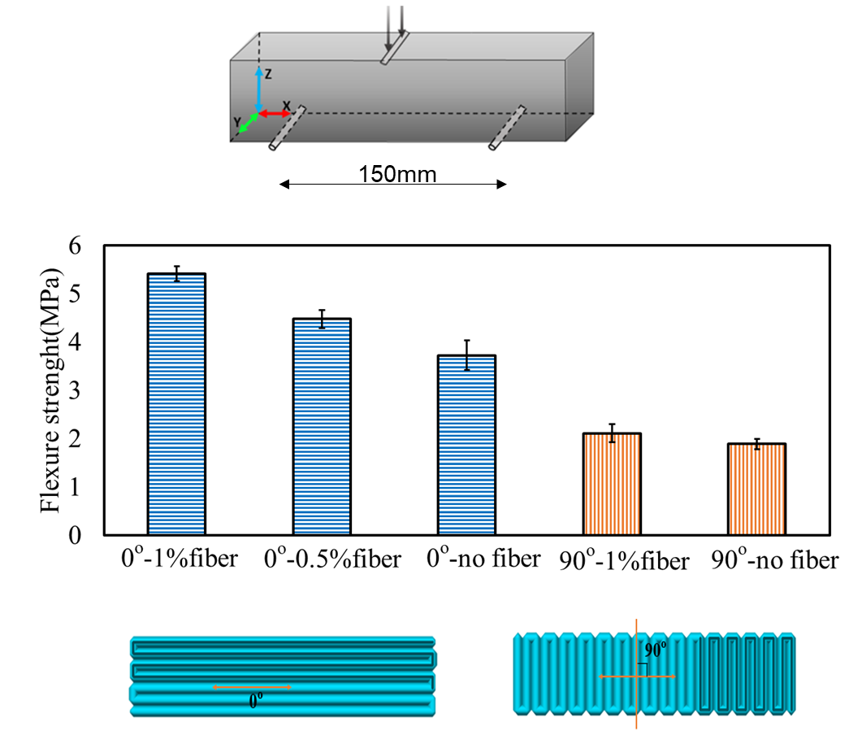

Fig.2 – Three-day flexural strength under three-point bending test for samples with different filament orientations and fiber volume fractions.

In Fig 3, the comparison of the compressive strength between cast elements and 3DP elements is presented. Overall, the 3DP elements exhibited a lower compressive strength than the cast elements. Specifically, the average compressive strength of 3DP elements tested in the X, Y, and Z directions was 24.4%, 13.0%, and 25.2% lower than that of the cast elements, respectively. Moreover, 3D printed elements tested along the X and Y directions exhibited comparable compressive strength, whereas those tested along the Z direction showed approximately a 15% reduction compared to the X and Y directions.

The 3DP elements exhibited a lower compressive strength than the cast elements due to the presence of interfaces. It should be noted that during the test, two types of interfaces (inter-layer and inter-filament) play a crucial role. The properties of the inter-filament interface are typically influenced by the design of the extrusion rate and filament overlap, while the properties of the inter-layer interface are affected by the designed layer height and the gravity of the previous layers. As shown in Fig 3, when tested in the X direction, only the interface between the layers influences the compressive behavior, whereas in the Z direction, only the interface between the filaments affects the compressive behavior. Testing in the Y direction shows that both interfaces between the layer and the filament influence the compressive behavior. The disparities observed in test results across different directions suggest variations in the mechanical properties of inter-layer and inter-filament interfaces.

Taken all together, the 3DP samples exhibit anisotropic behavior in both flexural and compressive tests due to the presence of interfaces. The interfacial properties and anisotropic behavior described in this report will be utilized in our future modeling and design of architected materials. As mentioned in previous paragraphs, the aim of this study is to mimic damage mechanisms from nature and leverage inherent anisotropy and interface characteristics to design architected materials. These materials could enable novel functionalities, such as enhanced energy absorption capacity in concrete for transportation infrastructure applications like roadside barriers. Roadside barriers designed with architected materials have the potential to absorb more energy during impacts, thereby reducing vehicle damage and protecting passengers more effectively.

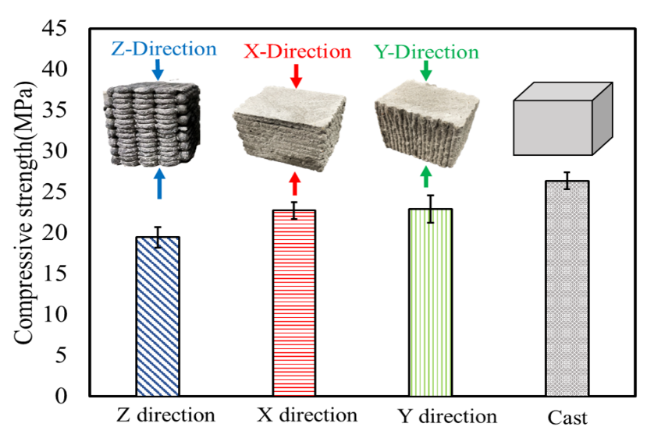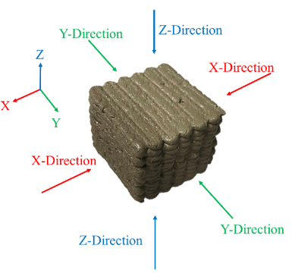

Fig.3 – Compressive strength comparison between cast samples and 3D printed samples tested in various directions

In Fig. 4 (a) and (b), a comparison is made between the compressive strength and work of failure (WOF) of samples with different filament architectures. WOF is computed as the area under the load-displacement curve up to a specified level of damage, representing the energy required to cause failure of the sample. In this study, WOF was estimated by calculating the area under the load-displacement curve after reductions of 0%, 20%, and 40% in the peak load.

The compressive strength of Bu-10 and Bu-5 samples exceeded that of the Z-direction regular sample by 22.5% and 18.4%, respectively, while remaining 8.6% and 14.4% lower than that of the cast counterparts. Additionally, the 40% Drop WOF of Bu-10 and Bu-5 samples exhibited levels similar to the cast samples and were 142.3% and 126.8% larger than that of the Z-direction regular sample. With the incorporation of sinusoidal helicoidal architecture, both the compressive strength and WOF experienced significant enhancements (Fig. 4 (a) and (b)). Specifically, the compressive strength of SinHeli-10 and SinHeli-5 samples surpassed that of the Z-direction regular sample by 53.6% and 31.5%, respectively. Additionally, the 40% Drop WOF of SinHeli-10 and SinHeli-5 samples exhibited increases of 216% and 214% compared to the straight-regular sample. When compared to the cast samples, SinHeli-10 exhibited a 13.5% higher compressive strength, a difference that was found to be statistically significant according to the T-test results.

Furthermore, the average 40% Drop WOF of SinHeli-10 was 35% greater than that of the cast counterparts. The results comparison highlights the capacity of Bouligand and sinusoidal helicoidal architectures to enhance compressive strength, increase work of failure and energy dissipation. It is evident that filament architecture plays a pivotal role in enhancing mechanical responses. This is particularly noteworthy for Bouligand and sinusoidal helicoidal designs, due to their ability to utilize twist crack mechanisms along the interface, facilitating the spread of damage and enhancing energy dissipation.

The existence of the interfaces emerges as a critical factor in slowing crack propagation and improving the work of failure. Moreover, In the case of the sinusoidal helicoidal architecture, fibers are likely to align in accordance with the sinusoidal shape, resulting in distinct mechanical behavior under compressive load. The alignment of steel fibers within the filament following the architecture design may contribute to the enhancement of compressive strength. Most significantly, in this study, the sinusoidal helicoidal architecture statistically demonstrated improved compressive strength and work of failure compared to the cast sample. Given that transportation infrastructure always requires optimal mechanical properties, this enhanced mechanical performance can directly contribute to the improvement of transportation infrastructure performance.

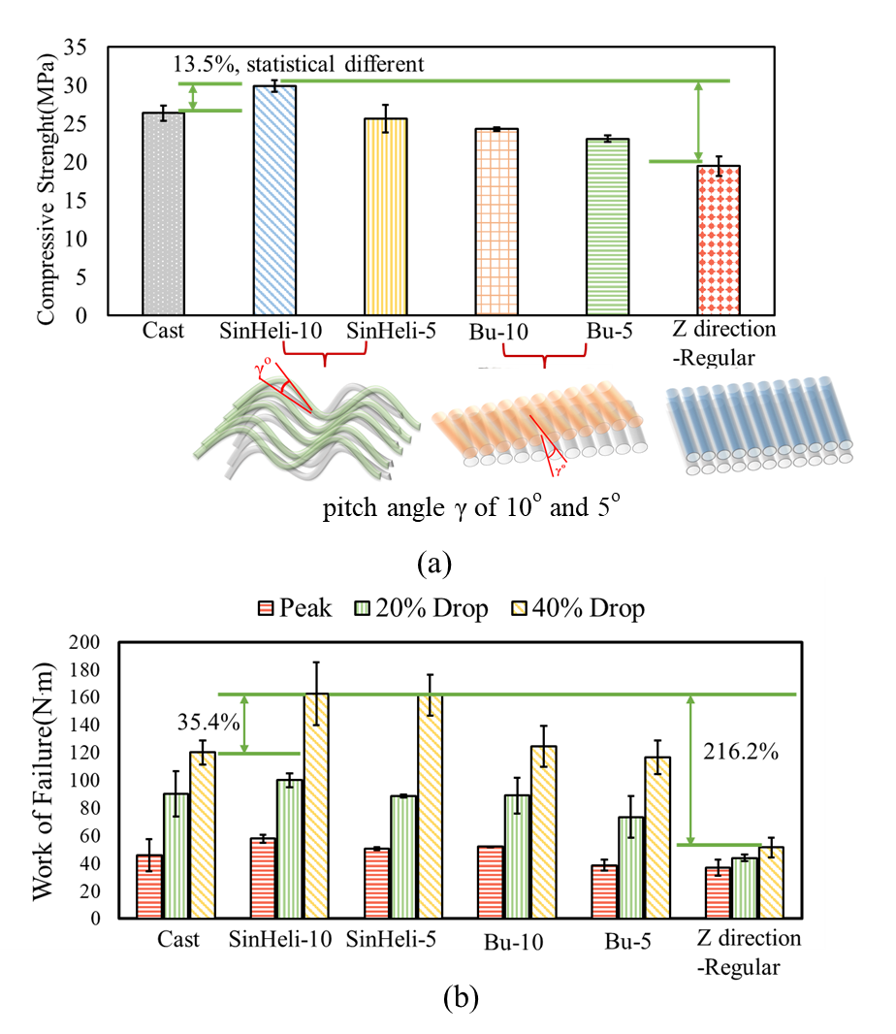

Fig.4 – Compressive strength comparison between cast samples, 3DP sample with sinusoidal helicoidal, Bouligand architecture and regular filament configuration

**Response to reviewer’s comments:**

*The report lacks a clear connection between the work done and the actual proposed barrier designs or transportation infrastructure in general. It’s recommended that the research team establish this connection in future reports and how their technology will improve infrastructure durability. It’s not clear whether the stated educational activities are focused on workforce development in the transportation sector.*

The authors appreciate the reviewer's comments. The first phase of this project aims to explore the use of 3D printing technology, bio-inspired design, and proper mixture design to enhance the mechanical properties of concrete. These improvements can directly contribute to enhancement of performance of transportation infrastructure, such as roadside barriers. Our results demonstrate that adding cellulose nanofiber to the mixture can significantly enhance the rheological and mechanical properties of 3D-printed concrete. Additionally, we found that filament architectures significantly influence mechanical properties.

As shown in the task 4 progress in this report, 3D-printed specimens with regular filament configurations exhibit weakened compressive strength when tested in different directions compared to cast specimens. However, by using a sinusoidal helicoidal architecture, both the compressive strength and work of failure of the 3D-printed samples are improved, surpassing those of the cast specimens. This enhancement is crucial for applications like roadside barriers, which are often subjected to high impact loads (test levels 4 and 5 in Table 1) and must possess superior mechanical strength and energy dissipation capacity. The improved compressive strength and work of failure observed in this study can directly contribute to the enhancement on the roadside barrier’s performance.

Additionally, the primary objective of this phase was not to investigate the durability performance of 3D-printed concrete. The durability aspects of our design, such as resistance to freezing and thawing and chloride exposure from deicing salt, will be evaluated in future phases.

The educational activities conducted by the research team provide students with knowledge of 3D printing technology, cementitious materials, and basic mechanics. These activities introduce students to fundamental concepts, advanced materials, and technologies relevant to transportation infrastructures.

1. Percent of research project completed

*80%*

1. Expected progress for next quarter.

*Task 4 is expected to be completed in the next quarter.*

1. Educational outreach and workforce development

* The research team offered CE 497 - 3D Printing for Infrastructure Applications during the spring semester (01/2024-05/2024) at the Lyles School of Civil Engineering, Purdue University. The course, which enrolled 23 students, introduced 3D printing technology and exposed students to basic concepts related to transportation infrastructure.
* During the summer of 2024 (06/2024-08/2024), the research team is collaborating with two Purdue Summer Undergraduate Research Fellows and industry partner Terran Robotics on projects focusing on sustainable earth-based materials and additive manufacturing technology. This research project enables students to explore the impact of novel materials and technologies on the development of general and transportation infrastructures.
* The research team is participating in Purdue's Summer College for High School Students program. We will organize a session on July 18th focusing on 3D printing concrete technology. This program will expose students to advanced technologies for transportation infrastructures.
* Pictures for 3D printing class and large-scale 3D printing activities with participation of undergraduate students:

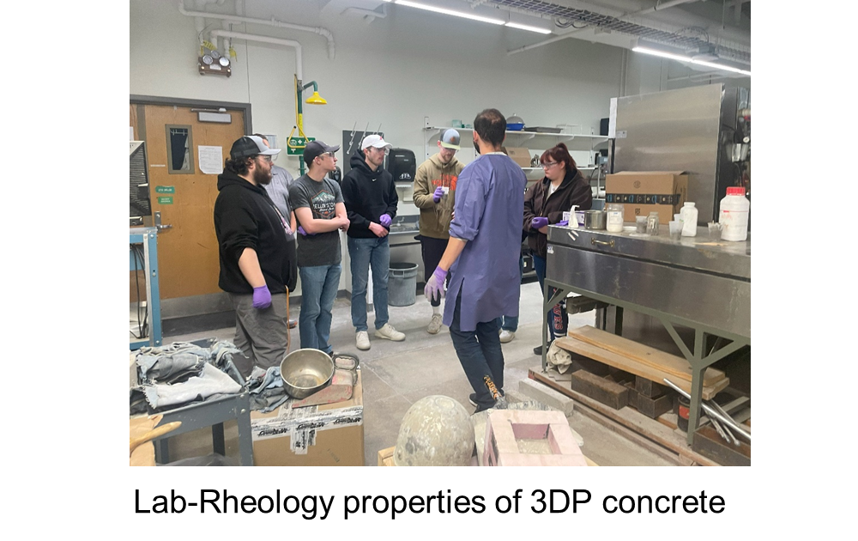

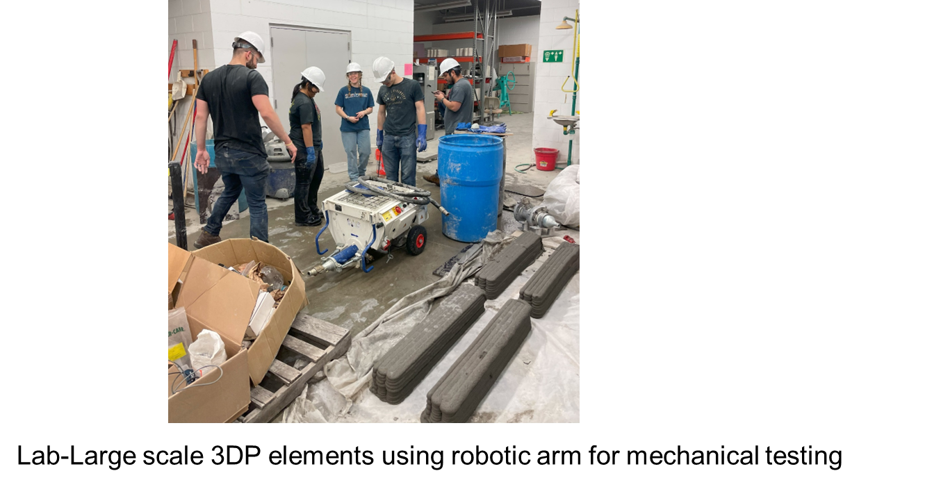

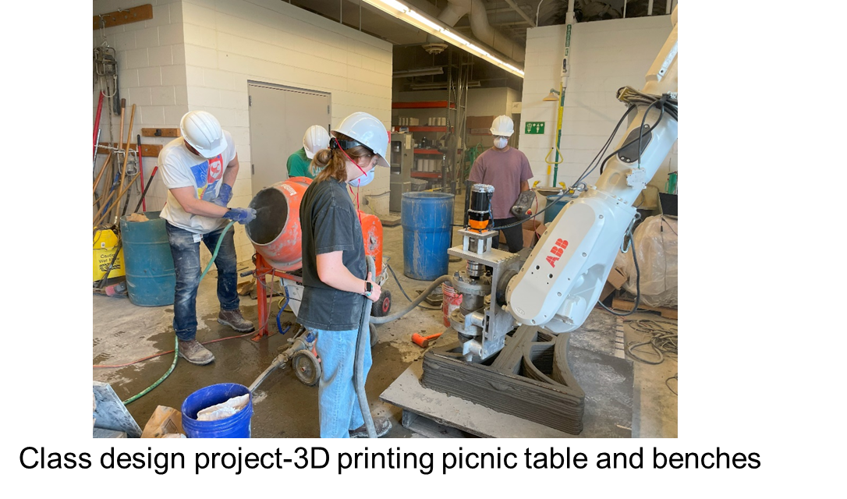

1. Technology Transfer

Paten under review: Low Carbon, Low Cost Cement Mix For Additive Manufacturing (3D Concrete Printing)

**Research Contribution:**

1. Papers that include TRANS-IPIC UTC in the acknowledgments section:

Two papers under preparation, will include TRANS-IPIC UTC in the acknowledgments section:

* Y. Wang, A. Douba, J. Olek, J. Youngblood, P. Zavattieri, Bio-inspired Sinusoidal Helicoidal Architecture in Additively Manufactured Cementitious Materials.
* Y. Wang, A. Douba, J. Olek, J. Youngblood, P. Zavattieri, Sustainable Cementitious Composite Containing Cellulose Nano Fiber and Limestone Filler for Concrete 3D-Printing.

1. Presentations and Posters of TRANS-IPIC funded research:

* Y. Wang, A. Douba, J. Olek, J. Youngblood, P. Zavattieri, “Bio-inspired Sinusoidal Helicoidal Architecture in Additively Manufactured Cementitious Materials” Engineering Mechanics Institute (EMI) Conference Spring 2024, Chicago, IL
* Y. Wang, A. Douba, J. Olek, J. Youngblood, P. Zavattieri (2024) “Sustainable cementitious composite containing cellulose nano fibers and limestone filler for concrete 3D-Printing”, American Concrete Institute (ACI) Spring 24 convention, New Orleans, LA.

1. Please list any other events or activities that highlights the work of TRANS-IPIC occurring at your university (please include any pictures or figures you may have). Similarly, please list any references to TRANS-IPIC in the news or interviews from your research.

All the activities are listed in the outreach and workforce development session

**References:**

[1] *ROADSIDE DESIGN*. 2011.

[2] M. Budzynski, K. Jamroz, L. Jelinski, D. Bruski, and L. Pachocki, “Assessing Roadside Hybrid Energy Absorbers Using the Example of SafeEnd,” pp. 1–21, 2022.

[3] C. Wilson *et al.*, *A Mobile Concrete Laboratory to Support Quality Concrete , Technology Transfer , and Training — Phase I*, vol. SPR 3858. 2016. doi: 10.5703/1288284316341.

[4] S. N. Patek, W. L. Korff, and R. L. Caldwell, “Deadly strike mechsanism of a mantis shrimp,” *Nature*, vol. 428, no. 6985, pp. 819–820, 2004, doi: 10.1038/428819a.

[5] L. K. Grunenfelder *et al.*, “Bio-inspired impact-resistant composites,” *Acta Biomater.*, vol. 10, no. 9, pp. 3997–4008, 2014, doi: 10.1016/j.actbio.2014.03.022.

[6] N. Suksangpanya, N. A. Yaraghi, D. Kisailus, and P. Zavattieri, “Twisting cracks in Bouligand structures,” *J. Mech. Behav. Biomed. Mater.*, vol. 76, no. June, pp. 38–57, 2017, doi: 10.1016/j.jmbbm.2017.06.010.

[7] N. A. Yaraghi *et al.*, “A Sinusoidally Architected Helicoidal Biocomposite,” *Adv. Mater.*, vol. 28, no. 32, pp. 6835–6844, 2016, doi: 10.1002/adma.201600786.

[8] W. Huang *et al.*, “Multiscale Toughening Mechanisms in Biological Materials and Bioinspired Designs,” *Advanced Materials*, vol. 31, no. 43. Wiley-VCH Verlag, Oct. 01, 2019. doi: 10.1002/adma.201901561.

[9] Y. Wang, F. B. Rodriguez, J. Olek, P. D. Zavattieri, and J. P. Youngblood, “Influence of Type of Fibers on Fresh and Hardened Properties of Three-Dimensional-Printed Cementitious Mortars,” *ACI Mater. J.*, vol. 121, no. 2, pp. 31–40, 2024, doi: 10.14359/51740263.