**Transportation Infrastructure Precast Innovation Center**

**(TRANS-IPIC)**

**University Transportation Center (UTC)**

Design and Implementation of Digital Twin Models for Continuous Monitoring and Performance Prediction of Precast Concrete Bridges

UI-23-RP-03

Quarterly Progress Report

For the performance period ending 03/31/2024

**Submitted by:**

Volodymyr Kindratenko, kindrtnk@illinois.edu

National Center for Supercomputing Applications (NCSA)

University of Illinois at Urbana-Champaign

**Collaborators / Partners:**

N/A

**Submitted to:**

TRANS-IPIC UTC

University of Illinois Urbana-Champaign

Urbana, IL

**TRANS-IPIC Quarterly Progress Report:**

**Project Description:**

1. Research Plan - Statement of Problem

This research project aims to design and validate a digital twin model of a precast concrete bridge structure, subsequently integrating this model with sensor data derived from a real-world bridge. This integration will serve as the foundation for driving the simulation and analysis of the bridge model. The digital twin model will be constructed utilizing NVIDIA Omniverse, an innovative platform that facilitates the creation of collaborative and immersive 3D objects, equipped with real-time simulation capabilities.

1. Research Plan - Summary of Project Activities (Tasks)

Task 1: Digital Model Development: We explore how to use technical drawings and the design and inspection data that may exist for the bridge itself or the precast parts used in its construction in order to rapidly implement a digital twin model. The outcome of this task is a methodology for rapidly prototyping a 3D model of a PC bridge based on the above-mentioned sources of initial information.

Task 2: Digital Model Implementation: We will study how NVIDIA Omniverse platform for digital twins operates and how to build new models within the platform’s capabilities, including linking it with external data sources. The outcome of this task is a PC bridge twin model implemented in NVIDIA Omniverse environment.

Task 3: Bridge Simulation using Real-Time Data: Our goal is to enable ingesting real-time data from a specific PC bridge to be incorporated with the digital twin model as well as any readily available environmental data, such as weather, traffic, any imagery. Such data will be used to model the bridge performance and predict its response to different usage conditions. The outcome of this task will be a data-driven digital twin model of a PC bridge updated each time new data about the bridge is available.

**Project Progress:**

1. Progress for each research task

*Task 1 progress [75% completed]:*

For this part of the project, we investigated how to build models of bridge beams that are evaluated for stress in the lab. Specifically, we built models of an 838mm x 914mm PPC deck girder and a precast bridgein Blender before exporting to NVIDIA Omniverse. We exported the Blender models to Omniverse with the compatible Universal Scene Description (USD) format. The exact dimensions of the models were extracted from the plans given in ISO drawing format. Furthermore, versions of the beams with cracks built into the 3D model were also made to test how effective the cracks would translate to Omniverse. Lastly, the components of the beams were exported separately to multiple USD files along the fully assembled beams. These components comprised of physical sections of the beam such as end and middle spans, as well as abstract components such as voids within the beam which made 3D models of to better represent them in NVIDIA Omniverse. The beam digital twin model was built and exported to NVIDIA prior to the test with no cracks.

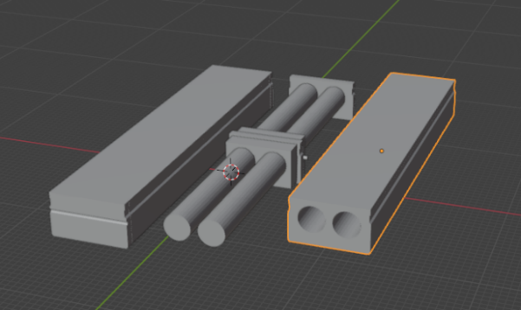 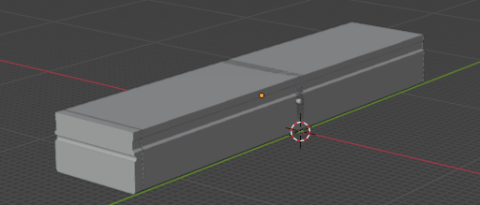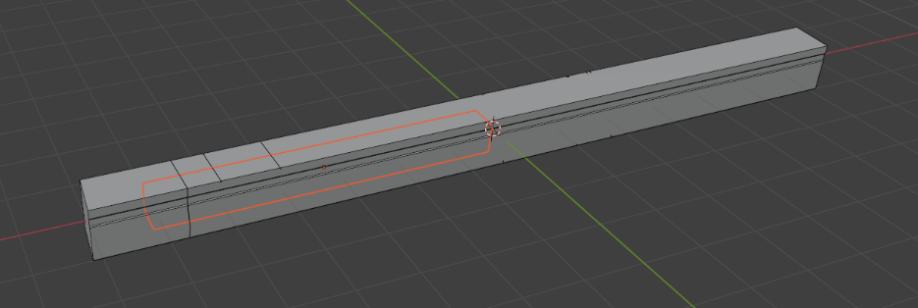 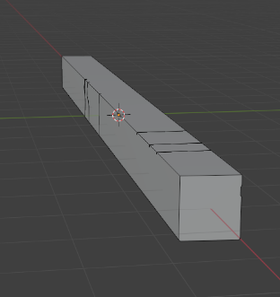

*Task 2 progress [50% completed]:*

We exported modeling of test beam into Omniverse platform, loading the data connected with it during experiments. The slider on the bottom of the widgets indicates the progress of the experiment. When moving the slider, the curve will change corresponding to time showing the compression of the crack selected. We also used the curve drawing tools in Omniverse to represent cracks on the surface of the test beam, which is based on the images captured during the experiment. We programmed the cracks and made it grow when dragging the slider.

Users can click on the crack that they are interested in, when they do so, the widget on the right side will display experiment data related to that crack, including crack width and sensor data related to that.

*Task 3 progress [25% completed]:*

We collected data from a recent experiment of a new test beam (a 533mm x914 mm IDOT PPC deck girder beam with a span of 15.24m span length) under four-point bending test and collected data related to that at the Newmark Structural Engineering Laboratory. In general, the test was divided into two phases, in the first phase, an actuator applied incremental loads to the beam to induce and monitor initial cracks. The second phase involved increasing the load until the beam's ultimate failure, observing its structural behavior, deflection, and crack development. We setup several cameras around the beam to mainly capture the crack growth during experiments. Some are also used for Digital Image Correlation (DIC) analysis to measure the deflection of beam during the experiment. The images are captured every 30 seconds. The setups for cameras and devices are shown in the image below.

The beam condition before test start is shown in the image below.

The beam condition during test (cracks are marked in black) is shown below.

Picture below shows the crushed beam.

We also have written some Python scripts and Dropbox API to support real-time image collection and transfer. The pictures taken from cameras during the experiment were saved in the local folder of a computer connected to the cameras, and these were automatically uploaded to a Dropbox folder. In addition, we also built an Omniverse extension that user could view the images of cracks on the widget, and replay it to view the progress of experiment.

In addition, we also explored approaches to extract cracks from images captured during experiment, and attach them to the surface of the test beam shown in Omniverse. We utilized UNet convolutional neural network as the backbone to segment the crack from background, and saved them into a PNG file with transparent background. Then we can load the PNG file into Omniverse and attach it to the surface of the beam.

Due to the width of cracks, some of them are too small to visualize clearly in the Omniverse platform, which still needs development on how to refine cracks extraction and visualization.

1. Percent of research project completed

50%

1. Expected progress for next quarter

We will continue to add the necessary functionality needed to implement the original vision of this project. Specific focus is on the integration of observed and simulated data and its accurate reflection in the Omniverse environment.

1. Educational outreach and workforce development

None

1. Technology Transfer

None

**Research Contribution:**

1. Number of papers

None yet

1. Number presentations (when, where)

None this time

**References:**

None