Standard Operating Procedure for Corrosive Materials

|  |  |
| --- | --- |
| Department: | Choose a department.  Enter department here if not listed. |
| Principal Investigator: | PI name. |
| Group Safety Coordinator/Lab Manager: | Name of safety contact. |
| SOP written by:  *All author’s names should be recorded in “Changes” section.* | CoE SOP Committee  engrsafety@illinois.edu |
| Date of this version of the SOP:  *Dates of revisions should be recorded in “Changes” section.* | Click here to enter the date of this version of the SOP. |
| Date SOP was approved by PI/lab supervisor: | Click here to enter date SOP was approved. |
| Lab Phone: | Enter the lab phone number |
| PI’s Phone: | Enter the PI office or mobile phone number |
| Location(s) covered by this SOP: | Enter the building and room number |
| Emergency contact information for this location: | Enter contact information of lab personnel to be notified in case of emergency. |

|  |  |  |  |
| --- | --- | --- | --- |
| Type of SOP: | Hazardous material  (SOP describes a specific hazardous chemical) | Hazardous class  (SOP describes a group of hazardous materials ) | Hazardous Process  (SOP describes a hazardous process or equipment) |

**NOTE**: This SOP is intended as an initial resource and as a general reference regarding the topic discussed. It is not a substitute for hands-on training and supervision by experienced laboratory personnel. The Principal Investigator must review and approve of all information in this document for the SOP to be valid and useable.

*This SOP is not complete until: 1) Clear and detailed instructions are written that will ensure safe handling of the material or safe performance of the procedure, and 2) SOP has been approved and dated by the PI or laboratory supervisor.*

Print a hardcopy and insert into your *Laboratory Safety Manual* and *Chemical Hygiene Plan*.

Table of Contents

Purpose 4

Key Points 4

Hazard Awareness 5

Definition of terms 5

Hazards and pertinent regulations 5

Means to control the hazards 6

Examples of hazardous materials or processes 6

Important considerations 8

Prior approval from PI required? 8

Consultation of other reference material, documents or knowledgeable persons required? 8

Pre-requisite training or skill? 8

Experiment Risk Assessment required? 8

Other important considerations: 8

Emergency response 9

Introduction to emergency response 9

Necessary emergency equipment 9

What to do if there is a spill or a fault in the process. 9

What to do if there is an exposure or injury 10

Storage 11

Considerations for safe storage of materials 11

Quantity limits and other considerations 11

Work Practices and Engineering Controls 12

Introduction to work practices and engineering controls 12

Designated area to work with the material or process 12

Necessary engineering or administrative controls 12

If necessary, consult 12

Required Personal Protective Equipment (PPE) 12

If necessary, consult the 12

Detailed procedures or techniques 14

Step-by-step procedures 14

Waste disposal procedure. 19

Record of changes made to this SOP 20

Training record 21

# Purpose

These safe handling guidelines describe standard procedures to be observed when handling corrosive materials in research laboratories.

These guidelines are intended to function as an initial resource and as a general reference for the safe handling of corrosive materials. The use of this SOP as a training tool is encouraged, however, it is not a replacement for personal hands-on training and supervision by experienced laboratory personnel, nor does it avoid the need to ascertain specific details concerning the safe handling of individual corrosive reagents before use. Research laboratories needing to make lab-specific changes to these guidelines should edit this document however they deem necessary to suit their needs. The edited document should then be placed in the research group’s laboratory safety plan, with training being documented. *Principal investigators must approve of all edits before they are accepted into this document*.

# Key Points

* Know what personal protective equipment will protect you against exposure to corrosive materials – your life may depend on it!
* Know how to clean up a corrosive material spill before working with it.
* Know the locations of the nearest emergency shower, eye wash and sink. The ability to quickly wash off spills is imperative in protecting your health and well-being. **The availability of nearby emergency showers and eye washes is a must for working with corrosive materials!**
* Always thoroughly clean up the equipment and the work area when finished working with corrosive materials to prevent chemical exposures from accidental contact.
* Know how to safely store corrosive materials and what materials they are incompatible with. **Store acids separately from bases!**
* Work with corrosive materials in a chemical fume hood.
* Stir corrosives slowly. When dilution is necessary, always carefully add corrosives to water, to limit the rate at which heat is released. If done in the reverse, enough heat is often generated to cause spattering of concentrated corrosive.
* Many corrosive materials attack and corrode metals. When acids attack metals, hydrogen gas can be given off which can burn or explode if an ignition source is present. Common bases such as hydroxides can attack some metals such as aluminum, zinc, etc. and also produce hydrogen gas.
* Hydrofluoric acid and some hydroxides etch glass and should not be used with or stored in glass.
* This SOP **does not** cover the use of hydrofluoric acid. Refer to the hydrofluoric acid SOP.
* This SOP **does not** cover the use of corrosive gases. These are also toxic and require the use of a vented gas cabinet (discussed in another SOP).

# Hazard Awareness

## Definition of terms

*Corrosive materials* are chemicals that cause harm or injury by damaging and destroying tissue, such as eyes or skin, at the site of contact. Corrosives can be gases, liquids, solids or solutions. Researchers utilizing corrosive materials **must** read and understand the manufacturer’s Safety Data Sheet (SDS) prior to commencing work with such materials.

Characteristics of corrosive materials include:

* Very low pH (acids) or very high pH (bases).
* React with incompatible chemicals to produce heat, gas or fire.
* Cause burns and the destruction of body tissues upon contact.
* Have the following GHS symbol:

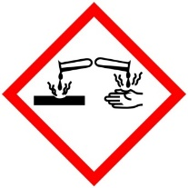

* Often dissolved in water for ease of handling – generally not flammable.
* May corrode or degrade other materials upon storage, including the container they are stored in.

## Hazards and pertinent regulations

Most common corrosives, such as strong acids in solution and strong bases (as solids or solutions), can severely irritate or burn and damage skin upon contact. Severe corrosive burns over a large part of the body can cause death. Corrosive materials can severely irritate, or in some cases, burn the eyes, resulting in blindness. The stronger, or more concentrated, the corrosive material and the longer it remains in contact with the body, the worse the injury will be. Corrosive powders, gases, fumes, mists or vapors can be inhaled and cause severe damage to skin, eyes, nose and mucous membranes. If the sensitive lining in the lungs is exposed to corrosives, fluid buildup may occur (the effect may be delayed). This is known as Pulmonary Edema, a dangerous medical condition that can be fatal.

Note that corrosive materials may have additional hazard classifications, in which case those additional hazards must be considered. For example, fluorine gas is toxic as well as corrosive. Picric acid is an explosive. Nitric acid is an oxidizer.

The OSHA laboratory standard (29 CFR 1910.1450) provides guidelines on the use of hazardous materials in laboratories, including corrosives. OSHA’s personal protective equipment standards (29 CFR 1910 subpart I) provide guidelines for the use of PPE, some of which are applicable to the use of corrosives. Eye and face protection devices in use must comply with the American National Standards Institute (ANSI) Z87.1 set of standards. Use of any amount of corrosives require that emergency eyewash and shower facilities be available in the work area, pursuant to 29 CFR 1910.151 (c). The Standard for Emergency Eyewashes and Shower Equipment (ANSI Z358.1) provides detailed information regarding the installation and operation of emergency eyewash and shower equipment.

## Means to control the hazards

Minimizing exposure is very important when working with corrosive materials. The use of engineering controls and personal protective equipment (PPE) is necessary. Proper storage of corrosive materials must be followed. The key to ensuring safety is to recognize that a material has corrosive properties, assess the risk of exposure (i.e., how you might be exposed in the course of your work while using these materials), minimize the hazard through the use of engineering controls and PPE, perform the appropriate procedures, prepare for spills and splashes of corrosive materials by ensuring the availability of the necessary safety equipment, and to have a rehearsed plan to deal with emergencies.

## Examples of hazardous materials or processes

*PI’s and Lab managers: enter all corrosive materials used in your lab in this section.*

Examples of corrosive materials include but are not limited to:

Acetic acid

Ammonium hydroxide

Benzoic acid

Bleach

Bromine

Chromic acid

Hydrochloric acid

Hydrofluoric acid

Hydrogen peroxide

Lithium hydroxide

Nitric acid

Perchloric acid

Phenol

Phosphoric acid

Phosphoryl chloride

Potassium hydroxide

Pyridine

Sodium hydroxide

Sulfuric acid

Tetramethylammonium hydroxide

Thionyl chloride

Trifluoroacetic acid

Trinitrophenol (Picric acid)

**Identification Tip**

Many bulk corrosive chemicals have color coded caps (see Figure 1). **Note of caution:** This is not a standard; not all manufacturers use this color code on their products.

Red cap – Nitric acid

Blue cap – Hydrochloric acid

Yellow cap – Sulfuric acid

Brown cap – Acetic acid

Green cap – Ammonium hydroxide

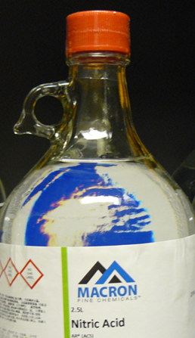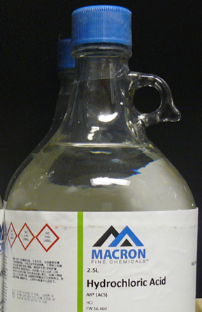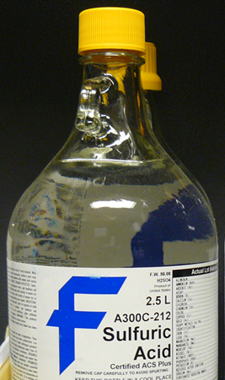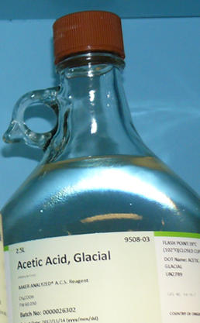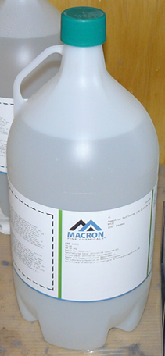

Figure 1. Color-coded caps for common acid bottles.

# Important considerations

## Prior approval from PI required?

Yes

## Consultation of other reference material, documents or knowledgeable persons required?

The Division of Research Safety website has information on [mineral acids](https://www.drs.illinois.edu/SafetyLibrary/MineralAcids), [*aqua regia*](https://www.drs.illinois.edu/SafetyLibrary/AquaRegia), [hydrofluoric acid](https://www.drs.illinois.edu/SafetyLibrary/HydrofluoricAcid), [perchloric acid](https://www.drs.illinois.edu/SafetyLibrary/PerchloricAcid), [“piranha” solutions](https://www.drs.illinois.edu/SafetyLibrary/PiranhaSolutions), and [bases (hydroxides)](https://www.drs.illinois.edu/SafetyLibrary/BasesHydroxides) that may serve as useful reference information.

## Pre-requisite training or skill?

Training appropriate for laboratory personnel. Personnel must have demonstrable skill in the safe handling of chemicals. See the [DRS training curriculum and requirements](https://drs.illinois.edu/Page/Programs/LaboratorySafetyTraining).

Enter any pre-requisite training or skill. Please elaborate and link to training (if online).

## Experiment Risk Assessment required?

Consult this link: [Risk Assessment for Chemical Experiments](http://www.drs.illinois.edu/site-documents/RiskAssessmentWorksheet.docx)

Enter any required risk assessment step or procedure.

## Other important considerations:

Any special First Aid concerns? Any special tips or tricks?

# Emergency response

## Introduction to emergency response

Skin and eye exposure is the most likely hazard associated with corrosive materials. Inhalation is another likely hazard if corrosive vapors, fumes, powders or mists are encountered. While prevention is key, ample preparation for emergencies is necessary. Examples of such preparation include making sure emergency showers and eyewash are operating properly, and that spill kits are stocked to deal with corrosives. Spills of corrosive materials are another possible emergency scenario. Spill response requires taking the necessary steps to avoid contact or exposure to the corrosive materials during clean up. Clean up of spill material should be followed by proper storage and disposal of the waste.

## Necessary emergency equipment

**Spill Kit for Corrosive Materials**

An ideal spill kit for corrosive materials should be composed of the following;

* Chemically resistant gloves
* Sealable plastic bags
* 3-5 kg of acid neutralizer (sodium bicarbonate for general acid use)
* 3-5 kg of base neutralizer (citric acid, tartaric acid or sodium bisulfate)
* Dust pan and whisk broom
* 5-gallon plastic pail

Place all listed materials in the 5-gallon pail and label the pail “Spill Kit”. Place spill kit in an easily accessible place that is known to all lab personnel.

**Emergency shower and eye wash**

Emergency showers and eye washes are needed wherever there is a possibility of exposure to corrosive materials. An emergency shower/eyewash that provides a 15-minute flush of the eyes and body should be located within 10 seconds (about 55 feet) of the area where work on corrosives is being performed. Keep the path to emergency equipment clear and free of any obstruction.

## What to do if there is a spill or a fault in the process.

**IMPORTANT NOTES:**

**Before work begins** – You must know how to clean up any spill or leak of a material before working with it! You should be aware of the location of emergency equipment before performing the cleanup.

**Comfort level** – If the person faced with cleaning up the spill or their supervisor feels that it is too large to safely clean up, he or she instead should proceed as described in **Large/Complicated Spill** section below.

**SPILLS**

**Small/Simple Spills**

First, don personal protective equipment (PPE), such as: chemically resistant gloves, lab coat, and safety glasses. If the corrosive material is:

* **Solid –** use whisk broom and a dust pan to carefully pick up the corrosive solid. Then place material in a sealable plastic bag or pail.
* **Liquid** – sprinkle the appropriate neutralizer on all surfaces exposed to the corrosive material until the material stops reacting to the neutralizer. Let stand for 5-10 minutes and then proceed to clean up the spill by transferring the material into sealable plastic bags or pail.

Seal the waste bags or pail and store in a safe manner while awaiting pickup. Carefully and thoroughly wash spill area with soap and water. Dispose of all spill and clean up material through the University of Illinois chemical waste management program (see **Waste disposal** section).

**Large/Complicated Spills**

If an unmanageable spill of corrosive material happens:

* Inside the fume hood - close the sashes of the chemical fume hood.
* Outside the fume hood – open the sashes of the chemical fume hood (to evacuate corrosive vapors in the lab through the fume hood) and cordon off the area where spill occurred.

In either case, immediately evacuate the laboratory and call 911 to alert emergency responders.

## What to do if there is an exposure or injury

**FIRST AID**

Rinse off exposed areas with large quantity of water for 15 minutes. Eye exposure will require the *immediate* use of an eye wash. Seek medical assistance. Get help from a lab mate. If no one is available to help you, **call** **911 immediately**. Seek medical care without delay*.

**Third party:** Assist the victim. Seek medical assistance*. In case of life-threatening situations (impaired person or loss of consciousness, difficulty breathing, etc.) **call 911 immediately**! Stay with the victim. If possible, ask another person to meet responders so that they can find you quickly.

* See the Division of Research Safety guidance document [Emergency Response Guide](https://drs.illinois.edu/Page/IncidentResponse/EmergencyResponse) for more information.

*PI’s and Lab managers: enter first aid information for specific corrosive materials used in your lab in this section. Document not valid until filled in.*

# Storage

## Considerations for safe storage of materials

Corrosive materials must be stored:

* Separating acids from bases.
* With containers kept inside secondary containment or a spill tray, such as a plastic bin. The secondary containment must be big enough to hold a spill amounting to the total volume of containers stored in it, with extra volume to spare. (see Figure 2)
* In accordance with manufacturers’ SDS, in approved containers, inside an approved storage cabinet.
* Keeping quantities to a minimum.
* In a compatible manner with other reagents. **IMPORTANT:** Avoid acid storage with alcohols, azides, bases, bleach, cyanides, sulfides, nitrides, carbides, and metals. Some corrosive materials are also strong oxidizers and must be stored away from flammable organic materials. Examples include hydrogen peroxide, chromic, nitric, perbromic, perchloric, periodic, and sulfuric acids.
* In a compatible cabinet with sufficient ventilation of vapors that may escape a container.

**NOTE:** All corrosive materials attack metal! Some will etch glass!

*Determine the most dangerous hazards and address those first!*

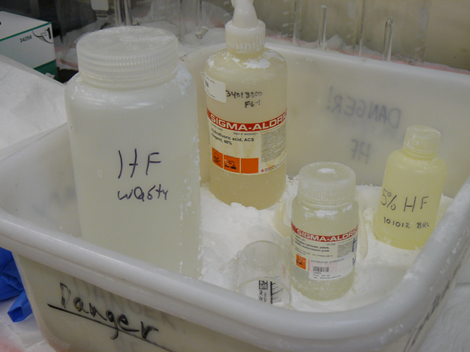

Figure 2. Example of acid storage – note the calcium carbonate powder inside secondary containment to neutralize acid that may drip down sides of bottles.

## Quantity limits and other considerations

Specify applicable regulatory or self-imposed storage quantity limits.

# Work Practices and Engineering Controls

## Introduction to work practices and engineering controls

* Be sure that all equipment being utilized is compatible with the corrosive material being used. Example: Glassware is incompatible for working with hydrofluoric acid.
* De-clutter the work area.
* Remove incompatible material from the work area.
* The manipulation of corrosive materials should utilize locking mechanisms (luer locks, etc.) and have apparatus connections clamped (keck, etc.) when appropriate.
* Inexperienced users of corrosive materials must be supervised while performing experiment.
* To prevent spills, don’t fill vessels near their maximum capacity.
* Have reaction apparatus staged/set up before transferring corrosive materials to it.
* Always thoroughly clean equipment and the work area when finished to prevent chemical exposures from accidental contact with corrosive materials. This also helps to prevent damage and corrosion to equipment.

## Designated area to work with the material or process

A thorough risk assessment should determine the appropriate work area to perform the procedure involving corrosive materials. An important consideration is the availability of a nearby emergency eyewash and shower.

## Necessary engineering or administrative controls

If necessary, consult the [Campus guidance on use of chemical fume hoods](https://www.drs.illinois.edu/SafetyLibrary/ChemicalFumeHoods).

All experiments utilizing corrosive materials should be done inside of a properly operating chemical fume hood or appropriate engineering control with nearby emergency spill kits. Corrosive gases are also classified as toxic and must be kept in a vented gas cabinet*. The use of corrosive gases is not within the scope of this SOP.*

## Required Personal Protective Equipment (PPE)

If necessary, consult the [Campus guidance on personal protective equipment.](https://www.drs.illinois.edu/SafetyLibrary/PersonalProtectiveEquipment)

Fully-enclosed shoes (no holes in the top) must be worn when manipulating corrosive materials. Long hair should be tied back and full-length pants or skirts must also be worn along with basic PPE to include:

* **Eye protection –** Safety glasses meeting American National Standards Institute (ANSI) standard Z87.1 are required while manipulating corrosive materials. If a splash hazard is present, it is recommended that a face shield be worn in addition to safety glasses.
* **Gloves –** Gloves are required at all times. Glove choice should balance the need for dexterity and chemical resistance. Select the glove for compatibility with the material being handled.
* **Lab coat –** Chemical-resistant, knee-length lab coats that is buttoned up.
* **Apron or smock –** A chemically-resistant apron or smock can offer protection from splashes.

# Detailed procedures or techniques

## Step-by-step procedures

**SOLIDS**

Techniques for manipulating corrosive solids are the same as for other standard solids (as taught in standard chemistry lab classes) with three additional considerations: Ventilation, PPE and thorough cleanup. Ventilation and PPE are of critical importance to reduce exposure to corrosive materials and must be used whenever possible. Once the manipulation of corrosive solids is completed, a thorough cleaning of all equipment and lab space (e.g. scales, counter tops, etc.) should be performed to reduce chemical exposures to lab personnel and to avoid damage to lab equipment via corrosion.

**LIQUIDS**

In a similar vein, techniques for manipulating corrosive liquids require paying attention to three considerations: Ventilation, PPE and thorough cleaning. Ventilation and PPE are of critical importance to reduce exposure to corrosive materials and must be used whenever possible. Once the manipulation of corrosive liquid is completed, a thorough cleaning of all equipment and lab space (e.g. containers, counter tops, etc.) should be performed to reduce chemical exposures to lab personnel and to avoid damage to lab equipment via corrosion

**Corrosive Liquids – Pipette Technique**

Note: The technique below can also be utilized with a mechanical or electronic pipettor by substitution of the bulb/pipette combination with the pipettor.

**Procedure (see** Figure 3**)**

1. Uncap the reagent bottle and insert pipette with bulb that has been compressed.
2. Decompress bulb and allow corrosive liquid to be drawn up into the pipette until an excess of the desired liquid has been reached.
3. Now manipulate the bulb (compressing and decompressing) until the desired level of corrosive liquid has been obtained.

**OR**

If an analytical pipette is being utilized, remove the bulb and quickly stopper the bulb end of the pipette. Manipulate the bulb end opening with a finger/thumb, allowing excess liquid to drain out of the pipette until the desired liquid level is obtained.

1. Transfer the pipette of corrosive liquid to the intended vessel and expel the corrosive liquid from the pipette.
2. Close the reagent bottle and place it back into its proper storage location.
3. Clean equipment and the work surface in the appropriate manner.



Figure 3. Liquid transfer via pipette.

**Corrosive Liquids – Graduated Cylinder Technique (see** Figure 4**)**

**Procedure**

1. Place a graduated cylinder on a level and stable surface.
2. Remove the cap from reagent bottle and place a funnel in the mouth of the graduated cylinder.
3. With the lip of the reagent bottle in direct contact with the funnel, pour the corrosive liquid into the graduated cylinder until the liquid reaches the desired level. You may need to use a Pasteur pipette to get the exact desired level of corrosive liquid.
4. Once the desired amount of corrosive liquid is obtained in the graduated cylinder and with the lip of the graduated cylinder in direct contact with the funnel of your vessel, slowly pour the graduated cylinder contents into the receiving vessel.
5. Close the reagent bottle and return to its proper storage location.
6. Clean up the equipment and the work surface in the appropriate manner.

**NOTE:** When diluting concentrated corrosives with water, always add the concentrated corrosive to the water–never vice-versa. Concentrated corrosives tend to have a greater density and don’t allow added water to mix well. This causes exothermic hot spots and can cause the acid to splatter. Slowly adding the concentrated corrosive to water alleviates this effect.



Figure 4. Liquid transfer via graduated cylinder.

**Corrosive Liquids – Syringe Technique (see** Figure 5**)**

**Some corrosives react with water vapor in the air and need to be kept dry. In this case, syringe and cannula techniques are used with inert gas to transfer the desired volume from a sealed container and into a reaction vessel.**

* Use the appropriate septa to seal containers (see Figure 6 below).
* Utilize 16-18 gauge needles of ~8-12” in length (24” for cannula).
* Use syringe needles with stainless Luer hubs (rather than nickel-plated hubs) for use with corrosive materials.
* Never use a syringe at its maximum volume. Syringe plungers can easily “pop-out” near their maximum volume. Examples are: If you need 5 mL of reagent, use a 10 mL syringe. If you need 25 mL of reagent, use a 50 mL syringe. If you need >25 mL of corrosive liquid use a cannula, double-tipped needle or use multiple smaller-volume withdrawals *via* syringe.
* Detailed information on handling air-sensitive reagents can be found in [Sigma-Aldrich Technical Bulletin AL-134](https://www.sigmaaldrich.com/deepweb/assets/sigmaaldrich/marketing/global/documents/685/583/al_techbull_al134.pdf).



Figure 5. Liquid transfer via syringe and needle.

**Procedure**

1. Clamp the bottle of reagent to a solid support to prevent unnecessary movement. If the bottle is coming from cold storage and is stable at ambient temperature, allow it to come to ambient temperature first.
2. Remove the screw-cap from the reagent bottle and insert an inert gas line needle into the septum to place reagent contents under low positive pressure of inert gas.
3. Purge a needle/syringe combination with inert gas a few times. Insert the needle (with the syringe attached, locked and the plunger fully forward) into the reagent bottle through the septum until the needle comes near the bottom of the reagent bottle.
4. Draw the reagent out slowly (to avoid air bubbles) with the syringe pointing downward until a small excess of reagent is withdrawn.
5. Now flip the syringe so that it is pointing upward and the gas in the syringe is allowed to rise. With the syringe still pointing upward, push on the plunger until the exact volume of liquid is desired.
6. Now, with the syringe still pointing upward, bring the tip of the needle out of the liquid reagent until it is in the headspace of the reagent bottle (the headspace is the gas-filled portion of the reagent bottle above the liquid), then slowly pull the plunger back to bring in some inert gas as a head space inside of the syringe.
7. With the syringe still pointing upward, pull the needle out of the septa of the reagent bottle but leaving the inert gas needle in place.
8. Now, with the syringe still pointing upward, insert the needle into the septa of the reaction apparatus that has already been set up. Slowly push the plunger of the syringe inward until it stops and then remove the needle from the septa of the apparatus.
9. At this point you may rinse the syringe and its needle with a solvent that is the same or compatible with the solvent the corrosive liquid was dissolved in. Do this by inserting the needle tip into a flask of the solvent (twice the volume of the syringe) and slowly withdrawing and ejecting the solvent from the syringe. Then rinse with water and clean as normal.

**OR**

If the syringe is disposable, just quench with water by quickly withdrawing and ejecting water out of the syringe and needle, prior to disposal.

1. Once done, be sure reagent bottle is still under an inert atmosphere, withdraw needle from inert gas manifold and recap the reagent bottle. Be sure to use parafilm, bakelite caps or other means to ensure corrosive liquid remains under inert atmosphere. Place reagent bottle back into its appropriate storage location. Clean up equipment and the work surface in the appropriate manner.

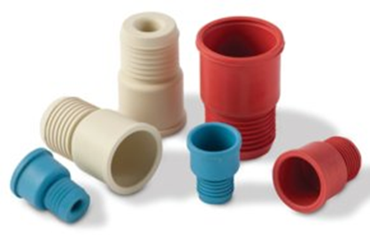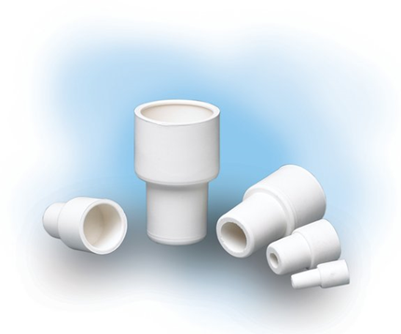

Figure 6. Examples of septa that maybe required for working with corrosive materials. Septa help maintain a sealed enclosure but still allow for the addition and withdrawal of material via needle-syringe.

## Waste disposal procedure.

If necessary, consult the [Chemical waste procedures](https://drs.illinois.edu/Page/Waste/ChemicalWasteProcedures).

Upon completion of work with corrosive materials, dispose of the waste material in the following manner:

* Store the waste in an appropriate container.
* Each waste stream must have a unique number (UI#) assigned by DRS to identify a chemical waste generated on campus. Label the container clearly with a description of the contents and the corresponding UI#.
* Notify the DRS Chemical Waste Section by sending a completed CWM-TRK form to [cws@illinois.edu](mailto:cws@illinois.edu) or making a request [online](https://drs.illinois.edu/site-documents/CampusUserPickupRequest.pdf).
* If the waste material remains corrosive, store it under appropriate conditions and add the words “Corrosive waste” to the label.

# Record of changes made to this SOP

Describe the changes made to this document since its creation.

|  |  |  |
| --- | --- | --- |
| **Date of change** | **Changed by** | **Description of change** |
| 11/17/2022 | Student Assistant | Updated footer and header, revised and updated links. |
|  |  |  |
|  |  |  |
|  |  |  |
|  |  |  |
|  |  |  |
|  |  |  |
|  |  |  |
|  |  |  |
|  |  |  |
|  |  |  |
|  |  |  |

Standard Operating Procedure for Corrosive Materials

# Training record

|  |  |  |  |  |  |
| --- | --- | --- | --- | --- | --- |
| **Training Date** | **Name of Trainer** | **UIN of Trainer** | **Initials of Trainer** | **Name of Trainee** | **UIN of Trainee** |
|  |  |  |  |  |  |
|  |  |  |  |  |  |
|  |  |  |  |  |  |
|  |  |  |  |  |  |
|  |  |  |  |  |  |
|  |  |  |  |  |  |
|  |  |  |  |  |  |
|  |  |  |  |  |  |
|  |  |  |  |  |  |
|  |  |  |  |  |  |
|  |  |  |  |  |  |
|  |  |  |  |  |  |
|  |  |  |  |  |  |
|  |  |  |  |  |  |
|  |  |  |  |  |  |
|  |  |  |  |  |  |
|  |  |  |  |  |  |
|  |  |  |  |  |  |
|  |  |  |  |  |  |
|  |  |  |  |  |  |