**Transportation Infrastructure Precast Innovation Center**

**(TRANS-IPIC)**

**University Transportation Center (UTC)**

*3D-printed Advanced Materials to Mitigate Prestressed*

*Concrete Girder End Cracks – Phase II*

*UB-23-RP-02*

Quarterly Progress Report

For the performance period ending March 31, 2025

**Submitted by:**

Ravi Ranade, Associate Professor, [ranade@buffalo.edu](mailto:ranade@buffalo.edu)

Department of Civil, Structural and Environmental Engineering

University at Buffalo

Co-PIs: Chi Zhou (chizhou@buffalo.edu) and Pinar Okumus (pinaroku@buffalo.edu), University at Buffalo

**Collaborators / Partners:**

*None*

**Submitted to:**

TRANS-IPIC UTC

University of Illinois Urbana-Champaign

Urbana, IL

**TRANS-IPIC Quarterly Progress Report:**

**Project Description:**

1. Research Plan - Statement of Problem

*Precast-prestressed concrete bridge girders are susceptible to cracking at their ends [1,2]. Such end-cracking is a major concern for bridge owners as these cracks could facilitate rapid chloride penetration and lead to corrosion of the prestressing strands and deterioration of the girder’s load capacity. A new method to mitigate the girder end cracks using 3D-printed ductile concrete covers was proposed and developed significantly in the first year of this project. The second year of the research aims to transform this novel method into a practical solution by solving inter-layer and inter-material bonding issues, quantifying gains in durability, and demonstrating the construction of lab-scale beam specimens.*

*The specific objectives of this project’s second-year research are as follows:*

*1. To investigate the inter-layer bond of 3D-printed SHCC filaments and the inter-material bond of 3D-printed SHCC covers with conventional concrete.*

*2. To understand the durability of concrete with 3D-printed covers in uncracked and cracked conditions at varying levels of tensile cracking.*

*3. To explore the behavior of concrete beams with partial zone covers as permanent formwork by performing small-scale beam tests.*

1. Research Plan - Summary of Project Activities (Tasks)

*The following research tasks will be performed to meet the objectives of this study:*

*1.1 Inter-material bond characterization: While there are several methods for characterizing bond between two cementitious composites under tension and shear [3,4], this research will utilize a direct shear (push out) test for determining the SHCC-concrete bond as the interfacial stress state in this state closely resembles that in the given application. In addition, direct tension (pull-off) tests in accordance with ASTM C1583 [5] will be performed to determine the lower bound of the SHCC-concrete bond.*

*1.2 Numerical modeling:* *A detailed numerical model of a prestressed concrete girder (Tx70) was developed during Year 1 of this project, and the model was calibrated using the experimental results reported in [1]. The model was used to establish the target material properties of 3D-printable SHCC. In Year 2, the numerical model will be refined and used to determine the bounds of shear stress demand at the SHCC/concrete interface assuming perfect or weak bond, which will be used to check the adequacy of bond strength determined in Task 1.1.*

*1.3 Mechanical testing: Quasi-static tension tests on cylindrical specimens with a central longitudinal rebar will be conducted to determine the effectiveness of the SHCC-concrete bonded system in reducing the widths (openings) of surface cracks that may propagate from the concrete core. SHCC-concrete bond modifications will be made if needed to reduce surface crack widths and improve durability.*

*1.4 Bond modifications: If the SHCC-concrete bond is deemed inadequate in either tasks 1.2 or 1.3, it will be increased or decreased as needed through various approaches. For increasing the bond, approaches such as roughening (for example, by sanding) the inside of the SHCC shell or printing the SHCC shell with grooves will be employed. For loosening the bond, approaches such as grease application at selected locations on the inside surface of the SHCC shell will be used.*

*2.1 Inter-layer bond evaluation: Splitting tensile test (similar to [6]) and direct tension (pull-off) test (similar to [7]) will be used to evaluate the interlayer bond strength of SHCC. As the proposed application is new, it is challenging to know beforehand whether the evaluated interlayer bond strength is enough. As an alternative, the ratio of interlayer bond strength to cracking strength of SHCC under direct tension will be compared to that presented in the literature for optimally bonded cementitious composites.*

*2.2 Bond improvement: While there are several methods suggested in the literature to improve the inter-layer bond of cementitious composites, the investigators will explore the use of grooving and roughening of layers, along with modifying the printing parameters, such as changing the time gap and/or vertical displacement of printer head between successive layers.*

*3.1 Durability evaluation: To evaluate the implications of surface crack patterns on the corrosion of embedded steel reinforcement, accelerated corrosion tests will be performed on the specimens described in Task 1.3 after mechanical loading. The experimental arrangement, which had been previously used by the investigators [8], will be employed for durability evaluation.*

*3.2 Post-processing and analysis of results: The anodic current obtained from the accelerated corrosion tests will be integrated over time to compute rebar mass loss using Faraday’s law of electrolysis. In addition, actual rebar mass loss will be determined after extracting and cleaning up the corroded rebar from the cylindrical specimen. The rebar mass loss of specimens protected with SHCC shells will be compared to that of specimens made only of concrete.*

*4.1 Design of lab-scale composite beam specimens: Beam specimens will be used to understand the impact of SHCC-concrete bond at a larger scale. They will also demonstrate the effects of the cover discontinuity between the end zone and the rest of the beam on the capacity. Reinforced concrete specimens will be designed, the sizes of which are constrained by the size of the in-house concrete printer. Specimen will be designed to fail under flexure and shear. For each specimen with SHCC cover, a benchmark specimen will be built with only conventional concrete.*

*4.2 Mechanical testing of beams: Three-point and four-point bending tests will be performed to observe shear and flexure behavior, respectively. The crack formation, surface strains, gap opening or slip at the SHCC concrete interfaces, and the load-displacement relationship will be documented under a monotonically increasing load. The behavior of benchmark specimens will be compared to those with SHCC covers to ensure that the SHCC cover does not detach and adversely impact the capacity.*

*5. Printer optimization: In Year 1, the printability and buildability of SHCC materials were extensively investigated through rheological analysis of concrete and tested by a stand-alone extruder. The team developed a custom 3D printer, complete with motion control, material extrusion, and dedicated software to process shell design data and interface with the printer. In Year 2, the team plans to integrate an AC motor-driven extruder with the 3D printer system to ensure full control and coordination. Additionally, nozzle geometry will be optimized to enhance printing quality by improving accuracy, surface finish, and structural integrity, ensuring better bonding with fewer voids.*

**Project Progress:**

1. Progress for each research task

***Task 1.1 - 50%***

*This task aims to evaluate bond strength between a 3D-printable SHCC developed in year 1 of the project and a conventional concrete typically used for bridge girders. As mentioned above, two types of experiments will be performed to assess the inter-material bonding behavior:*

* *Shear experiments: S-shaped specimens with a 2”x4” contact area, as shown in Figure 1(a), have been prepared and are about to finish curing. They will be tested in the second quarter by loading in compression to generate a pure shear loading at the bonded interface.*
* *Axial pull-off experiments: Cylindrical specimens with a bonded circular zone of diameter 3”, as shown in Figure 1(b), are being prepared. These specimens will be tested under uniaxial tension to determine the lower bound of the SHCC-concrete bond.*

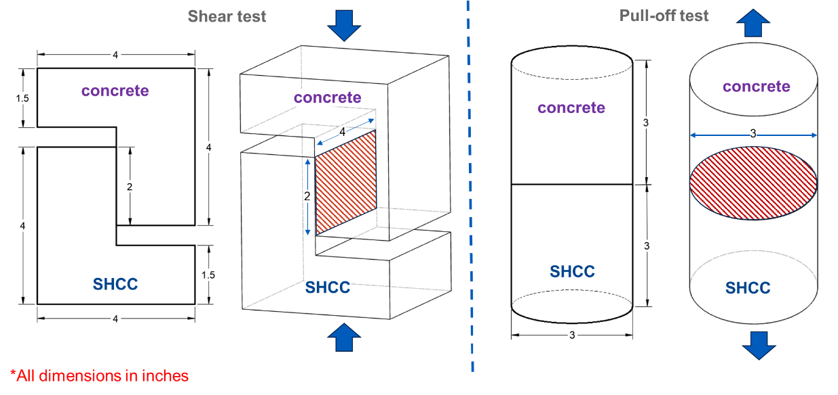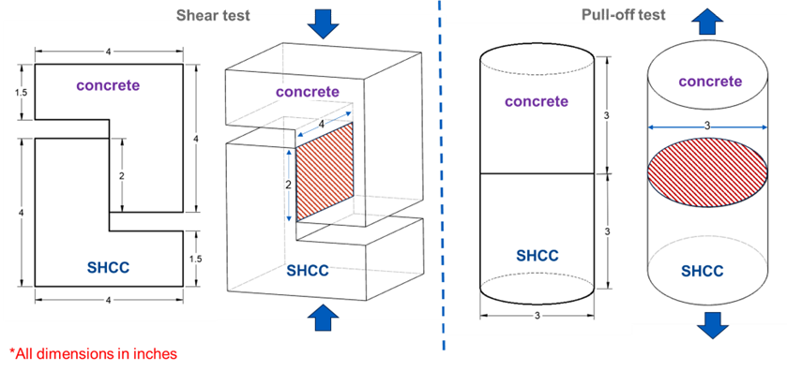

(b)

(a)

*Figure 1: (a) Shear test; (b) Axial pull-off test*

***Task 1.2 - 30%***

*This task aims to extend the numerical model developed in year 1 of the project to incorporate the bonding behavior between the concrete and SHCC covers. The bond is modeled using cohesive-frictional interface property between concrete and SHCC. Initial models assume interface properties from existing literature [9] with different cementitious composite pairs as a starting point, which will be updated upon completion of Task 1.1. The numerical model developed thus far assumes a linear, uncoupled traction separation behavior, stress-based failure initiation, and energy-based damage evolution, as shown in Figure 2.*

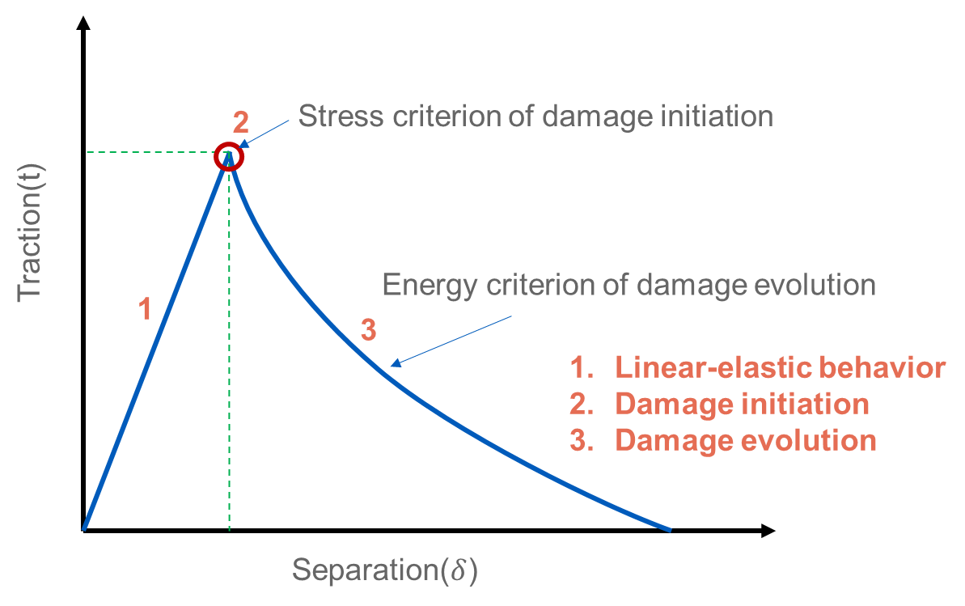

*Figure 2. Representative traction-separation model for numerical simulations*

***Task 1.3 - 10%***

*This task aims to evaluate the effect of SHCC covers on surface cracking in circular concrete specimens with central longitudinal rebar. The testing protocol for such specimens has been developed, and specimen preparation and loading setup are under development.*

***Task 1.4 - 10%***

*This task examines the bond strength’s adequacy based on the experimental findings in tasks 1.1 to 1.3. The bond tests and numerical models will present more comprehensive insights into the following three methodologies to improve inter-material bond strength.*

* *Optimizing the duration between the 3D printing of covers and the casting of concrete inside the cover*
* *Improving interface frictional coefficient*
* *Incorporating grooves in 3D-printed cover if needed*

***Task 2.1 - 50%***

*This task aims to evaluate the interlayer bond strength of the 3D-printable SHCC developed in year 1 of the project. For testing the interlayer bond strength, the following two experiments are currently underway.*

* *Axial tensile test – Single-filament thick sheets of SHCC were printed and cut into a dogbone shape for the axial tension test, as shown in Figure 3(a). These specimens will be tested using a protocol similar to tensile testing of SHCC specimens [10].*
* *Split tensile test – Split-tensile test specimens were prepared by printing two layered sheets and cutting the sheet into cubes with two-filament thickness, as shown in Figure 3(b). The specimen will be loaded in a compression testing machine with steel cylinders at the interface to generate tensile stresses at the interface.*

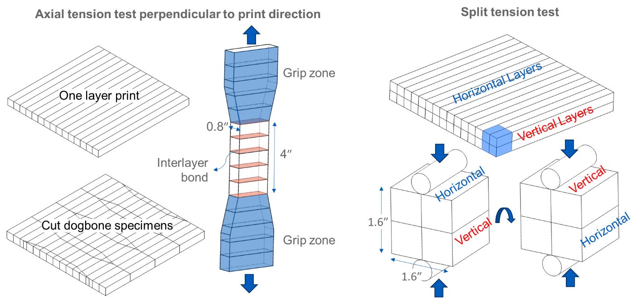

(b)

(a)

*Figure 3(a)Axial tensile test (b)Split Tensile test*

***Tasks 2.2 to 4.2***

*Not started*

***Task 5 - 15%***

*Task 5 aims to enhance and optimize the small-scale 3D concrete printer developed in the project’s first year. The printer is being optimized to improve the printing of SHCC covers. Specifically, the following three improvements are being incorporated into the 3D concrete printing system.*

* *Extrusion control*
* *Nozzle with integrated extrusion system*
* *Horizontal extrusion through nozzles.*

1. Percent of research project completed

***20%***

1. Expected progress for next quarter

*Tasks 1.1 to 2.2 will be completed, and a plan to execute the remaining tasks will be developed.*

1. Educational outreach and workforce development

* ***SCIENCE EXPLORATION DAY (SED), Spring 2025***

*Location-* *Department of Civil, Structural and Environmental Engineering (CSEE), University at Buffalo, Buffalo, New York.*

*Date-March 19, 2025*

*Details- Two groups of local high school students visited the Department of Civil, Structural and Environmental Engineering (CSEE) at the University at Buffalo. They interacted with TRANS-IPIC-associated faculty and students.*

*TRANS-IPIC associated PhD student and faculty demonstrating 3D-printing of SHCC to high school students*

1. Technology Transfer

*None*

**Research Contribution:**

1. Papers that include TRANS-IPIC UTC in the acknowledgments section:
   1. *Peer-reviewed conference paper: Singh, P., Gadde, V.S., Zhou, C., Okumus, P., and Ranade, R. (2024) “Development of 3D printable strain hardening cementitious composites for bridge-related applications.” Editors: Viktor Mechtcherine, Cesare Signorini, and Dominik Junger. In proceedings of 11th International Symposium on Fiber Reinforced Concrete (BEFIB-2024), 15-18 September 2024, Dresden, Germany, pp. 451-458. DOI: 10.1007/978-3-031-70145-0_55*
2. Presentations and Posters of TRANS-IPIC funded research:
3. *Poster presentation at the Annual meeting of the Transportation Research Board (TRB) in Washington, D.C. from January 7-11, 2024.* *Authors: Singh, P., Gadde, V.S., Zhou, C., Okumus, P., and Ranade, R. Title: 3D-printed advanced materials to mitigate prestressed concrete girder end cracks.*
4. *Presentation at TRANS-IPIC workshop, Chicago, April 22, 2024. Authors: Singh, P., Gadde, V.S., Zhou, C., Okumus, P., and Ranade, R. Title: 3D-printed advanced materials to mitigate prestressed concrete girder end cracks.*
5. *Presentation to the UB Institute of Bridge Engineering External Advisory Board, which consists of current and past DOT officials, practicing engineers, and UB alums, April 30, 2024, Buffalo, NY. Authors: Singh, P., Gadde, V.S., Zhou, C., Okumus, P., and Ranade, R. Title: 3D-printed Advanced Materials to Mitigate Prestressed Concrete Girder End Cracks.*
6. *Presentation at TRANS-IPIC monthly research webinar, July 22, 2024, online. Authors: Singh, P., Zhou, C., Okumus, P., and Ranade, R. Title: 3D-printed advanced materials to mitigate prestressed concrete girder end cracks.*
7. *Presentation at conference BEFIB 2024 XI International symposium on fiber reinforced concrete. 15-18 September 2024, Dresden, Germany. Authors: Singh, P., Gadde, V.S., Zhou, C., Okumus, P., and Ranade, R., Title: Development of 3D printable strain hardening cementitious composites for bridge-related applications*
8. *Poster presentation at Summer School of the Research Training Group GRK 2250 “Mineral-bonded composites for enhanced structural impact safety” 18-20 September 2024, Dresden, Germany. Authors: Singh, P., Landge, S.D., Zhou, C., Okumus, P., and Ranade, R., Title: 3D-printed SHCC as permanent formwork for crack width control in prestressed precast concrete bridge girders.*
9. *Extended abstract and Presentation at TRB AAMCT 2024 – Transportation Research Board Conference on Advancing Additive Manufacturing and Construction in Transportation, November 2024. Authors: Singh, P., Gadde, V.S., Zhou, C., Okumus, P., and Ranade, R. Title: Development of 3D printable strain hardening cementitious composites for bridge-related applications.*
10. *Presentation at the Annual meeting of the Transportation Research Board (TRB) in Washington, D.C. from January 5-9, 2025. Authors: Singh, P., Zhou, C., Okumus, P., and Ranade, R. Title: Additive Manufacturing of Concrete for Corrosion Protection of Prestressed Concrete Bridges.*
11. *Presentation at TRANS-IPIC research highlight webinar, February 19, 2025, online. Authors: Singh, P., Zhou, C., Okumus, P., and Ranade, R. Title: 3D-printed advanced materials to mitigate prestressed concrete girder end cracks.*
12. Please list any other events or activities that highlights the work of TRANS-IPIC occurring at your university (please include any pictures or figures you may have). Similarly, please list any references to TRANS-IPIC in the news or interviews from your research.

* ***CSEE Department Poster Competition, Spring 2025***

*Location: Department of Civil, Structural and Environmental Engineering (CSEE), University at Buffalo (UB), Buffalo, New York.*

*Date: January 31, 2025*

*Details: The CSEE department hosted a poster competition where TRANS-IPIC-associated student presented findings from this project. This project received the first place award.*

*CSEE Department poster competition*

* ***SEAS Lightening talk, Spring 2025***

*Location:*  *School of Engineering and Applied Sciences (SEAS), UB, Buffalo, New York.*

*Date: January 31, 2025*

*Details: The SEAS hosted lightning talk event where TRANS-IPIC associated student presented their findings from this project.*

*SEAS lightning talk event*

**Appendix 1**: Research Activities, leadership, and awards (cumulative, since the start of the project)

1. Number of presentations at academic and industry conferences and workshops of UTC findings

* No. = 9

1. Number of peer-reviewed publications submitted based on outcomes of UTC funded projects

* No. = 1

1. Number of peer-reviewed journal articles published by faculty.

* No. = 20

1. Number of peer-reviewed conference papers published by faculty.

* No. = 8

1. Number of TRANS-IPIC sponsored thesis or dissertations at the MS and PhD levels.

* No. MS thesis = 0
* No. PhD dissertations = 0
* No. citations of each of the above = 0

1. Number of research tools (lab equipment, models, software, test processes, etc.) developed as part of TRANS-IPIC sponsored research

* Research Tool #1 = Customizable small-scale 3D concrete printing system with non-proprietary hardware and firmware components for specimen preparation at material scale.
* Research Tool #2 = Method for integrating 3D-printed covers with precast workflow as permanent formworks.
* Research Tool #3 = Rapid screening protocol for 3D-printable strain-hardening cementitious composites development and iterative modifications.

1. Number of transportation-related professional and service organization committees that TRANS-IPIC faculty researchers participate in or lead.

* Professional Societies
  + No. participated in = 10
  + No. lead = 0
* Advisory committees (No. participated in & No. led)
  + No. participated in = 1
  + No. lead = 0
* Conference Organizing Committees (No. participated in & No. led)
  + No. participated in = 1
  + No. lead = 0
* Editorial board of journals (No. participated in & No. led)
  + No. participated in = 2
  + No. lead = 0
* TRB committees (No. participated in & No. led)
  + No. participated in = 5
  + No. lead = 1

1. Number of relevant awards received during the grant year

* No. awards received = 0

1. Number of transportation related classes developed or modified as a result of TRANS-IPIC funding.

* No. Undergraduate = 0
* No. Graduate = 2

1. Number of internships and full-time positions secured in the industry and government during the grant year.

* No. of internships = 0
* No. of full-time positions = 1

**References:**

1. *O’Callaghan, M.R. and O. Bayrak, Tensile stresses in the end regions of pretensioned I-beams at release. 2008, University of Texas: Austin, TX.*
2. *Okumus, P. and M.G. Oliva, Evaluation of crack control methods for end zone cracking in prestressed concrete bridge girders. PCI Journal, 2013. 58(2): p. 91-105.*
3. *Momayez, A., et al., Comparison of methods for evaluating bond strength between concrete substrate and repair materials. Cement and Concrete Research, 2005. 35(4): p. 748-757.*
4. *Zanotti, C. and N. Randl, Are concrete-concrete bond tests comparable? Cement and Concrete Composites, 2019. 99: p. 80-88.*
5. *ASTM C1583-20, Standard Test Method for Tensile Strength of Concrete Surfaces and the Bond Strength or Tensile Strength of Concrete Repair and Overlay Materials by Direct Tension, in ASTM International. 2020: West Conshohocken, PA.*
6. *Teng, F., et al., Development of strain-hardening cementitious composites (SHCC) as bonding materials to enhance interlayer and flexural performance of 3D-printed concrete. Cement and Concrete Composites, 2024. 152: p. 105657.*
7. *Sanjayan, J.G., et al., effect of surface moisture on inter-layer strength of 3D-printed concrete. Construction and Building Materials, 2018. 172: p. 468-475.*
8. *Fakhri, H., Y. Han, and R. Ranade. Influence of Damage on the Effectiveness of SHCC Covers for Reducing Corrosion Rates in Reinforced-Concrete Structural Elements. in 3rd International RILEM Conference on Strain-Hardening Cement-Based Composites (SHCC4). 2018. Dresden, Germany: Springer Netherlands.*
9. *Luu, X.-B., and S.-K. Kim. Finite Element Modeling of Interface Behavior between Normal Concrete and Ultra-High Performance Fiber-Reinforced Concrete. Buildings, 2023. 13 (4): p. 950.*
10. *Kumar, D., and R. Ranade. Development of strain-hardening cementitious composites utilizing slag and calcium carbonate powder. Construction and Building Materials, 2020. 273: p. 122028.*